Supplementary information

Mutation of KCNJ5 induced adrenal aldosterone adenoma via CYP11A1 regulation

Materials and Methods
- Built KCNJ5 mutant cells by CRISPR/Cas9 gene editing
After SW-13 cells （human adrenocortical small cell carcinoma）were cultured, we used the genome targeting technology mediated by the CRISRP/Cas9 system to obtain SW-13 mutant cell lines with mutation (c.451G>A and c.503T>G) in the KCNJ5 gene. Details of mutations were shown in Figure S1.
Figure S1 Target mutations in KCNJ5

- Design of gene targeting
Figure S2 Schematic diagram of gene editing

  - sgRNA design and activity detection
A total of 17 guide RNAs were designed as shown in Table S1. Among the 17 sgRNAs, sgRNA4 and sgRNA16 have the highest activity (Figure S3) and will be used for subsequent targeting experiments.
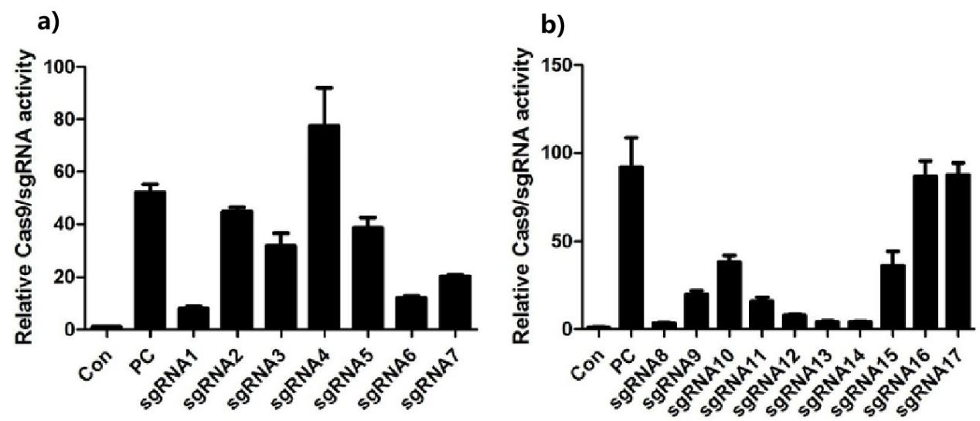
Figure S3 A total of 17 guide RNAs were designed

  - Construct Targeting vector
    - Fragment amplification and sequencing primer design
The anti-PURO targeting vectors and anti-NEO targeting vectors were constructed, and A1 (937bp) was amplified by primers A-F and A-R (in), A2(1408bp) was amplified by primers A-F (in) and A-R, and A (2303bp) was amplified by overlap PCR. Table S2 (Figure S4).
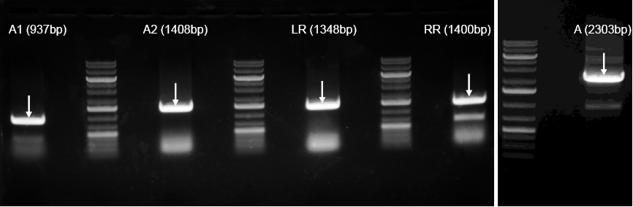
Figure S4 Construct Targeting vector
    - Digestion verification of the CL-CYH-009-puro-ΔTK
LR (1348bp), RR(1400bp) and A were ligated to lSCKO-4G vector， to gain the final targeting vector CL-CYH-009-puro-ΔTK. The Cl-CyH-009-PURO - δ TK was digested. The CL-CYH-009-puro-ΔTK（#1） was digested by SalI+Xhol, NcoI and Hind III +BamHI. Respectively. The length of the product was as expected ( 7944bp+ 2289bp, 5827bp+3536bp+870bp and 7660bp+2573bp) (Figure S5).
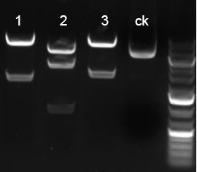
Figure S5 Digestion verification of the CL-CYH-009-puro-ΔTK
    - Digestion verification of the CL-CYH-009-ΔTK-P2A-neo
LR, RR and A were ligated to LScKO-4G（ΔTK-P2A-neo）vector, to gain the final targeting vector CL-CYH-009-ΔTK-P2A-neo, TheCL-CYH-009-ΔTK-P2A-neo were digested by restriction endonuclease SalI+EcoR ⅴ, SacI and XbaI respectively. The length of the digested products were as expected (8388bp+ 2021bp+104bp, 8449bp+1573bp+483bp+8bp and 6250bp+2964bp+1299bp)( Figure S6 ).
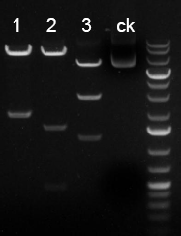
Figure S6. Digestion verification of the CL-CYH-009-ΔTK-P2A-neo

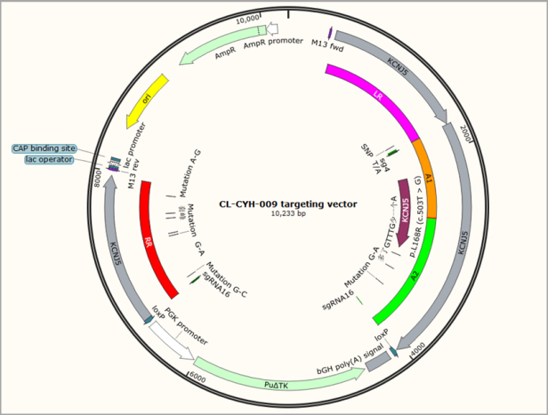
Figure S7. Map of the CL-CYH-009 targeting vector
  - Electroporation and Drug screening
According to the electroporation conditions of the preliminary experiment，SgRNA4, sgRNA16 and targeting vectors (Cl-CyH-009-PURO-δTK and/or Cl-CyH-009-δ TK-P2A-neo) were transferred into SW-13 cell, the hybrid clones were screened according to the concentration of Puro drug sieve explored in the pre experiment.

  - Primer design for hybrid clone detection
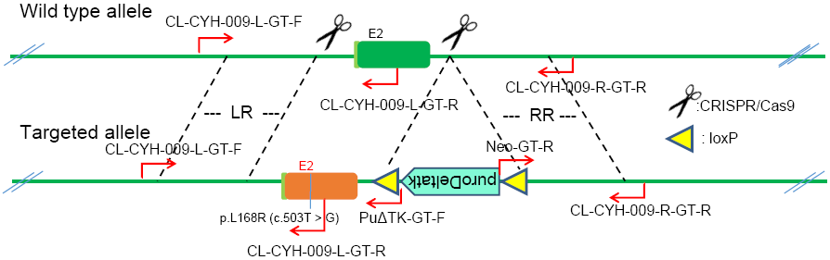
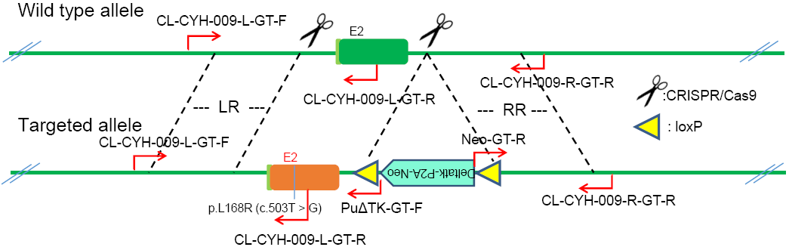
  - Hybrid clone detection
PCR products were performed by agarose gel electrophoresis and by the drug sieve, the targeting hybrid clone were obtained, and the results were in line with expectations(Figure S8).
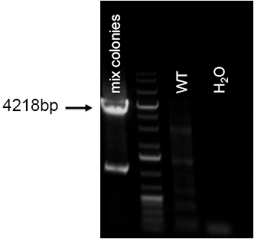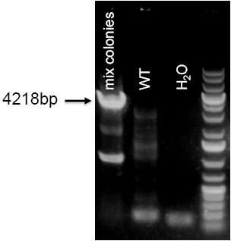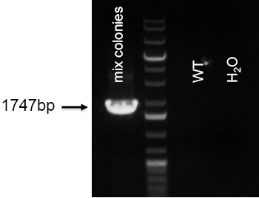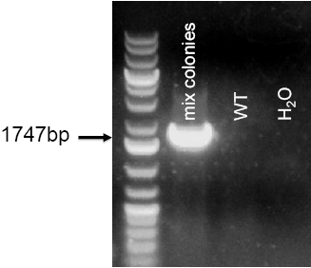
Figure S8. Hybrid clone detection

  - Monoclonal detection
The monoclonal antibodies obtained from drug screening were detected by PCR, the PCR products were detected by agarose gel electrophoresis, and the results were in line with expectations.
CL-CYH-009-L-GT-F/PuΔTK-GT-F | Neo-GT-R/CL-CYH-009-R-GT-R
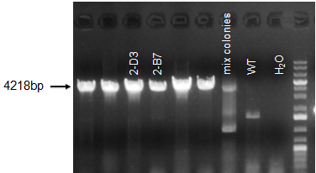 | 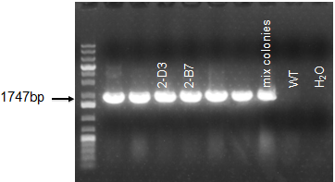
CL-CYH-009-L-GT-F/CL-CYH-009-L-GT-R
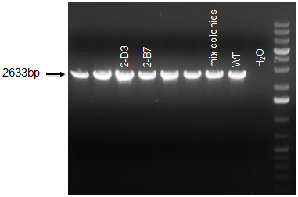
Figure S9. Monoclonal detection(CL-CYH-009-L-GT-F/PuΔTK-GT-F, Neo-GT-R/
CL-CYH-009-R-GT-R, CL-CYH-009-L-GT-F/CL-CYH-009-L-GT-R)

- Cellular aldosterone content detection
Take the cell culture supernatant for aldosterone content detection. Double-antibody one-step sandwich enzyme-linked immunosorbent assay (Human ALD Elisa Kit, SAIPEISEN Biotechnology Co., Ltd., shanghai, China) was used. To the coated microwells pre-coated with human aldosterone (ALD) capture antibody, add the specimen, standard, and HRP-labeled detection antibody in sequence, incubate and wash thoroughly. The color is developed with the substrate TMB. TMB is converted into blue under the catalysis of peroxidase and into the final yellow under the action of acid. The intensity of the color is positively correlated with the human aldosterone (ALD) in the sample. Measure the absorbance (OD value) with a microplate reader at a wavelength of 450 nm to calculate the sample concentration.The specific steps are as follows:
1. Take out the required slats from the aluminum foil bag that has been equilibrated at room temperature for 20 minutes, and seal the remaining slats with a ziplock bag and put it back to 4°C.
2. Set up standard wells and sample wells, add 50μL of standards of different concentrations to each of the standard wells;
3. Add 50μL of the sample to be tested into the sample hole; do not add the blank hole.
4. In addition to the blank wells, add 100μL of horseradish peroxidase (HRP)-labeled detection antibody to each well of the standard wells and sample wells, seal the reaction wells with a sealing film, and incubate in a 37°C water bath or incubator 60min.
5. Discard the liquid, pat dry on absorbent paper, fill each hole with washing solution (350μL), let stand for 1 min, shake off the washing solution, pat dry on absorbent paper, and repeat the plate washing 5 times (also can be washed with a plate washer) plate).
6. Add 50μL each of Substrate A and B to each well and incubate at 37°C for 15min in the dark.
7. Add 50μL of stop solution to each well and measure the OD value of each well at 450nm wavelength within 15min.
Calculation of experimental results: Take the OD value of the measured standard product as the abscissa, and the concentration value of the standard product (the concentration of the standard product is: 400, 200, 100, 50, 25, 12.5 pg/mL) as the ordinate, on the graph paper or use the relevant The software draws the standard curve, and obtains the linear regression equation, substitutes the OD value of the sample into the equation, and calculates the concentration of the sample.

4. Cellular pregnenolone/progesterone/ corticosterone/cholesterol content detection
The detection of pregnenolone/progesterone/corticosterone/cholesterol content in cells was carried out using a commercial double-antibody sandwich ELISA kit (SAIPEISEN Biotechnology, Shanghai, China), and the specific operation method was the same as the aldosterone detection method.

5. Fluo-4 AM calcium ion fluorescent probe to detect intracellular calcium ion concentration
The maximum excitation wavelength of Fluo-4 AM fluorescent probe combined with calcium ion is 494nm, and the maximum emission wavelength is 516nm. The changes in intracellular calcium ion levels can be detected by laser confocal microscope or flow cytometry. The specific experimental methods are as follows:
1) Prepare Pluronic F-127 stock solution: Weigh Pluronic F-127 powder and add 500ul DMSO to 20% (W/V) stock solution.
2) Dissolve Fluo-4 with anhydrous DMSO and prepare 5mM stock solution with AM;
3) Dilute the Fluo-4 AM+DMSO stock solution to 10uM working solution with PBS, add an appropriate amount of 20% Pluronic F-127 solution in advance to make the final concentration 0.02%;
4) Add the prepared Fluo-4 AM working solution to the cells, the amount added is subject to covering the cells. Incubate at 37℃ or room temperature for 1h;
5) Aspirate the staining working solution and wash with PBS 3 times to remove excess probes;
6) Use a fluorescence microscope to observe the intensity of intracellular fluorescence and/or quantitatively detect intracellular fluorescence intensity by flow cytometry.
We target the mutant cell line, and the wild type SW-13 cell line through normal culture (90% high glucose DMEM+10%FBS+1% P/S) and high salt culture (high K⁺ conditions: K⁺ concentration 7mM; high Na⁺ conditions: Na⁺ concentration 200mM). In order to study the main mechanism of KCNJ5 causing hypertension.

- SBFI AM sodium ion indicator probe to detect intracellular sodium ion concentration
SBFI (Sodium-binding Benzofuran Isophthalate) is a Na+ selective fluorescent indicator that can be used to predict purified mitochondrial Na+ gradients, detect intracellular Na+ levels, measure cellular Na+ outflow, and use it in combination with other fluorescent indicators to analyze Na+ and Ca+ Correlation with Mg2+ concentration, intracellular pH and membrane potential changes. The spectral response of SBFI after bound ions can be determined by the measurement of excitation light ratio. When the system contains physiological concentration of K+/Na+ (-135mM), the number of dissociation fields (Kd) of SBFI to Na+ is 11.3mM; there is no K+ The Kd for Na+ of the system is 3.8 Mm. The selectivity of SBFI to Na+ is about 18 times stronger than that of K+. The specific experimental methods are as follows:
1) Configure 5Mm SBFI AM storage solution: Take 50μg of SBFI AM and place it at room temperature for 20 minutes, centrifuge at low speed and add 8.8723μl of anhydrous DMSO to the tube to fully dissolve it, and prepare a 5mM storage solution;
2) Preparation of Pluronic F-127 mother liquor: Weigh Pluronic F-127 powder and add 500ul DMSO to prepare 20% (W/V) mother liquor;
3) Mix the 5Mm SBFI AM stock solution with 20% Pluronic F-127 stock solution in equal volume and add an appropriate amount of PBS to reach the required working concentration (10μM), and add the probe to the cell for labeling. The incubation temperature is 37 degrees Celsius, and the time is 4h;
4) At the end of the incubation, add PBS and incubate for an additional hour to ensure that the cells completely esterase SBFI AM;
5) Wash the cells 2-3 times with PBS to reduce the extracellular background fluorescence. Use flow cytometry to detect intracellular fluorescence intensity.

- PBFI AM potassium ion indicator probe to detect the intracellular potassium ion concentration
PBFI (Potassium-binding benzofuran isophthalate) is a K+ sensitive fluorescent probe used to measure the K+ level changes in cells and intracellular compartments. The dissociation constant of PBFI to K+ is very dependent on the presence or absence of Na+. In the system without Na+, the Kd value of PBFI to K+ is 5.1 mM; and in the solution system containing the total concentration of K+/Na+ (about physiological ionic strength), the Kd value of PBFI to K+ is 44 mM; Na+ was replaced by tetramethylammonium chloride, and the Kd value of PBFI to K+ was 11 mM; choline chloride and nitrogen methyl glucosamine were the other two compounds that could replace Na+ in the medium. Although the selectivity of PBFI for K+ is only 1.5 times stronger than that of Na+, this selective ability is sufficient to meet the monitoring needs, because the intracellular K+ is about 10 times higher than Na+ under normal circumstances. The specific detection method is the same as the SBFI AM probe.

Results

- Effect of KCNJ5 gene mutation on cell proliferation
Take the cells in the logarithmic growth phase to prepare a certain concentration of cell suspension and add 100 ul per well to a 96-well cell culture plate. For cell proliferation experiments, 2×10³ cells/100ul cells were added to each well. After plating, perform pre-incubation in a 37°C incubator for 4 hours and wait for the cells to adhere to the wall before starting the experiment. At 0, 24, 48, 72, 96 hours, add 10ul of CCK-8 solution to 96-well cell culture plate, and continue to incubate for 1 hour in a 37°C incubator. Use a microplate reader to detect the absorbance of the culture supernatant at a wavelength of 450 nm. Compared with the wild-type control group SW-13, the cell growth rate of the mutant group had no significant difference (Figure S10).
Figure S10 Investigation on the proliferation of wild-type and mutant SW-13 cells

- Detection of intracellular potassium/calcium/sodium ion concentration
The average fluorescence intensity of the intracellular PBFI/Fluo-4/SBFI probe was detected by flow cytometry, which reflects the concentration of potassium/calcium/sodium ions. The results showed that compared with the wild-type control group, the potassium ion content in the mutant cell lines did not change significantly; the calcium ion content in the cells of the B7, C5, and D3 groups increased significantly; the sodium ion content of the four groups of mutant cell lines increased significantly compared with the wild type.
Figure S11 Investigation of potassium/calcium/sodium ion content in wild-type and mutant SW-13 cells (** is P<0.05)

- Influence of potassium ion concentration in culture system on intracellular ion concentration
Under normal circumstances, the intracellular potassium ion concentration is about 150mM, the extracellular concentration is about 5mM; the intracellular sodium ion concentration is about 15mM, and the extracellular concentration is 150mM. When the potassium ion concentration in the culture system was increased from 5.4 mM to 7 mM, the changes in the concentration of potassium, calcium, and sodium ions in wild-type and mutant cells were investigated. Taking the culture group under normal conditions as a control, the relative fluorescence intensity of fluorescent probes was used to reflect the changes in intracellular ion concentration. The results are shown in Figure S12 below. The results showed that when the potassium ion concentration in the extracellular environment was increased, the potassium ion concentration in the wild-type cells increased significantly, the sodium ion concentration decreased significantly, and the calcium ion concentration remained unchanged; while the intracellular concentrations of the three ions in the mutant B7 cell line were lower There is no significant change. For normal cells, when the extracellular potassium ion concentration increases, the potassium influx increases, causing the resting potential to shift upward. According to the Nernst equation, the cell will depolarize, and the voltage-sensitive sodium ion channel will continue to depolarize due to the cell's continuous depolarization. Chemical inactivation leads to the closure of the sodium ion channel, which is the blockage of the sodium ion channel, which inhibits the influx of sodium ions. The mutant cell line did not show this phenomenon.
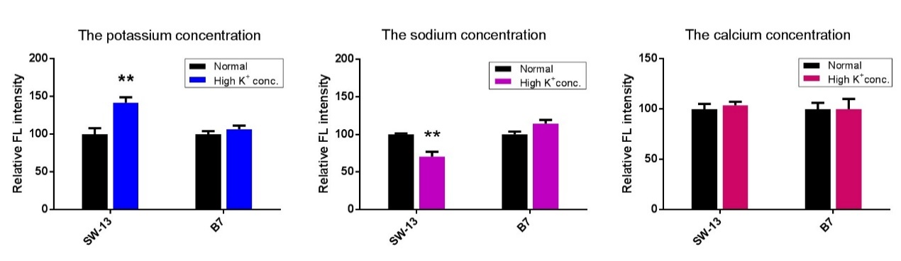
Figure S12 Investigation on the concentration of potassium, sodium and calcium ions in wild-type and mutant-type cells under high potassium ion culture conditions

- Influence of sodium ion concentration in culture system on intracellular ion concentration
When the concentration of sodium ions in the culture system was increased from 140 mM to 200 mM, the changes in the concentration of potassium, calcium, and sodium ions in wild-type and mutant cells were investigated. The result is shown in Figure S13. It can be seen that when the extracellular sodium ion concentration increases, the intracellular sodium ion content of SW-13 wild-type and mutant cell line B7 both increases, and the increase rate is basically similar. The reason for the analysis may be that when the concentration of extracellular sodium ions is high, sodium ions will enter the intracellular fluid due to the increase of sodium gradient, so the concentration of sodium ions in the intracellular fluid also increases. The changes in intracellular potassium and calcium ion concentrations were not significant.
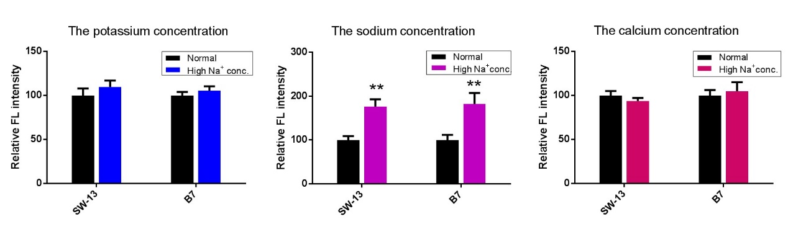
Figure S13 Investigation on the concentration of potassium, sodium and calcium ions in wild-type and mutant-type cells under high sodium ion culture conditions

- Multi-omics bioinformatics analysis
We studied the mutant cell lines at the WGS, WTS and WGBS levels, respectively, and the analysis software refers to Table S1.
Table S1 Software of analysis for WGS, WTS and WGBS.
Software | WGS | WGBS | WTS
Cleaning data | SOAPnuke¹ | SMAP² | Fastp³
alignment | BWA⁴ | BSMAP² | Hisat2⁵
SNP calling | GATK⁶ | BS-SNPer⁷ | GATK⁶
DMR analysis | - | SMAP² | -
DGE analysis | - | - | DESeq2⁸

Whole genome sequencing data analysis
Through the three cell lines we obtained, the wild-type wild and mutant strains were sequenced, the WGS sequencing of the three samples reached more than 30x. The specific sequencing depth is shown in Supplementary Table S2. The study found that the target KCNJ5 mutation was successful, all of which were pure and mutations. In addition, it was found that the sites where non-synonymous mutations occurred in the mutant cell line did not overlap, and there was no significant difference in the number of mutations generated according to the passage theory. Therefore, there is no off-target effect in the cas9 experiment, which can be used to analyze the subsequent data normally (Table S3).
Table S2 Whole-genome sequencing quality control results
Sample ID | Platform | Reads (M) | Bases (G) | ReadLength（PE） | Q20 | GC
Wild | Illumina(HiSeq X-Ten) | 827.10 | 121.16 | 150 | 98.07% | 41.80%
B7 | Illumina(HiSeq X-Ten) | 918.00 | 134.47 | 150 | 98.09% | 41.58%
D3 | Illumina(HiSeq X-Ten) | 699.60 | 102.48 | 150 | 95.95% | 41.26%
#NOTE: Reads: the total number of sequenced fragments after filtering; Bases: the total number of bases after filtering; ReadLength: the length of sequenced fragments; Q20: the number of nucleotides with sequencing quality greater than 20/total number of nucleotides; GC: guanine (or cell Pyrimidine) Number of Nucleotides/Total Number of Nucleotides.

We separately sequenced the two mutant clones of c.T503G and found that each clone has a small number of mutations except T503G of KCNJ5, but there is no mutation at the same site Table S3. The reason may be due to the occurrence of the passage process. It shows that the CRISPR/Cas9 gene editing experiment works well.

Table S3 Mutations determined by both PCR-based clone sequencing and WGS-based sequencing

CHR | Pos | Ref | Mutation (B7) | Mutation (D3)
chr1 | 13061364 | A | AC
chr1 | 171784445 | G | GT
chr10 | 47502991 | C | CT
chr10 | 51698432 | C | CT
chr11 | 128911776 | T | GG | GG
chr11 | 130129126 | C |  | CT
chr12 | 82358737 | G | CG
#NOTE: Position in red is T503G of KCNJ5.
- Whole genome bisulfite sequencing data analysis
We performed WGBS analysis on Wild type, B7 and D3 samples respectively, and the quality of sequencing data is shown in Table S4. The results showed that the promoter region of CYP11B2 gene was indeed hypomethylated, indicating that KCNJ5 mutation can indeed lead to methylation changes of CYP11B2 gene low.
Table S4 Bisulfite whole-genome sequencing quality control results
Sample ID | Platform | Reads (M) | Bases (G) | ReadLength（PE） | Q20 | GC
Wild | Illumina(HiSeq X-Ten) | 909.16 | 137.88 | 150 | 98.05% | 22.25%
B7 | Illumina(HiSeq X-Ten) | 904.68 | 132.52 | 150 | 99.63% | 22.00%
D3 | Illumina(HiSeq X-Ten) | 984.17 | 144.17 | 150 | 99.63% | 23.00%
#NOTE: Reads: Total number of sequenced fragments after filtering; Bases: Total number of bases after filtering; ReadLength: Length of sequenced fragments; Q20: Number of nucleotides/total number of nucleotides with sequencing quality greater than 20; GC: Guanine (or cytosine) ) Number of nucleotides/total number of nucleotides.

However, through the analysis of multiple WTS and qPCR, there was still no difference in the transcription of CYP11B2 gene, but the change of aldosterone was obvious, so CYP11B2 was not the only reason for the increase of aldosterone. The methylation changes in the promoter region of the gene are shown in Table S4. Table S4 Correlation between methylation and expression

- Transcriptome data analysis
We performed transcriptome sequencing on the constructed human adrenal cortex small cell carcinoma wild-type cell line SW-13 and mutant cell lines D3, B7, C5 and F1 on the Illumina platform and the BGISEQ-500 platform, The quality control results are shown in Table S5.
Table S5 Whole transcriptome sequencing quality control results
Sample | ID | Cell line | Clean Reads(M) | Clean Bases(G) | Q20(%) | Q30(%) | GC(%) | Read Length(bp)
Wild | Sw13-normal | Wild SW-13 | 91.3696M | 13.7054G | 95.98 | 90.91 | 49.43 | 150
Wild | widA1 | Wild SW-13 | 41.2976M | 6.1739G | 95.35 | 85.32 | 47.21 | 150
Wild | widA2 | Wild SW-13 | 40.6135M | 6.0734G | 95.15 | 84.84 | 47.58 | 150
Wild | Sw13-K | Wild SW-13 | 40.3770M | 6.0566G | 97.4 | 93.05 | 48.73 | 150
Wild | Sw13-K_redo | Wild SW-13 | 46.5495M | 6.9824G | 97.13 | 92.46 | 48.15 | 150
Wild | Sw13-Na | Wild SW-13 | 37.2816M | 5.5922G | 97.35 | 93.03 | 49.39 | 150
Wild | Sw13-Na_redo | Wild SW-13 | 47.6170M | 7.1426G | 97.12 | 92.47 | 48.18 | 150
B7 | B7C1 | c.T503G SW-13 | 40.1200M | 6.0180G | 95 | 84.38 | 47.76 | 150
B7 | B7C2 | c.T503G SW-13 | 39.4877M | 5.9232G | 95.07 | 84.53 | 47.72 | 150
B7 | B7T1 | c.T503G SW-13 | 104.6379M | 15.6957G | 97.05 | 93.1 | 50.57 | 150
B7 | B7-K | c.T503G SW-13 | 40.3972M | 6.0596G | 97.43 | 93.16 | 49.22 | 150
B7 | B7-K_redo | c.T503G SW-13 | 46.6792M | 7.0019G | 97.27 | 92.8 | 47.93 | 150
B7 | B7-Na | c.T503G SW-13 | 40.5067M | 6.0760G | 97.44 | 93.16 | 49.27 | 150
D3 | D3C1 | c.T503G SW-13 | 40.0944M | 6.0142G | 95.14 | 84.77 | 47.33 | 150
 | D3C2 | c.T503G SW-13 | 39.5366M | 5.9305G | 95.11 | 84.7 | 47.21 | 150
 | D3T1 | c.T503G SW-13 | 107.1619M | 16.0743G | 96.48 | 91.94 | 51.74 | 150
C5 | C5K | c.G451C SW-13 | 40.5427M | 6.0814G | 97.36 | 92.99 | 49.17 | 150
 | C5Na | c.G451C SW-13 | 40.7416M | 6.1112G | 97.2 | 92.54 | 49.6 | 150
 | C5T1 | c.G451C SW-13 | 51.7427M | 7.7395G | 94.97 | 85.43 | 49.46 | 147
F1 | F1T1 | c.G451C SW-13 | 54.0031M | 8.0774G | 94.96 | 85.3 | 49.32 | 150
#NOTE: Reads: Total number of sequenced fragments after filtering; Bases: Total number of bases after filtering; ReadLength: Length of sequenced fragments; Q20: Number of nucleotides/total number of nucleotides with sequencing quality greater than 20; GC: Guanine (or cytosine) Number of nucleotides/total number of nucleotides.

Reference
1. Chen Y, Chen Y, Shi C, Huang Z, Zhang Y, Li S, Li Y, Ye J, Yu C, Li Z, Zhang X, Wang J, Yang H, Fang L, Chen Q. SOAPnuke: A MapReduce acceleration-supported software for integrated quality control and preprocessing of high-throughput sequencing data. Gigascience. 2018; 7:1-6. <https://doi.org/10.1093/gigascience/gix120>.
2. Gao S, Zou D, Mao L, Zhou Q, Jia W, Huang Y, Zhao S, Chen G, Wu S, Li D, Xia F, Chen H, Chen M, Ørntoft TF, Bolund L, Sørensen KD. SMAP: A streamlined methylation analysis pipeline for bisulfite sequencing. Gigascience. 2015; 4. <https://doi.org/10.1186/s13742-015-0070-9>.
3. Chen S, Zhou Y, Chen Y, Gu J. Fastp: An ultra-fast all-in-one FASTQ preprocessor. In: Bioinformatics. Vol 34. Oxford University Press, 2018, pp i884-i890.
4. Li H, Durbin R. Fast and accurate short read alignment with Burrows-Wheeler transform. Bioinformatics. 2009; 25:1754-1760. <https://doi.org/10.1093/bioinformatics/btp324>.
5. Kim D, Paggi JM, Park C, Bennett C, Salzberg SL. Graph-based genome alignment and genotyping with HISAT2 and HISAT-genotype. Nat Biotechnol. 2019; 37:907-915. <https://doi.org/10.1038/s41587-019-0201-4>.
6. Poplin R, Ruano-Rubio V, DePristo MA, Fennell TJ, Carneiro MO, Van der Auwera GA, Kling DE, Gauthier LD, Levy-Moonshine A, Roazen D, Shakir K, Thibault J, Chandran S, Whelan C, Lek M, Gabriel S, Daly MJ, Neale B, MacArthur DG, Banks E. Scaling accurate genetic variant discovery to tens of thousands of samples. November 2017. <https://doi.org/10.1101/201178>.
7. Gao S, Zou D, Mao L, Liu H, Song P, Chen Y, Zhao S, Gao C, Li X, Gao Z, Fang X, Yang H, Ørntoft TF, Sørensen KD, Bolund L. BS-SNPer: SNP calling in bisulfite-seq data. Bioinformatics. 2015; 31:4006-4008. <https://doi.org/10.1093/bioinformatics/btv507>.
8. Love MI, Huber W, Anders S. Moderated estimation of fold change and dispersion for RNA-seq data with DESeq2. Genome Biol. 2014; 15. <https://doi.org/10.1186/s13059-014-0550-8>.

