Supplementary information

Engineering an in vivo charging station for CAR-redirected invariant natural killer T cells to enhance cancer therapy

Yan-Ruide Li^{1,2,*}, Haochen Nan^{1,*}, Zeyang Liu^{1,*}, Ying Fang², Yichen Zhu², Zibai Lyu², Zhengyao Shao³, Enbo Zhu^{2,4}, Bo Zhang¹, Youcheng Yang¹, Xinyuan Shen², Yuning Chen², Tzung Hsiai⁴, Lili Yang^{1,2,5,6,7,8,§}, Song Li^{1,5,6,§}

Author Affiliation:
¹Department of Bioengineering, University of California, Los Angeles, Los Angeles, CA 90095, USA
²Department of Microbiology, Immunology & Molecular Genetics, University of California, Los Angeles, Los Angeles, CA 90095, USA
³Department of Pharmacology, University of California, San Diego, La Jolla, CA 92093, USA
⁴Division of Cardiology, Department of Medicine, David Geffen School of Medicine, University of California, Los Angeles, Los Angeles, CA 90095, USA
⁵The Eli and Edythe Broad Center of Regenerative Medicine and Stem Cell Research, University of California, Los Angeles, Los Angeles, CA 90095, USA
⁶Jonsson Comprehensive Cancer Centre, University of California, Los Angeles, Los Angeles, CA 90095, USA
⁷Molecular Biology Institute, University of California, Los Angeles, Los Angeles, CA 90095, USA
⁸Parker Institute for Cancer Immunotherapy, University of California, Los Angeles, Los Angeles, CA 90095, USA
*These authors contributed equally
§Corresponding author. Email: liliyang@ucla.edu (L.Y.), and songli@ucla.edu (S.L.).

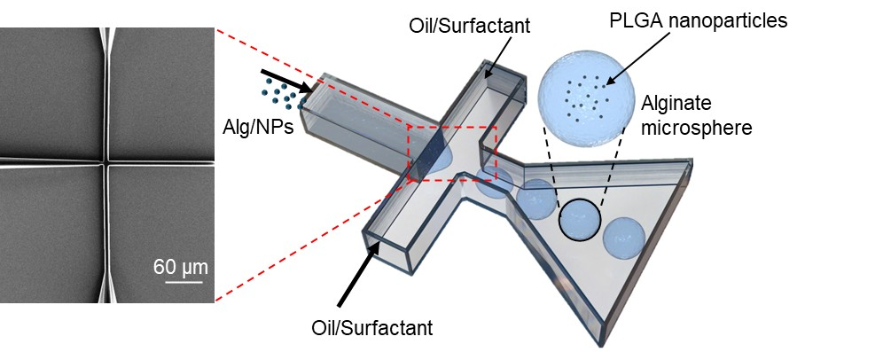
Supplementary Fig. 1 | Microfluidic fabrication of nanoparticle-loaded hydrogel microparticles. Schematic representation of a microfluidic droplet generation system used for encapsulating nanoparticles within alginate microparticles. The oil/surfactant phase facilitates controlled droplet formation, while nanoparticles are trapped within the polymeric network of the resulting microparticles.

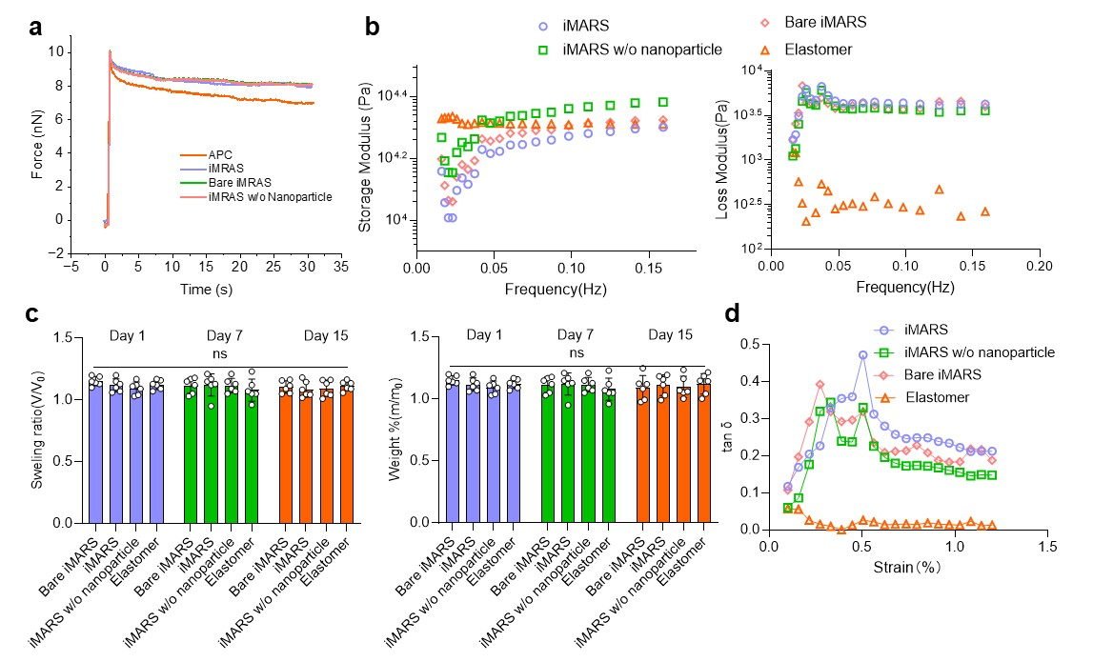
Supplementary Fig. 2 | Mechanical characterization of iMRAS. a, Stress relaxation of human APC, iMRAS, bare iMRAS and iMRAS without nanoparticles with AFM indentation technique. b, Rheology measurements of the storage modulus and loss modulus of iMRAS, bare iMRAS, iMRAS without nanoparticles, and elastomer at varying frequencies (n = 3 batches of gels). c, Swelling of iMRAS with different components and elastomer after 1, 7, and 15 days of DMEM immersion, quantified by the ratio fo the volume of gels at day 1, day 7 or day 15 to their volumes before immersion. (n = 3). d, Shear storage and shear loss modulus as a function of frequency for iMRAS with different components and elastomer. Data are presented as the mean ± s.e.m. Statistically significant difference was determined by one-way ANOVA in (c). NS, not significant,

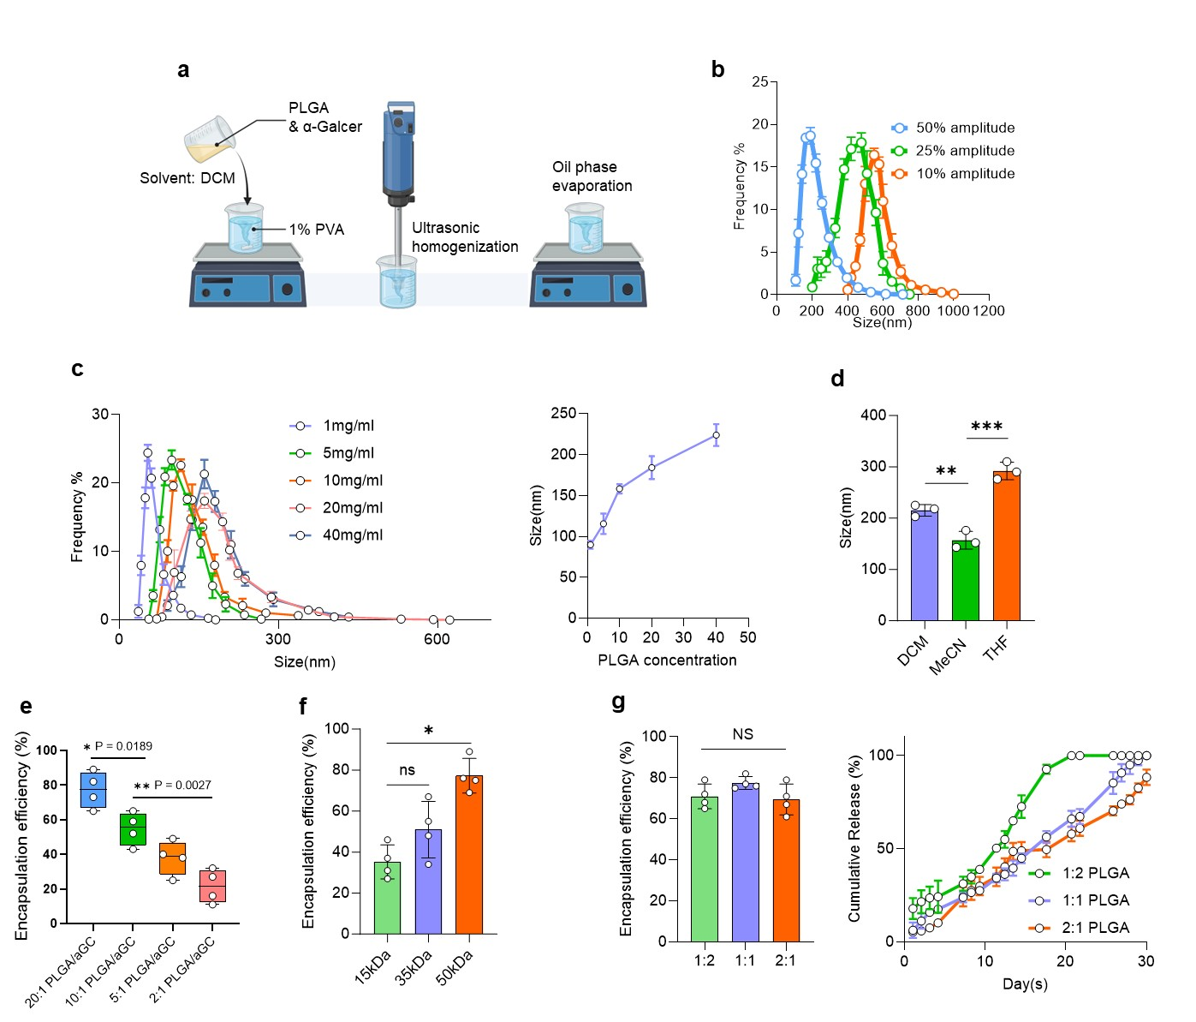
Supplementary Fig. 3 | Fabrication and characterization of PLGA nanoparticles for iMRAS. a, Schematic representation of PLGA nanoparticles fabrication steps using solvent evaporation and ultrasonic homogenization. b, PLGA nanoparticles size distribution at different ultrasonic homogenization amplitude at 50%, 25%, and 10% (frequency fixed at 20kHz. c, Size distribution of PLGA nanoparticles prepared with varying PLGA concentrations at 1 mg/mL, 5 mg/mL, 10 mg/mL, 20 mg/mL, and 40 mg/mL. d, Comparison of nanoparticle size when different organic solvents DCM, MeCN, and THF are used. e, Encapsulation efficiency of αGC under different PLGA-to-αGC mass ratios. Based on optimal encapsulation efficiency and drug release kinetics, a ratio of 20:1 was selected for subsequent experiments. f, Encapsulation efficiency of PLGA nanoparticles at different molecular weight. g, Encapsulation efficiency and cumulative release profiles of αGC from PLGA nanoparticles with different lactic acid (LA) to glycolic acid (GA) ratios. (b-g) Data are presented as the mean ± s.e.m. NS, not significant; **P < 0.01, ***P < 0.001, by one-way ANOVA (d-g).

Supplementary Fig. 4 | Gene Set Enrichment Analysis (GSEA) of CAR-iNKT cell samples.
GSEA plots show the enrichment of gene signatures of proliferating, naïve, effector, cytotoxic, memory, and exhausted cells in the indicated cell clusters. Normal p value calculated as two-tailed t-test.

Supplementary Fig. 5 | Gene profiling of CAR-iNKT cell samples. UMAP plots show the expression of gene signatures of proliferating, naïve, effector, cytotoxic, memory, and exhausted cells in the indicated CAR-iNKT cell samples.

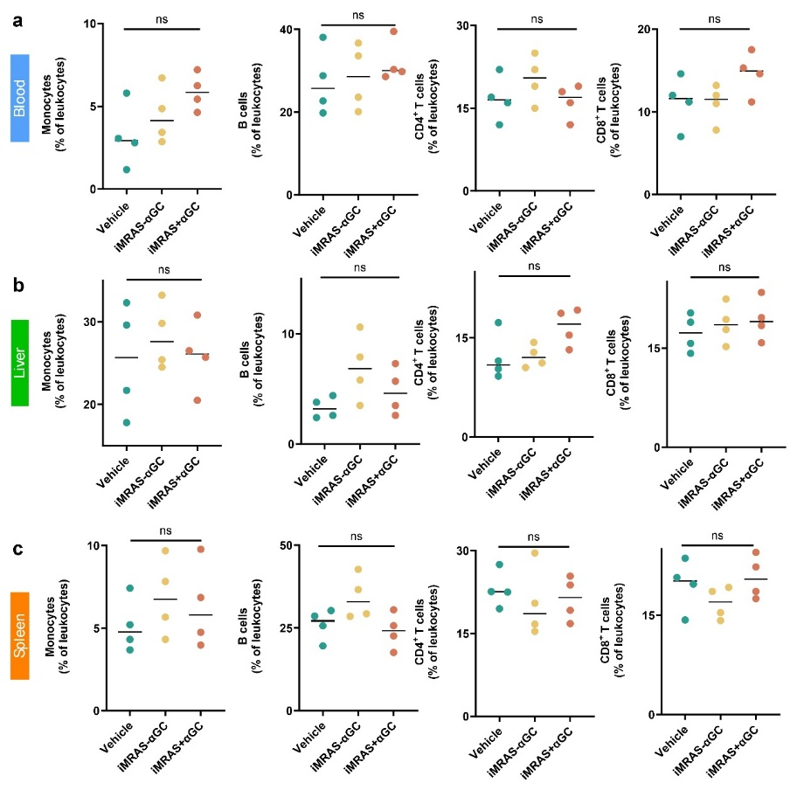
Supplementary Fig. 6 | Systemic immune profiling following iMRAS treatment in C57BL/6 mice at day 1 post-treatment. Effect of IMRAS loaded with or without αGC on leukocytes populations in blood (a), liver (b) and spleen (c) respectively (n = 4). Data are presented as the mean ± s.e.m. NS, not significant, by one-way ANOVA.

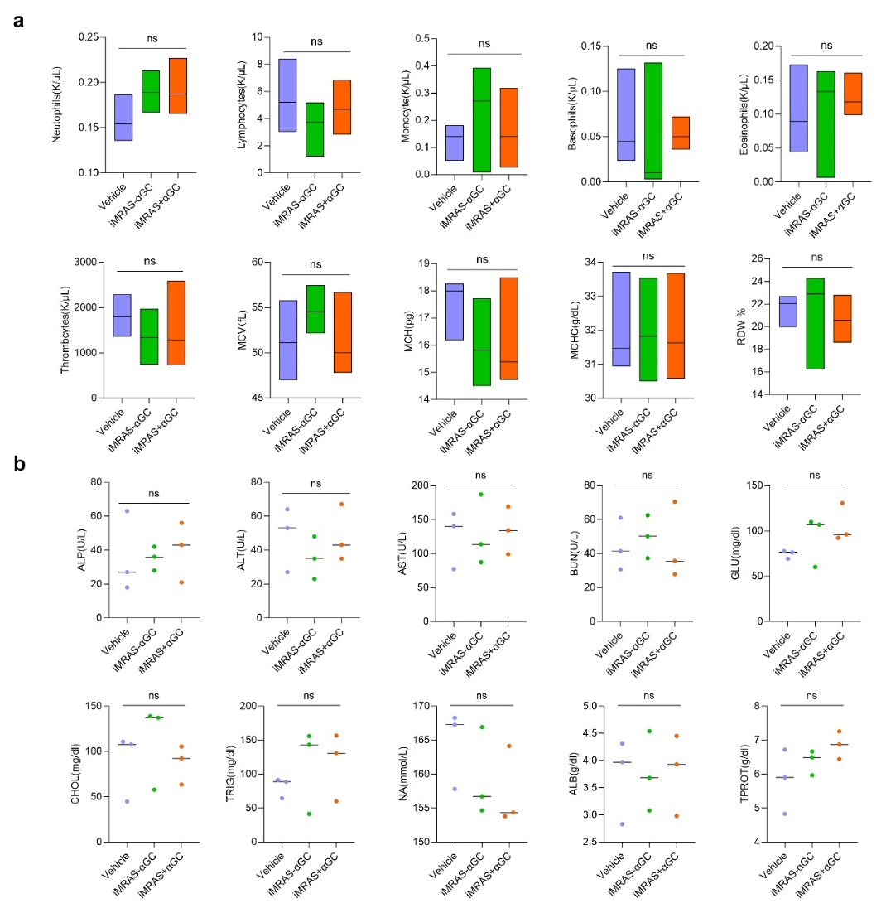
Supplementary Fig. 7 | Hematological and biochemical analysis following iMRAS treatment in C57BL/6 mice. a, Blood routine analysis of mice after 5 days of treatment with saline, iMRAS with αGC, and iMRAS without αGC, including Neutrophils, lymphocytes, monocytes, basophils, eosinophils, thrombocytes, mean corpuscular volume (MCV), mean corpuscular hemoglobin (MCH), mean corpuscular hemoglobin concentration (MCHC), and red cell distribution width (RDW). b, Alkaline phosphatase (ALP), alanine aminotransferase (ALT), glucose (GLU), cholesterol (CHOL), triglycerides (TRIG), sodium (NA⁺), albumin (ALB), and total protein (TPRO/TOT) (n = 3). Data are presented as the mean ± s.e.m. NS, not significant, by one-way ANOVA.

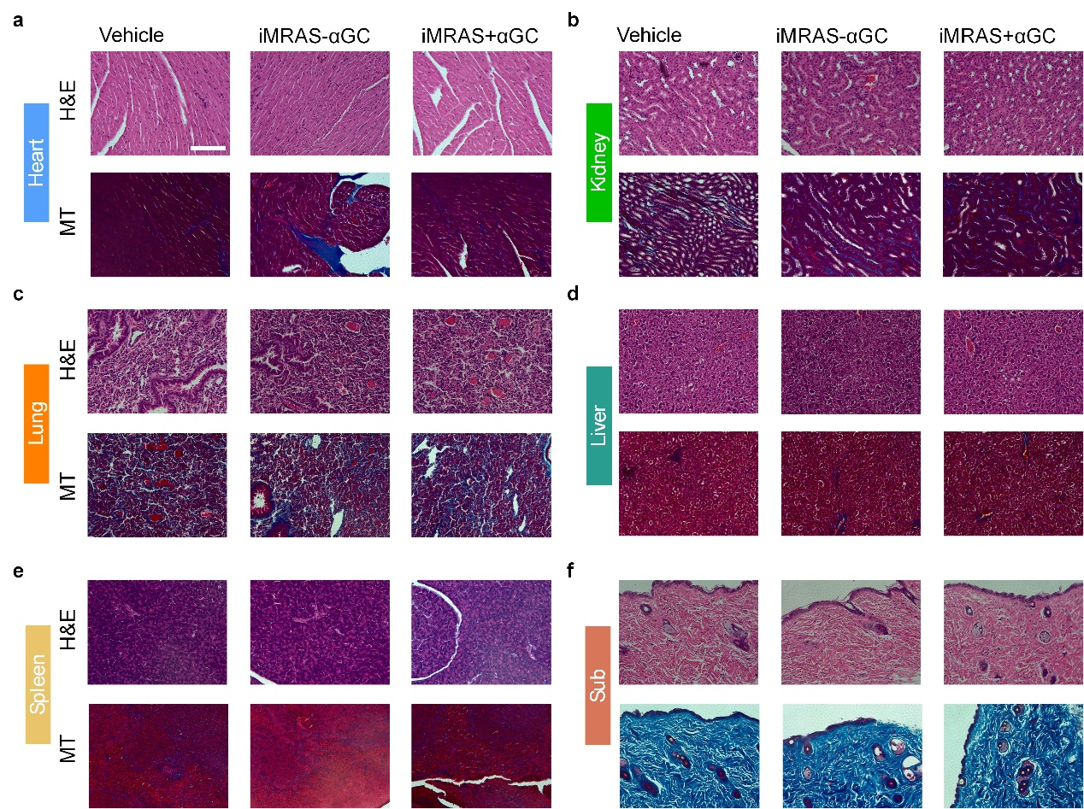

Supplementary Fig. 8 | Acute toxicity testing in C57BL/6 mice. Representative histological examinations of H&E-stained and Masson's trichrome (MT) staining organs from mice receiving iMRAS with or without αGC. Various organs are shown, including heart (a), kidney (b), lung (c), liver (d), spleen (e), and sub (f). Scale bar, 100 μm. Images are the representative of 3 experiments.

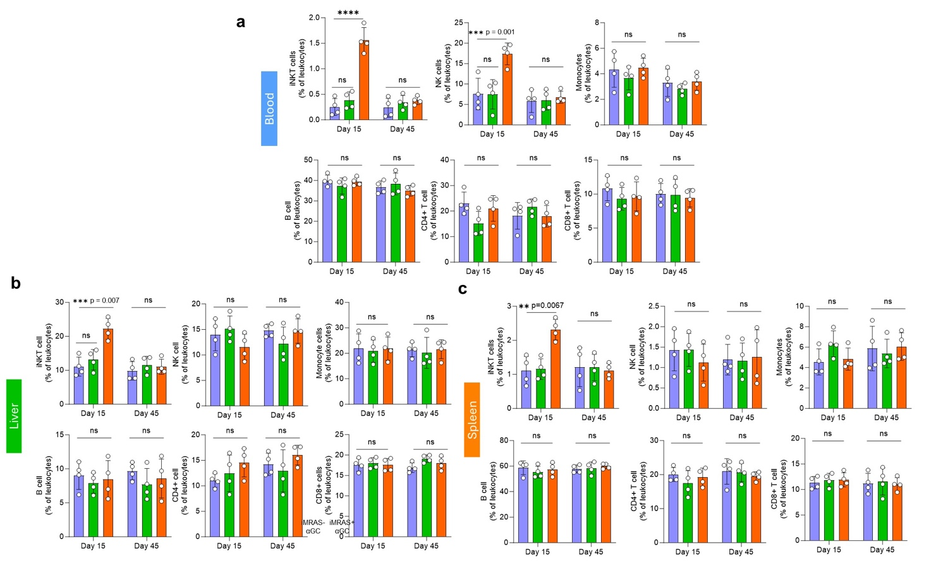
Supplementary Fig. 9 | Longitudinal immune profiling of NKT, NK, Monocyte, B and T cells following iMRAS treatment in C57BL/6 mice. Middle-term (15 days) and long-term (45 days) effects of IMRAS loaded with or without αGC on leukocyte populations in blood (a), liver (b) and spleen (c) of C57BL/6 mice (n = 4). Data are presented as the mean ± s.e.m. NS, not significant; **P < 0.01, ***P < 0.001, ****P < 0.0001, by one-way ANOVA.

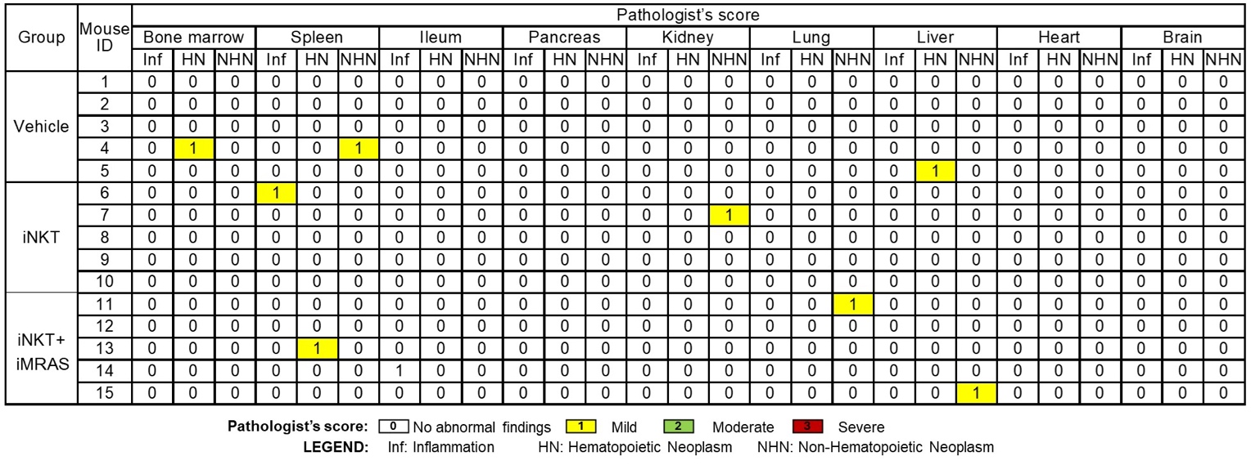
Supplementary Fig. 10 | Pathological assessment of major organs following CAR-iNKT and CAR-iNKT + iMRAS treatments in NSG mice.

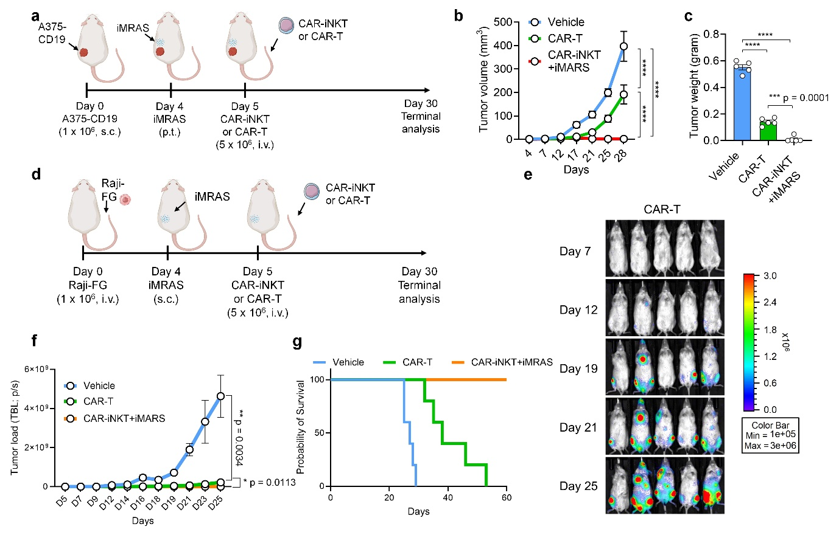
Supplementary Fig. 11 | Superior antitumor efficacy of CAR-iNKT cells with iMRAS compared to conventional CAR-T cell in blood cancer and solid tumor xenograft models.
a-c, Comparing the in vivo antitumor capacity between CAR-iNKT + iMRAS and conventional CAR-T cells using an A375 human melanoma xenograft mouse model. a, Experimental design. b, Tumor volume measurements over time (n = 5). c, Tumor weight measurements at Day 30 (n = 5). Note that the data for the Vehicle and CAR-iNKT+iMARS groups were also presented in the main Figs. 5e-g. d-g, Comparing the in vivo antitumor capacity between CAR-iNKT + iMRAS and conventional CAR-T cells using a Raji human lymphoma xenograft mouse model. d, Experimental design. e, BLI images showing the presence of tumor cells in CAR-T cell-treated experimental mice over time. f, Quantification of e (n = 5). g, Kaplan-Meier survival curves of experimental mice over time (n = 5). Note that the data for the Vehicle and CAR-iNKT+iMARS groups were also presented in the main Figs. 6b-f. Data are presented as the mean ± s.e.m. NS, not significant; *P < 0.05, **P < 0.01, ***P < 0.001, ****P < 0.0001, by one-way ANOVA (c), or by two-way ANOVA (b and f).

