Supplementary materials

Table S1: List of variables extracted from the European Surveillance System (TESSy)
Variable | Full name | Coded value list
Age | Age
BornReportingCountry | Born in the country of report | YesNoUnk:
CountryOfBirth | Country of birth of patient
CountryOfNationality | Country of nationality of patient
DateOfEntryToCountry | Date of entry to country
DateUsedForStatistics | Date used for statistics
DiagnosedAnteMortem | TB diagnosed ante-mortem | YesNoUnk:
EnrolledToTreatment | Enrolment to treatment | N = No, patient didn’t start the treatment  NA = Not applicable  UNK = Unknown  Y = Yes, treatment have been started
Gender | Gender | F = Female M = Male O = Other (e.g., transsexual) Unk = Unknown
HIVStatus | HIV status | NEG = Negative POS = Positive UNK = Unknown
MajorSiteOfTB | Major site of the disease | BONEOTHER = Bone/joint other than spine  CNSOTHER = Central nervous system other than meningitis  DISSEM = Disseminated  EXTRAPULMNOTSPEC = Extrapulmonary, exact site unk  GASTROINTEST = Peritoneal/digestive  LYMPHEXTHOR = Lymphatic extrathoracic  LYMPHINTHOR = Lymphatic intrathoracic  MENING = Meningitis  O = Other  PLEURAL = Pleural  PULMONARY = Pulmonary (lung parenchyma, tracheobronchial tree, larynx)  SPINE = Spine  Unk = Unknown  UROGEN = Genito-urinary
NationalityReportingCountry | Citizen of the country of report | YesNoUnk:
Outcome12Months | Outcome at 12 months | COMPLETED = Treatment completed  CURED = Cured  DEFAULTED = Defaulted or Lost to follow-up  DIEDOTHER = Died because of other cause  DIEDTB = Died because of TB  DIEDUNK = Cause of death unknown  FAILED = Treatment failed  NA = Not Applicable  STILLTREATMENT = Still on treatment  TRANSFERRED = Transferred  Unk = Unknown outcome
Outcome24Months | Outcome at 24 months | COMPLETED = Treatment completed  CURED = Cured  DEFAULTED = Defaulted or Lost to follow-up  DIEDOTHER = Died because of other cause  DIEDTB = Died because of TB  DIEDUNK = Cause of death unknown  FAILED = Treatment failed  NA = Not Applicable  STILLTREATMENT = Still on treatment  TRANSFERRED = Transferred  Unk = Unknown outcome
Outcome36Months | Outcome at 36 months | COMPLETED = Treatment completed  CURED = Cured  DEFAULTED = Defaulted or Lost to follow-up  DIEDOTHER = Died because of other cause  DIEDTB = Died because of TB  DIEDUNK = Cause of death unknown  FAILED = Treatment failed  NA = Not Applicable  TRANSFERRED = Transferred  Unk = Unknown outcome
PrevDiagnosis | Previous diagnosis | YesNoUnk:
PrevTreatment | Previous anti-TB drug treatment | YesNoNAUnk:
RecordId | Record id
ReportingCountry | Reporting country
ResultCulture | Result of the test for diagnosis | N = Negative for Mycobacterium tuberculosis complex  P = Positive for Mycobacterium tuberculosis complex  Unk = Unknown
ResultMicroscopy | Result of test for acid-fast bacilli (AFB) | N = Negative for acid-fast bacilli (AFB)  P = Positive for acid-fast bacilli (AFB)  Unk = Unknown
ResultOtherTest | Additional lab test results | HISTOL = Detection of granulomata at histo-pathology  NONUCLA = No detection of nucleic acid  NUCLA = Detection of M.tuberculosis complex nucleic acid in any sample  NUCLAHISTOL = Detection of both nucleic acid and granulomata  Unk = Unknown

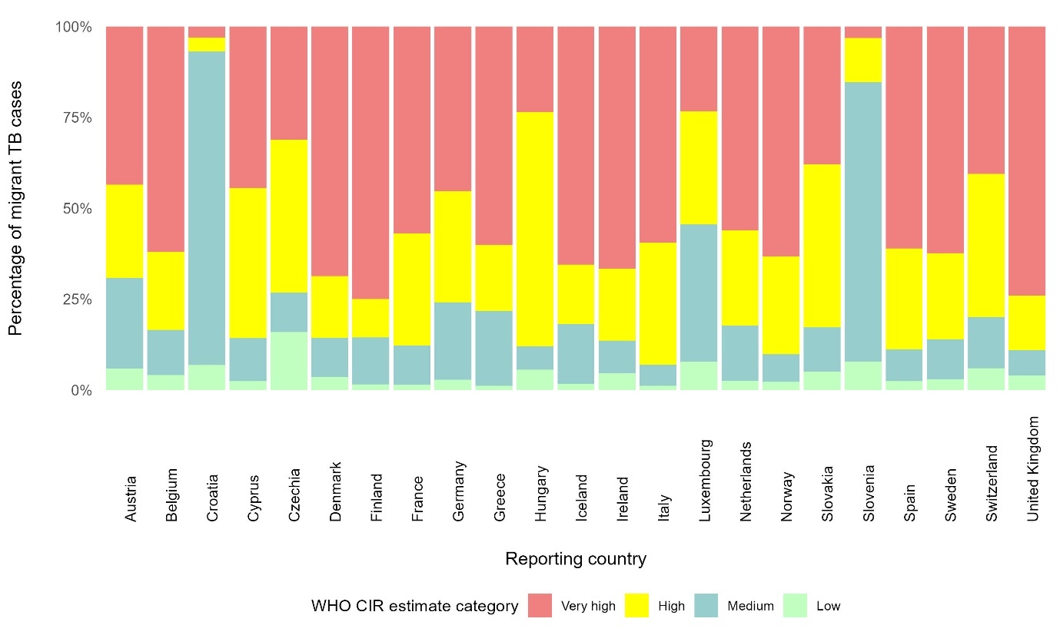

Figure S1: Percentage of migrant TB patients classified by reporting country and median WHO incidence estimate of the migrant origin country

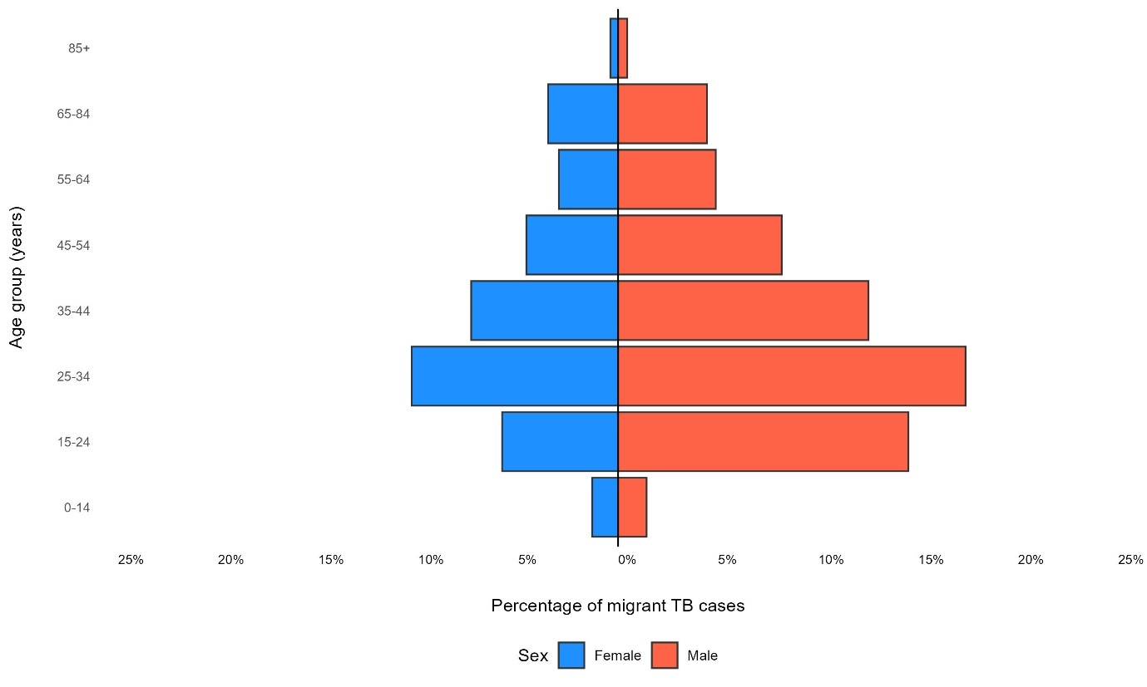

Figure S1: Percentage of migrant TB patients by age group and sex, 2014-2020

Table S2: Migrant TB patient characteristics by reporting year
Characteristic | Overall  N = 114,370 | 2014  N = 14,061 | 2015  N = 18,019 | 2016  N = 18,769 | 2017  N = 18,399 | 2018  N = 17,829 | 2019  N = 16,660 | 2020  N = 10,633
Median age  (Mean age) | 34 (38) | 35 (38) | 34 (37) | 33 (37) | 34 (37) | 34 (38) | 35 (38) | 34 (38)
(Missing) | 2,713 | 17 | 2,626 | 38 | 10 | 13 | 3 | 6
Gender
Female | 41,365 (36.3%) | 5,542 (39.5%) | 6,454 (36.0%) | 6,603 (35.4%) | 6,448 (35.1%) | 6,177 (34.7%) | 6,363 (38.2%) | 3,778 (35.6%)
Male | 72,730 (63.7%) | 8,505 (60.5%) | 11,460 (64.0%) | 12,069 (64.6%) | 11,924 (64.9%) | 11,634 (65.3%) | 10,289 (61.8%) | 6,849 (64.4%)
(Missing) | 275 | 14 | 105 | 97 | 27 | 18 | 8 | 6
People living with HIV
Positive | 992  (6.7%) | 143  (7.1%) | 153  (6.8%) | 131  (6.5%) | 18  (8.2%) | 93  (5.6%) | 181  (7.3%) | 108  (5.1%)
Negative | 13,746 (93.3%) | 1,864 (92.9%) | 2,089 (93.2%) | 1,879 (93.5%) | 2,061 (91.8%) | 1,569 (94.4%) | 2,289 (92.7%) | 1,995 (94.9%)
(Missing) | 99,632 | 12,054 | 15,777 | 16,759 | 16,155 | 16,167 | 14,190 | 8,530
Diagnostic site
Pulmonary | 73,446 (64.6%) | 8,685 (61.9%) | 11,762 (65.5%) | 11,921 (64.7%) | 11,819 (64.4%) | 11,515 (64.9%) | 10,727 (64.8%) | 7,017 (66.3%)
Extrapulmonary | 40,212 (35.4%) | 5,338 (38.1%) | 6,207 (34.5%) | 6,507 (35.3%) | 6,520 (35.6%) | 6,234 (35.1%) | 5,838 (35.2%) | 3,568 (33.7%)
(Missing) | 712 | 38 | 50 | 341 | 60 | 80 | 95 | 48
Previous TB diagnosis
Yes | 8,883 (10.9%) | 1,103 (9.7%) | 1,399 (11.7%) | 1,801 (14.0%) | 1,593 (11.9%) | 1,205 (9.4%) | 1,111 (9.4%) | 671  (9.0%)
No | 72,649 (89.1%) | 10,219 (90.3%) | 10,604 (88.3%) | 11,063 (86.0%) | 11,764 (88.1%) | 11,584 (90.6%) | 10,659 (90.6%) | 6,756 (91.0%)
(Missing) | 32,838 | 2,739 | 6,016 | 5,905 | 5,042 | 5,040 | 4,890 | 3,206
Any 1st line drug resistance
Yes | 4,251 (9.8%) | 540  (9.0%) | 686  (9.7%) | 683  (9.3%) | 651 (10.0%) | 688 (10.8%) | 534  (9.8%) | 469 (10.2%)
No | 39,063 (90.2%) | 5,487 (91.0%) | 6,409 (90.3%) | 6,627 (90.7%) | 5,835 (90.0%) | 5,684 (89.2%) | 4,893 (90.2%) | 4,128 (89.8%)
MDR-TB
Yes | 1,235 (3.2%) | 176  (3.6%) | 212  (3.5%) | 196  (3.1%) | 201  (3.5%) | 185  (3.2%) | 144  (2.9%) | 121  (2.8%)
No | 36,831 (96.8%) | 4,697 (96.4%) | 5,846 (96.5%) | 6,048 (96.9%) | 5,620 (96.5%) | 5,626 (96.8%) | 4,834 (97.1%) | 4,160 (97.2%)
(Missing) | 5,248 | 1,154 | 1,037 | 1,066 | 665 | 561 | 449 | 316

Table S3: Patient characteristics of migrant TB patients according to the interval between arrival in the destination country and notification as a patient; 2017-2020 (9 destination countries, N = 17,021)
Characteristic | Overall,  N = 17,021 | 0-1,  N = 3,365 | 2-4,  N = 3,487 | 5-9,  N = 2,983 | 10+  N = 7,186
Median age (Mean age) | 37.0 (40.2) | 28.0 (30.5) | 29.0 (31.4) | 34.0 (36.6) | 49.0 (50.5)
(Missing) | 1 | 0 | 0 | 0 | 1
Gender
F | 6,783 (40%) | 1,270 (38%) | 1,332 (38%) | 1,283 (43%) | 2,898 (40%)
M | 10,237 (60%) | 2,094 (62%) | 2,155 (62%) | 1,700 (57%) | 4,288 (60%)
(Missing) | 1 | 1 | 0 | 0 | 0
WHO incidence estimate category
Low | 690 (4.1%) | 88 (2.6%) | 111 (3.2%) | 89 (3.0%) | 402 (5.6%)
Medium | 1,779 (10%) | 296 (8.8%) | 318 (9.1%) | 287 (9.6%) | 878 (12%)
High | 3,759 (22%) | 1,168 (35%) | 1,107 (32%) | 653 (22%) | 831 (12%)
Very high | 10,779 (63%) | 1,812 (54%) | 1,950 (56%) | 1,954 (66%) | 5,063 (71%)
(Missing) | 14 | 1 | 1 | 0 | 12
HIV co-infection
Positive | 180 (5.8%) | 69 (7.1%) | 32 (4.8%) | 20 (4.4%) | 59 (5.8%)
Negative | 2,920 (94%) | 904 (93%) | 628 (95%) | 435 (96%) | 953 (94%)
(Missing) | 13,921 | 2,392 | 2,827 | 2,528 | 6,174
Diagnostic site
Extrapulmonary | 7,328 (43%) | 1,121 (33%) | 1,507 (43%) | 1,327 (45%) | 3,373 (47%)
Pulmonary | 9,682 (57%) | 2,243 (67%) | 1,979 (57%) | 1,653 (55%) | 3,807 (53%)
(Missing) | 11 | 1 | 1 | 3 | 6
Previous TB diagnosis
Yes | 1,080 (6.8%) | 194 (6.3%) | 198 (6.1%) | 182 (6.4%) | 506 (7.4%)
No | 14,911 (93%) | 2,863 (94%) | 3,044 (94%) | 2,645 (94%) | 6,359 (93%)
(Missing) | 1,030 | 308 | 245 | 156 | 321
Any 1st line drug resistance | N= 4,153 | N = 1,172 | N = 1,053 | N = 644 | N = 1,284
Yes | 473 (11%) | 141 (12%) | 135 (13%) | 81 (13%) | 116 (9.0%)
No | 3,680 (89%) | 1,031 (88%) | 918 (87%) | 563 (87%) | 1,168 (91%)
MDR-TB
Yes | 116 (2.8%) | 51 (4.4%) | 32 (3.1%) | 16 (2.5%) | 17 (1.3%)
No | 3,978 (97%) | 1,101 (96%) | 1,009 (97%) | 622 (97%) | 1,246 (99%)
(Missing) | 59 | 20 | 12 | 6 | 21

Table S4: Annual number and proportion of migrant TB patients in low TB incidence European countries, 2014-2020
Destination country | 2014 | 2015 | 2016 | 2017 | 2018 | 2019 | 2020 | Total
Austria | 378 (2.7%) | 402 (2.2%) | 432 (2.3%) | 400 (2.2%) | 324 (1.8%) | 275 (1.7%) | 247 (2.3%) | 2,458 (2.1%)
Belgium | 611 (4.3%) | 641 (3.6%) | 698 (3.7%) | 629 (3.4%) | 661 (3.7%) | 676 (4.1%) | 593 (5.6%) | 4,509 (3.9%)
Croatia | 64 (0.5%) | 79 (0.4%) | 1 (0.0%) | 4 (0.0%) | 4 (0.0%) | 6 (0.0%) | 2 (0.0%) | 160 (0.1%)
Cyprus | 34 (0.2%) | 52 (0.3%) | 56 (0.3%) | 38 (0.2%) | 49 (0.3%) | 62 (0.4%) | 31 (0.3%) | 322 (0.3%)
Czech Republic | 96 (0.7%) | 110 (0.6%) | 151 (0.8%) | 158 (0.9%) | 147 (0.8%) | 140 (0.8%) | 125 (1.2%) | 927 (0.8%)
Denmark | 222 (1.6%) | 238 (1.3%) | 216 (1.2%) | 180 (1.0%) | 196 (1.1%) | 176 (1.1%) | 154 (1.4%) | 1,382 (1.2%)
Finland | 86 (0.6%) | 116 (0.6%) | 109 (0.6%) | 93 (0.5%) | 92 (0.5%) | 94 (0.6%) | 63 (0.6%) | 653 (0.6%)
France | 0 (0.0%) | 2,614 (14.5%) | 2,974 (15.8%) | 2,966 (16.1%) | 3,140 (17.6%) | 3,236 (19.4%) | 2,736 (25.7%) | 17,666 (15.4%)
Germany | 2,740 (19.5%) | 4,083 (22.7%) | 4,319 (23.0%) | 3,932 (21.4%) | 3,995 (22.4%) | 3,413 (20.5%) | 2,895 (27.2%) | 25,377 (22.2%)
Greece | 190 (1.4%) | 173 (1.0%) | 173 (0.9%) | 187 (1.0%) | 198 (1.1%) | 244 (1.5%) | 219 (2.1%) | 1,384 (1.2%)
Hungary | 64 (0.5%) | 60 (0.3%) | 59 (0.3%) | 51 (0.3%) | 57 (0.3%) | 74 (0.4%) | 48 (0.5%) | 413 (0.4%)
Iceland | 9 (0.1%) | 6 (0.0%) | 4 (0.0%) | 8 (0.0%) | 8 (0.0%) | 11 (0.1%) | 9 (0.1%) | 55 (0.0%)
Ireland | 135 (1.0%) | 129 (0.7%) | 161 (0.9%) | 143 (0.8%) | 142 (0.8%) | 123 (0.7%) | 122 (1.1%) | 955 (0.8%)
Italy | 1,775 (12.6%) | 1,713 (9.5%) | 1,919 (10.2%) | 2,294 (12.5%) | 2,241 (12.6%) | 1,871 (11.2%) | 1,239 (11.7%) | 13,052 (11.4%)
Luxembourg | 20 (0.1%) | 19 (0.1%) | 22 (0.1%) | 25 (0.1%) | 34 (0.2%) | 45 (0.3%) | 28 (0.3%) | 193 (0.2%)
Netherlands | 601 (4.3%) | 624 (3.5%) | 670 (3.6%) | 585 (3.2%) | 616 (3.5%) | 570 (3.4%) | 455 (4.3%) | 4,121 (3.6%)
Norway | 302 (2.1%) | 277 (1.5%) | 262 (1.4%) | 231 (1.3%) | 179 (1.0%) | 147 (0.9%) | 130 (1.2%) | 1,528 (1.3%)
Slovakia | 8 (0.1%) | 11 (0.1%) | 11 (0.1%) | 5 (0.0%) | 10 (0.1%) | 7 (0.0%) | 6 (0.1%) | 58 (0.1%)
Slovenia | 36 (0.3%) | 50 (0.3%) | 43 (0.2%) | 45 (0.2%) | 44 (0.2%) | 36 (0.2%) | 26 (0.2%) | 280 (0.2%)
Spain | 885 (6.3%) | 1,141 (6.3%) | 1,020 (5.4%) | 1,754 (9.5%) | 1,394 (7.8%) | 1,457 (8.7%) | 1,223 (11.5%) | 8,874 (7.8%)
Sweden | 604 (4.3%) | 729 (4.0%) | 641 (3.4%) | 467 (2.5%) | 421 (2.4%) | 415 (2.5%) | 282 (2.7%) | 3,559 (3.1%)
Switzerland | 357 (2.5%) | 417 (2.3%) | 481 (2.6%) | 408 (2.2%) | 372 (2.1%) | n/a | n/a | 2,035 (1.8%)
United Kingdom | 4,844 (34.4%) | 4,335 (24.1%) | 4,347 (23.2%) | 3,796 (20.6%) | 3,505 (19.7%) | 3,582 (21.5%) | n/a | 24,409 (21.3%)
Total | 14,061 (100.0%) | 18,019 (100.0%) | 18,769 (100.0%) | 18,399 (100.0%) | 17,829 (100.0%) | 16,660 (100.0%) | 10,633 (100.0%) | 114,370 (100.0%)
n/a = no longer reporting to TESSy

Destinations countries: Austria, Belgium, Cyprus, Czechia, Iceland, Netherlands, Sweden, Slovenia and the UK.
HIV co-infection results are from six destination countries (Belgium, Cyprus, Czechia, Iceland, Netherlands and Slovenia) that reported HIV status for ≥50% of migrant TB patients in addition to having ≥70% completeness for year of arrival.
First line drug resistance and MDR-TB results are derived from a sub-sample of 4,153 patients from 8 destination countries with 70% completeness of first line drug susceptibility results.

