Synergistic effect of chitosan derivative and DOPO for simultaneous improvement of flame retardancy and mechanical property of epoxy resin

Junjie Wang ª, Xuejun Yu ^{b}, Shengsong Dai ª, Xinyu Wang ª, Zhiquan Pan ^{a,b},
Hong Zhou^{a,}*

Supporting information

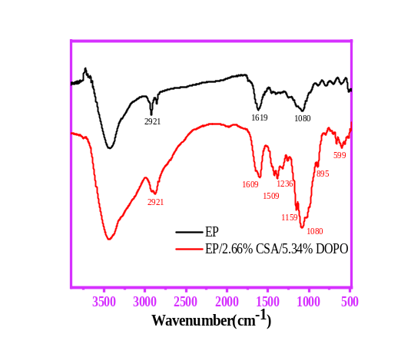
Fig. S1. FTIR spectra of char residues of neat EP and EP/2.66%CSA/5.34%DOPO
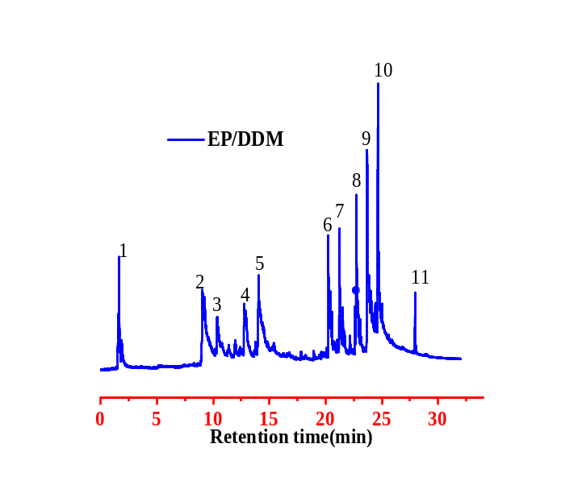
Fig. S2. Pyrolysis mass spectrum of neat EP
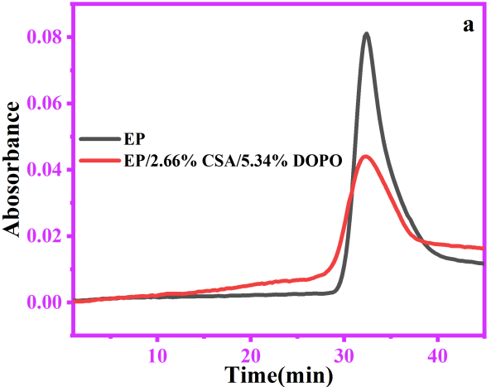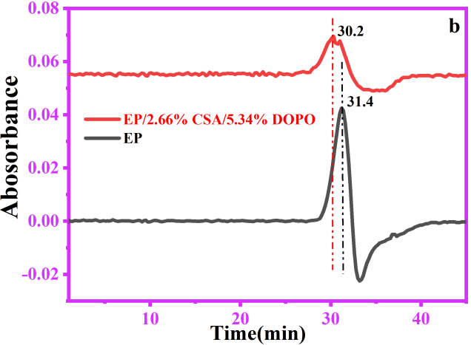
Fig. S3. The changes in the absorbance of EP and EP/2.66%CSA/5.34%DOPO pyrolysis products over time (a) and the curve obtained from the first derivative (b)
Table S1 Elemental analysis data of chitosan and CSA and the calculated values of H and N elements in CAS
Elemental sample |  | C | H | N
CS |  | 44.58 | 6.74 | 8.21
CSA | Characterization data | 68.04 | 5.61 | 4.66
CSA | Calculated data |  | 5.57 | 4.40

Table S2 Thermal decomposition parameters of CSA, DOPO and CSA/DOPO modified epoxy resins
Sample | T5% (°C) | Tmax (°C) | Weight-loss rate at Tmax (wt%/min) | Residue at 750 °C (%)
EP | 355 | 382 | 1.48 | 18.7
CSA | 230 | 300 | 0.98 | 34.6
EP/8%CSA | 352 | 391 | 1.46 | 20.3
EP/8% DOPO | 303 | 381 | 1.33 | 12.9
EP/2.66%CSA/5.34%DOPO | 328 | 378 | 1.22 | 17.6

Table S3 Element composition of the char residues
Sample | C (wt %) | O (wt %) | N (wt %) | P (wt %)
EP | 82.52 | 11.43 | 6.03 | 0
EP/2.66%CSA/5.34%DOPO | 87.68 | 8.24 | 3.6 | 0.48

Table S4 XPS data of different chemical bonds for EP and EP/2.66%CSA/5.34%DOPO
Samples | C_{1S} (area (%)) |  |  | N_{1S}  (Area (%)) |  | O_{1S}  (Area (%)) |  |  | P_{2S}  (Area (%))
Samples | - H,  C-C | C-OH,C-N,  C-O-P | C=C,C=O | C-N | C=N | C-O-C,C-OH, C-O-P | C=O P=O |  | C-O-P | P=O
EP | 54 | 25 | 21 | 22 | 78 | 69 |  | 31 | 0 | 0
EP/2.66%CSA/5.34%DOPO | 63 | 28 | 9 | 26 | 74 | 83 |  | 17 | 65 | 35

Table S5 The main products of neat EP detected by Py-GC/MS
Peaks | Times | m/z | Chemical structure | Peaks | Times | m/z | Chemical structure
1 | 1.63 | 44 | 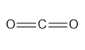 | 7 | 21.15 | 211 | 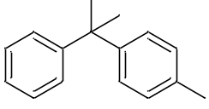
2 | 9.04 | 94 | 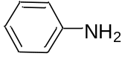 | 8 | 22.72 | 227 | 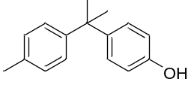
3 | 10.36 | 107 | 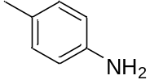 | 9 | 23.69 | 213 | 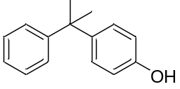
4 | 12.81 | 121 | 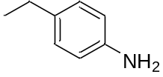 | 10 | 24.69 | 254 | 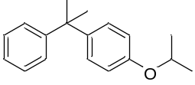
5 | 14.02 | 135 | 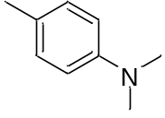 | 11 | 27.92 | 213
6 | 20.22 | 196 | 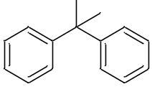

Table S6 Comparison data of flame retardancy and mechanical properties for the CS containing flame retardants in EP
Flame retardants | LOI | UL-94 | Flexural  strength | Tensile strength | impact strength | Ref.
EP/10 %CCD | 31.6% | V-0 | \ | \ | \ | (Chen et al. 2020)
EP/7%6BL@BF/3%  EG-3 | 25.8% | V-0 | -11.8% | 2.4% | \ | (Chen et al. 2020)
EP/3HNT@  CSZFMOH | 28% | \ | \ | \ | \ | (Zhang et al. 2021)
EP/15%CMEP/1%  OMMT | 30.6% | V-0 | \ | \ | \ | (Yu et al. 2020)
EP/15%CEUP/3%  OMMT | 34.8% | V-0 | \ | \ | \ | (Yu et al. 2019)
EP/15%APP/5%CS/  5%melamine/15%  Boric Acid/3%ZrO₂ NPs/ | 38.7% | V-0 | \ | \ | \ | (Rao et al. 2019)
EP/10wt%HNT@CS@Fe₃O₄ | 31.3% | \ | \ | -0.65% | \ | (Zhang et al. 2019)
EP/(PEC8.1@CF) | 30.4% | V-0 | \ | \ | \ | (Shi et al. 2018)
EP/APP Chitosan SiO₂ NPs (Polyurethane coatings) | 35.7% | V-0 | \ | \ | \ | (Kong et al. 2019)
EP/2.66%CSA/5.34%DOPO | 36.4% | V-0 | 52.3% | 16.7% | 33.3% | this work

