SUPPLEMENTARY MATERIAL
Supplementary Material Table S1 Tidal marsh complexes in coastal Mississippi from West to East that were surveyed for breeding marsh birds in 2021 and 2022. County, marsh type, and area of estuarine marsh is included for each complex.
Marsh complex | County | Marsh type | Area (ha) of  estuarine marsh
Hancock County Marshes | Hancock | Riverine | 6788
Jourdan River | Hancock | Riverine | 1525
Wolf River | Harrison | Riverine | 920
Bayou Portage | Harrison | Marine | 301
Back Bay of Biloxi | Harrison | Riverine | 1208
Deer Island | Jackson | Marine | 119
Old Fort Bayou | Jackson | Marine | 419
Gulf Park Estates | Jackson | Marine | 537
Graveline | Jackson | Marine | 1027
Pascagoula River | Jackson | Riverine | 6299
Grand Bay National Estuarine Research Reserve | Jackson | Marine | 4166

Supplementary Material Table S2 Local vegetation composition/structure (vegetation height, percent black needlerush, percent smooth cordgrass, percent freshwater vegetation) and broad scale landscape (distance to estuarine marsh, distance to palustrine marsh, distance to development, distance to upland, distance to open water) predictor variables that were a-priori identified as influencing species-specific abundance of breeding tidal marsh birds across their range in North America based on a literature review.
Species | Vegetation height | Percent black needlerush | Percent smooth cordgrass | Percent freshwater vegetation | Dist. to estuarine marsh | Dist. to palustrine wetland | Dist. to development | Dist. to upland | Dist. to open water
CLRA | x | x | x |  | x |  | x |  | x
COGA |  |  |  | x | x | x |  |  | x
PUGA |  |  |  | x | x | x |  |  | x
LEBI | x |  |  | x | x | x | x |  | x
MAWR | x | x | x | x | x | x | x | x | x
SESP | x | x | x |  | x |  | x | x
RWBL |  | x | x |  | x |  | x
COYE |  |  |  | x |  | x | x | x | x
Species = alpha codes, Dist. = Distance
Supplementary Material Table S3 Detection probability per species as determined by N-mixture abundance models with broad scale landscape predictors and the distance (m) used to truncate species detections based on distance detection curves from point count surveys across coastal Mississippi in 2021 and 2022.
Species | 2021 Detection Probability | 2022 Detection Probability | Truncation Distance (m)
Clapper Rail | 0.275 | 0.261 | 230
Common/Purple Gallinule | 0.313 | 0.180 | 200
Least Bittern | 0.083 | 0.100 | 175
Marsh Wren | 0.002 | 0.002 | 100
Seaside Sparrow | 0.566 | 0.399 | 100
Red-winged Blackbird | 0.411 | 0.489 | 210
Common Yellowthroat | 0.406 | 0.488 | 290

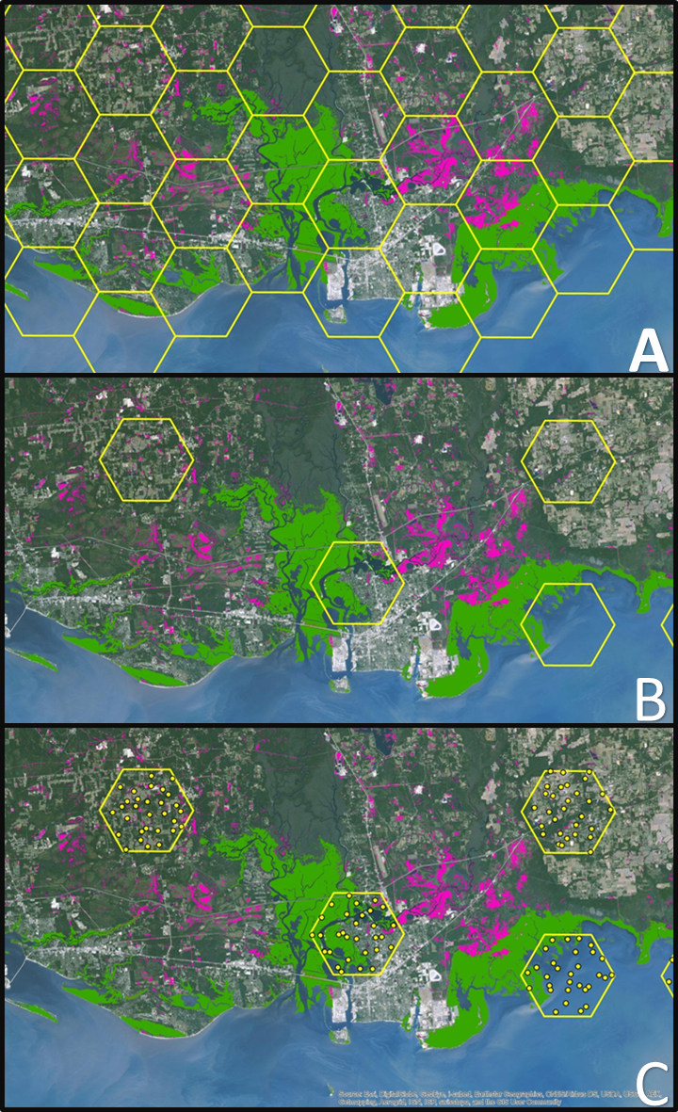
Supplementary Material Figure S1 The sampling design consisted of a A) 40 km² hexagon grid (outlined in yellow) in which the point count locations were generated in two-stages. B) Primary sampling units were selected using Generalized Random Tessellation Stratification (GRTS) (PSUs; outlined in yellow). C) Secondary sampling units, or the potential survey points (SSUs; yellow dots), were randomly generated within the PSUs.

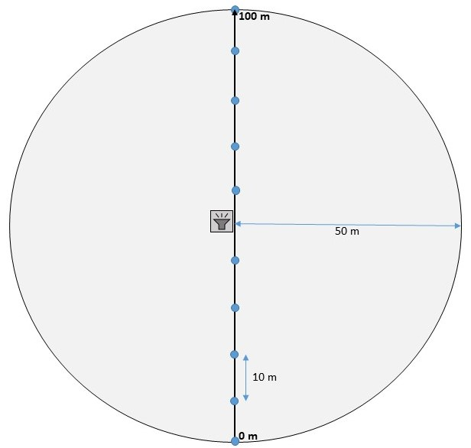
Supplementary Material Figure S2 Schematic of local vegetation sampling design. The vertical black line depicts the 100 m transect with blue points indicating where vegetation height (cm) was recorded every 10 meters. The speaker icon indicates the marsh bird survey point count location.
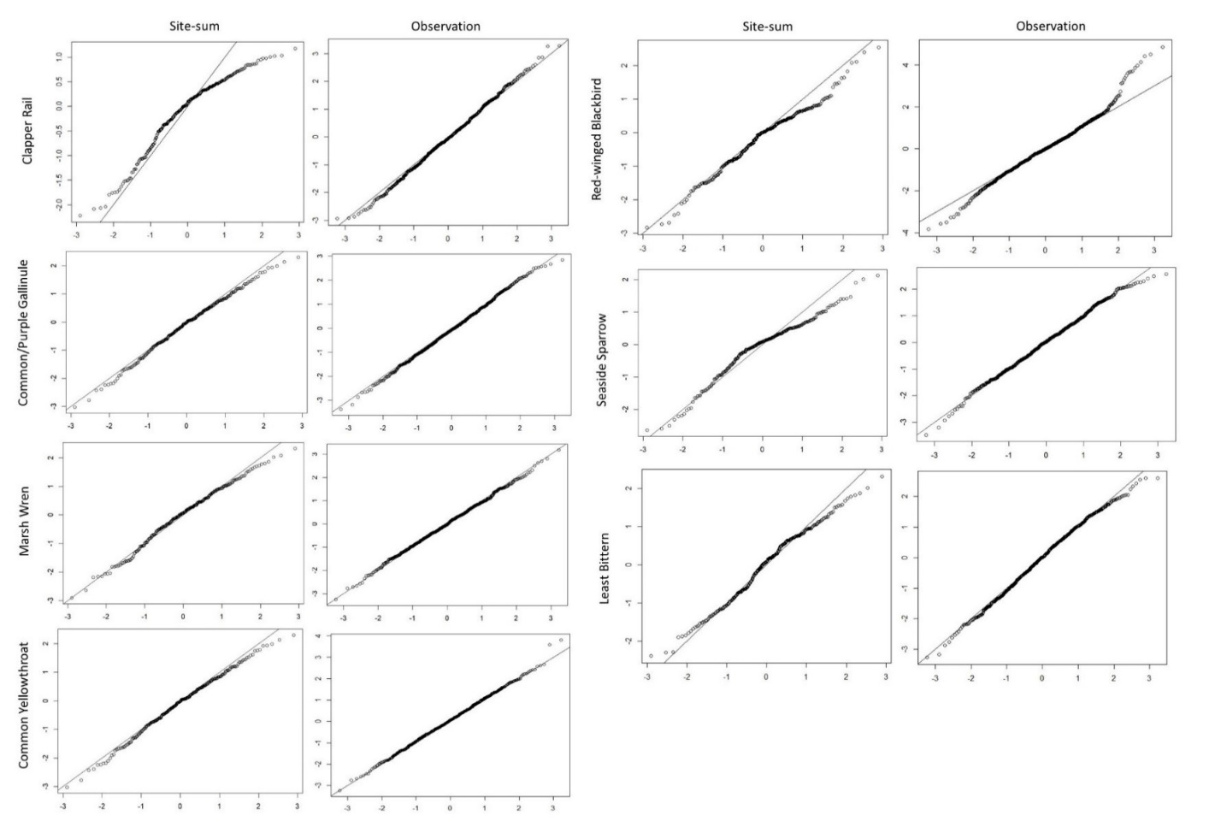
Supplementary Material Figure S3 QQ plots were generated for site-sum and observation randomized quantile (rq) residuals for species-specific models of abundance from breeding tidal marsh bird point count survey data. Site-sum rq residuals are computed from aggregating counts across sites, whereas the observation rq residuals are derived from the observation sub-model. Site-sum and observation residuals are included for each species for a single year due to great overlap in residuals across years. The center diagonal line is the identity line, for which good fit residuals should be close to.

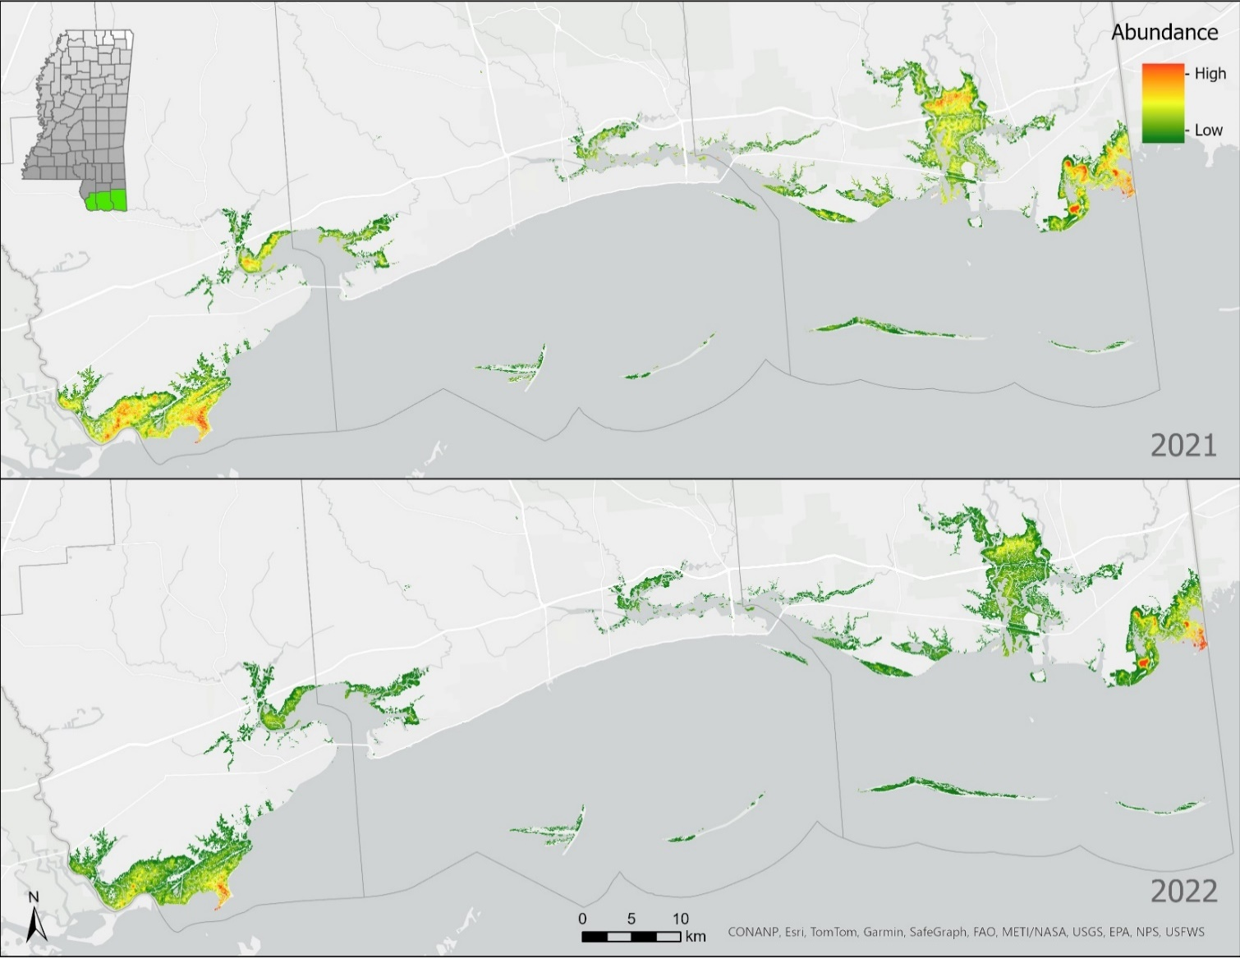
Supplementary Material Figure S4 Species distribution maps for Clapper Rails in 2021 and 2022 across estuarine tidal marsh.
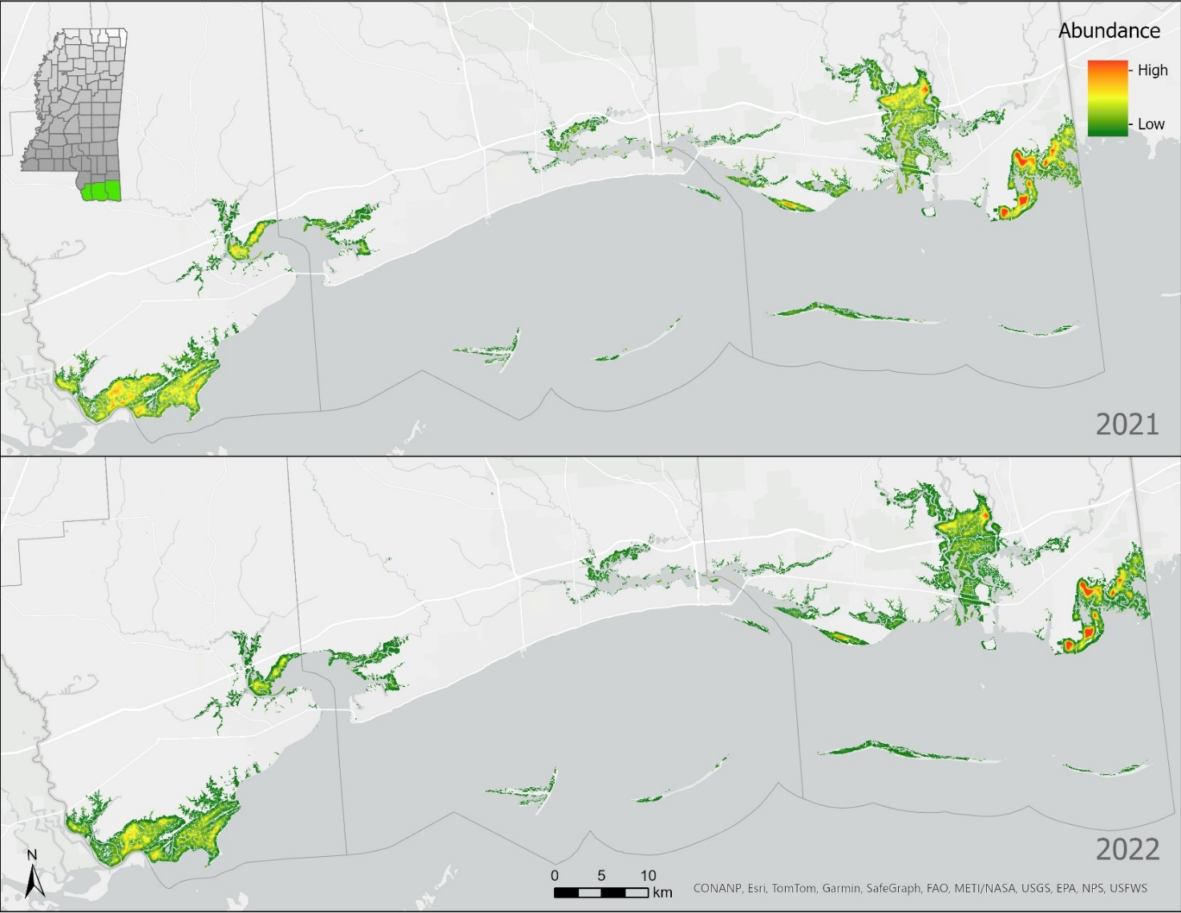
Supplementary Material Figure S5 Species distribution maps for Common and Purple Gallinules in 2021 and 2022 across estuarine tidal marsh.
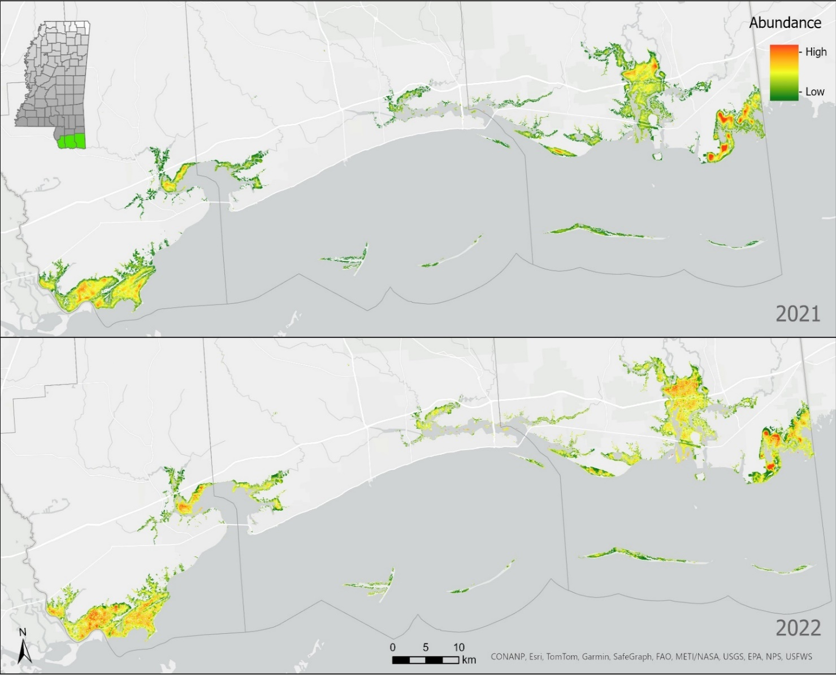
Supplementary Material Figure S6 Species distribution maps for Least Bitterns in 2021 and 2022 across estuarine tidal marsh.
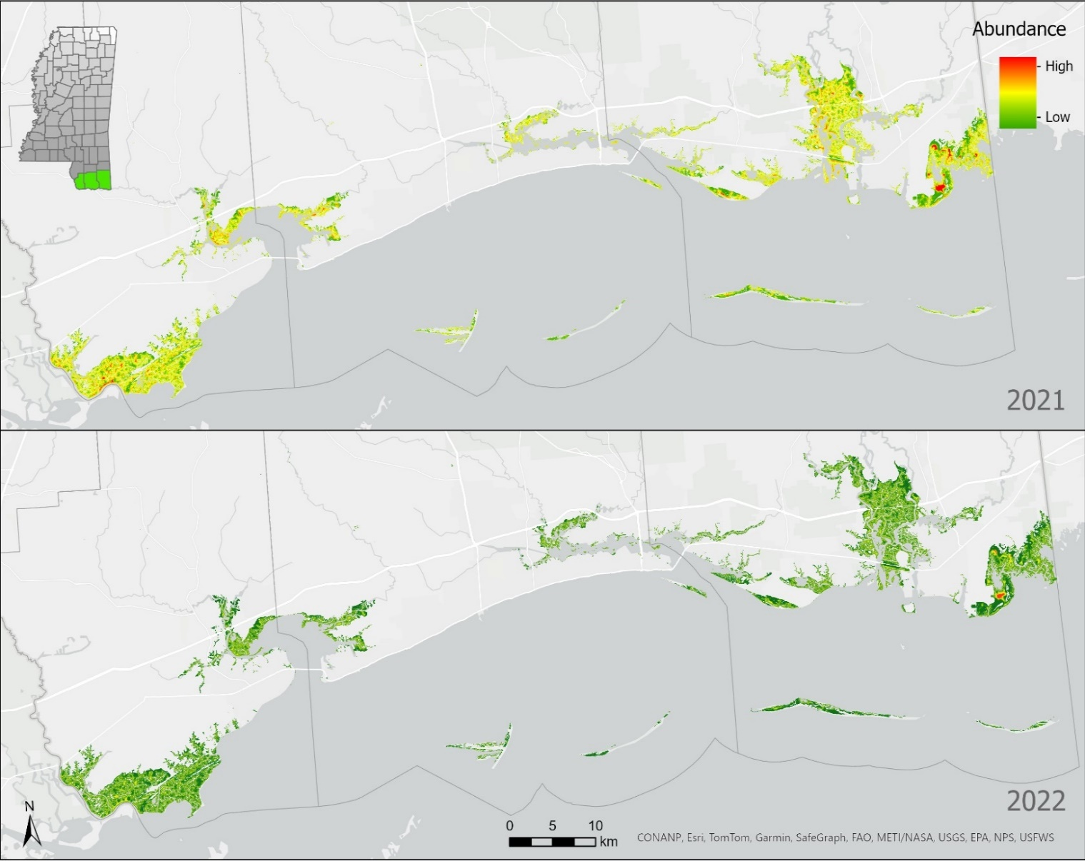
Supplementary Material Figure S7 Species distribution maps for Marsh Wrens in 2021 and 2022 across estuarine tidal marsh.
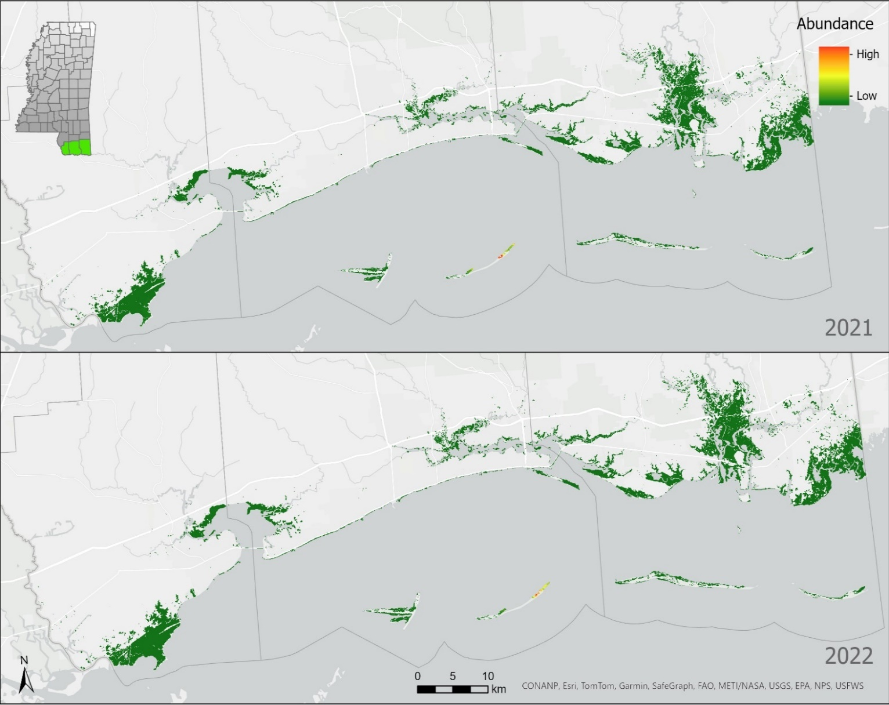
Supplementary Material Figure S8 Species distribution maps for Seaside Sparrows in 2021 and 2022 across saline tidal marsh.
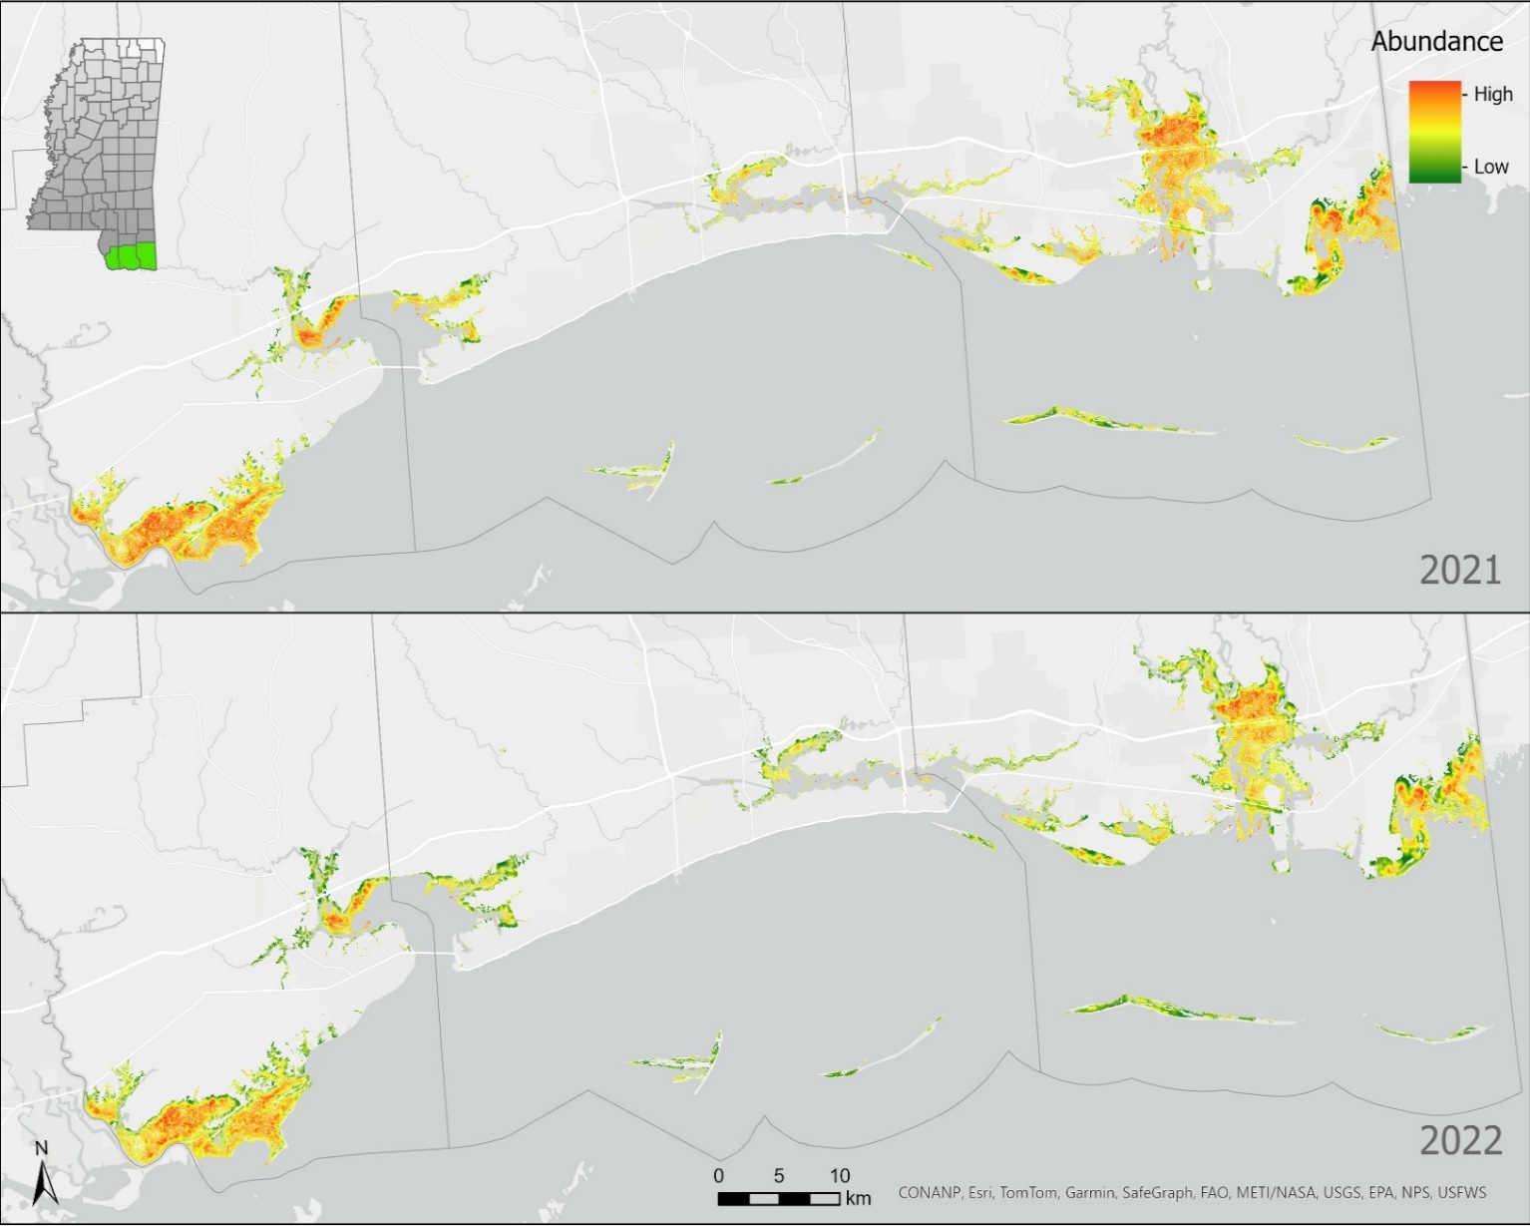
Supplementary Material Figure S9 Species distribution maps for Red-winged Blackbirds in 2021 and 2022 across estuarine tidal marsh.
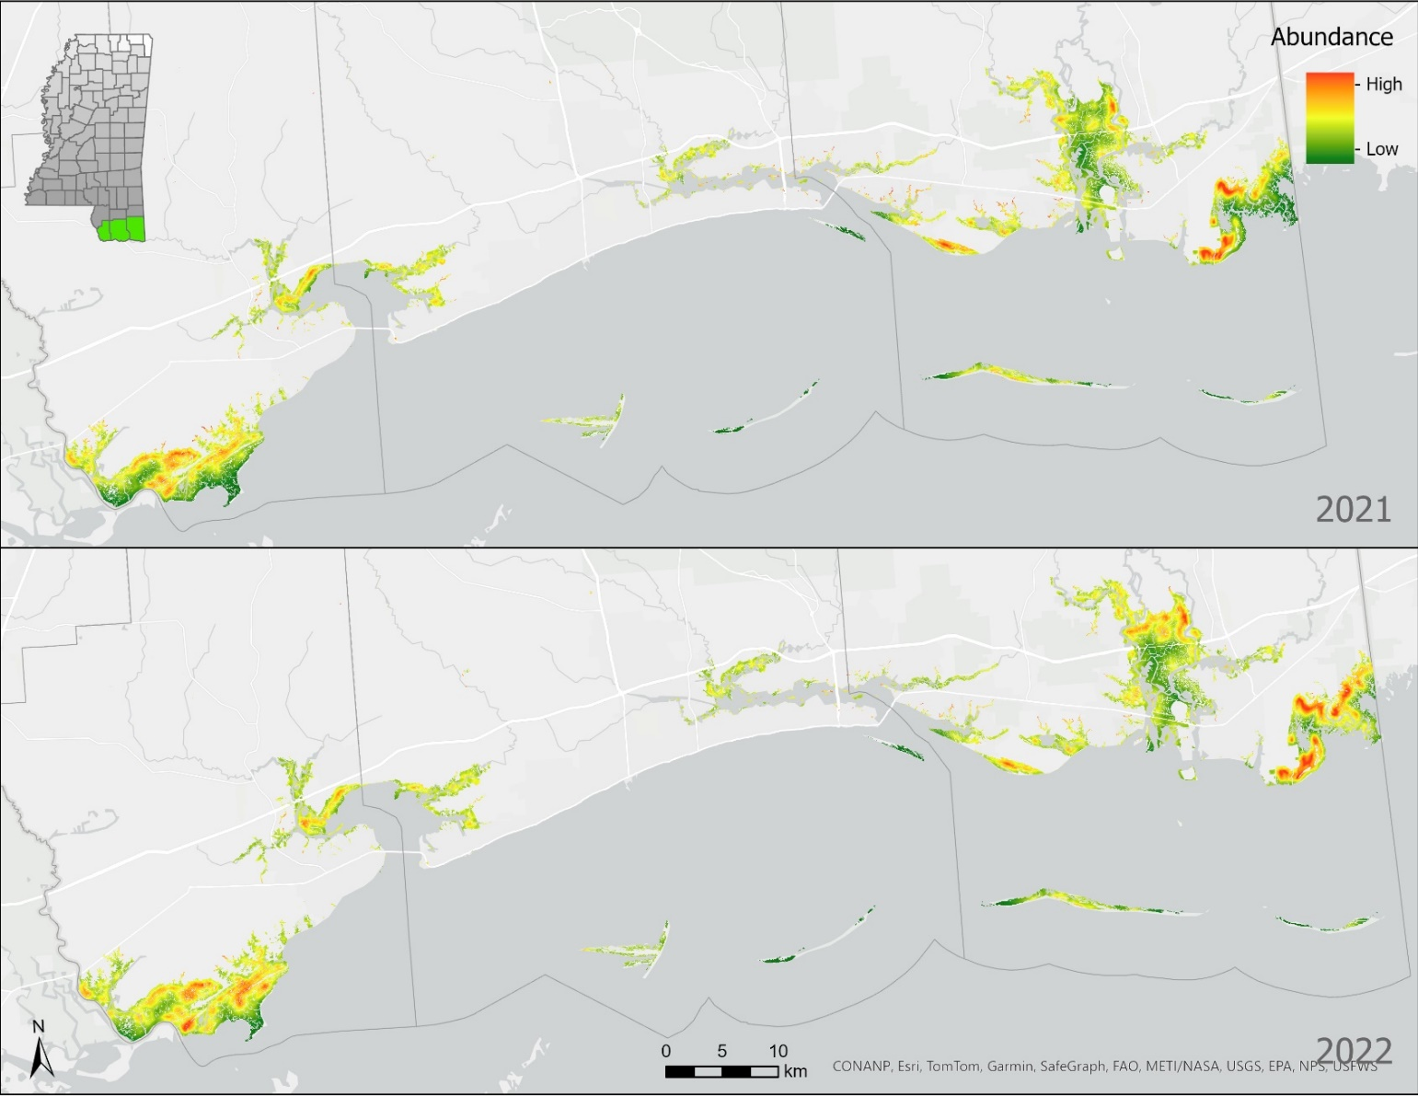
Supplementary Material Figure S10 Species distribution maps for Common Yellowthroats in 2021 and 2022 across estuarine tidal marsh.

