Emergence and Spread of Plasmodium falciparum Kelch 13 Mutations in Selected Counties of Kenya: Implications for Responding to Artemisinin Partial Resistance.

Supplementary Table 1: Parasitemia for samples obtained from seven counties across Kenya
County | Number of samples | Minimum | 25% Percentile | Median | 75% Percentile | Maximum
Laikipia | 2 | 0.04 | 0.04 | 0.12 | 0.2 | 0.2
Kisii | 70 | 0.009 | 0.1 | 0.18 | 0.2525 | 7.9
Busia | 215 | 0.0008 | 0.12 | 0.5 | 1.6 | 16.3
Baringo | 81 | 0.002 | 0.085 | 0.6 | 1.5 | 13
Kericho | 48 | 0.004 | 0.3 | 1.55 | 5.825 | 28.1
Nakuru | 2 | 0.03 | 0.03 | 0.515 | 1 | 1
Kisumu | 323 | 0.00004 | 0.14 | 1.5 | 4 | 22
Supplementary Table 1: Parasitemia for samples obtained from seven counties across Kenya Parasitemia estimated as absolute counts of infected red blood cell per 2000 high power fields. Only samples collected from Laikipia and Nakuru counties. Busia and Baringo had comparable parasitemia, significantly lower than those of Kisumu and Kericho counties.

Supplementary Table 2: Pfk13 haplotypes
Haplotype | Mutation | Type | Frequency | n
Haplotype_1 | Wildtype | - | 94.43813
Haplotype_2 | A675V  (2024C>T) | Non-synonymous | 2.63503 | 18
Haplotype_3 | C469Y  (1406G>A) | Non-synonymous | 0.29269 | 2
Haplotype_4 | C469Y  (1406G>A)  A675V  (2024C>T) | Non-synonymous  Non-synonymous | 0.14634 | 1
Haplotype_5 | N489K  (1467T>G) | Non-synonymous | 0.14634 | 1
Haplotype_6 | C469C  (1405T>C) | Synonymous | 0.29268 | 2
Haplotype_7 | A675A | Synonymous | 0.14634 | 1
Haplotype_8 | P553L  (1658C>T)  L488L  (1462T>C)  G497G  (1491T>C) | Non-synonymous  Synonymous  Synonymous | 0.14634 | 1
Haplotype_9 | A578S  (1732G>T) | Non-synonymous | 0.5854 | 4
Haplotype_10 | R561H  (1682G>T) | Non-synonymous | 0.14634 | 1
Haplotype_11 | R561P  (1682G>C) | Non-synonymous | 0.14634 | 1
Haplotype_12 | R561R  (1683T>A) | Synonymous |  | 1
Haplotype_13 | R561P  (1682G>C)  R561H  (1682G>T) | Non-synonymous  Non-synonymous |  | 1
Haplotype_14 | A627A  (1881T>A) | Synonymous |  | 1
Haplotype_15 | E612D |  |  | 1
Haplotype_16 | F491L  (1473C>A) | Non-synonymous |  | 1
Haplotype_17 | S600F  (1799C>T) | Non-synonymous |  | 1
Haplotype_18 | A504A  (1512T>C) | Synonymous |  | 1
Haplotype_19 | V637V  (1911T>A) | Synonymous |  | 1
Haplotype_20 | A626A  (1878A>C) | Synonymous |  | 1
Haplotype_21 | K455E  (1363A>G) | Non-synonymous |  | 1
Haplotype_22 | V386A  (1157T>C) | Non-synonymous |  | 1
Haplotype_23 | V386V  (1158T>A)  A675V  (2024C>T) | Synonymous  Non-synonymous |  | 1
Haplotype_24 | A504V  (1511C>T) | Non-synonymous |  | 1
Haplotype_25 | S522C  (1564A>T) | Non-synonymous |  | 1
Haplotype_26 | G690G  (2070C>A) | Synonymous |  | 1

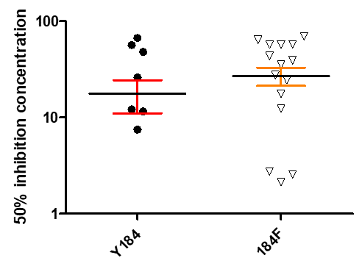
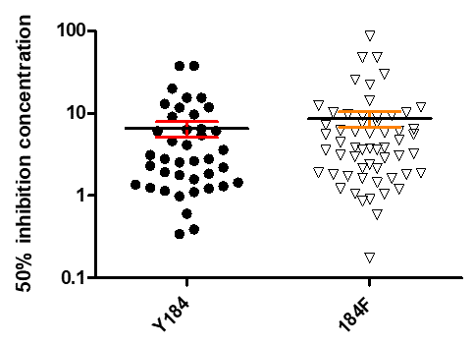
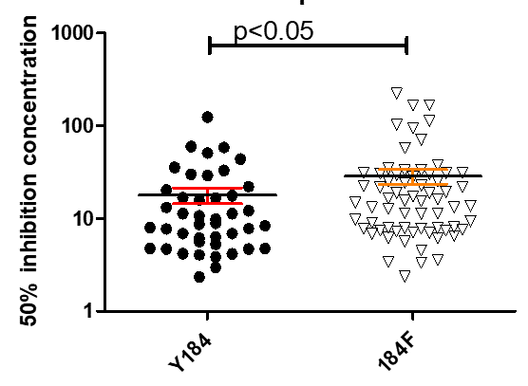
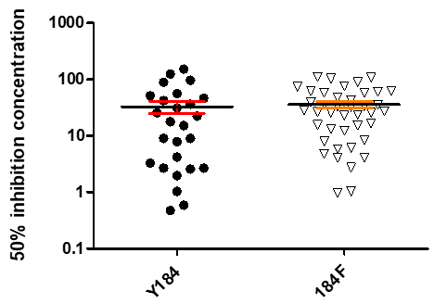
c
b
a
d

Supplementary Figure 1: Scatter plots showing 50% Inhibition concentration for different antimalarial drugs among parasites with different Pfmdr1 genotypes. (a = chloroquine, b = artemether, c = lumefantrine, and d = mefloquine.) The median IC50s for isolates with Pfmdr1 184F allele was significantly higher than Y184 allele.

