Schedule No. |  | Interview Schedule | Interview Date
Informant category |  | Interview Schedule | Time spend

[A] respondent details
1. name |  | 5. designation
2. gender |  | 6. occupation
3. age: |  | 7. highest education
4. marital status |  | 8. contact details
9. Have you any experience of working on water, health, eco-hydro sensitivity? |  | 10. please explain (if yes in previous question)

[B] scheduled questions
s.n. | questions
for informant categories 1, 2 and 3 as mention in endnote
1 | What are the current sources of water in village? (follow the sand watch model [Fig.1)
2 | What are the sources of water earlier in village? (follow the sand watch model [Fig.1)
3 | What were the sources of water long back at the time your grandfather? (follow the sand watch model [Fig.1])
4 | How the sources of water changes over time? (follow the sand watch model [Fig.1])
5 | What has been the impact on health in general and household members (female)?
6 | What do think about water issues in Gaya/Vaishali?
7 | How government is managing the water resources in Gaya/Vaishali?
8 | What are the general irrigation systems in Gaya or Vaishali?
9 | There are traditional water resource management/irrigation systems in Gay,, how is it working?
10 | Any water systems in the village that were used traditionally and have now been lost/destroyed?
11 | What are the issue emerges due to water contamination?
12 | There are arsenic issues in Vaisali, what are social and health implication?
13 | How people and government are reacting or acting for the arsenic issues?
14 | How the Swachh Bharat Mission has received and working in the village?
for informant categories 4,5,6,7,8 and 9 as mention in endnote
15 | What is your understanding about water issues in Bihar?
16 | What are the reasons of the water issues in Bihar as there are geographies where abundant of water, however there are parts in droungt?
17 | What is your take on water policy and schemes in Bihar?
18 | How is the new water program ‘Jal Jeevan Hariyali’ is receiving?
19 | Any changes in health problems from the past? Any of them related to water?
20 | How ecology is affecting water resources and health?
21 | How is quality and quantity aspects of water is affecting?
22 | How anthropogenic activities in Bihar is affecting water resources
[B] Additional questions if emerges during interview
s.n. | questions
1
2
3
4
5

Figure: 1 Sand Watch Model to Trace Social History of Water

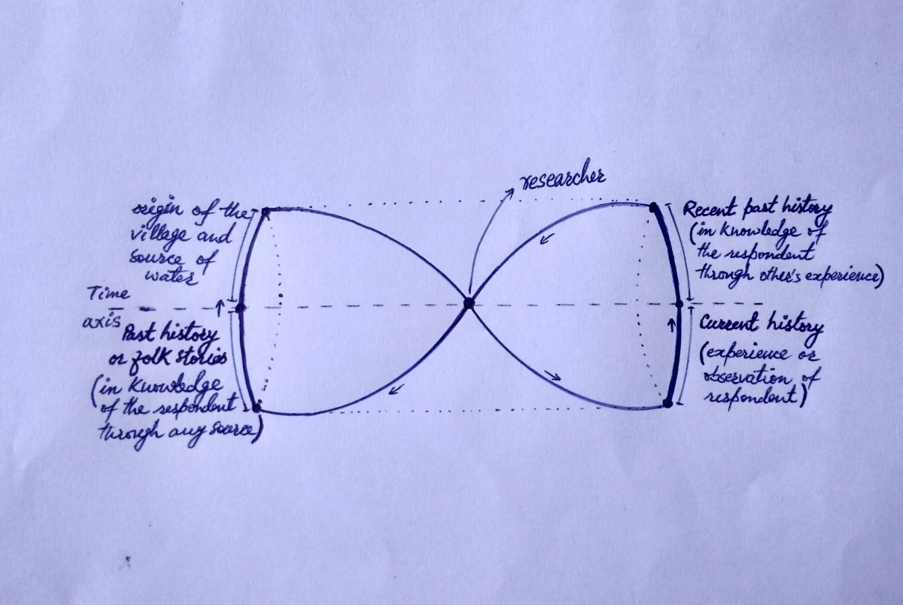

The interview schedule is semi-structure in nature. As per the flow of the interview, the researcher would probe the information.
Village head-1, designated person in the village-2, village sanitation and water committee members-3, officer at PHED-4, activist working on water and health-5, professional social worker-7, politicians-8, arsenic expert-9

