Supplemental Information

Synthetic control methods enable stronger causal inference using participatory science data in cities

Asia Kaiser^{1*}, Julian Resasco^{1†}, Laura E. Dee^{1†}

¹ Department of Ecology and Evolutionary Biology, The University of Colorado at Boulder, Boulder, CO, USA

*Corresponding author: Asia Kaiser, asia.kaiser@colorado.edu
† Laura Dee and Julian Resasco contributed equally to this work as co-senior authors

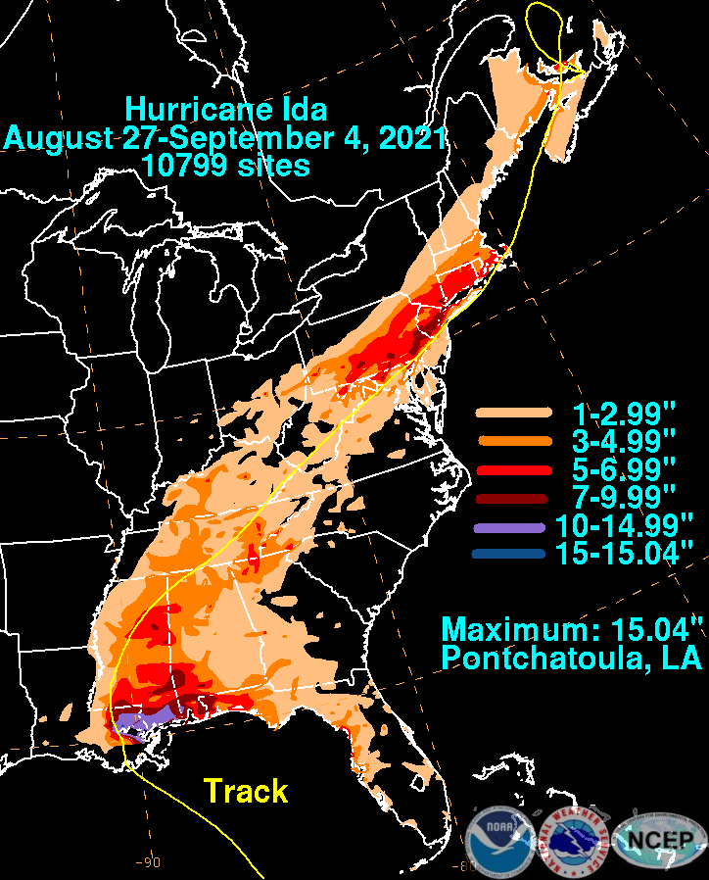
Figure S1. Hurricane Ida flood map showing rainfall in inches. Hurricane Ida originated in Louisiana as a Category 4 hurricane, with winds up to 150 mph on August 29, 2021, and traveled from the Gulf Coast to the Northeastern coast of the United States. Figure from the US Weather Prediction Center (2021).

Section I: Case Study - Data Collection and Analysis Pipeline
​​Donor Pool Selection
The initial dataset comprised 325 large U.S. cities with populations exceeding 100,000. Central latitude and longitude coordinates for each city were obtained from the online geographic tool Latlong.net. Population data for U.S. cities between 2010 and 2023, as well as city land area (in km²), were sourced from the U.S. Census Bureau (US Census Bureau, 2020; Bureau, 2021). To enhance the similarity between our donor pool and the treated city, Philadelphia, the dataset was filtered to include only cities with populations greater than 300,000 in 2023.
Predictor Variables
Bioclimatic variables, including Annual Mean Temperature (℃) and Annual Precipitation (kg m⁻²), were retrieved from WorldClim and calculated based on the central coordinate of each city. Land use and land cover data were obtained from the National Land Cover Database (NLCD) for the Continental United States (CONUS). Specifically, we used the NLCD 2019 Percent Developed Imperviousness and the NLCD 2021 USFS Tree Canopy Cover rasters. The summed raster values within a 45 km buffer around each city's central coordinates were extracted using the ‘terra’ package in R (v1.7.78, Hijmans 2024).
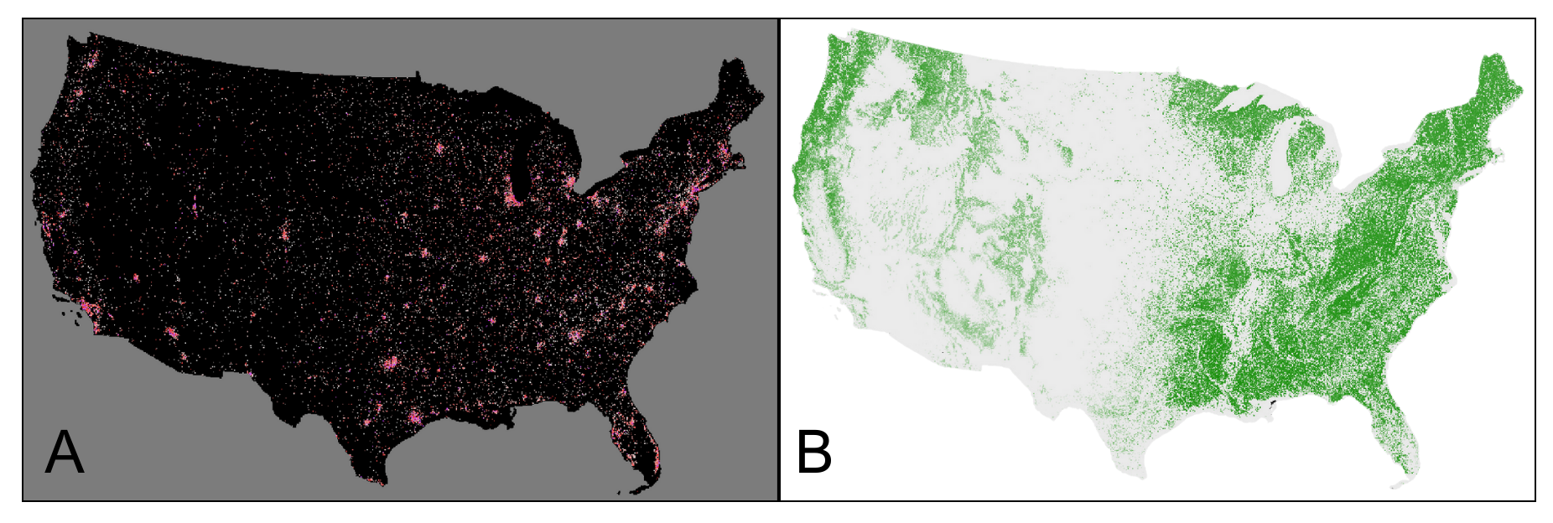
Figure S2. Plots of A) The National Land Cover Database (NLCD) 2019 Percent Developed Imperviousness and B) 2021 USFS Tree Canopy Cover rasters for the Continental United States.
Biodiversity Metrics
Research-grade iNaturalist data, downloaded from GBIF on March 12, 2024 (GBIF, 2024), served as the basis for our biodiversity metrics. The sample period spanned from 2015 to 2023, the latest year of available data, and the expected duration for the attenuation of the event's impact. The data were filtered to include only bee taxa found in the continental United States (families: Apidae, Halictidae, Megachilidae, Andrenidae, Colletidae, Melittidae). Bee abundance values were calculated from observations within a 45 km buffer of each city's central coordinates for each year in the dataset.

Creating the Synthetic Control
The final dataset included bee abundance, annual precipitation, mean annual temperature, and population by year for each city. Since annual data for some variables were not available, the most recent yearly values for tree canopy cover, percent imperviousness, and city area were included, as these variables were not expected to change significantly during the study period. These variables were included as predictors because iNaturalist data collection is influenced by city population size and density, while bee populations are affected by impervious surfaces, tree canopy cover, temperature, and precipitation. Cities that may have been affected by the event (i.e., spillover) or showed unusual changes in bee abundance in the pretreatment era—Boston, Atlanta, Baltimore, and Houston—were excluded from the donor pool to meet the key assumptions outlined in Table 1 in the main text.
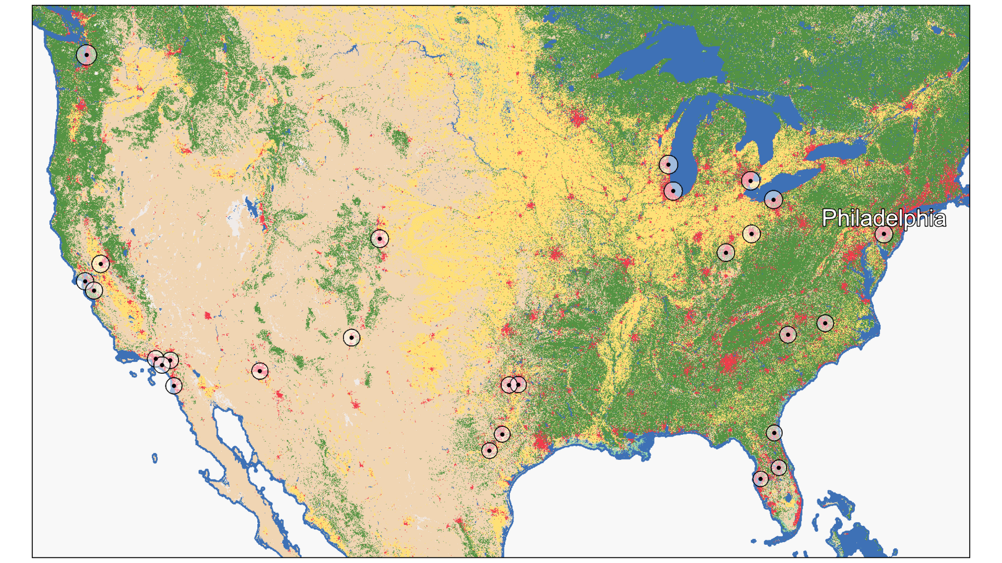
Figure S3. Map of the final cities in the donor pool (n = 26), with the treated city, Philadelphia, labelled. 45 km buffers are shown surrounding the central point for each city. The base map is a Sentinel-2 10m land use/land cover map showing data from 2021 - 2022, produced by Impact Observatory and Esri (Karra et al., 2021).

Section II: Case Study - Inference from the Synthetic Control
The synthetic control was generated using the tidysynth package in R (v0.2.0, Dunford 2023). Predictors included in the synthetic control were mean temperature (℃), annual precipitation (kg m⁻²), population, total impervious surface, total tree canopy cover, and city area (km²). The optimization window for generating weights in the synthetic control was set from 2015 to 2021, representing the pre-event period.
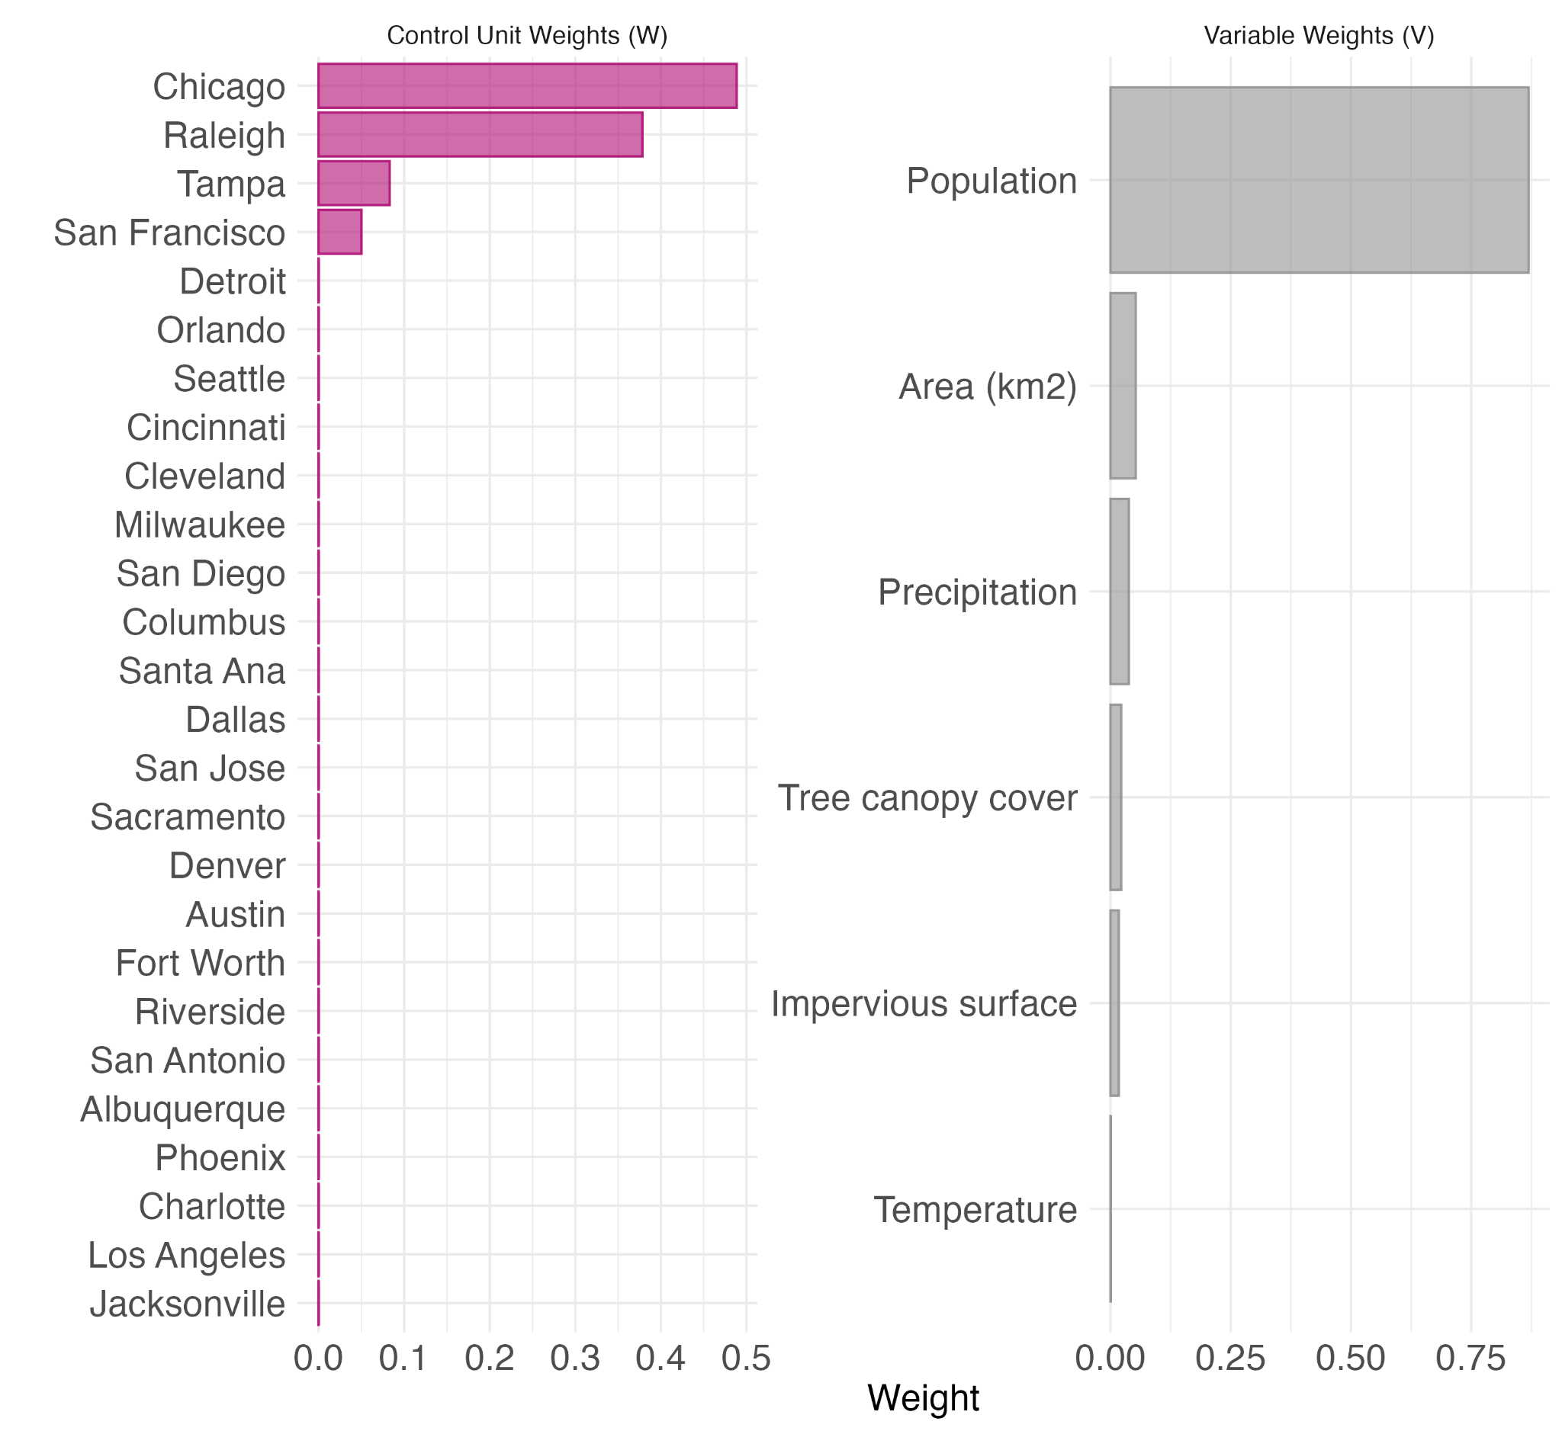
Figure S4. Control unit and predictor variable weights in the ‘tidysynth’ synthetic control.

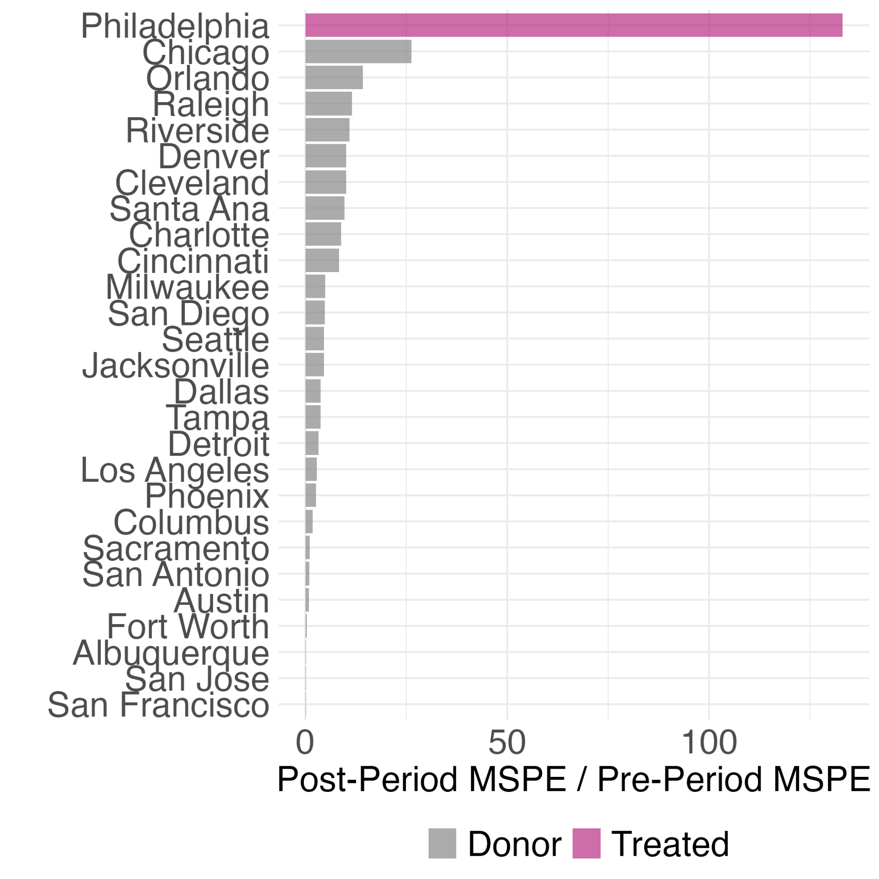
Figure S5. The Mean Square Prediction Error (MSPE) ratios for each unit listed in descending order. A higher ratio shows a higher divergence in the outcome variable pre-and post-treatment.
Table S1. A significance table ranking units in descending order based on the Mean Square Prediction Error (MSPE) ratio. Fisher’s Exact P-values are constructed by dividing a unit's rank by the total.
City | Type | Pre MSPE | Post MSPE | MSPE  ratio | Rank | Fishers Exact Pvalue | z score
Philadelphia | Treated | 12.07 | 1,605.41 | 133.06 | 1 | 0.037* | 4.870
Chicago | Donor | 597.09 | 15,659.84 | 26.23 | 2 | 0.074 | 0.625
Orlando | Donor | 465.67 | 6,627.20 | 14.23 | 3 | 0.111 | 0.148
Raleigh | Donor | 595.30 | 6,885.13 | 11.57 | 4 | 0.148 | 0.042
Riverside | Donor | 1,168.90 | 12,747.19 | 10.91 | 5 | 0.185 | 0.016
Denver | Donor | 490.91 | 4,957.40 | 10.10 | 6 | 0.222 | -0.016
Cleveland | Donor | 859.77 | 8,654.28 | 10.07 | 7 | 0.259 | -0.018
Santa Ana | Donor | 12,594.63 | 121,946.81 | 9.68 | 8 | 0.296 | -0.033
Charlotte | Donor | 1,777.58 | 15,767.97 | 8.87 | 9 | 0.333 | -0.065
Cincinnati | Donor | 2,556.68 | 21,391.41 | 8.37 | 10 | 0.370 | -0.085
Milwaukee | Donor | 1,251.41 | 6,186.09 | 4.94 | 11 | 0.407 | -0.221
San Diego | Donor | 8,508.78 | 40,748.79 | 4.79 | 12 | 0.444 | -0.227
Seattle | Donor | 4,379.79 | 20,060.35 | 4.58 | 13 | 0.481 | -0.236
Jacksonville | Donor | 912.21 | 4,154.74 | 4.55 | 14 | 0.519 | -0.237
Dallas | Donor | 636.90 | 2,398.06 | 3.77 | 15 | 0.556 | -0.268
Tampa | Donor | 67.23 | 252.37 | 3.75 | 16 | 0.593 | -0.268
Detroit | Donor | 12,878.51 | 42,530.09 | 3.30 | 17 | 0.630 | -0.286
Los Angeles | Donor | 4,137.59 | 11,614.45 | 2.81 | 18 | 0.667 | -0.306
Phoenix | Donor | 1,896.37 | 4,911.51 | 2.59 | 19 | 0.704 | -0.315
Columbus | Donor | 1,420.81 | 2,622.19 | 1.85 | 20 | 0.741 | -0.344
Sacramento | Donor | 2,458.45 | 2,554.83 | 1.04 | 21 | 0.778 | -0.376
San Antonio | Donor | 173.61 | 173.55 | 1.00 | 22 | 0.815 | -0.378
Austin | Donor | 2,159.21 | 1,879.42 | 0.87 | 23 | 0.852 | -0.383
Fort Worth | Donor | 2,562.64 | 912.45 | 0.36 | 24 | 0.889 | -0.403
Albuquerque | Donor | 1,931.57 | 295.69 | 0.15 | 25 | 0.926 | -0.411
San Jose | Donor | 5,641.29 | 811.31 | 0.14 | 26 | 0.963 | -0.412
San Francisco | Donor | 9,454.01 | 1,142.65 | 0.12 | 27 | 1.000 | -0.413

Estimating Uncertainty from the Synthetic Control in ‘scpi’
The same dataset of predictor variables and donor units were used for generating a synthetic control and estimating uncertainty in the R package ‘scpi’ (v3.0.0, Cattaneo et al. 2025). For this package, all predictor variables need to be scaled before creating the synthetic control.
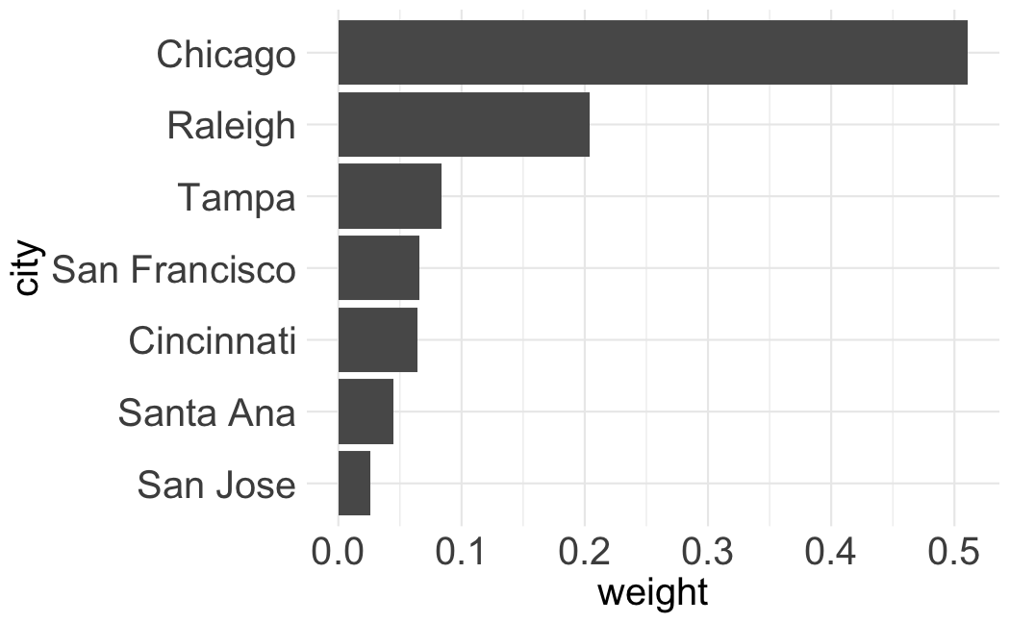
Figure S6. Control unit weights in the ‘scpi’ synthetic control.

Section III: Case Study - Inference from Alternative Methods
Table S2. Model output for the Before-After (BA) linear regression with an adjusted R² of 0.492 and a residual std. error of 77.93 on 12 degrees of freedom.
 | Estimate | Std. Error | t-value | p-value
Intercept | 49.25 | 22.5 | 2.189 | 0.04907*
Treatment | 219.25 | 59.52 | 3.684 | 0.00313**

Table S3. Model output for the Before-After Control-Impact (BACI) analysis with Philadelphia as the treated city and Detroit as a control city. The model has an adjusted R² of 0.545 and a residual std. error of 57.78 on 24 degrees of freedom.
 | Estimate | Std. Error | t-value | p-value
Intercept | 13.67 | 16.68 | 0.819 | 0.4206
Treated | 35.58 | 23.59 | 1.509 | 0.1445
Time | 96.33 | 44.13 | 2.183 | 0.0391*
Treated*Time | 122.92 | 62.41 | 1.970 | 0.0605

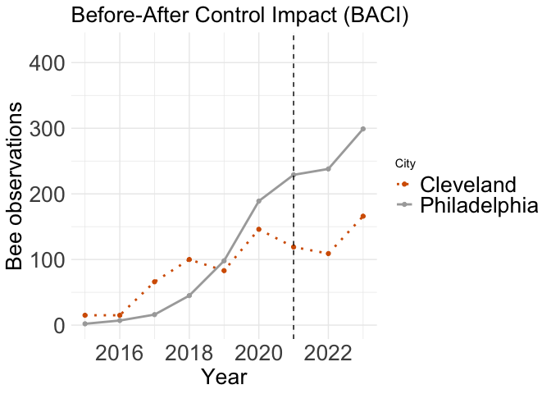Figure S7. A trend plot showing observed bee abundance in Philadelphia, the treated city, and Cleveland, the control city, in a before-after control impact (BACI) analysis. The dotted vertical line indicates the timing of the event (Hurricane Ida). No significant change in bee abundance in Philadelphia was detected post-event (t = 1.805, df = 24, p = 0.084).

Table S4. Model output for the Before-After Control-Impact (BACI) linear regression with Philadelphia as the treated city and Cleveland as a control city. The model has an adjusted R² of 0.422 and a residual std. error of 66.17 on 24 degrees of freedom.
 | Estimate | Std. Error | t-value | p-value
Intercept | 47.25 | 19.10 | 2.474 | 0.021*
Treated | 2.00 | 27.01 | 0.074 | 0.942
Time | 90.25 | 50.53 | 1.786 | 0.087
Treated*Time | 129.00 | 71.47 | 1.805 | 0.084

Table S5. Model output for the Interrupted Time Series generalized least squares regression with a residual std. error of 24.99 on 9 (5 residual) degrees of freedom.
 | Estimate | Std. Error | t-value | p-value
Intercept | -74969 | 15488 | -4.840 | 0.005**
Year | 37.19 | 7.675 | 4.846 | 0.005**
Treated | -52.27 | 53.170 | -0.983 | 0.371
Time since treatment | 25.74 | 30.498 | 0.844 | 0.437

References

- Bureau, U. C. (2021, August 19). Gazetteer Files. Census.gov. https://web.archive.org/web/20211026060851/https://www.census.gov/geographies/reference-files/time-series/geo/gazetteer-files.2020.html
- Cattaneo M, Feng Y, Palomba F, Titiunik R (2025). _scpi: Prediction Intervals for Synthetic Control Methods with Multiple Treated Units and Staggered Adoption_. R package version 3.0.0, <https://CRAN.R-project.org/package=scpi>.
- Dunford E (2023). _tidysynth: A Tidy Implementation of the Synthetic Control Method_. R package version 0.2.0.
- GBIF.org (12 March 2024) GBIF Occurrence Download https://doi.org/10.15468/dl.jvuxa3
- Hijmans, R. (2024). terra: Spatial Data Analysis. R package version 1.7-78, <https://CRAN.R-project.org/package=terra>.
- Karra, Kontgis, et al. “Global land use/land cover with Sentinel-2 and deep learning.” IGARSS 2021-2021 IEEE International Geoscience and Remote Sensing Symposium. IEEE, 2021.
- US Census Bureau. (2020). Data. Census.gov. https://www.census.gov/data.html
- US Weather Prediction Center. (2021). Hurricane Ida Rainfall Map [Map]. NOAA. https://www.wpc.ncep.noaa.gov/tropical/rain/ida2021filledrainblk.gif

