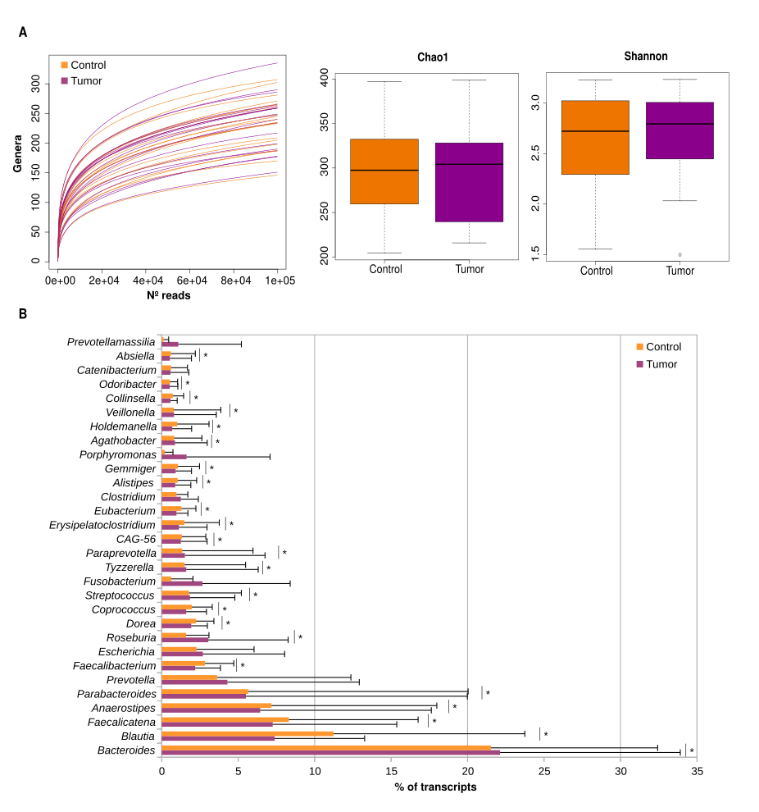
Fig S1. Active microbiome composition as assessed by metagenomic RNA sequencing. A) Richness and diversity estimates (left to right: rarefaction curves, Chao1 richness and Shannon diversity indexes) of control and tumor tissue at the genus taxonomic level. B) Percentage of transcripts assigned to each bacterial genera. * adjusted p-value <0.05 by the ANCOM-BC method. Mean and standard deviation.
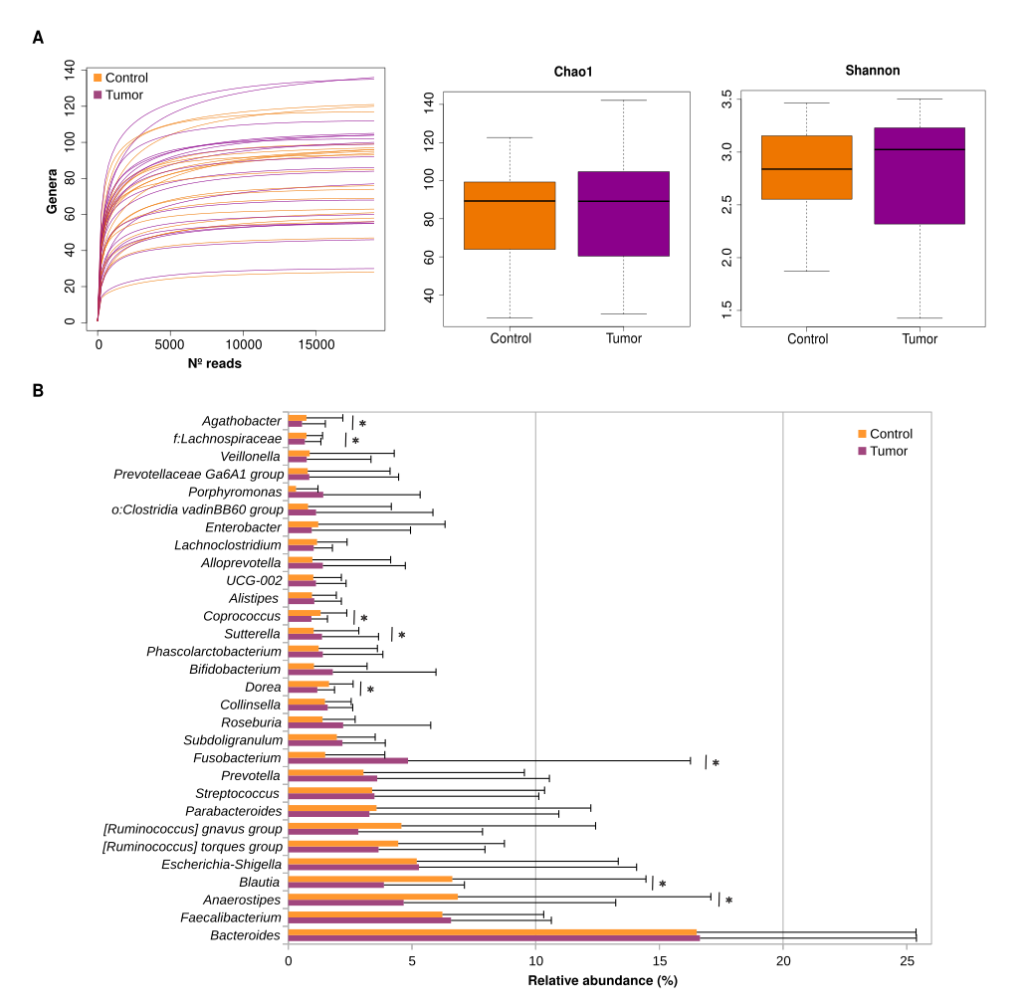
Fig S2. Microbiome composition as assessed by DNA extraction and 16S gene sequencing. A) Richness and diversity estimates (left to right: rarefaction curves, Chao1 and Shannon indexes) of control and tumor tissue at the genus taxonomic level. B) Relative abundance of top-30 genera. * adjusted p-value <0.05 by the ANCOM-BC method. Mean and standard deviation.
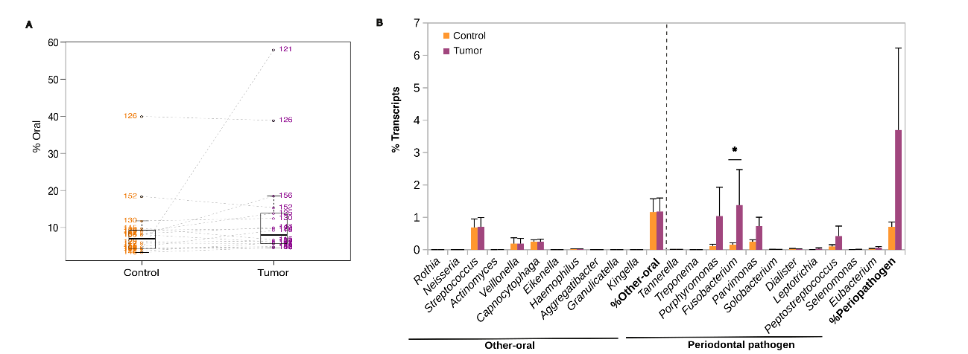
Fig S3. Oral bacteria in gut tissue. A) Percentage of reads annotated to the Extended Human Oral Microbiome Database (EHOMD) of paired tumor:control samples. B) Mean percentage of transcripts corresponding to oral bacteria (SE, standard error). * adjusted p-value <0.05 by Wilcoxon paired test.
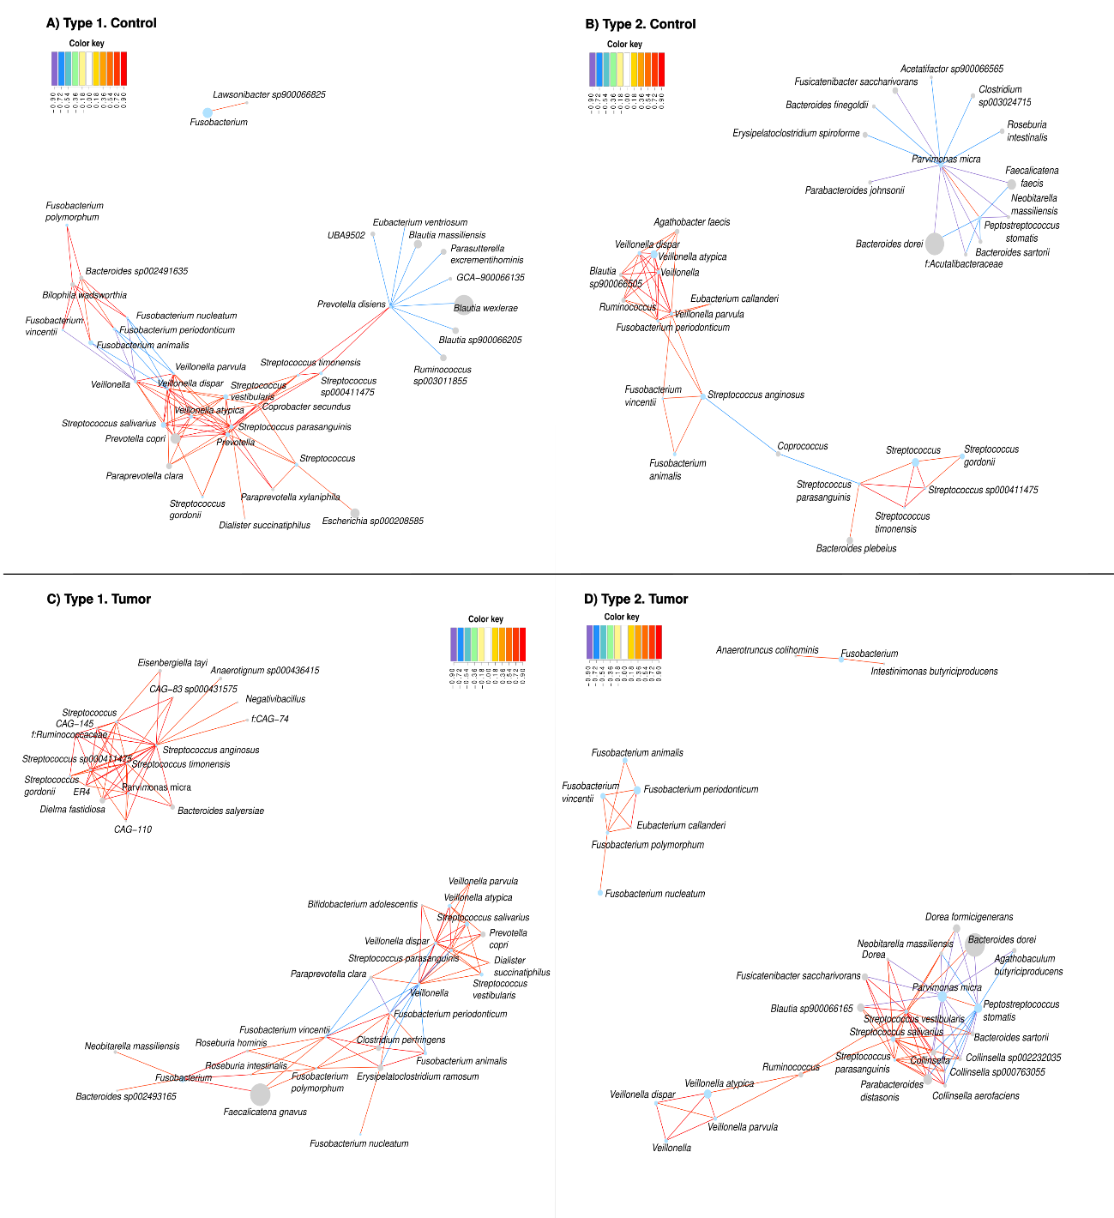
Fig S4. Interactions of oral bacteria in the gut by RNA-based enterotypes. Networks in the top panels represent correlations of oral bacterial species in the control, unaffected tissue according to the sPLS method, in the RNA enterotypes 1 (A) and 2 (B). Networks in the down panels represent correlations of oral bacterial species in the cancer tumor tissue according to the sPLS method, in the RNA enterotypes 1 (C) and 2 (D). Blue nodes represent oral species, grey nodes gut species. Lines are marked in different colors according to their positive (red) or negative (blue) correlations.
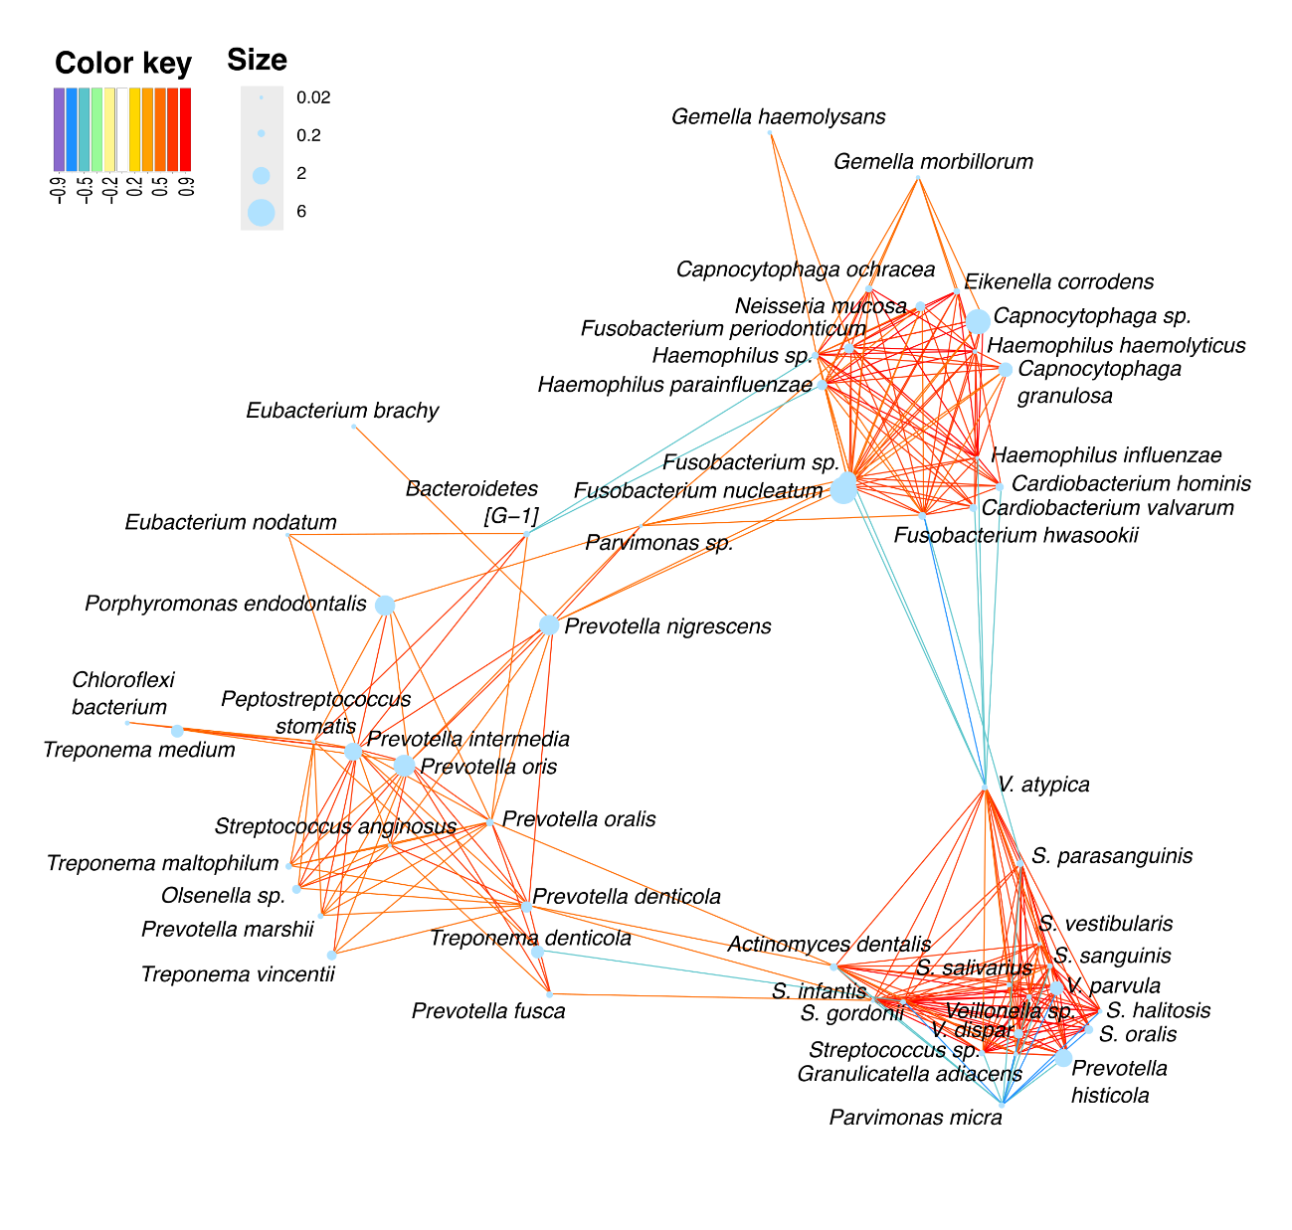
Fig S5. Potential bacterial interactions in the subgingival samples. Correlation networks of the oral bacteria based on their transcriptional profile in the oral cavity by the sPLS method. Lines are marked in different colors according to their positive (red) or negative (blue) correlations. Node size corresponds to relative abundance based on transcripts.

