
Author agreement:
We the undersigned declare that this manuscript is original, has not been published before and is not currently being considered for publication elsewhere.
We confirm that the manuscript has been read and approved by all named authors and that there are no other persons who satisfied the criteria for authorship but are not listed.
We further confirm that the order of authors listed in the manuscript has been approved by all of us.
We understand that the Corresponding Author is the sole contact for the Editorial process.
He/she is responsible for communicating with the other authors about progress, submissions of revisions and final approval of proofs.
The author has no potential conflicts of interest to disclose.
Author Contributions:
Wenjun Wang drafted and revised the manuscript. Ying Song* designed and revised the manuscript. Yibiao Shi found the literature. Sitian Qiu revised the manuscript. Xi Chen revised the manuscript. Xiaomin Zhang participated in the experiment. Qisong Li participated in the experiment.
Name | Signature
Wenjun Wang | 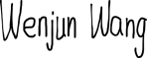
Yibiao Shi | 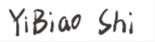
Sitian Qiu | 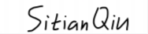
Ying Song | 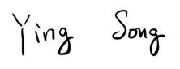
Xi Chen | 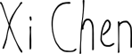
Xiaomin Zhang | 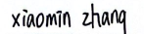
Qisong Li | 