SUPPLEMENTARY MATERIALS:

- People inside fusion reactors – illustrating possibilities of operator to move inside various fusion reactors.

- Telescopic arm of the real in-situ LIBS setup used for testing low pressure work possibilities

- Concept proof - showing measuring head used during leakage testing (with vacuum connections and manometer)

- Sealing rings drawing and photographs of the two elastomer sealant types together with the metallic tool for their production

- Photographs of the realized measuring head

- Photographs of upper view of the adapter with electrodes

- PEOPLE INSIDE FUSION REACTORS
Our proposal of measuring head used by the operator inside plasma fusion reactor is based on the following photographs.

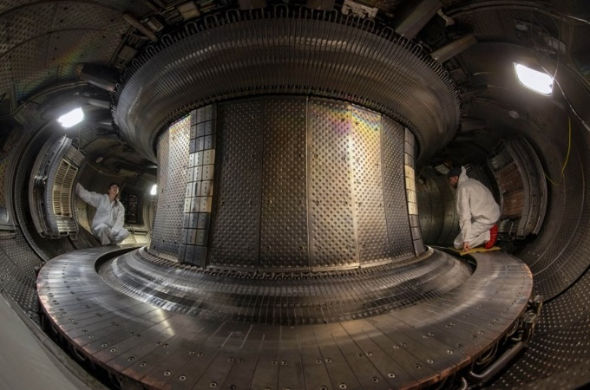
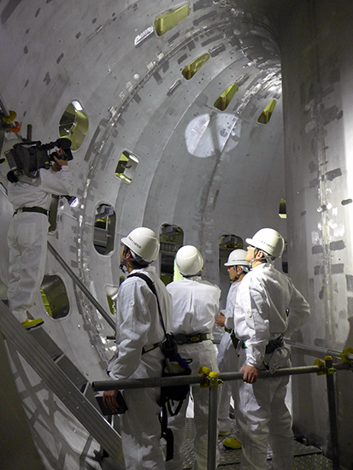

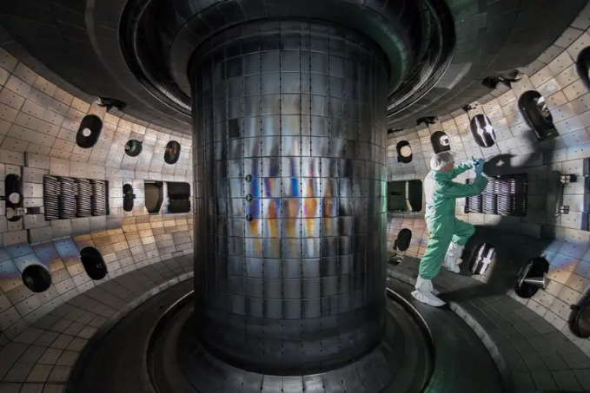
Inside WEST

Inside JT-60SA
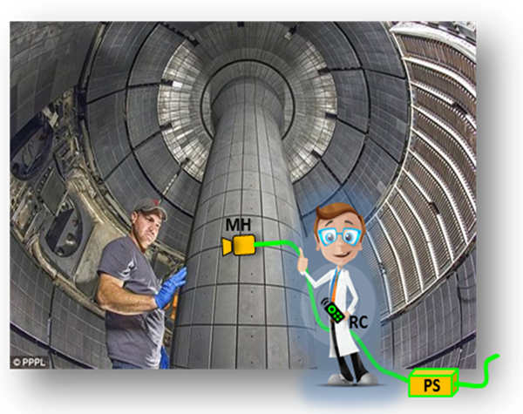
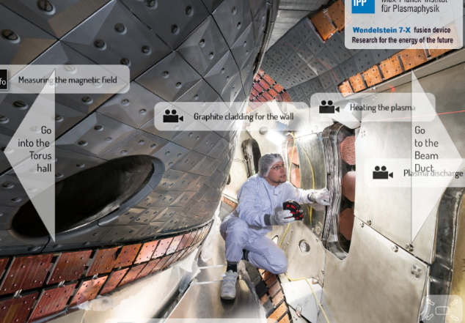
Inside DIII D

Inside Wendelstein 7X Inside JET

2. TELESCOPIC ARM for the real in-situ low pressure LIBS

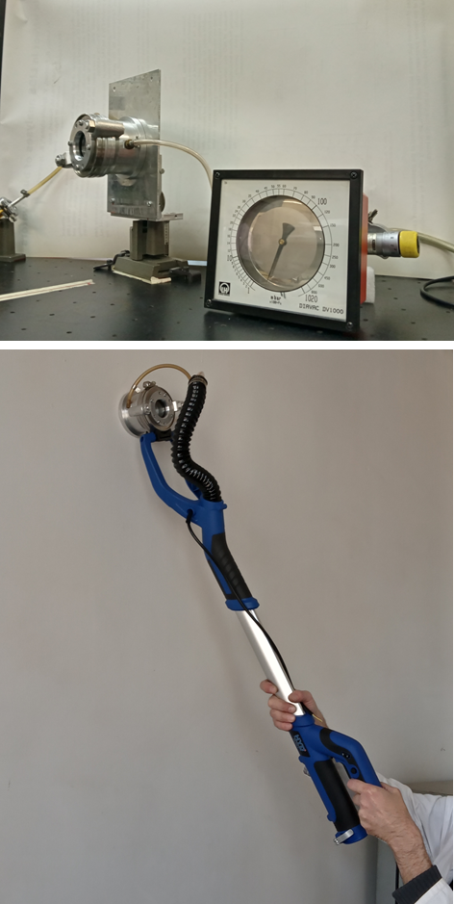
3

1

2
For our experimental testing we used measuring head (1) with upper part having only one optical window. The head was positioned using telescopic arm of the commercial wall grinding machine (in which motor was replaced with a measuring head).

3. CONCEPT PROOF showing measuring head used during leakage testing (with vacuum connections and manometar)

With use of the gasket shown in Figure 4a by using a vacuum pump with a capacity of 15 m3/h the realized pressure inside of the measuring head was less than 0.1 mbar, what enabled their attachment to the vertical metallic plate.

4. SEALING RINGS DRAWING
and photographs of the two elastomer sealant types
together with the metallic tool for their production

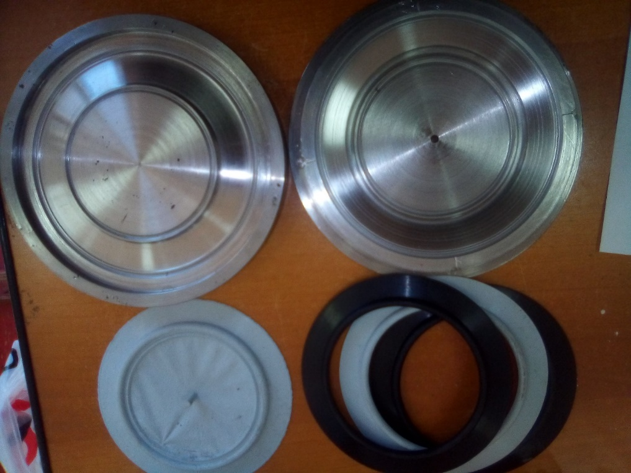
5. PHOTOGRAPHS OF THE REALIZED MEASURING HEAD
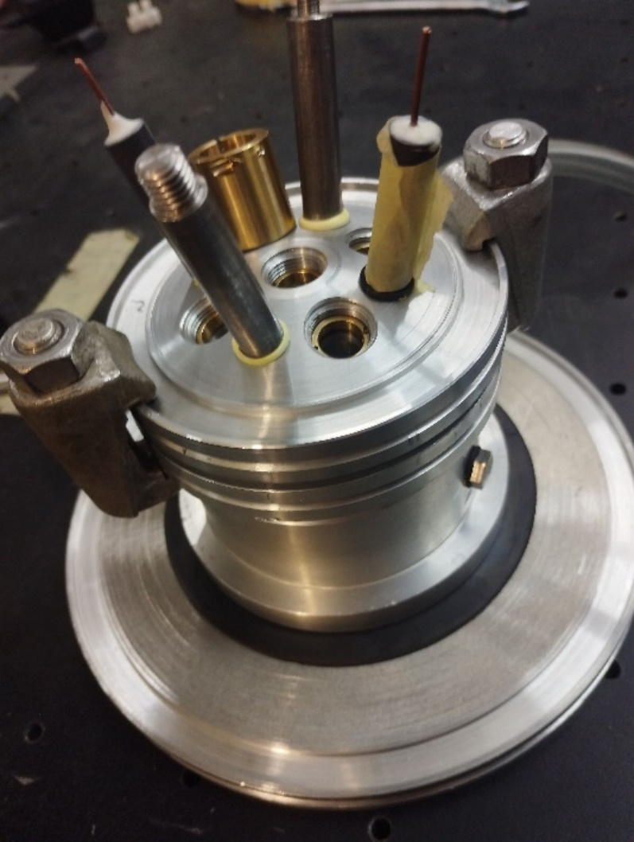
SIDE VIEW
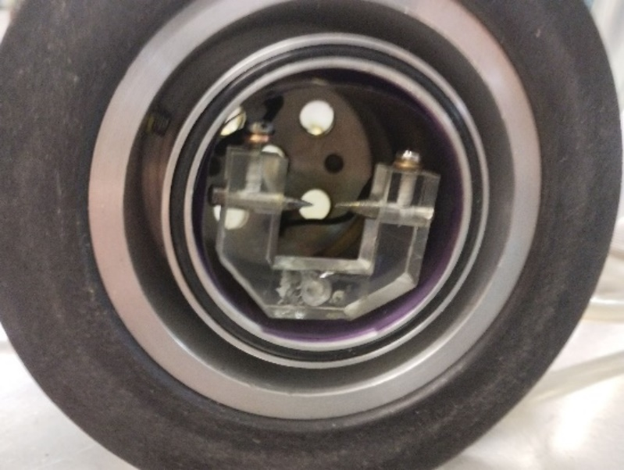
BOTTOM VIEW

6. UPPER VIEW OF THE ADDAPTER WITH ELECTRODES
