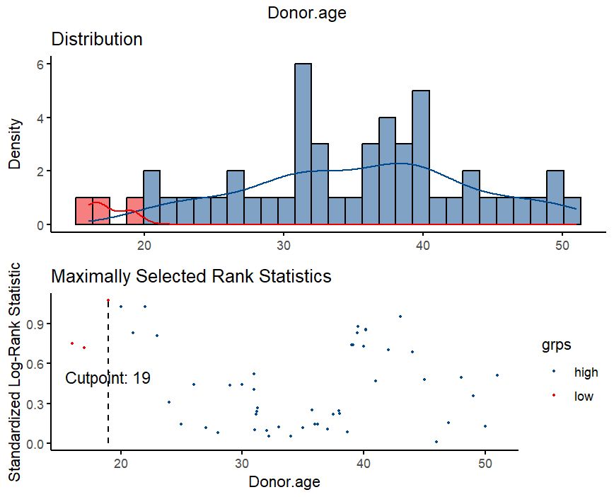
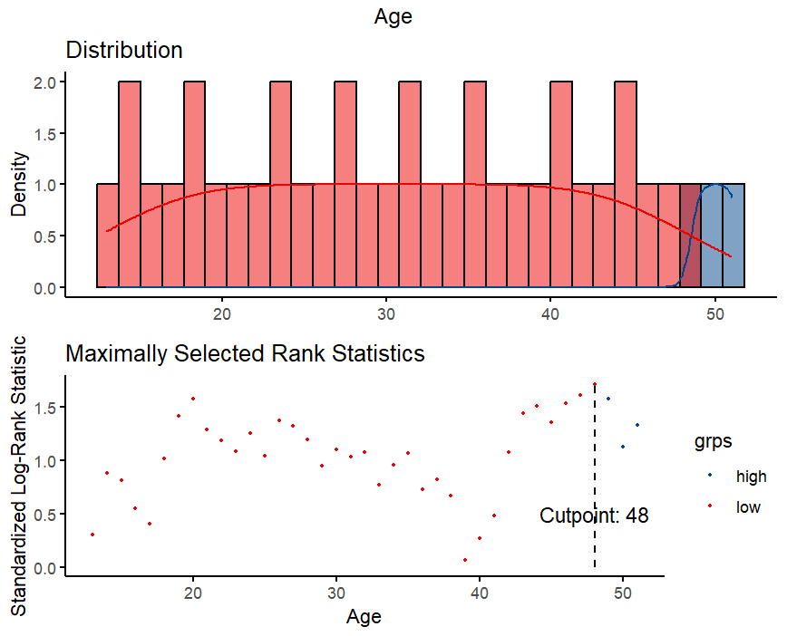
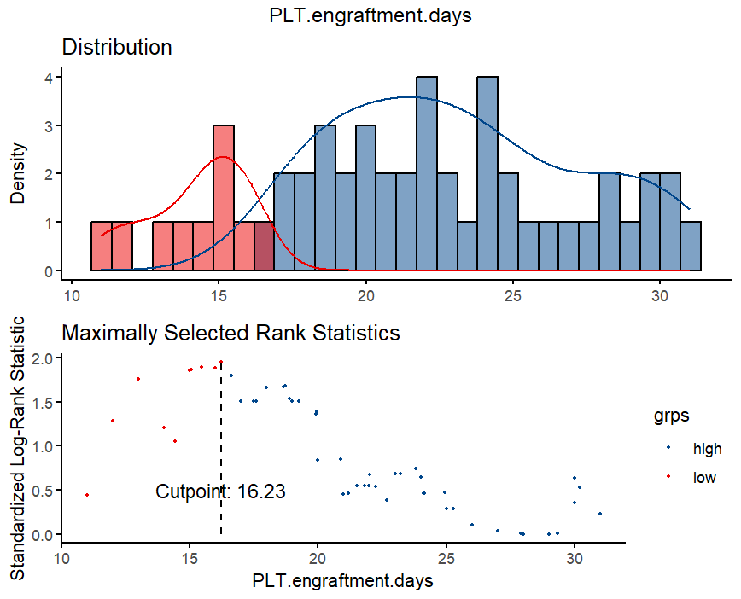
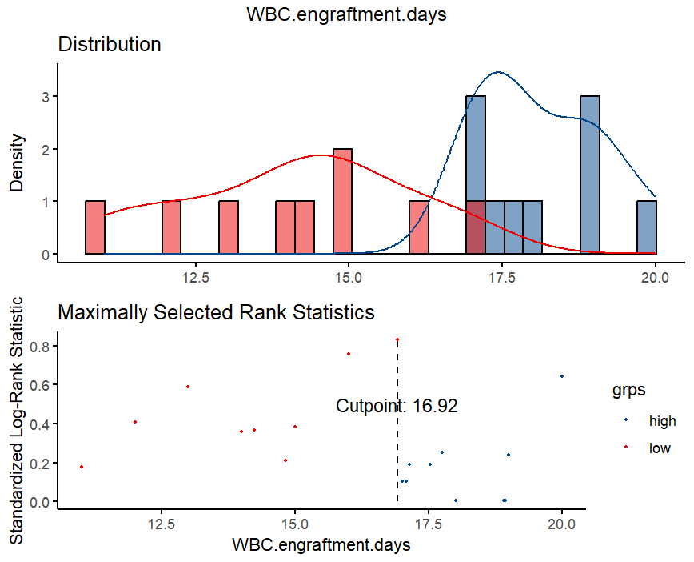
Figure S1. Continuous variable cutoff value visualization
D
C
B
A
A:WBC engraftment days’ cutpoint≈17 B:PLT engraftment days’ cutpoint≈17
C:Age’s cutpoint=48 D:Donor age’s cutpoint=19
WBC: White Blood Cell, PLT: Platelet
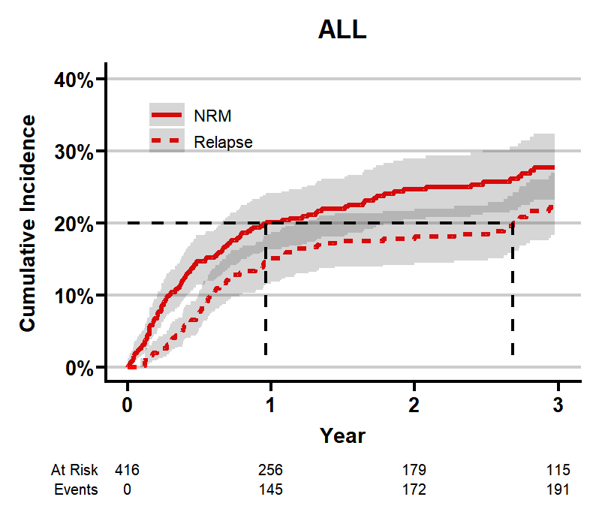
Figure S2. CIF curve of the entire population in the training set (Non-relapse mortality (NRM) and Relapse)

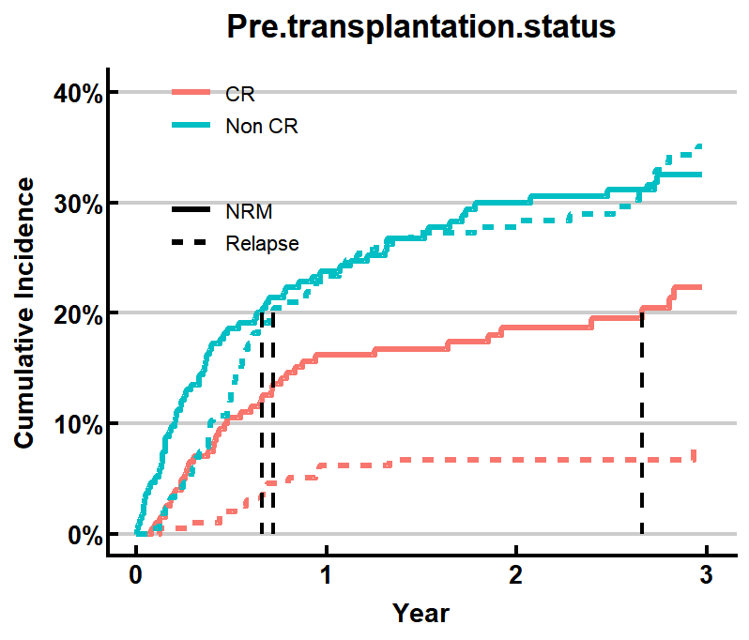
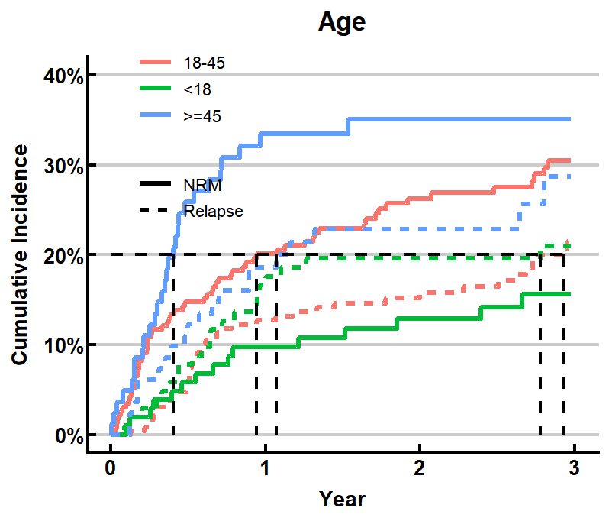
B
A

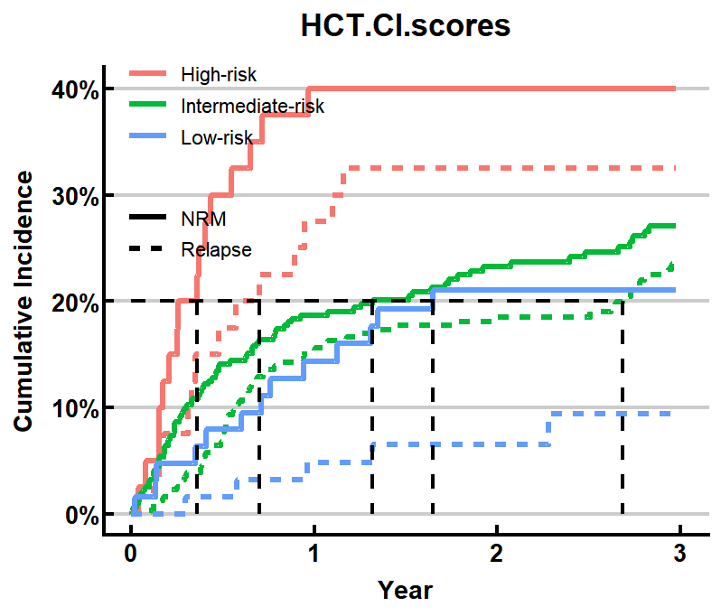
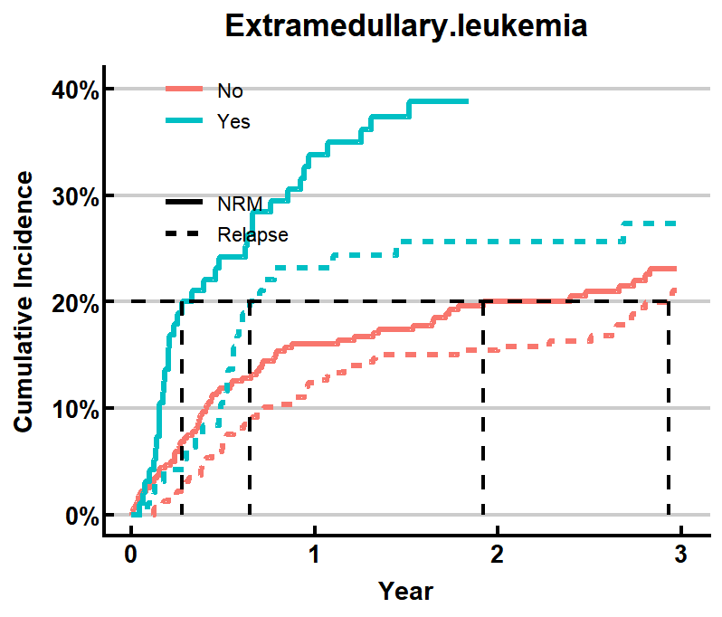
D
C
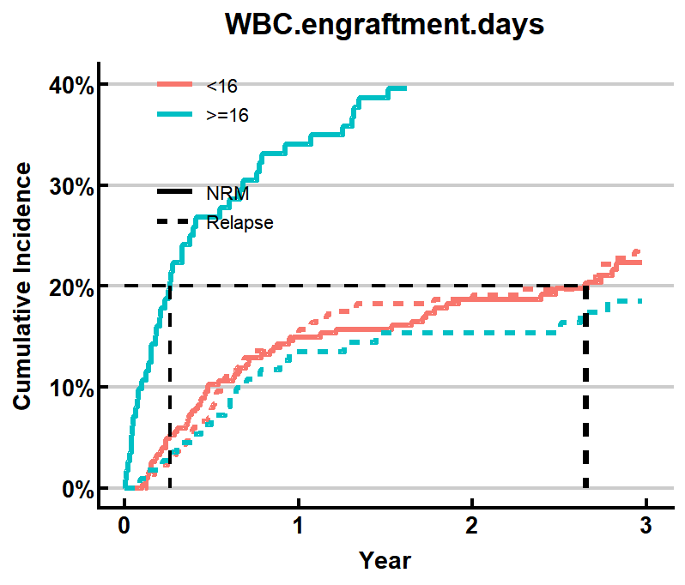
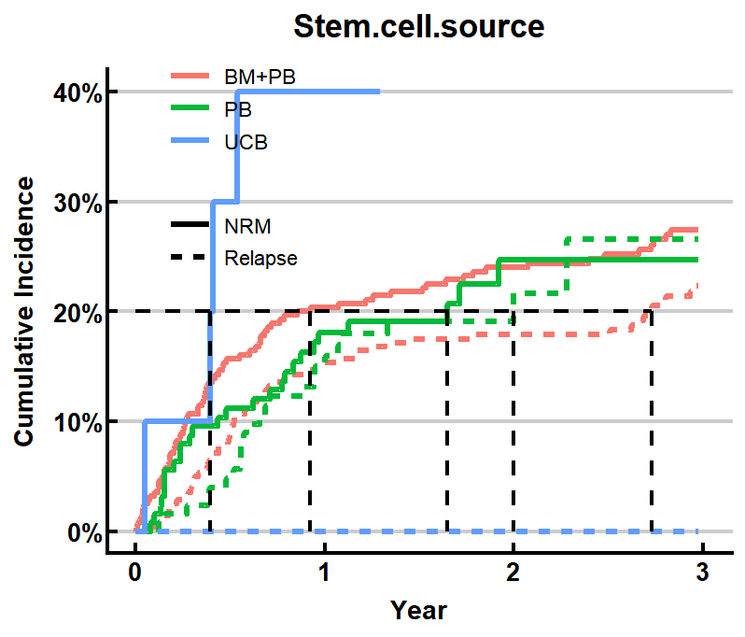
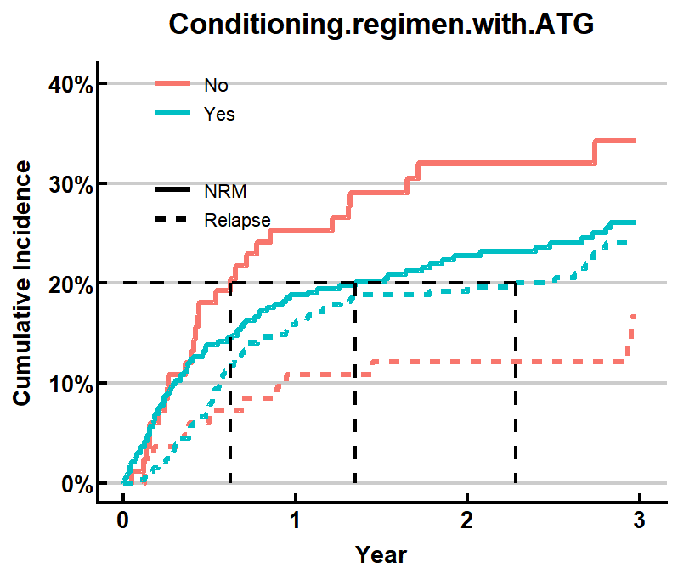
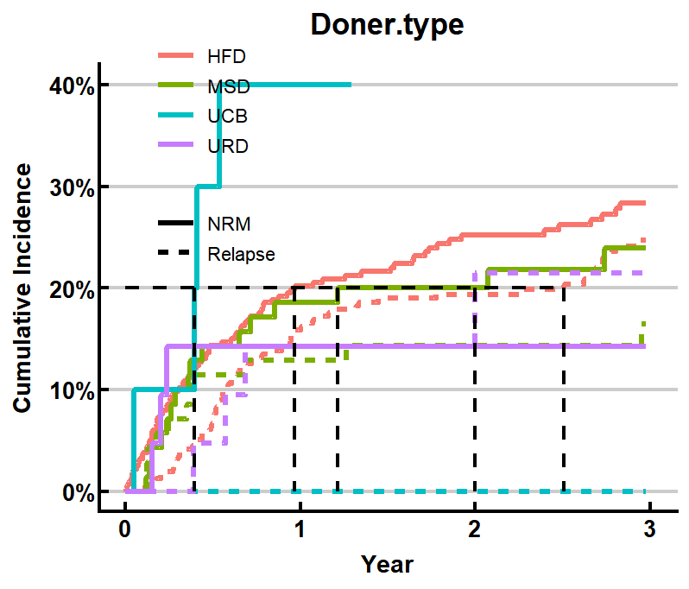
H
G
F
E
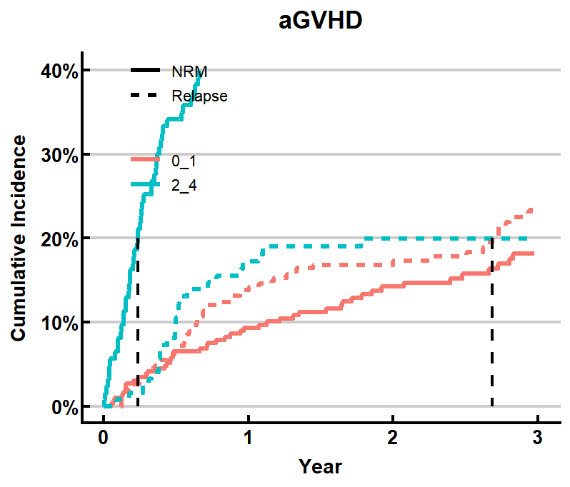
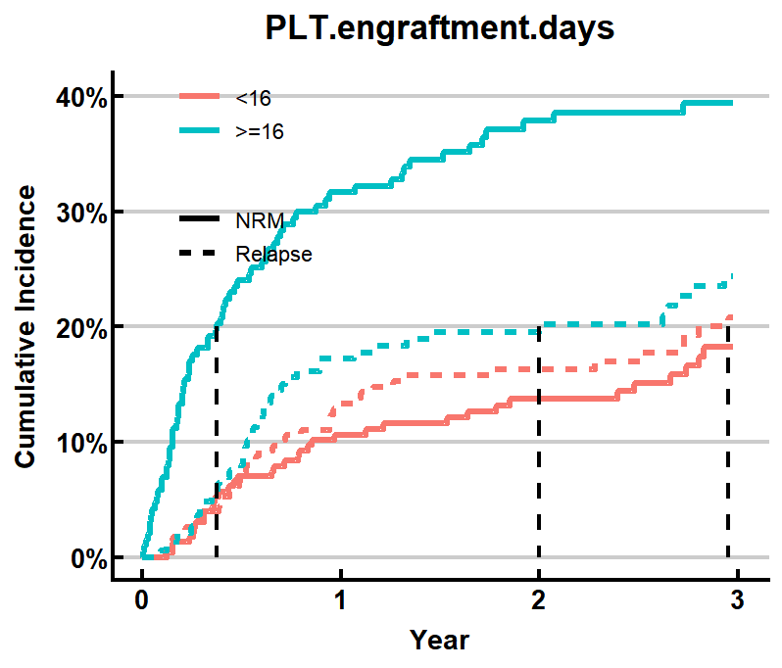
J
I

Figure S3. Single characteristic CIF curve
A:Age’s CIF curve B:Pre transplantation status’ CIF curve
C:Extramedullary leukemia’s CIF curve D:HCT-CI scores’ CIF curve
E:Doner type’s CIF curve F:Conditioning regimen with ATG’s CIF curve
G:Stem cell source’s CIF curve H:WBC engraftmen days group’s CIF curve
I:PLT engraftment days group’s CIF curve J:aGVHD’s CIF curve
NRM:Non-relapse mortality, CIF:Cumulative Incidence Function, HCT-CI: Hematopoietic Cell Transplantation-Specific Comorbidity Index, MSD: Matched Sibling Donor, HFD: Haploidentical Family Donor, URD: Unrelated Donor, UCB: Umbilical Cord Blood, ATG: Anti-Thymocyte Globulin, BM: Bone Marrow, PB: Peripheral Blood, WBC: White Blood Cell, PLT: Platelet,GVHD: Graft-versus-Host Disease

Table S1. Training set and validation set
Characteristic | Cohort |  | p-value²
Characteristic | Training Cohort, N = 417¹ | Internal Test Cohort, N = 178¹ | p-value²
Sex |  |  | 0.080
Male | 257 (61.6%) | 96 (53.9%)
Female | 160 (38.4%) | 82 (46.1%)
Age_group |  |  | 0.804
< 18 | 94 (22.5%) | 40 (22.5%)
18 - 45 | 239 (57.3%) | 98 (55.1%)
≥ 45 | 84 (20.1%) | 40 (22.5%)
Underlying.disease |  |  | 0.919
AML | 311 (74.6%) | 133 (74.7%)
T-ALL | 35 (8.4%) | 13 (7.3%)
B-ALL | 57 (13.7%) | 27 (15.2%)
MAPL | 14 (3.4%) | 5 (2.8%)
Pre.transplantation.status |  |  | 0.295
CR | 214 (51.3%) | 83 (46.6%)
Non CR | 203 (48.7%) | 95 (53.4%)
CNSL |  |  | 0.340
No | 379 (90.9%) | 166 (93.3%)
Yes | 38 (9.1%) | 12 (6.7%)
Extramedullary.leukemia |  |  | 0.964
No | 324 (77.7%) | 138 (77.5%)
Yes | 93 (22.3%) | 40 (22.5%)
HCT.CI.scores |  |  | 0.566
Low-risk | 70 (16.8%) | 24 (13.5%)
Intermediate-risk | 310 (74.3%) | 136 (76.4%)
High-risk | 37 (8.9%) | 18 (10.1%)
Donor.recipient.sex.matched |  |  | 0.337
Male-male | 203 (48.7%) | 75 (42.1%)
Male-female | 116 (27.8%) | 62 (34.8%)
Female-male | 54 (12.9%) | 21 (11.8%)
Female-female | 44 (10.6%) | 20 (11.2%)
Donor.age_group |  |  | 0.012
< 18 | 51 (12.2%) | 16 (9.0%)
18 - 45 | 265 (63.5%) | 98 (55.1%)
≥ 45 | 101 (24.2%) | 64 (36.0%)
Doner.type |  |  | 0.133
MSD | 71 (17.0%) | 28 (15.7%)
HFD | 309 (74.1%) | 142 (79.8%)
UCB | 15 (3.6%) | 1 (0.6%)
URD | 22 (5.3%) | 7 (3.9%)
Donor.recipient.blood.type.matched |  |  | 0.758
Matched | 230 (55.2%) | 93 (52.2%)
Major dismatched | 89 (21.3%) | 37 (20.8%)
Minor dismatched | 69 (16.5%) | 36 (20.2%)
Bidirectional | 29 (7.0%) | 12 (6.7%)
TCI |  |  | 0.257
Median (IQR) | 2.00 (1.50, 2.00) | 2.00 (2.00, 2.50)
Conditioning.regimen.with.ATG |  |  | 0.401
No | 90 (21.6%) | 33 (18.5%)
Yes | 327 (78.4%) | 145 (81.5%)
Stem.cell.source |  |  | 0.040
BM+PB | 271 (65.0%) | 129 (72.5%)
PB | 131 (31.4%) | 48 (27.0%)
UCB | 15 (3.6%) | 1 (0.6%)
With.UCB |  |  | 0.101
No | 136 (32.6%) | 46 (25.8%)
Yes | 281 (67.4%) | 132 (74.2%)
MNC.cell.dose.count_group |  |  | 0.865
< 10 | 356 (85.4%) | 151 (84.8%)
≥ 10 | 61 (14.6%) | 27 (15.2%)
CD34..cell.dose.count_group |  |  | 0.187
< 2 | 64 (15.3%) | 20 (11.2%)
≥ 2 | 353 (84.7%) | 158 (88.8%)
WBC.engraftment.days_group |  |  | 0.365
< 16 | 277 (66.4%) | 125 (70.2%)
≥ 16 | 140 (33.6%) | 53 (29.8%)
PLT.engraftment.days_group |  |  | 0.591
< 16 | 229 (54.9%) | 102 (57.3%)
≥ 16 | 188 (45.1%) | 76 (42.7%)
CMV.infections |  |  | 0.231
No | 49 (11.8%) | 15 (8.4%)
Yes | 368 (88.2%) | 163 (91.6%)
EBV.infections |  |  | 0.066
No | 281 (67.4%) | 106 (59.6%)
Yes | 136 (32.6%) | 72 (40.4%)
Hemorrhagic.cystitis |  |  | 0.185
No | 85 (20.4%) | 28 (15.7%)
Yes | 332 (79.6%) | 150 (84.3%)
aGVHD |  |  | 0.914
0_1 | 297 (71.2%) | 126 (70.8%)
2_4 | 120 (28.8%) | 52 (29.2%)
cGVHD |  |  | 0.692
No | 27 (6.5%) | 10 (5.6%)
Yes | 390 (93.5%) | 168 (94.4%)
¹n (%)
²Pearson's Chi-squared test; Fisher's exact test; Wilcoxon rank sum test
AML: Acute Myeloid Leukemia, ALL: Acute Lymphoblastic Leukemia, MAPL: Mixed Phenotype Acute Leukemia, CNSL: Central Nervous System Leukemia, HCT-CI: Hematopoietic Cell Transplantation-Specific Comorbidity Index, MSD: Matched Sibling Donor, HFD: Haploidentical Family Donor, URD: Unrelated Donor, UCB: Umbilical Cord Blood, ATG: Anti-Thymocyte Globulin, TCI: Transplant Conditioning Intensity, BM: Bone Marrow, PB: Peripheral Blood, MNC: Mononuclear Cells, WBC: White Blood Cell, PLT: Platelet, CMV: Cytomegalovirus, EBV: Epstein-Barr Virus, GVHD: Graft-versus-Host Disease

Table S2. Cumulative incidence of NRM and Relapse in the entire population
 | 1-year cumulative incidence rate | 2-year cumulative incidence rate | 3-year cumulative incidence rate
NRM | 20% (16%, 24%) | 25% (20%, 29%) | 28% (23%, 32%)
Relapse | 15% (12%, 19%) | 18% (14%, 22%) | 22% (18%, 27%)

Table S3. Fine-Gray test’s p value
 | NRM | Relapse
Age | <0.001 | 0.41
Pre.transplantation.status | 0.006 | <0.001
Extramedullary.leukemia | <0.001 | 0.17
HCT.CI.scores | 0.022 | <0.001
Doner.type | 0.10 | 0.14
Conditioning.regimen.with.ATG | 0.055 | 0.066
Stem.cell.source | 0.061 | 0.21
WBC.engraftment.days | <0.001 | 0.12
PLT.engraftment.days | <0.001 | 0.61
aGVHD | <0.001 | 0.96
HCT-CI: Hematopoietic Cell Transplantation-Specific Comorbidity Index, WBC: White Blood Cell, PLT: Platelet, GVHD: Graft-versus-Host Disease

