Supplementary information:

Light-Induced Thermomechanical Reorientation and Helicity Flipping in Ferroelectric Nematic Phase
Tibor Tóth-Katona^{1,}*, István Jánossy¹, Péter Salamon¹, Antal Jákli^{1,2,3}
¹Institute for Solid State Physics and Optics, HUN-REN Wigner Research Centre for Physics, P.O. Box 49, Budapest H-1525, Hungary
²Material Science Graduate Program and Advanced Materials and Liquid Crystal Institute, Kent State University, Kent, Ohio 44242, USA
³Department of Physics, Kent State University, Kent, Ohio 44242, USA

* E-mail: tothkatona.tibor@wigner.hun-ren.hu

Supplementary note 1:

Determination of the size and intensity profile of the laser line and the beam
To determine the size and intensity profile of the laser line and Gaussian beam, a solution of anthraquinone dye in toluene has been filled in an EHC cell and placed in the experimental setup shown in Figure S9. Under laser illumination at λ=445 nm the anthraquinone solution fluoresces in the red region, so the laser spot/line becomes visible in the setup. Results are shown in Figure S1 for a beam/line of P=100 mW. In Fig. S1(a) the intensity profile of the beam is shown together with the best fit for Gaussian distribution (with FWHM of 132.6 μm, full line). In Fig. S1(b) the intensity profiles for the horizontal and vertical laser lines (measured in the perpendicular direction) are shown together with the best fit for Gaussian distribution (full lines, with FWHM of 107 μm and 86 μm for horizontal and vertical laser line, respectively). The length of the laser line has been found approximately L≈3.5 mm. The original pictures from which the intensity profiles were determined are also inserted in the graphs (in case of laser lines with brightness enhanced for better visibility).
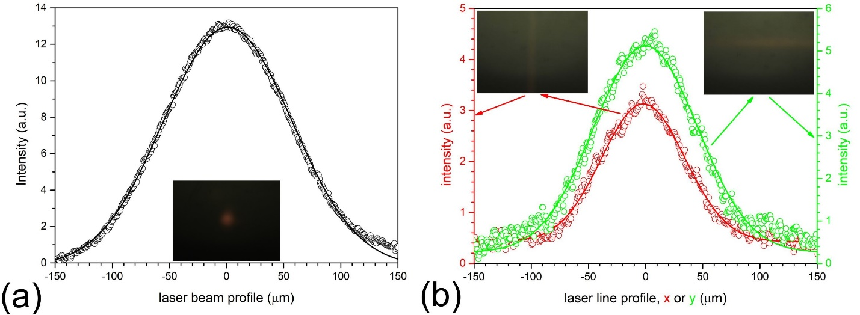
Figure S1 | Intensity profiles of the laser lines and the Gaussian beam. (a) Intensity profile of the laser beam. The full line is the Gaussian distribution fit (FWHM=132.6 μm). (b) Intensity profile of the vertical laser line (red) and horizontal laser line (green). The full lines are the Gaussian distribution fits with FWHM=86 μm and FWHM=107 μm for vertical and horizontal laser lines, respectively.

Supplementary note 2:

Laser line in parallel rubbed cell enclosing 45º with the rubbing direction
Figure S2 shows the light-induced pattern evolution when the laser line encloses 45º with the parallel rubbed direction R. For clarity, pictures in Figure S2 are made at the same elapsed times as those in Figs. 1(a) and 1(b).
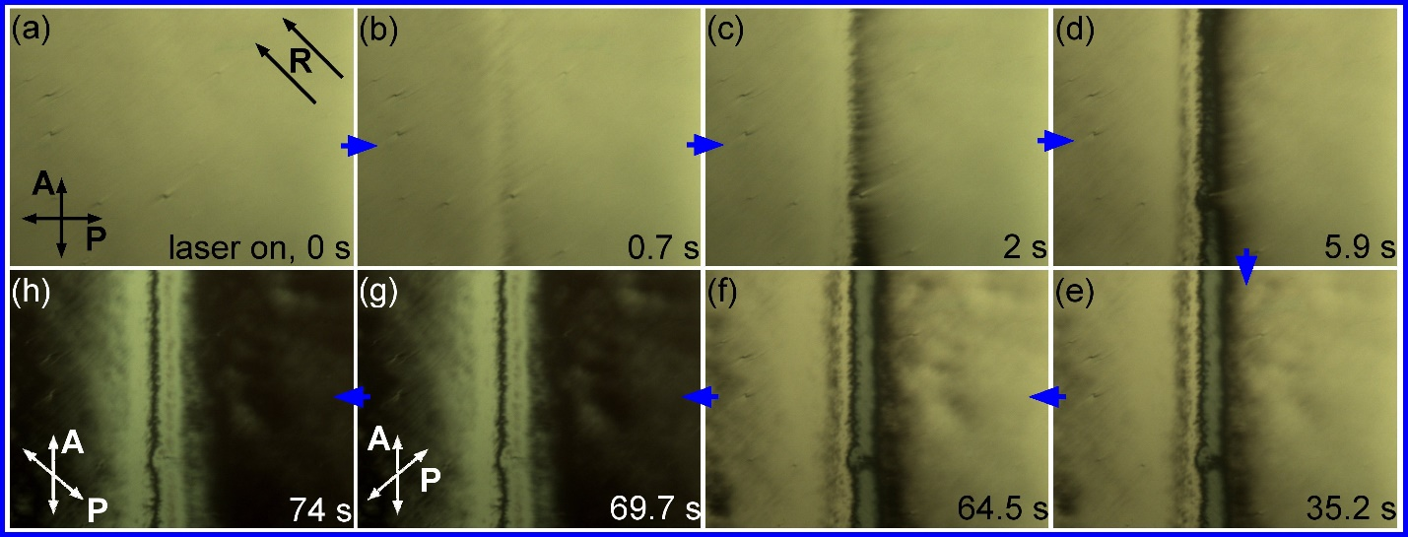
Figure S2 | Time evolution of P=90 mW laser line induced pattern in parallel rubbed LC cell enclosing 45º with rubbing direction, R. The elapsed times from the start of the illumination, the directions of the polarizer P and analyzer A, and the rubbing directions (R) on the two substrates are indicated. Each picture represents 1350 μm × 1050 μm area.

Supplementary note 3:

Example of helicity flipping after the laser is switched off
Figure S3 shows an example of light-induced N_{F} domain nucleation with opposite twist helicity that often happens (especially at low P values) when the laser light is switched off.

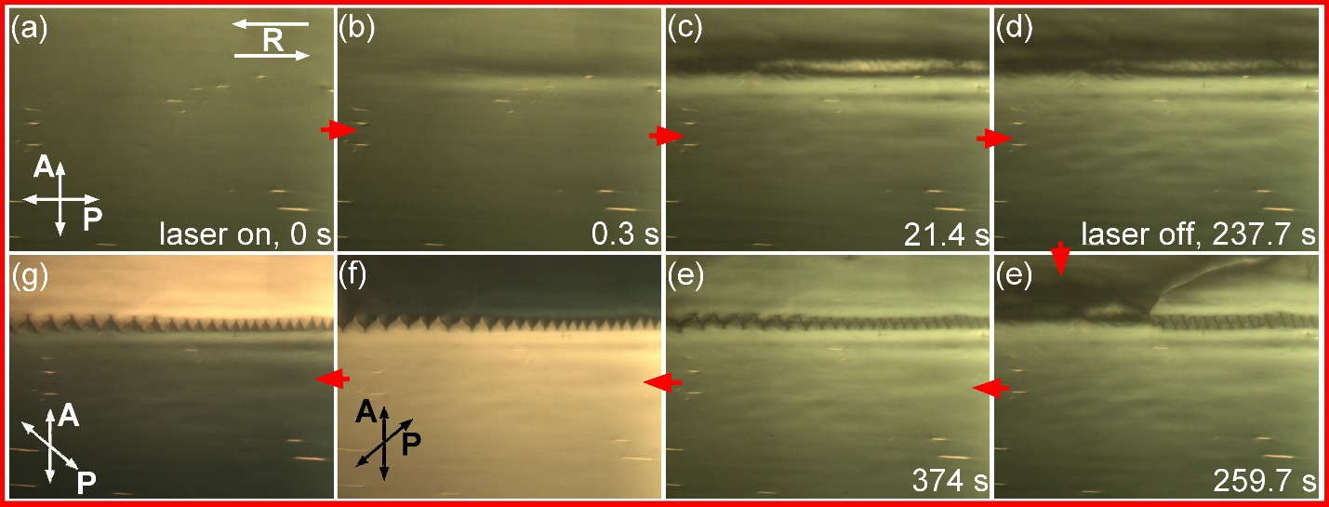
Figure S3 | An example of N_{F} domain nucleation after a P=90 mW laser line parallel with R is switched off. (a) - (e): Time evolution of the light-induced horizontal serrated domain wall. The elapsed times from the start of the illumination, the end of illumination, the directions of the polarizer P and analyzer A, and the rubbing directions (R) on the two substrates are indicated. (f) - (g): Illustration of the difference between two N_{F} domains a few minutes after the light-induced nucleation with uncrossed polarizer and analyzer. Each picture represents 1350 μm × 1050 μm area.

Supplementary note 4:

Laser line in antiparallel rubbed cell at 45º with the rubbing direction
Figure S4 shows static photo-induced patterns, like those shown in Fig. 2(b), appeared when the rubbing directions R at the bounding plates are a 45º with the (horizontal) laser line. No serrated N_{F} domain forms upon successive switching off and on the laser light.

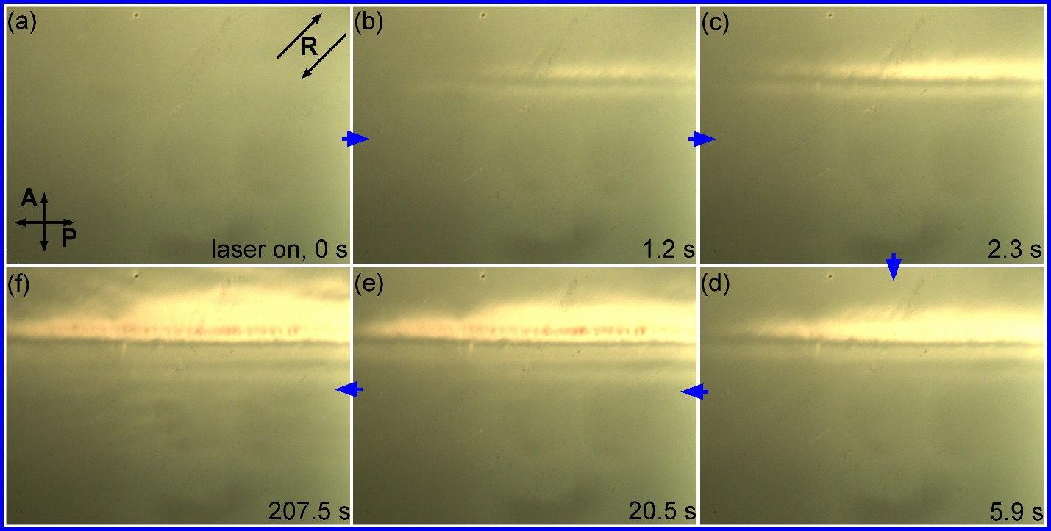
Figure S4 | Time evolution of P=90 mW laser line-induced pattern in antiparallel rubbed cell enclosing 45º with rubbing direction. The elapsed times from the start of the illumination, the directions of the polarizer P and analyzer A, and the rubbing directions (R) on the two substrates are indicated. Each picture represents 1350 μm × 1050 μm area.

Supplementary note 5:

Complex structures
Since in the N_{F} phase, the photo-induced patterns stay after switching the laser light off, it is possible to combine these patterns and study their interaction. An example is shown in Figure S5 after the sample with the serrated domain wall obtained from the experiment shown in Fig. 2(a) has been rotated anticlockwise by 90º, so that the serrated domain wall (and R) became horizontal, and the vertical laser line has been reapplied. Apparently, the original serrated domain wall is not influenced significantly by the new light-induced pattern.

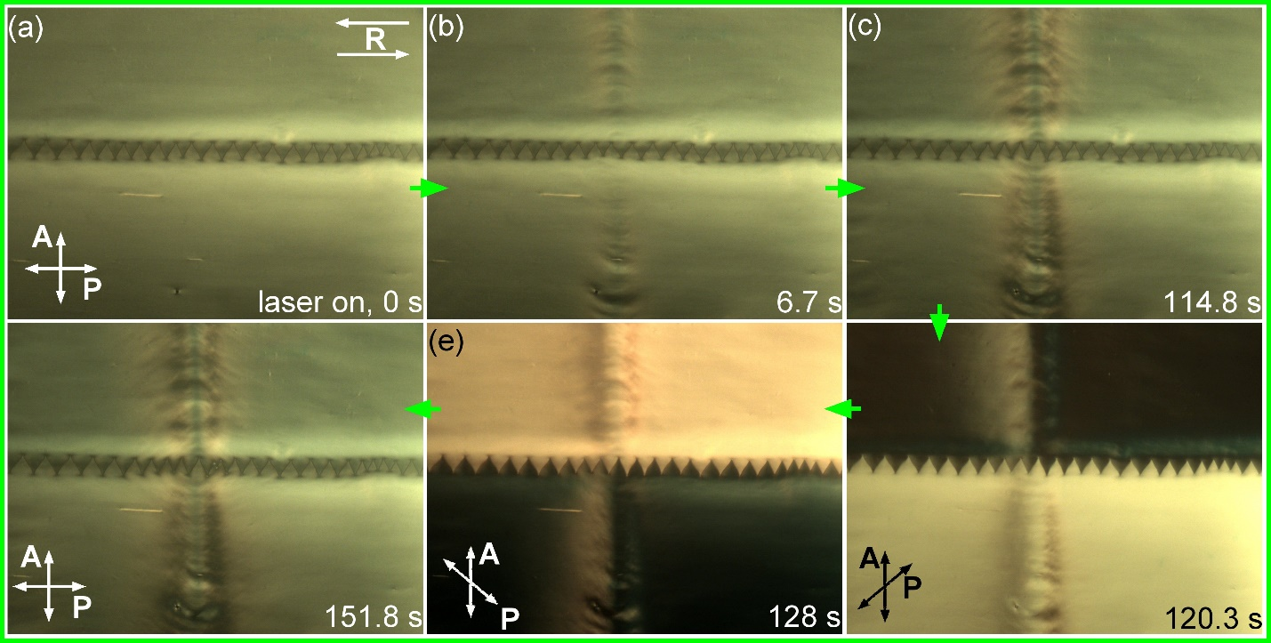
Figure S5 | An example for the time evolution of complex structure induced by a P=90 mW laser line perpendicular to R in the N_{F} phase. The sample was rotated counterclockwise after finishing the experiment shown in Fig. 2(a). The elapsed times from the start of the illumination, the directions of the polarizer P and analyzer A, and the rubbing direction (R) are indicated. Each picture represents 1350 μm × 1050 μm area.

Supplementary note 6:

The light-induced helicity flipping
As Fig. 4(b) indicates, the asymmetric pattern grows in the opposite direction in the two N_{F} domains having the opposite initial helicity. In both cases, within the growing pattern, the direction of the spontaneous polarization P_{o} (and the twist handedness) is inverted compared to P_{o} (and handedness) of the N_{F} domain before the illumination. The results presented in Figure S6 verify this observation. The light-induced N_{F} domain growing to the right (Figure S6(a-c)) has obviously the opposite helicity than that growing to the left (Figure S6(d-f)). Note that the initial helicity of the two N_{F} domains before the illumination is also the opposite in Figure S6(a-c) and Figure S6(d-f), similarly as shown in Fig. 4(b).

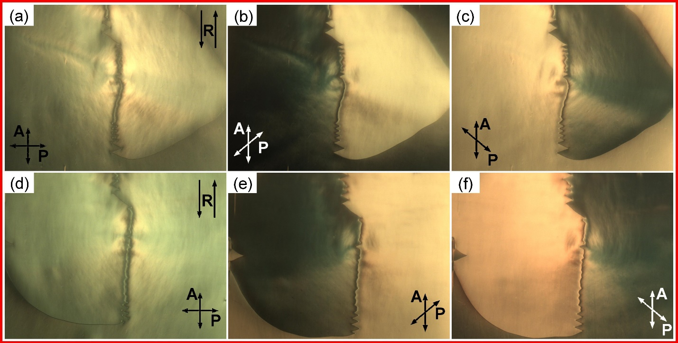
Figure S6 | Illustration of twist handedness in two tongue-like domains growing in the opposite directions. Developed photo-induced tongue-like patterns within two different N_{F} domains (as shown in Fig. 4(b)) under crossed and uncrossed polarizer P and analyzer A as indicated. Each picture represents 1350 μm × 1050 μm area.

Supplementary note 7:

The importance of the absorbing layer
In areas without absorbing ITO coating, illuminations up to P=90 mW do not have any effect on the N_{F} layer. This is demonstrated in Figure S7 for P=10 mW laser power. The pictures are taken under crossed polarizers, near the edge of the electrodes (marked with the yellow vertical line in Figure S7(a)). The illumination starts at t=0 s in the area without any ITO coating, in which the LC director in the N_{F} phase of DIO is unoriented (right-hand side of (a) and (b)). Nothing happens until t=30 s after illumination, when the sample (under illumination) has been started to translate slowly to the right. The trace of the translation can be seen in (c) when the laser beam enters the area with two ITO layers. The translation has been stopped at the location indicated by the white circle in (c) for about two seconds. During that time a drop-shaped domain nucleated (d), and then translated further to the final position. At that position, another drop-shaped domain has nucleated and started to grow (e). The growth of this domain started to suppress the first one (f), which has finally disappeared. Such shrinkage and disappearance of a nucleated domain was not observable for an isolated domain after the light was switched off. Presumably, it is caused by the stabilizing effect of the second domain (the right-hand side area of the domain growing to the left).

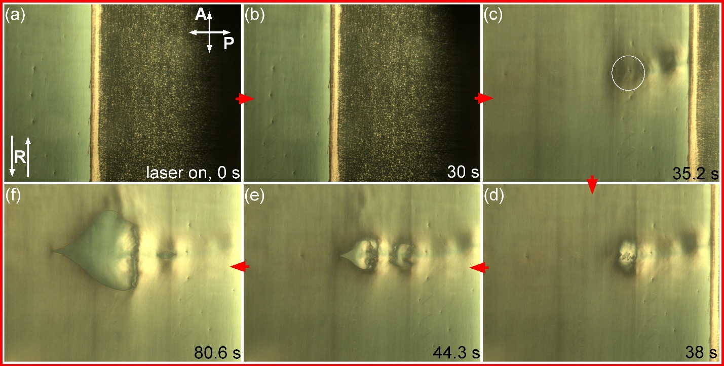
Figure S7 | Illustrating the importance of the absorbing layer. Time series of snapshots made near the electrode edges. The illumination started in the area without any ITO layer, and the sample was moved to the right. For details see the text. Each picture represents 1350 μm × 1050 μm area.

Supplementary note 8:

Photo-thermal effect
Let us consider a Gaussian laser beam passing through the sample and is partially absorbed in the indium-tin-oxide (ITO) layers, in contact with the liquid crystal film.
The temperature at the outer surface of the substrates is supposed to be the temperature set by the furnace, $T_{f}$. The intensity distribution of the laser beam is either
$I\left(r\right)=\frac{P}{r_{0}^{2}π} e^{-{r^{2}}/{r_{0}^{2}}}$ (Gaussian beam),
or
$I(x,y)=\left\{\begin{aligned}\frac{P}{r_{0}L\sqrt{π}}.e^{-x^{2}/r_{0}^{2}} \text{i}\text{f} \left|y\right|<L/2 \\ 0 \text{if} \left|y\right|≥L/2\end{aligned}\right.$ (laser line),
where P is the laser power, $r_{0}$is the radius of the beam, L is the length of the laser line along the y-axis, and x is the distance perpendicular to the laser line. $FWHM=2\sqrt{\ln{2}}r_{0}=1.67r_{0}$.
The absorption takes place in the tin-oxide layers. As the liquid crystal layer is very thin compared to the glass substrates, one can assume for the heat production, Q
$$Q=IAδ(z)$$
where A is the total attenuation of the laser beam due to absorption, $δ(z)$ is the Dirac delta function.
The temperature rise $ΔT$ for a steady state can be computed from the heat conduction equation
$κΔT+Q\left(r\right)=0$,
where κ is the heat conductivity. As the liquid crystal layer is very thin compared to the laser spot size $r_{0}$ and the cell thickness (including the glass substrates) l, we can identify κ with the heat conductivity of the glass (1.2 W/m K).
The temperature rise was calculated using the Green-function technique ¹. Examples of the results of the calculation are shown in Figure S8. To approximate the experimental conditions the following parameters were taken: cell thickness of l=2.2 mm; P=2 mW for the Gaussian beam, and P=79 mW for the L=3.5 mm long laser line, while r₀=0.1 mm (FWHM=0.167 mm) for the Gaussian beam, and r₀=0.05 mm (FWHM=0.084 mm) for the laser line.
As can be seen in Figure S8, the laser-induced temperature rise is of the order of a few ºC, while the temperature gradient is up to ~10 ºC/mm at the distance of r₀ from the centre of the laser, for both the Gaussian beam and laser line. Calculations have also shown that the light-induced temperature rise is established within a second, i.e., considering the time scale of the reorientation, the thermal steady state is established almost instantaneously.

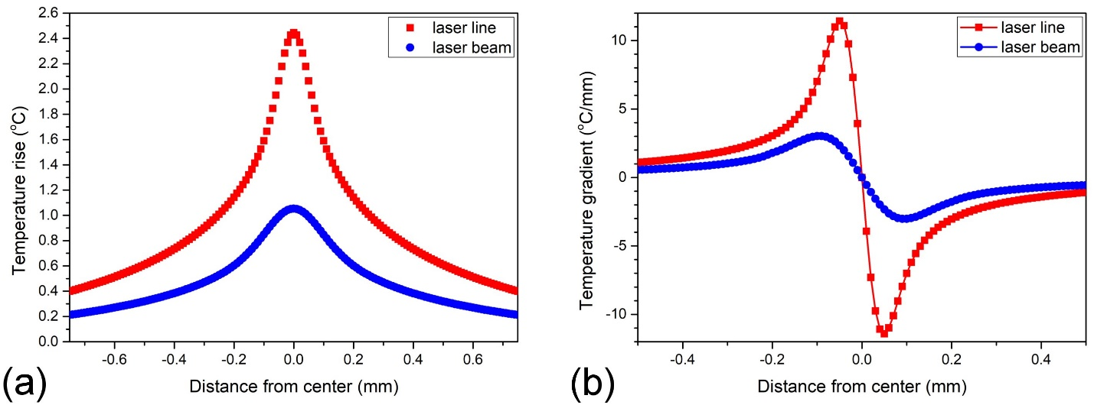
Figure S8 | Photo-thermal effect. Laser-induced temperature rise (a) and temperature gradient (b) calculated for the Gaussian beam and laser line with parameters given in the text.

Supplementary note 9:

Experimental setup
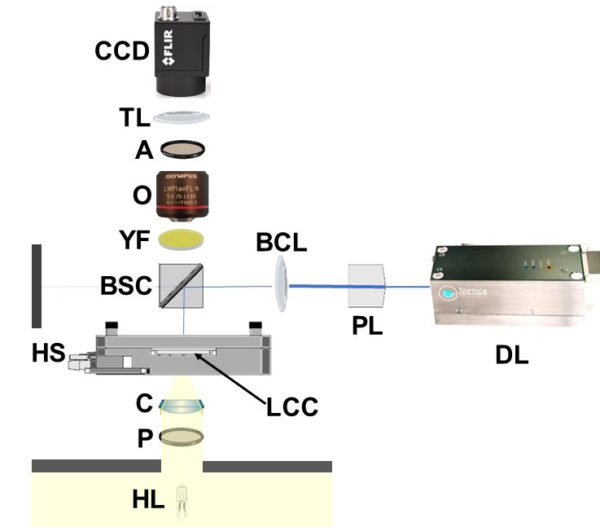

Figure S9 | The experimental setup for visualization of the laser light-induced patterns. DL: diode laser Toptica iBeam-Smart 445-S with variable light power from 0.1 mW to 100 mW at wavelength λ = 445nm; PL: Powell lens with fan angle of 1º (Laserline Optics, Canada), for producing a laser line (removed from the optical path when Gaussian laser beam is needed); BCL: biconvex lens to focus the laser light; HL: halogen lamp; P: polarizer; C: condenser; HS: hot stage (Instec HCS402, regulated by Instec mK2000 controller); LCC: liquid crystal cell; BSC: beam-splitter cube (90% : 10%); YF: yellow color filter, to filter out the scattered laser light; O: objective (5×); A: analyzer; TL: tube lens; CCD: CCD camera (Flir BFS-U3-32S4C-C). HL, P, C, O, A, and TL are the integral parts of the polarizing optical microscope (POM) Olympus BX50.

Supplementary References
1 H.S. Carslaw, J.C. Jaeger, Conduction of Heat in Solids (Oxford Press, 1959), Chapter XIV.

