Unravelling drivers of the future Mediterranean precipitation paradox during cyclones

Supplementary information
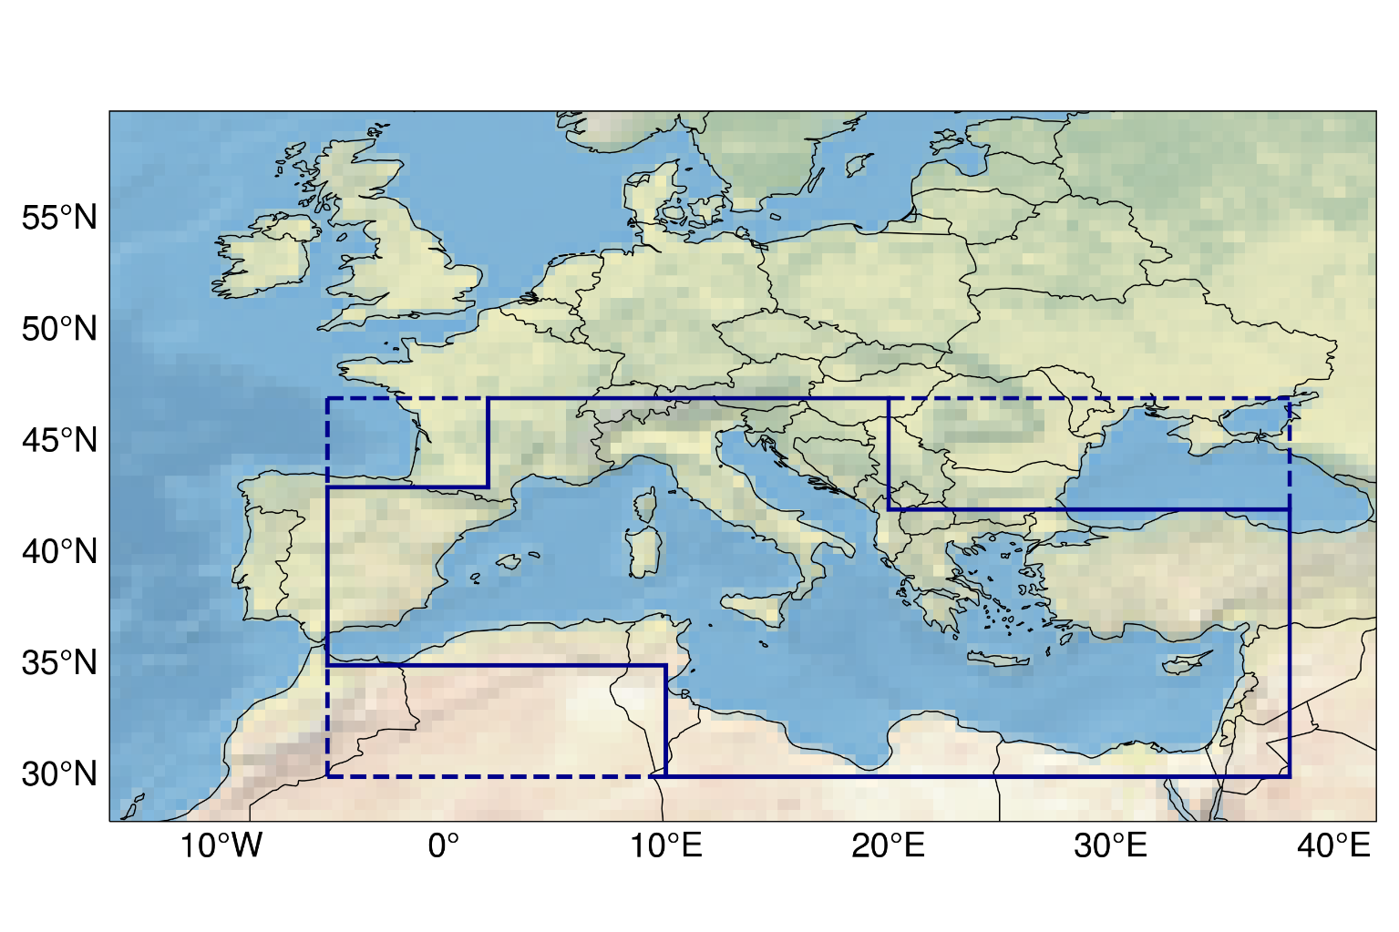
Figure S1: Med-CORDEX domain. Cyclones are retained if their minimum SLP tracking point is present within the area outlined by solid lines. The atmospheric fields are computed within the rectangular area outlined by dashed lines.
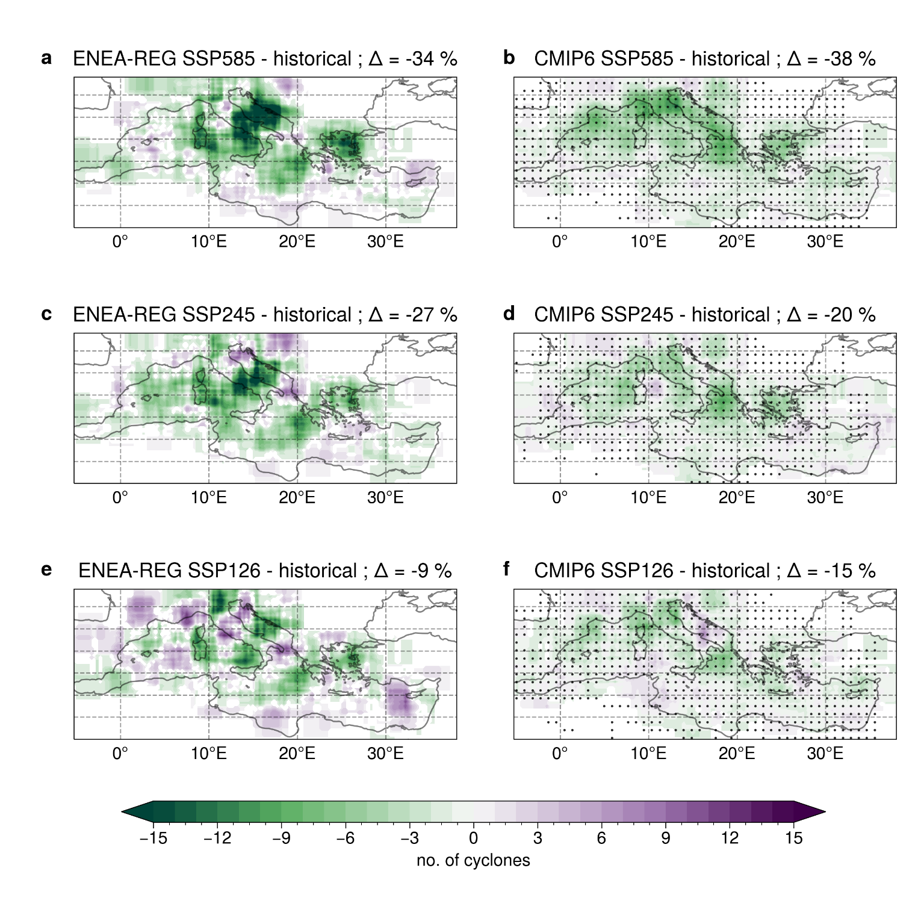
Figure S2: Changes in spatial distribution of intense Mediterranean cyclones. Maps of the differences in the number of occurrences of cyclone centre densities (CCD) between the far future (2071-2100) and the historical period (1985-2014) for SSP 5-8.5, 2-4.5 and 1-2.6 scenarios. Results are shown for the ONDJFM cold season in ENEA-REG (panels a, c, e) and the CMIP6 ensemble (panels b, d, f). To highlight the cyclones’ area of influence, each centre is represented by a square area with a side length of 3 degrees centred in the tracked minimum SLP point. ∆ values represent the percentage of the change in total number of CCD between the far-future and the historical. Black points on the CMIP6 maps indicate areas where at least four out of six models (i.e., more than 50%) agree on the sign of the difference.
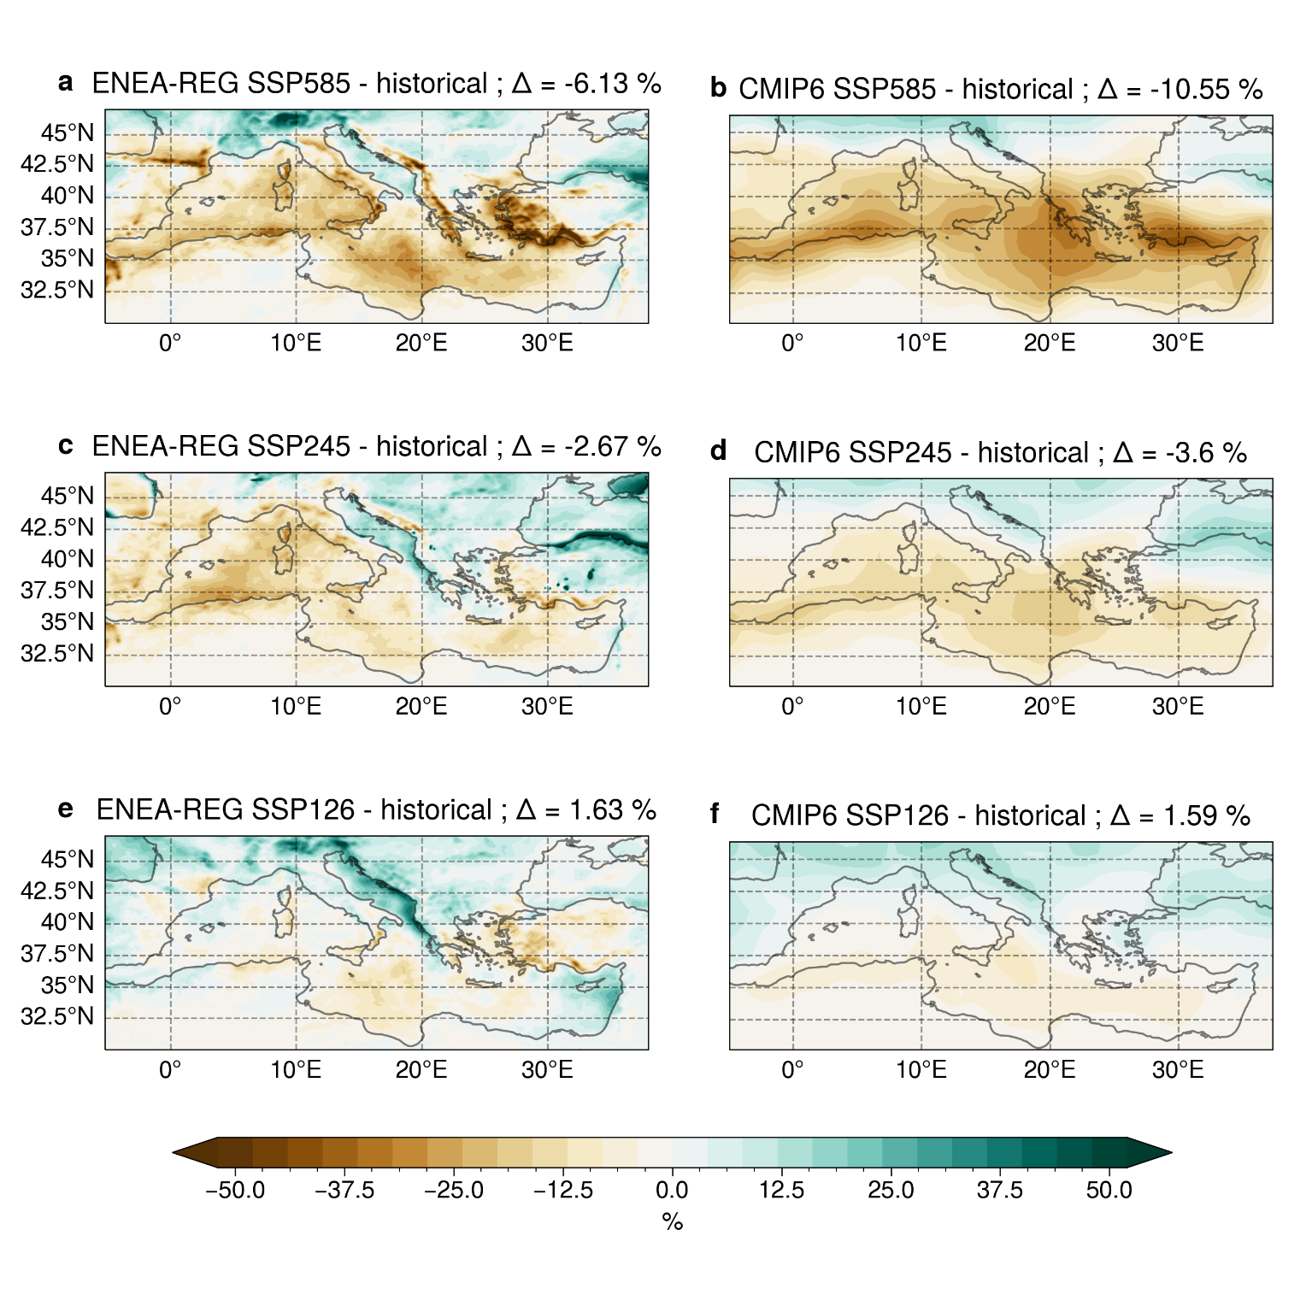
Figure S3: Seasonal precipitation changes. Maps of the differences in seasonal precipitation between the far future (2071-2100) and the historical period (1985-2014) for SSP 5-8.5, 2-4.5 and 1-2.6 scenarios. Results are shown for the ONDJFM cold season in ENEA-REG (panels a, c, e) and the CMIP6 ensemble (panels b, d, f). The differences are normalized by the historical mean value of precipitation. ∆ values represent the domain average of the differences.
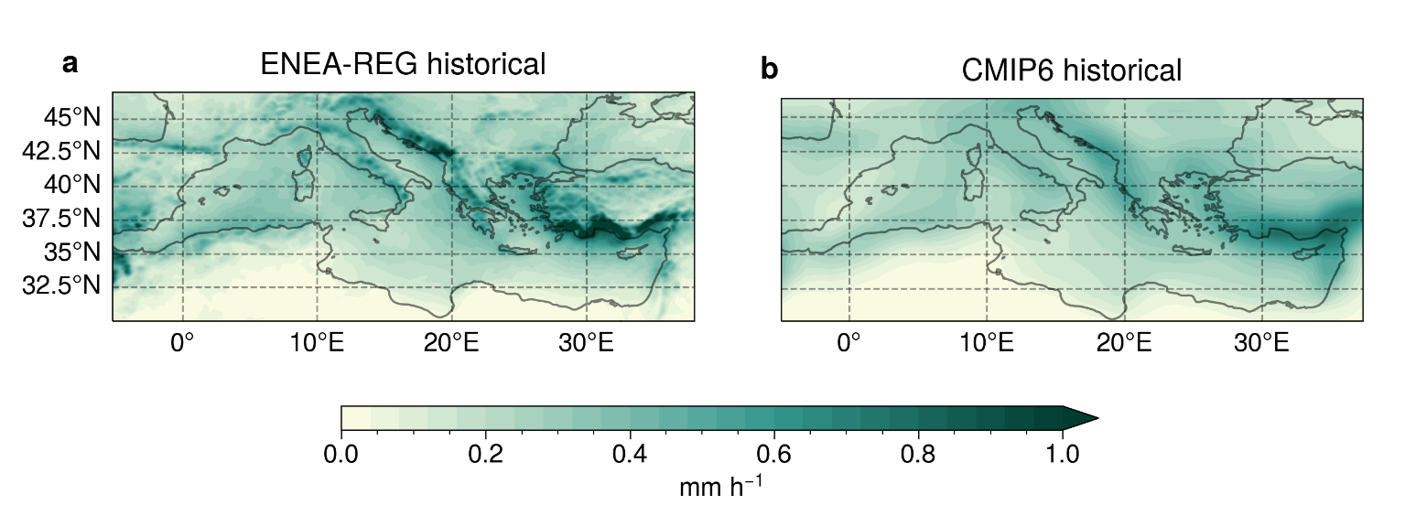
Figure S4: Cyclone-related precipitation. Maps of the precipitation associated with intense Mediterranean cyclones in the historical period. Results are shown for the ONDJFM cold season in ENEA-REG (a) and the CMIP6 ensemble (b).
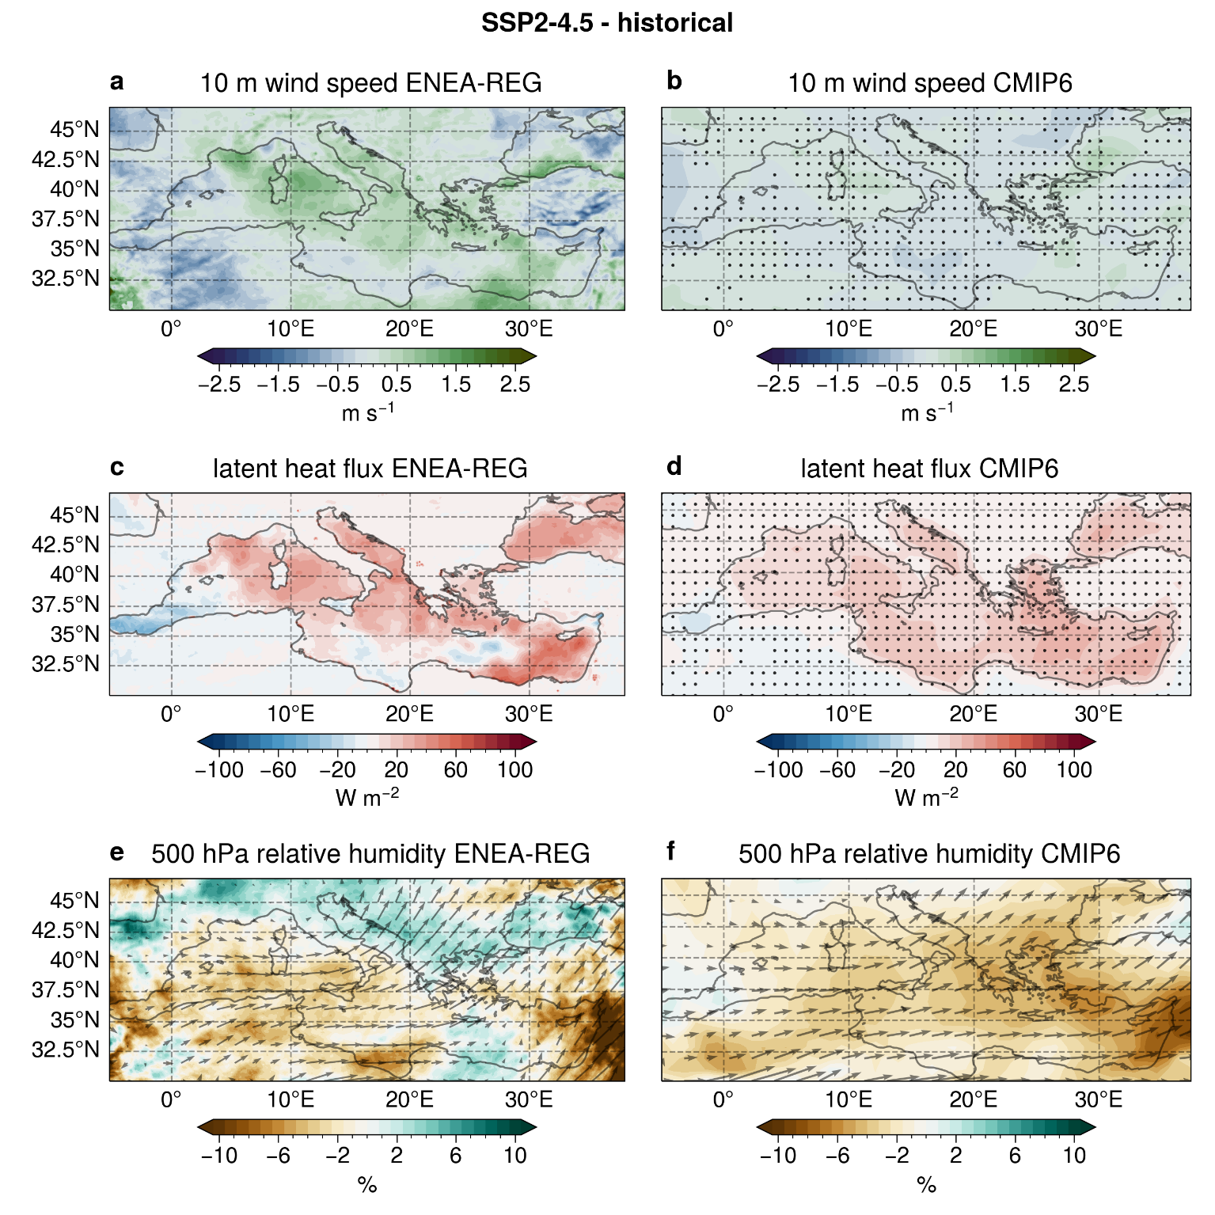
Figure S5: Cyclone-related atmospheric field changes for SSP 2-4.5. Same as Figure 3, but for SSP2-4.5
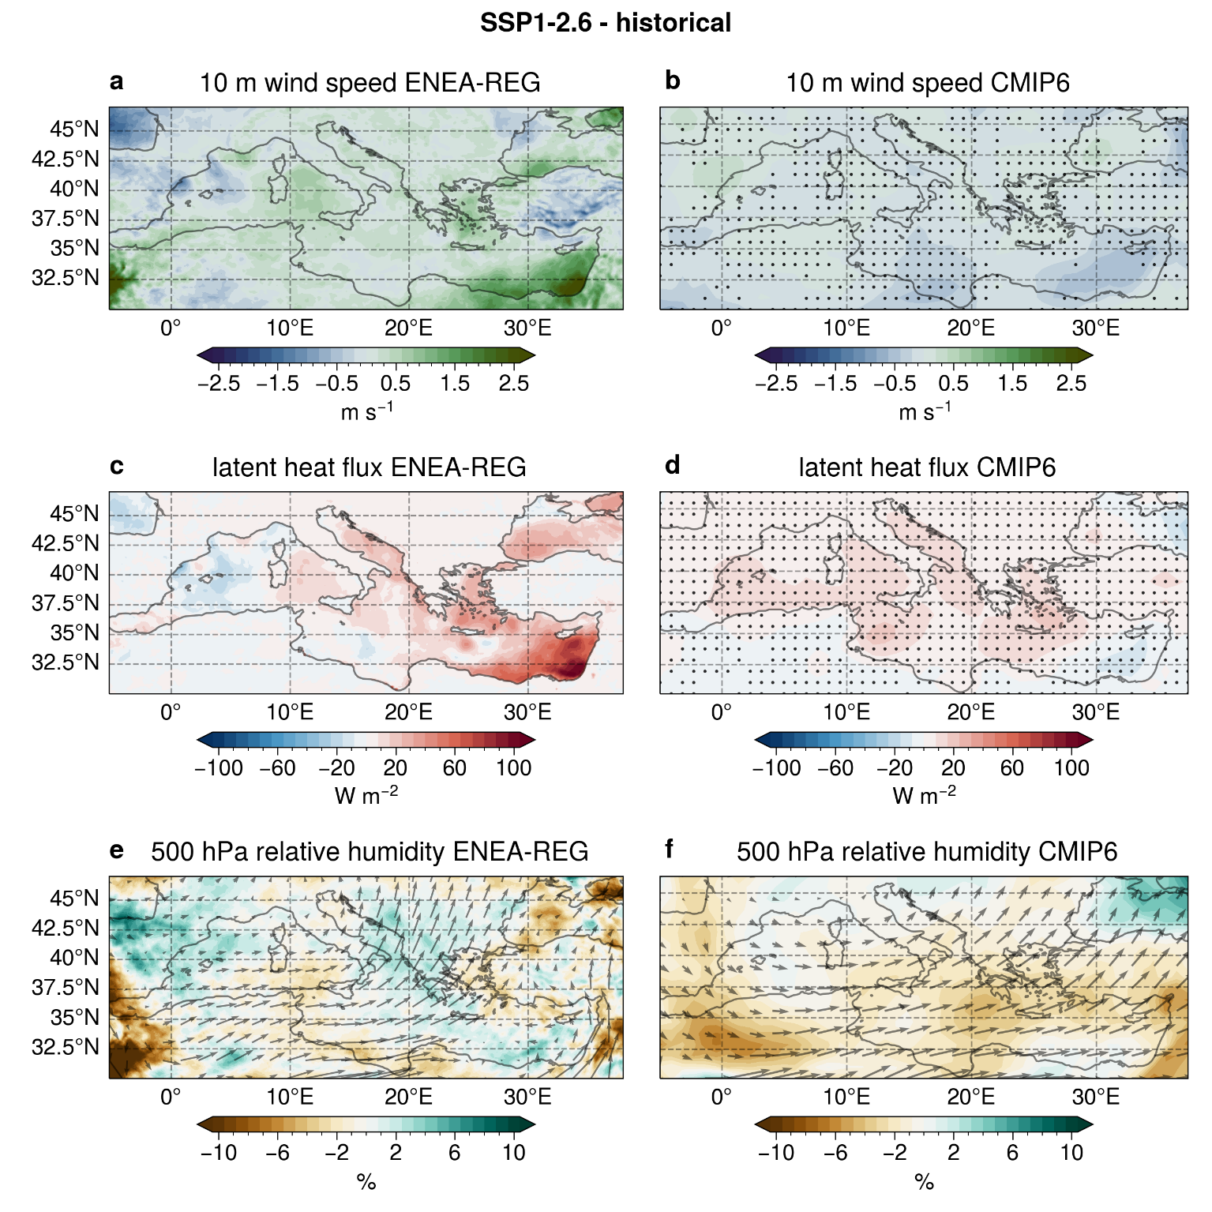
Figure S6: Cyclone-related atmospheric field changes for SSP 1-2.6. Same as Figure 3, but for SSP1-2.6

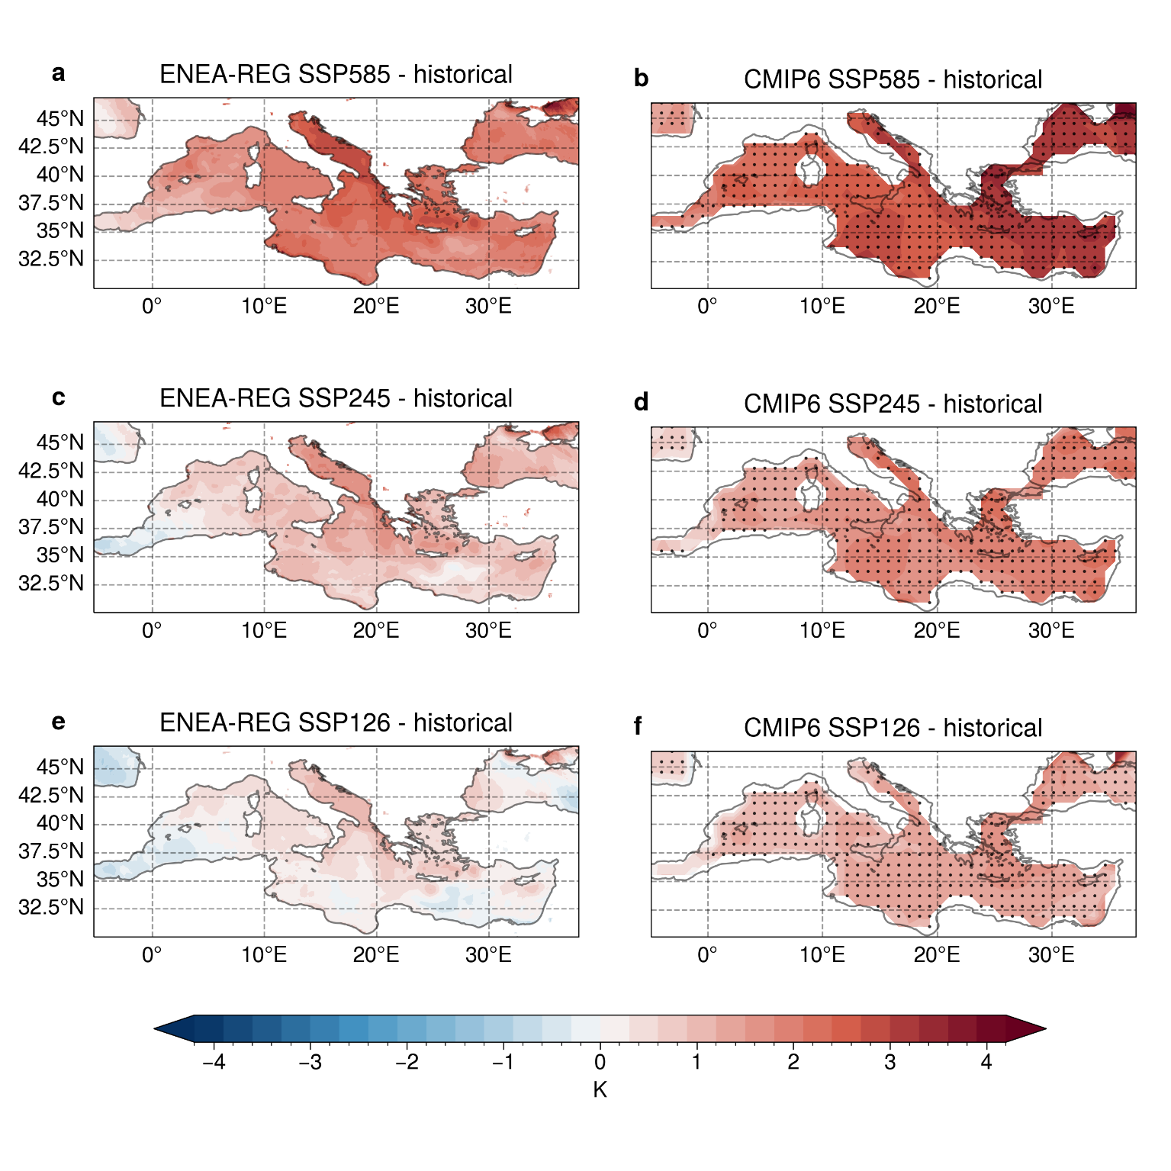
Figure S7: Cyclone-related Sea Surface Temperature (SST) changes. Maps of the differences in SST associated with intense Mediterranean cyclones between the far future (2071-2100) and the historical period (1985-2014) for SSP 5-8.5, 2-4.5 and 1-2.6 scenarios. Results are shown for the ONDJFM cold season in ENEA-REG (panels a, c, e) and the CMIP6 ensemble (panels b, d, f). Black points on the CMIP6 maps indicate areas where at least four out of six models (i.e., more than 50%) agree on the sign of the difference.

Models validation
The ENEA-REG model and the ensemble of CMIP6 models are validated against ERA5 reanalysis to assess their ability in reproducing the seasonal cycle (Fig. S8) and spatial distribution (Fig. S9) of intense Mediterranean cyclones during the historical period (1985-2014). Additionally, these models are compared to an ensemble of seven high-resolution (~30 km) CMIP6 models (CMIP6-HR, see table 1 in methods) to investigate the benefits of higher resolution in capturing cyclone characteristics. To note that the analysis is restricted to the cyclones’ climatology, while a full evaluation of ENEA-REG against ERA5 has already been performed by Anav et al. (2024).
The CMIP6-HR ensemble more accurately reproduces the seasonal cycle (red line, Fig. S8) compared to coarser resolution (~100 km) CMIP6 models (black line, Fig. S8), showing a higher number of intense cyclones thanks to a resolution closer to ERA5. Similarly, ENEA-REG performs well, accurately reproducing the total number of cyclones, despite higher occurrences in spring. The spatial distribution of cyclones (Fig. S9) is assessed using cyclone centre densities (CCD), following the methodology of Flaounas et al. (2018) and Neu et al. (2013). The CCD is defined as the absolute number of cyclone occurrences, with each cyclone centre represented by a square area with a side length of 3 degrees around the tracked minimum sea-level pressure (SLP) point. Compared to ERA5, all models capture the main regions of frequent cyclogenesis, such as the gulf of Genoa, the Adriatic, the Aegean and the Levantine Seas. High-resolution models, including CMIP6-HR and ENEA-REG, show better alignment with ERA5 reanalysis in representing CCD, highlighting the importance of higher resolution for accurately simulating cyclone activity in the Mediterranean. Nonetheless, all models tend to underestimate CCD over the Mediterranean Sea while overestimating it over land. Cyclones seasonality and location depend on a combination of large-scale baroclinic forcing and diabatic processes linked to convection within cyclone systems (Flaounas et al., 2021, 2022). Thus, differences between the models and ERA5 primarily arise from the different resolution, dynamics and physical parameterisations, which affect how models simulate these processes. Indeed, the magnitude of these discrepancies is consistent with findings from previous studies (Chericoni et al., 2024; Flaounas et al., 2018; Reale et al., 2022). Overall, the results confirm the reliability of both ENEA-REG and the CMIP6 model ensembles for studying future Mediterranean cyclone activity.

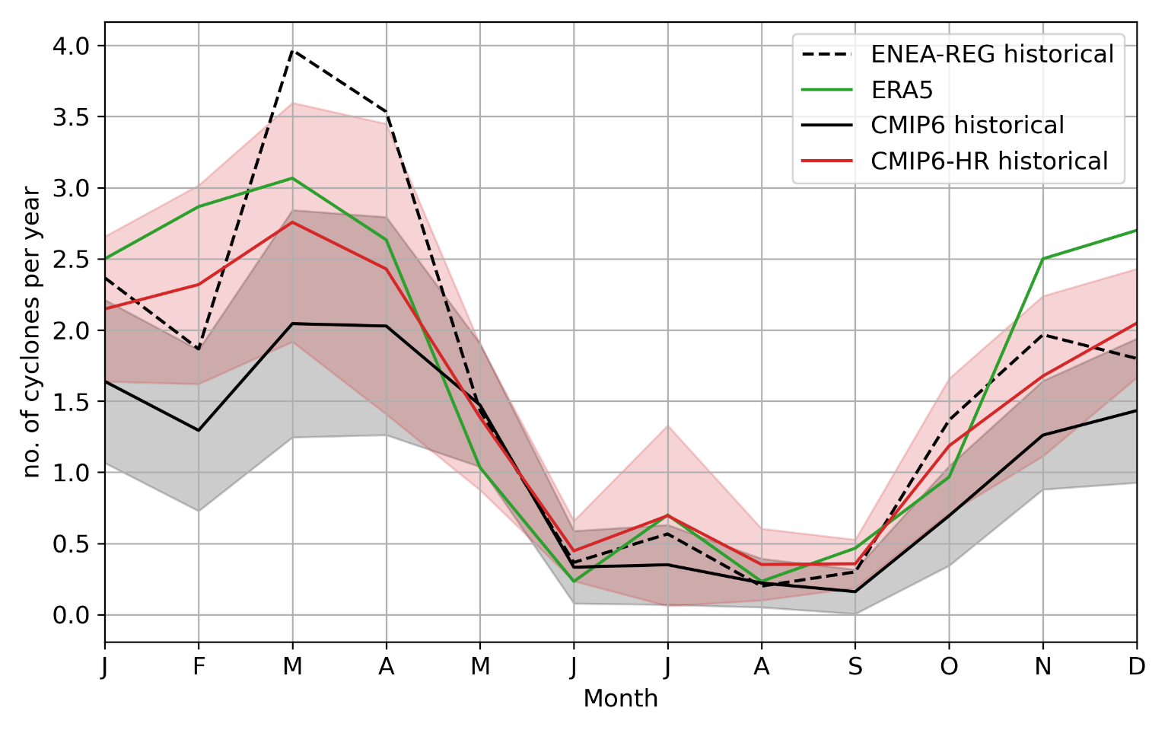
Figure S8: Seasonal cycle of intense Mediterranean cyclones. Seasonal cycle of intense Mediterranean cyclones in the historical period (1985-2014). Results are shown for ERA5 (green line), ENEA-REG (dashed black line), CMIP6-HR ensemble (red line) and CMIP6 ensemble (solid black line). The colour bands represent the confidence interval of 1 standard deviation for the CMIP6 (black) and the CMIP6-HR (red) ensemble.
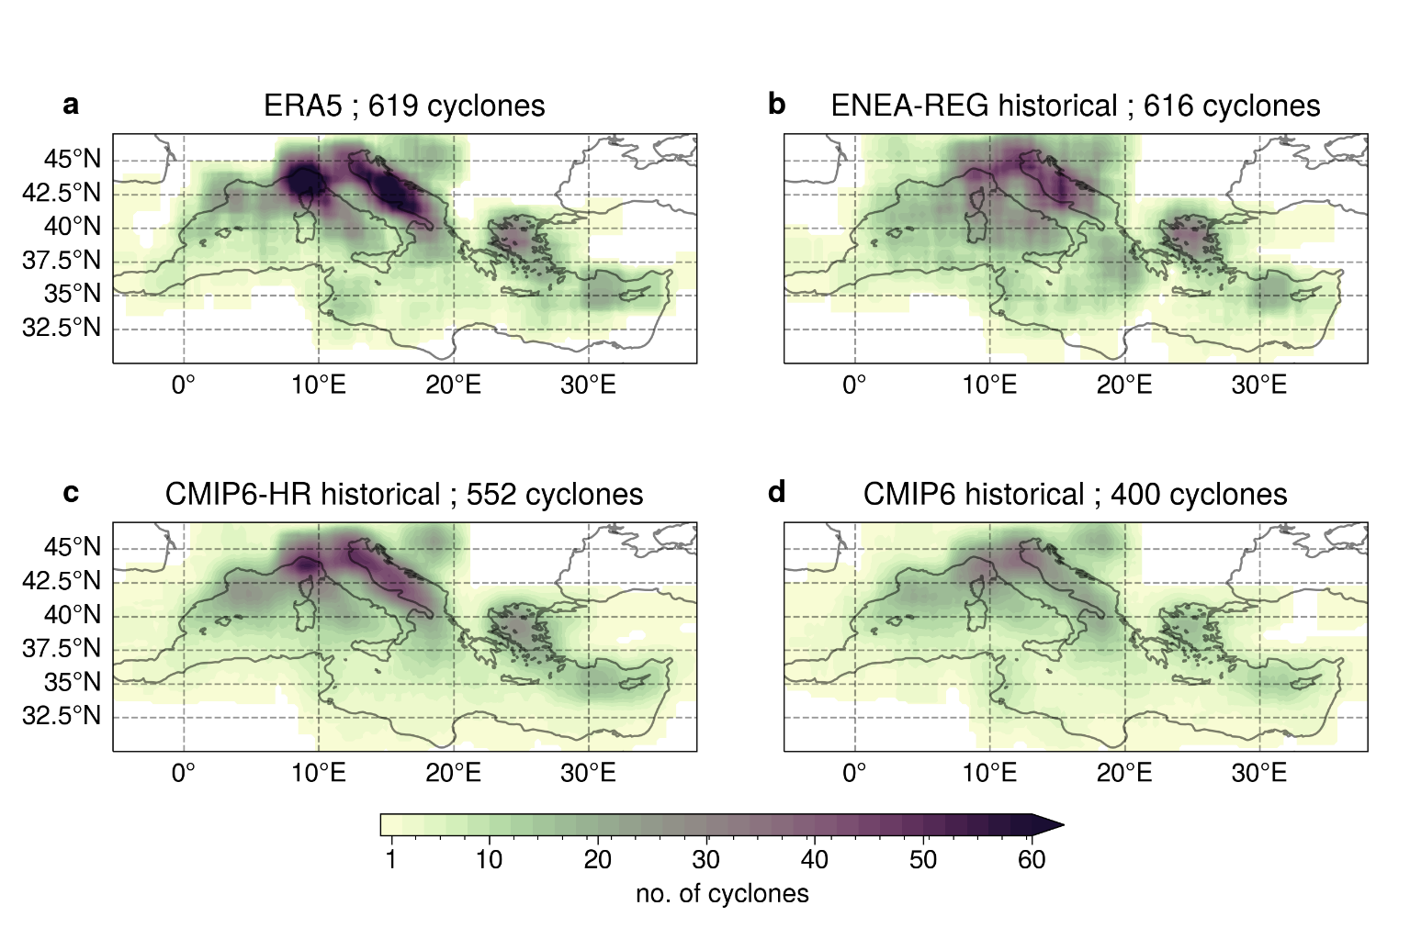
Figure S9: Spatial distribution of intense Mediterranean cyclones. Number of occurrences of cyclone centre densities (CCD) for the intense Mediterranean cyclones in the historical period (1985-2014). Results are shown for ERA5 (a), ENEA-REG (b), CMIP6-HR ensemble (c) and CMIP6 ensemble (d). To highlight the cyclones’ area of influence, each centre is represented by a square area with a side length of 3 degrees around the tracked minimum SLP point.

References
Anav, A., Antonelli, M., Calmanti, S., Carillo, A., Catalano, F., Dell’Aquila, A., Iacono, R., Marullo, S., Napolitano, E., Palma, M., Pisacane, G., Sannino, G., and Struglia, M. V.: Dynamical downscaling of CMIP6 scenarios with ENEA-REG: an impact-oriented application for the Med-CORDEX region, Clim Dyn, https://doi.org/10.1007/s00382-023-07064-3, 2024.
Chericoni, M., Fosser, G., Flaounas, E., Sannino, G., and Anav, A.: Extreme Mediterranean cyclones and associated variables in an atmosphere-only vs an ocean-coupled regional model, https://doi.org/10.5194/egusphere-2024-2829, 27 September 2024.
Flaounas, E., Kelemen, F. D., Wernli, H., Gaertner, M. A., Reale, M., Sanchez-Gomez, E., Lionello, P., Calmanti, S., Podrascanin, Z., Somot, S., Akhtar, N., Romera, R., and Conte, D.: Assessment of an ensemble of ocean–atmosphere coupled and uncoupled regional climate models to reproduce the climatology of Mediterranean cyclones, Clim Dyn, 51, 1023–1040, https://doi.org/10.1007/s00382-016-3398-7, 2018.
Flaounas, E., Gray, S. L., and Teubler, F.: A process-based anatomy of Mediterranean cyclones: from baroclinic lows to tropical-like systems, Weather and Climate Dynamics, 2, 255–279, https://doi.org/10.5194/wcd-2-255-2021, 2021.
Flaounas, E., Davolio, S., Raveh-Rubin, S., Pantillon, F., Miglietta, M. M., Gaertner, M. A., Hatzaki, M., Homar, V., Khodayar, S., Korres, G., Kotroni, V., Kushta, J., Reale, M., and Ricard, D.: Mediterranean cyclones: current knowledge and open questions on dynamics, prediction, climatology and impacts, https://doi.org/10.5194/wcd-3-173-2022, 2022.
Neu, U., Akperov, M. G., Bellenbaum, N., Benestad, R., Blender, R., Caballero, R., Cocozza, A., Dacre, H. F., Feng, Y., Fraedrich, K., Grieger, J., Gulev, S., Hanley, J., Hewson, T., Inatsu, M., Keay, K., Kew, S. F., Kindem, I., Leckebusch, G. C., Liberato, M. L. R., Lionello, P., Mokhov, I. I., Pinto, J. G., Raible, C. C., Reale, M., Rudeva, I., Schuster, M., Simmonds, I., Sinclair, M., Sprenger, M., Tilinina, N. D., Trigo, I. F., Ulbrich, S., Ulbrich, U., Wang, X. L., and Wernli, H.: IMILAST: A Community Effort to Intercompare Extratropical Cyclone Detection and Tracking Algorithms, Bull Am Meteorol Soc, 94, 529–547, https://doi.org/10.1175/BAMS-D-11-00154.1, 2013.
Reale, M., Cabos Narvaez, W. D., Cavicchia, L., Conte, D., Coppola, E., Flaounas, E., Giorgi, F., Gualdi, S., Hochman, A., Li, L., Lionello, P., Podrascanin, Z., Salon, S., Sanchez-Gomez, E., Scoccimarro, E., Sein, D. V., and Somot, S.: Future projections of Mediterranean cyclone characteristics using the Med-CORDEX ensemble of coupled regional climate system models, Clim Dyn, 58, 2501–2524, https://doi.org/10.1007/s00382-021-06018-x, 2022.

