Supplementary Information for

Endogenic mantle-driven orogenic evolution: Slab rollback dynamics as the architect of retreating accretionary systems

Xing Cui et al.

*Corresponding author: Guochun Zhao, gzhao@hku.hk

This PDF file includes:

Sections S1 to S5
Figs. S1 to S9
Tables S4 and S5
References

(Supplementary tables S1-S3 are in a separate Excel file)

S1. Sedimentary phases analysis and detrital zircon age patterns of the Altai Zone

The oldest sedimentary units in the Hovd Zone are the Lower Paleozoic Bij Group (metamorphosed equivalent of the Zuunnuruu Formation) and the Zuunnuruu, Tsetseg, and Sagsai formations, which are composed of volcano-sedimentary and siliciclastic rocks and carbonate sequences¹ (Fig. S2). The rhythmically interbedded siltstones and greywackes transition upward into well-sorted quartz sandstones, intercalated with basic pillow lavas². Detrital zircon spectra from the Zuunnuruu Formation and Bij Group (Fig. S3a) show primary age populations at ca. 520–500 Ma, with minor clusters between 1.0 Ga and 700 Ma and scattered small peaks between 3.0 and 1.0 Ga. The youngest detrital zircon ages (ca. 520–438 Ma; Table S1) and a ca. 462 Ma rhyolite interbed constrain their deposition from the Cambrian to early Silurian.
The deepest sedimentary sequences in the Mongolian and Chinese Altai are thick flysch deposits of sandstone and slate (Fig. S2). In the Mongolian Altai, the Tugrug Formation exhibits alternating sandstone, graywacke, shale, and slate/schist, preserving sedimentary bedding or displaying greenschist-facies metamorphism with penetrative foliation^{3–5}. Whole-rock geochemistry and zircon U-Pb-Hf isotopes for the metasedimentary samples and volcanogenic rocks from this sequence show their deposition proximal to arc-related igneous rocks^{3,5}. Zircon dating reveals predominant Cambro-Ordovician ages (ca. 540–460 Ma) and minor Neoproterozoic clusters (1000–600 Ma; Fig. S3b). The youngest zircon ages from these flysch sequences (ca. 470–438 Ma; Table S1) suggest deposition between the Ordovician and early Silurian. The Tugrug Formation extends into the Chinese Altai region as the Habahe Group, featuring sandstone-siltstone-shale assemblages with localized limestone, metamorphosed from sub-greenschist to amphibolite facies^{6,7}. The geochemical signatures suggest their deposition at an active continental margin with low maturity^{6,8}. Zircon U-Pb ages from Habahe sedimentary rocks mirror the Mongolian succession: predominant 550–460 Ma populations with minor Neoproterozoic ages and sparse Mesoproterozoic to Archean grains (Fig. S3c). Deposition of the Habahe Group spanned the Cambrian to early Silurian, bracketed by ca. 502 Ma (basal) and 443 Ma (upper) rhyolites (Table S1).
The Tsetseg Formation unconformably overlies the Zuunnuruu Formation in the Hovd Zone¹ (Fig. S2). The lower formation resembles the underlying Zuunnuruu Formation, dominated by tuffs, shales, greywackes, basaltic lavas, sandstones, and conglomerates intercalated with rhyolite and ignimbrite. The upper section develops as a flysch sequence with alternating layers of coarse- immature greywackes and fine-grained siltstones. The detrital zircon age spectra of two conglomerates from the Tsetseg Formation reveal a conspicuous peak at 470–465 Ma, with small numbers of ages at ca. 1.0–0.7 Ga and 2.2–1.4 Ga¹. The conformably overlying Sagsai Formation displays turbiditic siliciclastic sequences dominated by greywacke-siltstone-shale lithofacies¹ (Fig. S2). Compiled U-Pb zircon age data from this formation reveal main age peaks clustering between 540 and 390 Ma, with subordinate 1.5–0.75 Ga peaks (Fig. S3d). The youngest zircon ages of 394–360 Ma indicate deposition until the late Devonian (Table S1).
The thick early Paleozoic sequence in the Mongolian and Chinese Altai is overlain by Silurian and Devonian volcanic successions, referred to as the Kangbutiebao and Altay formations (Fig. S2). The Kangbutiebao Formation features felsic volcanics with minor mafic components, marine pyroclastics, and terrigenous clastic rocks⁷, with the interlayered volcanic rocks yielding zircon U-Pb ages of 410–375 Ma (Table S1). A mylonite from the Kangbutiebao Formation contains dominant Cambro-Ordovician zircons (545–471 Ma) and the youngest grain at ca. 429 Ma. The turbiditic sequence of the Altay Formation comprises schist-phyllite turbidites interbedded with meta-basalts showing back-arc basin geochemical signatures dated at ca. 380 Ma⁹. The detrital zircon age spectra from its sedimentary rocks reveal dominant 525–460 Ma populations, subordinate 900–700 Ma clusters, and rare > 1.1 Ga grains¹⁰ (Fig. S3e).

S2. Geochronological and geochemical data of magmatic rocks from the western Mongolia Collage

The granitoids in the Lake Zone span a wide age interval from ca. 551 to 440 Ma (Table S2). The earliest intrusive rocks dated at 551 ± 13 Ma are calc-alkaline diorite–tonalite–plagiogranite associations from the Three Hills massif, coeval with regional island-arc andesitic volcanic rocks (546 ± 3 Ma, ref.¹¹). The Cambrian volcanic rocks intercalated within the Baatar Formation in the Lake Zone show a bimodal signature². The basalts (No. 2 in Figs. 2 and S4) have subalkaline compositions, with relatively flat REE (rare-earth elements) distribution patterns and high Th contents and depletions in HFSE (high-field strength elements), as shown in the N-MORB-normalized spider diagram (Fig. S4). These characteristics strongly suggest a subduction-related formation environment, plotting into the volcanic-arc calc-alkaline or tholeiitic basalt fields (Fig. S4). The contemporaneous granitoids in this region (ca. 535–494 Ma; No. 1 in Fig. 2; Table S2) have calc-alkaline geochemical signatures and a characteristic enrichment in LILE (large-ion lithophile elements, including Li, Rb, K, Sr, and Pb), U, and Th relative to the HFSE (Nb and Ta), indicating origins from a magmatic arc in a subduction environment. The chemical compositions of these granitoids suggest heterogeneous sources across their distribution. The southern Zamtyn Nuruu Range orthogneiss (ca. 540 Ma) reveals the involvement of Mesoproterozoic Baydrag basement crust in the magma source with εNd(t) values of +2.5. Towards the west, the Khantaishir complex granitoids (ca. 516 Ma) have negative εNd(t) values of -0.6 and positive zircon εHf(t) values of +2.5 to +6.2, suggesting origins from remelting of the pre-existing juvenile meta-basic crust with recycling some older crustal rocks¹². Further north, the granitoids possess rather juvenile εNd(t) isotopic values of +6.5 to +7.9, suggesting the little involvement of old crustal materials (Table S2). Following the primary stage of arc magmatism, sporadic Ordovician to Silurian granitoids (ca. 465–441 Ma; Table S2) coincided with magmatic activity in the Hovd Zone (Fig. 2). The main rock types are calc-alkaline I-type granites, except for the Bayan Khairkhan Massif (No. 4 in Fig. 2), which has an alkaline composition and was associated with a phase of alkaline magmatism occurring between 470–440 Ma, which includes subalkaline and alkaline gabbro and granite, as well as nepheline syenite and granosyenite¹³. The Khaldzan-Buregtei massif¹¹ near the boundary of the Lake Zone and Hovd Zone indicates the emplacement of alkali rocks as young as Devonian (391 ± 2 Ma; No. 5 in Fig. 2), and was accompanied by coeval felsic-intermediate volcanic rocks¹⁴.
The oldest magmatic intrusions from the Hovd Zone are represented by ca. 476–467 Ma I-type granites¹⁵, coeval with the basaltic lava within the Zuunnuruu Formation (Fig. 2). Cambro-Ordovician mafic magmatism in the Gobi Altai region (SE extension of the Mongolian Altai) produced tholeiitic to low-K calc-alkaline basalts (No. 4, 7 in Figs. 2 and S4) characterized by slight LREE enrichment and significant Nb-Ta depletions, consistent with subduction-related arc basalts. The early Silurian (ca. 430 Ma) quartz monzodiorite from the Hovd Zone (No. 7 in Fig. 2) shows the alkaline composition and coincided with renewed basaltic magmatism and deposition of the Tsetseg Formation. Silurian-Devonian basalts from the Tsetseg and Sagsai formations (No. 5, 6 in Figs. 2 and S4) show LILE and LREE enrichment but no or slight HFSE depletion, classifying them as within-plate basalt series in the MORB-OIB enrichment array with slightly elevated Th/Yb ratios. The early Devonian Mongolian Altai basalts (No. 8 in Figs. 2 and S4) are calc-alkaline in composition with elevated LILE and Th, LREE, coupled with depletions in Nb and Ta. One sample (H0843) from the upper part of the Gichgene Formation (No. 9 in Figs. 2 and S4) presents a moderately steep curve with a mild Zr spike and Ti trough, showing transitional trace element composition towards the OIB. Both the Hovd Zone and Mongolian Altai are characterized by prolonged felsic magmatism lasting from the early Devonian to early Carboniferous, with zircon U-Pb ages of granitoids ranging from ca. 398 Ma to 350 Ma (Table S2). The Hovd Zone granitoid samples are mostly I-type with juvenile zircon εHf(t) values of +4.0 to +16.9, suggesting the dominance of juvenile materials in the source region^{16,17}. One granite from the Bulgan Batholith (393 ± 4 Ma) in the Mongolian Altai has zircon εHf(t) values of +0.7 to +7.6, reflecting the incorporation of old crustal materials¹⁷. Minor S-type granites (369 ± 5 Ma) in this region reflect recycling of the sediments¹⁶.
The Chinese Altai records continuous early-middle Paleozoic magmatism from ca. 507 to 360 Ma (Table S2; Fig. 2). The oldest magmatic record is manifested by the ca. 502 Ma rhyolite¹⁸ and ca. 507 Ma granitoid¹⁹ (No. 10 in Fig. 2) within the Habahe turbidites near the boundary with the Mongolian Altai. The most extensive Devonian magmatic phase is characterized by prolific intrusions of both I- and S-type granites clustered around 410–390 Ma, which was also coeval with mafic to felsic volcanic eruptions throughout the Altai Zone (Fig. 2). The early Devonian basalts from the Kangbutiebao Formation (No. 12 in Figs. 2 and S4) and middle Devonian basalts from the Ashele and Qiye formations (No. 13) exhibit typical arc-like signatures with depletions in Nb-Ta and Zr-Hf (Fig. S4). The Qiye and Ashele basalts have lower LILE and LREE contents and higher whole rock εNd(t) values than the Kangbutiebao basalts, which is interpreted to reflect some depleted MORB mantle contribution⁹. Basalts from the Altay Formation (No. 14), however, display transitional geochemistry between island arc basalt and N-MORB (Fig. S4), with whole-rock εNd(t) values of 3.1–10.3⁹. These characteristics suggest their formation in a back-arc basin environment, with variable engagement of depleted MORB mantle and subduction-enriched mantle components in the source. The Chinese Altai granitoids (ca. 507 Ma to 360 Ma) have mostly positive zircon εHf(t) values (Table S2; Fig. S5), suggesting the dominant engagement of mantle material in the magma source. Specifically, the S-type granites generally have more crustal-like whole-rock εNd(t) values of -6.1 to +1.7, suggesting a larger degree of sediment melt metasomatism or involvement (e.g. ref.²⁰).

S3. Deformation and metamorphis history

Available structural and petrological analysis with zircon and monazite geochronology for the Altai Zone is reviewed and shown in Table S3.
Evaluation of high-grade meta-sedimentary and meta-igneous basement rocks in the Hovd Zone reveals a four-stage tectono-metamorphic events²¹. The earliest D1-M1 event (ca. 455 Ma based on monazite ages from the garnet) involved horizontal shortening with garnet core growth and S1 fabric development under peak conditions of 590–610 °C and 5.5–5.9 kbar. The middle Silurian monazite age populations of ca. 435 Ma constrains the timing of the D2-M2 event, marked by sub-horizontal S2 foliations and decompression to 4.5 kbar with elevated temperatures (630–690 °C), reflecting crustal thinning under geothermal gradients of 38–44 °C/km. Subsequent D3 deformation (ca. 385 Ma based on monazite recrystallization ages) reworked earlier fabrics through NE-SW compression, producing subvertical S3 schistosity with chlorite-muscovite assemblages and NW-SE trending F3 folds. The final D4 shortening phase postdates the early Carboniferous, evidenced by localized NW-SE upright F4 folds that minimally affected the study area.
The tectono-thermal history of the Tseel Terrane (Fig. S1) in the Gobi Altai, which is the SE extension of the Mongolian Altai, was studied by Burenjargal et al.^{22,23}. Pelitic gneisses record HP-LT conditions (520–570 °C, 4.5–7 kbar) within the kyanite stability field and LP-HT conditions (570–680 °C, 3–6 kbar) in the sillimanite stability field. The LP-HT event is dated to the Devonian through metamorphic zircon ages from a cordierite-bearing sample (377 ± 30 Ma) and adjacent gneissic granites (385 ± 7 Ma)²². While the HP-LT event lacks direct geochronological constraints due to zircon scarcity in staurolite-zone samples, garnet zoning patterns suggest its earlier timing relative to LP-HT metamorphism. In the adjacent Chandman massif (Fig. S1), the domal metamorphic cores exhibit two-stage evolution^{24,25}: (1) Subhorizontal migmatitic S1 foliation developed at 6–7 kbar and 710–780 °C, recorded by sillimanite-ilmenite-magnetite inclusions in garnet; (2) Subsequent upright F2 folding with vertical S2 foliation accompanied by decompression to 3–4 kbar at 680–750 °C, evidenced by cordierite and garnet rim compositions. The enveloping lower-grade rocks show near-isobaric heating from 2.5–3 kbar/500–530 °C to cordierite-stable conditions, with D2 deformation occurring at 3–4 kbar/540–620 °C. This structural-metamorphic progression interprets D1 as a crustal heating phase and D2 as syn-deformational exhumation. Chronological constraints place the D2-M2 event at 365 ± 1 Ma (monazite ages), extending into the early Carboniferous as evidenced by monazite recrystallization (347 ± 4 Ma) and ⁴⁰Ar/³⁹Ar dating (347 ± 5 Ma) from andalusite schists²⁶. The D1-M1 thermal episode, while undated, correlates temporally with the Tseel Terrane heating event based on structural-thermal coherence.
Jiang et al.²⁷ uncovered four stages of tectono-metamorphic evolution that have shaped the architecture of the Chinese Altai. Initial deformation (D1_{B}) developed subhorizontal amphibolite-facies foliations (S1_{B}) in Habahe Group mica schists, accompanied by a Barrovian-type MP/MT metamorphic progression from ca. 6–7 kbar and 560 °C to ca. 7.3 kbar and 593 °C in staurolite-zone assemblages, interpreted as crustal burial. Although poorly constrained temporally, this phase predates ~ 400 Ma based on crosscutting granite ages. A transitional D1_{M} phase marked by horizontal extension is evidenced by sillimanite-zone P-T trajectories (7.3 kbar and 593 °C to 5.6–6.0 kbar and 660–670 °C) and ~ 400 Ma granites containing S1_{M} melt-bearing shear bands. This extensional regime correlates spatially with Devonian magmatic intrusions and coeval volcano-sedimentary basins (Fig. 2). Subsequent NW-SE compression (D2) generated upright F2 folds with NE-SW trending hinges, driving exhumation that juxtaposed deep orogenic crust with supercrustal units²⁸. The estimated P-T evolution during the D2-M2 event ranges from 5–6 kbar to at least 2–4 kbar for the middle crust and from 8–9 kbar to at least 4–5 kbar for the lower crust. The D3 event pervasively reworked the earlier foliations, represented by upright F3 folds and steep NW-SE trending cleavage fronts. It reflects an intense NE-SW-directed shortening, which was simultaneous with the emplacement of the 287–277 Ma pegmatite dykes.

S4. Mantle density phase transition

Perple_X generates a mantle density phase diagram by constructing a lookup table that captures density variations as a function of temperature, pressure, and composition. This approach ensures a realistic representation of mantle density changes across the depth range of interest, allowing for integration into geodynamic models.
The phase diagram is computed over a temperature range of 0–1800 °C and a pressure range of 0–333,333 bar (equivalent to ~ 0–1000 km depth). The thermodynamic calculations are based on the minimization of Gibbs free energy, using the internally consistent thermodynamic database of Stixrude and Lithgow-Bertelloni²⁹, optimized for mantle mineral assemblages. This database includes equations of state for key mantle phases such as clinopyroxene, orthopyroxene, ringwoodite, wadsleyite, peridotite, garnet, spinel, perovskite, post-perovskite, wüstite, ilmenite, and picrite, ensuring comprehensive coverage of phase transitions relevant to the upper mantle, transition zone, and lower mantle. The reference bulk composition for the mantle is adopted from the Depleted Mid-Ocean-Ridge-Basalt Mantle (DMM) model of Workman and Hart³⁰, which represents a pyrolitic mantle depleted by partial melting at mid-ocean ridges. This composition is chosen as it reflects Earth's dominant source of oceanic crust production, avoiding complexities introduced by hotspot or arc magmatism. The DMM composition used in this study comprises the following mass fractions: SiO₂ (45.2 wt%), Al₂O₃ (3.54 wt%), FeO (8.47 wt%), MgO (37.48 wt%), CaO (3.08 wt%), and Na₂O (0.57 wt%). These values align closely with pyrolite models (for example, ref.³¹). To model the mantle’s heterogeneity, we deconvolve the DMM into its constituent basalt and residual peridotite fractions. The basalt composition ($X_{B}$) is approximated as a primary Normal Mid-Ocean Ridge Basalt (N-MORB), derived from the average glass compositions reported by Presnall and Hoover³², which Workman and Hart³⁰ also used. This composition, characterized by low incompatible element concentrations, serves as a representative end-member for the oceanic crust. Sensitivity tests indicate that variations in MORB compositions (e.g., DSDP3-18 basaltic glass; ref.³³) result in negligible changes to physical properties, with shear wave velocity differences of less than 0.01 km/s relative to our chosen $X_{B}$.
The complementary residual mantle is modeled as a harzburgite (${X_{H}}^{*}$), adopting the most depleted abyssal peridotite composition from Baker and Beckett³⁴. Harzburgite, consisting primarily of olivine and orthopyroxene with minor clinopyroxene and garnet, represents the refractory residue after basalt extraction. However, the harzburgite composition from Baker and Beckett³⁴ does not perfectly balance the DMM and N-MORB components in terms of mass conservation. To address this, we adjust the harzburgite composition slightly—reducing FeO and increasing MgO by less than 1 wt%—to achieve mass balance with the DMM. The basalt fraction ($f_{p}$) that regenerates the DMM composition ($X_{p}$) is then determined using the relation:
$$X_{p}= f_{p}X_{B}+(1-f_{p}){X_{H}}^{*}$$
The adjusted DMM composition is input into Perple_X alongside the specified P-T grid. The software computes stable mineral assemblages and their proportions at each grid point, accounting for phase transitions such as olivine to wadsleyite (~ 410 km), wadsleyite to ringwoodite (~ 520 km), and ringwoodite to perovskite + magnesiowüstite (~ 660 km). Density is derived from the molar volumes and masses of the equilibrium phases, incorporating thermal expansion and compressibility effects via the Birch-Murnaghan equation of state³⁵. The resulting lookup table provides density as a continuous function of depth, temperature, and pressure, which is then interpolated into our geodynamic simulations.

S5. Numerical modeling supplementary results

We conducted a series of parametric numerical experiments with representative results shown in Figure S8.
In Model A (20 Myr convergence, 40 Myr slab age, 135° initial angle; Fig. S8A) with a young incoming oceanic plate, we observed a shallower subduction angle and ultimately subduction polarity reversal. In contrast to the trench retreat behavior of the reference Model B (20 Ma convergence, 60 Myr slab age, 135° initial angle; Fig. S8B–C), Model A fails to exhibit slab rollback. Instead, continental lithosphere subduction occurred, accompanied by a less pronounced extensional stress regime in the overriding plate.
Model C (40 Ma convergence, 60 Myr slab age, 155° initial angle; Fig. S8D–F) displays a markedly different evolutionary scenario. With a longer convergence duration and steeper initial subduction angle, the upper plate transitions towards a pervasive and persistent compressional regime, in contrast to the overall extension observed in Model B. Quantitatively, the integrated horizontal stress within the overriding plate at a distance of 300 km from the trench reached 100–200 MPa in Model C, compared to an extensional stress of 30–50 MPa in Model B. This transition to compression in Model C is attributed to enhanced plate coupling and reduced slab rollback efficiency under these parameter settings.
Figure S8G further synthesizes these parametric dependencies, illustrating the systematic shift from extensional to compressional conditions as a function of oceanic plate age and initial subduction angle under both 20 Ma and 40 Ma convergence durations. These numerical experiments underscore the pivotal role of slab rollback dynamics in dictating orogenic style. The presence of a younger, less dense oceanic plate in Model A impedes slab rollback, resulting in reduced mantle upwelling and a weaker extensional response in the overriding plate. Conversely, the steeper initial subduction angle and prolonged convergence in Model C promote slab flattening and enhance compressional stresses, characteristic of "advancing" type orogens. The intermediate parameter configuration of Model B, however, facilitates efficient slab rollback, which induces robust mantle convection within the mantle wedge. This rollback-induced mantle upwelling weakens the overriding plate, promoting upper plate deformation closely associated with mantle flows.

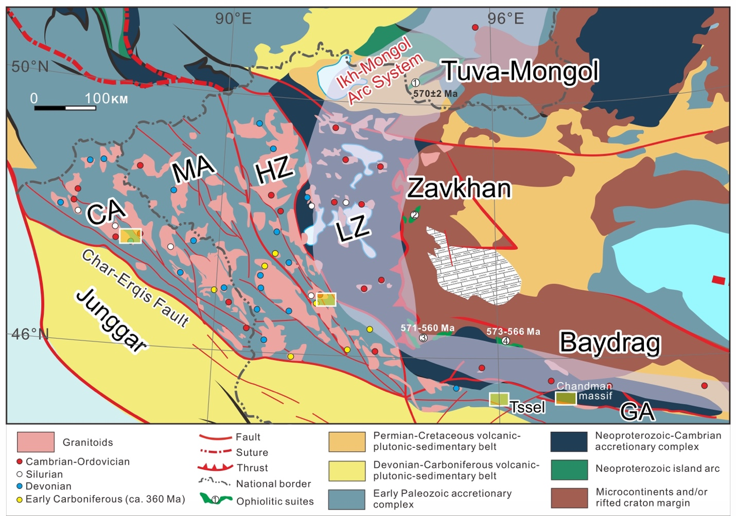

Fig. S1. Geological map of the study area of the western Mongolia Collage (Supplement to Figure 2a). The small circles are dated granitoids with ages and references shown in Table S2. The four yellow rectangular frames represent the locations for the structural studies listed in Table S3. Ages for the ophiolitic suites: 1. Agardag-Teskhem ophiolite (570 ± 2 Ma)³⁶; 2. Tas Khairkhan ophiolite³⁷; 3. Dariv ophiolite (571–560 Ma)^{38,39}; 4. Khantaishir ophiolite (573–566 Ma)³⁸. Abbreviations: CA: Chinese Altai; MA: Mongolian Altai; HZ: Hovd Zone;.LZ: Lake Zone; GA: Gobi Altai.

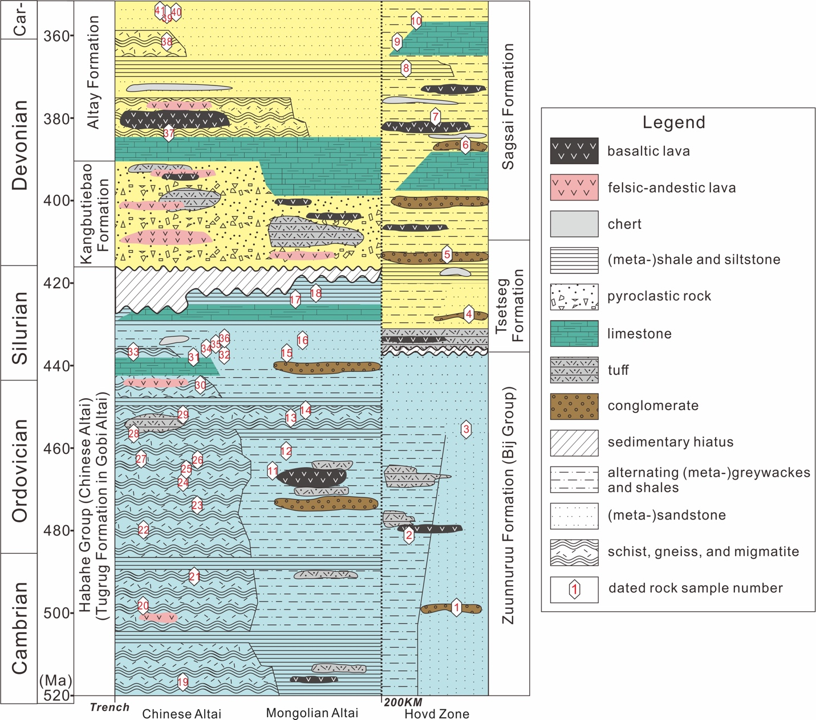

Fig. S2. Simplified lithostratigraphic diagram for the lower-middle Paleozoic sedimentary sequences of the Altai Zone. The sample numbers and information for those rock dated for detrital zircons are shown in Table S1, with referenced included.

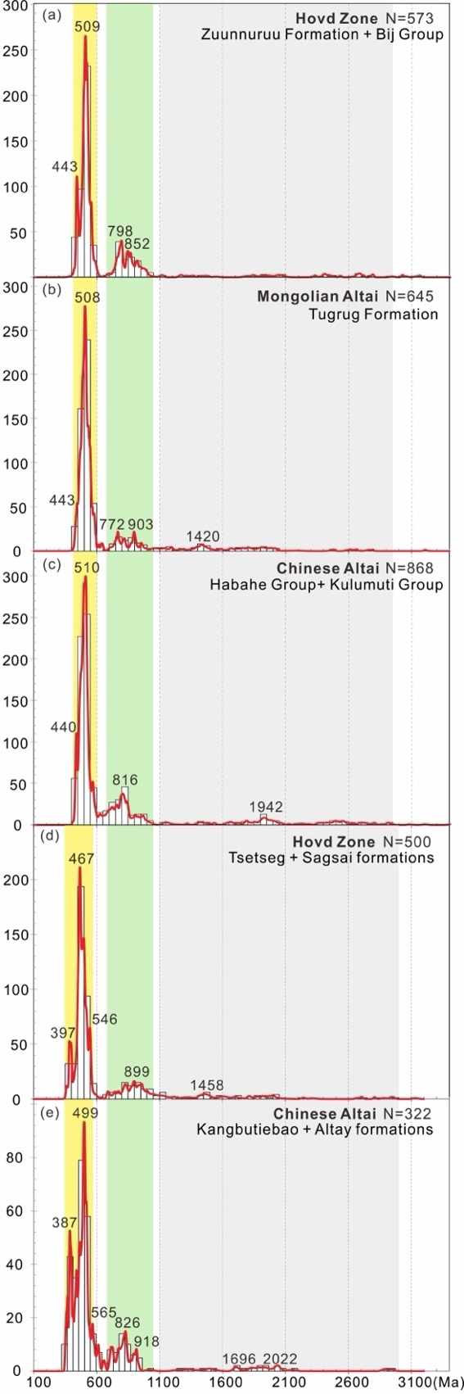

Fig. S3. Relative probability plots for detrital zircons from the early Paleozoic (a–c) and middle Paleozoic (d, e) sedimentary rocks in different regions of the Altai Zone. Sample information and data sources can be found in Table S1. Discordant ages and metamorphic zircon ages have been deleted in the original references.

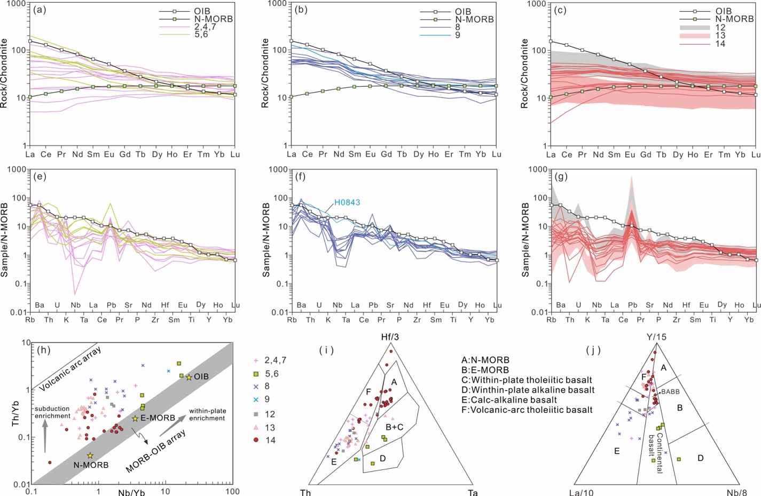

Fig. S4. Geochemical discrimination diagram for basaltic rocks in the study area. (a–c) Chondrite-normalized REE patterns, (d–f) N-MORB-normalized spider diagrams, and (g–i) Tectonic setting discrimination diagrams. The sample numbers in the legends are the same as Figure 3: No. 2, 4, 7 for Cambrian-Ordovician basalts from Lake Zone, Hovd Zone, and Mongolian Altai; No. 5, 6 for Tsetseg and Saigsai basalts; No. 8, 9 for Takhitt and Gichgene basalts; No. 12 for Kangbutiebao basalts; No. 13 for Qiye and Ashele basalts; No. 14 for Altay basalts. Data are from whole-rock samples with references listed in Table S2.

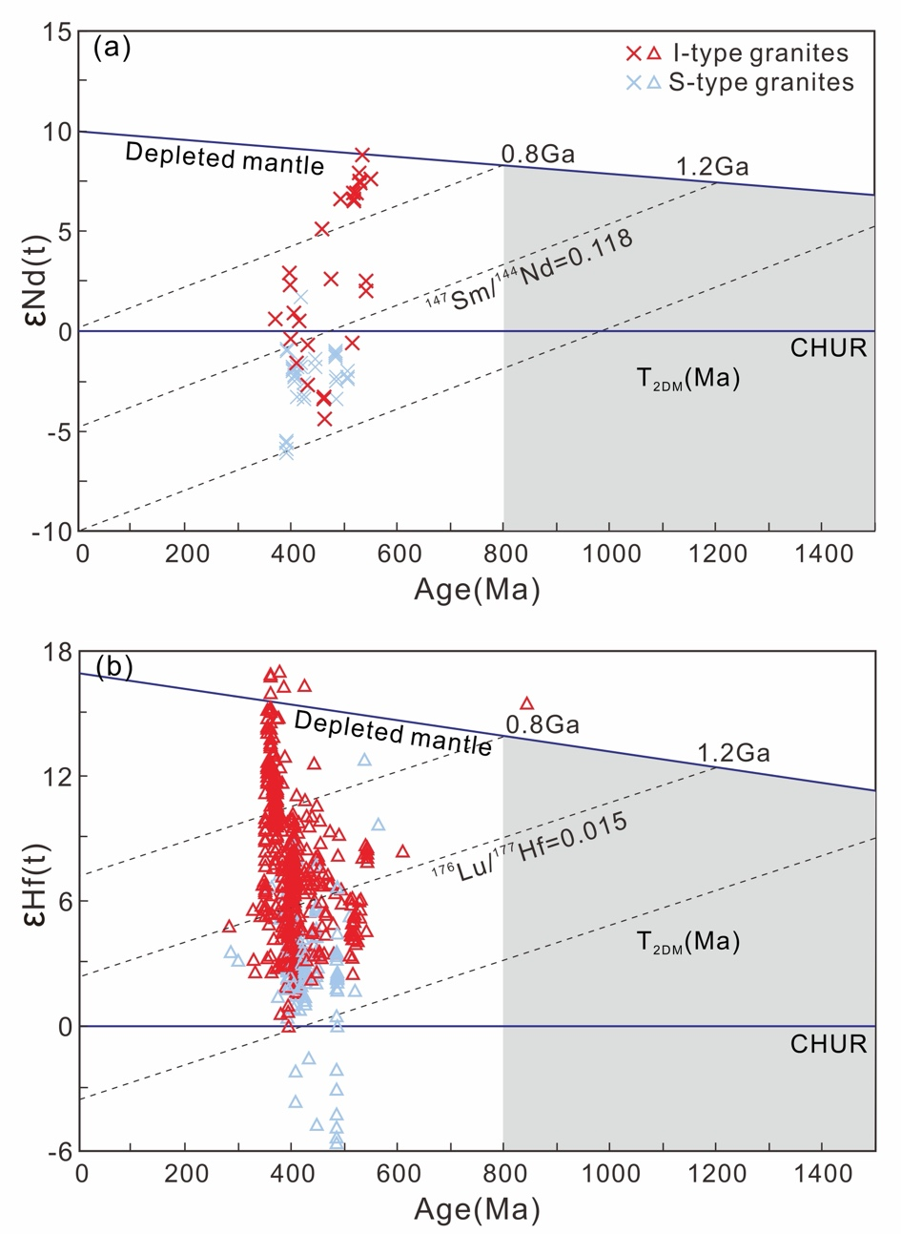

Fig. S5. Whole-rock Nd and zircon Hf isotopic data for the early-middle Paleozoic granitoids from the Altai Zone. ¹⁴⁷Sm/¹⁴⁴Nd of 0.118 and ¹⁷⁶Lu/¹⁷⁷Hf of 0.015 were used as continental crust average values^{40,41}. CHUR, chondritic uniform reservoir. T_{2DM} represents the two-stage depleted mantle model ages. Data points and sources are listed in Table S2.

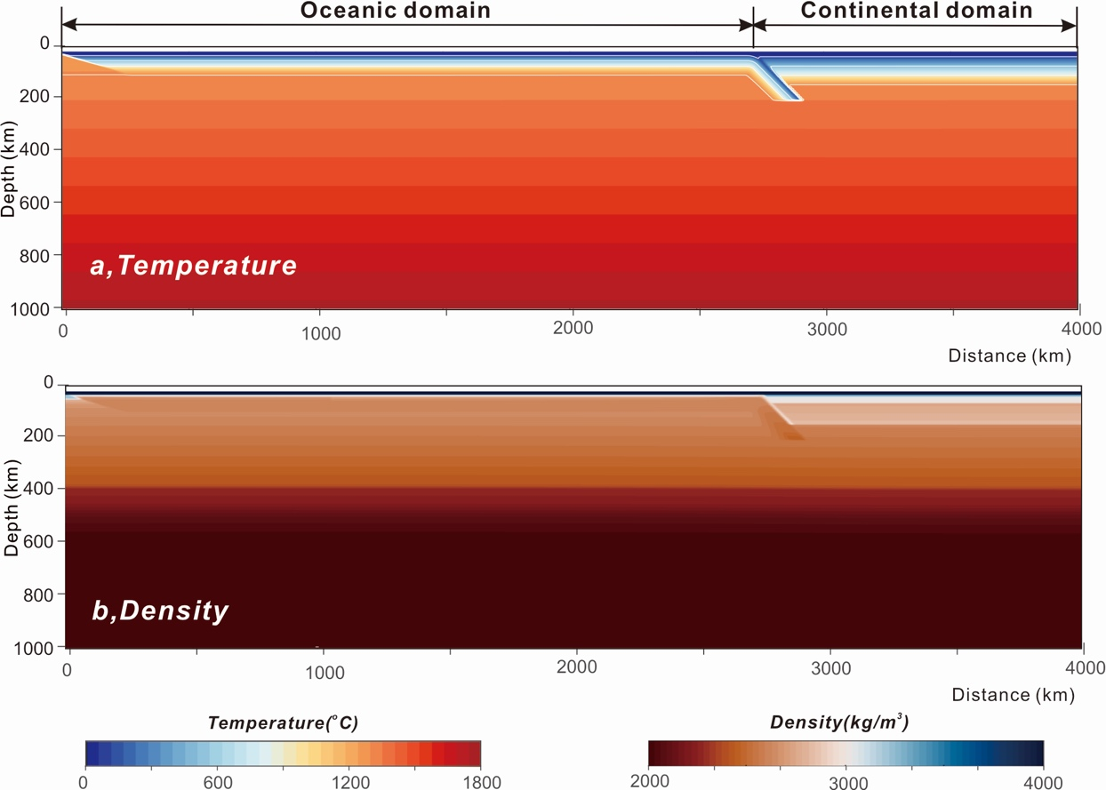

Fig. S6. Design and boundary conditions of the numerical model. (a) Temperature field of the whole computational domain (4000 km × 1000 km). White contour lines represent isotherms, with intervals of 400 °C, commencing from 100 °C. (b) Temperature field of the whole computational domain. The color scales below indicate the numerical ranges for temperature (°C) and density (kg/m³), respectively. The initial subduction zone is generated by exerting a fixed velocity on the left region of the subducting plate.
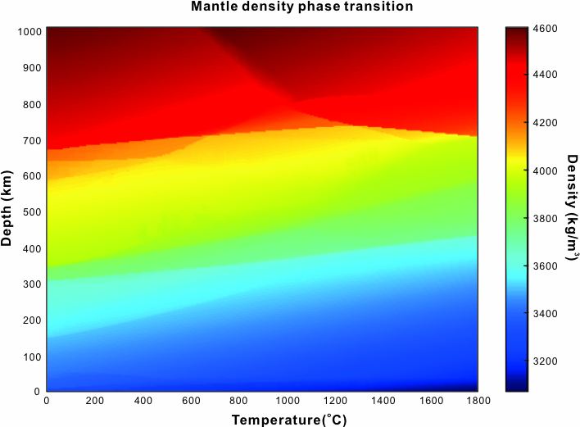

Fig. S7. Mantle density phase transition. The changes in mantle density as a function of temperature and depth.

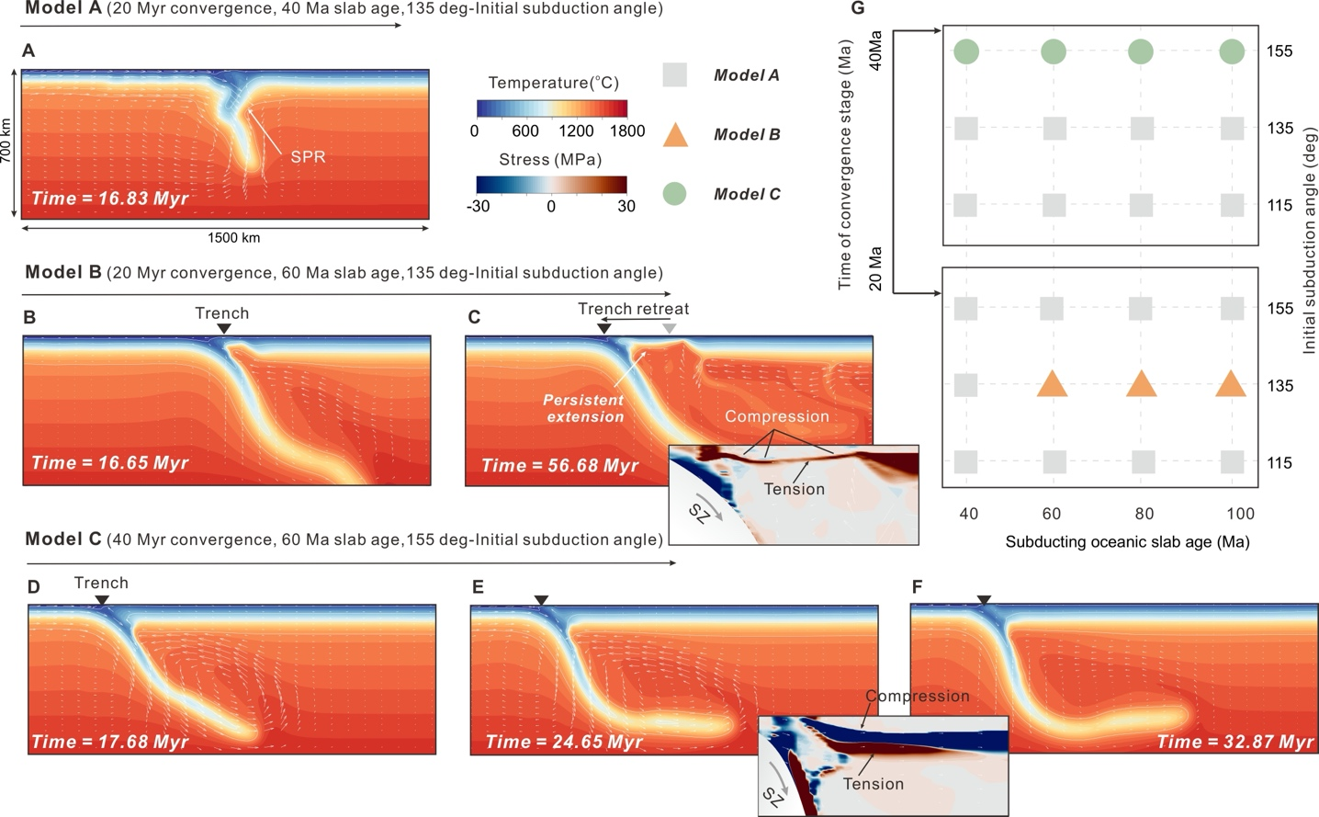

Fig. S8. Parameter sensitivity of orogenic styles in numerical models. (A) Model A shows the temperature and stress fields after 16.83 Myr of model evolution. SPR: subduction polarity reversal. (B, C) Model B displays the temperature and stress fields at (B) initial stage, and (C) a later stage with the stress distribution in the overriding plate. Trench retreat and regions of tension and compression are highlighted. (D–F) Model C presents the temperature and stress fields at three different time stages: (D) at the initial stage, (E) and (F) at later stages showing the stress distribution in the overriding plate. (G) Parameter space diagram summarizing the influence of subducting oceanic slab age and initial subduction angle on orogenic styles under two different convergence durations (20 Myr and 40 Myr). Green circles, orange triangles, and grey squares represent the parameter settings for Models A, B, and C, respectively.

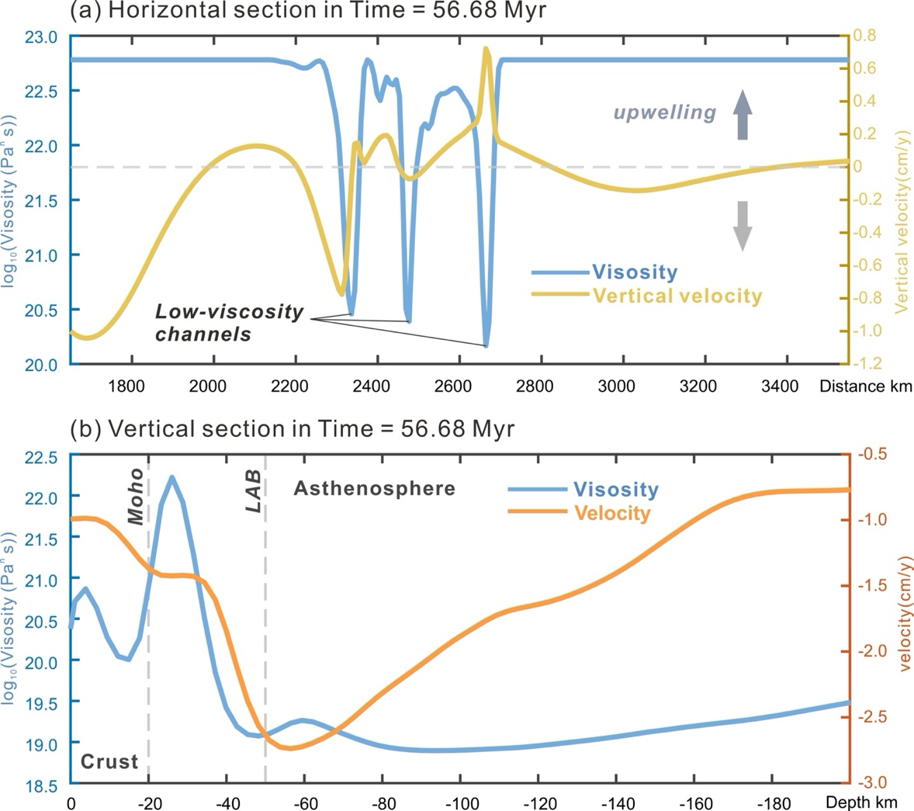

Fig. S9. Detailed velocity and viscosity profile extracted from the simulation at 56.68 Myr. (a) Distance profile depicting lateral variations in viscosity and vertical velocity across the lithosphere, corresponding to the horizontal dashed line in Figure 3c. Key features such as low-viscosity channels and upwelling zones are highlighted. (b) Depth profile showing variations in viscosity and velocity with depth, as indicated by the vertical dashed line in Figure 3c.

Table S4. Creep parameters used in this study.
Parameter | Symbol | Units | Diffusion Creep | Dislocation Creep
 |  |  | Dry olivine | Dry olivine | Wet quartzite | Diabase | Granite
Stress exponent | n | - | 1 | 3.5 | 2.3 | 3.05 | 3.3
Prefactor | B | Pa^{-n} s⁻¹ | 1.5×10⁹ | 1.1×10⁵ | 3.2×10⁻⁴ | 3.2×10⁻²⁰ | 3.16×10⁻²⁶
Activation energy | E | J mol⁻¹ | 3.75×10⁵ | 5.3×10⁵ | 1.54×10⁵ | 2.76×10⁵ | 1.865×10⁵
Activation volume | V | m³ mol⁻¹ | 5×10⁻⁶ | 15×10⁻⁶ | 0 | 0 | 0
Numbers in brackets refer to the following reference: (1) Dry olivine⁴²; (2) Wet quartzite⁴³; (3) Diabase⁴⁴; (4) Granite⁴⁴.

Table S5. Material parameters used in the experiments.
 | Parameter | Symbol | Unit | Air | UC | LC | CL | OC |  | Asth to OC | EG | OL | WL | Asth | MMB
 |  | - | - | 1019 | A* | B* | C*+D* | E* |  | E* | E* | C*+D* | - | C*+D* | C*+D*
  Flow law
 | Density |  | Kg/m³ | 1 | 2900 | 3100 | 3300 | 3300 |  | 3000 | 3400 | PD_1 | 3000 | PD_2 | PD_1
 | Cohesion | C | MPa | 1×10⁶ | 2×10⁷ | 2×10⁷ | 2×10⁷ | 5×10⁶ |  | 2×10⁷ | 2×10⁷ | 2×10⁷ | 5×10⁶ | 2×10⁷ | 2×10⁷
 |  |  | ° | 0 | 30 | 30 | 30 | 1 |  | 30 | 30 | 30 | 0 | 30 | 30
  Friction angle
 | Elastic shear module | G | Gpa | 50 | 50 | 50 | 50 | 50 |  | 50 | 50 | 74 | 50 | 50 | 50
 | Flow laws: A*, Quartzite⁴³; B*, Diabase⁴⁴; C* and D* are dislocation creep and diffusion creep of dry olivine⁴²; E*, Wet quartzite⁴³. Abbreviations for rock types: UC = upper crust, LC = lower crust, CL = continental lithosphere, OC = oceanic crust, Asth to OC = Asthenosphere change to oceanic crust, represents the oceanic crust formed when the asthenosphere upwells to above -20 km due to subduction. EG = eclogite, OL = oceanic lithosphere, WL = weak layer, Asth = Asthenosphere, MMB = mantle micro-block. Thermal expansivity = 3×10⁻⁵ 1/K, thermal compressibility = 1×10⁻¹¹ 1/Pa, thermal conductivity k =3 W/(m•K) and heat capacity 𝐶_{𝑃} = 1200 J/(kg•K) are the same for all the rocks.

References

1. Soejono, I. et al. Early Palaeozoic sedimentary record and provenance of flysch sequences in the Hovd Zone (western Mongolia): Implications for the geodynamic evolution of the Altai accretionary wedge system. Gondwana Research 64, 163–183 (2018).
2. Buriánek, D. et al. Subduction-controlled temporal and spatial variations in early Palaeozoic sedimentary and volcanic record of the Mongol-Altai Domain. Journal of Asian Earth Sciences 230, 105182 (2022).
3. Jiang, Y. D. et al. Neoproterozoic‐Early Paleozoic Peri‐Pacific Accretionary Evolution of the Mongolian Collage System: Insights From Geochemical and U‐Pb Zircon Data From the Ordovician Sedimentary Wedge in the Mongolian Altai. Tectonics 36, 2305–2331 (2017).
4. Buslov, M. M. et al. Evolution of the Paleo-Asian Ocean (Altai-Sayan Region, Central Asia) and collision of possible Gondwana-derived terranes with the southern marginal part of the Siberian continent. Geosci J 5, 203–224 (2001).
5. Long, X. et al. Detrital zircon U-Pb ages and whole-rock geochemistry of early Paleozoic metasedimentary rocks in the Mongolian Altai: Insights into the tectonic affinity of the whole Altai-Mongolian terrane. (2019).
6. Long, X., Sun, M., Yuan, C., Xiao, W. & Cai, K. Early Paleozoic sedimentary record of the Chinese Altai: Implications for its tectonic evolution. Sedimentary Geology 208, 88–100 (2008).
7. Windley, B. F. et al. Neoproterozoic to Paleozoic Geology of the Altai Orogen, NW China: New Zircon Age Data and Tectonic Evolution. The Journal of Geology 110, 719–737 (2002).
8. Wang, Y. et al. Provenance of Early Paleozoic metasediments in the central Chinese Altai: Implications for tectonic affinity of the Altai-Mongolia terrane in the Central Asian Orogenic Belt. Lithos 210–211, 57–68 (2014).
9. Cui, X. et al. A Devonian arc–back-arc basin system in the southern Chinese Altai: Constraints from geochemical and Sr-Nd-Pb isotopic data for meta-basaltic rocks. Lithos 366–367, 105540 (2020).
10. Long, X. et al. Detrital zircon age and Hf isotopic studies for metasedimentary rocks from the Chinese Altai: Implications for the Early Paleozoic tectonic evolution of the Central Asian Orogenic Belt. Tectonics 26, 2007TC002128 (2007).
11. Kozakov, I. K. et al. The Khaldzan-Buregtei Massif of Peralkaline Rare-Metal Igneous Rocks: Structure, Geochronology, and Geodynamic Setting in the Caledonides of Western Mongolia. 12, 412–436 (2004).
12. Janoušek, V. et al. Cambrian–Ordovician magmatism of the Ikh-Mongol Arc System exemplified by the Khantaishir Magmatic Complex (Lake Zone, south–central Mongolia). Gondwana Research 54, 122–149 (2018).
13. Yarmolyuk, V. V. et al. Composition, sources, and mechanism of continental crust growth in the Lake zone of the Central Asian Caledonides: I. Geological and geochronological data. Petrology 19, 55–78 (2011).
14. Badarch, G., Dickson Cunningham, W. & Windley, B. F. A new terrane subdivision for Mongolia: implications for the Phanerozoic crustal growth of Central Asia. Journal of Asian Earth Sciences 21, 87–110 (2002).
15. Soejono, I. et al. A reworked Lake Zone margin: Chronological and geochemical constraints from the Ordovician arc-related basement of the Hovd Zone (western Mongolia). Lithos 294–295, 112–132 (2017).
16. Boldbaatar, D. et al. Geochronology and geochemistry of granitoids from the Mongolian Altai. Journal of Mineralogical and Petrological Sciences 116, 293–308 (2022).
17. Cai, K. et al. A synthesis of zircon U–Pb ages and Hf isotopic compositions of granitoids from Southwest Mongolia: Implications for crustal nature and tectonic evolution of the Altai Superterrane. Lithos 232, 131–142 (2015).
18. Yang, T. N., Li, J. Y., Zhang, J. & Hou, K. J. The Altai-Mongolia terrane in the Central Asian Orogenic Belt (CAOB): A peri-Gondwana one? Evidence from zircon U–Pb, Hf isotopes and REE abundance. Precambrian Research 187, 79–98 (2011).
19. Zhang, C., Liu, L., Santosh, M., Luo, Q. & Zhang, X. Sediment recycling and crustal growth in the Central Asian Orogenic Belt: Evidence from Sr–Nd–Hf isotopes and trace elements in granitoids of the Chinese Altay. Gondwana Research 47, 142–160 (2017).
20. Yu, Y. et al. Whole-rock Nd–Hf isotopic study of I-type and peraluminous granitic rocks from the Chinese Altai: Constraints on the nature of the lower crust and tectonic setting. Gondwana Research 47, 131–141 (2017).
21. Soejono, I. et al. Structural, metamorphic and geochronological constraints on Palaeozoic multi-stage geodynamic evolution of the Altai accretionary wedge system (Hovd Zone, western Mongolia). Lithos 396–397, 106204 (2021).
22. Burenjargal, U. et al. Thermal evolution of the T seel terrane, SW Mongolia and its relation to granitoid intrusions in the C entral A sian O rogenic B elt. Journal Metamorphic Geology 32, 765–790 (2014).
23. Burenjargal, U. et al. Contrasting geochemical signatures of Devonian and Permian granitoids from the Tseel Terrane, SW Mongolia. Jour. Geosci. 51–66 (2016) doi:10.3190/jgeosci.210.
24. Broussolle, A. et al. P–T–t–D record of crustal‐scale horizontal flow and magma‐assisted doming in the SW Mongolian Altai. Journal Metamorphic Geology 33, 359–383 (2015).
25. Lehmann, J. et al. Structural constraints on the evolution of the Central Asian Orogenic Belt in SW Mongolia. American Journal of Science 310, 575–628 (2010).
26. Lehmann, J. et al. Detachment folding of partially molten crust in accretionary orogens: A new magma-enhanced vertical mass and heat transfer mechanism. Lithosphere 9, 889–909 (2017).
27. Jiang, Y. D. et al. Structural and Geochronological Constraints on Devonian Suprasubduction Tectonic Switching and Permian Collisional Dynamics in the Chinese Altai, Central Asia. Tectonics 38, 253–280 (2019).
28. Jiang, Y. D. et al. Juxtaposition of Barrovian and migmatite domains in the Chinese Altai: a result of crustal thickening followed by doming of partially molten lower crust. Journal Metamorphic Geology 33, 45–70 (2015).
29. Stixrude, L. & Lithgow-Bertelloni, C. Influence of phase transformations on lateral heterogeneity and dynamics in Earth’s mantle. Earth and Planetary Science Letters 263, 45–55 (2007).
30. Workman, R. K. & Hart, S. R. Major and trace element composition of the depleted MORB mantle (DMM). Earth and Planetary Science Letters 231, 53–72 (2005).
31. Ringwood, Alfred Edward. Composition and Petrology of the Earth’s Mantle. in The Earth’s Crust and Upper Mantle: Structure, Dynamic Process, and their Relations to Deep-Seated Geological Phenomena (ed. Pembroke J. Hart) vol. 13 1–17 (Geophysical Monograph Series, Washington, D. C.).
32. Presnall, D. C. & Hoover, J. D. Composition and depth of origin of primary mid-ocean ridge basalts. Contrib Mineral Petrol 87, 170–178 (1984).
33. Green, D. H., Jaques, L. A. & Hibberson, W. O. Petrogenesis of Mid-ocean Ridge Basalts. in The Earth: Its Origin, Structure and Evolution (ed. McElhinny, M. W.) 265–300 (Academic Press, London, 1979).
34. Baker, M. B. & Beckett, J. R. The origin of abyssal peridotites: a reinterpretation of constraints based on primary bulk compositions. Earth and Planetary Science Letters 171, 49–61 (1999).
35. Birch, F. ELASTICITY AND CONSTITUTION OF THE EARTH’S INTERIOR. Journal of Geophysical Research 57, 227–286 (1952).
36. Pfänder, Jörg A, Jochum, Klaus Peter, Todt, W, Kröner, Alfred, & Kozakov, I. Coupled evolution of back-arc and island arc-like mafic crust in the late-Neoproterozoic Agardagh Tes-Chem ophiolite, Central Asia: evidence from trace element and Sr-Nd-Pb isotope data. Contributions to Mineralogy and Petrology 143, 154–174 (2002).
37. Khukhuudei, U., Kusky, T., Otgonbayar, O. & Wang, L. The Early Palaeozoic mega‐thrusting of the Gondwana‐derived Altay–Lake zone in western Mongolia: Implications for the development of the Central Asian Orogenic Belt and Paleo‐Asian Ocean evolution. Geological Journal 55, 2129–2149 (2020).
38. Jian, P. et al. Zircon dating of Neoproterozoic and Cambrian ophiolites in West Mongolia and implications for the timing of orogenic processes in the central part of the Central Asian Orogenic Belt. Earth-Science Reviews 133, 62–93 (2014).
39. Khain, EV et al. The Palaeo-Asian ocean in the Neoproterozoic and early Palaeozoic: new geochronologic data and palaeotectonic reconstructions. Precambrian Research 122, 329–358 (2003).
40. Jahn, Bor-Ming & Condie, Kent C. Evolution of the Kaapvaal Craton as viewed from geochemical and Sm-Nd isotopic analyses of intracratonic pelites. Geochimica et Cosmochimica Acta 59, 2239–2258 (1995).
41. Griffin, WL et al. Zircon chemistry and magma mixing, SE China: in-situ analysis of Hf isotopes, Tonglu and Pingtan igneous complexes. Lithos 61, 237–269.
42. Hirth, G. & Kohlstedt, D. Rheology of the upper mantle and the mantle wedge: A view from the experimentalists. in Geophysical Monograph Series (ed. Eiler, J.) vol. 138 83–105 (American Geophysical Union, Washington, D. C., 2003).
43. Ranalli, G. Rheology of the Earth. (Springer Science & Business Media, 1995).
44. Huismans, R. S., Podladchikov, Y. Y. & Cloetingh, S. Transition from passive to active rifting: Relative importance of asthenospheric doming and passive extension of the lithosphere. J. Geophys. Res. 106, 11271–11291 (2001).

