Multimedia Appendix: Large Language Models in Automated Suicide Risk Factor Monitoring: A Comparative Study of AI and Human Ratings Using LLM-Based Chat Agents on an Observational Suicide Scale

Appendix Table 1. Performance Metrics by Chain Type for NGASRa Risk Levels (N=2,700 per condition), assessing the presence of suicide risk factors based on n=100 session transcripts of German Youth Crisis Helpline Users between 2021-11-30 and 2022-04-30

Risk Level | Chain Type | Balanced Accuracy | F1 Score | Sensitivity | Specificity
High Risk | Chain of Thought | 0.63 (0.58-0.66) | 0.44 (0.38-0.51) | 0.44 (0.33-0.51) | 0.81 (0.77-0.83)
 | Few-shot | 0.58 (0.52-0.62) | 0.36 (0.30-0.40) | 0.38 (0.31-0.44) | 0.78 (0.74-0.83)
 | Zero-shot | 0.56 (0.52-0.60) | 0.36 (0.28-0.42) | 0.40 (0.33-0.57) | 0.72 (0.68-0.77)
Low Risk | Chain of Thought | 0.68 (0.64-0.71) | 0.47 (0.38-0.58) | 0.45 (0.31-0.48) | 0.90 (0.87-0.92)
 | Few-shot | 0.52 (0.46-0.54) | 0.16 (0.06-0.21) | 0.12 (0.04-0.18) | 0.92 (0.89-0.95)
 | Zero-shot | 0.50 (0.49-0.53) | 0.14 (0.08-0.23) | 0.12 (0.08-0.19) | 0.89 (0.87-0.92)
Moderate Risk | Chain of Thought | 0.56 (0.51-0.59) | 0.36 (0.29-0.41) | 0.44 (0.35-0.63) | 0.67 (0.61-0.73)
 | Few-shot | 0.44 (0.39-0.48) | 0.17 (0.07-0.23) | 0.17 (0.12-0.22) | 0.71 (0.66-0.75)
 | Zero-shot | 0.48 (0.42-0.48) | 0.20 (0.10-0.27) | 0.19 (0.10-0.29) | 0.77 (0.70-0.78)
Very High Risk | Chain of Thought | 0.66 (0.63-0.72) | 0.52 (0.48-0.57) | 0.41 (0.37-0.51) | 0.91 (0.87-0.93)
 | Few-shot | 0.52 (0.49-0.56) | 0.30 (0.27-0.38) | 0.25 (0.18-0.30) | 0.78 (0.73-0.82)
 | Zero-shot | 0.53 (0.48-0.56) | 0.35 (0.29-0.39) | 0.31 (0.26-0.40) | 0.75 (0.70-0.80)
Note: Mean Balanced Accuracy, Sensitivity, Specificity and F1 values with respective 95% confidence intervals attained over majority voted values per risk level. Bold values indicate highest performance within each category. a NGASR = Nurses Global Assessment of Suicide Risk

Appendix Table 2. Item-Specific Reliability and Observer Agreement Values Across Prompting Styles at Temperature = 0 (N=144,000 total ratings), assessing the presence of suicide risk factors based on n=100 session transcripts of German Youth Crisis Helpline Users between 2021-11-30 and 2022-04-30

Item | Human Alpha | Corrected Alpha |  |  | LLM Alpha
 |  | Chain-of-thought | Few-shot | Zero-shot | Chain-of-thought | Few-shot | Zero-shot
depression | 0.75 | 0.39 | 0.06 | 0.11 | 0.91 | 0.84 | 0.95
grief | 0.87 | 0.62 | 0.72 | 0.67 | 0.90 | 0.94 | 0.96
hopeless | 0.62 | 0.15 | -0.25 | -0.07 | 0.84 | 0.81 | 0.96
hospitalized | 0.86 | 0.57 | 0.58 | 0.54 | 0.92 | 0.86 | 0.95
illness | 1.00 | 0.99 | 0.91 | 0.99 | 1.00 | 0.96 | 1.00
low_ses | 0.97 | 0.69 | 0.56 | 0.43 | 0.86 | 0.86 | 0.96
psychosis | 1.00 | 0.99 | 0.90 | 0.99 | 1.00 | 0.96 | 1.00
substance use | 0.96 | 0.85 | 0.79 | 0.90 | 0.95 | 0.95 | 1.00
social_withdrawal | 0.92 | 0.11 | 0.11 | -0.52 | 0.72 | 0.89 | 0.98
stressful_life_event | 0.77 | 0.30 | 0.41 | 0.40 | 0.90 | 0.91 | 1.00
suicide_attempts | 0.88 | 0.66 | 0.64 | 0.64 | 0.93 | 1.00 | 1.00
suicide_family_history | 0.87 | 0.93 | 0.87 | 0.81 | 0.98 | 0.97 | 1.00
suicide_ideation | 0.84 | 0.60 | 0.70 | 0.70 | 0.87 | 0.96 | 0.94
suicide_plan | 1.00 | 0.53 | 0.57 | 0.57 | 0.96 | 0.90 | 1.00
voices | 1.00 | 0.95 | 0.86 | 0.89 | 0.97 | 0.98 | 1.00
widowed | 1.00 | 0.95 | 0.92 | 1.00 | 0.98 | 0.97 | 1.00
low_risk | 0.92 | 0.75 | 0.71 | 0.67 | 0.89 | 0.97 | 0.99
moderate_risk | 0.66 | 0.32 | 0.33 | 0.37 | 0.81 | 0.95 | 1.00
high_risk | 0.60 | 0.53 | 0.53 | 0.43 | 0.89 | 0.94 | 1.00
very_high_risk | 0.76 | 0.74 | 0.52 | 0.59 | 0.90 | 0.96 | 0.98
sum_score | -0.07 | -0.70 | -0.76 | -0.74 | 0.39 | 0.62 | 0.96

Note: Table presents two key metrics for each prompting style and NGASRa item: (1) Regression bias corrected Krippendorff's alpha coefficients comparing human versus LLMb ratings (observer agreement), and (2) Krippendorff's alpha coefficients among LLM ratings only (interrater reliability). Bold values indicate highest agreement within each category. a NGASR = Nurses Global Assessment of Suicide Risk b LLM = Large Language Model
Appendix Table 3: Performance Metrics by Chain Type for NGASR Items
Item | Chain Type | Balanced Accuracy | F1 Score | Sensitivity | Specificity
Depression | Chain of Thought | 0.61 (0.60-0.65) | 0.69 (0.66-0.75) | 0.79 (0.73-0.83) | 0.44 (0.40-0.51)
 | Few-shot | 0.48 (0.45-0.49) | 0.63 (0.58-0.66) | 0.80 (0.73-0.82) | 0.15 (0.08-0.23)
 | Zero-shot | 0.54 (0.49-0.58) | 0.67 (0.64-0.70) | 0.85 (0.81-0.87) | 0.22 (0.13-0.31)
Grief | Chain of Thought | 0.69 (0.60-0.72) | 0.54 (0.49-0.60) | 0.50 (0.37-0.56) | 0.88 (0.86-0.90)
 | Few-shot | 0.61 (0.57-0.65) | 0.39 (0.36-0.43) | 0.32 (0.25-0.40) | 0.89 (0.88-0.93)
 | Zero-shot | 0.68 (0.66-0.74) | 0.52 (0.47-0.60) | 0.54 (0.47-0.64) | 0.82 (0.79-0.86)
Hopelessness | Chain of Thought | 0.55 (0.52-0.56) | 0.66 (0.63-0.71) | 0.86 (0.80-0.92) | 0.23 (0.14-0.29)
 | Few-shot | 0.47 (0.43-0.52) | 0.58 (0.52-0.62) | 0.77 (0.69-0.80) | 0.17 (0.14-0.22)
 | Zero-shot | 0.49 (0.48-0.51) | 0.63 (0.59-0.67) | 0.88 (0.86-0.92) | 0.10 (0.06-0.13)
Hospitalized | Chain of Thought | 0.66 (0.60-0.71) | 0.55 (0.48-0.61) | 0.50 (0.43-0.58) | 0.82 (0.76-0.83)
 | Few-shot | 0.56 (0.54-0.63) | 0.41 (0.37-0.47) | 0.38 (0.31-0.45) | 0.74 (0.72-0.80)
 | Zero-shot | 0.63 (0.56-0.68) | 0.51 (0.41-0.60) | 0.50 (0.45-0.54) | 0.76 (0.70-0.82)
Illness | Chain of Thought | N/A | N/A | N/A | N/A
 | Few-shot | 0.49 (0.47-0.53) | 0.00 | 0.00 | 0.97 (0.96-0.99)
 | Zero-shot | N/A | N/A | N/A | N/A
Low SES | Chain of Thought | 0.76 (0.61-0.82) | 0.31 (0.21-0.43) | 0.69 (0.57-0.90) | 0.84 (0.80-0.88)
 | Few-shot | 0.61 (0.51-0.72) | 0.15 (0.11-0.19) | 0.53 (0.46-0.66) | 0.69 (0.63-0.73)
 | Zero-shot | 0.83 (0.80-0.88) | 0.27 (0.19-0.31) | 1.00 (1.00-1.00) | 0.65 (0.61-0.68)
Psychosis | Chain of Thought | 0.67 (0.61-0.83) | 0.50 (0.06-0.71) | 0.33 (0.12-0.81) | 1.00 (1.00-1.00)
 | Few-shot | 0.64 (0.49-0.77) | 0.22 (0.08-0.28) | 0.33 (0.19-0.94) | 0.95 (0.92-0.97)
 | Zero-shot | 0.83 (0.73-0.99) | 0.80 (0.68-0.97) | 0.67 (0.34-0.97) | 1.00 (1.00-1.00)
substance use | Chain of Thought | 0.86 (0.82-0.90) | 0.75 (0.69-0.81) | 0.78 (0.69-0.86) | 0.95 (0.93-0.98)
 | Few-shot | 0.75 (0.68-0.82) | 0.54 (0.46-0.63) | 0.61 (0.51-0.72) | 0.89 (0.87-0.94)
 | Zero-shot | 0.87 (0.84-0.93) | 0.77 (0.66-0.83) | 0.79 (0.67-0.81) | 0.96 (0.93-0.97)
Social Withdrawal | Chain of Thought | 0.56 (0.51-0.62) | 0.24 (0.18-0.26) | 0.82 (0.77-0.89) | 0.30 (0.25-0.32)
 | Few-shot | 0.59 (0.56-0.67) | 0.25 (0.21-0.33) | 0.75 (0.65-0.92) | 0.43 (0.40-0.50)
 | Zero-shot | 0.51 (0.49-0.52) | 0.22 (0.18-0.27) | 0.97 (0.91-1.00) | 0.05 (0.03-0.07)
Stressful Life Event | Chain of Thought | 0.55 (0.53-0.60) | 0.33 (0.29-0.40) | 0.20 (0.18-0.25) | 0.90 (0.85-0.95)
 | Few-shot | 0.57 (0.53-0.60) | 0.50 (0.45-0.56) | 0.35 (0.31-0.39) | 0.78 (0.76-0.85)
 | Zero-shot | 0.54 (0.46-0.58) | 0.46 (0.43-0.50) | 0.32 (0.27-0.35) | 0.75 (0.67-0.78)
Suicide Ideation | Chain of Thought | 0.77 (0.74-0.79) | 0.71 (0.68-0.75) | 0.56 (0.51-0.60) | 0.98 (0.94-1.00)
 | Few-shot | 0.77 (0.72-0.82) | 0.80 (0.77-0.83) | 0.70 (0.65-0.73) | 0.83 (0.73-0.91)
 | Zero-shot | 0.83 (0.79-0.86) | 0.80 (0.79-0.84) | 0.67 (0.59-0.69) | 1.00 (1.00-1.00)
Suicide Family History | Chain of Thought | 0.54 (0.50-0.59) | 0.16 (0.05-0.27) | 0.13 (0.10-0.27) | 0.95 (0.95-0.98)
 | Few-shot | 0.52 (0.48-0.58) | 0.10 (0.01-0.14) | 0.08 (0.00-0.16) | 0.95 (0.94-0.98)
 | Zero-shot | 0.54 (0.52-0.63) | 0.15 (0.04-0.16) | 0.18 (0.02-0.29) | 0.90 (0.87-0.92)
Suicide Plan | Chain of Thought | 0.59 (0.54-0.61) | 0.35 (0.28-0.39) | 0.22 (0.17-0.28) | 0.95 (0.92-0.97)
 | Few-shot | 0.63 (0.58-0.65) | 0.48 (0.44-0.54) | 0.34 (0.29-0.43) | 0.92 (0.88-0.96)
 | Zero-shot | 0.60 (0.59-0.64) | 0.37 (0.34-0.42) | 0.23 (0.20-0.27) | 0.97 (0.94-1.00)
Suicide Attempts | Chain of Thought | 0.67 (0.64-0.68) | 0.53 (0.47-0.58) | 0.37 (0.29-0.46) | 0.96 (0.94-1.00)
 | Few-shot | 0.65 (0.61-0.67) | 0.51 (0.49-0.54) | 0.36 (0.30-0.39) | 0.93 (0.90-0.97)
 | Zero-shot | 0.62 (0.60-0.64) | 0.39 (0.33-0.45) | 0.24 (0.18-0.28) | 1.00 (1.00-1.00)
Voices | Chain of Thought | 0.91 (0.78-0.94) | 0.63 (0.49-0.79) | 0.86 (0.64-0.93) | 0.96 (0.95-0.97)
 | Few-shot | 0.97 (0.96-0.98) | 0.63 (0.51-0.73) | 1.00 (1.00-1.00) | 0.94 (0.92-0.96)
 | Zero-shot | 0.93 (0.87-0.96) | 0.53 (0.40-0.62) | 0.92 (0.72-1.00) | 0.93 (0.90-0.95)
Widowed | Chain of Thought | N/A | N/A | N/A | N/A
 | Few-shot | N/A | N/A | N/A | N/A
 | Zero-shot | N/A | N/A | N/A | N/A
Mean Balanced Accuracy, Sensitivity, Specificity and F1 values with respective 95% confidence intervals attained over majority voted item wise values per item (N=2700 each) assessing the presence of suicide risk factors based on n= 100 session transcripts of German Youth Crisis Helpline Users between 2021-11-30 and 2022-04-3
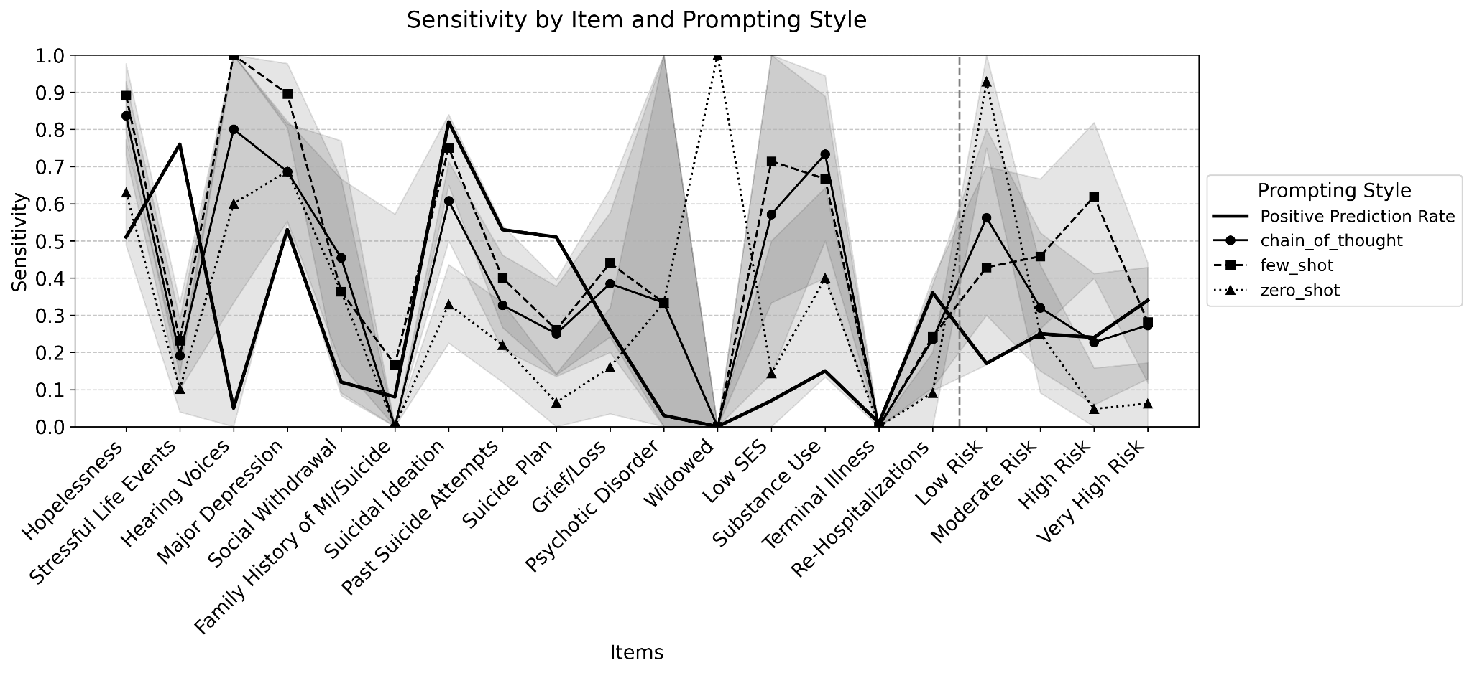
Appendix Figure 1. Sensitivity Values Comparing Human (n=4) and LLMa Ratings (N=30) Aggregated per Item, Risk Level and NGASRb Sum-Score (N=2,700 each), measured with Krippendorff's α, values shown as Mean and 95% Confidence Interval, assessing the presence of suicide risk factors based on n=100 session transcripts of German Youth Crisis Helpline Users between 2021-11-30 and 2022-04-30
a LLM = Large Language Model
b NGASR = Nurses Global Assessment of Suicide Risk Scale
^{b} NGASR = Nurses Global Assessment of Suicide risk Scale
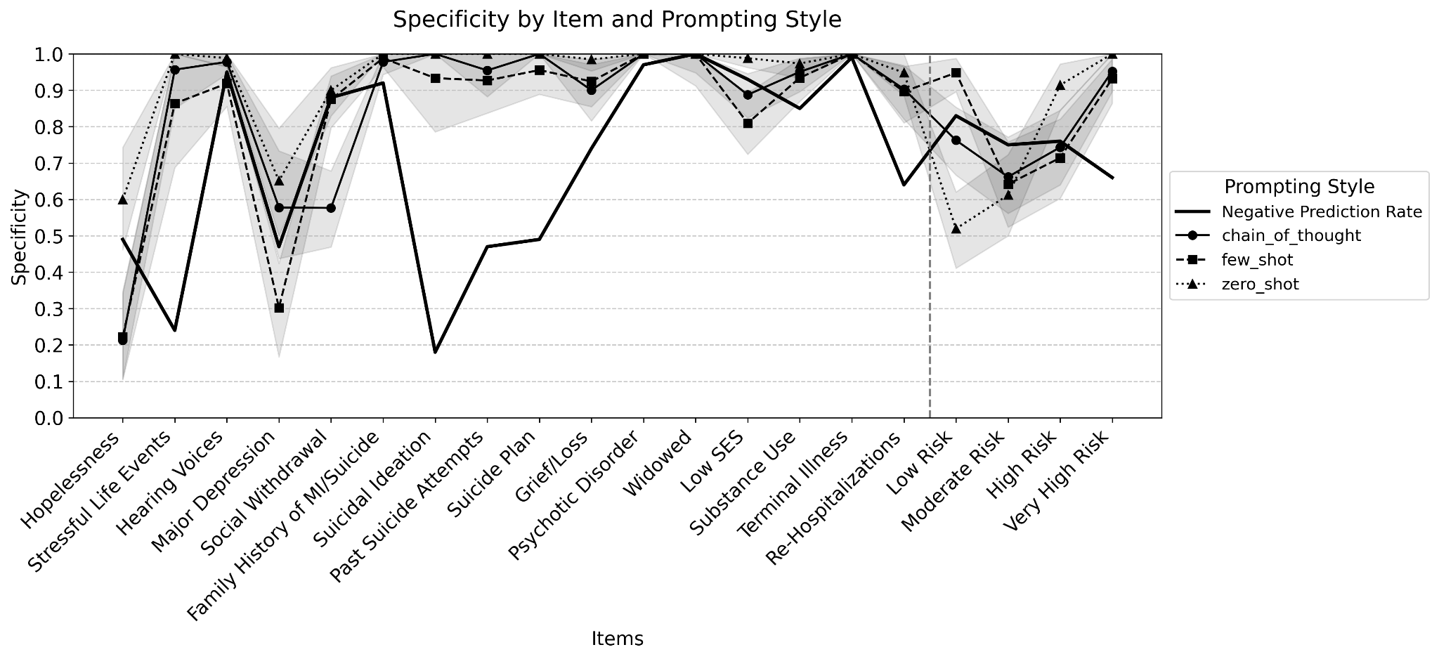
Appendix Figure 2. Specificity Values Comparing Human (n=4) and LLMa Ratings (N=30) Aggregated per Item, Risk Level and NGASRb Sum-Score (N=2,700 each), measured with Krippendorff's α, values shown as Mean and 95% Confidence Interval, assessing the presence of suicide risk factors based on n=100 session transcripts of German Youth Crisis Helpline Users between 2021-11-30 and 2022-04-30
a LLM = Large Language Model
b NGASR = Nurses Global Assessment of Suicide Risk Scale

CONSORT-AI Checklist
Title: Automated Suicide Risk Factor Monitoring in Crisis Text Line Users: Comparative Study of AI and Human Ratings Using Large Language Models
Appendix Table 4. Consort-AI Checklist Items

TITLE AND ABSTRACT
Section | Item | CONSORT-AI Extension | Information from Manuscript | Page
Title | 1a | Indicate that the intervention involves artificial intelligence/machine learning in the title and/or abstract | Title clearly states "Automated Suicide Risk Factor Monitoring" and "Using Large Language Models" | 1
Abstract | 1b | Provide a structured summary including AI-specific aspects (e.g., model architecture, training approach, data characteristics, main outcome, version) | Abstract mentions "Mixtral-7x8b-Instruct" model, three temperature settings, three prompting styles (zero-shot, few-shot, chain-of-thought), and reliability metrics. | 1

INTRODUCTION
Section | Item | CONSORT-AI Extension | Information from Manuscript | Page
Background | 2a | Explain rationale for using an AI intervention | Introduction explains LLMs' potential in clinical psychology due to language processing capabilities, supporting information retrieval, and potential for clinical assessment | 2
Background | 2b | Specify the intended use of the AI intervention | Study aims to investigate conditions for reliable psychological assessments in suicide risk evaluation by comparing LLM ratings with human expert ratings | 2-3

METHODS
Section | Item | CONSORT-AI Extension | Information from Manuscript | Page
Participants | 4a | Describe eligibility criteria for participants, including AI-specific considerations | Sample included female participants aged 14+ seeking help for themselves, excluding help-seeking for others | 5
Interventions | 5a | Specify AI model architecture, training approach, inputs, outputs | Mixtral 8x7B model with sparse mixture of experts architecture; RAG approach with T5-based instructor-transformer embeddings | 7-8
Interventions | 5b | Specify integration into the trial setting, technological infrastructure | Implementation used Python 3.8 on Google Cloud Platform Kubernetes cluster with 5-bit quantized model on 24GB L4 GPU using Ollama | 10
Interventions | 5c | Describe expertise of human operators | Four expert raters from specialized suicide and self-harm counseling unit with comprehensive training on NGASR items | 6
Interventions | 5d | Describe domain shift (if any) and potential for distributional shift | Not explicitly addressed, but study used authentic clinical data from the same service | -
Outcomes | 6a | Explain performance metrics and how they relate to the AI intervention | Used reliability analysis (Krippendorff's α), observer agreement, and classification metrics (balanced accuracy, sensitivity, specificity) | 8-10

STATISTICAL METHODS
Section | Item | CONSORT-AI Extension | Information from Manuscript | Page
Sample size | 7a | Detail how the sample size was determined, accounting for AI performance | Sample included 100 cases stratified by NGASR-assigned risk levels (25 cases per risk level) | 5
Statistical methods | 12a | Describe methods for analyzing performance metrics and their statistical uncertainty | Used bootstrapping (1000 resamples) to compute 95% confidence intervals for α values and classification metrics | 8-9
Statistical methods | 12b | Include specific methods for analyzing subgroups and interactions with the AI system | Conducted item-specific analyses using deterministic model outputs from different prompting approaches | 10

RESULTS
Section | Item | CONSORT-AI Extension | Information from Manuscript | Page
Participant flow | 13a | Include a flowchart showing AI-specific elements | Figure 1 presents methodological framework and data processing pipeline | 5
Baseline data | 15 | Include baseline demographic and clinical characteristics | Table 1 shows demographic and clinical characteristics stratified by risk level | 14
Outcomes and estimation | 17a | Report performance metrics for the AI intervention | Tables 2-4 present reliability metrics, observer agreement values, and classification performance metrics | 14-17

DISCUSSION
Section | Item | CONSORT-AI Extension | Information from Manuscript | Page
Limitations | 20 | Discuss limitations, including potential bias, security, safety | Discussion acknowledges limitations in risk assessment and clinical reasoning consistency | 18-20
Generalizability | 21 | Discuss generalizability of the findings, considering technical factors and setting | Acknowledges limited generalizability due to narrow demographic scope and potential language model biases | 19
Interpretation | 22 | Interpret findings considering benefits, harms, implementation factors | Discussion identifies three promising clinical applications while noting conditions required and limitations | 20-21

OTHER INFORMATION
Section | Item | CONSORT-AI Extension | Information from Manuscript | Page
Registration | 23 | Provide registration details, including version of the AI intervention | Not explicitly addressed for trial registration, but model version (Mixtral-7x8b-Instruct) is specified | 7
Protocol | 24 | State where the protocol can be accessed | Study protocol received approval from Ethics Committee of IPU Berlin (approval number: 2023_08) | 11
Data availability | 29 | State whether and where the AI system and validation data are available | Data availability statement indicates data cannot be shared due to sensitive nature of crisis helpline conversations | 11-12

TRIPOD-AI Checklist
Title: Automated Suicide Risk Factor Monitoring in Crisis Text Line Users: Comparative Study of AI and Human Ratings Using Large Language Models
Appendix Table 5. Consort-AI Checklist Items

TITLE & ABSTRACT
Section | Item | TRIPOD-AI Extension | Information from Manuscript | Page
Title | 1 | Identify the study as developing or validating an AI prediction model | Title mentions "Comparative Study of AI and Human Ratings Using Large Language Models" | 1
Abstract | 2 | Provide structured abstract including type of AI model, key data, target population, predictors, outcome, and results | Abstract includes model type (Mixtral-7x8b-Instruct), data source (crisis conversations), outcome (NGASR ratings), and results (reliability/accuracy metrics) | 1

INTRODUCTION
Section | Item | TRIPOD-AI Extension | Information from Manuscript | Page
Background | 3a | Explain rationale for developing or validating the AI model | Introduction explains the need for cost-effective suicide monitoring tools and potential of LLMs for clinical assessment | 2-3
Objectives | 3b | Specify the objectives, including whether the study validated existing models or developed new ones | Objectives clearly stated: to investigate conditions for reliable assessments by comparing human and LLM ratings across configurations | 3

METHODS
Section | Item | TRIPOD-AI Extension | Information from Manuscript | Page
Source of data | 4a | Describe the study design, source of data, key dates | Study analyzed chat transcripts from German crisis text line (krisenchat) between 2021-11-30 and 2022-04-30 | 4
Participants | 4b | Specify inclusion and exclusion criteria | Study included female participants aged 14+ seeking help for themselves | 5
Outcome | 6a | Clearly define the outcome that is predicted | Prediction of suicide risk factors using the NGASR scale (16 items) | 5-6
Outcome | 6b | Report any actions taken to blind assessment of the outcome | Four independent expert raters conducted assessments; integrity discussions conducted between rating sessions | 6
Predictors | 7a | Define all predictors available at model development | All counseling transcripts were used as input for the LLM model | 5
AI model development | 9a | Specify model architecture, pre-training approach, and hyperparameters | Mixtral 8x7B model with sparse mixture of experts architecture; implementation parameters described | 7-8
AI model development | 9b | Describe model customization approach (fine-tuning, prompting) | Tested three prompting styles (zero-shot, few-shot, chain-of-thought) and three temperature settings | 7-8
Model evaluation | 10a | Specify performance measures used | Used Krippendorff's α, observer agreement, balanced accuracy, sensitivity, specificity | 8-10
Model evaluation | 10d | Justify sample size | Selected 100 cases using stratified random sampling (25 cases per risk level) | 5
Risk groups | 11 | Explain and justify any grouping of predictions | Risk levels categorized as low (<4), moderate (5-8), high (9-11), and very high (≥12) per NGASR manual | 6

RESULTS
Section | Item | TRIPOD-AI Extension | Information from Manuscript | Page
Participants | 13a | Report number of participants and events | Analysis included 100 stratified cases from a pool of 439 labeled cases | 13
Model performance | 16a | Report performance measures with confidence intervals | Tables 3-4 show reliability, agreement, and classification metrics with 95% CIs | 15-17
Model performance | 16b | Present both overall performance and for relevant subgroups | Results presented across risk levels, prompting styles, and temperature settings | 13-17
Model updating | 17 | Report any model updates during validation | Not applicable - no model updating was performed | -

DISCUSSION
Section | Item | TRIPOD-AI Extension | Information from Manuscript | Page
Limitations | 18 | Discuss limitations including data quality, AI-specific issues | Discussion acknowledges limitations in generalizability, data scope, and technical implementation | 19
Interpretation | 19a | Interpret results considering objectives, previous studies, and other models | Results compared with previous research on LLMs in psychological assessment | 20
Interpretation | 19b | Discuss clinical relevance and expected benefits, harms, and costs | Discussion identifies three promising clinical applications and implementation considerations | 20-21
Implications | 20 | Discuss implications for practice, AI system deployment, and future research | Future directions section outlines priorities for advancing LLM applications in mental health | 21-22

OTHER INFORMATION
Section | Item | TRIPOD-AI Extension | Information from Manuscript | Page
Transparency | 21 | Provide information about model, data, code availability | Study employed open-source models with documentation of implementation steps | 10-11
Funding | 22 | Provide information about funding and conflicts of interest | Funding section states "There was no funding for this study" | 23

