Supplementary materials

Risk factors and their interactions for knee pain in female volleyball athletes
Christina Frese, Ph.D., Biomechanics and sports biology, University of Stuttgart, Stuttgart, Germany
Friedemann Schwenkreis, Prof. Dr., Baden-Wuerttemberg Cooperative State University, Stuttgart, Germany
Dieter Bubeck, Dr., Biomechanics and sports biology, University of Stuttgart, Stuttgart, Germany
Tobias Siebert, Prof. Dr., Motion and Exercise Science, University of Stuttgart, Stuttgart, Germany
Fabian Tobias, M. A., Performance Analysis and Sports Informatics, Technical University of Munich, Munich, Germany
Wilfried Alt, Prof. Dr., Biomechanics and sports biology, University of Stuttgart, Stuttgart, Germany

A Foot-Posture Index
The following figure shows the characteristics of the Foot-Posture-Index.
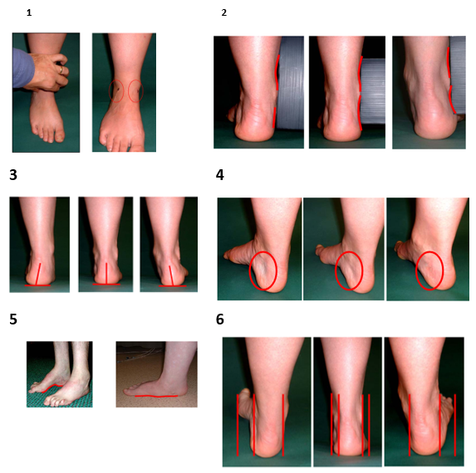

Fig.S1. Evaluation of foot-posture-Index based on six criteria. They include palpation of talar head (1), supra and infra curvature of lateral malleoli (2), calcaneal angle in frontal plane (3), prominence of tarso navicular joint (4), prominence of longitudinal arch (5) and abduction/adduction of forefoot (6). Values for each characteristic reach from -2 (supination) to +2 (pronation). 0 is the best value. Values from each characteristic are summarized to a score.

B Questionnaire
Tab.S1. Questionnaire for the Diagnosis of Knee Pain. Pain levels are reported on a VAS scale from 0 to 10.
Pain Occurrence:  a) Do you experience knee pain?  If no, you can skip the following questions. | Yes / No
Pain Location:  a) Do you have pain above the patella?  b) Do you have pain in the patellar tendon?  c) Do you specifically have pain in the lower part of the tendon that connects to the shinbone?  d) Do you have pain behind the kneecap? | Yes / No  Yes / No  Yes / No  Yes / No
Category 1: Daily Activities:  How severe is your pain on a scale from 0 to 10 in the following situations?  a) When sitting for a long time?  b) When going up and down stairs?  c) When walking long distances?  d) When performing squats?  e) When kneeling?  f) When running/jogging for a longer duration?  g) When jumping for an extended period? | 0-10  0-10  0-10  0-10  0-10  0-10  0-10
Category 2: Volleyball  - How intense is your pain during physical activity such as volleyball?  - Have you had knee pain for more than 3 months in the past (>1 year ago) but no longer experience issues? | 0-10  Yes / No

