Supporting Information

Enhanced mid-IR detection characteristics of microplastics and nanoplastics using gold nanorods cluster at microneedle tips

Hyeyeon Hur¹ , Cholong Kim¹, Ahyeon Jo¹, Gillhwan Kim¹ , Jonghoon Choi², and Hyun Ho Lee^{1*}
¹Department of Chemical Engineering, Myongji University
Yongin 17058, Republic of Korea
²School of Integrative Engineering, Chung-Ang University, Seoul 06974, Republic of Korea

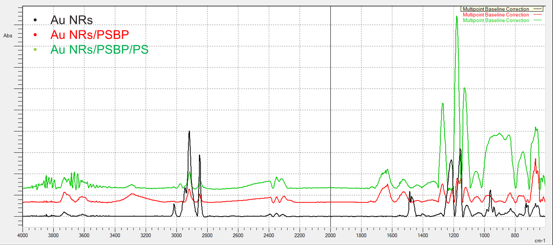

Figure S1. FTIR spectra for Au NRs’s conjugation of PSBP and after binding of PS MPs on IR detection card (PTFE mesh)

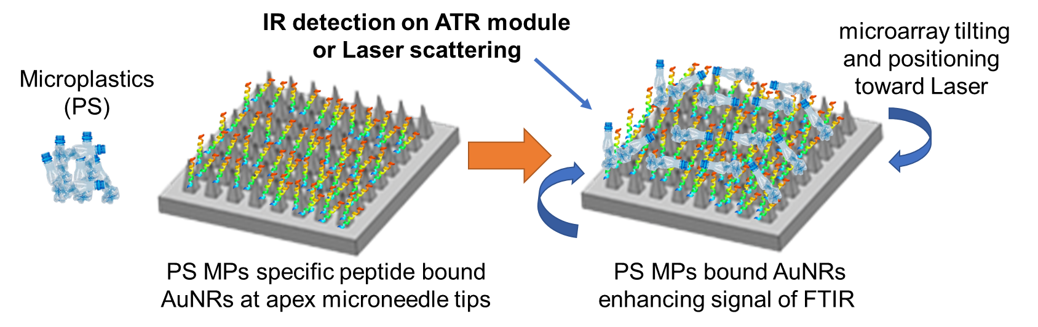
Figure S2. Illustration of microneedle array angle tuning for Raman measurement

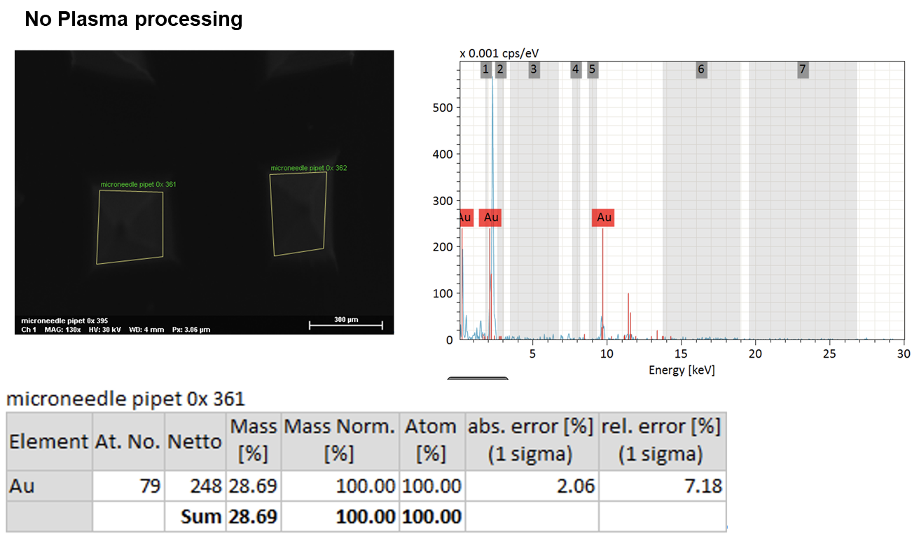
(a)
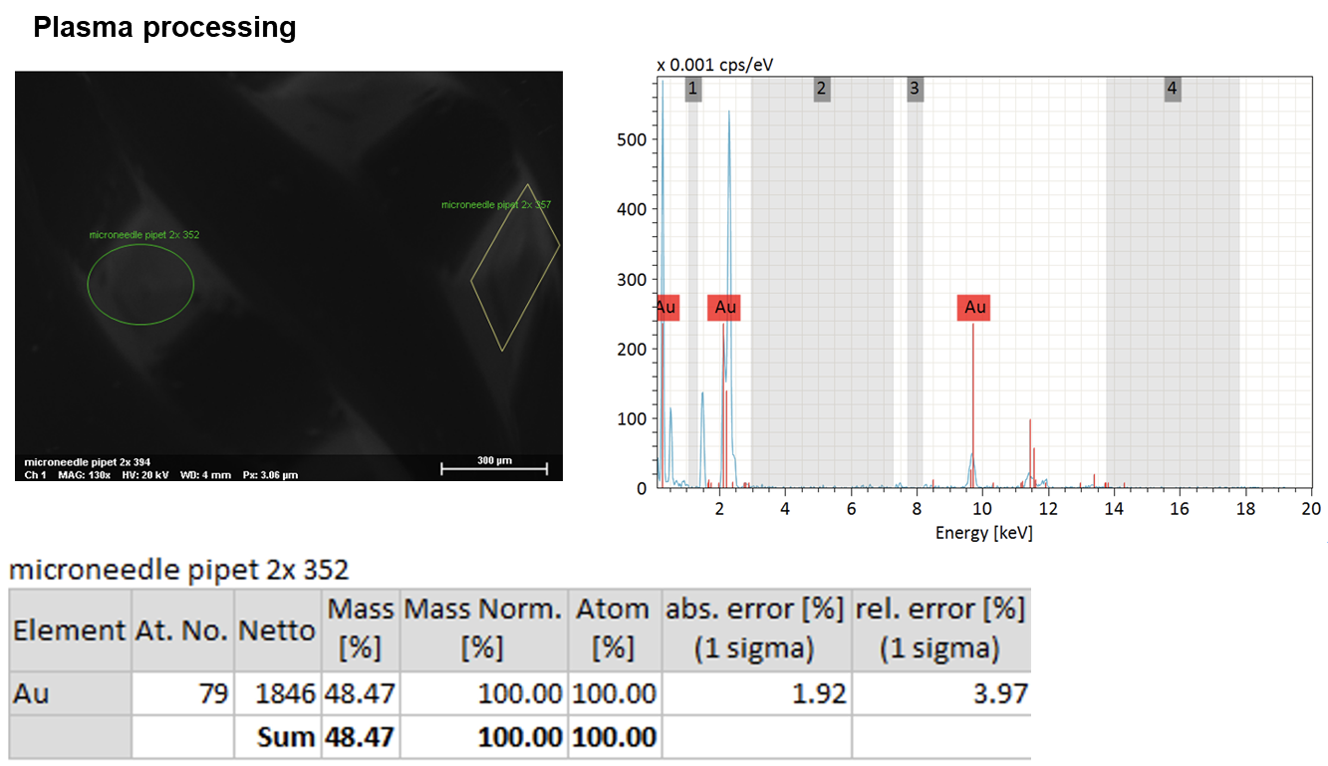
(b)
Figure S3 EDX analysis at tips of microneedle (a) before O₂ plasma treatment (b) after O₂ plasma treatment

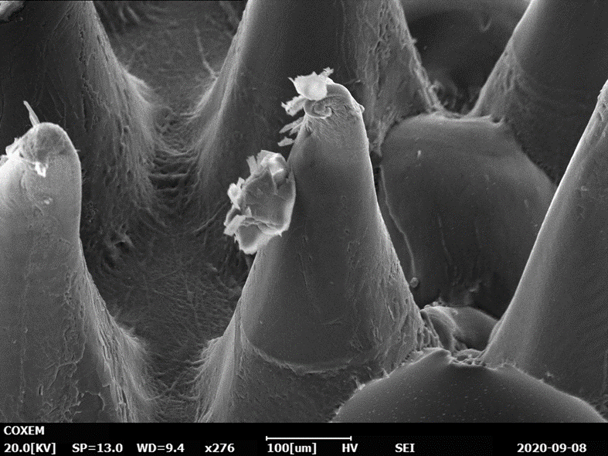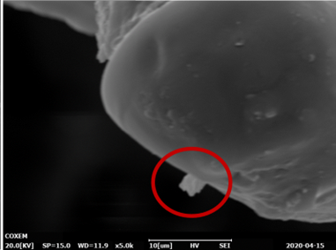
Figure S4. SEM image of imprinted conical shaped NOA microneedle array

