Supplementary information
Large scale toxicoepigenetics on histones: a mass spectrometry-based screening assay applied to developmental toxicity
Sigrid Verhelst¹, Bart Van Puyvelde¹, Sander Willems², Simon Daled¹, Senne Cornelis¹, Laura Coveleyn¹, Ewoud Willems¹, Dieter Deforce¹, Laura De Clerck^{1,#}, Maarten Dhaenens^{1,#,*}
¹ ProGenTomics, Laboratory of Pharmaceutical Biotechnology, Ghent University, Ghent, Belgium
² Department of Proteomics and Signal Transduction, Max Planck Institute of Biochemistry, 82152 Martinsried, Germany
# These authors jointly supervised
* Corresponding author

Table of Contents
Supplementary Data 1
Supplementary Data S1. 1
Supplementary Data S2 1
Supplementary Data S3. 1
Supplementary Data S4. 1
Supplementary Data S5. 1
Supplementary Figures 2
Supplementary Figure S1. 2
Supplementary Figure S2 3
Supplementary Figure S3 3

Supplementary Data
Supplementary Data S1. Excel report containing the calculations for the median, count, median of the absolute deviation, estimate of the standard deviation, and the robust estimation mean and limits for the purposes of normalization.
Supplementary Data S2. Excel report containing the deconvoluted peptide ion data exported from Progenesis QI for proteomics for all the samples included in the experiment.
Supplementary Data S3. Excel report of the data used for the creation of the heatmap for the example of VPA. The same workflow was used for all other compounds.
Supplementary Data S4. Excel report containing the calculations of the relative abundance and the boxplot representation for valproic acid. The same workflow was used for all other compounds.
Supplementary Data S5. Excel report of the flow cytometry data exported from the Kaluza analysis software (Beckman Coulter Life Sciences) and CNRQ values exported from the qbasePLUS software.

Supplementary Figures
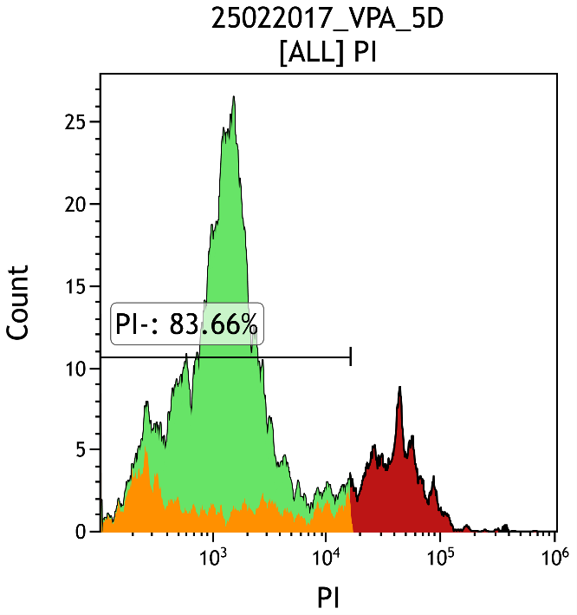
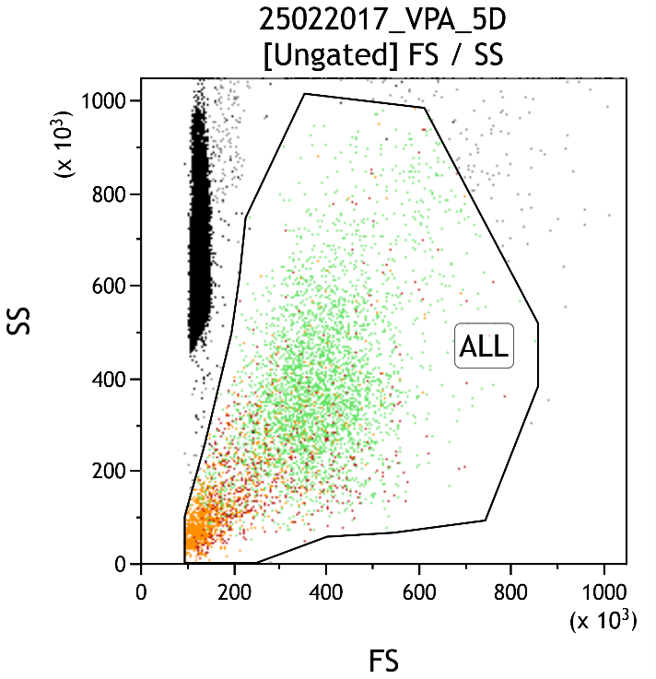
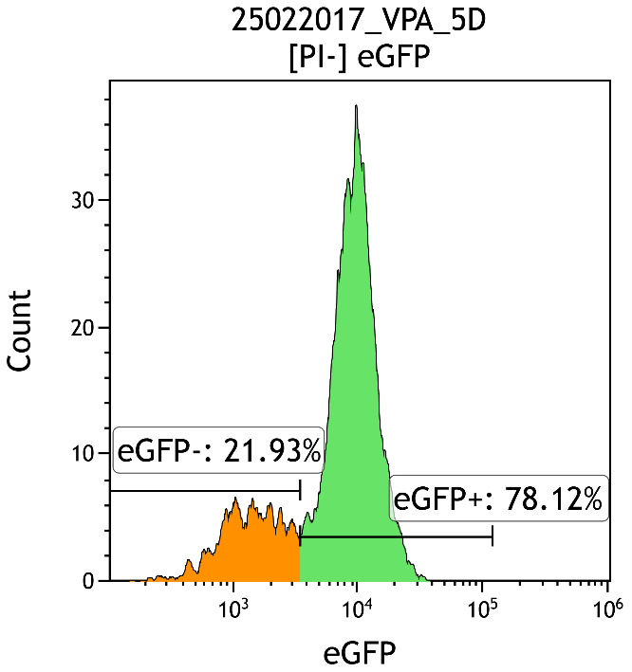
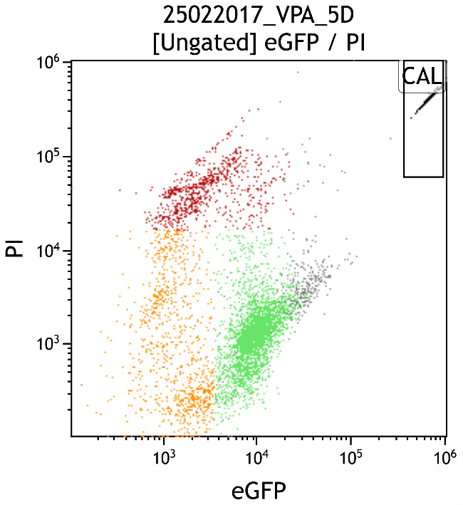
a
c
d
b

Supplementary Figure S1. Flow cytometry gates. (a) The side scatter (SS) in function of the forward scatter (FS). The black dots on the left represent the flow count beads. The green dots are the living cells (PI-), the red dots are the dead cells (PI+), and the orange dots are the eGFP negative cells. (b) is gated on A and is used to select the living cells (PI-). (c) is gated on the PI- cells and is used to select the differentiating cells (eGFP-). (d) PI in function of eGFP. In the right upper corner the flow count beads are represented. The grey dots are the cells that were not gated. (This is sample VPA 5D)

a
b
Supplementary Figure S2. Flow cytometry data of eGFP reporter hESC. (a) shows the percentage of the living cells (PI-). PI was used for staining of dead cells (PI+). The highest concentration of TSA resulted in more cell death. (b) shows the percentage of eGFP positive cells within the living cells. The highest concentration of VPA and TSA resulted in an increase of eGFP+ cells, i.e. differentiating cells.

