a 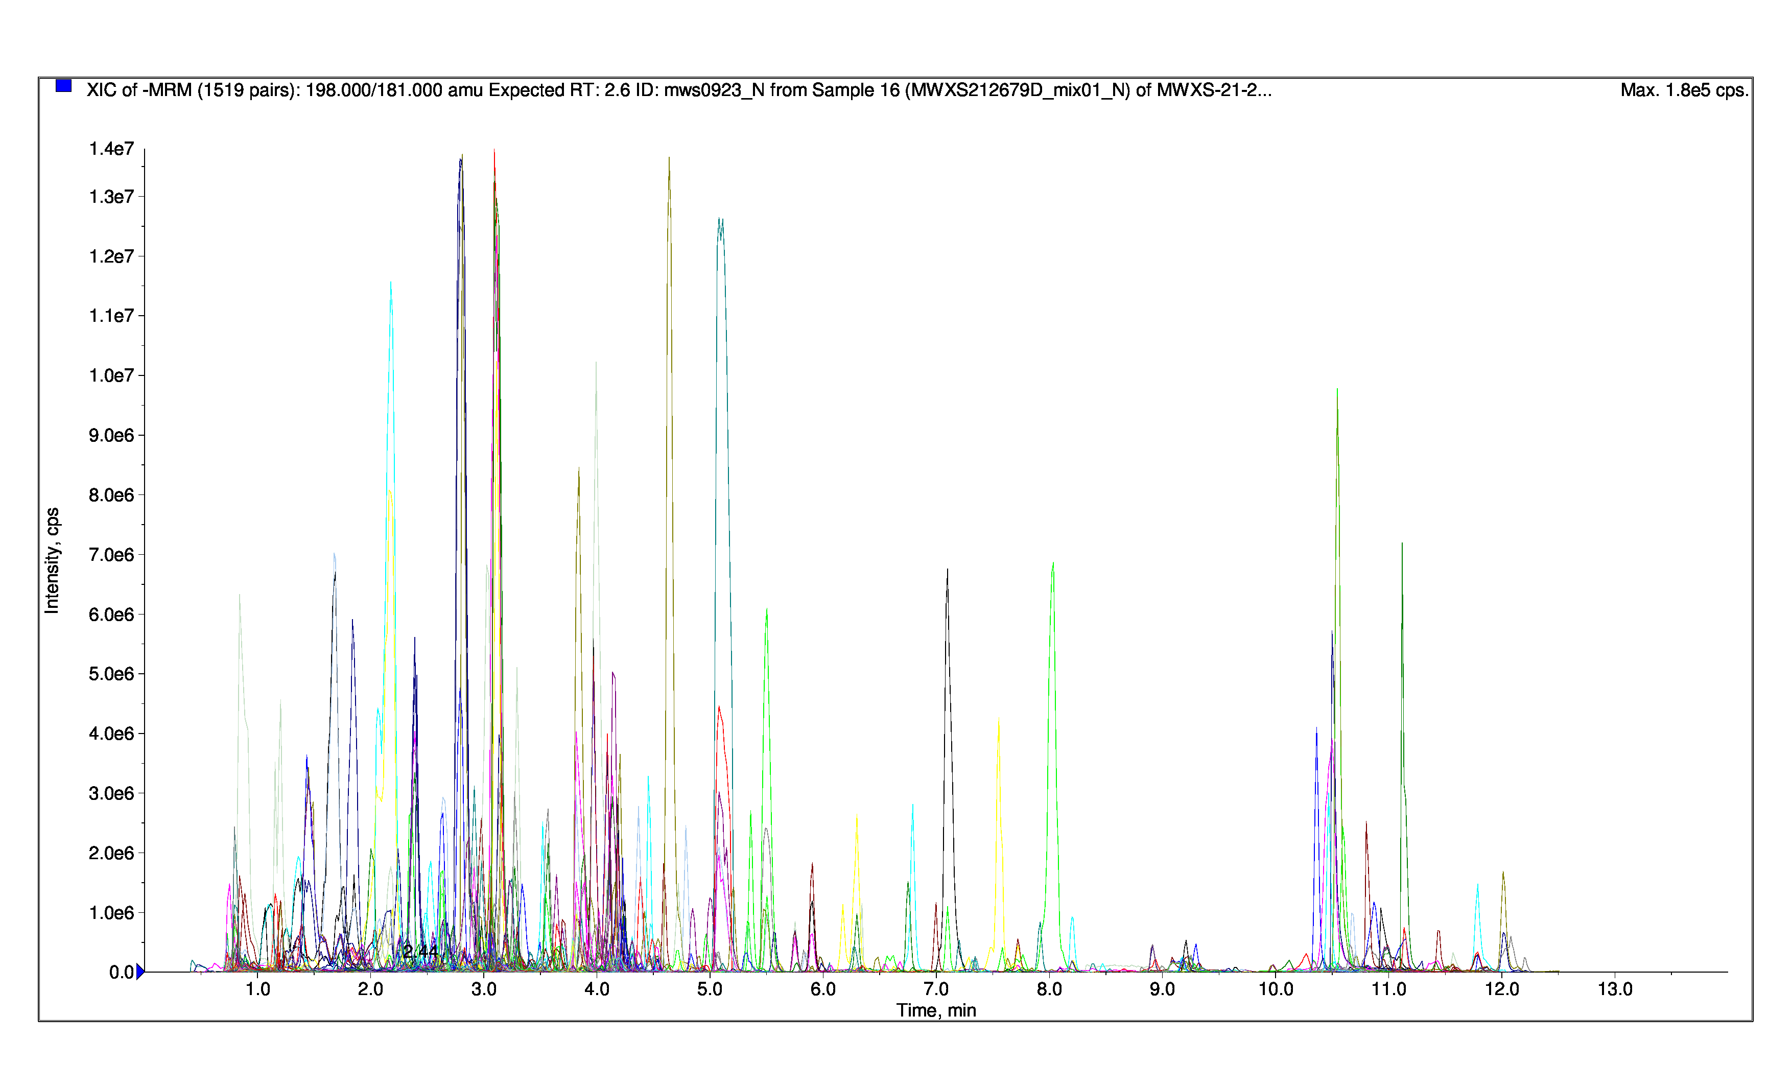 b 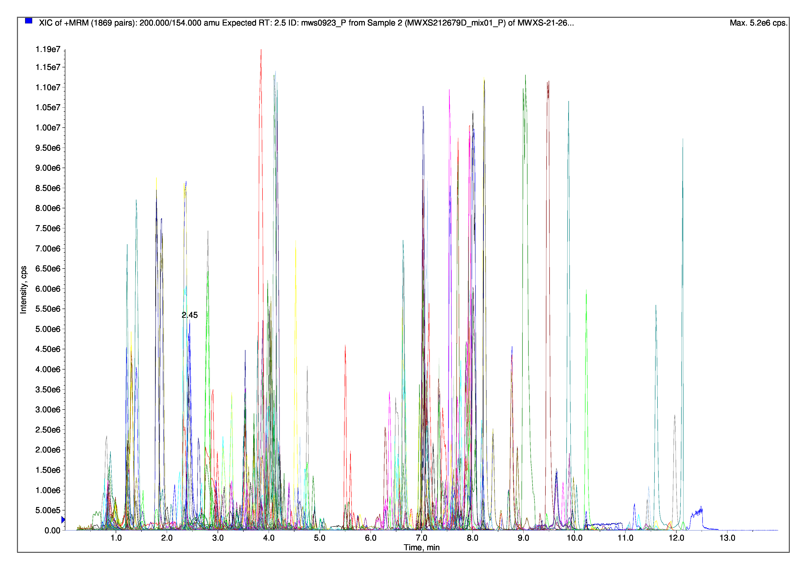
(a) Negative ion mode. (b) Positive ion mode.
Figure S1 Total ion chromatograms in positive and negative ion modes were obtained by Liquid Chromatograph Mass Spectrometer(LC-MS). Different colored peaks represent detected metabolites (horizontal axis represents retention time (Rt) of metabolite detection and vertical axis represents ion signal intensity (CPS).

