Supplementary material
Gene |  | 5'--3'
actin | F | CATGAAGTGTGATGTCGATGTCC
actin | R | CAGACGGAGTACTTTCGCTCG
DN29494 | F | GCTGCACTGCCGTATCATTG
DN29494 | R | CTGCTGCTTGAACGCTTCG
DN1711 | F | TCTCCTCGTCAACGCCATC
DN1711 | R | CCAGCAAGCAAGGTAGTTATGT
DN7069 | F | TCGACTGGTTCAAGGATAGAGG
DN7069 | R | GAGGCAGGAGAGTAGCACATAT
DN1795 | F | GATGTCGGCAATGGCAAGG
DN1795 | R | GATGGTAGCAGCAGCGTTC
DN282 | F | TTGTTGGTGGTTGCCTATGTG
DN282 | R | ACTGAGGTTGAGGAGCGATG
DN6019 | F | CGTCACCAGCAAGTACAAGAA
DN6019 | R | GCGAGGAAGAGCGAGATCA
DN4252 | F | TTGCCATCGCCACCACAT
DN4252 | R | GAAGACGCCCAGAAAGTAGAAG
DN2957 | F | AACCACTCTCAACCACCTCTC
DN2957 | R | TGGCCTTGGAGAAGTACATCTT
DN15761 | F | GTGACGCAGGACAAGAGAAC
DN15761 | R | GGATGATGAGGATAGAGCCGAA
DN10881 | F | CTTCGCCGCCATCATATTCC
DN10881 | R | CCTTCCAGACGATCAGCATTG
DN1864 | F | TACGAGCAAGGACTGGAGATTA
DN1864 | R | CGAGATGGATCACGGAGACT
DN4898 | F | CACTCTCGTCTCCAGCCTTAT
DN4898 | R | GCAGCGGTCTTGAACTCCT
DN1741 | F | GGCAGGAGCAGTACCACAT
DN1741 | R | GCGTGACCACTTATCATCTTCT
DN2618 | F | AACCAGACCGACATCACTCAT
DN2618 | R | CTTAGGACCTCCACCAATCGT
DN20386 | F | CTGGCTCTGTTCACATTCCTTC
DN20386 | R | AATGCTGCGGTGGCTGAT
Supplementary Table. 1 Target genes and the respective PCR primers

Sample | CleanData(bp) | GC(%) | Q30(%)
Arg2.5-1 | 10,583,680,200 | 54.84% | 94.39%
Arg2.5-2 | 10,376,371,200 | 55.67% | 94.36%
Arg2.5-3 | 10,050,920,100 | 55.68% | 94.33%
Arg30-1 | 9,270,846,900 | 55.20% | 94.47%
Arg30-2 | 10,137,659,700 | 55.67% | 94.55%
Arg30-3 | 9,755,761,500 | 55.44% | 94.61%
CK-1 | 9,733,505,700 | 55.79% | 94.43%
CK-2 | 10,203,585,300 | 55.88% | 94.54%
CK-3 | 9,994,708,200 | 55.58% | 94.44%
Supplementary Table. 2 Base information statistics

Group | All DEG | Up | Down
CK vs 2.5 mM | 3,370 | 1,934 | 1,436
CK vs 30 mM | 1,112 | 573 | 539
2.5 mM vs 30 mM | 3,296 | 1,851 | 1,445
Supplementary Table. 3 Differentially Expressed Genes (DEGs) Count Table
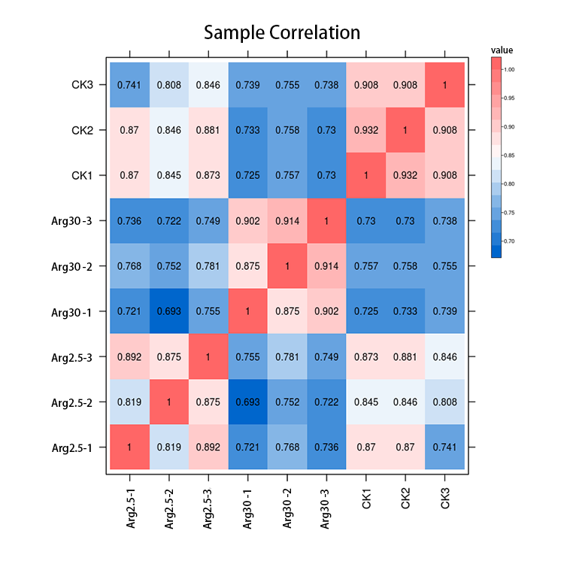
Supplementary Fig. 1 Heat map of sample correlation

