Supplementary File D:
Data repository Link

Age stratification by classifier and collection
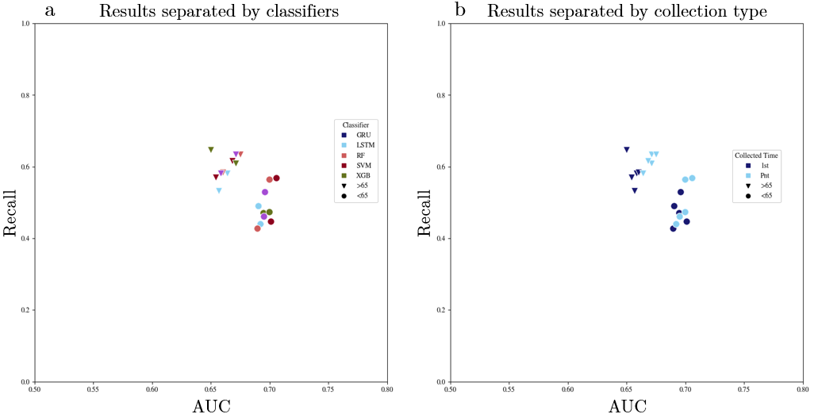
Results for Age stratification. (a) all the models created for this age stratification balanced dataset produced evident better results that unbalanced. (b) results divided by classifier aspect of models that used balanced datasets, and (c) results divided by collection time aspect of models that used balanced datasets.

