Supplementary File B:

Data Cleaning and filtering ranges

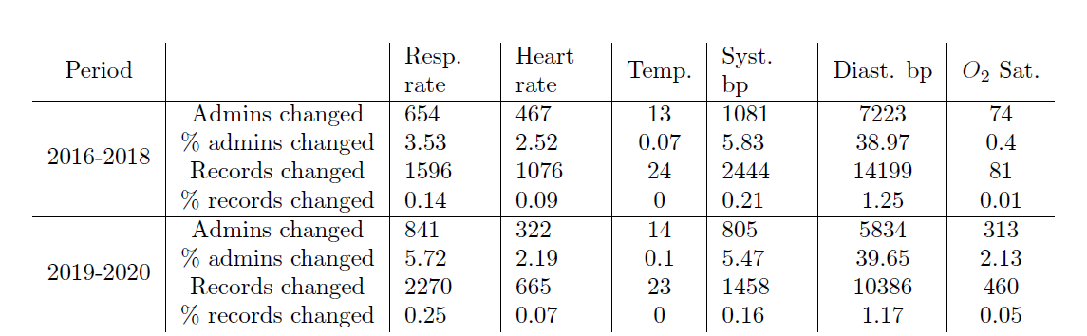
Data cleaning results based on the admissions processed. this table shows the number
of admissions changed by features in vital signs that were out of the data normal range defined based
on the clinical normal range.

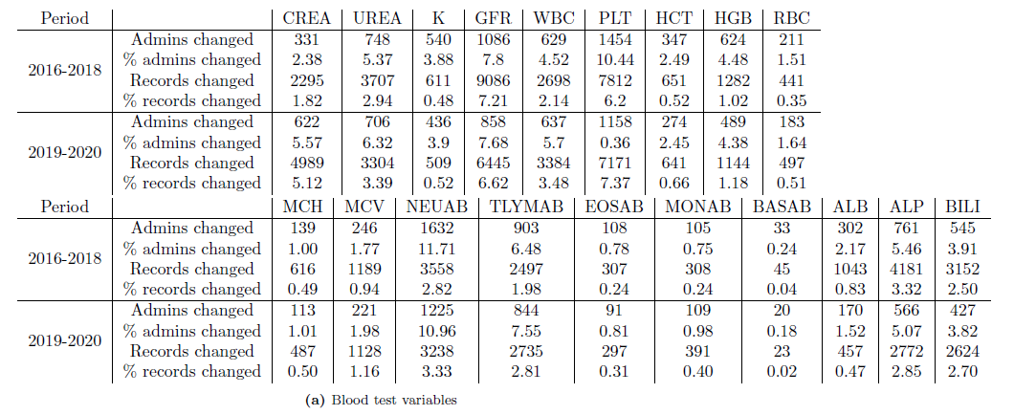
Data cleaning results based on the admissions processed. this table shows the number of admissions changed by features in blood tests that were
out of the data normal range defined based on the clinical normal range

