Salivary cystatin S in children with early childhood caries in comparison with caries-free children; statistical analysis and machine learning

Maryam Koopaie ª , Mahsa Salamati ^{b}, Roshanak Montazeri ^{c, *}, Mansour Davoudi ^{d},
Sajad Kolahdooz ^{e}

ª Associated Professor, Department of Oral Medicine, School of Dentistry, Tehran University of Medical Sciences, Tehran, Iran
^{b} Dentist, Department of Oral Medicine, School of Dentistry, Tehran University of Medical Sciences, Tehran, Iran
^{c} Associated Professor, Department of Pediatric Dentistry, School of Dentistry, Tehran University of Medical Sciences, Tehran, Iran
^{d} Department of Computer Science and Engineering and IT, School of Electrical and Computer Engineering, Shiraz University, Shiraz, Iran
^{e} Universal Scientific Education and Research Network (USERN), Tehran, Iran

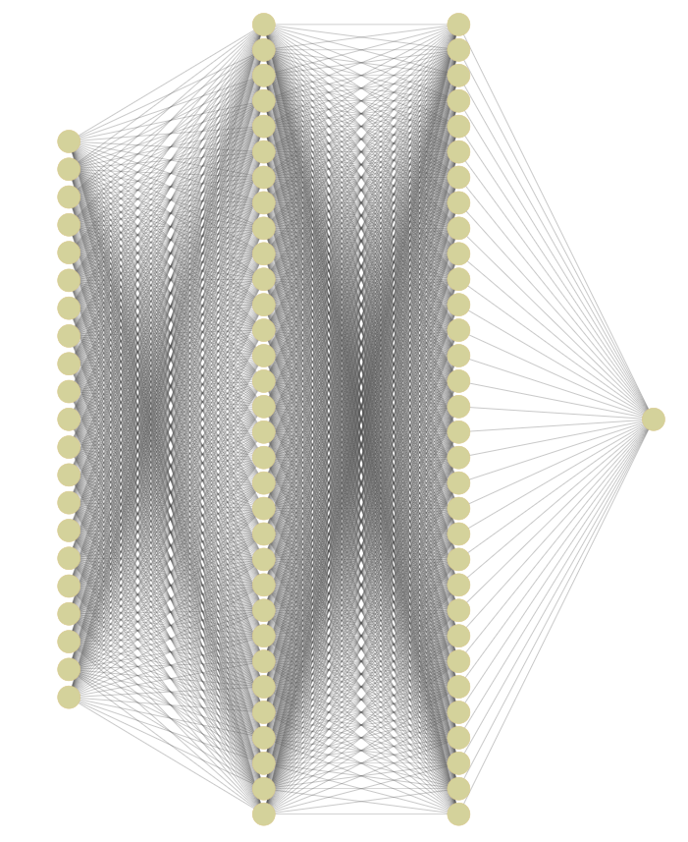
Figure 1S: Machine learning model schematic using all features expect cystatin S levels

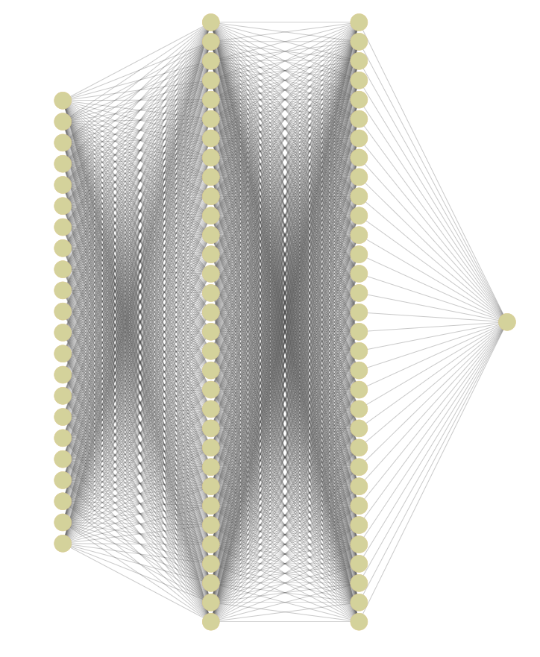
Figure 2S: Machine learning model schematic using all features

