Supplemental materials for: Assessing a low-dose copper treatment for dreissenid mussels: effects on zebra mussel (Dreissena polymorpha) population
Barbour et al., 2025

Supplement A. Application System Configuration
EarthTec QZ was applied to St. Albans Bay (Lake Minnetonka, Hennepin County, MN) in 2019 from a barge fitted with a custom application system (Figures 1.1 and 1.2). The application system used a pump (model: WB30XT; Honda Engines Group, Alpharetta, GA) to draw water directly from the bay and pump water through a venturi (model: 3090-PVDF; Mazzei Injector Company, Bakersfield, CA). The vacuum created by the venturi drew EarthTec QZ from a 275 US gal (~1040 L) intermediate bulk container (IBC tote) on deck and through a flow meter and totalizer (model: SPT-100; Seametrics Inc., Kent, WA). Two IBC totes were loaded on the boat at a time and were drawn from independently of each other. The flow rate of EarthTec QZ to the venturi was controlled with a gate valve. The water and EarthTec QZ were mixed within the venturi and delivered to a 4.9 m (16 ft) wide boom. The boom was fitted with 16 dropper hoses which applied the diluted EarthTec QZ into the bay at a depth of ~1 m. We used an agricultural GPS unit (model: FM-750; Trimble Navigation Limited, Sunnyvale, CA) to visualize and monitor the areas treated within the bay in real time.
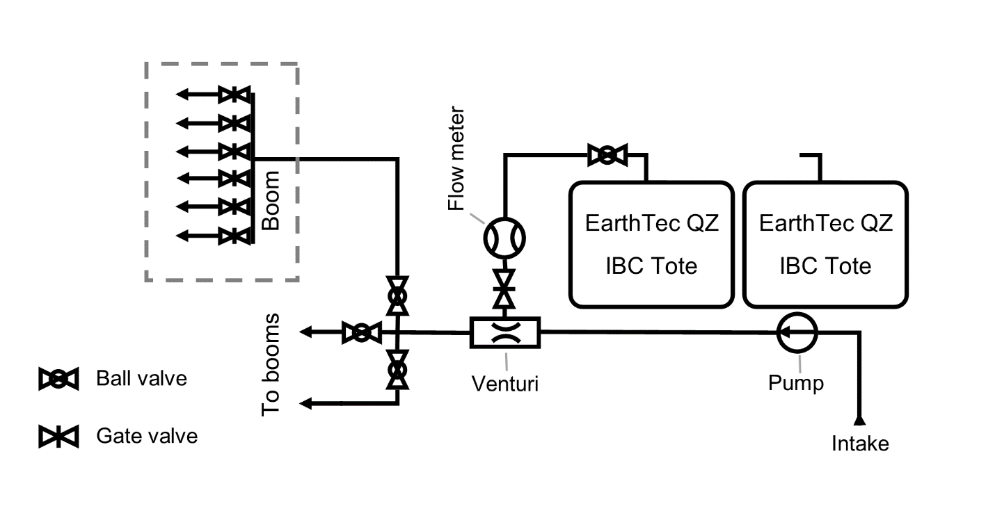
Figure A1. Schematic of the application system for EarthTec QZ applications for zebra mussel veliger suppression to St. Albans Bay in Lake Minnetonka (Hennepin County, MN) during the summer of 2019. The starboard and port boom segments each had 4 dropper hoses and the bow (center) boom had 8 dropper hoses.
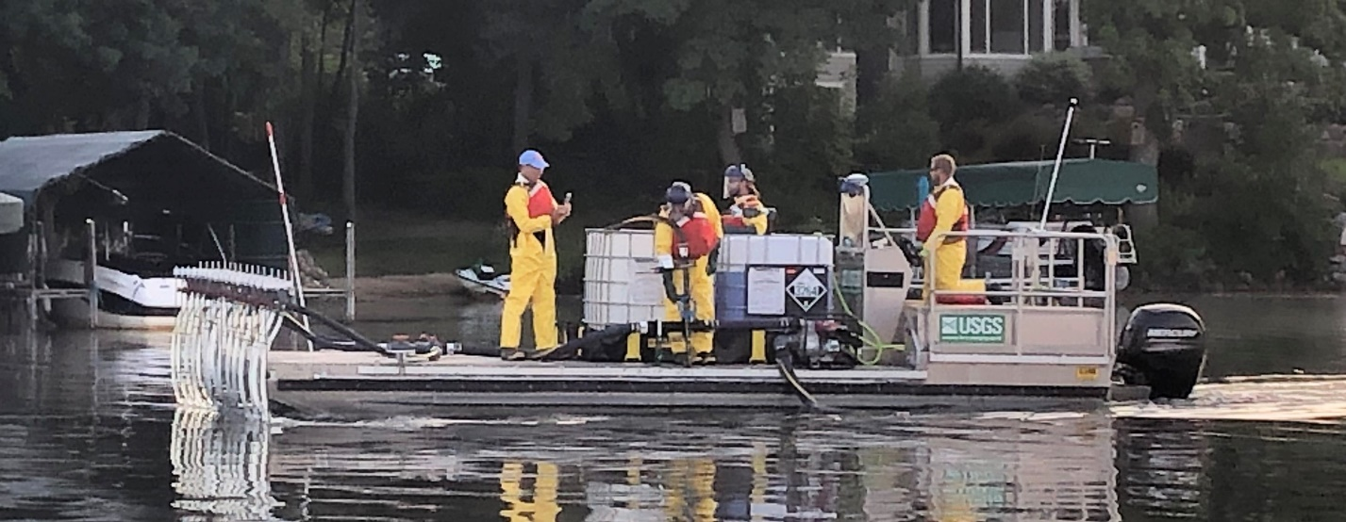
Figure A2. Flat-deck boat with application system (diagrammed in Figure 1.2) applying EarthTec QZ to St. Albans Bay, Lake Minnetonka (Hennepin County, Minnesota) on 24 July 2019.

Supplement B. Contract laboratory methods

RMB Environmental Laboratory, Inc.
220 W 95th Street, Bloomington, MN 55431, USA

Zooplankton and Veligers
RMB Environmental Laboratories uses the following protocol to analyze lake zooplankton samples based on Minnesota Department of Natural Resources lab procedures. Each zooplankton sample was filtered through an 80-μm mesh sieve, with the original alcohol retained for future sample preservation. Specimens were rinsed into a graduated beaker and water was added to dilute the sample to a known volume. An aliquot of 1 mL was withdrawn from each sample using a pipette and transferred to a Sedgewick-Rafter counting cell. Specimens from each aliquot were enumerated and identified to family or genus level where possible. In the copepod group, only mature calanoid specimens and mature female cyclopoid specimens could be identified beyond family level. Each cell was also analyzed for zebra mussel veligers using cross-polarized light sources. Veligers were enumerated and grouped into the following size classes: D-hinge (<112 μm), umbonal (112-231 μm), and pediveliger (>231 μm). Measurements were taken using digital imaging software to confirm specimen lengths where needed. Additional 1-mL aliquot subsamples were analyzed until a minimum of 150 zooplankton specimens were identified. The sample was then condensed into glass Petri dishes for a large/rare scan. Samples were analyzed under a dissecting microscope for large organisms such as Leptodora or Bythotrephes which are not collected as readily through subsampling methods. Densities (individuals per L) and total counts for each taxonomic group identified were calculated for each sample.
References
Balcer, M. D., N. L. Korda, and S. I. Dodson. 1984. Zooplankton of the Great Lakes: A Guide to the Identification and Ecology of the Common Crustacean Species. University of Wisconsin Press, Madison, WI.
Smith, D. G. 2001. Pennak’s Freshwater Invertebrates of the United States: Porifera to Crustacea. 4th edition. John Wiley and Sons, Inc., Hoboken, NJ.
Torke, B. G. 1979. A key to the identification of the cyclopoid copepods of Wisconsin, with notes on their distribution and ecology. Wisconsin Department of Natural Resources.
Torke, B.G. Unpublished. A Key to the Calanoid Copepoda of Wisconsin.

Benthic Invertebrates
RMB Environmental Laboratories uses the following protocol to analyze lake macroinvertebrate samples based on Minnesota Pollution Control Agency lab procedures. Each macroinvertebrate sample was filtered through an 80-µm mesh sieve, with the original alcohol retained for future sample preservation. The sample was rinsed into a series of glass petri dishes with water to allow the detritus to be easily moved around and searched for organisms. Samples were searched under a dissecting scope at low power (7–10x) to locate all macroinvertebrate specimens, which were stored in a vial with 80% ethanol. Samples with macroinvertebrates far exceeding the 300-count target were to be subsampled; however, none of the samples in this project reached densities that high. The remaining debris was returned to the original sample container and preserved with the original alcohol. Each sample was identified to genus level where possible using current published taxonomic references. Taxonomically challenging specimens were photographed and other taxonomists were consulted to determine designations. All identifications were recorded on original data sheets and entered in a spreadsheet for the project.
References
Burch, J. B. 1989. North American freshwater snails. Malacological Publications, Hamburg, MI.
Burch, J. P. 1972. Freshwater sphaeriacean clams (Mollusca: Pelecypoda) of North America. University of Michigan Library, Ann Arbor, MI.
Hilsenhoff, W. L. 1995. Aquatic insects of Wisconsin : keys to Wisconsin genera and notes on biology, habitat, distribution and species. no. 3, Natural History Museums Council, University of Wisconsin-Madison, Madison, WI.
Holsinger, J. R., Oceanography and Limnology Program (Smithsonian Institution), and U.S. Environmental Protection Agency. 1972. The freshwater amphipod crustaceans (Gammaridae) of North America. Biota of freshwater ecosystems identification manual no. 5, U.S. Environmental Protection Agency, Washington, DC.
Kathman, R. D., and R. O. Binkhurst. 1998. Guide to the freshwater oligochaetes of North America. Aquatic Resources Center, College Grove, TN.
Klemm, D. J. 1985. A Guide to the freshwater Annelida (Polychaeta, naidid and tubificid Oligochaeta, and Hirudinea) of North America. Kendal Hunt Publishing Company, Dubuque, IA.
Klemm, D. J. 1991. Taxonomy and pollution ecology of the Great Lakes region leeches (Annelida: Hirudinea). Michigan Academy of Science, Arts, and Letters, Alma, MI.
Klubertanz, T. H. 2016. Mayfly larvae of Wisconsin. University of Wisconsin-Extension, Madison, WI.
Merritt, R. W., K. W. Cummins, and M. B. Berg, editors. 2019. An Introduction to the Aquatic Insects of North America. 5th edition. Kendal Hunt Publishing Company, Dubuque, IA.
Needham, J. G., M. J. Westfall, and M. L. May. 2000. Dragonflies of North America. Revised. Scientific Publishers, Gainesville, FL.
Peckarsky, B. L., P. R. Fraissnet, M. Penton, and D. J. Conklin. 1990. Freshwater Macroinvertebrates of Northeastern North America. New Books, Inc., Portland, OR.
Smith, D. G. 2001. Pennak’s Freshwater Invertebrates of the United States: Porifera to Crustacea. 4th edition. John Wiley and Sons, Inc., Hoboken, NJ.
Wiggins, G. B. 1996. Larvae of the North American caddisfly genera (Trichoptera). 2nd edition. University of Toronto Press, Ottowa, ON.
Williams, W. D., Oceanography and Limnology Program (Smithsonian Institution), and U.S. Environmental Protection Agency. 1972. Freshwater isopods (Asellidae) of North America. Biota of freshwater ecosystems identification manual no. 7, U.S. Environmental Protection Agency, Washington, DC.

Supplement C. Water Chemistry Summary
There were no treatment-related trends in the monitored water chemistry parameters in either bay. The lowest dissolved oxygen measurement (5.94 mg/L) was 2 weeks after the treatment in St. Albans Bay (Figure 3.1). Mean (standard deviation) dissolved oxygen in St. Albans Bay during the treatment was 7.77 (0.49) mg/L, temperature was 25.5 (0.7) °C, pH was pH 8.09 (0.07), and specific conductance was 387.9 (13.8) µS/cm at 25 °C. In Robinson Bay, mean dissolved oxygen was 9.19 (0.35) mg/L, temperature was 25.2 (0.8) °C, pH was pH 8.51 (0.05), and specific conductance was 392.1 (11.8) µS/cm at 25 °C. Mean (range) alkalinity was 128 mg/L as CaCO₃ (105 – 156) and total hardness was 150 mg/L as CaCO₃ (130 – 169) in St. Albans Bay over the duration of observation.
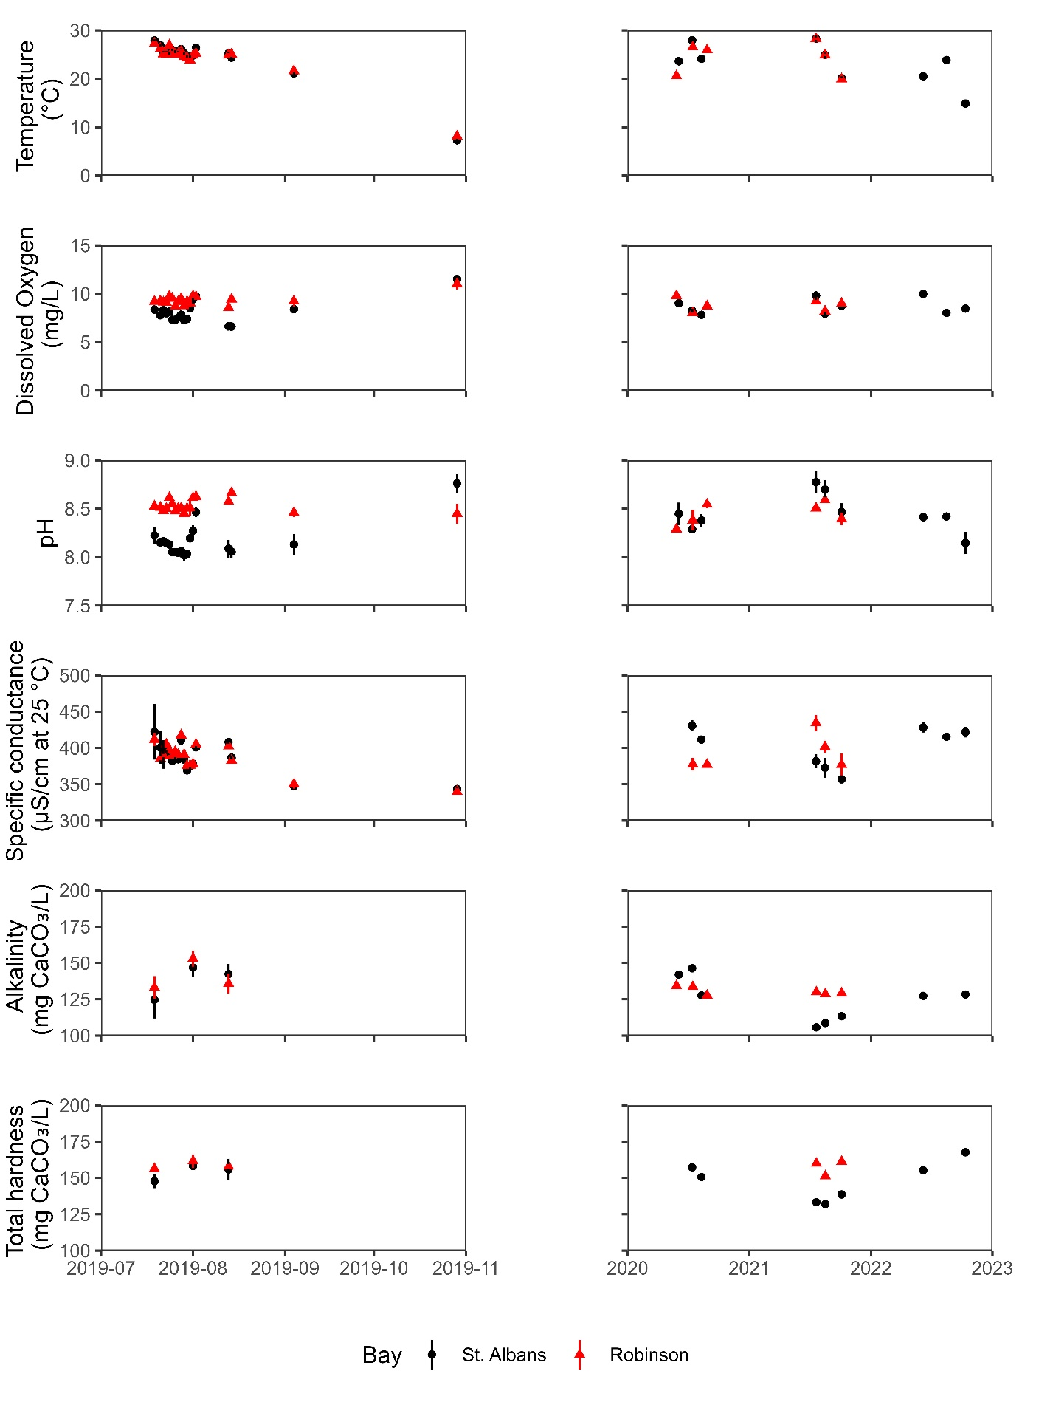
Figure B1. Select water chemistry parameters monitored before, during, and after a 10-d copper treatment using EarthTec QZ in 2019 in St. Albans Bay (treated; black circle) and Robinson Bay (reference; red triangle). Points are the mean measurement of 5 locations in each bay. Error bars represent 1 standard deviation.

