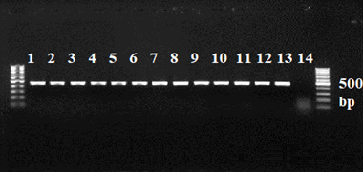
Figure 2. Electrophoresis of the PCR product using specific primers for Acanthamoeba using the mip gene sequence isolated from hospital water sources in Birjand city.
(M: JDP1,2 Marker, Line 1-12: positive samples, Line13: PC positive control, and Line14: NC negative control)

