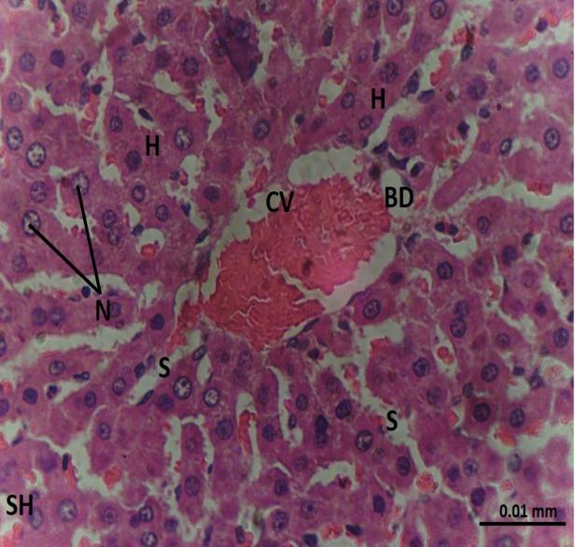
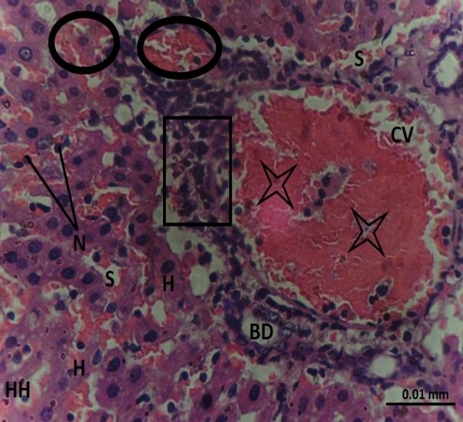
Sham (X100) HIRI (X100)
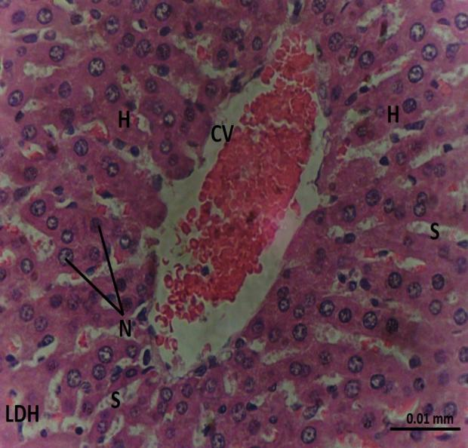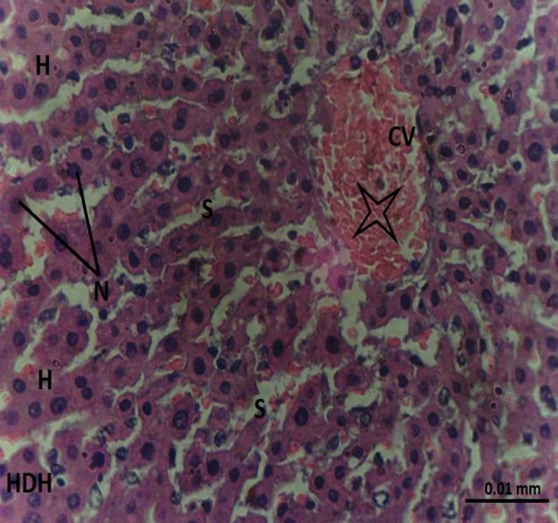
LDH (X100) HDH (X100)

Plate 1: Photomicrographs showing the effects of B. pinnatum on the histology of the liver following HIRI

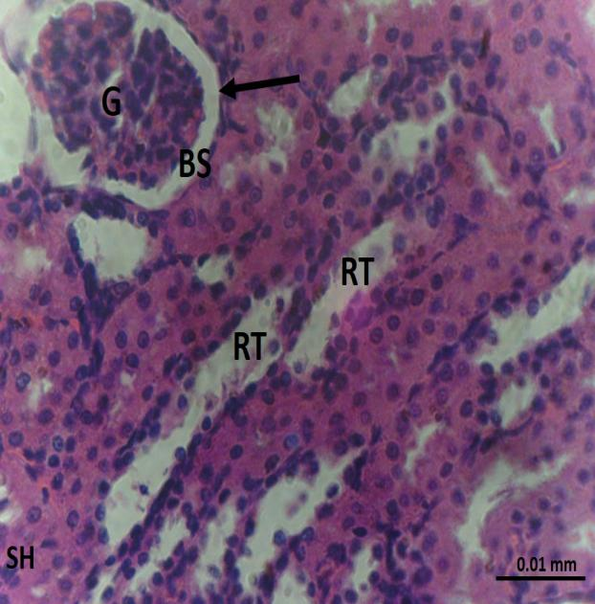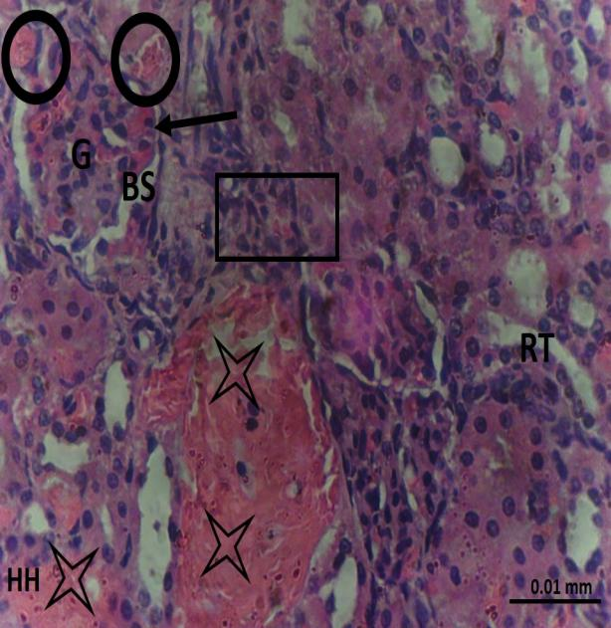
Sham (X100) HIRI (X100)

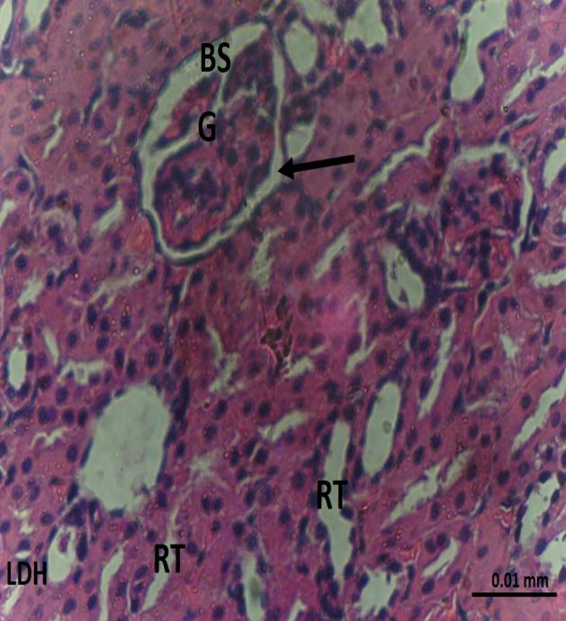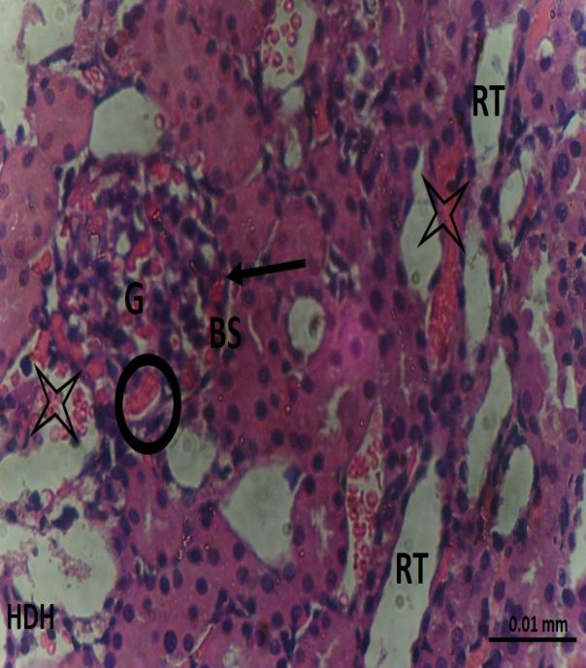
LDH (X100) HDH (X100)

Plate 2: Plate 1: Photomicrographs showing the effects of B. pinnatum on the histology of the kidney following HIRI

