Supplementary Information:

Appendix 1: Questionnaire

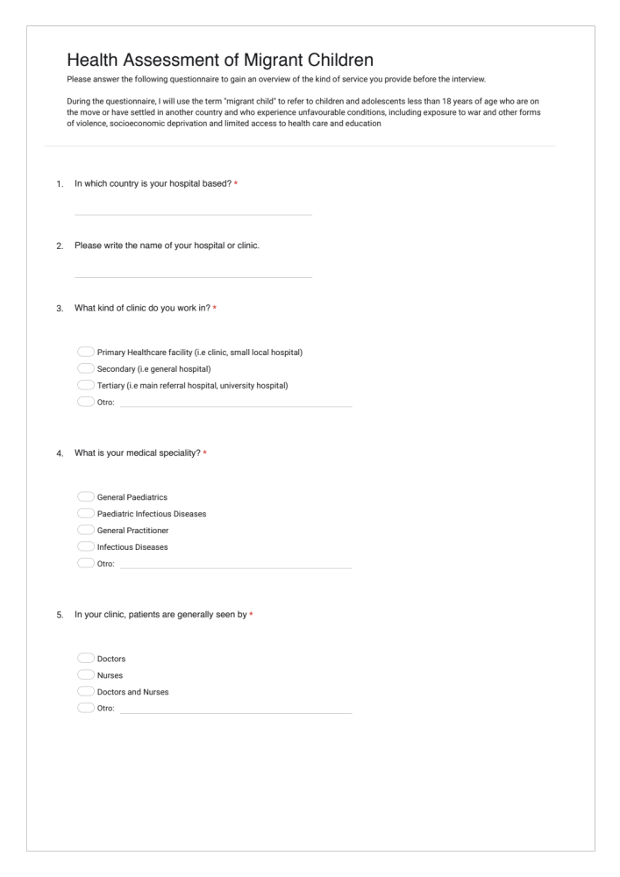
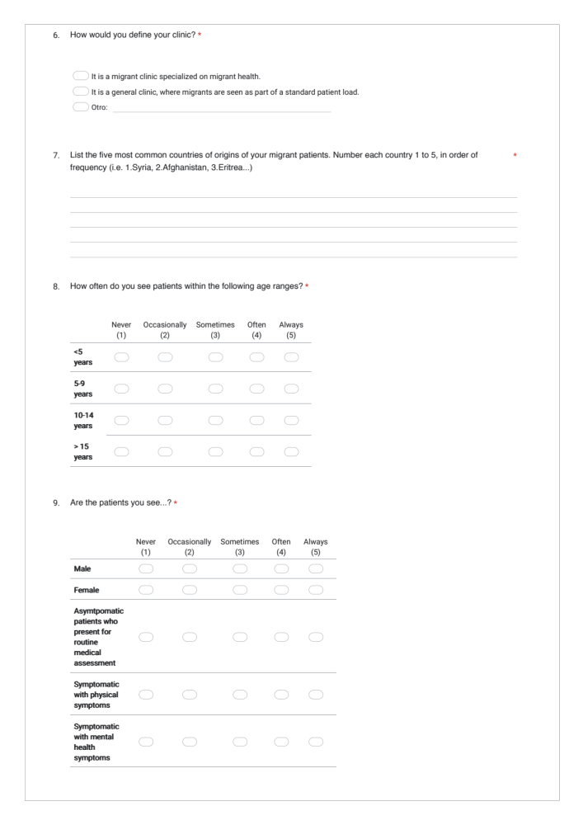

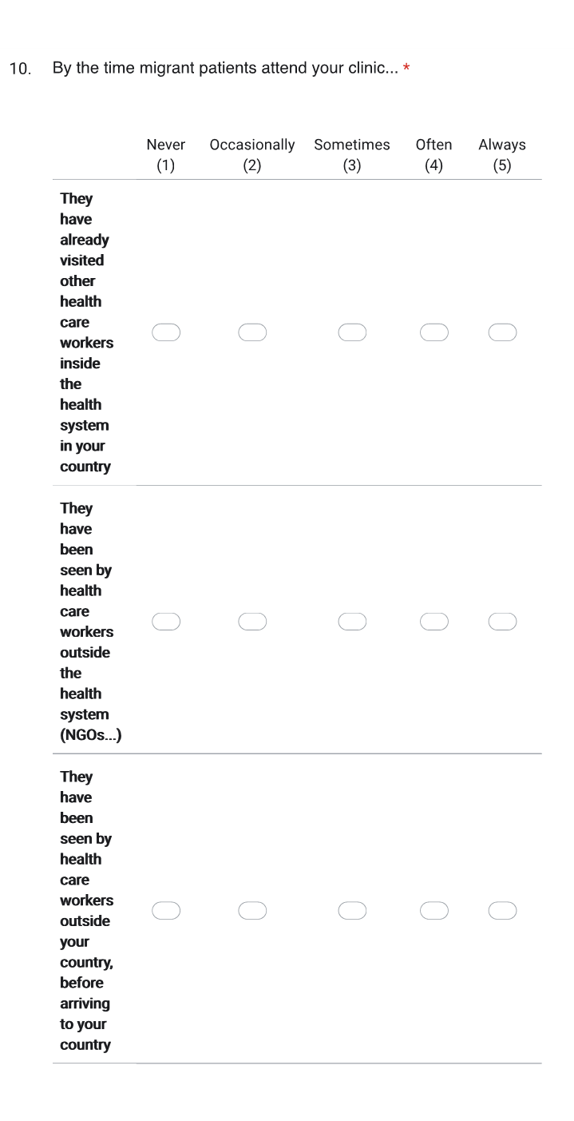
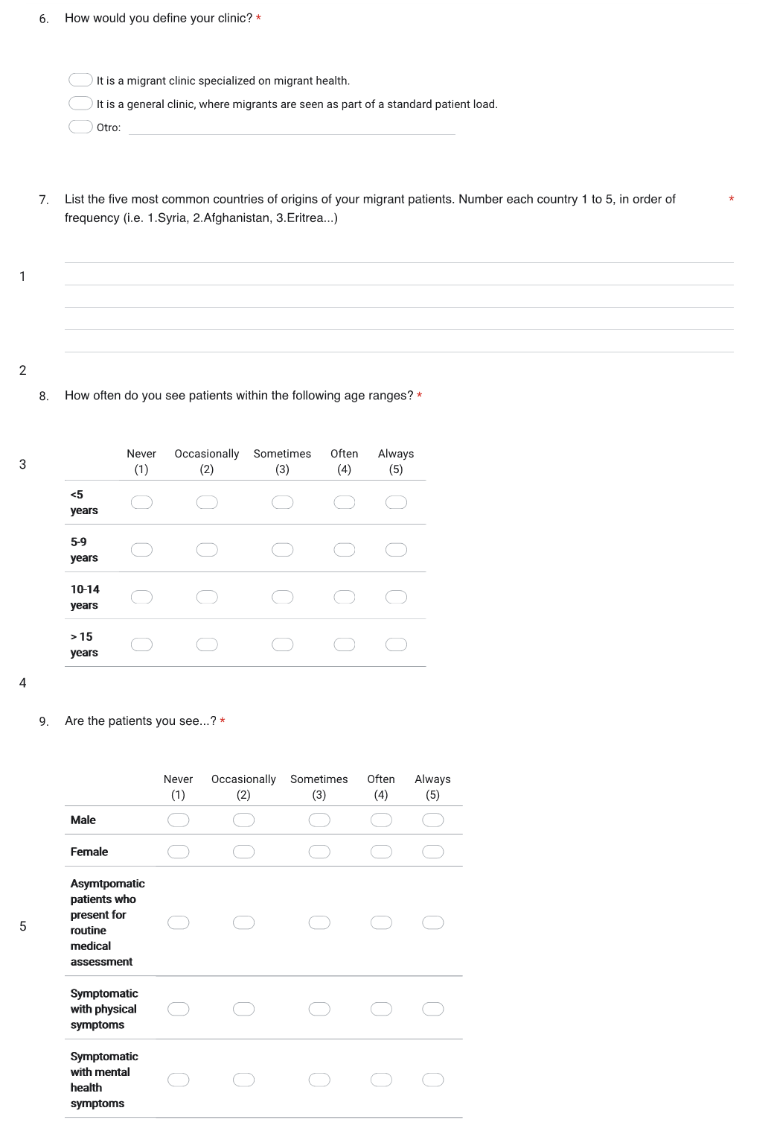
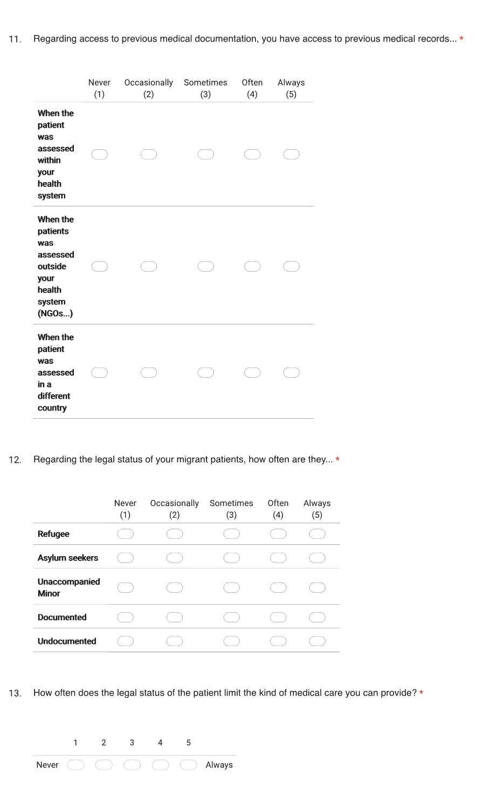
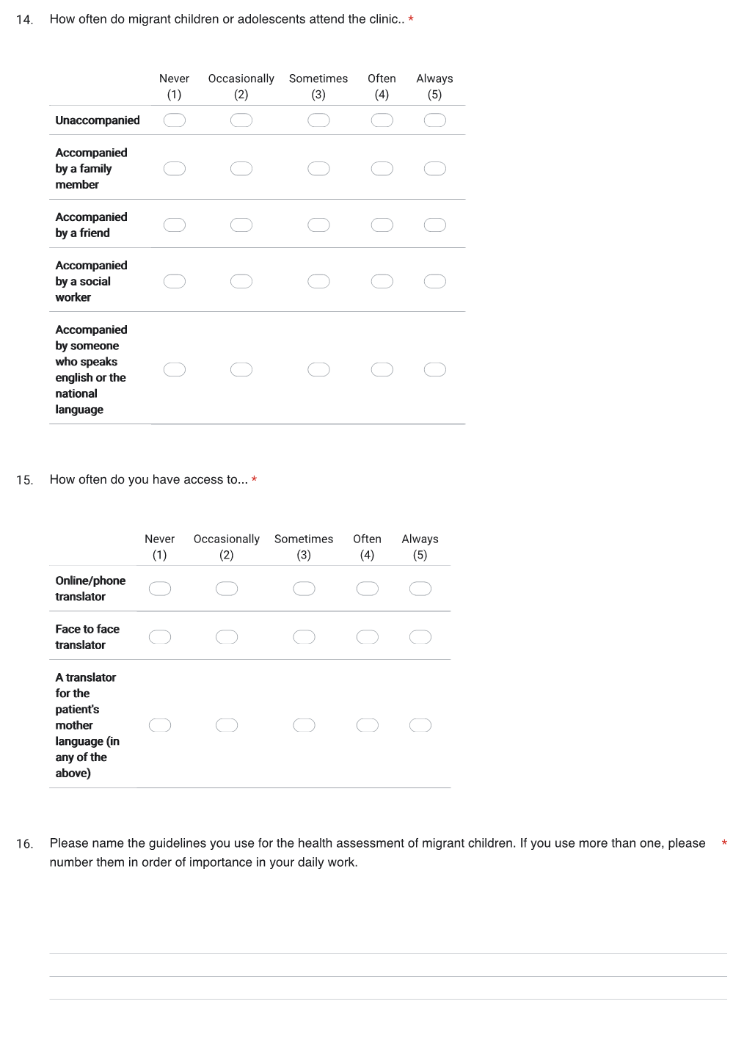
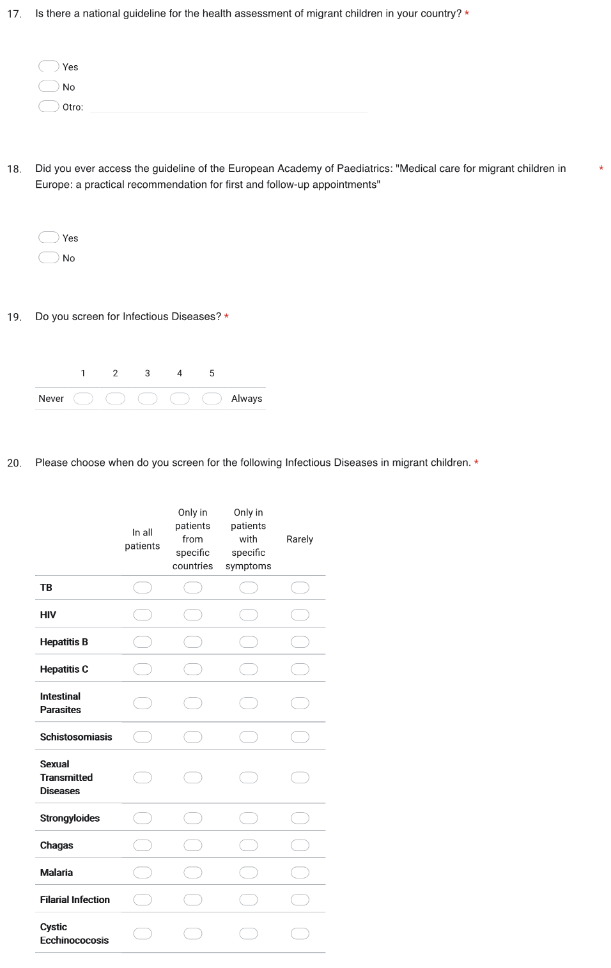
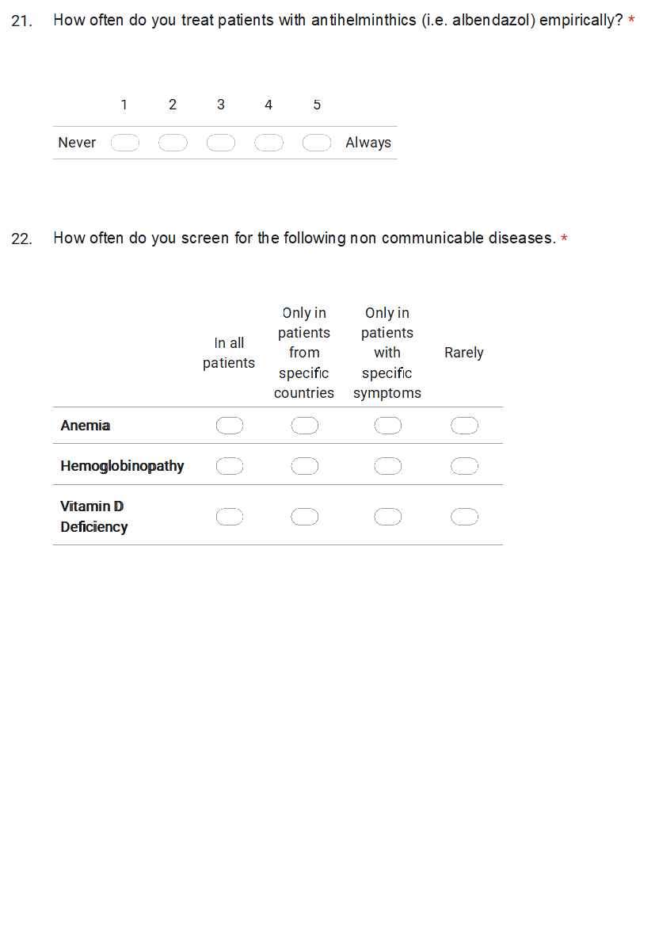
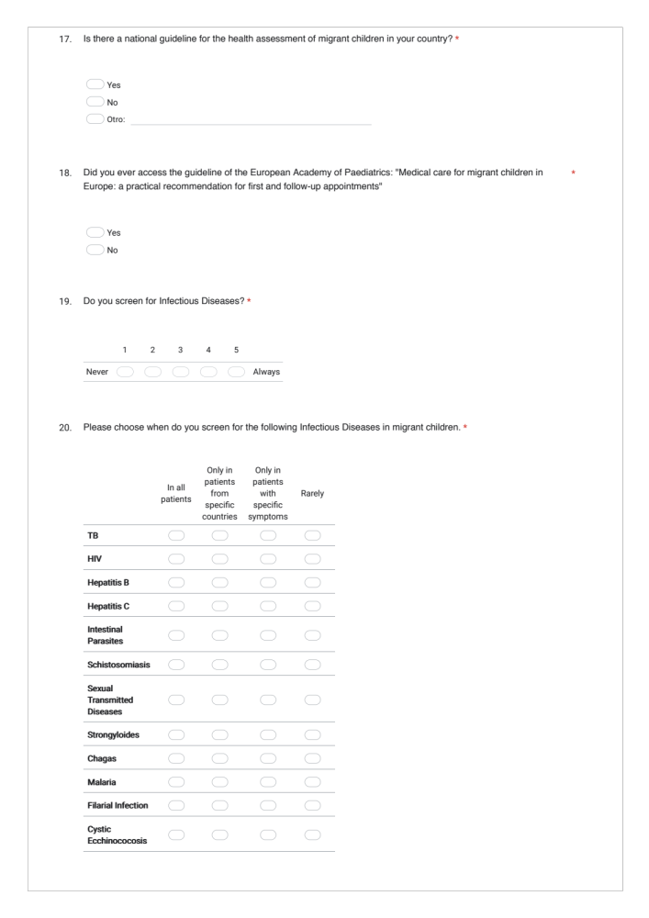

Appendix 2: Topic Guide

- Features of the Initial Health Assessment - Comment and Summarise the results of the questionnaire

To start we will go through some of your questionnaire answers so you can comment on why you do things in a certain way and share challenges and positive ressources you find at each point.

Key Areas | Headline Questions? | Themes | Subtopic | Potential questions
ID Screening | Comment on Questionnaire answers. | TB |  | Are there specific regulations, perceptions or other barriers that stop you doing these
ID Screening | Comment on Questionnaire answers. | HIV
ID Screening | Comment on Questionnaire answers. | Hepatitis
ID Screening | Comment on Questionnaire answers. | Intestinal Parasites | Empirical Treatment with Albendazole?
ID Screening | Comment on Questionnaire answers. | Schistosomiasis
ID Screening | Comment on Questionnaire answers. | STD
ID Screening | Comment on Questionnaire answers. | Other | Chagas diseases | Are there things you feel are more important etc?
ID Screening | Comment on Questionnaire answers. | Other | Filarial infection | Are there things you feel are more important etc?
ID Screening | Comment on Questionnaire answers. | Other | Malaria | Are there things you feel are more important etc?
ID Screening | Comment on Questionnaire answers. | Other | Cystic echino. | Are there things you feel are more important etc?
ID Screening | Comment on Questionnaire answers. | Other | Strongyloidis | Are there things you feel are more important etc?
Immunisation | “How do you approach immunisation?” | Access to previous immunisation | Documentation | How do you identify if there was previous vaccination?
Immunisation | “How do you approach immunisation?” | Vaccination | Completion of the entire national vaccination program?
Immunisation | “How do you approach immunisation?” | Vaccination | Only specific vaccines?  - Which vaccines?
Immunisation | “How do you approach immunisation?” | Vaccination | - Where does vaccination occur?
Immunisation | “How do you approach immunisation?” | Vaccination | SOP for catch-up/ accelerated vaccination?
Non-communicable diseases + Developement  (Non-ID Screening)  **Paediatric population. | In younger children, how do you approach growth and development? | Growth and Nutrition | - parents/carers have concerns about their child’s growth/nutrition
 |  | Growth and Nutrition | diet, nutrition and access to healthy food
 |  | Growth and Nutrition | centiles for body mass index
 |  | Growth and Nutrition | vit D and iron deficiency anaemia | here check questionnaire answers
 |  | Development and Education | -parents/carers have any concerns about their child’s development?
 |  | Development and Education | - developmental or learning difficulties?
 |  | Development and Education | Vision and Hearing loss
 |  | Development and Education | previous and current access to education, and whether extra support was needed?
 |  | Congenital Anomalies |  | How often?
Sexual Health | “Regarding sexual health, how do you approach it?” | Screening | STD (adolescents)
Sexual Health | “Regarding sexual health, how do you approach it?” | Screening | Female genital mutilation
Mental Health | “Next I want to explore with you the issue of mental Health. How do you assess it?” | Screening  (of Risk Factor and Symptoms) |  | Do you ask or screen patients for Mental Health?
Mental Health |  | Symptoms | for parents: behavioural concerns | What kind of psychological manifestations do you see?
Mental Health |  | Medication
Mental Health |  | Available expert (psychiatrists and psychologists) | -Referral | Do you have access to a psychologist or psychiatrist?
Pathway | “From a health care perspective, where do patients come from and where do they land afterwards?” | -previous access to health care | primary care?
Pathway |  | -posterior access to healthcare
Pathway |  | - social/living situation  -since when in country
Pathway |  | Follow-up appointment |  | “How often do they have a follow up ?”  “In the same or different clinic?”
Documentation System | “What kind of documentation system do you use?” | Digital or Paper | Access for future doctors
Documentation System | “What kind of documentation system do you use?” | Inside the region and  country  Outside the country | Access to previous medical records
Documentation System | “What kind of documentation system do you use?” | Barriers | Time consuming?  Lack of prev medical history?
Documentation System | “What kind of documentation system do you use?” | Facilitators | New Tools  Access
Translators | “How relevant is the language barrier in your work?” | Access  Quality
Guideline | “I would like to hear your thoughts on the available guidelines?” | National Guideline | for ID screening
Guideline |  | National Guideline | for refugee assessment? or Migrant children?
Guideline |  | National Guideline | Access
Guideline |  | National Guideline | Quality | Comprehensive?
Guideline |  | National Guideline | Adapted to your context? | Designed for Primary Care or Second/Tertiary Care?
Guideline |  | European Guideline (EPA) | Access  Quality  Adapted to your context?
Guideline |  | Other guidelines? | European…
Training | “Are there trainings/courses on migrant health available in your area?” | availability  access  quality
Financial limitations | “What role does funding play in your assessment?” | Barriers | -Funding of Salaries for Healthcareworkers  -Lab and tests | Comment on questionnaire answer about limitations on care
Financial limitations | “What role does funding play in your assessment?” | Facilitators | -who pays?

2. Barriers, Facilitators and Suggestions

Introducing the last part of the discussion:
“We have now gone through the main aspects of the health assessment, and I would like to discuss with you the Assessment from a more overall perspective. “

Key Areas | Headline Questions? | Themes | Subtopic | Potential questions
Facilitators/ positive | “And what resources or other facilitators do you find most helpful?” | -Improvements in the last years. |  | How have the guidelines help you offer better care?
Barriers/ negative | “In your experience, which have been the main challenges in the assessment of these patients so far?” | -Lack of Resources  -Moving Patients  - Lack of Training
Suggestions for the future | “ In your opinion, what should be done to improve the health assessment of migrant children in the next years? “ | Evolution in care since last migrant crises? |  | What new tool have help you provide a better care since you first started working with refugees?

Appendix 3: Coding Framework

THEMES | SUBTHEMES | CODES
Service structure | Clinical Presentation
Service structure | Healthcare Pathway | Posterior Healthcare
Service structure | Healthcare Pathway | Previous Healthcare
Service structure | Access
Service structure | Coverage
Service structure | Funding | Funding available
Service structure | Funding | Funding challenges
Service structure | Level of Care | Describing the level of care
Service structure | Level of Care | Challenges in other levels of care
Service structure | Expertise in the service
Service structure | Type of patients | Accompanied minors
Service structure | Type of patients | Unaccompanied minors
Service structure | Type of patients | Undocumented Patients
Features of the Health Assessment | History taking
Features of the Health Assessment | Physical Examination
Features of the Health Assessment | Immunisation | Access to immunisation status
Features of the Health Assessment | Immunisation | Serology Screening
Features of the Health Assessment | Immunisation | Place of vaccination
Features of the Health Assessment | Immunisation | Documentation of the vaccines
Features of the Health Assessment | Immunisation | Vaccination Guidelines
Features of the Health Assessment | Infectious Diseases | Infectious Diseases Screening
Features of the Health Assessment | Infectious Diseases | Empirical Treatment with Albendazole
Features of the Health Assessment | Infectious Diseases | Tuberculosis Screening
Features of the Health Assessment | Infectious Diseases | Other ID mentioned
Features of the Health Assessment | Non-Communicable Diseases | Growth and Development
Features of the Health Assessment | Non-Communicable Diseases | Nutrition
Features of the Health Assessment | Non-Communicable Diseases | Vision and Hearing
Features of the Health Assessment | Non-Communicable Diseases | Chronic Diseases
Features of the Health Assessment | Non-Communicable Diseases | Blood tests
Features of the Health Assessment | Sexual Health | Sexually Transmitted Infections
Features of the Health Assessment | Sexual Health | Female Genital Mutilation
Features of the Health Assessment | Sexual Health | Sexual Education
Features of the Health Assessment | Sexual Health | Other Sexual health issues
Features of the Health Assessment | Mental Health | Mental health Screening tool
Features of the Health Assessment | Mental Health | Referral to Mental health professionals
Features of the Health Assessment | Mental Health | Education
Features of the Health Assessment | Mental Health | MH Symptoms
Features of the Health Assessment | Mental Health | Other MH issues
Features of the Health Assessment | Mental Health | Other MH tools
Features of the Health Assessment | Mental Health | Violence and Abuse
Features of the Health Assessment | Assessment lenght
Ressources in the service | Translation services | Access to Translation Services
Ressources in the service | Translation services | Type of Translators
Ressources in the service | Documentation | Access to International Documentation
Ressources in the service | Documentation | Access to National Documentation
Ressources in the service | Documentation | Description of their documentation system
Ressources in the service | Documentation | Migrant specific documentation
Ressources in the service | Other staff within the service | Social Workers
Ressources in the service | Other staff within the service | Other available Non Medical roles
Ressources in the service | Other staff within the service | Expressing the need for non medical staff
Ressources in the service | Guidelines and Training | Adaptability of the gudilenes
Ressources in the service | Guidelines and Training | Access to Trainining
Ressources in the service | Guidelines and Training | International Guidelines
Ressources in the service | Guidelines and Training | National Guideline
Ressources in the service | Guidelines and Training | Vaccinations Guideline
Other challenges | Lack of institutional communication and burocracy
Other challenges | Living situation of the patients
Other challenges | Time
Other challenges | Emotional burden
Other challenges | Patients Mobility
Other facilitators | Civil Society
Other facilitators | New tools | Networks
Other facilitators | New tools | Digital tools
Suggestions

