Supplementary Material

- Data pre-processing
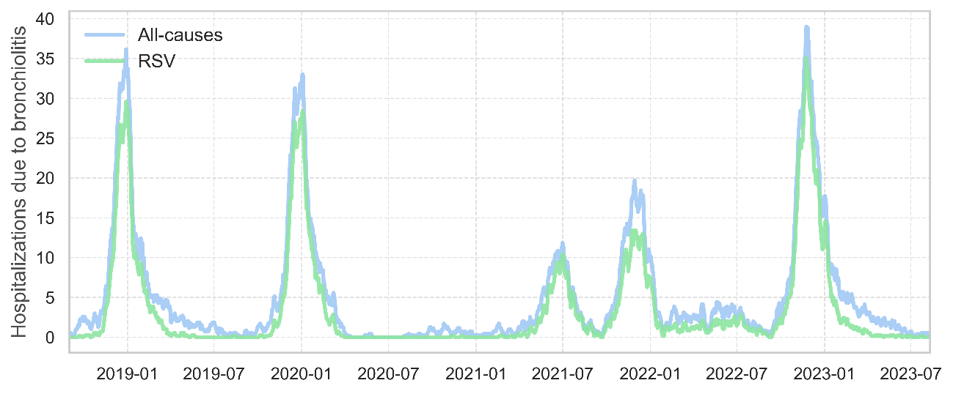
Figure 1S. Daily hospitalizations data from CMBD for all-causes (blue) and RSV-caused (green) bronchiolitis.

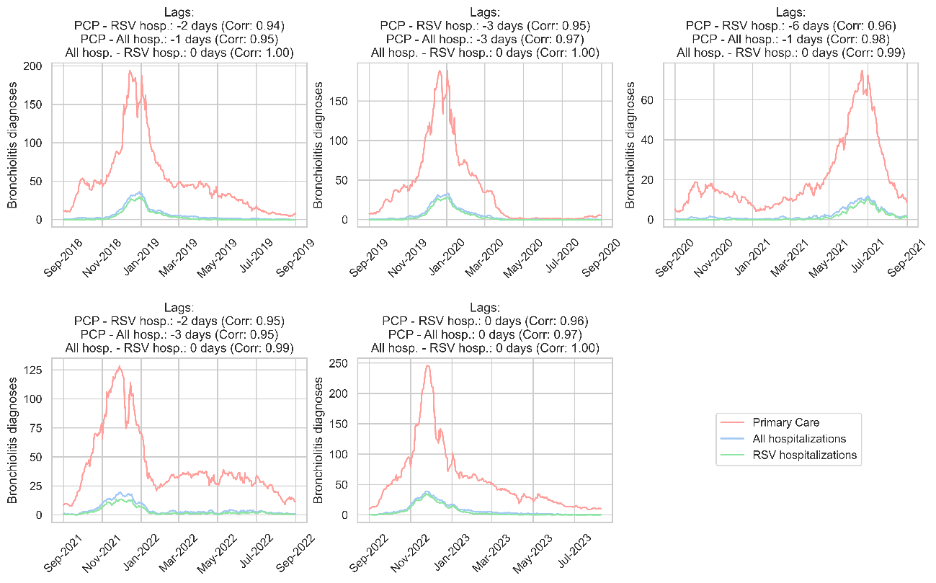

Figure 2S. Seasonal delayed correlation for all-causes primary care (red), all-causes hospitalization (blue) and RSV hospitalizations (green) bronchiolitis data.

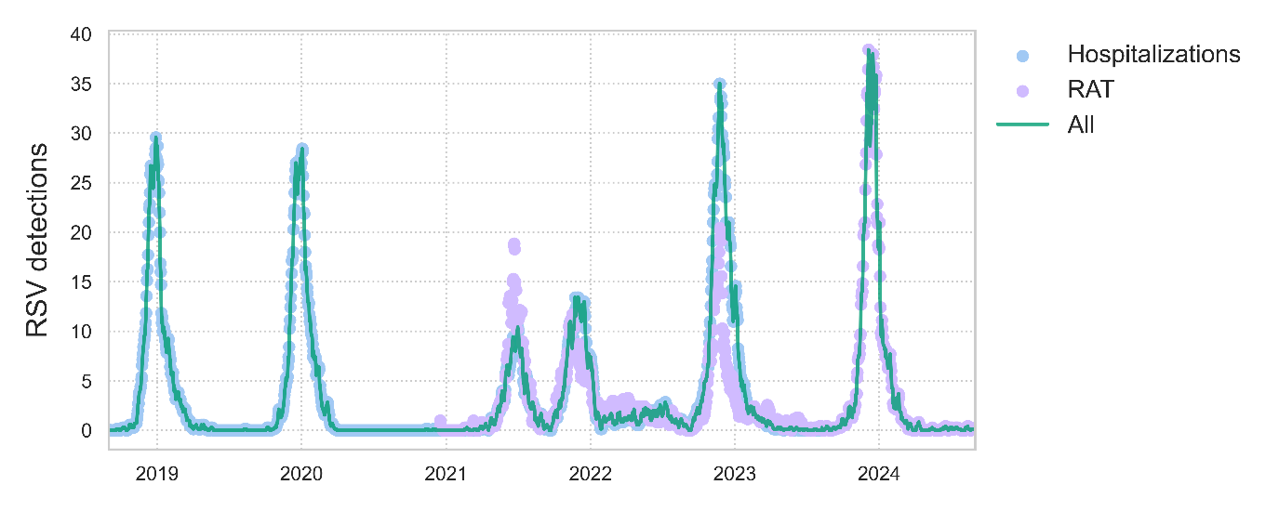
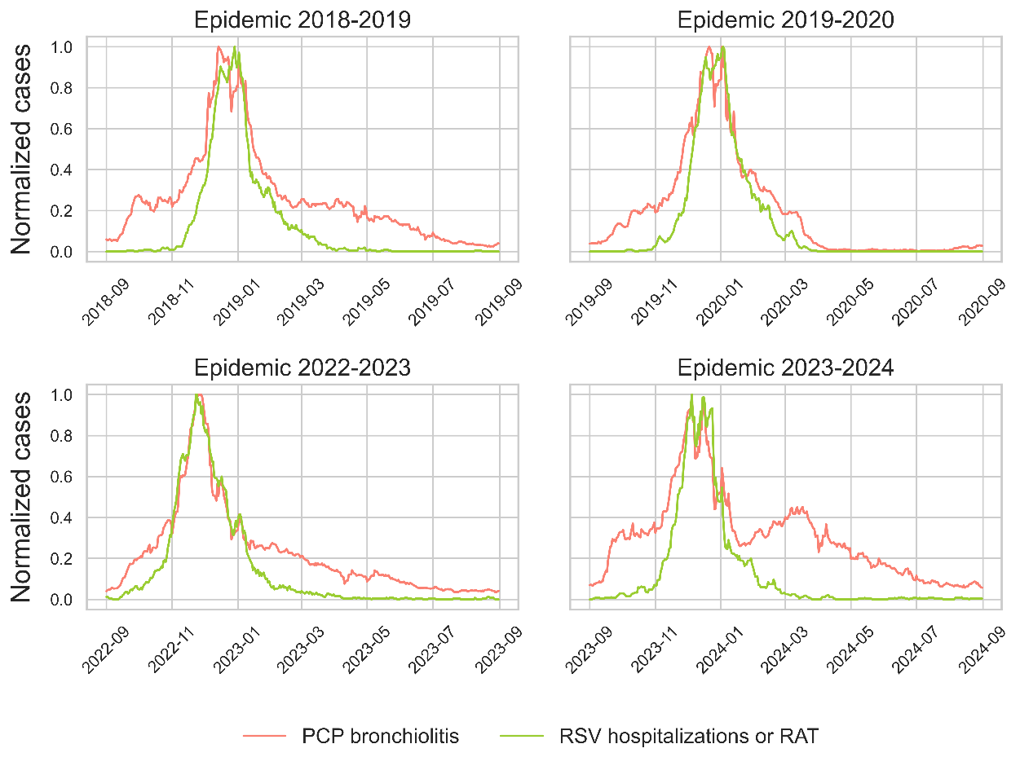
A
B
Figure 3S. (A) RSV daily detections in hospital admissions due to RSV bronchiolitis (blue), RAT in PCPs (purple) and the final series of RSV detections considering hospitalizations until the last day we have the data and RAT from then on (dark green). (B) Normalized cases of all-causes bronchiolitis reported in PCP (light green) and RSV detections (red, related to dark green line in A) per epidemic season of bronchiolitis. The percentage of normalized RSV detections over normalized all causes bronchiolitis (0-100%) is then used to compute estimated RSV-caused bronchiolitis in PCP.

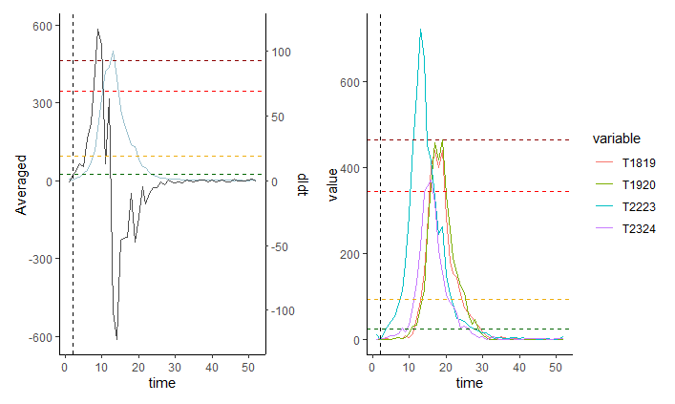
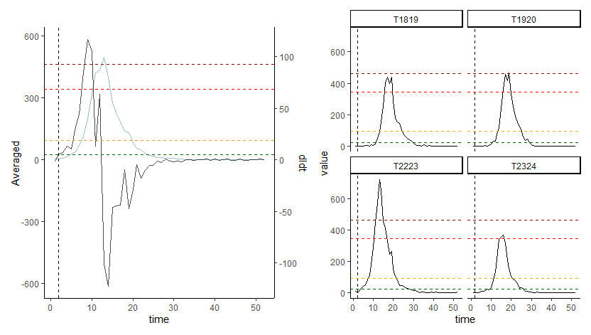
- Epidemiological levels
Figure 4S. Epidemic thresholds for estimated RSV-caused bronchiolitis. Computed from weekly cases per 100,000 inhabitants.

Table S1. Epidemic thresholds for estimated RSV-caused bronchiolitis. Computed from weekly cases per 100,000 inhabitants.
Epidemic level | Weekly cases per 100,000 inh.
Threshold | 3
Low | 25
Medium | 90
High | 340
Very high | 460

- Gompertz model adjustments
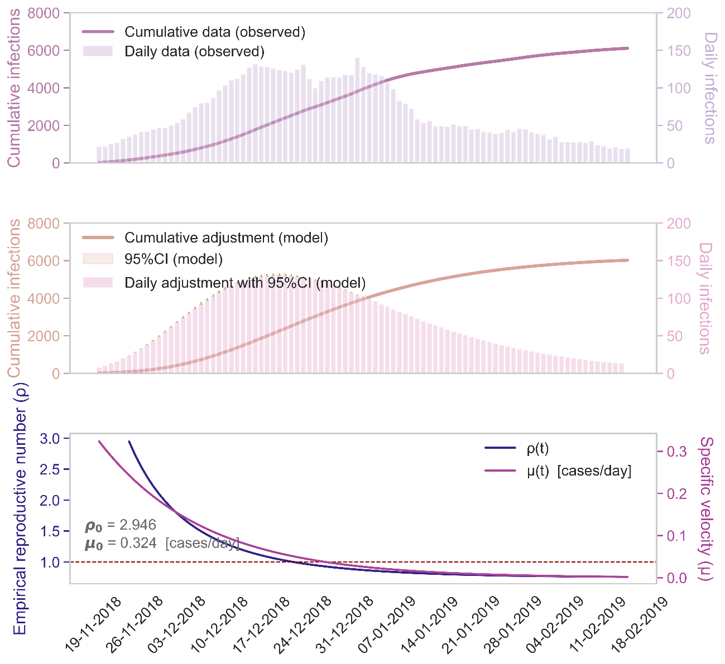
Figure 5S. Gompertz model adjustments for estimated RSV-bronchiolitis season 2018-2019. Top panel: estimated RSV-caused bronchiolitis from diagnoses counts, assuming a 75% factor. Middle panel: fitted model outcome in terms of cumulative and daily counts. Bottom panel: model-derived specific growth rate and empiric reproductive number, with their initial values; the dotted line represents the $ρ$ = 1 threshold, that stands for the inflection point of decrease in caseload.

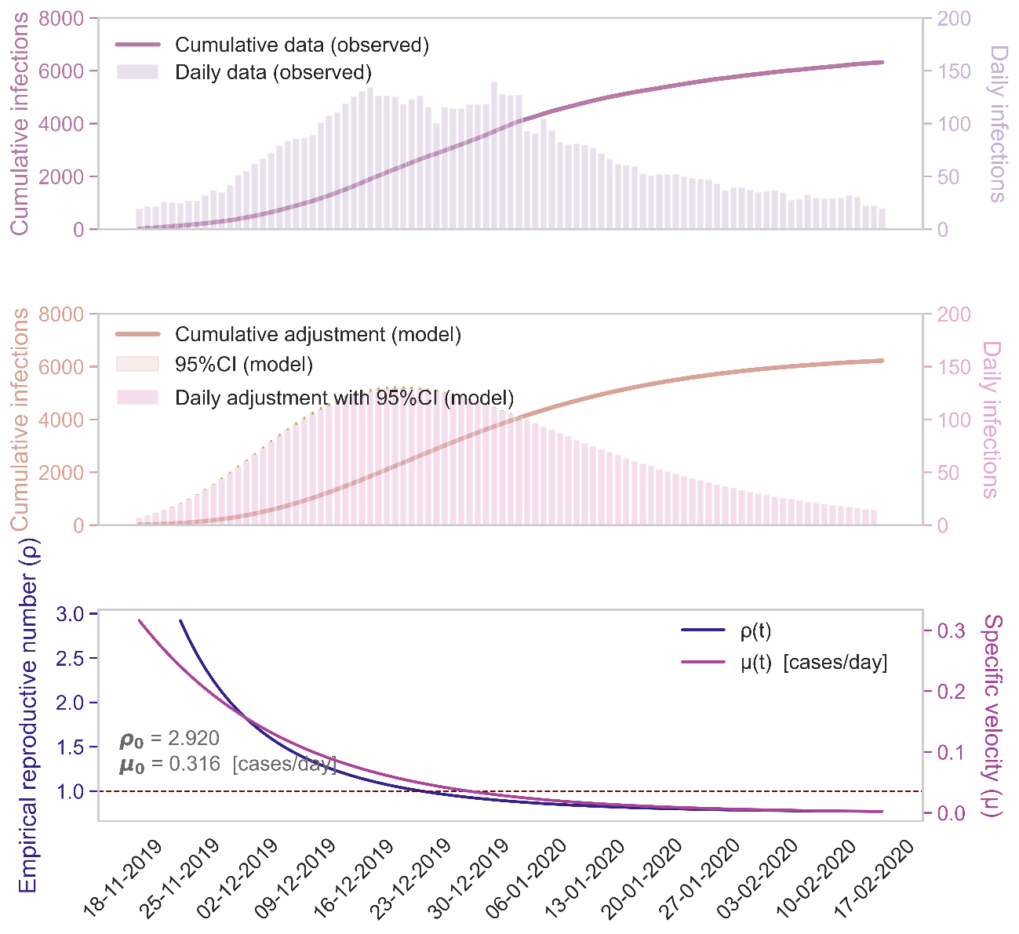
Figure 6S. Gompertz model adjustments for estimated RSV-bronchiolitis season 2019-2020. Top panel: estimated RSV-caused bronchiolitis from diagnoses counts, assuming a 75% factor. Middle panel: fitted model outcome in terms of cumulative and daily counts. Bottom panel: model-derived specific growth rate and empiric reproductive number, with their initial values; the dotted line represents the $ρ$ = 1 threshold, that stands for the inflection point of decrease in caseload.

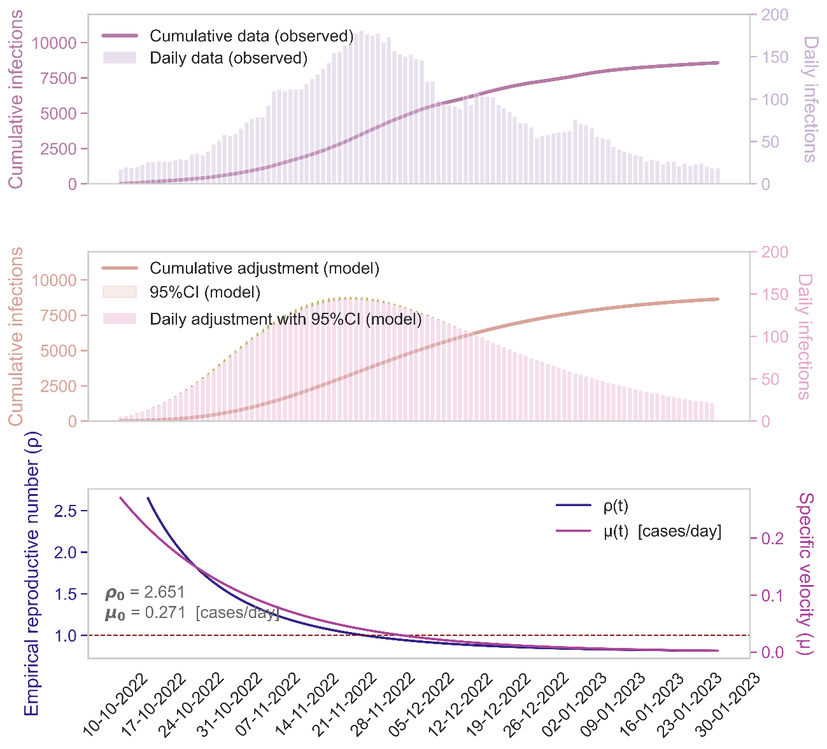
Figure 7S. Gompertz model adjustments for estimated RSV-bronchiolitis season 2022-2023. Top panel: estimated RSV-caused bronchiolitis from diagnoses counts, assuming a 75% factor. Middle panel: fitted model outcome in terms of cumulative and daily counts. Bottom panel: model-derived specific growth rate and empiric reproductive number, with their initial values; the dotted line represents the $ρ$ = 1 threshold, that stands for the inflection point of decrease in caseload.

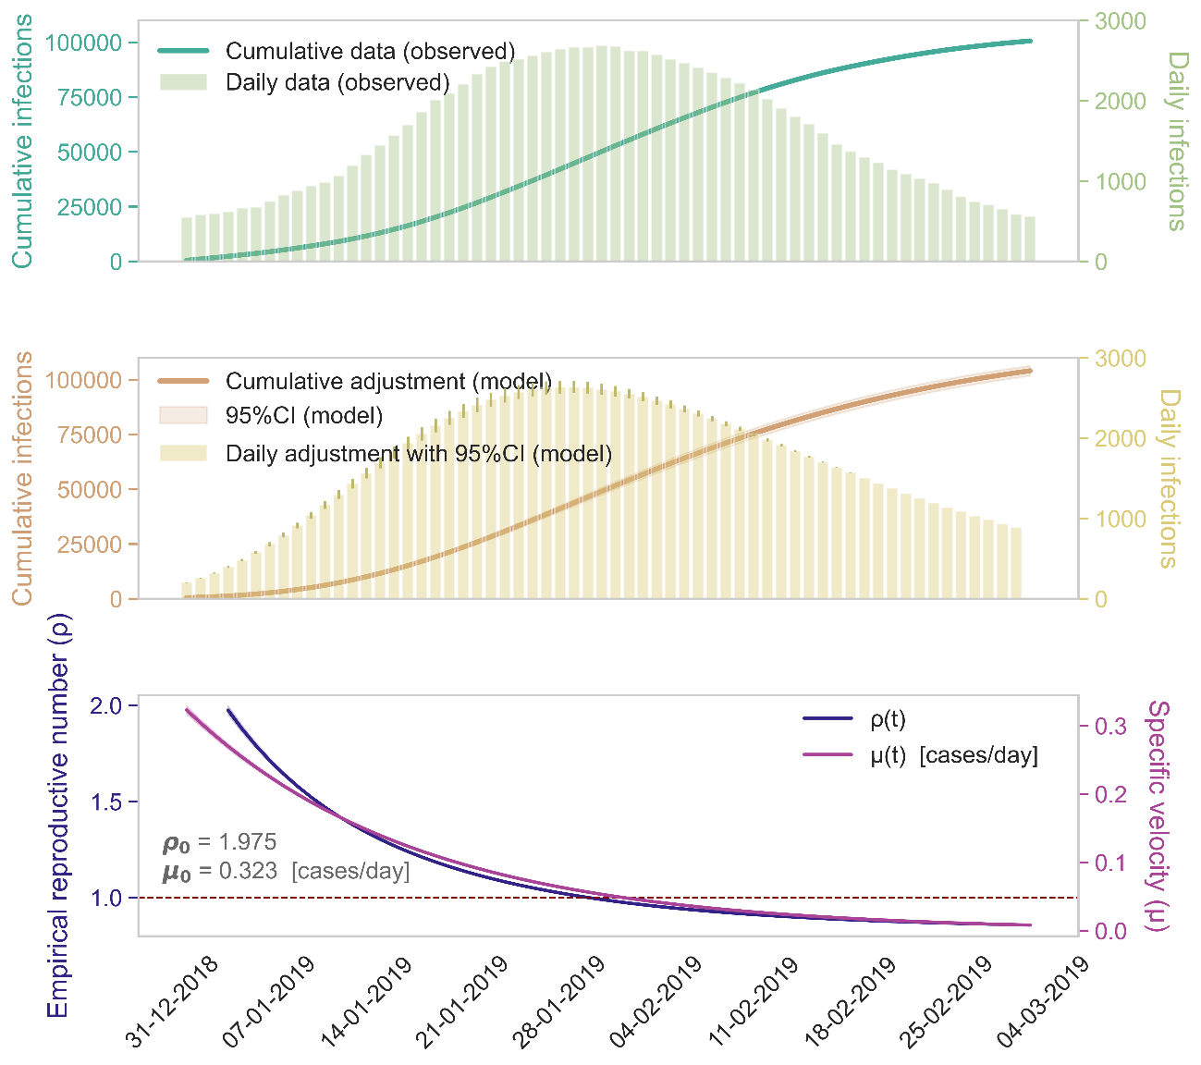
Figure 8S. Gompertz model adjustments for influenza season 2018-2019. Top panel: influenza diagnoses counts, considering daily and cumulative counts. Middle panel: fitted model outcome in terms of cumulative and daily counts. Bottom panel: model-derived specific growth rate and empiric reproductive number, with their initial values; the dotted line represents the $ρ$ = 1 threshold, that stands for the inflection point of decrease in caseload.

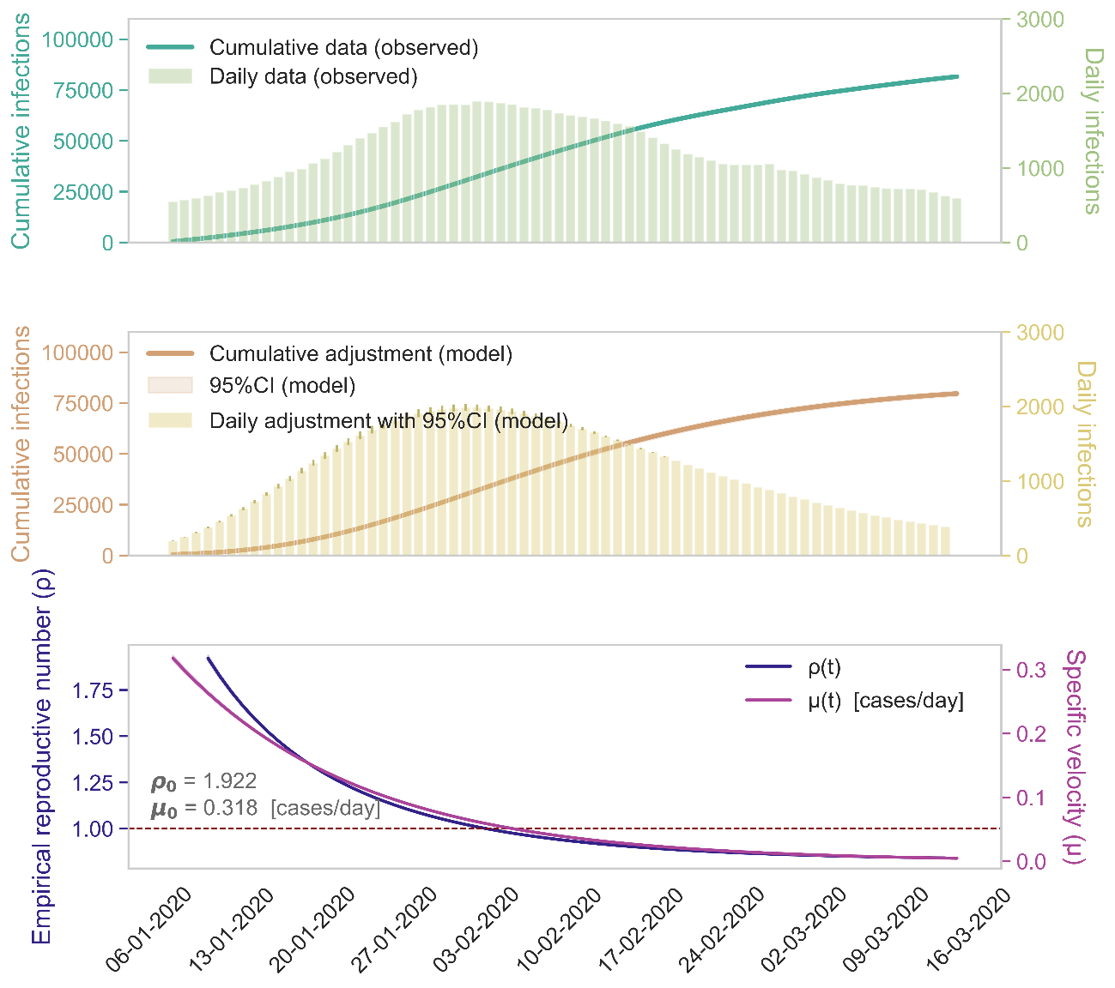
Figure 9S. Gompertz model adjustments for influenza season 2019-2020. Top panel: influenza diagnoses counts, considering daily and cumulative counts. Middle panel: fitted model outcome in terms of cumulative and daily counts. Bottom panel: model-derived specific growth rate and empiric reproductive number, with their initial values; the dotted line represents the $ρ$ = 1 threshold, that stands for the inflection point of decrease in caseload.

- Gompertz model automatic predictions

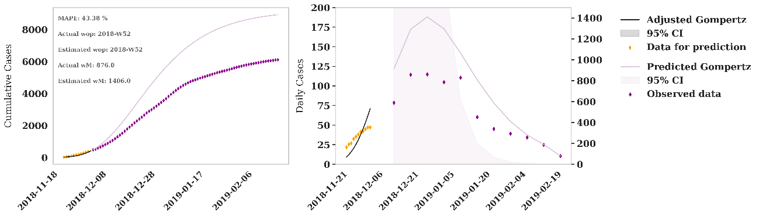
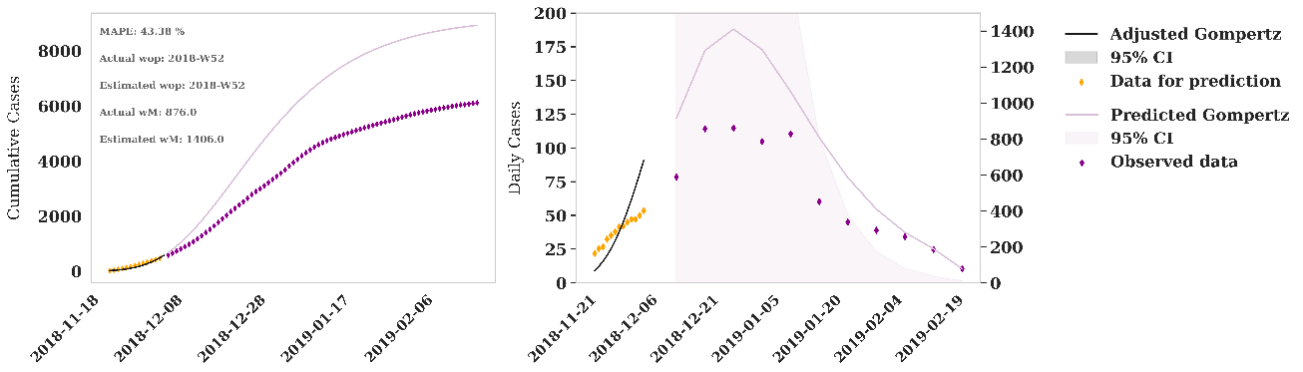
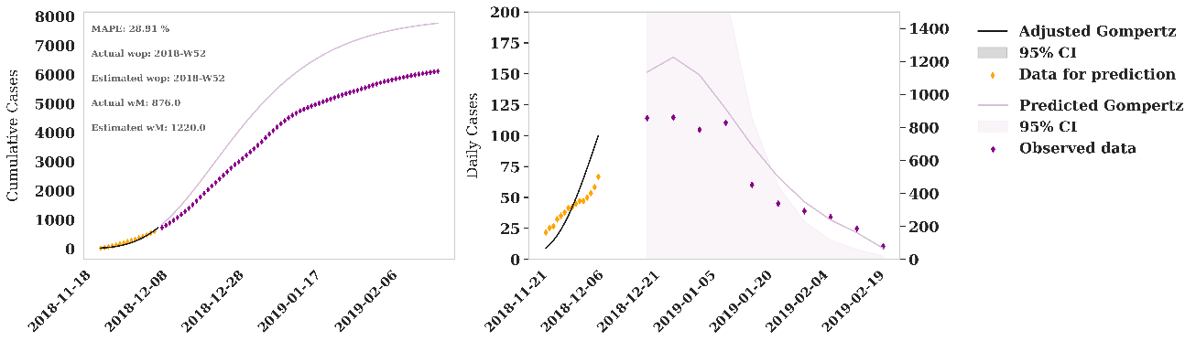
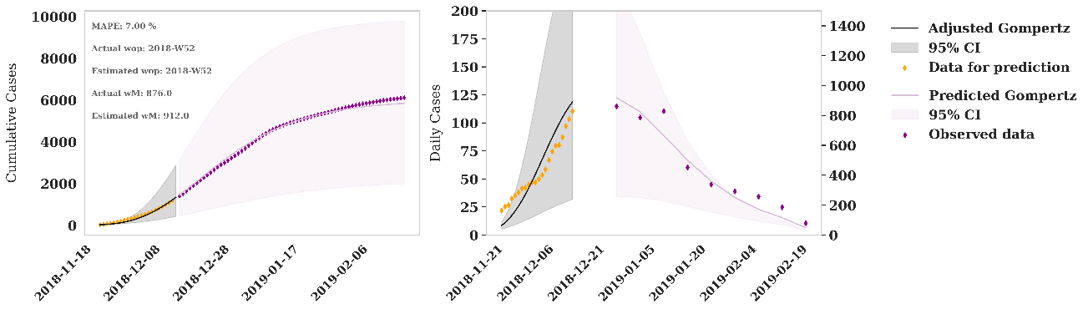
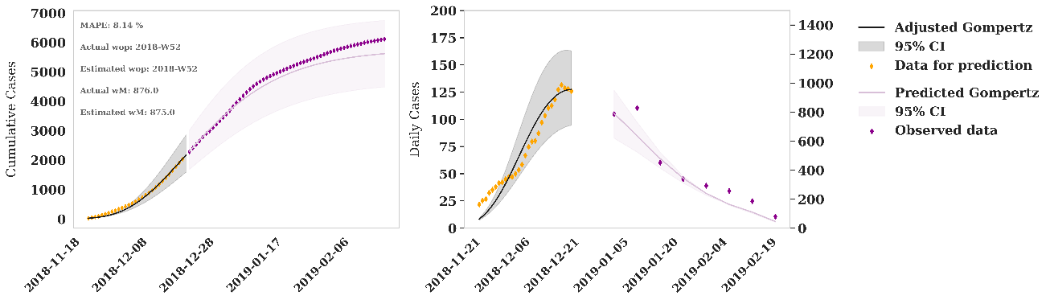
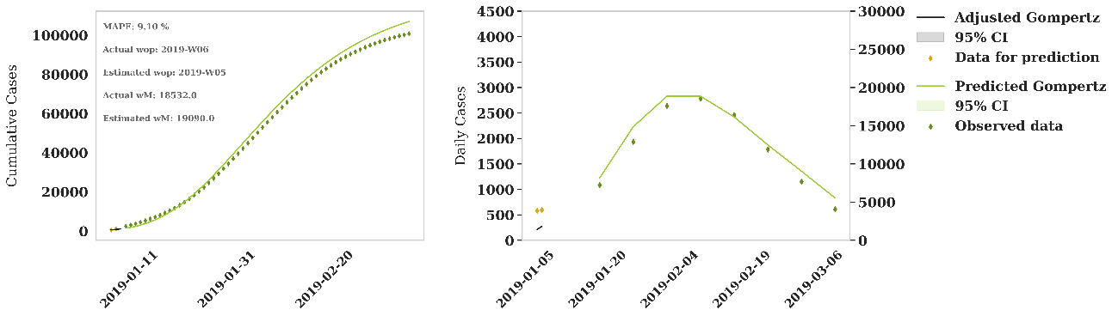
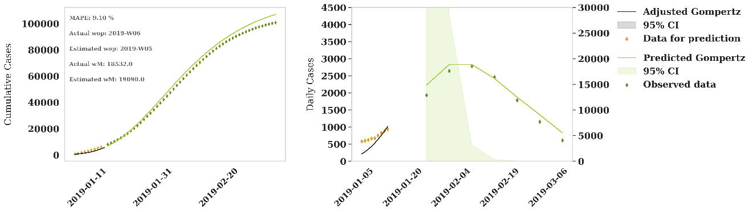
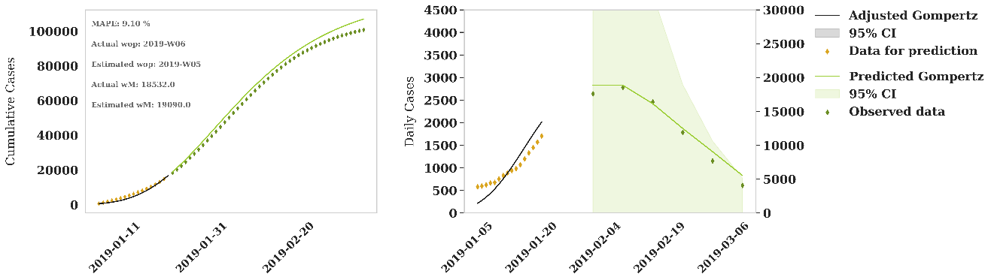
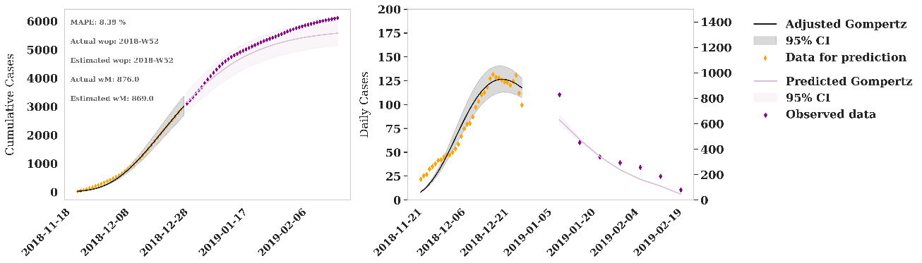
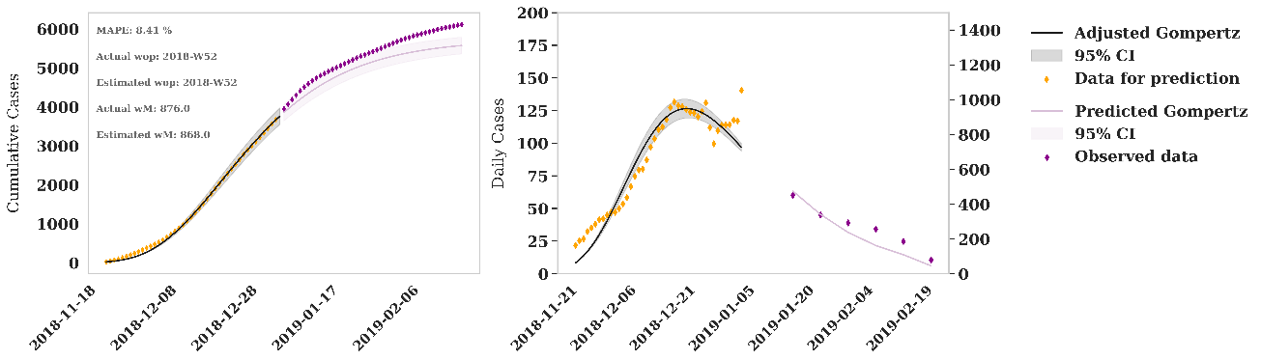
Figure 10S. Iterative adjustment and predictions for 2018-2019 season of RSV-bronchiolitis. From top to bottom, iteration with data for prediction of 32, 30, 28, 21, 14, 7 and 0 days until the peak.

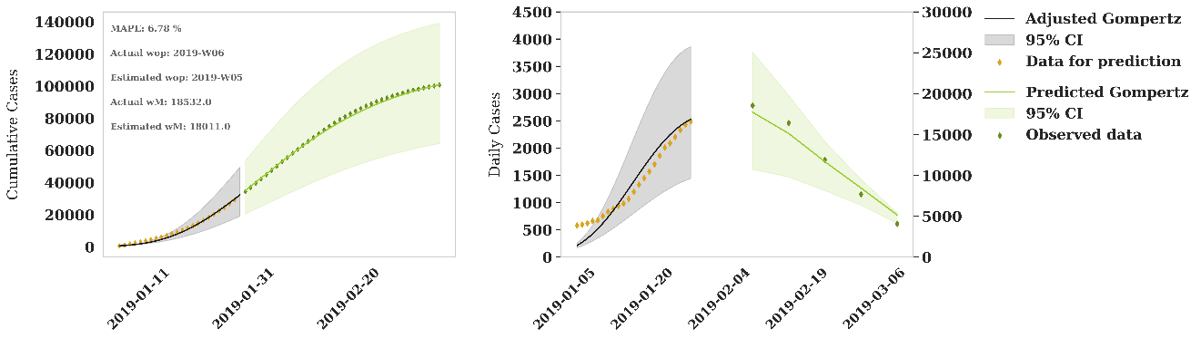
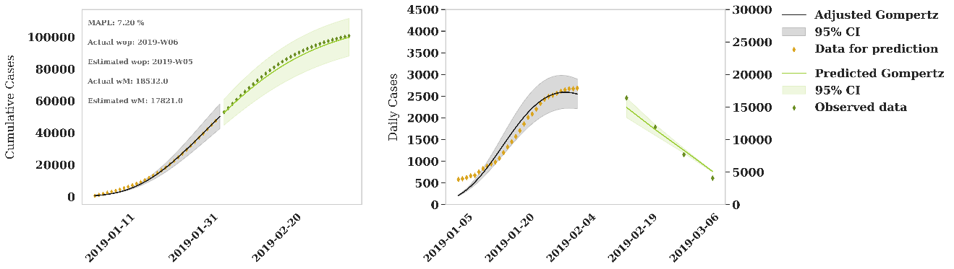
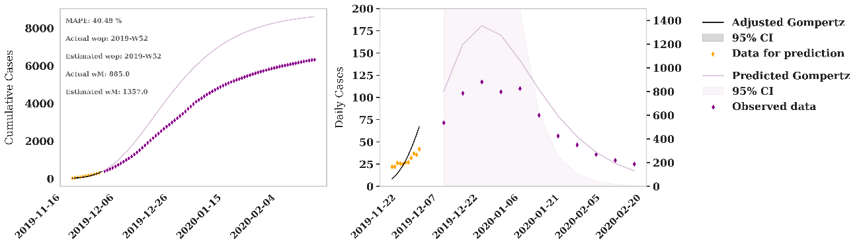
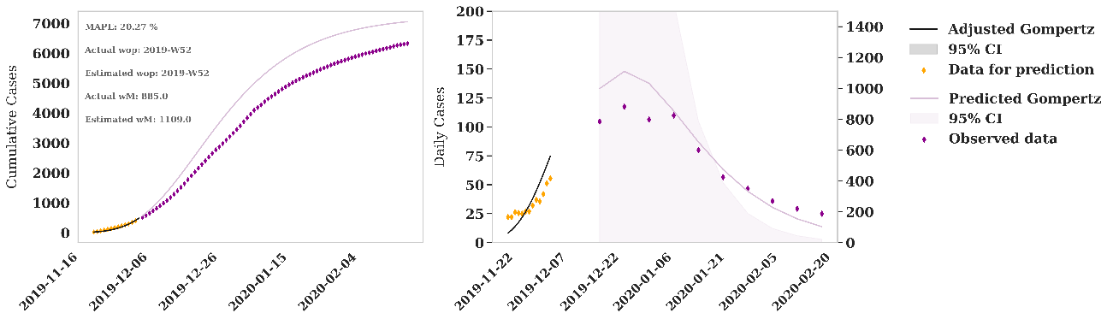
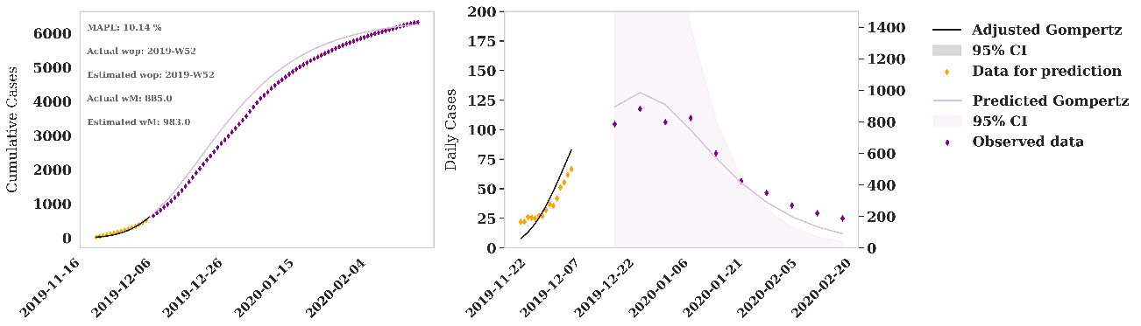
Figure 11S. Iterative adjustment and predictions for 2018-2019 season of influenza. From top to bottom, iteration with data for prediction of 28, 21, 14, 7 and 0 days until the peak.

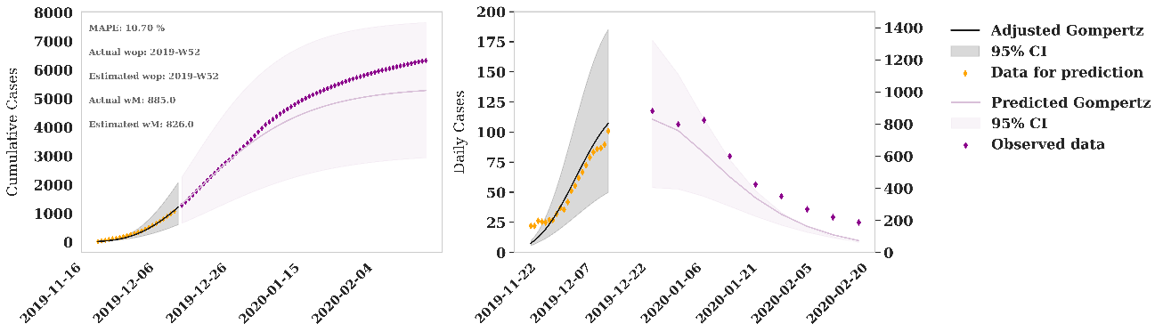
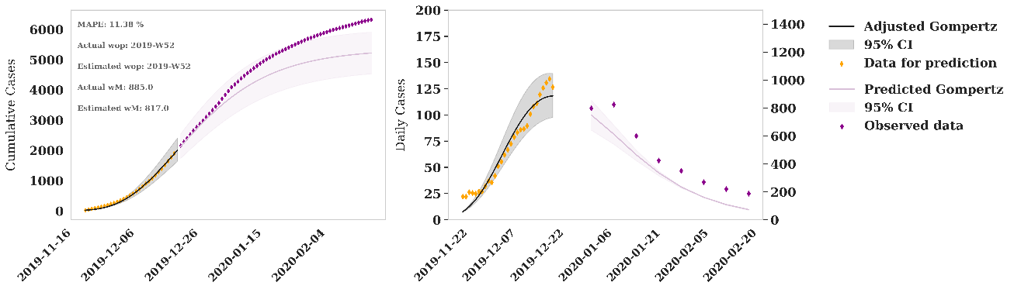
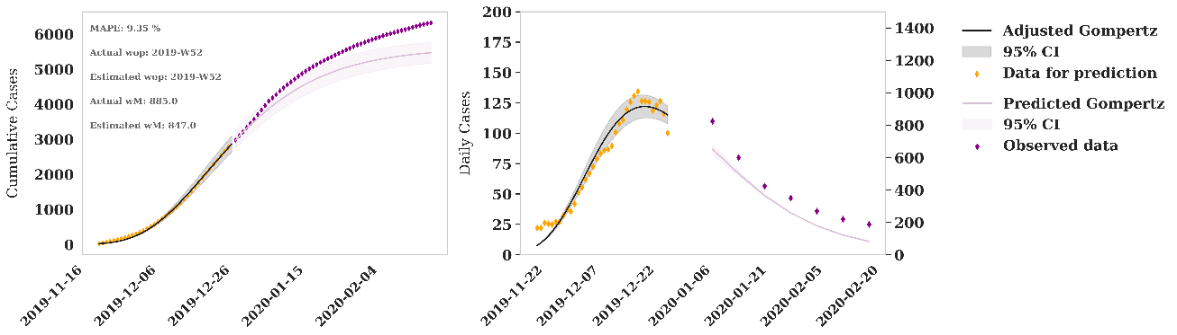
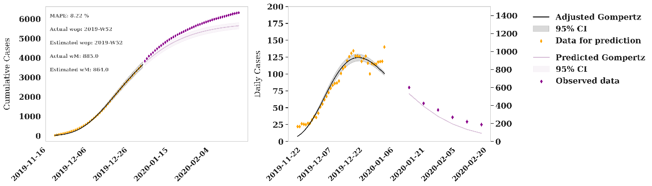
Figure 12S. Iterative adjustment and predictions for 2019-2020 season of RSV-bronchiolitis. From top to bottom, iteration with data for prediction of 32, 30, 28, 21, 14, 7 and 0 days until the peak.

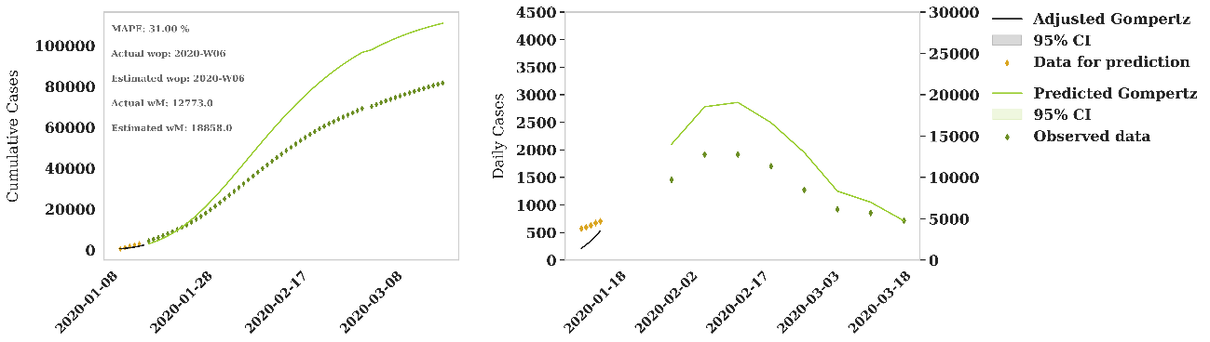
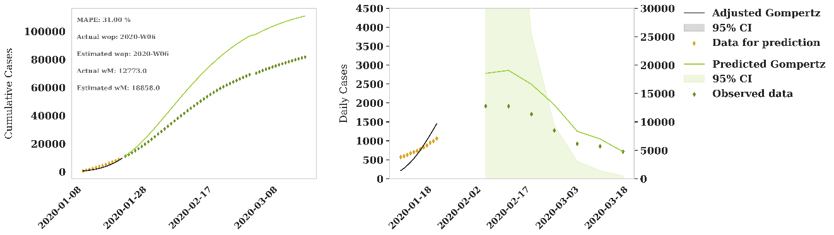
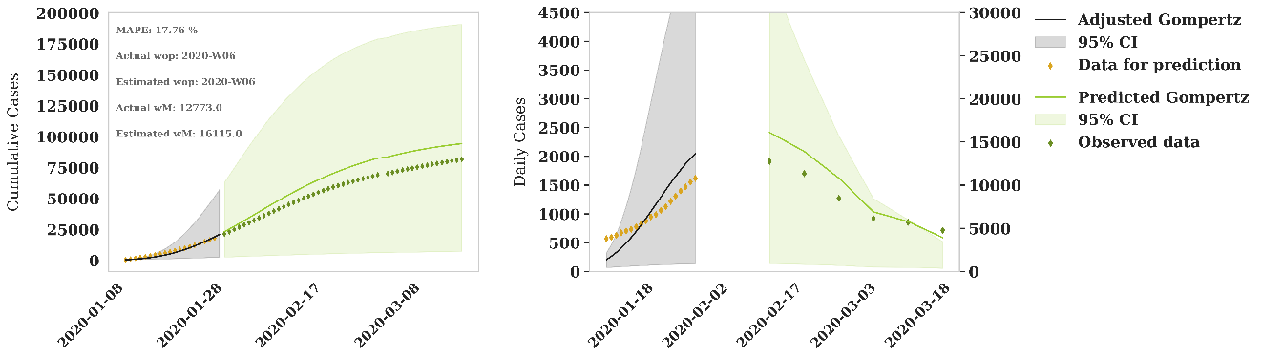
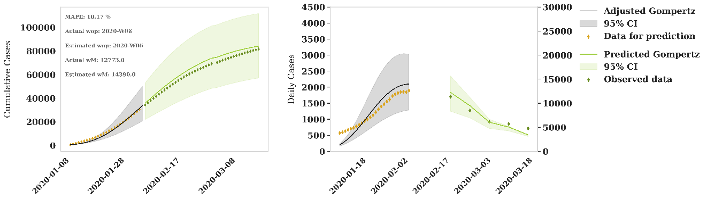
Figure 13S. Iterative adjustment and predictions for 2019-2020 season of influenza. From top to bottom, iteration with data for prediction of 21, 14, 7 and 0 days until the peak.

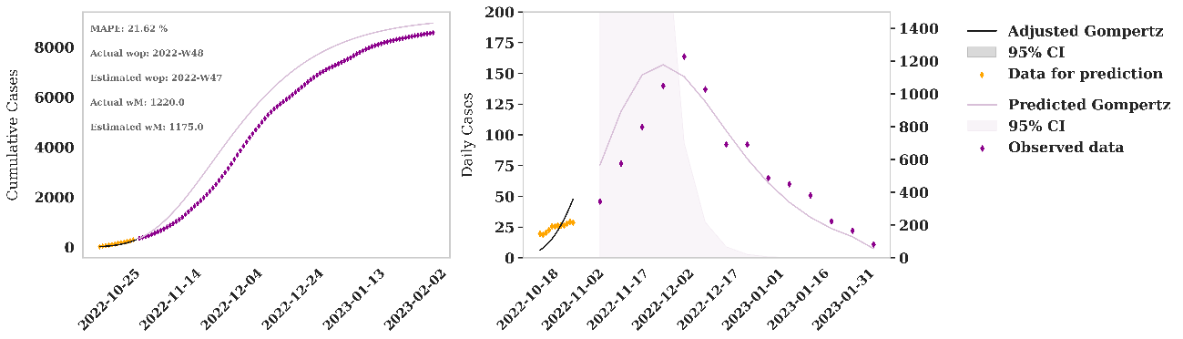
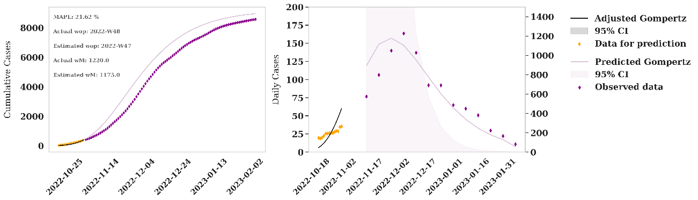
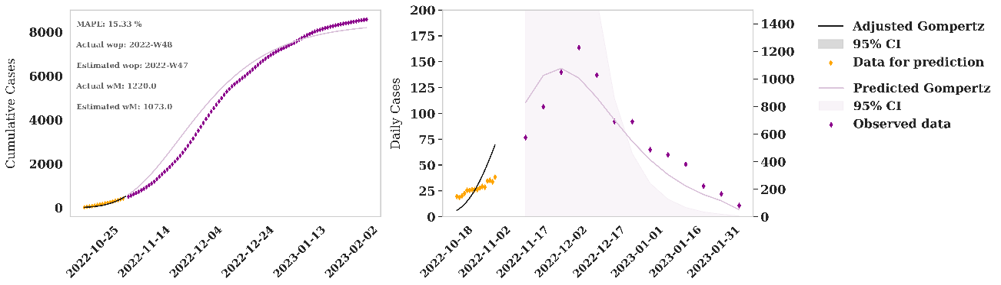
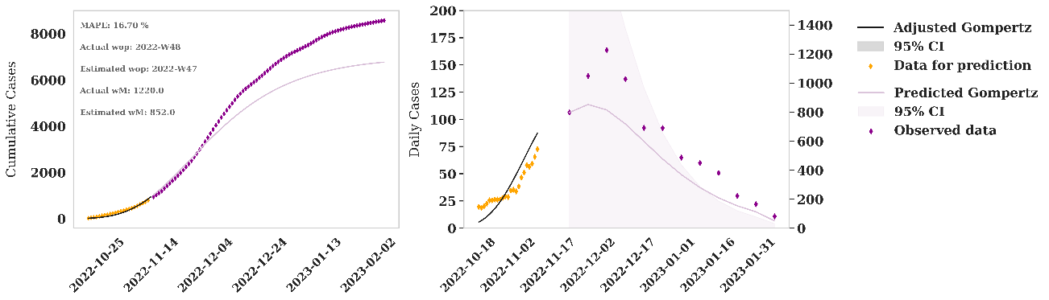
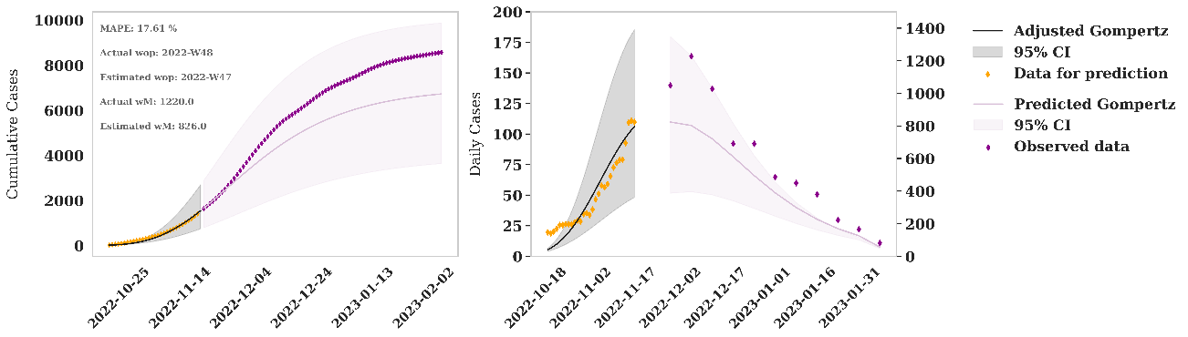

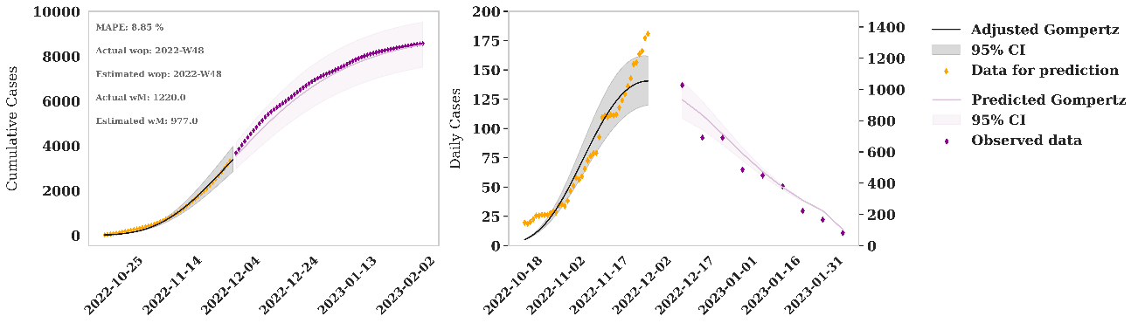
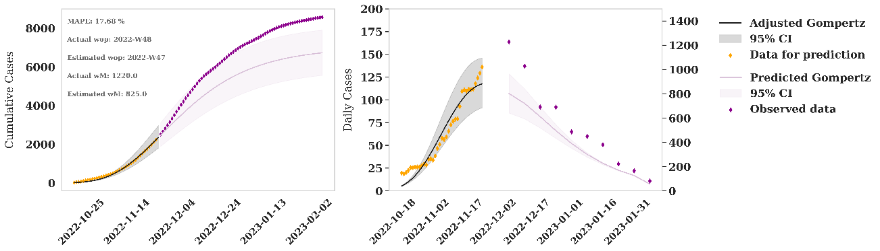
Figure 14S. Iterative adjustment and predictions for 2022-2023 season of RSV-bronchiolitis. From top to bottom, iteration with data for prediction of 32, 30, 28, 21, 14, 7 and 0 days until the peak.

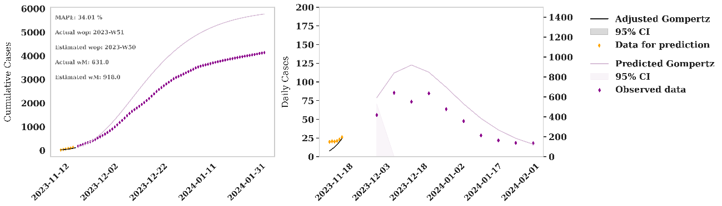
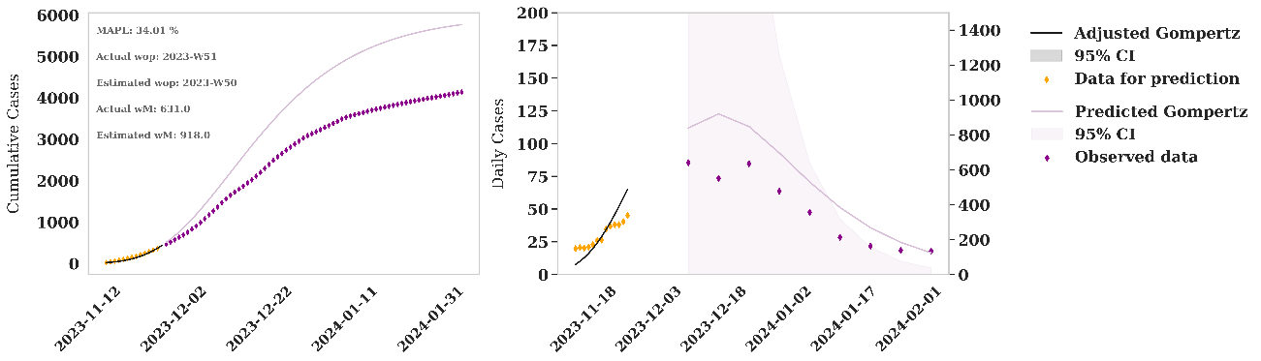
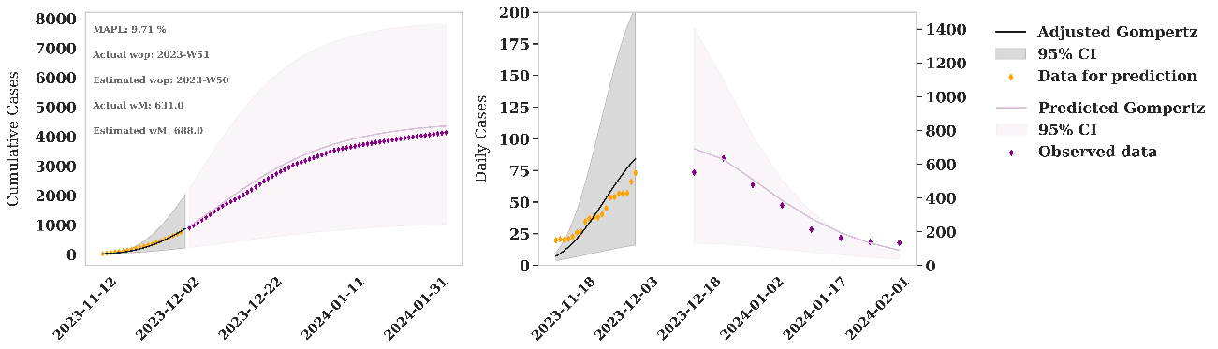
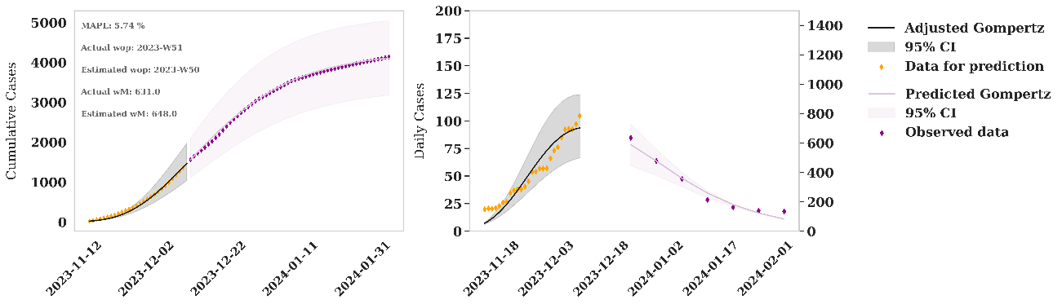
Figure 15S. Iterative adjustment and predictions for 2023-2024 season of RSV-bronchiolitis. From top to bottom, iteration with data for prediction of 21, 14, 7 and 0 days until the peak.

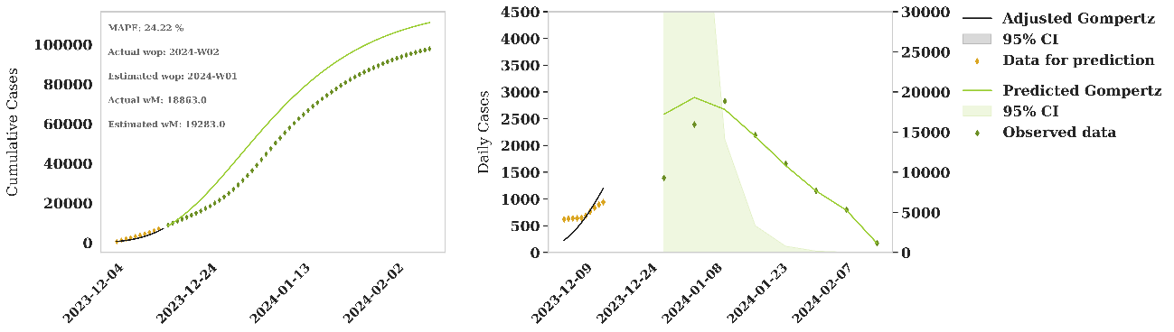
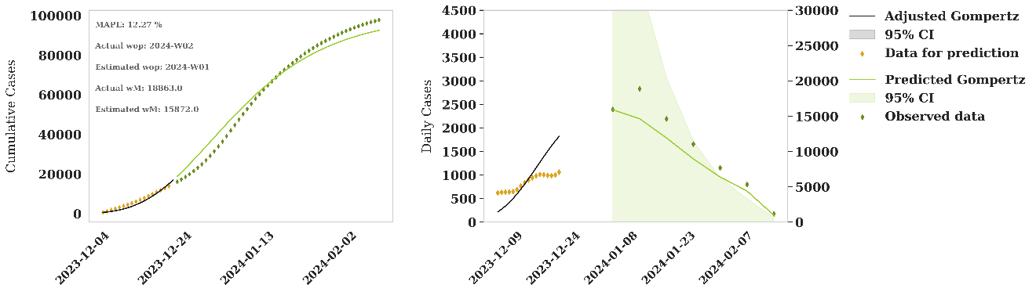
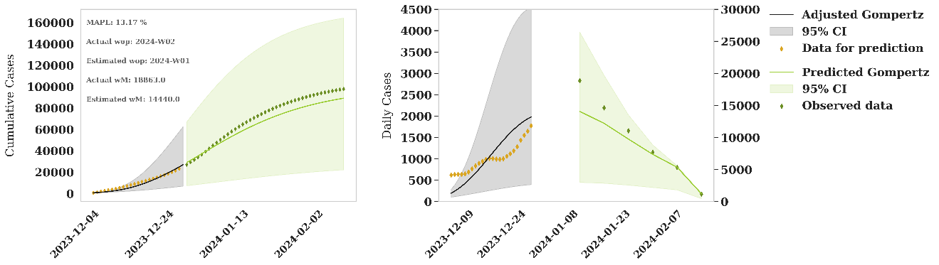
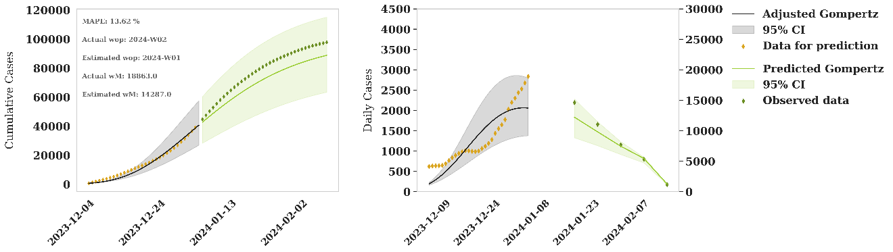
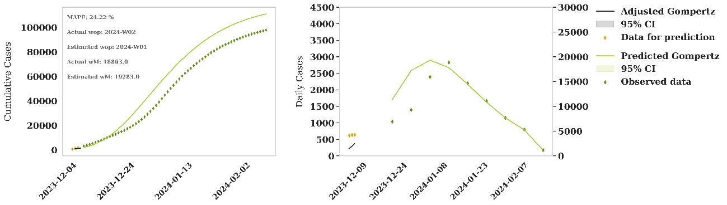
Figure 16S. Iterative adjustment and predictions for 2023-2024 season of influenza. From top to bottom, iteration with data for prediction of 21, 14, 7 and 0 days until the peak.

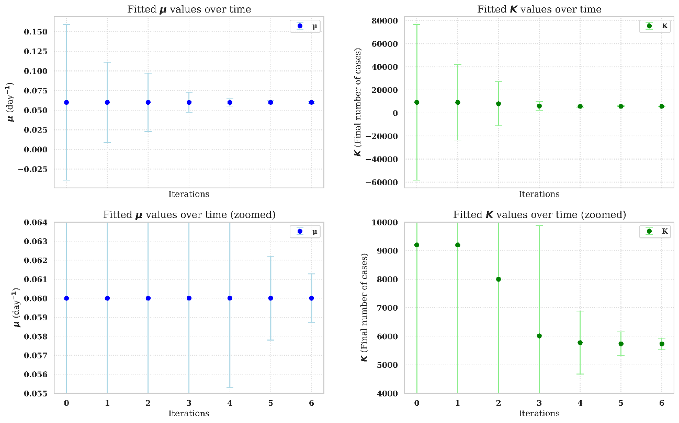
- Evolution of parameter values for model automatic predictions
Figure 17S. Parameter values evolution for the iterative adjustment and predictions for 2018-2019 season of RSV-bronchiolitis. Iterations 0 to 6 correspond to 32, 30, 28, 21, 14, 7 and 0 days until the peak.
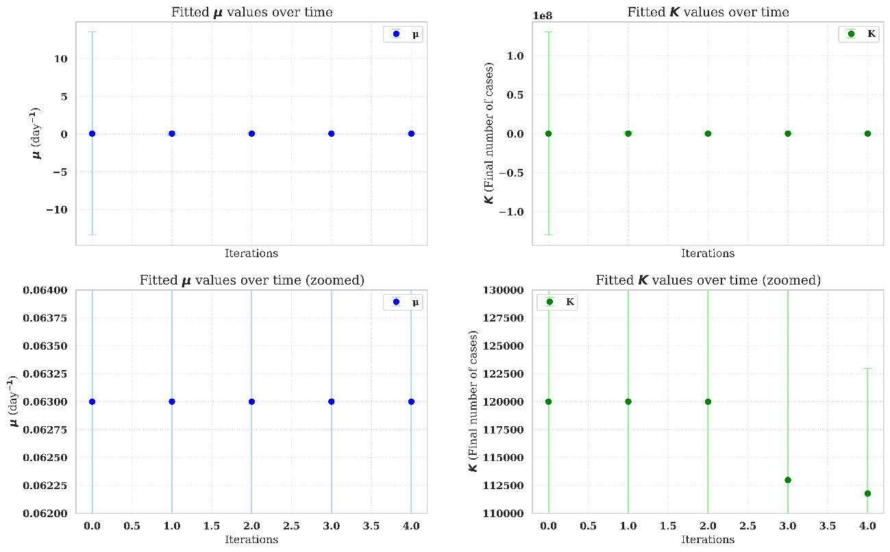
Figure 18S. Parameter values evolution for the iterative adjustment and predictions for 2018-2019 season of influenza. Iterations 0 to 4 correspond to 28, 21, 14, 7 and 0 days until the peak.

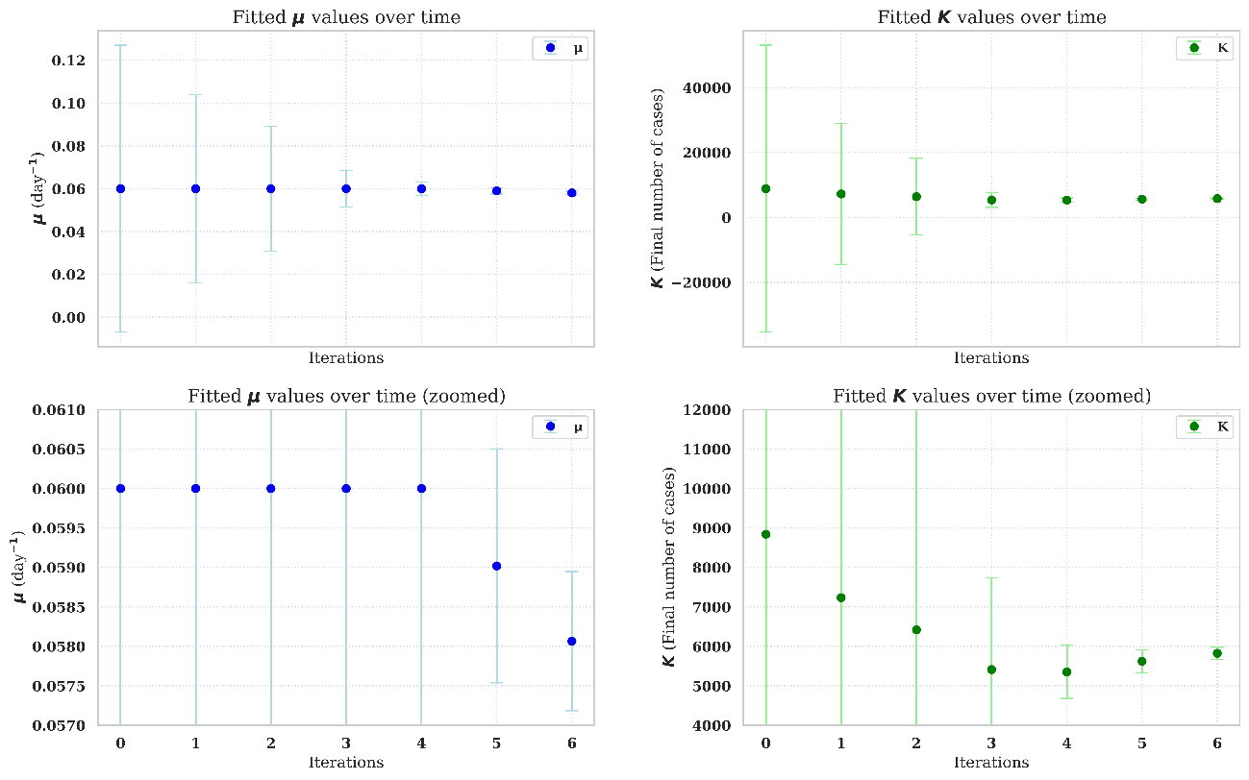
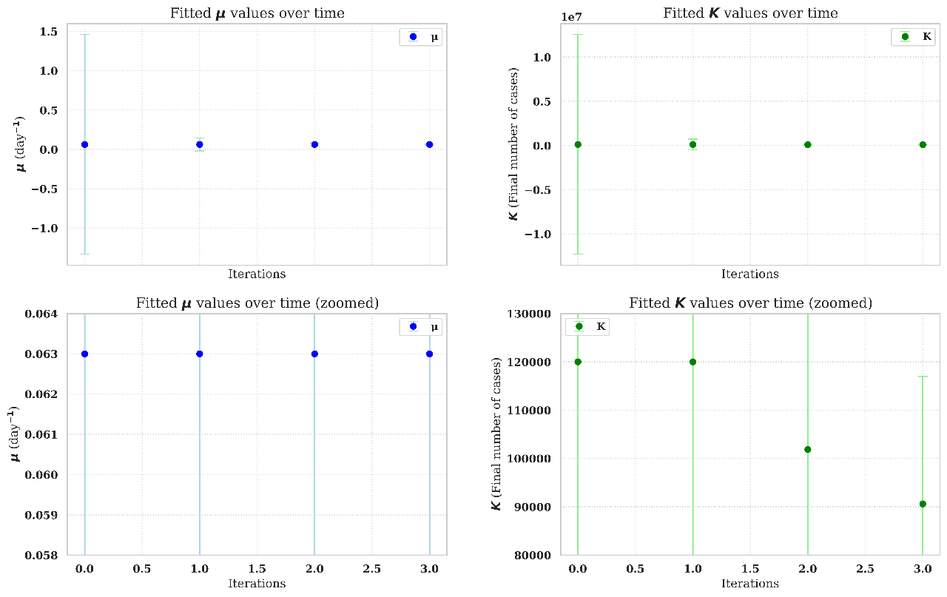
Figure 19S. Parameter values evolution for the iterative adjustment and predictions for 2019-2020 season of RSV-bronchiolitis. Iterations 0 to 6 correspond to 32, 30, 28, 21, 14, 7 and 0 days until the peak.
Figure 20S. Parameter values evolution for the iterative adjustment and predictions for 2019-2020 season of influenza. Iterations 0 to 3 correspond to 21, 14, 7 and 0 days until the peak.
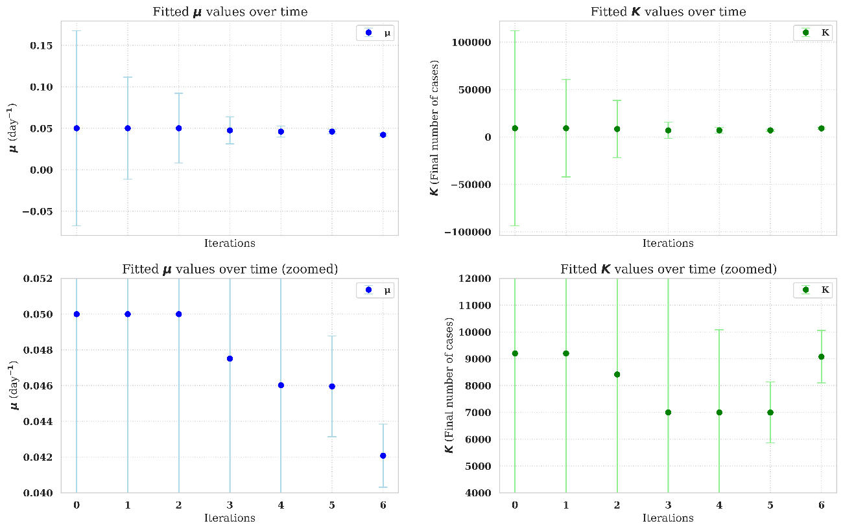
Figure 21S. Parameter values evolution for the iterative adjustment and predictions for 2022-2023 season of RSV-bronchiolitis. Iterations 0 to 6 correspond to 32, 30, 28, 21, 14, 7 and 0 days until the peak.

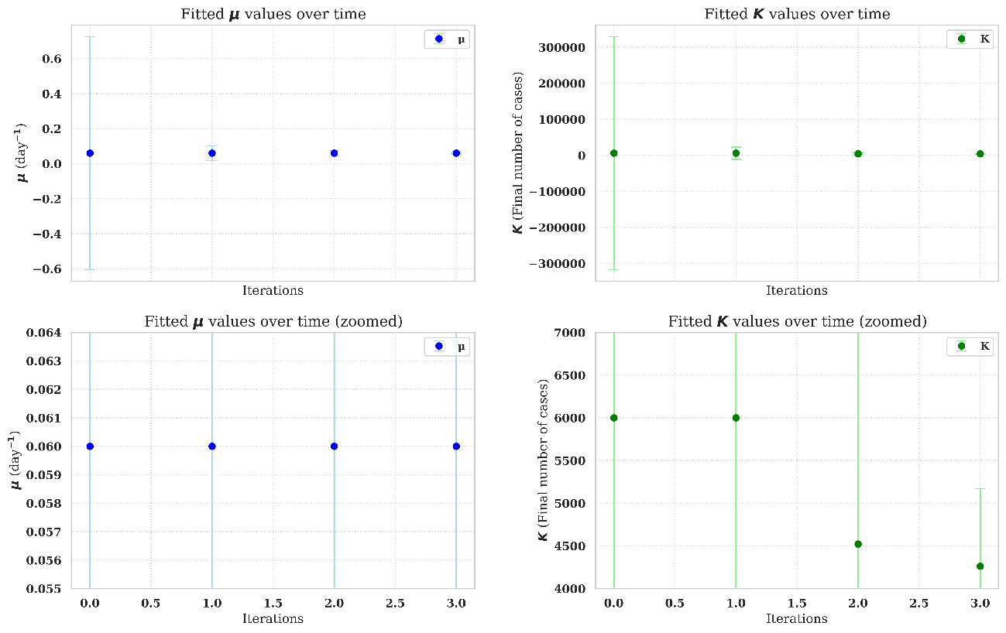
Figure 22S. Parameter values evolution for the iterative adjustment and predictions for 2023-2024 season of RSV-bronchiolitis. Iterations 0 to 3 correspond to 21, 14, 7 and 0 days until the peak.
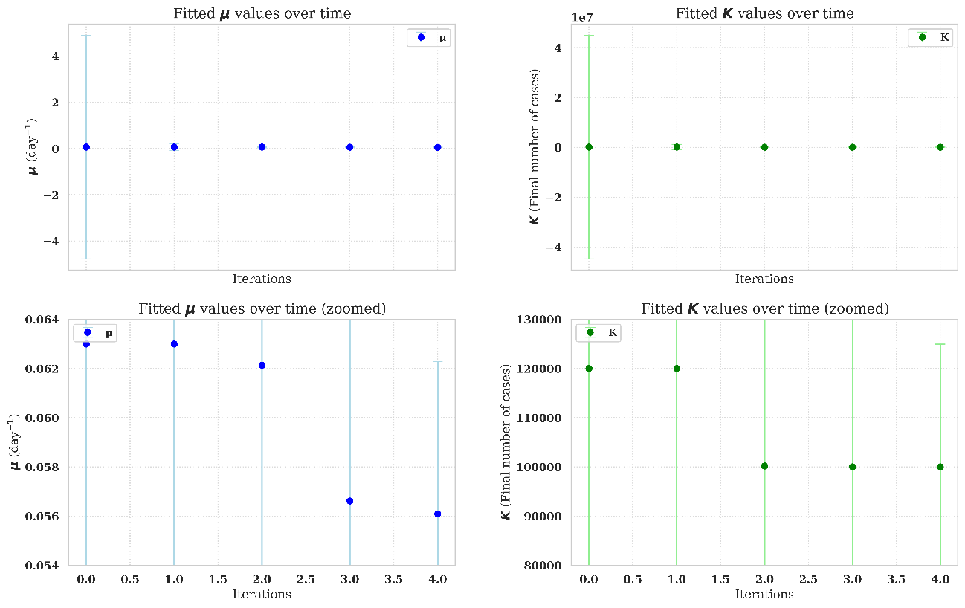
Figure 23S. Parameter values evolution for the iterative adjustment and predictions for 2023-2024 season of influenza. Iterations 0 to 3 correspond to 28, 21, 14, 7 and 0 days until the peak.

