Supplementary
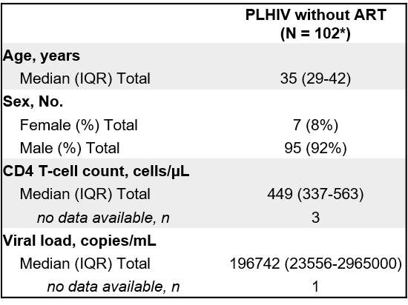
Supplementary Table 1. Demographic and clinical characteristics of 102 PLHIV without ART
(PLHIV= people living with HIV, IQR= interquartile range, ART= antiretroviral treatment, *N= 72 stained with Panel A, N= 30 stained with panel B)
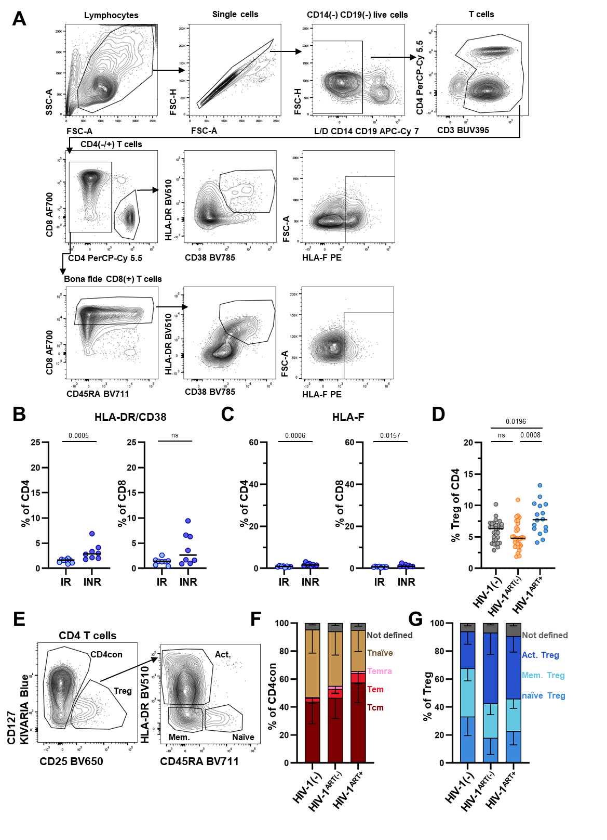
Suppl Figure 1: Gating and subset composition of CD4 T cell compartment in PLHIV with and without ART (related to Fig. 2)
(A) Gating strategy for flow cytometric analyses of HLA-F and HLA-DR/CD38 staining on CD4 and CD8 T cells. Gates was set on lymphocytes, followed by gating for single cells. Dead cells, CD14⁺, and CD19⁺ cells were excluded. T cells were identified by CD3 expression followed by further separation into CD4⁺ T cells and CD4⁽⁻⁾ T cells. Bona fide CD8⁺ cells were identified by gating on CD4⁽⁻⁾ T cells, followed by a gate set on cells with high CD8 expression. The final CD4⁺ and CD8⁺ T cell populations were used to analyze HLA-F surface expression and co-expression of HLA-DR and CD38 (B) Scatter plots depicting percentage of HLA-DR⁺/CD38⁺ CD4 (left) and CD8 (right) cells, and (C) scatter plots displaying percentage of HLA-F on CD4 (left) and CD8 (right) cells in peripheral blood of PLHIV with ART (HIV-1+^{ART+}) stratified into immunological responder (IR; light blue) and immunological non-responder (INR; dark blue). (D) Scatter plot displaying the percentage of Treg among CD4 cells in peripheral blood of HIV-1⁽⁻⁾ (grey), untreated PLHIV (HIV-1+^{ART(-)}) (orange) and PLHIV with ART (HIV-1+^{ART+}) (blue) individuals. (E) Contour plots showing gating strategy for activated Tregs (Act.), Memory Tregs (Mem.) and naïve Tregs (naïve) from CD4 cells based on their CD127, CD25 and HLA-DR, CD45RA expression. (F) Stacked bar plot displaying the mean ± SD proportions of conventional CD4 T cell (CD4con) subsets: Tcm (dark red), Tem (red), Temra (pink), and Tnaïve (light brown). (G) Stacked bar plot displaying the mean ± SD proportions of act. Treg (blue), mem. Treg (turquoise), and naïve Treg (light blue) subsets among regulatory T cells (Treg). Data information. HIV-1⁽⁻⁾: n=30; untreated PLHIV (HIV-1+^{ART(-)}): n=30; PLHIV with ART (HIV-1+^{ART+}): n=16 (n=8 IR, n=8 INR). Mann-Whitney (B,C) and unpaired Kruskal-Wallis test adjusted for multiple comparison (FDR of Benjamini/Hochberg) (D) were conducted to assess differences between groups. p values above 0.05 were considered non-significant (ns). Bars indicate median for each group.

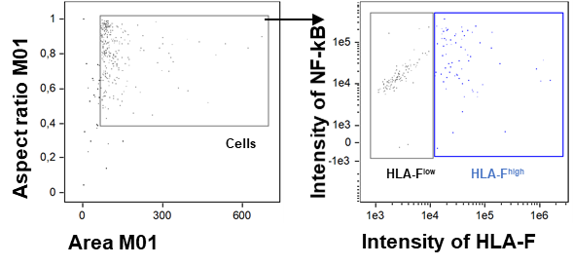
Suppl Figure 2: Gating strategy for assessing NF-κB/nuclear similarity scores (related to Fig. 3)
Gating strategy of enriched CD4 T cells of a PLHIV to identify cells with low and high HLA-F expression levels. Cells were measured using the ImageStream® X Mark II Imaging Flow cytometer. CD4 T cells were identified based on their size (Area) and singularity (Aspect Ratio), followed by separation into low (black gate) and high (blue gate) HLA-F surface expression. Cells from these gates were subsequently analyzed to determine the similarity score (S) between the nuclear signal and the NF-κB signal.

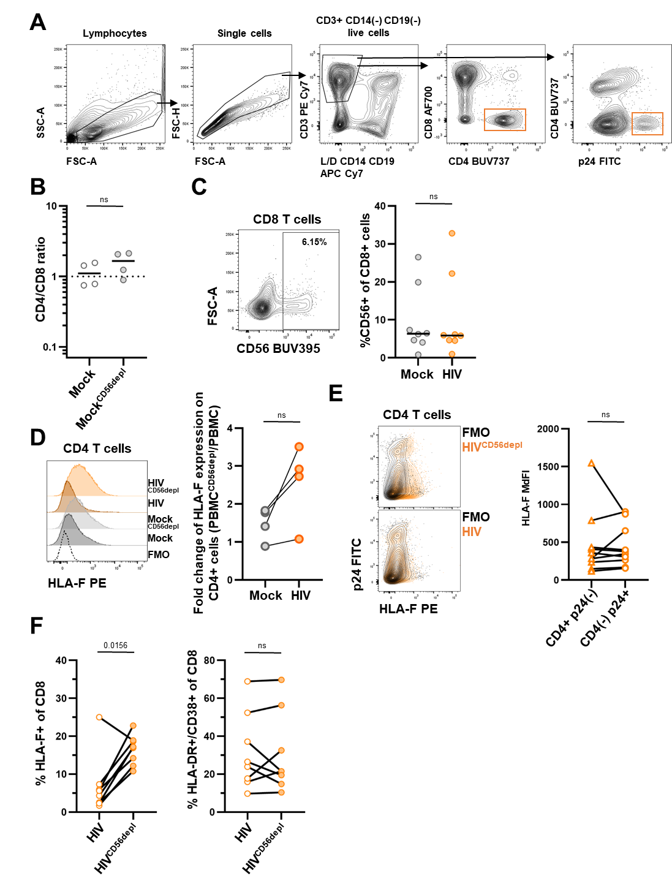
Suppl Figure 3: Effects of in vitro NK-cell depletion on HLA-F surface expression in T cells (related to Fig. 4)
(A) Gating strategy for flow cytometric analyses of HLA-F and CD4 T cells. Gates were set on lymphocytes based on forward and sideward scatter characteristics, followed by doublet exclusion and gating for live T cells (CD3⁺ cells lacking CD14 and CD19 expression and negative for live/dead viability day). Subsequently, CD4⁺ cells were identified by gating on CD4⁺ CD8⁽⁻⁾ T cells. For CD4 assessment in HIV-1 infection, CD3 T cells were used to subsequently gate on p24⁺ CD4⁽⁻⁾ cells and CD4⁺ CD8⁽⁻⁾ T cells (orange gates). Cells located in those gates were used for total CD4 T cell count (sum of orange gates) in order to not lose CD4 T cells that downregulated CD4 from the cell surface due to the effect of HIV-1 accessory proteins. (B) Scatter plot shows CD4/CD8 ratio in mock (grey empty dot) and mock^{CD56depl} (light grey). (C) Representative dot plot for CD56 expression on CD8 cells in HIV-1–infected PBMCs on day 7 (left). Scatter plot depicting frequency of CD56⁺ among CD8 T cells in mock-infected and HIV-1–infected PBMCs (right). (D) Histogram showing fluorescence intensity of HLA-F after CD56 depletion in mock-infected (grey) and HIV-1–infected (orange) CD4 cells on day seven (left). Fluorescence minus one (FMO; dotted line) served as a control for HLA-F surface expression. Right panel: Dot plot showing the fold change in MdFI of HLA-F after CD56 depletion in mock-infected (grey) and HIV-1–infected (orange) CD4 T cells. Dots connected by lines represent fold change between mock and HIV conditions for the same donor. (E) Representative contour plot (left) depicting p24 expression against HLA-F staining (clone 3D11) in CD4 T cells within NK cell depleted in vitro HIV-1–infected PBMCs (top) and non-NK cell depleted HIV-1–infected PBMCs (bottom). FMO for HLA-F is overlaid in black. Right panel: Cumulative data of HLA-F expression in CD4⁺ p24⁽⁻⁾ CD8⁽⁻⁾ and CD4⁽⁻⁾ p24⁺ CD8⁽⁻⁾ T cells is shown in scatter plot. (F) Scatter plots display percentage of HLA-F⁺ CD8 T cells (left) and HLA-DR⁺/CD38⁺ CD8 T cells (right) in PBMCs infected with HIV-1 with or without CD56 depletion within the same donor, indicated by connecting lines. Data information. HIV-1–infected: n=8; HIV-1–infected^{CD56depl}: n=8; mock: n=4, mock^{CD56depl}: n=4. Wilcoxon matched-pairs signed-rank test was conducted (B,C,D,E,F), p values above 0.05 were considered non-significant (ns). Bars indicate median for each group.

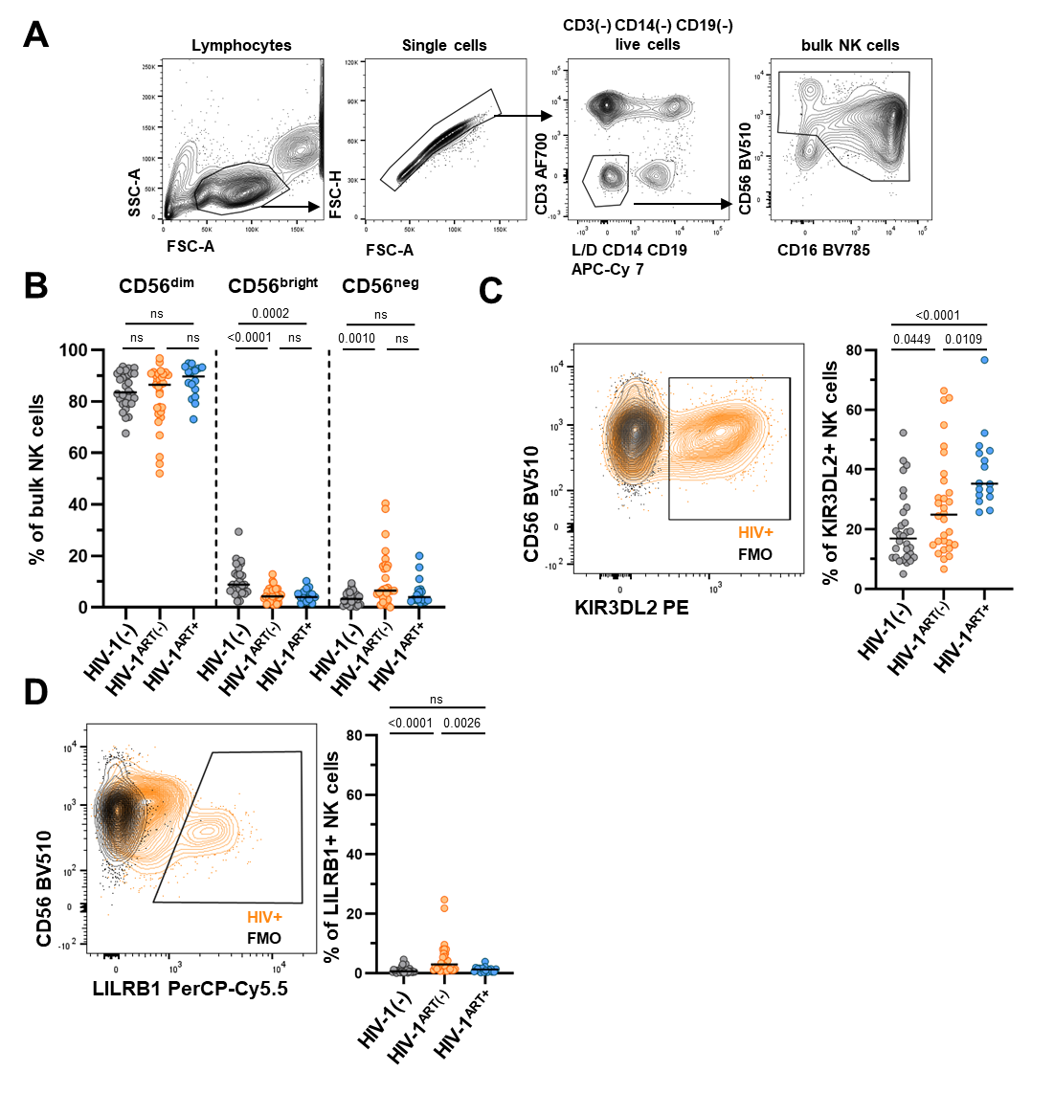
Suppl Figure 4: NK-cell subset composition and inhibitory HLA-F receptor expression in PLHIV (related to Fig. 5)
(A) Gating strategy for flow cytometric analyses of NK cells in in peripheral blood of HIV-1⁽⁻⁾ individuals, PLHIV with and without ART. Gates were set on lymphocytes based on forward and sideward scatter characteristics, followed by doublet exclusion. Next gate was set on live cells lacking expression of CD3, CD14 and CD19. NK cells were identified by their expression of CD16 and CD56. (B) Scatter plot showing the frequency of CD56^{dim} (left), CD56^{bright} (middle) and CD56^{neg} (right) subsets in HIV-1⁽⁻⁾ individuals (grey), PLHIV without ART (HIV-1+^{ART(-)}) (orange) and PLHIV with ART (HIV-1+^{ART+}) (blue). (C) Left: Representative contour plot of KIR3DL2 surface staining on NK cells. Fluorescence minus one (FMO) served as control (black). Right: Cumulative data for percentage of KIR3DL2⁺ NK cells within each subgroup. (D) Left: Representative contour plot of LILRB1 staining on NK cells. FMO served as control (black). Right: Cumulative data for percentage of LILRB1⁺ NK cells within each subgroup. Data information: HIV-1⁽⁻⁾: n=30; untreated PLHIV (HIV-1+^{ART(-)}): n=30; PLHIV with ART (HIV-1+^{ART+}): n=16. Unpaired Kruskal-Wallis test adjusted for multiple comparisons (FDR of Benjamini/Hochberg) (B,C,D) was conducted to assess differences between groups, p values above 0.05 were considered non-significant (ns). Bars indicate the median for each group.
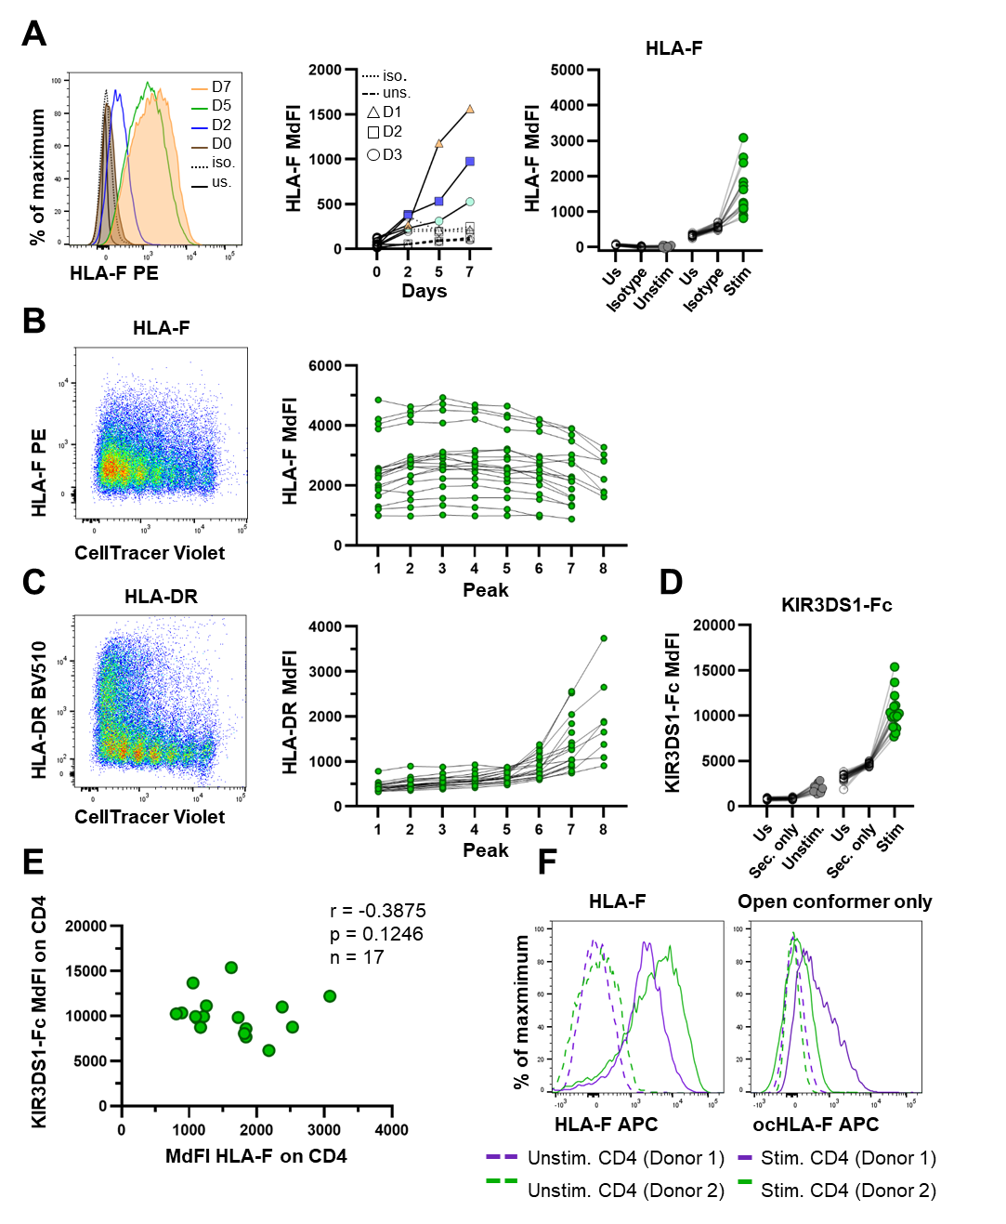
Suppl Figure 5: HLA-F upregulation following in vitro TCR stimulation and assessment of HLA-F conformation on CD4 T cells via KIR3DS1-Fc and conformation-specific HLA-F antibody
(A) Left panel: Representative histogram of HLA-F surface staining on CD4 T cells on day zero (brown), two (blue), five (green) and seven (orange) after anti-CD3/CD28/CD2 stimulation. Isotype staining (dotted line) and unstained (black solid line) served as control. Middle panel: Median fluorescence intensity (MdFI) of HLA-F surface expression of three donors (triangle, square, circle) over time (middle). Right panel: Cumulative data (n=17) of anti-CD3/CD28/CD2 stimulated and unstimulated CD4 T cells on day seven for HLA-F surface staining (clone 3D11). Isotype antibody (clone MOPC-21) and unstained (us) served as controls. (B) Representative dot plot of anti-CD3/CD28/CD2 stimulated CD4 T cells on day seven showing HLA-F surface expression plotted against CellTracer violet (left). Peaks (x-axis) were identified based on CellTracer violet expression and HLA-F surface expression was evaluated for each peak respectively (right) for n=19. (C) Representative dot plot of anti-CD3/CD28/CD2 stimulated CD4 T cells on day seven showing HLA-DR surface staining against CellTracer violet (left). Peaks (x-axis) were identified based on CellTracer violet expression and respective peak-population was evaluated for HLA-DR surface expression (right). (D) Cumulative data (n=17) of anti-CD3/CD28/CD2 stimulated and unstimulated CD4 T cells on day seven for KIR3DS1-Fc staining. KIR3DS1-Fc construct is the extracellular domain of KIR3DS1 fused to an Fc-construct that is then stained with a secondary anti-Fc antibody. Secondary only (sec. only) and unstained (us) served as controls. (E) Spearman rank correlation between the MdFI of HLA-F on CD4 T cells and MdFI of KIR3DS1-Fc on CD4 T cells (n=17). (F) Histograms showing HLA-F staining with a commercially available antibody (left; clone: 3D11) and a novel antibody specific to the open conformer of HLA-F (right) in unstimulated (dashed line) and stimulated (solid line) CD4 T cells (Donor 1=green and Donor 2=purple).

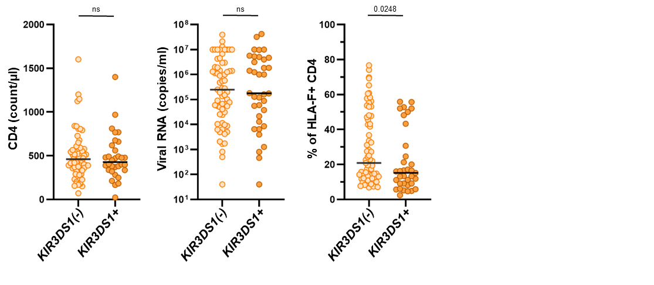
Suppl Figure 6: Reduced frequencies of HLA-F⁺ CD4 T cells in KIR3DS1⁺ PLHIV
Scatter plots show CD4 count/µL, viral load copies/mL, and HLA-F⁺ CD4 T cells (from left to right) of the combined dataset (n=102) in PLHIV without ART stratified by their KIR3DS1 genotype (KIR3DS1⁺: having one or two alleles of KIR3DS1, n=34; KIR3DS1⁽⁻⁾ n=68). CD4 count/µL: n=99 (clinical data missing for three donors); viral load: n=101 (clinical data missing for one donor); HLA-F⁺ CD4 T cells n=102. Mann-Whitney tests were conducted to assess differences between groups, p values above 0.05 were considered non-significant (ns). Bars indicate median for each group. Genotypes with truncated alleles of KIR3DS1 were considered KIR3DS1⁽⁻⁾.

