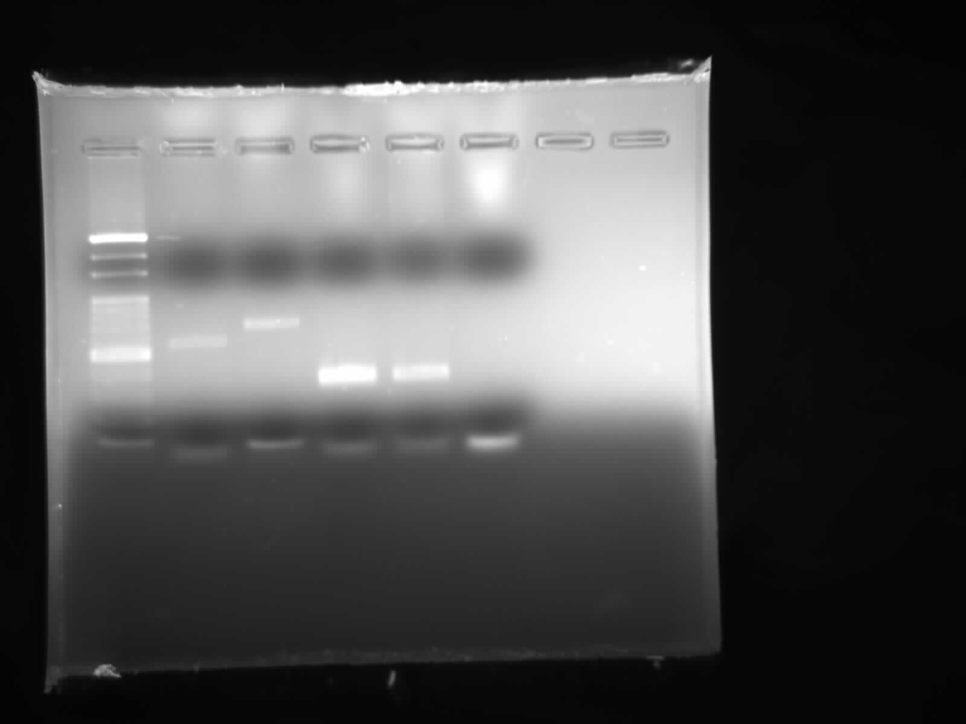
Figure 1. Agarose-gel image of possible host’s PCR products (M: marker (100- 1000 bp) band size for cow: 561 bp dog: 680 bp human: 334 bp chicken: 383 bp).
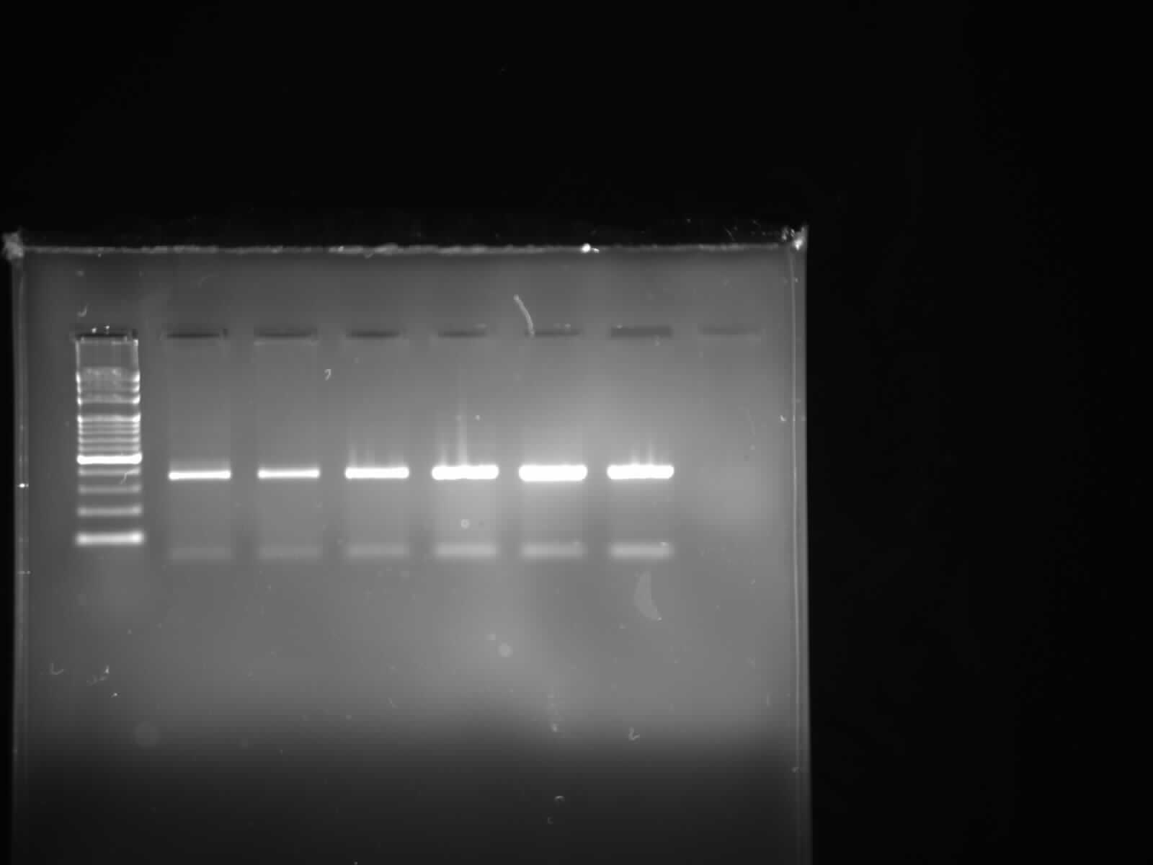
Figure 2. Agarose-gel image of PCR products of three sandfly species from Aydin (M: 100 bp, 1-6 chicken PCR prodcuts).

