PLATES
Plate 1
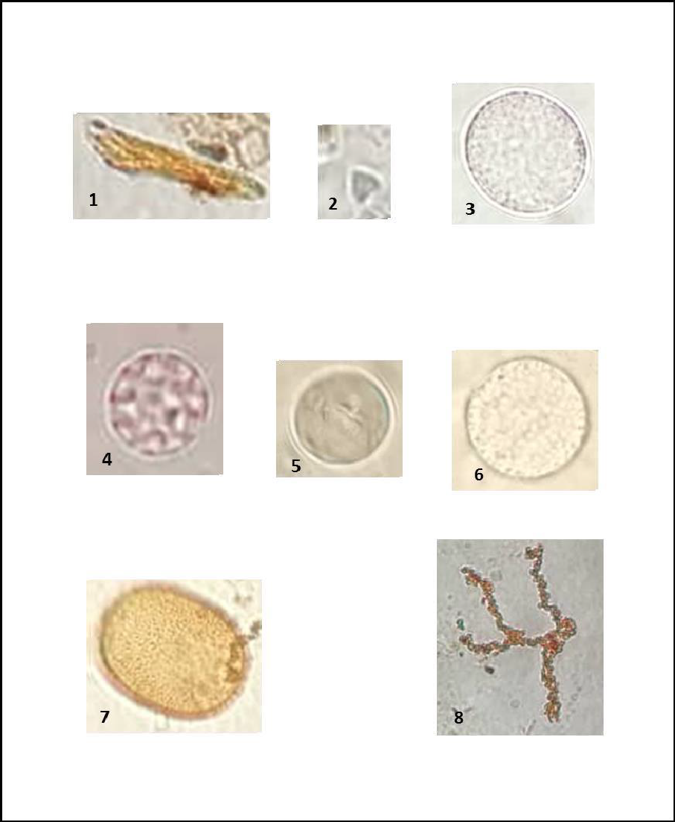
Photomicrographs of the Pollen Grains, and Fungal spores forKining’inila-1 Borehole; Scale bar = 20 µm, each species is identified by slide number, depth and England finder Coordinate number.
Plate 1 Explanation
1. Equisetosporites strigatus; Slide number, EYW-19/CS-001 Depth: 09.85 - 09.90 m; O44,
2. Triorites minor; Couper, Slide number; EYW-19/CS-001 Depth: 09.85 - 09.90 m N50-3,
3. Ascospores or conidia (fungal); Slide number; EYW-19/C001 Depth: 09.85 - 09.90 m, K48-2
4. Clay ball fungal Ascospores of Sordariales; Slide number; Slide number; EYW-19/CS-003 Depth: 09.85 - 09.90 m, N47
5, 6&7fungal spore Slide Number; EYW-19/CS-004 Depth: 28.77-28.82 mE43-2
8. Hyphae-like cell-strings in the thallus of epiphytic algae (Trentepohlia prolifera), Slide number; EYW-19/CS-004 Depth: 28.77-28.82m M50-3

Plate 2
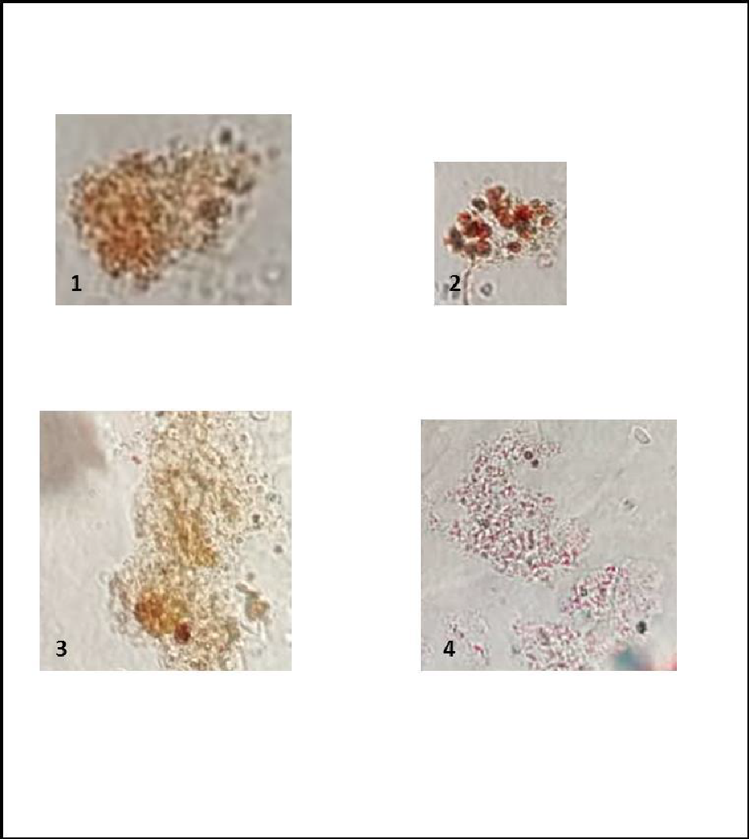
Photomicrographs of the Palynofacies; forKining’inila-1 Borehole Scale bar = 20µm, each species is identified by slide number, depth and England finder Coordinate number.
Plate 2 Explanation
1. &3 – Amorphous organic matter (AOM); Slide number; EYW-19/CS-005 Depth: 29.93-30.63G38
2. Massive Algae; Slide number; EYW-19/CS-009 Depth: 10.43 - 10.45, M44
4. Well preserved diffused edged Amorphous Organic Matter particles Slide number; EYW-19/CS-009 Depth: 10.43 - 10.45, T43-1.

Plate 3
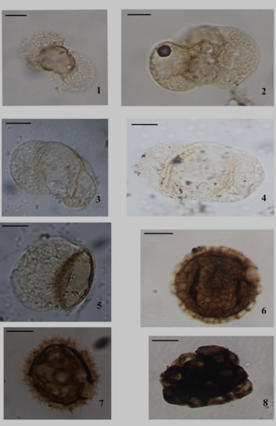
Photomicrographs of the Palynomorphs; for Nyalanja-1 Borehole Scale bar = 20µm, each species is identified by slide number, depth and England finder Coordinate number.

Plate 3 Explanation
1-4. Podocarpus capensis; Slide number; EYW-19/CS-003, Depth: 24.85 – 24.90 m P42-3
5. Podocarpus sp; Slide number; EYW-19/CS-003 Depth: 24.85-24.90, N46-4
6. Polygonum sp; Slide number; EYW-19/CS-007, Depth: 60.24-60.31 m, P37
7. Bothriodine amplifolia. Slide number; EYW-19/CS-008, 75.84-75.9m, H50-2
8. Acacia sp; Slide number; EYW-19/CS-011, Depth: 148.70-148.77 m, M45-1

Plate 4
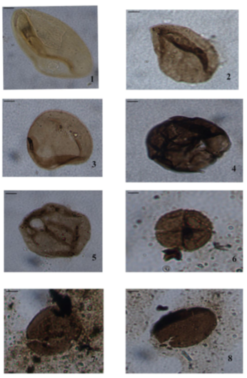
Photomicrographs of the Pollen grains; Scale bar = 25 µm, each species is identified by slide number, depth and England finder Coordinate number.

Plate 4 Explanation
1. Monocolpites sp, Slide number; EYW-19/CS-012, Depth: 148.70-148.77m, L41
2. Cycadopites sp, Slide number; EYW-19/CS-013, Depth: 158.91-158.98 m N32
4. Biodegraded Material
5. Cyclopsiella elliptica, Slide number, EYW-19/CS-013, Depth: 158.91-158.98m, S36-3
6. Euphorbia sp; Slide number; EYW-19/CS-014, Depth: 70.01-170.17, Q33
7&8. Taxodiaceapollenites sp; Slide number; EYW-19/CS-012, Depth: 148.70-148.77m, W46-4

Plate 5
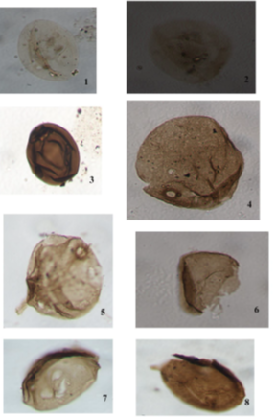
Photomicrographs of the Pollen grains; Scale bar = 25µm, each species is identified by slide number, depth and England finder Coordinate number.

Plate 5 Explanation
1, &3Monopollenites sp Slide number, EYW-19/CS-004, Depth: 24.85-24.90, L33-4, 2.
4&5 Cyclopsiella elliptica; EYW-19/CS-004, Depth: 24.85-24.90, M54,

Plate 6
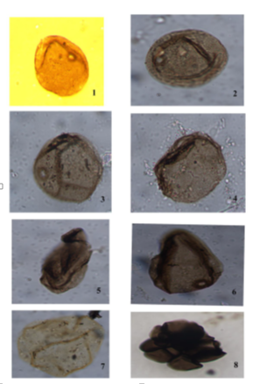
Photomicrographs of the Pollen grains; Scale bar = 25 µm, each species is identified by slide number, depth and England finder Coordinate number.

Plate 6 Explanation
1-4 Cyclopsiella elliptica
8. Acacia sp Slide number, EYW-19/CS-006, Depth: 24.85-24.90, P54-2

Plate 7
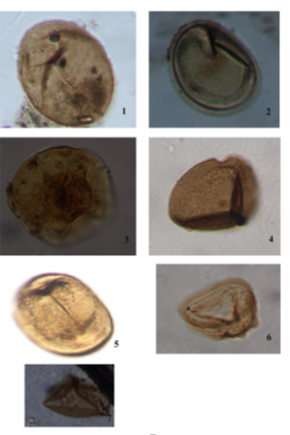
Photomicrographs of the Pollen grains; Scale bar = 25 µm, each species is identified by slide number, depth and England finder Coordinate number.
Plate 7 Explanation
1. Laevigatosporites ovatus Slide number; EYW-19/CS-010, Depth, 28.42-128.49m, E40-1,
2. Exesipollenites tumulus Slide number; EYW-19/CS-006, Depth: 24.85-24.90, R37-2,
3. Spheripollenites sp, Slide number; EYW-19/CS-006, Depth: 24.85-24.90, T21-2,
4. Monosporites sp, EYW-19/CS-011 Depth, 137.82-137.88m K39-4,
5. Spheripollenites sp Slide number EYW-19/CS-013, Depth: 158.91-158.98m, V43-1
6&7Deltoidosporites Africana EYW-19/CS-012, Depth, 48.70-148.77 m, G26-3

Plate 8
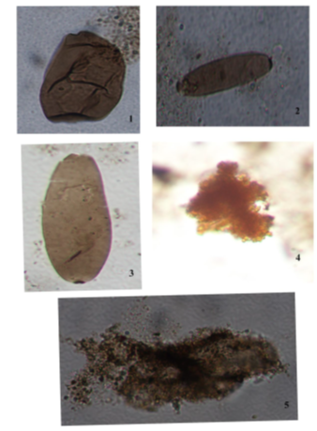
Photomicrographs of the Fungi spores and phytoclast; Scale bar = 25 µm, each species is identified by slide number, depth and England finder Coordinate number.

Plate 8 Explanation
1-3. Fungi spore.
4. Botryococcus sp.
5. Amorphous Organic Matter

Plate 9
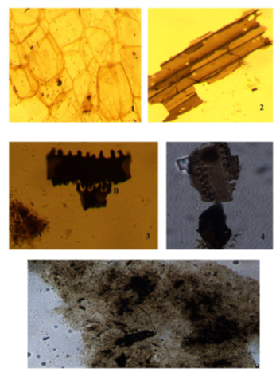
Photomicrographs of the Palynofacies and phytoclast; Scale bar = 25 µm, each species is identified by slide number, depth and England finder Coordinate number.

Plate 9 Explanation
1. Plant cell.
2. Well preserved brown wood.
3. Wood Cuticles.
4. Wood debris.
5. Amorphous Organic Matter.
Photomicrographs of the palynomorphs for Luono-1 Borehole; Scale bar = 25 µm, each species is identified by slide number, depth and England finder Coordinate number

Plate 10
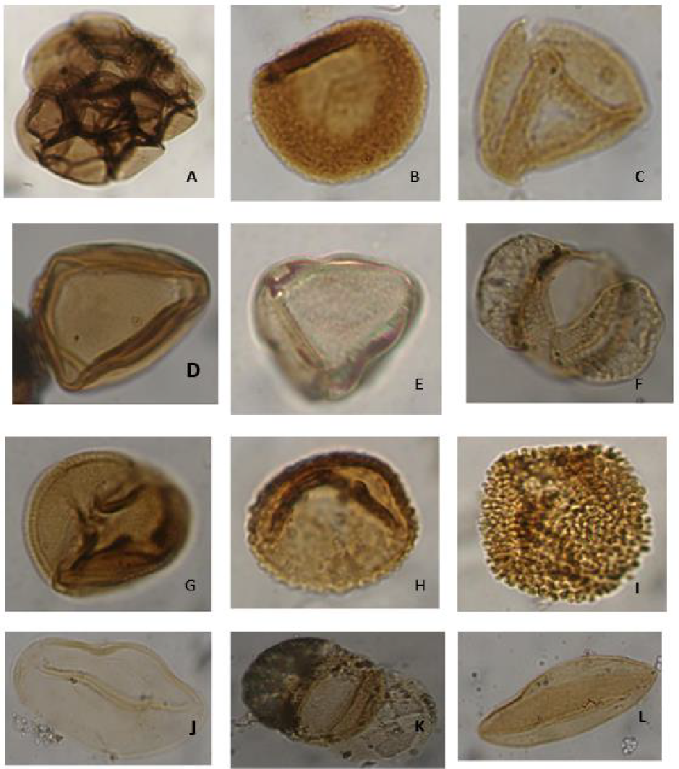
Photomicrographs of the Pollen Grains for Luono-1 Borehole; Scale bar = 25 µm, each species is identified by slide number, depth and England finder Coordinate number

Plate 10 Explanation
- Acacia sp Slide number; EYW-19/CS-001 Depth: 8.05-8.15, U54,
- Verrucatosporites usmensis Slide number; EYW-19/CS-011 Depth,137.82-137.88m K39-4,
C, D & E. Cyperaceae sp. EYW-19/CS-013 Depth, 139.33-139.38m, P42-2,
F & K. Podocarpus sp. Slide number; EYW-19/CS-009, Depth, 117.24-117.3m, U31-3,
G. Perfotricolpites digitatus. Slide number; EYW-19/CS-010, Depth, 106.47-106.53m, M33-1,
H. Junisperus sp Slide number, EYW-19/CS-010, Depth, 117.24-117.31m, K35-1,
I.? Ilex sp. Slide number; EYW-19/CS-015, Depth, 196.76-196.86m, H49-1,
J. Monocolpites sp. EYW-19/CS-015, Depth, 196, 76-196.86m, H49-1,
L. Crudia sp. EYW-19/CS-010, Depth, 117.24-117.31m, K35-1,

