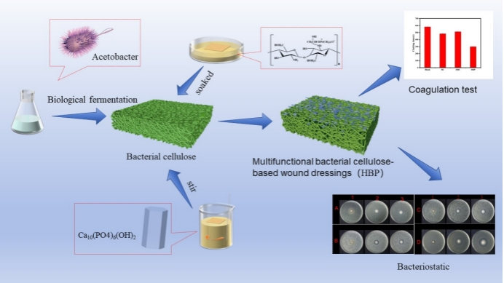
A multifunctional bacterial cellulose-based wound dressing is prepared using bacterial cellulose derived from pear juice fermentation by kombucha as the base material. It is then compounded with chitosan quaternary ammonium salt and hydroxyapatite via soaking and stirring methods. This dressing exhibits excellent biocompatibility, antibacterial properties, and in vitro hemostatic performance, making it suitable for rapid hemostasis and wound healing.

