Supplementary information 1
The multivariable analysis incorporating defined daily dose and the alternative predictive model

Associated factors of postoperative persistent hypertension using univariable and multivariable logistic regression model
Variables | Univariable |  | Multivariable
Variables | OR (95%CI) | P value | aOR (95%CI) | P value
Age ≥ 50 years | 5.83 (3.19-10.65) | <0.001 | 3.00 (1.43-6.29) | 0.003
Female gender | 0.48 (0.28-0.85) | 0.01
BMI ≥ 25 kg/m² | 2.14 (1.26-3.61) | <0.001
Family history of hypertension | 2.17 (0.98-4.8) | 0.05
Current or past smoking | 2.31 (1.01-5.28) | 0.049
Duration of hypertension ≥ 5 years | 4.9 (2.82-8.51) | <0.001 | 2.53 (1.31-4.88) | 0.006
Number of antihypertensive medications ≥ 3 | 3.13 (1.79-5.47) | <0.001
DDD of antihypertensive medication ≥ 3.5 | 3.41 (1.93-6.03) | <0.001 | 3.39 (1.78-6.45) | <0.001
Diabetes mellitus | 3.44 (1.53-7.73) | <0.001
Chronic kidney disease | 10.23 (2.38-43.87) | <0.001
Dyslipidemia | 4.92 (2.58-9.4) | <0.001 | 2.17 (1.01-4.64) | 0.046
eGFR < 60 mL/min/1.73 m² | 5.41 (1.59-18.46) | 0.01
Presence of LVH | 2.56 (1.34-4.87) | 0.002
Abbreviations: BMI, body mass index; DDD, defined daily dose; eGFR, estimated glomerular infiltration rate; LVH, left ventricular hypertrophy

Final prediction model for postoperative persistent hypertension
 | Coefficient | Score
Age
- < 50 years | 0 | 0
- ≥ 50 years | 1.10 (0.36-1.84) | 1
Dyslipidemia
- No | 0 | 0
- Yes | 0.77 (0.01-1.53) | 1
DDD of antihypertensive medication
- < 3.5 | 0 | 0
- ≥ 3.5 | 1.22 (0.58-1.86) | 2
Duration of hypertension
- < 5 years | 0 | 0
- ≥ 5 years | 0.93 (0.27-1.58) | 1
Total |  | 5
Internal validation for final model (N=233)
Hosmer–Lemeshow = 4.87 p-value= 0.30
ROC area = 0.79 (95%CI: 0.73-0.85)
External validation (N=98)
ROC area = 0.70 (95%CI: 0.60-0.80)

Abbreviations: DDD, defined daily dose

Receiver operating characteristic curves (ROC) and calibration plot of the model.
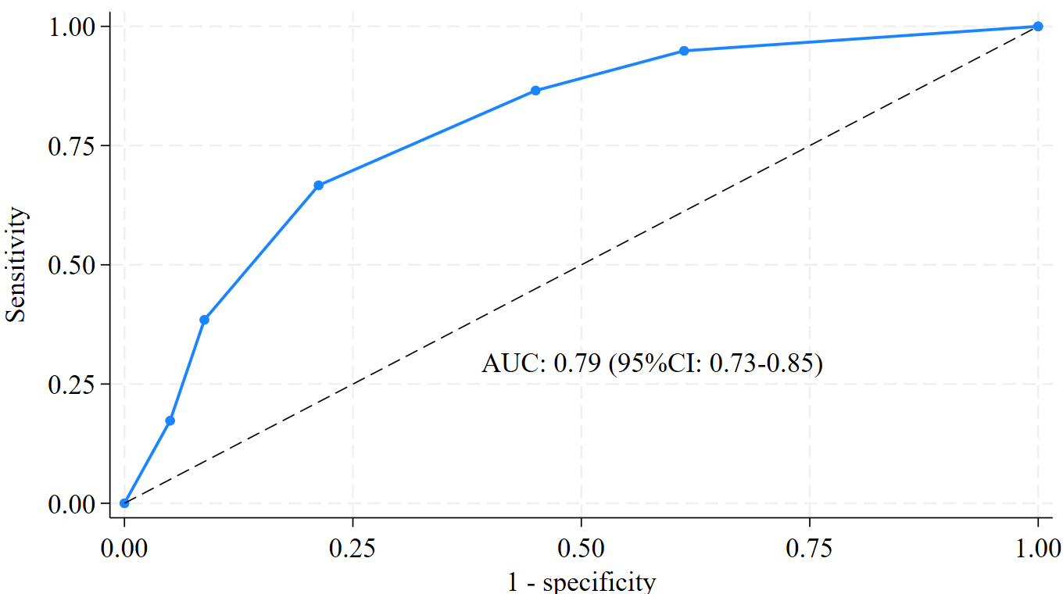
A
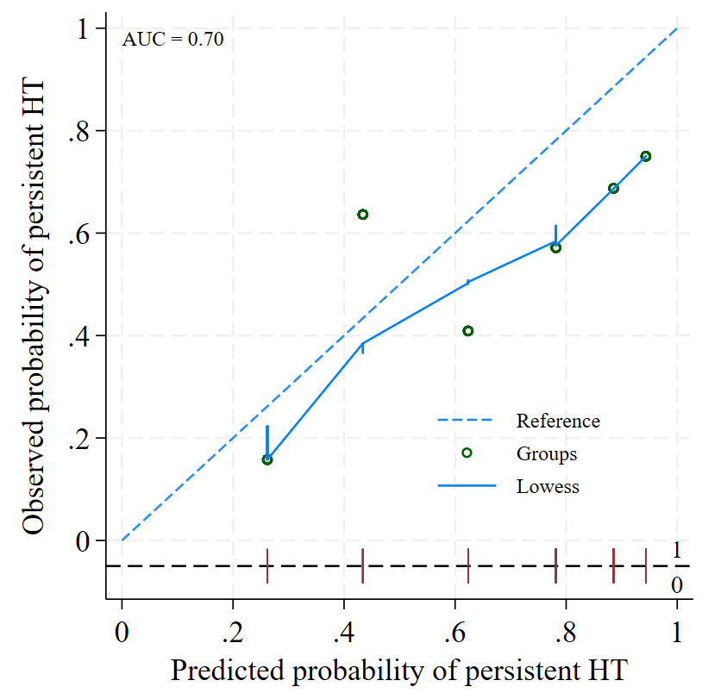
C
B
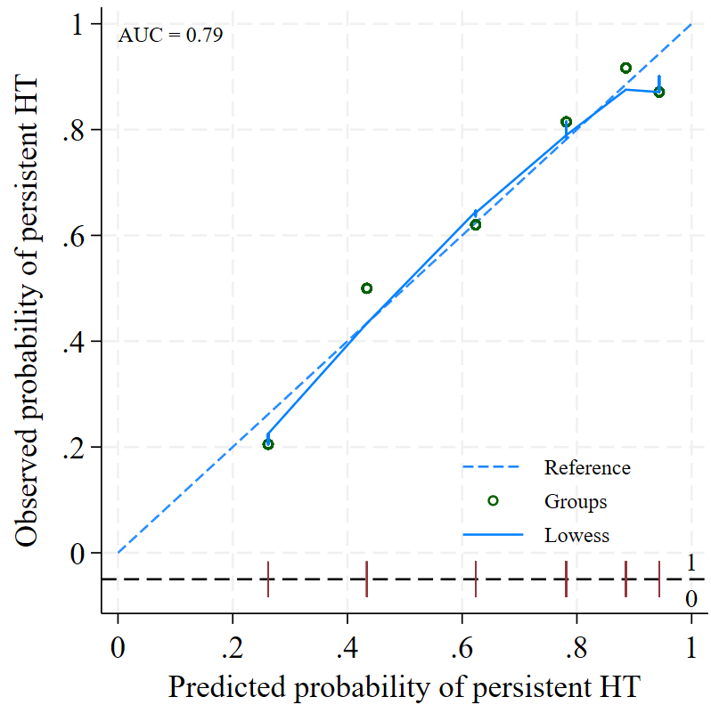
- ROC of the variables correlated with persistent hypertension (age ≥50 years, presence of dyslipidemia, Defined daily dose of antihypertensive medication ≥ 3.5, and duration of hypertension ≥ 5 years)
- The calibration plot indicating good agreement predictive possibility in training group
- The calibration plot indicating good agreement predictive possibility in testing group
Abbreviations: HT, Hypertension

Estimated data on persistent hypertension by score group
Score | Estimate Not resolved HT by score group
0 | 26.2%
1 | 43.4%
2 | 62.4%
3 | 78.2%
4 | 88.5%
5 | 94.3%
Risk stratification
0-1 (Low risk) | 32.3%
2-3 (moderate risk) | 72.1%
4-5 (high risk) | 89.6%

