Supplementary Materials for
Nonreciprocal surface plasmonic neural network for decoupled bidirectional analog computing
Xiaomeng Li^{1,2}, Haochen Yang^{1,2}, Enzong Wu^{1,2}, Xincheng Yao^{1,2}, Fei Gao^{1,2}, Hongsheng Chen^{1,2,*} and Zuojia Wang^{1,2,*}
¹International Joint Innovation Center, Zhejiang Key Laboratory of Intelligent Electromagnetic Control and Advanced Electronic Integration, Zhejiang University, Haining 314400, China
²State Key Laboratory of Extreme Photonics and Instrumentation, College of Information Science and Electronic Engineering, Zhejiang University, Hangzhou 310027, China.
*Corresponding authors. E-mail: zuojiawang@zju.edu.cn (Z. Wang); hansomchen@zju.edu.cn (H. Chen).

Supplementary Text 1 S-matrix and T-matrix
Supplementary Text 2 Phase shifter transmission characteristics
Supplementary Text 3 Transition structure design
Supplementary Text 4 The parameters of the multi-port network
Supplementary Text 5 Implication of each S submatrix of the feedback network
Supplementary Text 6 Structure diagram and field diagram of the feedback network
Supplementary Text 7 Different operator encoding processes in image processing
Supplementary Text 8 S parameter image of the NR cell
Supplementary Figure 1 The formation process of circularly polarized waves
Supplementary Figure 2 Three SSPP lines with different curvatures
Supplementary Figure 3 The transition structure
Supplementary Figure 4 Specific value of Si of the feedback network
Supplementary Figure 5 Feedback system
Supplementary Figure 6 The encoding methods of three operators
Supplementary Figure 7 Transmission of the NR cell
Supplementary Table 1: Transmission characteristics of the transition structures

Supplementary Text 1: S-matrix and T-matrix
The 2-input 2-output cells are described by the 4×4 S-matrices. The connection between the 1st and 2nd layers of the network consists of four reciprocal cells connected in parallel, with its expanded S-matrix denoted as $S_{1}=diag\left[S_{R}^{4×4}\text{,}{\text{S}}_{R}^{4×4},S_{R}^{4×4},S_{R}^{4×4}\right]$. The connection between the 3rd and 4th layers comprises three non-reciprocal cells and two direct transmission lines, and its S-matrix is represented as $S_{2}=diag\left[I^{2×2}\text{,}S_{NR}^{4×4},S_{NR}^{4×4},S_{NR}^{4×4}\right]$. It is worth noting that here we use the design of staggered interconnected cells to cascade four layers of nodes. This approach enhances coupling between cells, allowing flexible adjustment of the overall network's transmission.
In this configuration, the overall network can be described by a T-matrix, expressed as $T_{total}^{16×16}=T_{1}^{16×16}T_{2}^{16×16}$. Here, T₁ and T₂ represent the transmission between the nodes of the 1st and 2nd layers, and the 3rd and 4th layers, respectively. The non-diagonal elements of the S-matrix related to NR connections are fully controllable via three non-reciprocal cells. This is achieved because the interleaved design ensures that signals from all input ports pass through each non-reciprocal cell, thereby maximizing the impact of non-reciprocity
Relationship between the reciprocity of the S matrix and the determinant of the T matrix:
$\text{det}(T_{R}^{2×2})=S_{12}^{R}(S_{21}^{R})^{-1}=1$ (1.1)
$\text{det}(T_{NR}^{2×2})=S_{12}^{R}(S_{21}^{R})^{-1}≠1$ (1.2)
The reciprocity of a two-port network is related to the determinant of the T matrix. The determinant of the T matrix of a reciprocal two-port network is 1, and the determinant of a non-reciprocal network is not equal to 1. It serves as the mathematical manifestation of completely bidirectional independent transmission between two ports. Therefore, the non-reciprocal cells break the symmetric constraint between the forward and backward weight matrices, thus satisfying the need for biologically inspired bidirectional decoupled information processing.
Interestingly, the introduction of non-reciprocity significantly expands the mathematical space for matrix transformations, as evidenced by its influence on the T-matrix. The determinant of the T-matrix is directly associated with the symmetry of the S-matrix. This characteristic is more evident in two-port networks (proof provided in Supplementary Text 5). The determinants of the T-matrices for R and NR connections in Fig. 2a are given as: det (T_{R}) = 1 and det (T_{NR}) ≠1. Next we analyze the impact of the non-reciprocity on the linear space of matrix transformation. “The determinant of a matrix represents the (oriented) volume of a parallelepiped, where each edge corresponds to a column of the matrix.” ^{[38]} The columns of a matrix perform operations such as scaling the original coordinate system. The determinant represents the scaling factor of the arbitrary unit polyhedron volume after linear transformation. Hence, the output volume of the unit polyhedron after TNR undergoes a change. In other words, the introduction of non-reciprocity expands the completeness of transformation matrix. This provides a theoretical basis for bidirectional decoupled propagation in multi-port networks. And due to the introduction of non-reciprocity, the network’s S-matrix in Fig. 2b is asymmetric, thereby satisfying the prerequisite for independent bidirectional transmission matrices depicted in Fig. 1b.

Supplementary Text 2: Phase shifter transmission characteristics
The NRPS in Fig. 2c, consists of ferrite, SSPP transmission lines, and trapezoidal transition structure. The ferrite breaks time-reversal symmetry through the magneto-optical effect arising from the interaction between light and magnetic matter, showing the phase nonreciprocity for linear polarization. The phase nonreciprocity in gyrotropic devices shows symmetric transmission amplitude yet asymmetric phase response in the forward and backward directions, respectively. The simulation results of the NRPS are shown in Fig. 2d. Upon application of an external magnetic field, the dispersion curves for forward and backward waves split, allowing the bidirectional paths to be regarded as two decoupled unidirectional ones. These bidirectional waves exhibit distinct phase shifts, with the difference between them defined as the differential phase shift (DPS).
To maximize the effect in a minimal area, single-sided patterned SSPPs waveguide is designed as the coherent curved lines to transmit linearly polarized waves. Three SSPP lines with different curvatures are compared in Figs. S2a-c, namely microstrip lines, curved SSPP mentioned in the main text, and SSPP waveguides with weaker curvature. The three have the same longitudinal length. However, as shown in Figs. S2a-c, the forward and backward phase splitting of the SSPP line in this article is more obvious. The SSPP lines in this paper has more obvious nonreciprocity in unit length, thus the volume of ferrite required is effectively reduced. Therefore, the compact SSPP effectively enhances nonreciprocity and also has the prospect of miniaturization.

Supplementary Text 3: Transition structure design
In order to facilitate integration with existing microwave systems, a transition structure that achieves mode matching and impedance matching needs to be designed. As mentioned above, at the same frequency, the dispersion curve of the SSPP unit structure deviates significantly from the light line, so it is difficult to directly excite surface waves from free space; at the same time, there is a large momentum mismatch between the quasi-TEM mode transmitted in the microstrip line and the TM mode supported in the SSPP transmission line. As shown in the dispersion curve of Fig. 2e, as the frequency increases, the mismatch between the two becomes more and more obvious. Therefore, it is difficult to excite surface waves when the microstrip line is directly connected to the SSPP transmission line. In addition, there is an impedance mismatch problem between the SSPP transmission line and the 50Ω microstrip line. Due to the high dielectric constant of the substrate, a larger DPS requires an exceedingly narrow SSPP line. This width significantly deviates from that in traditional microstrip lines, posing challenges for interconnection. Therefore, the impedance matching problem needs to be solved to reduce the reflection of propagation and improve the transmission performance. In our article, the transition structure is designed as a uniform progressive structure to achieve a smooth transition of the line width. As is shown in Fig. S3, the transition structure is designed as a progressive gradient structure. And the impedance of the SSPP transmission line in FigureTable1 is 68Ω. But after connecting to the transition structure, the impedance is 50Ω, which is compatible with standard microstrip lines.

Supplementary Text 4: The parameters of the multi-port network
The forward parameters at 10.6Ghz are:$\left[a_{1} a_{2} a_{3} a_{4} a_{5} a_{6} a_{7} a_{8}\right]=\left[0.58 0.58 0.57 0.57 0.57 0.57 0.58 0.58\right]$,$\left[φ_{1} φ_{2} φ_{3} φ_{4} φ_{5} φ_{6} φ_{7} φ_{8}\right]=\left[-121° -121° -65° -65° -65° -65° -121° -121°\right]$.
The forward parameters at 10.6Ghz are: $\left[a_{1} a_{2} a_{3} a_{4} a_{5} a_{6} a_{7} a_{8}\right]=\left[0.54 0.45 0.52 0.42 0.54 0.45 0.6 0.6\right]$,$\left[φ_{1} φ_{2} φ_{3} φ_{4} φ_{5} φ_{6} φ_{7} φ_{8}\right]=\left[-96° 100° -90° 103° -96° 100° -97° -97°\right]$.
The forward parameters at 10Ghz are: $\left[a_{1} a_{2} a_{3} a_{4} a_{5} a_{6} a_{7} a_{8}\right]=\left[0.43 0.43 0.325 0.325 0.325 0.325 0.43 0.43\right]$,$\left[φ_{1} φ_{2} φ_{3} φ_{4} φ_{5} φ_{6} φ_{7} φ_{8}\right]=\left[-50° -50° 150° 150° 150° 150° -50° -50°\right]$.
The backward parameters at 10Ghz are: : $\left[a_{1} a_{2} a_{3} a_{4} a_{5} a_{6} a_{7} a_{8}\right]=\left[0.62 0.52 0.52 0.35 0.62 0.52 0.67 0.67\right]$,$\left[φ_{1} φ_{2} φ_{3} φ_{4} φ_{5} φ_{6} φ_{7} φ_{8}\right]=\left[-43° -5° -9° 23° 23° -43° -80° -80°\right]$.

Supplementary Text 5: Implication of each S submatrix of the feedback network
Consider the general case (the eigenvalue of the matrix to be calculated is less than unity), in which case the field in the system converges in a steady state. Taking reverse transmission as an example, input signals from ports 10, 12, and 14, and output signals are received by ports 4, 6, and 8. Theoretically, it can be achieved as equation 1.3. Among them, S_{i} is a sub-matrix of the S matrix of the original network without the feedback line, which is a 3*3 matrix, specifically as Fig. S4.
Taking port 10 as an example, since the input signal is transmitted bidirectionally in the system (transmitted to port 11 and port 3), there is bidirectional recursion in the feedback loop at the same time. Each recursion represents an interaction with the system, and finally the output solution is obtained in the steady state. In formula 1.1, $S_{N}$ represents the information transmission that does not participate in the iteration, which is directly transmitted from port 10 to port 4, and can be understood as the background noise. $g_{0}$represents that after input from port 10, it is input to the feedback line from port 3, and after it is transmitted to port 11, it starts the reverse recursion, and finally the steady-state solution is output through port 4. $g_{N}$represents that after input from port 10, it is input to the feedback line from port 11, and after it is transmitted to port 3, it starts the forward recursion, and finally the steady-state solution is output through port 4. is the sum of the series of matrices to be solved, which is equivalent to in mathematical form, so equation 1.1 is equivalent to equation 1.3. The inverse of the matrix is ​​embedded in equation 1.3, and the theoretical result can be obtained through operations such as denoising and de-embedding. The forward and backward transmission formulas are the same, except that the elements of each S submatrix are different. The parameters for forward transmission are as Fig. S4.

Supplementary Text 6: Structure diagram and field diagram of the feedback network
The structure diagram and field diagram of the feedback network in CST are shown in Fig. S5. Three feedback waveguides are used to introduce iteration, while the unused ports are terminated with matched loads. Since the original network without feedback lines is nonreciprocal, the feedback system exhibits different computational functions in the forward and backward directions.
In the final stages of this work, we achieved matrix inversion by introducing feedback. Many feedback-waveguide-based matrix solvers only solve fixed matrices related to specific kernels. In contrast, our feedback network can solve multiple inverse matrices in a fixed system by both the propagation direction and the ferrite bias magnetic field. Here, the feedback network has both forward and backward iteration paths, so noise removal is needed. This problem can be solved by introducing resistors in the power divider. When the 2-input 2-output cell with input isolation is constructed, a feedback network with only a unidirectional iteration path is realized. Furthermore, here we solve a matrix of 3×3. In the future, we can solve matrices of larger dimensions by expanding the number of network ports.

Supplementary Text 7: Different operator encoding processes in image processing
We utilized three first-order gradient operators to extract image edges. Each operator consists of two filtering operators. The first operator is the basic gradient, through which the edge line detection is achieved through local differential computations. It consists of two 2×2 filtering operators: dx= [1 -1; 0 0]; dy= [1 0; -1 0]. The second is the Robert operator, also known as the cross-gradient operator, which consists of two 2×2 operators: dx= [1 0; 0 -1]; dy= [0 -1; 1 0]. The third is the Prewitt operator, which includes two 3×3 operators representing horizontal and vertical gradients: dx= [1 1 1; 0 0 0; -1 -1 -1]; dy= [1 0 -1; 1 0 -1; 1 0 -1]. Compared to the basic gradient operator, the Robert algorithm uses gradients at $±45°$ for edge detection. And different from the two, Prewitt operator has the largest dimension of 3×3.
First, the input image is divided into several 2×2 pixel matrices, and each is encoded as a 1×8 vector in Fig. S6. Note that, the operators differ only in the encoded matrices. Second, the one-dimensional vector is expanded into a high-dimensional matrix, corresponding to multiple excitations. Next, the weight matrix is extended to a higher dimension, corresponding to repeated propagation in the physical system：$K_{8m×n}\text{=diag}{\left[D,D,D,D,D,D,D,D\right]}_{8m×n}$，where $D={\left[\begin{matrix}\text{1} & \text{-1} & \text{1} & \text{-1} & \text{1} & \text{-1} & \text{1} & \text{-1}\end{matrix}\right]}^{T}$. Last, the result Ri​ for each pixel block is placed in the corresponding position.：$R_{output}=I×K_{8m×n}$. The final output corresponds to the processed image, which effectively performs edge detection based on the basic gradient operator.

Supplementary Text 8: S parameter image of the NR cell
The S parameter image of a 2-input 2-output cell is shown in Fig. S7. The upper limit of the S-parameter amplitude of the two-input and two-output cell is 0.49 (6dB).

References
- Zhang H C, Gao Z, Cui T J. Measurement method of dispersion curves for spoof surface plasmon polaritons[J]. IEEE Transactions on Antennas and Propagation, 2019, 67(7): 4920-4923.
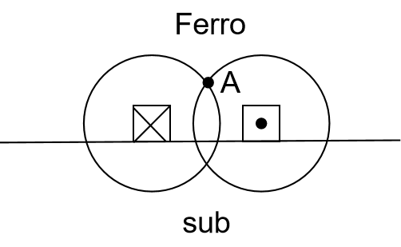
Supplementary Figure 1: The formation process of circularly polarized waves.

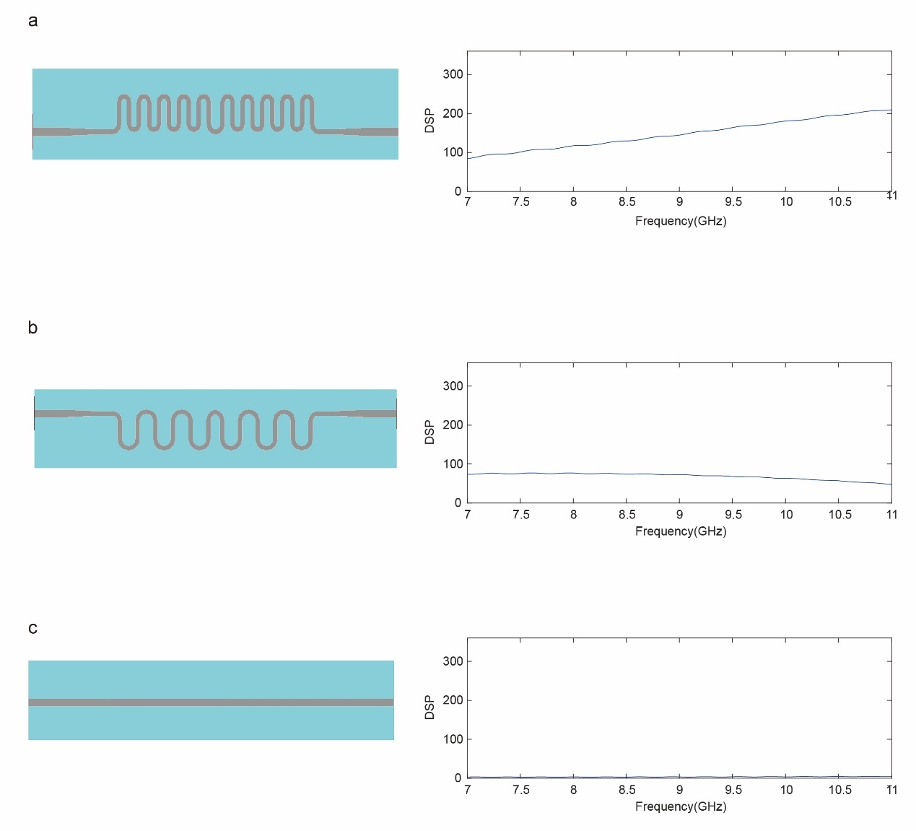

Supplementary Figure 2: Three SSPP lines with different curvatures. a-c, the DPS along the propagation direction for the large-curved SSPP, weak-curved SSPP, and microstrip line, respectively.

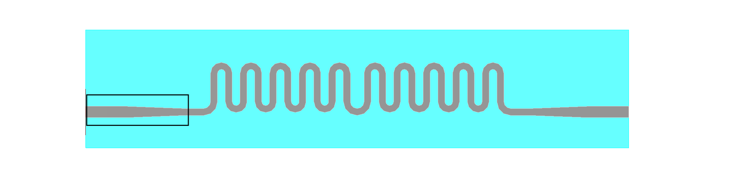

Supplementary Figure 3: The transition structure.

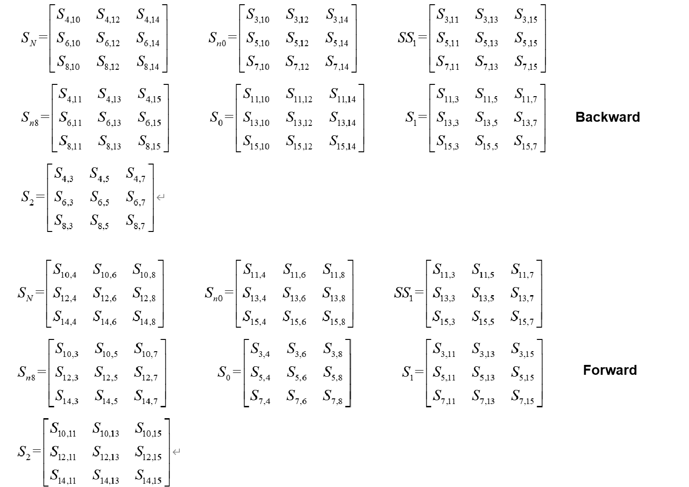
Supplementary Figure 4: Specific value of S_{i} of the feedback network.

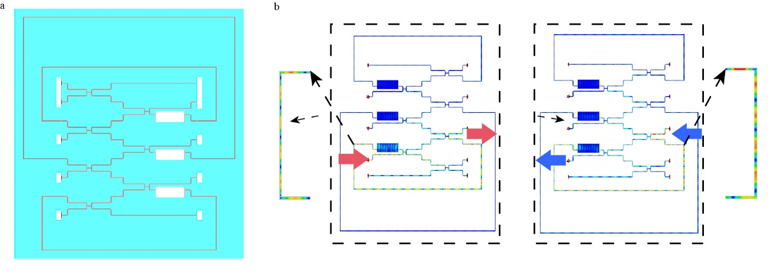
Supplementary Figure 5: Feedback system. a, Feedback system based on 8-input and 8-output computing network, where iterations are introduced through three feedback waveguides. b, Field distribution diagrams of forward (left) and backward (right).

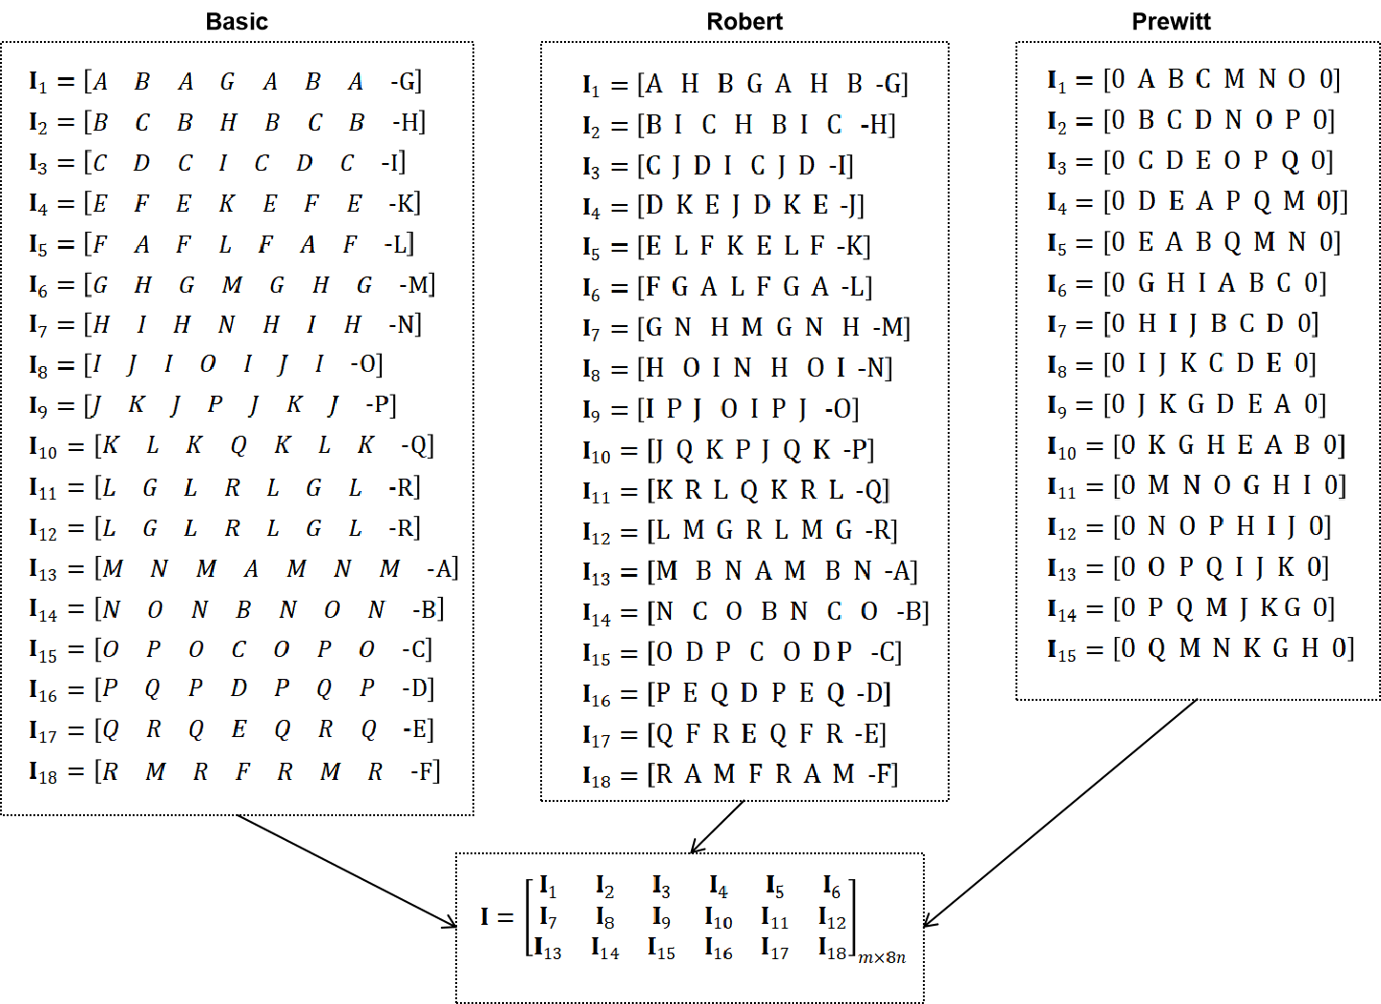
Supplementary Figure 6: The encoding methods of three operators.

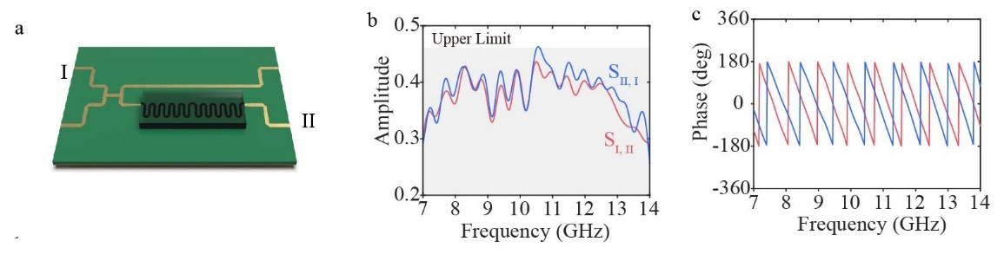
Supplementary Figure 7: Transmission of the NR cell. a, Schematic diagram of the structure of a non-reciprocal cell, which consists of a power divider and a phase shifter. b-c, Simulated amplitude and phase spectra of the cell.

Frequency | 10 GHz | 10 GHz
Phase | 0° | 0°
Mode type | Quasi TEM | Quasi TEM
Line Imp. | 67.5331Ω | 49.6462Ω

Supplementary Table 1: Transmission characteristics of the transition structures. The upper part shows the SSPP waveguide without transition structure, with an impedance value of 68Ω, which is incompatible with standard microstrip lines. The lower part shows the SSPP waveguide with transition structure, with an impedance value of 50Ω, which is compatible with standard microstrip lines.

