Simplified 3D genome and gap-less CC group Oryza genome reveal genetic dynamics of rice triploid lines from distant hybridization
Fangping Li^{1,2,3+}, Jiaxuan Chen²⁺, Can Chen¹⁺, Jieying Liu², Haifei Hu³, Rui Feng¹, Xiaoli Zhang¹, Xinghai Yang¹, Xiuzhong Xia¹, Zongqiong Zhang¹, Zhenpeng Gan¹, Baoxuan Nong¹, Shuhui Liang¹, Zhijian Xu1, Dekun Lei1, Yu Zeng¹, Yuntao Liang¹, Xianbing Jiang¹, Junliang Zhao³, Penglin Zhan², Danting Li^{1*}, Shaokui Wang^{2*}, Hui Guo^{1*}

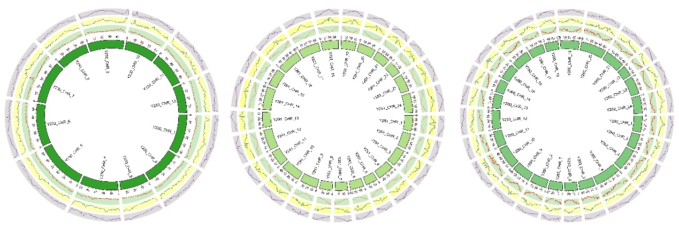
Supplemental Figure 1
The Genomic characteristics of two gapless CC genome assemblies. From inner to outer ring: gene density, TE density and long terminal repeated (LTR) density

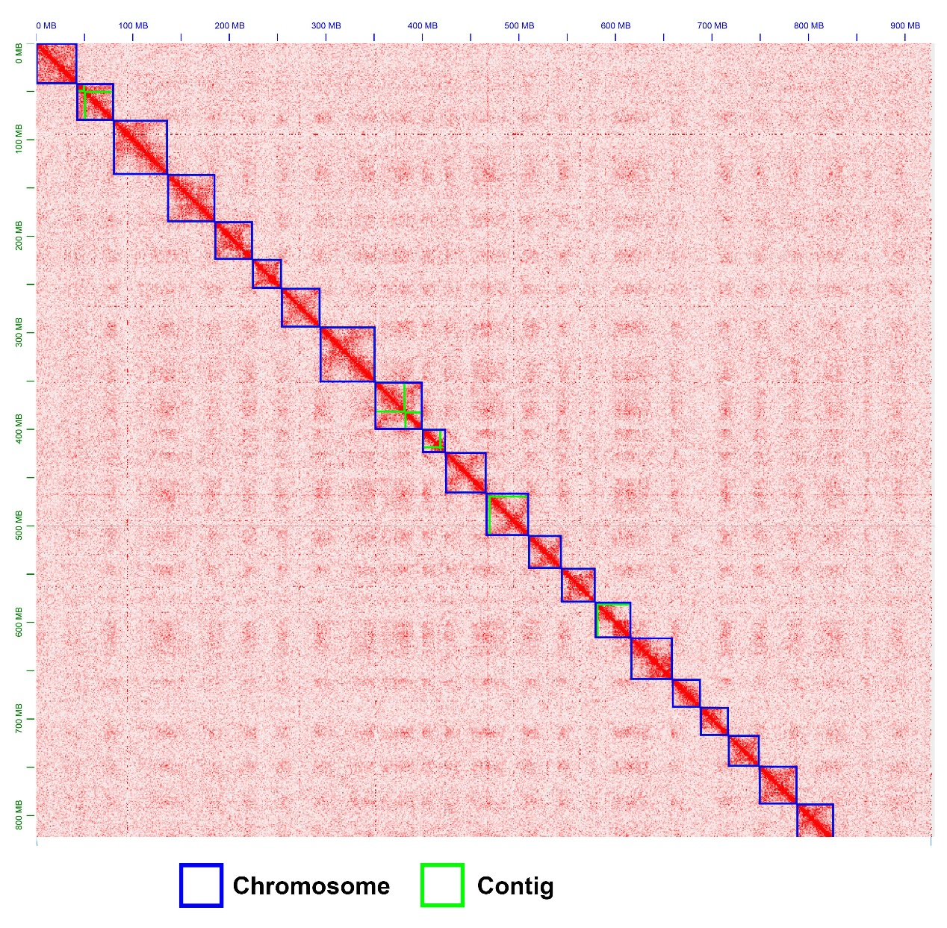
Supplemental Figure 2
The HI-C interaction matrix of wild rice Y260

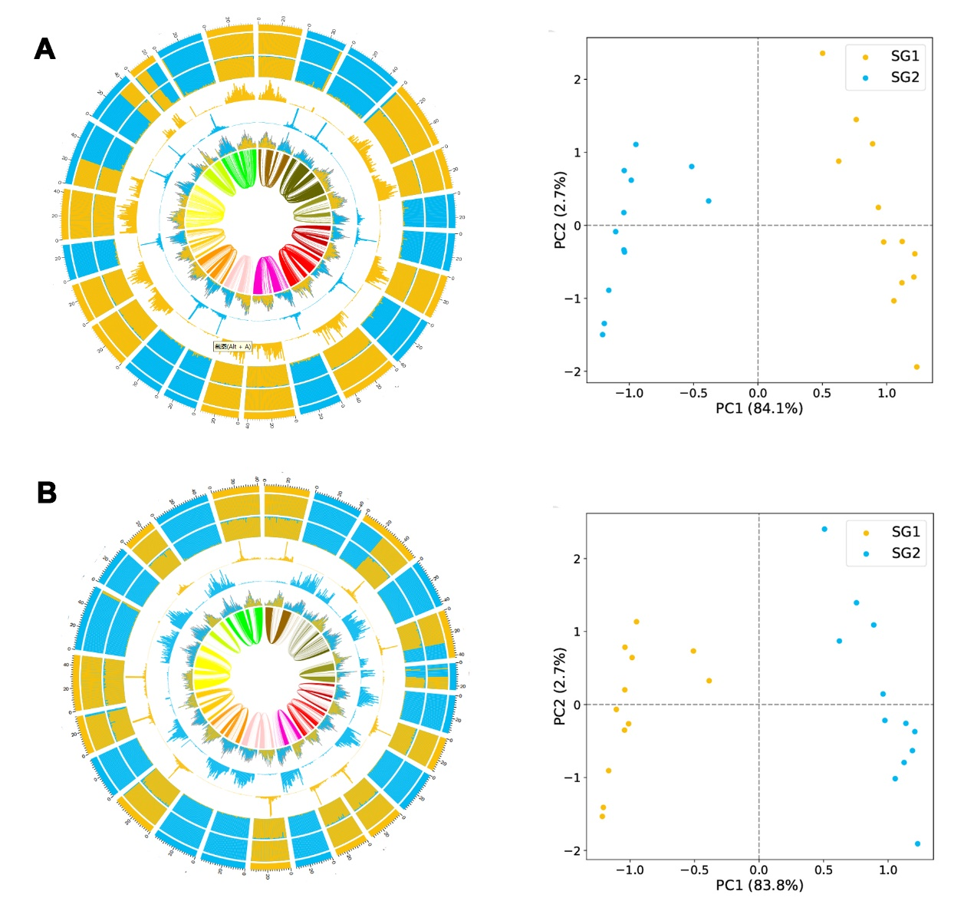
Supplemental Figure 3
Significant specific LTR distribution patterns exist in the two subgenomes as well as PCA analysis of K-mer analysis reveals that the tetraploid can be clearly divided into two subgenomes in tetraploidy rice (A) For Y259 (B) For Y260
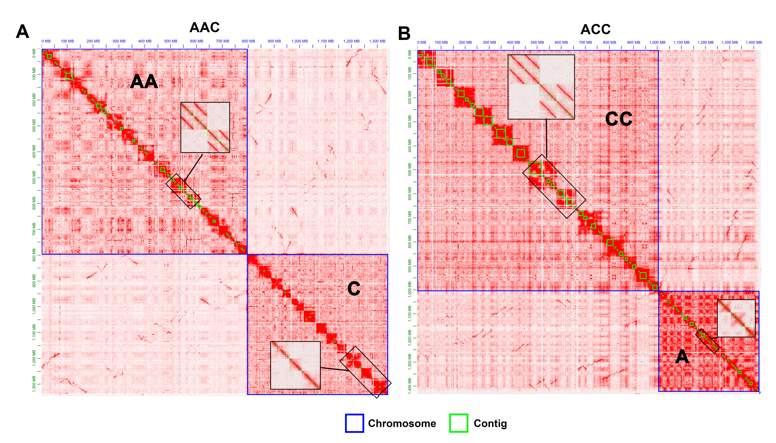
Supplemental Figure 4
The Haplotype solved assembly of two types of triploids (AAC/ACC) in backcross progeny. (A) For AAC (B) For ACC
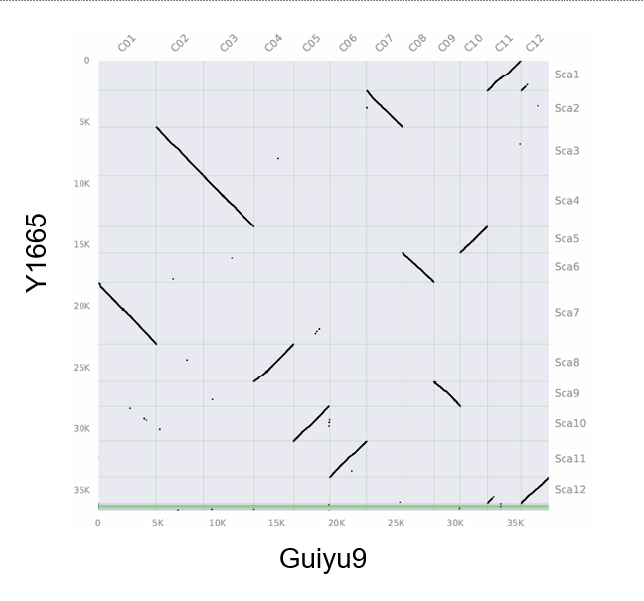
Supplemental Figure 5
The distribution of Allele pairs among two group (A/C; Y1665/Guiyu9) of Oryza genomes.

