Supplementary Information
Additional file 1: Fig. S1
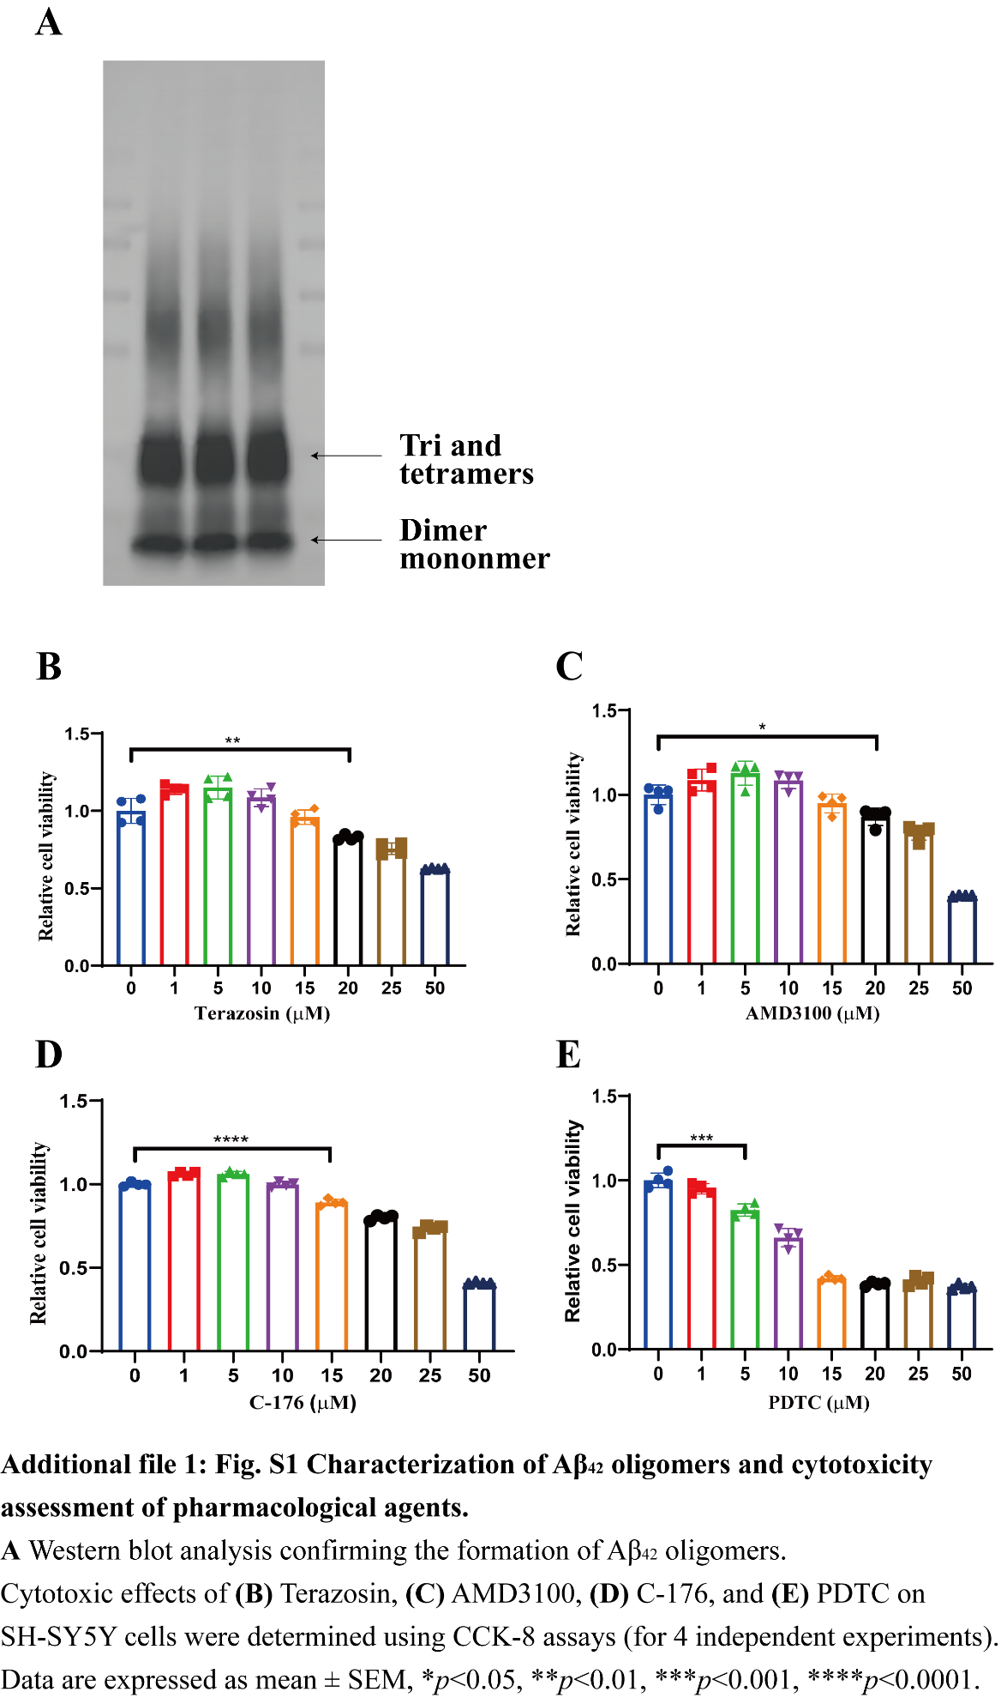
Additional file 2: Fig. S2
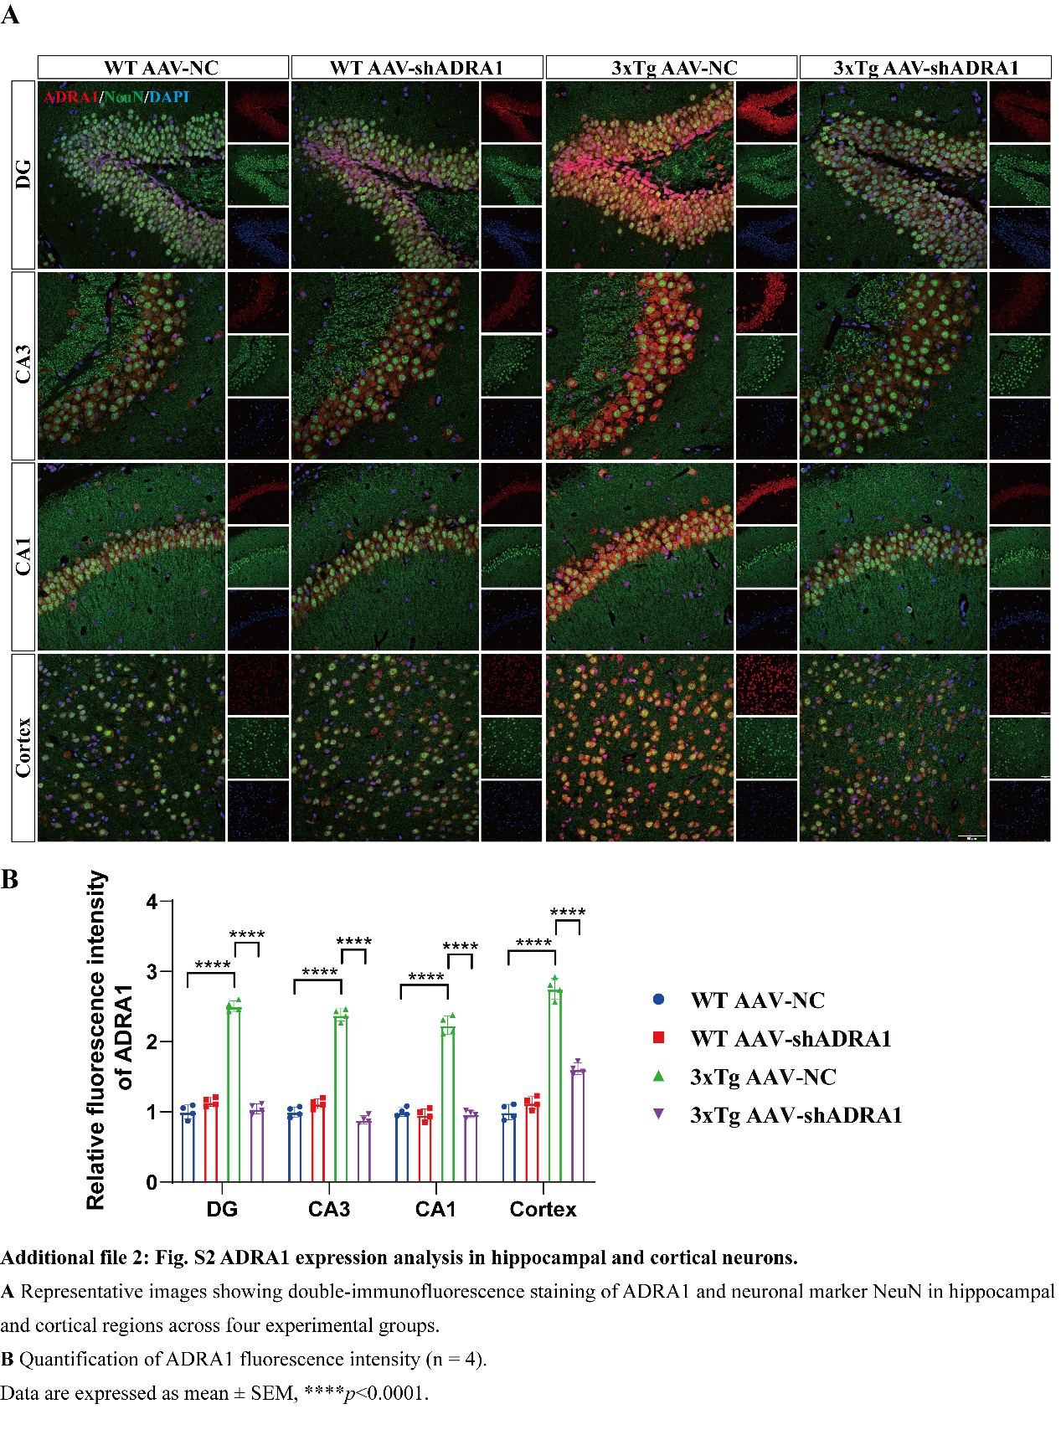
Additional file 3: Fig. S3
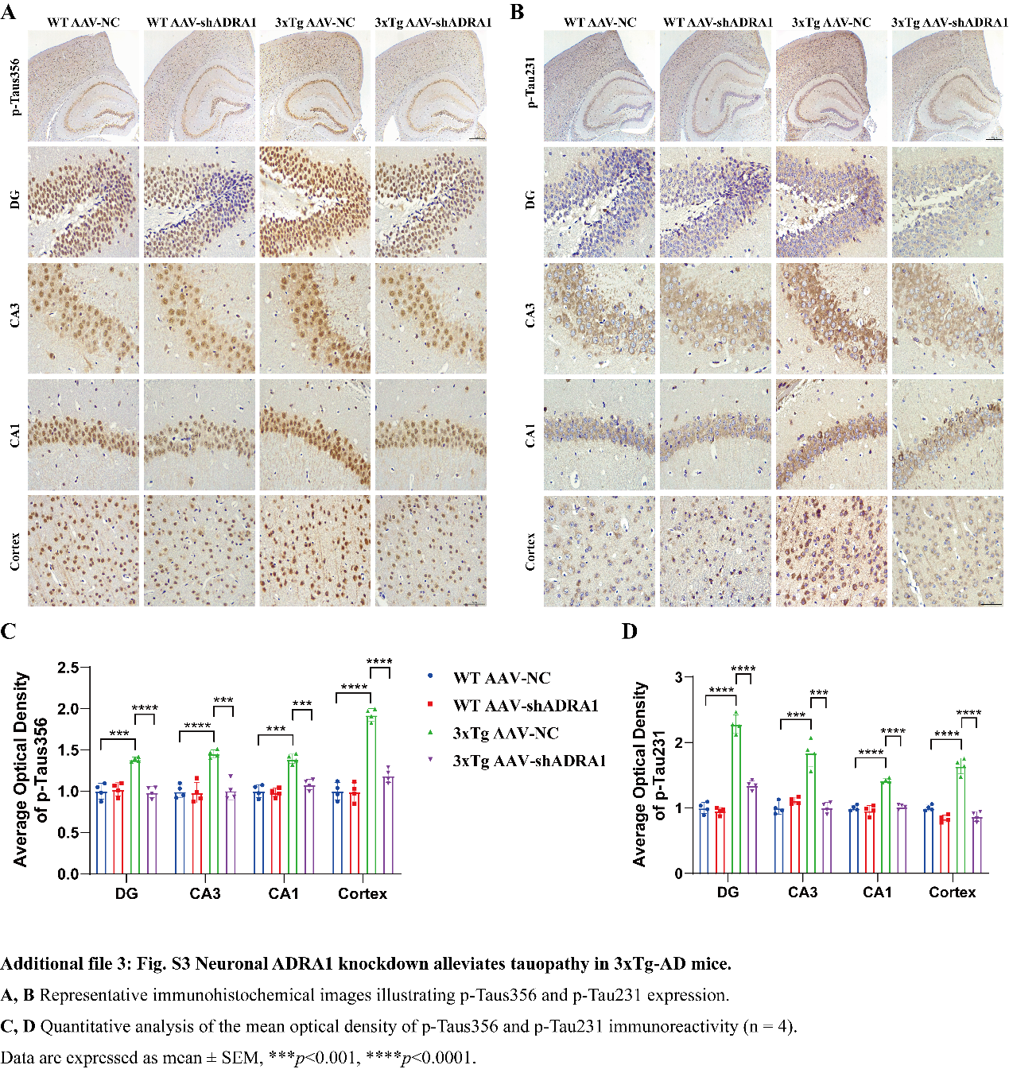
Additional file 4: Fig. S4
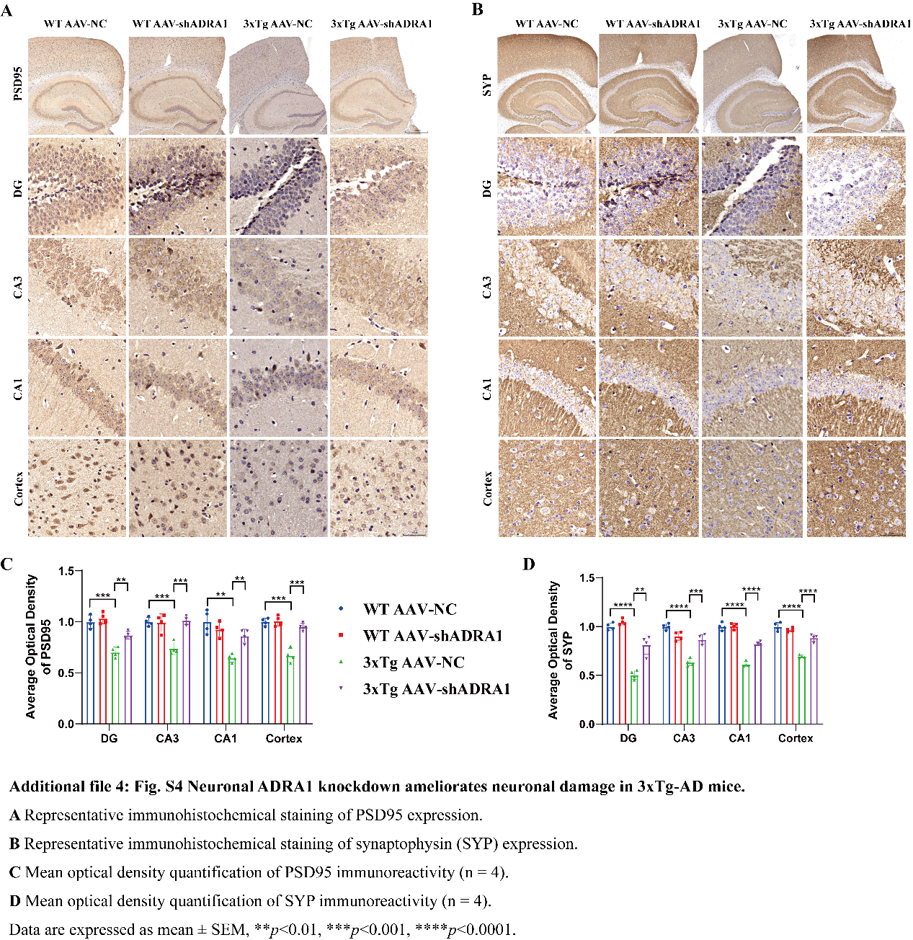
Additional file 5: Fig. S5
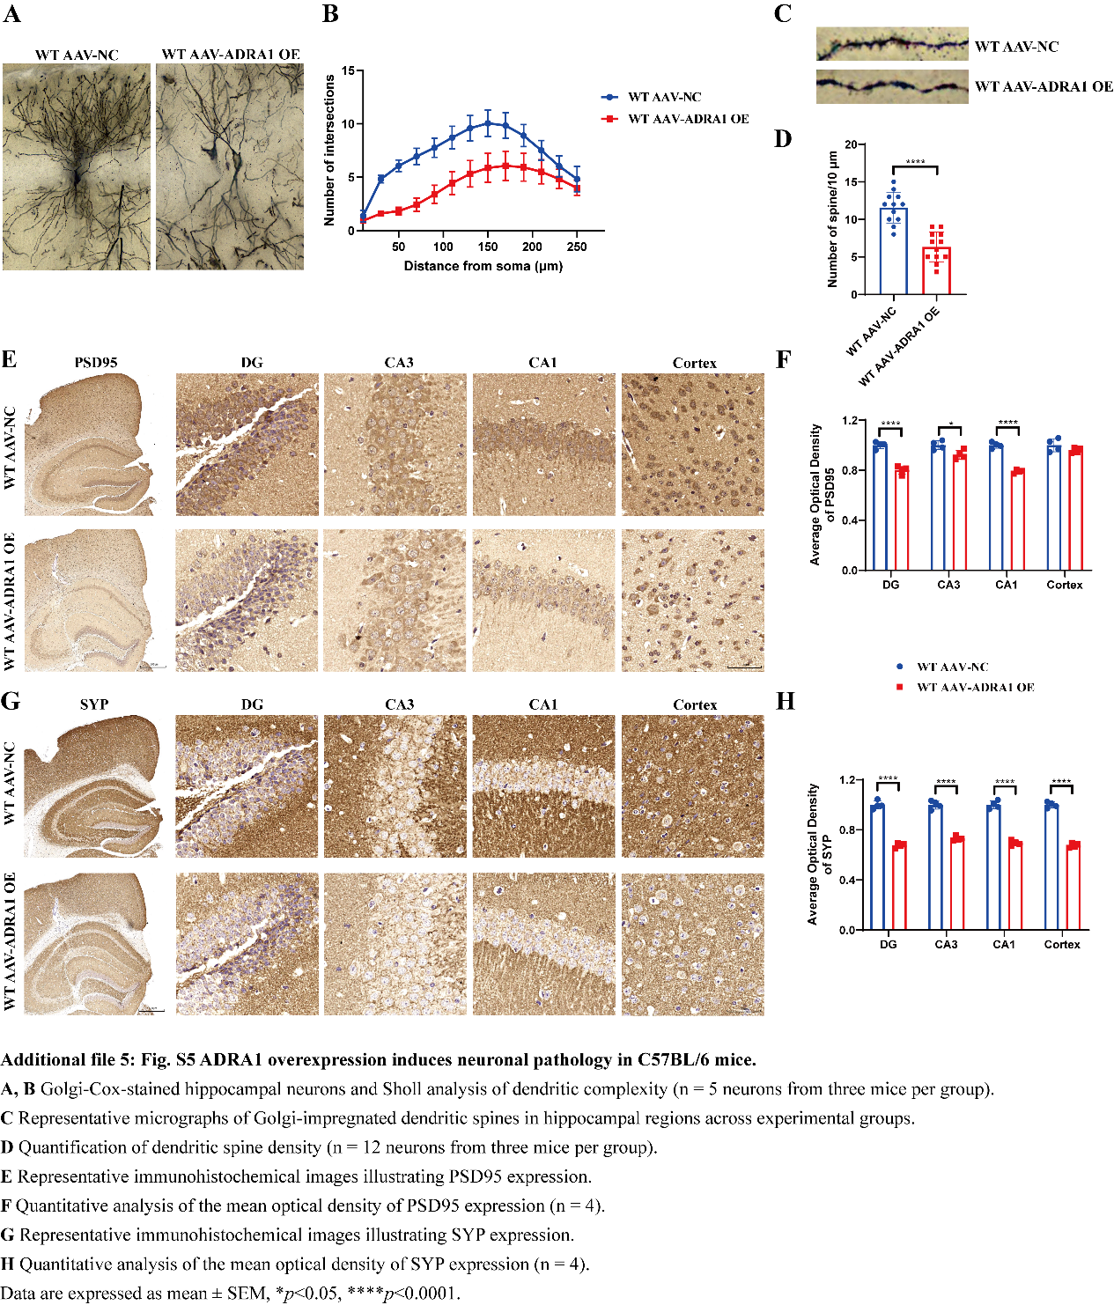
Additional file 6: Fig. S6
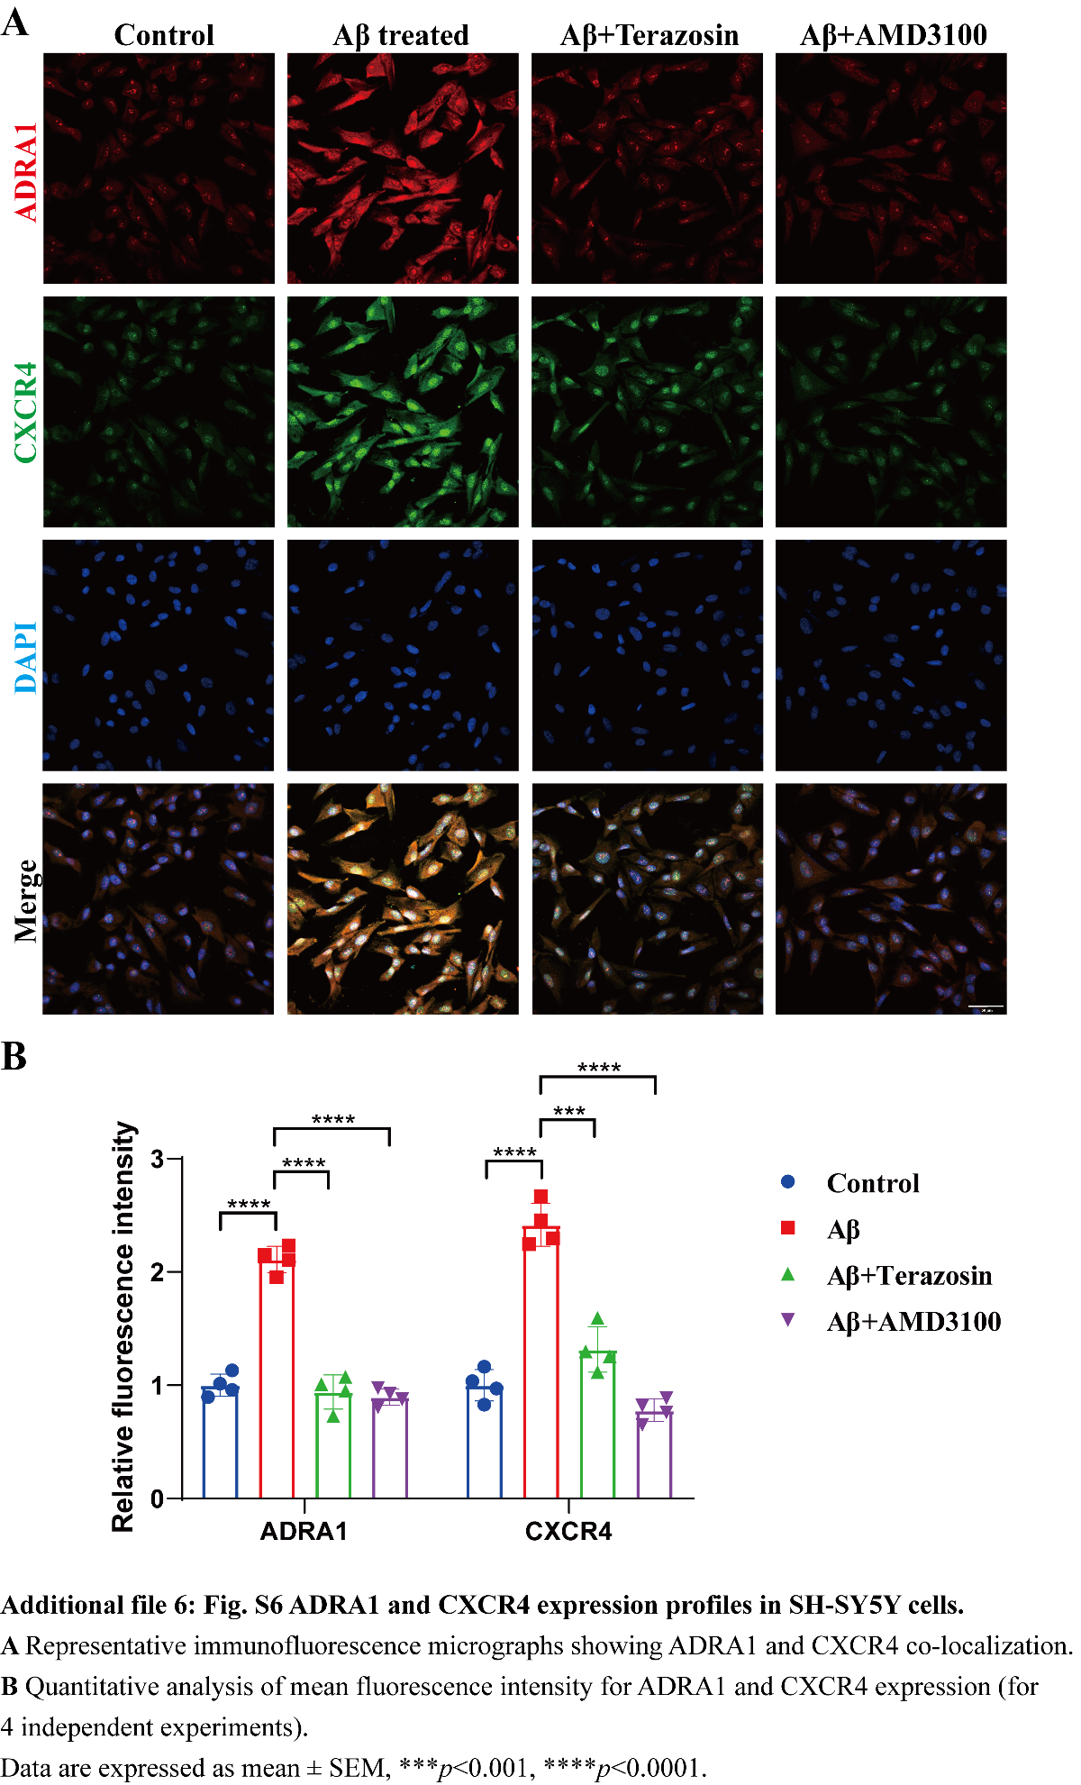
Additional file 7: Fig. S7
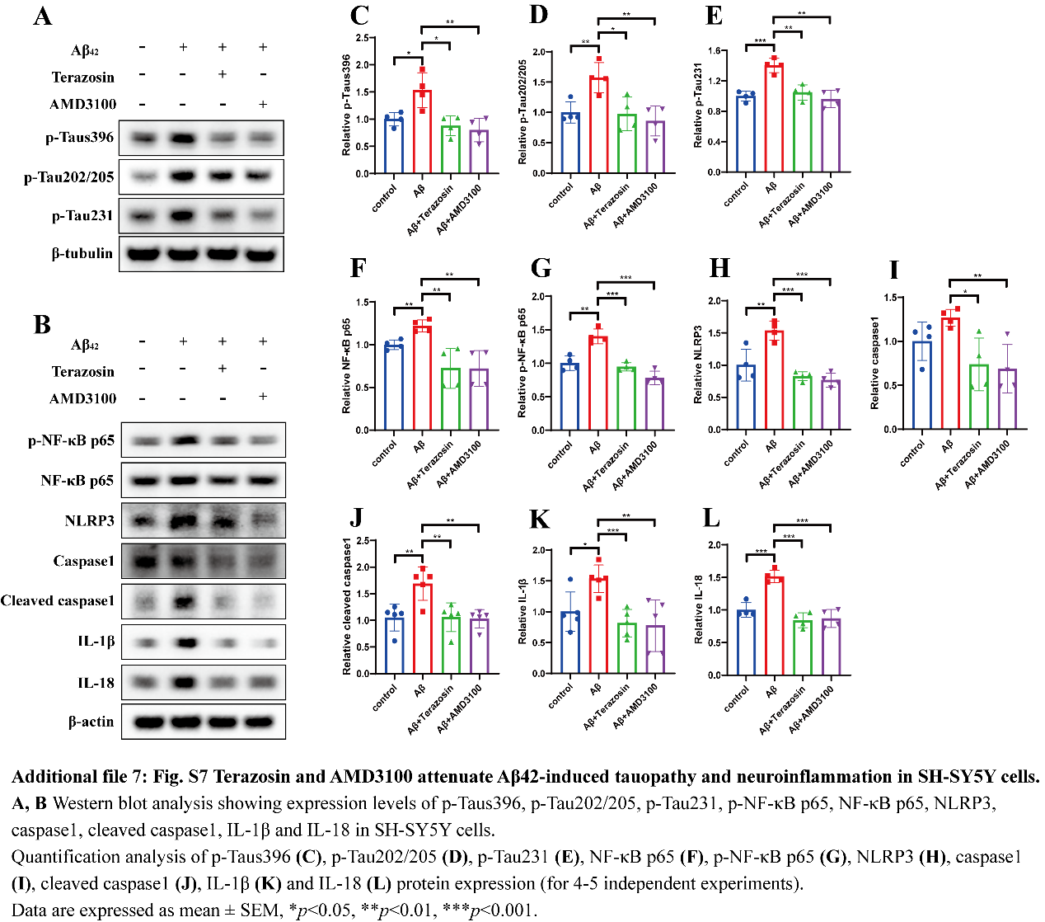
Additional file 8: Fig. S8
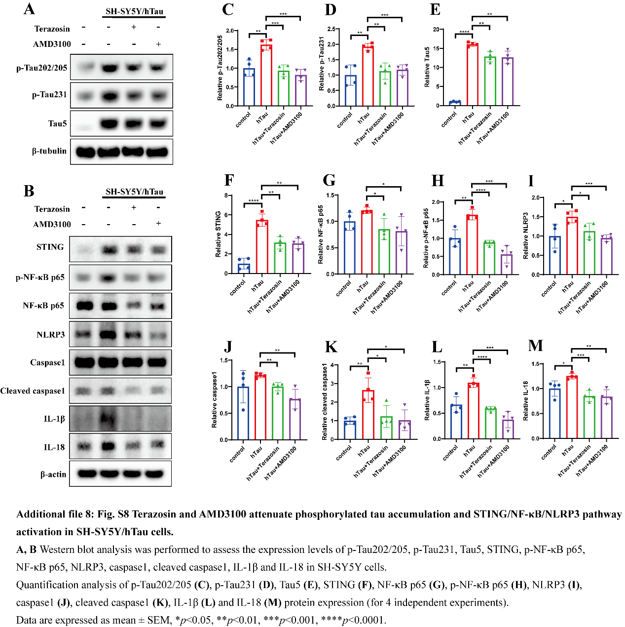
Additional file 9: Table S1 Detail of the postmortem human brain tissue used in this study. Table S2 Antibodies used in this study. Table S3 The sequences of primers used in this study.

