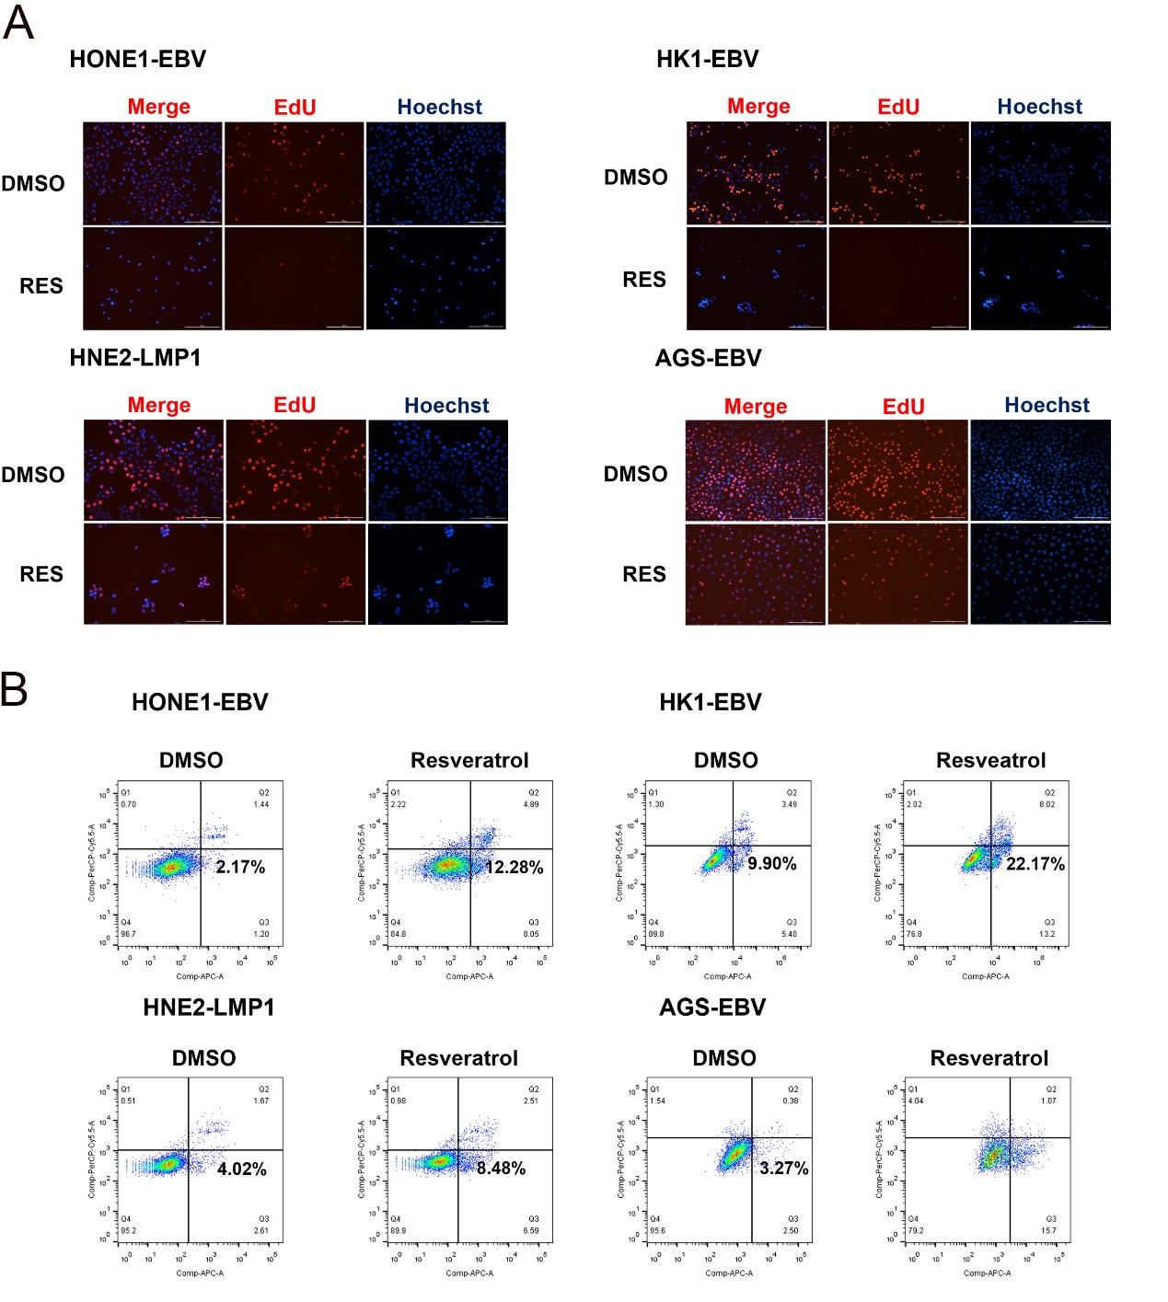
Supplementary Figure_1. (A) The EdU staining was performed to assess the S-phase cell cycle progression in cells treated with DMSO and resveratrol (80 µM; RES: Resveratrol). Hoechst 33342 staining was used to visualize the nuclei. (B) Flow cytometry analysis of cell death in EBV/LMP1-positive NPC and GC cells treated with resveratrol (80 µM) for 24 hours.

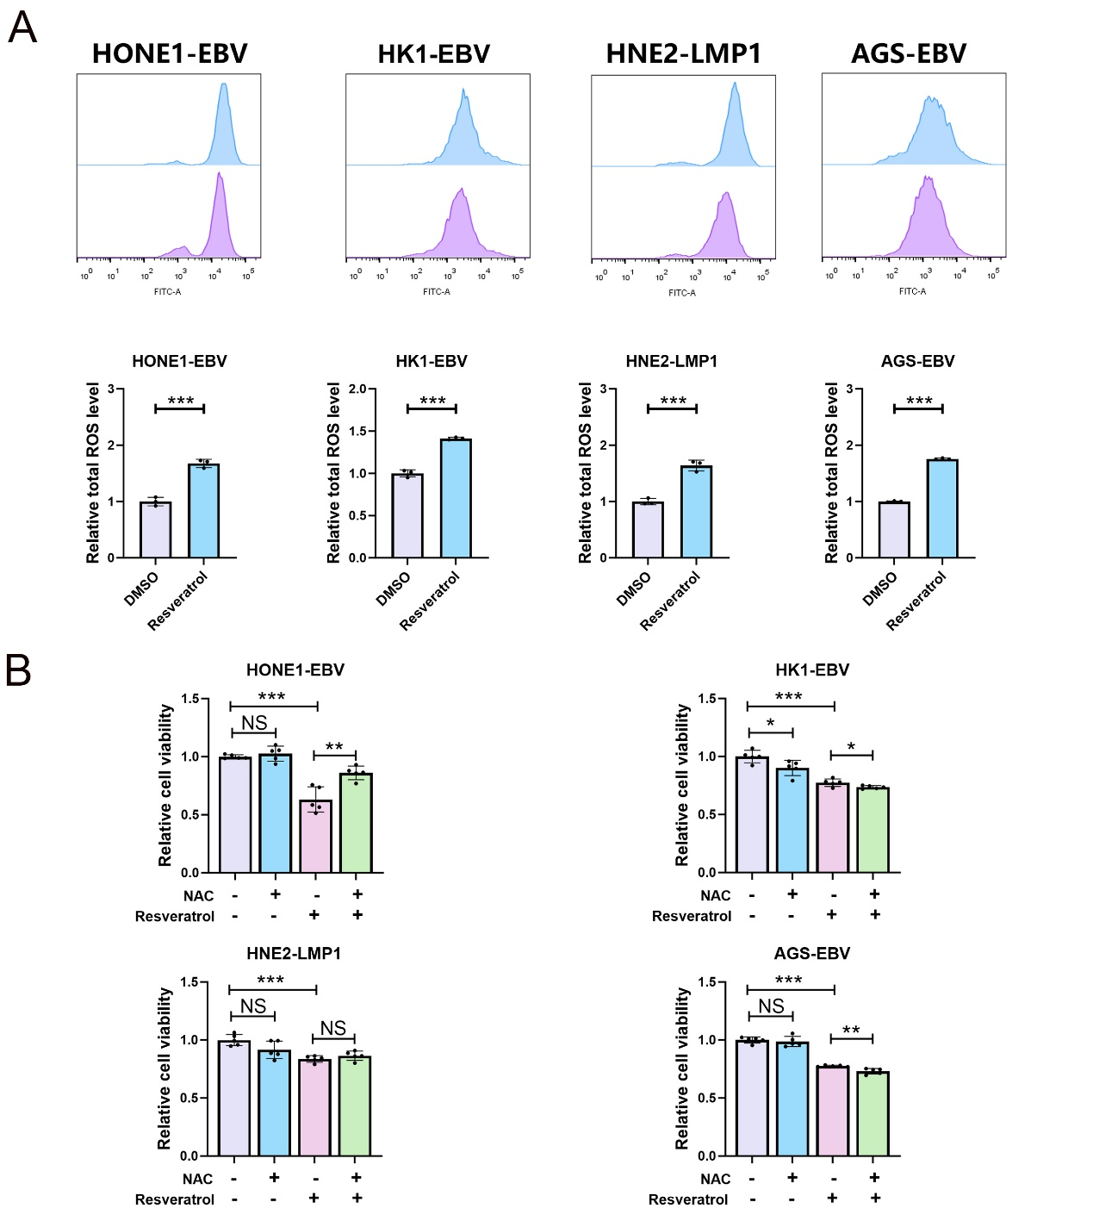
Supplementary Figure_2. (A) Flow cytometry analysis of ROS in EBV/LMP1-positive NPC and GC cells treated with resveratrol (80 µM) for 24 hours (n=3; ***, P < 0.001). (B) NPC and GC cells were treated with NAC (5 mM), resveratrol (80 µM), or a combination of both NAC (5 mM) and resveratrol (80 µM) for 24 hours. Cell viability was then assessed using the CCK-8 assay (n=5; NS, ＞0.05; *, P < 0.05; **, P < 0.01; ***, P < 0.001).

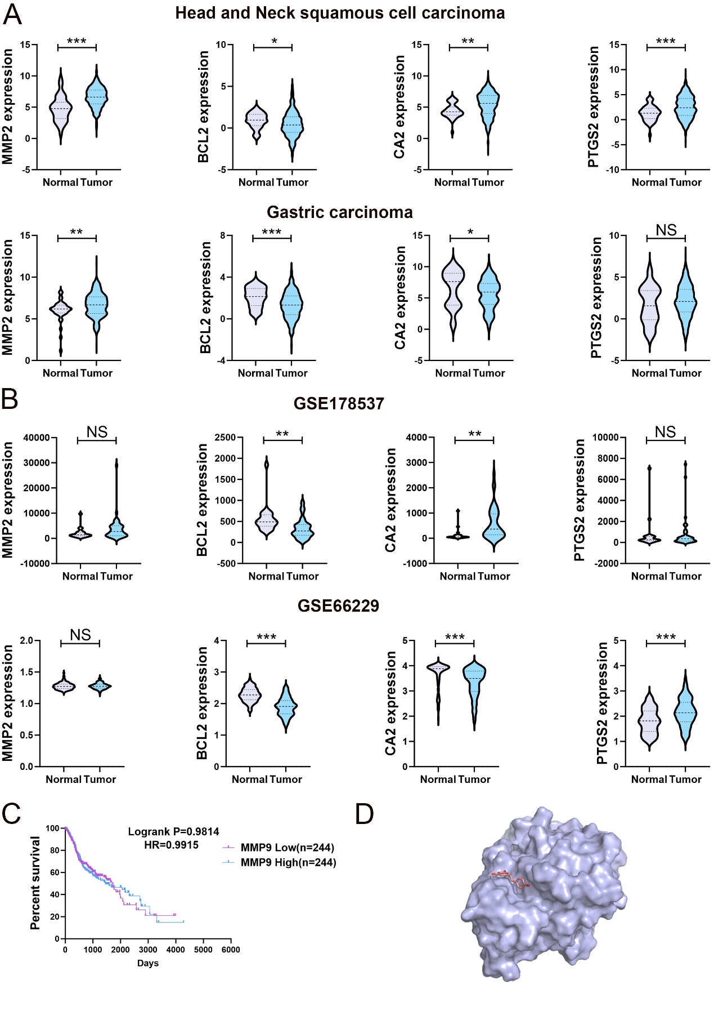Supplementary Figure_3. (A) Comparative analysis of MMP2, BCL2, CA2, and PTGS2 expression in HNSCC and GC patients from TCGA database (TCGA-HNSCC dataset: Normal=44, Tumor=520; TCGA-GC dataset: Normal=36, Tumor=414; NS, ＞0.05; *, P < 0.05; **, P < 0.01; ***, P < 0.001). (B) Analysis of MMP2, BCL2, CA2, and PTGS2 expression using the GEO database (GSE178537: Head and neck squamous cell carcinoma samples, Normal=21, Tumor=44; GSE66229: Gastric cancer samples, Normal=100, Tumor=300; NS, ＞0.05; **, P < 0.01; ***, P < 0.001). (C) Kaplan–Meier curve showing the overall survival probability of HNSCC patients from the TCGA database with low or high mRNA levels of MMP9. (D) The optimal structural conformation of PTPN1 (Purple) and the ligand resveratrol (Pink). docking score= -4.89.
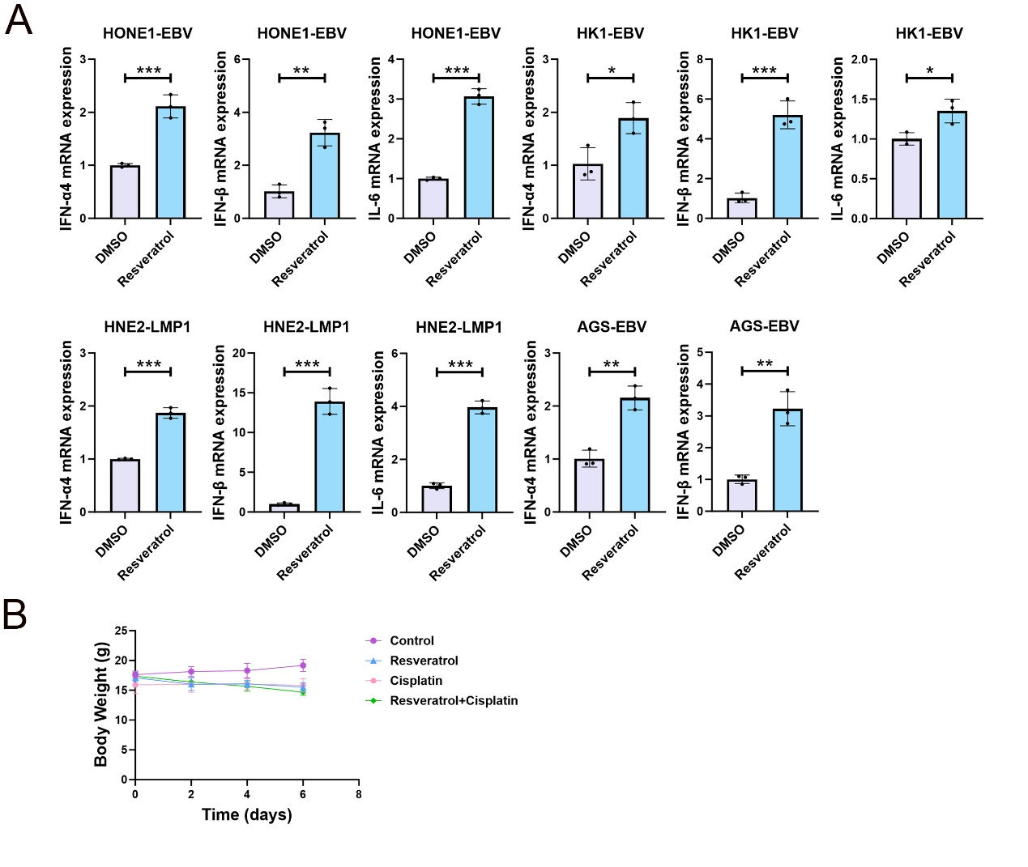Supplementary Figure_4. (A) EBV/LMP1-positive NPC and GC cells treated with resveratrol (80 µM) for 24 hours were analyzed by qPCR to detect mRNA expression levels of IFN-α, IFN-β, and IL-6 (n=3, *, P < 0.05; **, P < 0.01; ***, P < 0.001). (B) The mouse weight curve of the different treatment groups (n=5).

Supplementary Table 1 Fifty-eight potential medicinal targets
Gene | Proteins
MMP2 | Matrix metallopeptidase 2
PTPN1 | Protein tyrosine phosphatase non-receptor type 1
PTGS2 | Prostaglandin-endoperoxide synthase 2
BCL2 | BCL2 apoptosis regulator
CA2 | Carbonic anhydrase 2
MMP9 | Matrix metallopeptidase 9
SLC6A2 | Solute carrier family 6 member 2
CA13 | Carbonic anhydrase 13
LCK | LCK proto-oncogene
RAF1 | Raf-1 proto-oncogene
DRD2 | Dopamine receptor D2
CA5B | Carbonic anhydrase 5B
CYP1A2 | Cytochrome P450 family 1 subfamily A member 2
CA14 | Carbonic anhydrase 14
CA9 | Carbonic anhydrase 9
ABCC1 | ATP binding cassette subfamily C member 1
NOX4 | NADPH oxidase 4
ESR1 | Estrogen receptor 1
SHBG | Sex hormone binding globulin
F10 | Coagulation factor X
ESRRA | Estrogen related receptor alpha
BCL2L1 | BCL2 like 1
AKR1B1 | Aldo-keto reductase family 1 member B
ESR2 | Estrogen receptor 2
VCP | Valosin containing protein
NQO2 | N-ribosyldihydronicotinamide: quinone dehydrogenase 2
MMP1 | Matrix metallopeptidase 1
CA12 | Carbonic anhydrase 12
APP | Amyloid beta precursor protein
CDK2 | Cyclin dependent kinase 2
CA7 | Carbonic anhydrase 7
XDH | Xanthine dehydrogenase
TP53 | Tumor protein p53
TNF | Tumor necrosis factor
SIRT2 | Sirtuin 2
CCR2 | C-C motif chemokine receptor 2
XIAP | X-linked inhibitor of apoptosis
NQO1 | NAD(P)H quinone dehydrogenase 1
CCND1 | Cyclin D1
CDK4 | Cyclin dependent kinase 4
PLAUR | Plasminogen activator
PPARG | Peroxisome proliferator activated receptor gamma
MCL1 | MCL1 apoptosis regulator
PRKCA | Protein kinase C alpha
CASP3 | Caspase 3
HSP90AA1 | Heat shock protein 90 alpha family class A member 1
MTOR | Mechanistic target of rapamycin kinase
CYP19A1 | Cytochrome P450 family 19 subfamily A member 1
PLAT | Plasminogen activator
CCNE1 | Cyclin E1
PTGS1 | Prostaglandin-endoperoxide synthase 1
F3 | Coagulation factor III
IGF1R | Insulin like growth factor 1 receptor
CYP1A1 | Cytochrome P450 family 1 subfamily A member 1
RELA | NF-kB subunit
NOS3 | Nitric oxide synthase 3
CYP1B1 | Cytochrome P450 family 1 subfamily B member 1
AHR | Aryl hydrocarbon receptor

