Supporting Information
Response of soil microbial community composition and function to prolonged heavy metal exposure
Zhigang Zhao · Yongfeng Wang (corresponding author) · Linghao Kong · Liyuan Zhao · Yachao Li · Teng He · Shigao · Liu · Xiangcai Han · Songsong Gu · Shuyu Wu · Jiahao Zhang · Jintao Zhang · Bing Li
Z. Zhao
School of Earth Sciences, China University of Geosciences, Wuhan 430074, China
e-mail: 156513449@qq.com
Z. Zhao · Y. Wang ()· L. Kong ·L. Zhao · Y. Li · T. He · S. Liu · X. Han · S. Gu · S. Wu · J. Zhang · J. Zhang · B. Li
Yantai Center of Coastal Zone Geological Survey, China Geological Survey, Yantai 264000, China
Resources Observation and Research Station of Lan-Sea Interaction Field in the Yellow River Estuary, Yantai 264000, China
e-mail: wangyongfeng@qq.com
L. Kong
e-mail: 1245046910@qq.com
L. Zhao
e-mail: 353840397@qq.com
Y. Li
e-mail: 1095779284@qq.com
T. He
e-mail: 15169762229@163.com
S. Liu
e-mail: 758187672@qq.com
X. Han
e-mail: 1771879956@qq.com
S. Gu
e-mail: 372978364@qq.com
S. Wu
e-mail: hnwushuyu@163.com
J. Zhang
e-mail: 18769441868@163.com
J. Zhang
e-mail: 1026176676@qq.com
B. Li
e-mail: 493907595@qq.com

Contents
Fig. S1 The location of study area and the sampling sites.
Fig. S2. Total heavy metal concentrations of soil surrounding gold mining.
Fig. S3Venn diagram displaying the OTU richness distribution in three groups.
Fig. S4 Canonical correlation analysis (CCA) of environmental factors with the bacterial community.
Fig. S5 Heatmap of Spearman’s rank correlation between the environmental factor and the relative abundance of bacterial genera in soil.
Fig. S6 Relative abundance of keystone taxa under different level combined heavy metals concentrations in networks.
Fig. S7 The counts and varieties of bacterial community functions at KEGG class 3 in each phylum from the soil samples of group H
Table S1 Microbial community diversity index (sequence similarity 97%level).
Table S2 Significance tests of bacterial communities among samples with varying levels of heavy metal concentration
Table S3 Relative abundance of eleven most abundant phyla (>1%) in soil samples from different groups.
Table S4 Relative abundance of twenty five most abundant classes (>1%) in soil samples from different groups.

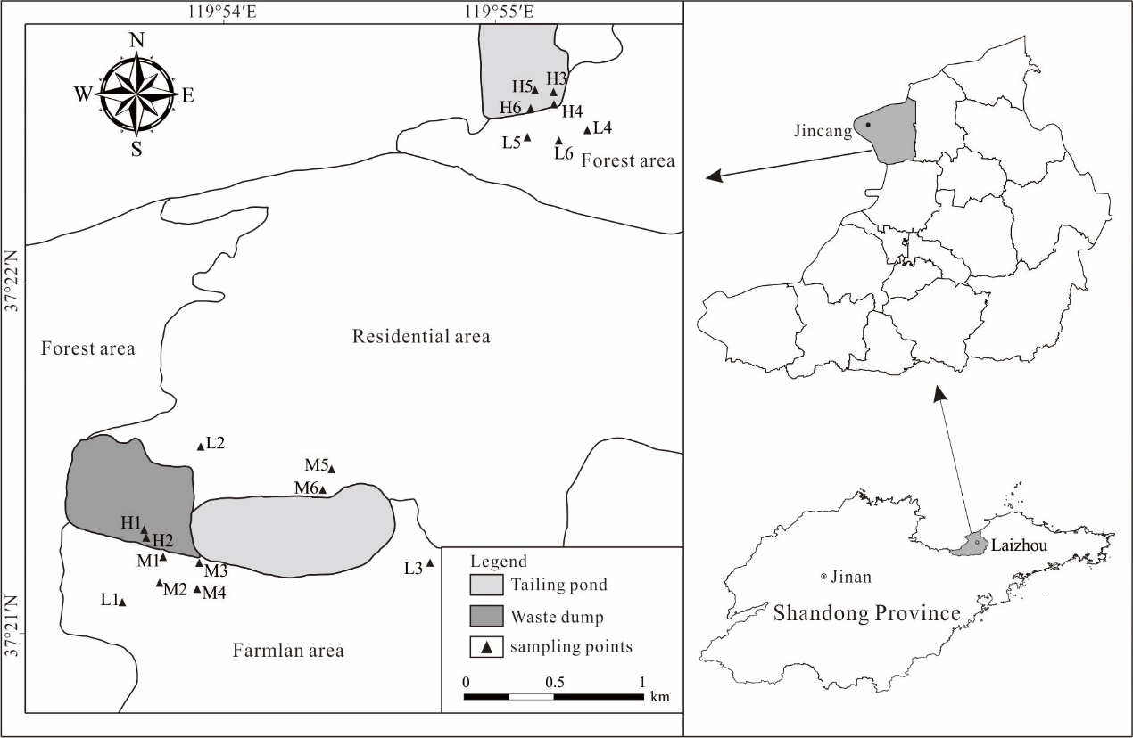
Fig. S1 The location of study area and the sampling sites.

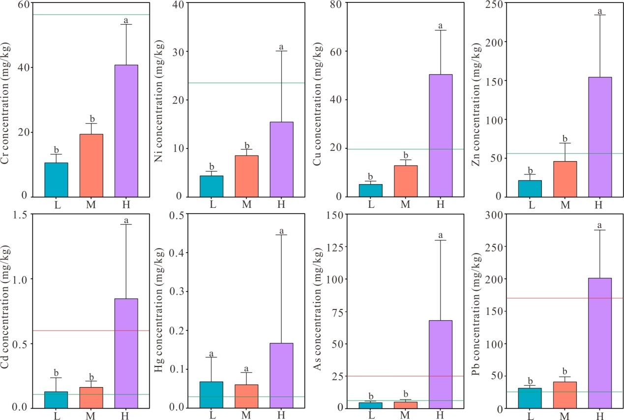
Fig. S2. Total heavy metal concentrations of soil surrounding gold mining. The error bars represent the standard deviation, and different letters imply significant differences at p < 0.05. The green solid line indicates the background value in Eastern Shandong province and the red solid line represents the risk screening value.

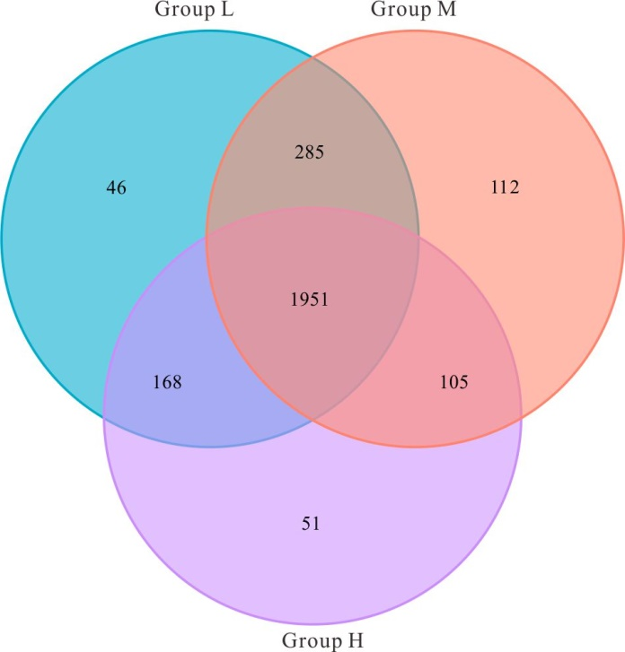
Fig. S3 Venn diagram displaying the OTU richness distribution in three groups

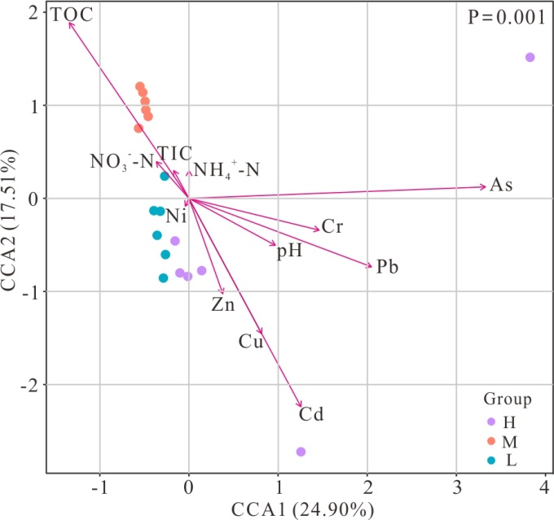
Fig. S4 Canonical correlation analysis (CCA) of environmental factors with the bacterial community.
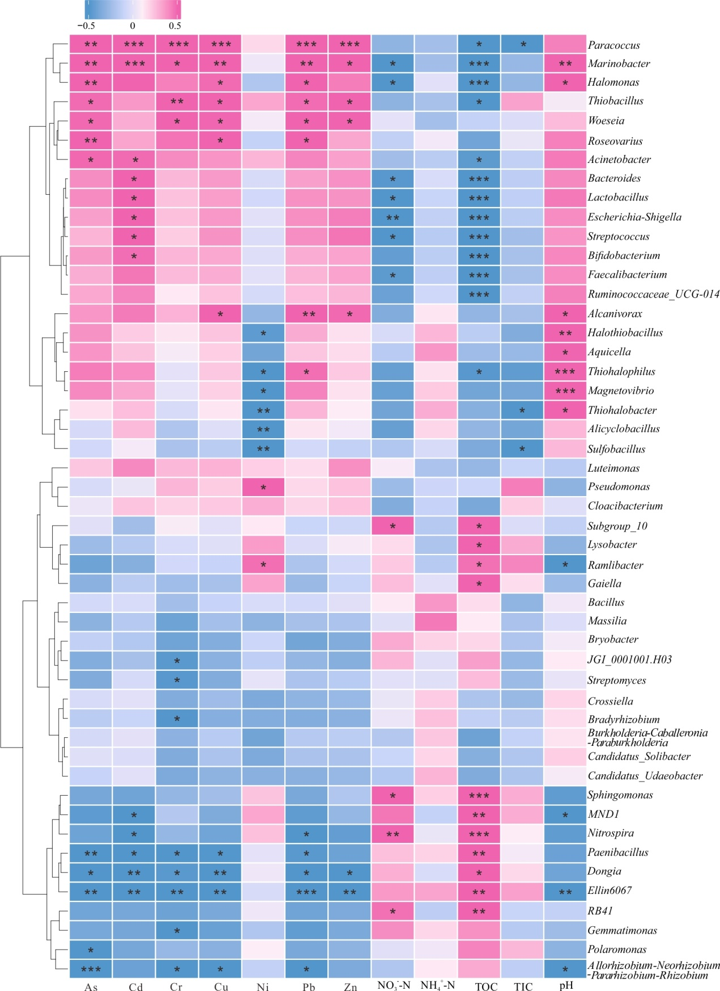
Fig. S5 Heatmap of Spearman’s rank correlation between the environmental factor and the relative abundance of bacterial genera in soil. * in the figure indicates p < 0.05, ** indicates p <0.01 and *** indicates p < 0.001.

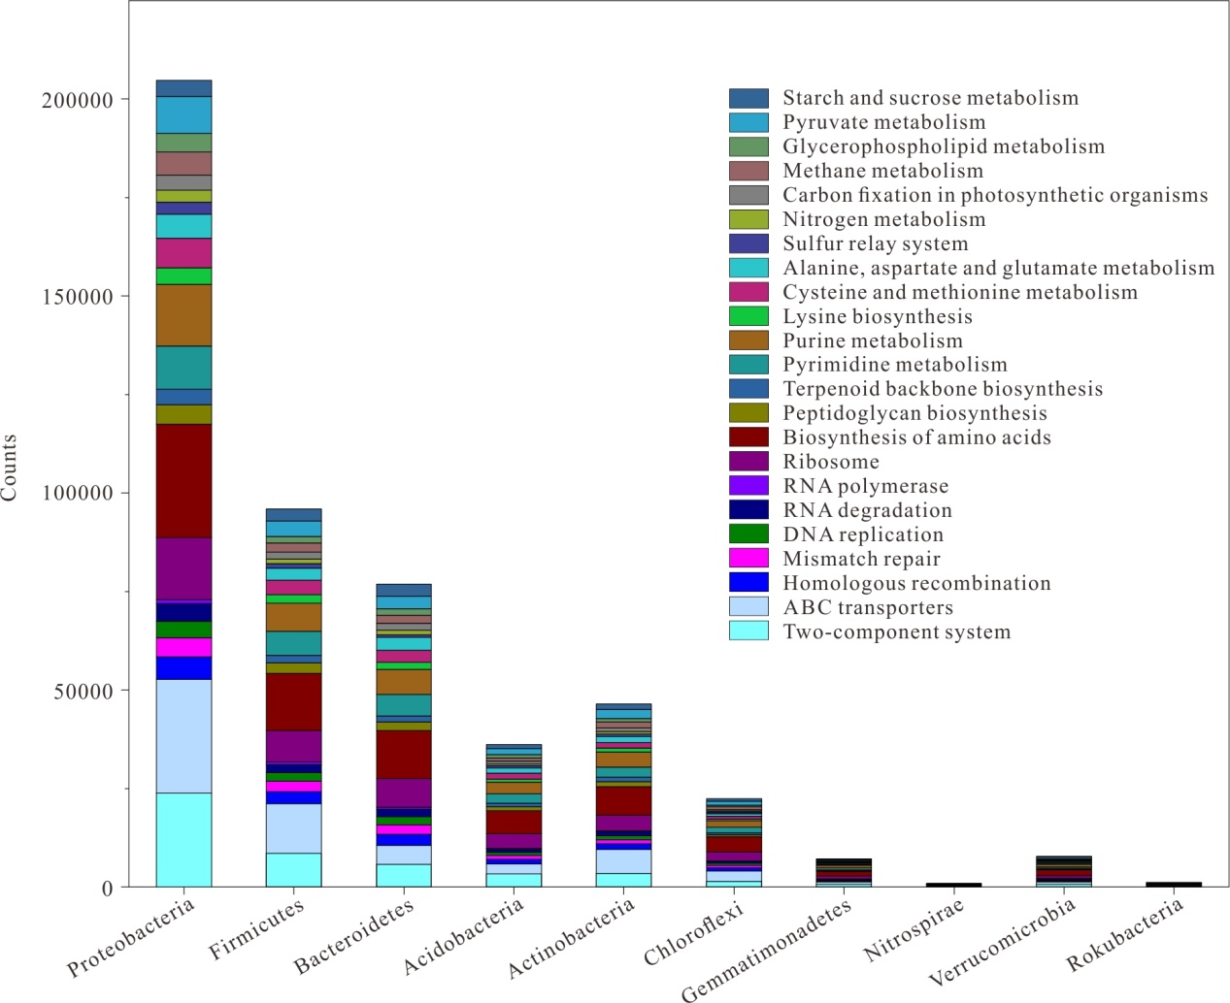
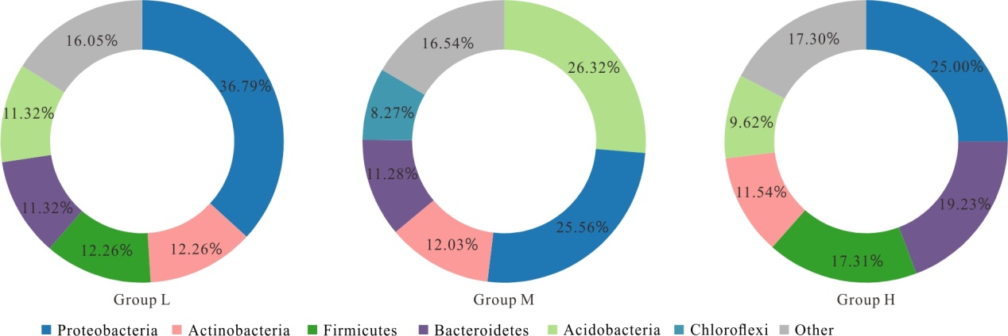
Fig. S6 Relative abundance of keystone taxa under different level combined heavy metals concentrations in networks.

Fig. S7 The counts and varieties of bacterial community functions at KEGG class 3 in each phylum from the soil samples of group H

Table S1 Microbial community diversity index (sequence similarity 97%) level
Groups | Sites | No. of seqs | No. of OTUs | Observed species | ACE | Chao 1 | Simpson | Shannon | Coverage
L | L1 | 63957 | 1461 | 462 | 1565.401 | 1640.158 | 0.991 | 8.159 | 0.994
L | L2 | 54217 | 1389 | 438 | 1447.600 | 1519.791 | 0.996 | 9.118 | 0.997
L | L3 | 56353 | 1511 | 487 | 1574.990 | 1629.009 | 0.993 | 8.783 | 0.996
L | L4 | 57114 | 1485 | 472 | 1538.474 | 1602.235 | 0.995 | 9.004 | 0.996
L | L5 | 55106 | 1503 | 481 | 1546.721 | 1584.258 | 0.996 | 9.142 | 0.997
L | L6 | 45247 | 1607 | 510 | 1660.003 | 1673.163 | 0.995 | 9.060 | 0.997
L | Mean | 55332 | 1493 | 475 | 1555.531 | 1608.102 | 0.994 | 8.877 | 0.996
M | M1 | 64285 | 1823 | 485 | 1873.264 | 1905.075 | 0.995 | 9.116 | 0.995
M | M2 | 62374 | 1866 | 488 | 1904.023 | 1920.390 | 0.995 | 9.217 | 0.996
M | M3 | 62838 | 1847 | 489 | 1871.943 | 1912.333 | 0.994 | 9.183 | 0.996
M | M4 | 61576 | 1859 | 497 | 1877.861 | 1912.457 | 0.995 | 9.343 | 0.996
M | M5 | 59364 | 1858 | 508 | 1952.707 | 1977.102 | 0.996 | 9.222 | 0.994
M | M6 | 48428 | 1678 | 466 | 1805.209 | 1850.593 | 0.994 | 8.771 | 0.994
M | Mean | 59811 | 1822 | 489 | 1880.834 | 1912.992 | 0.995 | 9.142 | 0.995
H | H1 | 44365 | 1383 | 481 | 1462.528 | 1637.634 | 0.996 | 9.172 | 0.997
H | H2 | 46478 | 1501 | 500 | 1545.977 | 1610.161 | 0.995 | 9.259 | 0.997
H | H3 | 45657 | 1340 | 483 | 1386.571 | 1495.528 | 0.997 | 9.290 | 0.998
H | H4 | 47317 | 1615 | 503 | 1650.514 | 1686.685 | 0.997 | 9.500 | 0.998
H | H5 | 63551 | 1060 | 423 | 1121.213 | 1230.802 | 0.915 | 5.790 | 0.995
H | H6 | 58109 | 1119 | 442 | 1214.364 | 1361.842 | 0.974 | 7.421 | 0.996
H | Mean | 50913 | 1336 | 472 | 1396.861 | 1503.775 | 0.979 | 8.405 | 0.997

Table S2 Significance tests of bacterial communities among samples with varying levels of heavy metal concentration
Groups | PERMAOVA |  |  | ANOSIM
Groups | F | P |  | R | P
L, M, H | 5.0122 | 0.001 |  | 0.6498 | 0.001
L,M | 5.4672 | 0.004 |  | 0.8148 | 0.001
L,H | 2.2463 | 0.007 |  | 0.3278 | 0.005
M,H | 7.6378 | 0.003 |  | 0.7833 | 0.002

Table S3 Relative abundance of eleven most abundant phyla (>1%) in soil samples from different groups
Phylum | Groups (Percentage, %)
Phylum | L | M | H
Proteobacteria | 31.89±5.46a | 29.64±4.71a | 40.09±17.75a
Acidobacteria | 20.98±5.33b | 30.43±7.36a | 9.32±4.41c
Firmicutes | 8.36±2.89b | 3.46±1.25b | 18.95±6.85a
Actinobacteria | 12.80±4.15a | 7.77±1.39b | 7.90±2.01b
Bacteroidetes | 6.19±2.24b | 3.89±0.55b | 12.67±3.74a
Chloroflexi | 5.92±1.10ab | 7.51±2.26a | 3.58±2.20b
Gemmatimonadetes | 3.83±1.03b | 8.69±1.02a | 1.28±0.53c
Verrucomicrobia | 2.56±0.94a | 1.01±0.31b | 1.48±0.75b
Nitrospirae | 1.36±0.64b | 2.52±0.66a | 0.38±0.17c
Rokubacteria | 0.84±0.55b | 2.43±0.67a | 0.36±0.17b
Note: Data are means±standard deviation (n=6). Different letters represent significant differences among three groups at p <0.05.

Table S4 Relative abundance of nineteen most abundant classes (>1%) in soil samples from different groups
Class | Groups (Percentage, %)
Class | L | M | H
Gammaproteobacteria | 12.61±5.27a | 12.61±3.41a | 25.24±14.05a
Alphaproteobacteria | 16.12±2.97a | 12.09±2.66a | 12.93±3.60a
Bacteroidia | 6.18±2.23b | 3.84±0.53b | 11.58±5.16a
Subgroup_6 | 4.19±1.54b | 12.72±2.47a | 1.97±1.25b
Acidobacteriia | 10.52±8.28a | 2.04±0.29b | 5.66±3.01ab
Bacilli | 4.15±1.40b | 2.12±0.89b | 8.16±3.05a
Blastocatellia_Subgroup_4 | 4.13±3.61b | 9.41±4.23a | 0.72±0.26b
Clostridia | 3.67±1.42b | 1.15±0.50b | 9.45±3.35a
Actinobacteria | 5.91±2.87a | 1.92±0.73b | 3.35±1.67ab
Deltaproteobacteria | 3.16±0.77b | 4.94±1.27a | 1.92±0.59b
Gemmatimonadetes | 3.60±1.00b | 5.44±0.52a | 0.87±0.52c
Acidimicrobiia | 2.17±0.64a | 2.79±0.95a | 2.67±1.59a
Thermoleophilia | 3.57±1.31a | 1.64±0.39b | 0.89±0.76b
Verrucomicrobiae | 2.56±0.94a | 1.01±0.31b | 1.48±0.75ab
Nitrospira | 1.36±0.64b | 2.52±0.66a | 0.38±0.17c
Anaerolineae | 0.97±0.83b | 2.73±1.04a | 0.51±0.30b
NC10 | 0.84±0.55b | 2.43±0.67a | 0.36±0.17b
KD4-96 | 1.20±0.28a | 1.43±0.81a | 0.73±1.02a
Holophagae | 1.08±0.40b | 1.84±0.54a | 0.37±0.29c
Note: Data are means±standard deviation (n=6). Different letters represent significant differences among three groups at p<0.05.

