Additional File 2

Accuracy of the modified Global Burden of Disease International Classification of Diseases coding methods for identifying sepsis: A prospective multicentre cohort study

Ashwani Kumar¹, Bala Venkatesh^{1,2}, Simon Finfer^{1,3}, Anthony Delaney^{1,4}, Kelly Thompson^{1,5}, Paul M Middleton^{6,15}, Anders Aneman⁶, Kavitha Shetty⁷, Deepak Bhonagiri⁸, Manoj Saxena^{1,9}, Frank M.P. van Haren^{9,10}, Celia Bradford¹¹, Graham Reece¹², Simon Rodda¹³, Candice Mackellar⁶, Francess Bass^{1,4}, Lewis Tsang⁷, Sandra Li⁶, Raymond Kwok⁹, Alexander Buckley⁴, Angela Zou⁴, Swathi Sridharan⁴, David Hu⁴, Mark Iskandar⁴, Sarah Frost⁴, Tori Headington⁴, Giuliana Connor⁸, Anthony Klironomos⁶, Sana Shan¹, Yang Li¹, Belinda Anderson⁹, Rebecca Sidoli⁹, Deborah Inskip⁹, Matthew Lam⁹, Garnette Fuller⁹, Christopher Yu¹¹, Bridget Sigurdson¹¹, Richard McNulty^{12,14}, Maeda Sadeghpour¹², Laurent Billot¹, and Naomi Hammond^{1,4}
¹The George Institute for Global Health, University of New South Wales, Australia
²Princess Alexandra Hospital, Queensland, Australia
³School of Public Health, Imperial College London, London, United Kingdom
⁴Royal North Shore Hospital, NSW, Australia
⁵Nepean Blue Mountains LHD, NSW, Australia
⁶Liverpool Hospital, NSW, Australia
⁷Fairfield hospital, NSW, Australia
⁸Campbelltown Hospital, NSW, Australia
⁹St. George Hospital, NSW, Australia
¹⁰College of Health and Medicine, Australian National University, Canberra
¹¹Sydney Adventist Hospital, NSW, Australia
¹²Blacktown Hospital, NSW, Australia
¹³Bowral Hospital, NSW, Australia
¹⁴Western Sydney University, NSW, Australia
¹⁵South Western Emergency Research Institute

Corresponding author: Ashwani Kumar, akumar@georgeinstitute.org.au
ORCID: 0000-0002-4787-7833
The George Institute for Global Health, Level 18, International Towers 3, 300 Barangaroo Ave, Barangaroo NSW 2000 Australia

Supplementary Table 1 Characteristics of overall study population (N=450)
Characteristics | N | %
Age, mean (SD) | 72.4 (18.3)
Elderly (>65 years) | 327 | (72.7%)
Sex
- Males | 230 | 51.1%
- Females | 217 | 48.2%
- Did not specify | 03 | 0.7%
Type of admission
- Elective surgical | 5 | 1.1%
- Emergency surgical | 47 | 10.5%
- Medical | 398 | 88.4%
Admitted to ICU | 82 | 18.2%
Outcome
- Median (IQR) Length of hospital Stay, days | 7.0 (4.0-13.0)
- Death | 41 | 9.1%
ICU: Intensive Care Unit, IQR: Inter Quartile Range, SD: Standard Deviation

Supplementary Figure 1. Characteristics in patient groups with sepsis by clinical diagnosis and ICD coding methods, and in those without sepsis
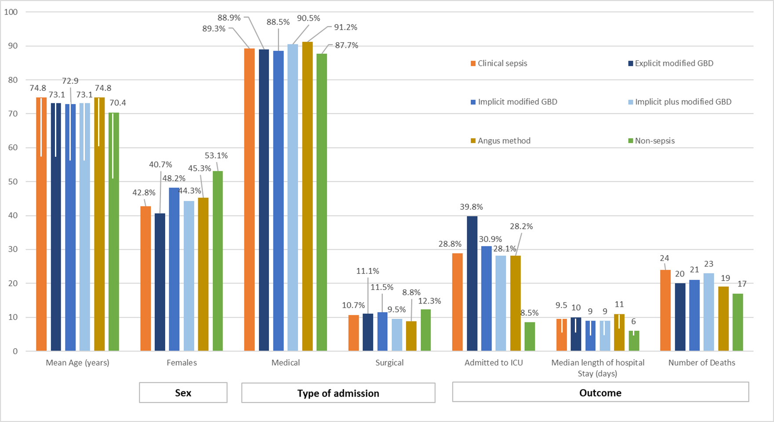
Note: Error bars denote standard deviation for age and Inter Quartile Range for length of hospital stay.
Clinical sepsis: Patients who met Sepsis 3 criteria. Non-sepsis: Patients who didn’t meet Sepsis-3 criteria
Explicit: Presence of one of the explicit sepsis ICD-10-AM codes (Additional File 1; Supplementary Table 1) as the primary or secondary diagnosis
Implicit: Presence of an infection code listed as the primary diagnosis and an “organ dysfunction code” listed as secondary diagnosis from the modified GBD codes (Additional File 1; Supplementary Tables 2 and 3) OR one of the explicit sepsis codes (Additional File 1; Supplementary Table 1)
Implicit plus: Presence of an infection code and an “organ dysfunction code” from the modified GBD codes (Additional File 1; Supplementary Tables 2 and 3) OR one of the explicit sepsis codes (Additional File 1; Supplementary Table 1) Angus: Presence of an infection code and an “organ dysfunction code” from the Angus codes (Additional File 1; Supplementary Tables 2 and 3) or R57.2 or R65.1 from the explicit sepsis codes (Additional File 1; Supplementary Table 1)
GBD: Global Burden of Disease; ICD-10-AM: International Classification of Diseases-10th Revision- Australian Modification

Characteristics of sepsis patients
In the clinical sepsis group (n=215), the mean (Standard Deviation; SD) Sequential Organ Failure Assessment (SOFA) score was 4.3 (2.6) and the most common type of organ dysfunction was respiratory noted in 40 (18.6%) patients. Twenty (9.3%) patients met the septic shock criteria and 11 (5.1%) patients acquired sepsis during their hospital stay (Supplementary Table 2).
Details of pathogen profile and administered antimicrobials in patients diagnosed with clinical sepsis is shown in supplementary Tables 4 and 5, respectively. Seventy-one (33.0%) patients diagnosed with clinical sepsis had infection with gram negative bacteria (E. coli being the most common), 46 (21.4%) with gram-positive bacteria (Staphylococcus Aureus being the most common) and 27 (12.6%) with other pathogens including SARS-CoV-2. A pathogen was not isolated in 103 (44.2%) patients of whom 90 patients received empiric antibiotic treatment. Cephalosporins were most common antimicrobial agents, administered to 83.3% of patients with ceftriaxone being the most common. Seven (3.3%) patients did not receive any antimicrobial agent while 24 (11.2%) patients were already receiving antimicrobial agents before the clinical diagnosis of sepsis was made.
Supplementary Table 2 Clinical characteristics of patients diagnosed with sepsis by clinical review and by the four methods using ICD coding
Characteristic | Clinical sepsis  (Sepsis 3 criteria) | Explicit modified GBD | Implicit modified GBD | Implicit plus modified GBD | Angus method
Mean (SD) SOFA score | 4.3 (2.6) | 4.6 (3.4) | 4.0 (3.1) | 3.7 (3.0) | 3.9 (3.1)
Hospital-acquired sepsis | 11/215 (5.1%) | 10/89 (11.2%) | 10/125 (8.0%) | 10/145 (6.9%) | 10/120 (8.3%)
Septic shock | 20/215 (9.3%) | 18/89 (20.2%) | 18/125 (14.4%) | 18/145 (12.4%) | 17/120 (14.2%)
Vasopressors use | 45/215 (23.0%) | 27/93 (29.0%) | 33/139 (23.7%) | 37/159 (23.3%) | 32/129 (24.8%)
Site of infection | N=215 | N=90 | N=132 | N=152 | N=126
- Pulmonary | 31 (14.4%) | 8 (8.9%) | 17 (12.9%) | 20 (13.2%) | 16 (12.7%)
- Intra-abdominal | 18 (8.4%) | 9 (10.0%) | 15 (11.4%) | 15 (9.9%) | 14 (11.1%)
- Blood | 13 (6.0%) | 10 (11.1%) | 14 (10.6%) | 14 (9.2%) | 11 (8.7%)
- CNS | 6 (2.8%) | 4 (4.4%) | 4 (3.0%) | 5 (3.3%) | 4 (3.2%)
- Genitourinary or Renal | 63 (29.3%) | 26 (28.9%) | 46 (34.8%) | 41 (27.0%) | 36 (28.6%)
- Skin/IV catheter site | 19 (8.8%) | 12 (13.3%) | 15 (11.4%) | 15 (9.9%) | 13 (10.3%)
- Others/Unconfirmed | 78 (36.3%) | 27 (30.0%) | 41 (31.1%) | 49 (32.2%) | 39 (31.0%)
Organ dysfunction# | N=215 | N=108 | N=175 | N=222 | N=170
- Cardiovascular | 22 (10.2%) | 19 (17.6%) | 20 (11.4%) | 20 (9.0%) | 18 (10.6%)
- Renal | 36 (16.7%) | 16 (14.8%) | 26 (14.9%) | 30 (13.6%) | 25 (14.7%)
- Respiratory | 40 (18.6%) | 16 (14.8%) | 25 (14.3%) | 26 (14.4%) | 22 (12.9%)
- Haematologic | 30 (14.0%) | 11 (10.2%) | 17 (9.7%) | 18 (8.1%) | 16 (9.4%)
- Hepatic | 14 (6.5%) | 9 (8.3%) | 11 (6.3%) | 11 (5.0%) | 10 (5.9%)
- CNS | 27 (12.6%) | 8 (7.4%) | 12 (6.9%) | 13 (5.9%) | 9 (5.3%)
#Respective organ dysfunction was calculated using corresponding SOFA component score of 2 or more.
Data presented as n (%), unless otherwise indicated. Denominator (N) is different in ICD coding methods due to missing values.
Explicit: Presence of one of the explicit sepsis ICD-10-AM codes (Additional File 1; Supplementary Table 1) as the primary or secondary diagnosis
Implicit: Presence of an infection code listed as the primary diagnosis and an “organ dysfunction code” listed as secondary diagnosis from the modified GBD codes (Additional File 1; Supplementary Tables 2 and 3) OR one of the explicit sepsis codes (Additional File 1; Supplementary Table 1)
Angus: Presence of an infection code and an “organ dysfunction code” from the Angus codes (Additional File 1; Supplementary Tables 2 and 3) or R57.2 or R65.1 from the explicit sepsis codes (Additional File 1; Supplementary Table 1)
Implicit plus: Presence of an infection code and an “organ dysfunction code” from the modified GBD codes (Additional File 1; Supplementary Tables 2 and 3) OR one of the explicit sepsis codes (Additional File 1; Supplementary Table 1)
CNS: Central Nervous System; SOFA: Sequential organ Failure Assessment; IQR: Inter Quartile Range; SD: Standard Deviation, ICD-10-AM: International Classification of Disease, GBD: Global Burden of Disease

Supplementary Table 3 Contingency 2x2 table for the ICD coding methods
Sepsis identified using ICD coding methods |  | Clinical sepsis (n)
 |  | Yes | No | Total
Explicit modified GBD | Yes | 89 | 19 | 127
Explicit modified GBD | No | 126 | 216 | 323
Explicit modified GBD | Total | 215 | 235 | 450
Implicit modified GBD | Yes | 125 | 50 | 175
Implicit modified GBD | No | 90 | 185 | 275
Implicit modified GBD | Total | 215 | 235 | 450
Implicit plus modified GBD | Yes | 145 | 77 | 222
Implicit plus modified GBD | No | 70 | 158 | 228
Implicit plus modified GBD | Total | 215 | 235 | 450
Angus | Yes | 120 | 49 | 169
Angus | No | 95 | 186 | 281
Angus | Total | 215 | 235 | 450
Explicit: Presence of one of the explicit sepsis ICD-10-AM codes (Additional File 1; Supplementary Table 1) as the primary or secondary diagnosis
Implicit: Presence of an infection code listed as the primary diagnosis and an “organ dysfunction code” listed as secondary diagnosis from the modified GBD codes (Additional File 1; Supplementary Tables 2 and 3) OR one of the explicit sepsis codes (Additional File 1; Supplementary Table 1)
Implicit plus: Presence of an infection code and an “organ dysfunction code” from the modified GBD codes (Additional File 1; Supplementary Tables 2 and 3) OR one of the explicit sepsis codes (Additional File 1; Supplementary Table 1)
Angus: Presence of an infection code and an “organ dysfunction code” from the Angus codes (Additional File 1; Supplementary Tables 2 and 3) or R57.2 or R65.1 from the explicit sepsis codes (Additional File 1; Supplementary Table 1)
GBD: Global Burden of Disease; ICD-10-AM: International Classification of Diseases-10th Revision- Australian Modification
Supplementary Table 4 Pathogen profile in patients diagnosed with sepsis by clinical criteria
 | No of infections | Percentage
Gram-positive bacteria | 46 | 21.4%
- Staphylococcus Aureus | 12 | 26.7%
- Pneumococcus | 7 | 15.6%
- Other streptococci | 5 | 11.1%
- Coagulase-negative staphylococcus | 3 | 6.7%
- Other staphylococcus | 4 | 8.9%
- Enterococcus Faecalis | 6 | 13.3%
- VRE | 1 | 2.2%
- MRSA | 1 | 2.2%
- Other gram-positive bacteria | 6 | 13.3%
Gram-negative bacteria | 71 | 33.0%
- E. coli | 26 | 36.6%
- Pseudomonas Aeruginosa | 9 | 12.7%
- Haemophilus influenzae | 3 | 4.2%
- Proteus Mirabilis | 10 | 14.1%
- Klebsiella pneumoniae | 6 | 8.5%
- Enterobacter cloacae | 4 | 5.6%
- Other gram-negative bacteria | 13 | 18.3%
Other pathogens | 27 | 12.6%
- Candida Species | 7 | 25.0%
- Influenza A | 5 | 17.9%
- COVID-19 | 12 | 42.9%
- Varicella Zoster | 1 | 3.6%
- Entamoeba Histolytica | 1 | 3.6%
- Mixed growth | 1 | 3.6%
No isolated pathogen | 103 | 44.2%
Antimicrobial administration with no identified pathogen | 90 | 41.9%
Mean (SD) number of infections | 1.1 (0.4)
Note: Percentages in each category are calculated using denominator from that respective category (highlighted in bold)
MRSA: Methicillin Resistant Staphylococcus Aureus; VRE: Vancomycin Resistant Enterococcus
SD: Standard Deviation

Supplementary Table 5 Antimicrobial agents usage patterns in patients with sepsis by clinical criteria
 | No. of antimicrobials | Percentage
Penicillin | 78 | 36.3%
- Amoxycillin | 25 | 32.1%
- Ampicillin | 15 | 19.2%
- Benzylpenicillin | 38 | 48.7%
Penicillins+ Beta lactamase inhibitor | 102 | 47.4%
- Amoxycillin + Clavulanate | 42 | 41.2%
- Piperacillin + tazobactam | 60 | 58.8%
Aminoglycosides - Gentamicin | 28 | 15.7%
Cephalosporins | 179 | 83.3%
- Ceftriaxone | 155 | 86.6%
- Cefalexin | 6 | 3.4%
- Cefazolin | 16 | 8.9%
- Cefuroxime | 2 | 1.1%
Glycopeptide | 27 | 12.6%
- Meropenem | 13 | 48.1%
- Vancomycin | 14 | 51.9%
Macrolide- Azithromycin | 18 | 8.4%
Quinolones | 51 | 23.7%
- Flucloxacillin | 48 | 94.1%
- Moxifloxacin | 3 | 5.9%
Sulfonamides - Trimethoprim | 3 | 1.4%
Tetracyclines - Doxycycline | 3 | 1.4%
Antiviral - Remdesvir | 1 | 0.5%
Antifungal - Fluconazole | 1 | 0.5%
No antimicrobial administered | 7 | 3.3%
Mean (SD) number of antimicrobials | 2.5 (1.2)
Note: Percentages in each category are calculated using denominator from that respective category (highlighted in bold).
SD: Standard Deviation
Distribution of ICD-10-AM codes in various sepsis groups
Unspecified sepsis (A41.9) was the most common sepsis-specific ICD-10-AM code in patients diagnosed with sepsis using clinical Sepsis 3 criteria (25.6%) as well as all ICD coding methods (30.0%-61.1%). Urinary tract infection (N39) and acute kidney failure, unspecified (N17.9) was the most common infection and organ dysfunction ICD-10-AM code, respectively, across all groups. (Supplementary Figure 2)
Supplementary Figure 2 Distribution of ICD-10-AM codes of sepsis, infection and organ dysfunction in various sepsis groups
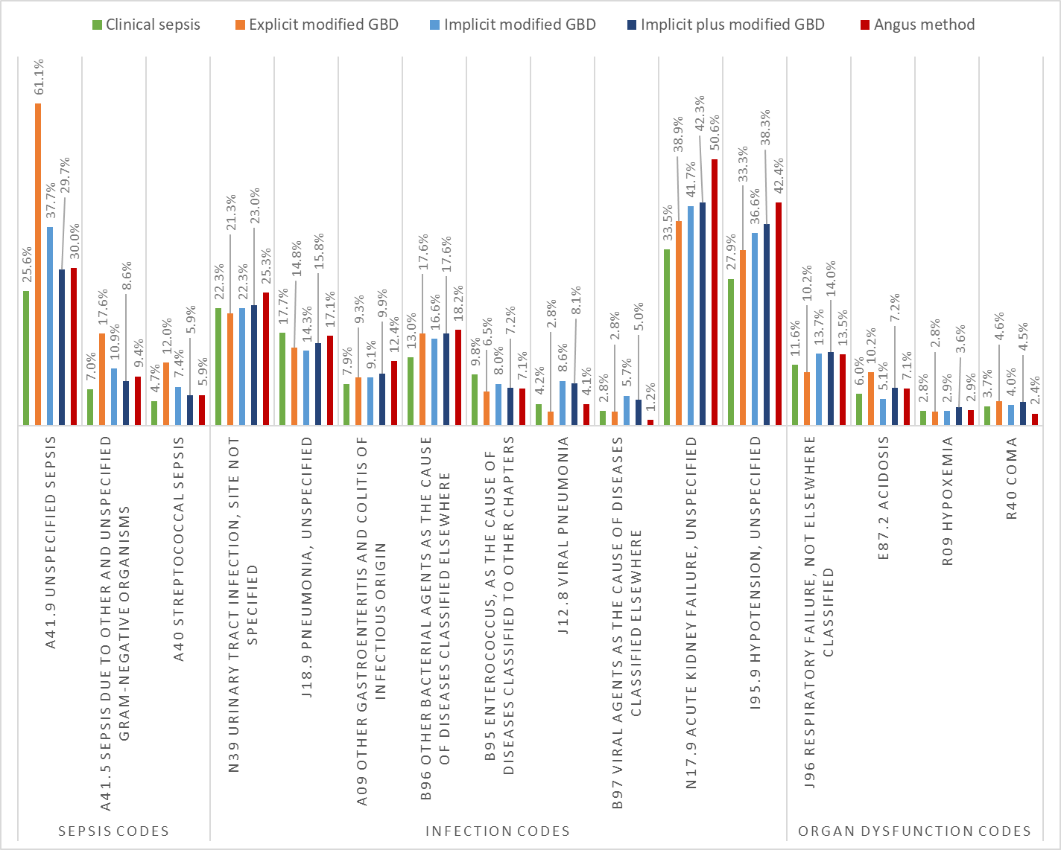
Explicit: Presence of one of the explicit sepsis ICD-10-AM codes (Additional File 1; Supplementary Table 1) as the primary or secondary diagnosis
Implicit: Presence of an infection code listed as the primary diagnosis and an “organ dysfunction code” listed as secondary diagnosis from the modified GBD codes (Additional File 1; Supplementary Tables 2 and 3) OR one of the explicit sepsis codes (Additional File 1; Supplementary Table 1)
Implicit plus: Presence of an infection code and an “organ dysfunction code” from the modified GBD codes (Additional File 1; Supplementary Tables 2 and 3) OR one of the explicit sepsis codes (Additional File 1; Supplementary Table 1)
Angus: Presence of an infection code and an “organ dysfunction code” from the Angus codes (Additional File 1; Supplementary Tables 2 and 3) or R57.2 or R65.1 from the explicit sepsis codes (Additional File 1; Supplementary Table 1)
GBD: Global Burden of Disease; ICD-10-AM: International Classification of Diseases-10th Revision- Australian Modification
Detailed characteristics of false negative cases
In false negative cases, the most common organ dysfunction ICD-10-AM code was F05 (Delirium, not induced by alcohol and other psychoactive Substances), noted in 34 (27.0%), 28 (31.1%) and 25 (35.7%) in explicit, implicit, and implicit plus modified GBD method, respectively while the most common infection ICD-10-AM code was N39 (Urinary tract infection, site not specified), noted in 32 (25.4%), 22 (24.4%) and 20 (28.6%) patients, respectively. Notably, four out of top 10 ICD-10-AM codes were not included in the modified GBD code list and same proportion of top 10 ICD-10-AM codes were unspecific (Supplementary Table 6).
Across three modified GBD methods, about 30% patients didn’t have either a pathogen or site of infection identified. Of those with identified pathogens, E. coli was the most common and renal/genitourinary and pulmonary were the predominant infection sites (Supplementary Figure 3).

Supplementary Table 6 List of common infection and organ dysfunction ICD-10-AM codes in false negative cases of the modified GBD method
ICD-10-AM code | Explicit |  |  | Implicit |  |  | Implicit plus
ICD-10-AM code | N | % |  | N |  | % | N | %
Infection codes
N39 Urinary tract infection, site not specified | 32 | 25.4% |  | 22 |  | 24.4% | 20 | 28.6%
J18.9 Pneumonia, unspecified | 24 | 19.0% |  | 14 |  | 15.6% | 10 | 14.3%
J44.0 COPD with acute lower respiratory infection* | 17 | 13.5% |  | 13 |  | 14.4% | 7 | 10.0%
U07 COVID-19* | 15 | 11.9% |  | 4 |  | 4.4% | 4 | 5.7%
B95 Enterococcus, as the cause of diseases classified to other chapters | 15 | 11.9% |  | 10 |  | 11.1% | 9 | 12.9%
B96 Other bacterial agents as the cause of diseases classified elsewhere | 14 | 11.1% |  | 9 |  | 10.0% | 6 | 8.6%
A49 Bacterial infection of unspecified site | 9 | 7.1% |  | 3 |  | 3.3% | 2 | 2.9%
J12.8 Viral pneumonia | 8 | 6.3% |  | 3 |  | 3.3% | 2 | 2.9%
L03 Cellulitis | 7 | 5.6% |  | 6 |  | 6.7% | 3 | 4.3%
A09 Other gastroenteritis and colitis of infectious origin | 7 | 5.6% |  | 5 |  | 5.6% | 1 | 1.4%
J15.9 Bacterial Pneumonia, unspecified | 6 | 4.8% |  | 2 |  | 2.2% | 2 | 2.9%
B97.2 Viral agents as the cause of diseases classified elsewhere | 4 | 3.2% |  | 4 |  | 4.4% | 4 | 5.7%
J22 Unspecified acute lower respiratory infection | 4 | 3.2% |  | 2 |  | 2.2% | 2 | 2.9%
K83 Cholangitis | 4 | 3.2% |  | 1 |  | 1.1% | 1 | 1.4%
J10 Influenza due to other identified influenza virus | 4 | 3.2% |  | 2 |  | 2.2% | 1 | 1.4%
J47 Bronchiectasis* | 2 | 1.6% |  | 2 |  | 2.2% | 1 | 1.4%
J09 Influenza due to certain identified influenza viruses | 1 | 0.8% |  | 1 |  | 1.1% | 1 | 1.4%
B37.4 Candidiasis of other urogenital sites | 1 | 0.8% |  | 2 |  | 2.2% | 0 | 0.0%
J13 Pneumonia due to Streptococcus pneumoniae | 0 | 0.0% |  | 0 |  | 0.0% | 0 | 0.0%
Organ Dysfunction codes
F05 Delirium, not induced by alcohol and other psychoactive Substances* | 34 | 27.0% | 28 |  | 31.1% |  | 25 |  | 35.7%
N17.9 Acute Kidney Failure, unspecified | 32 | 25.4% | 14 |  | 15.6% |  | 6 |  | 8.6%
I95.9 Hypotension, unspecified | 26 | 20.6% | 16 |  | 17.8% |  | 4 |  | 5.7%
I95 (except I95.9) Hypotension block* | 13 | 10.3% | 6 |  | 6.7% |  | 3 |  | 4.3%
D69.6 Thrombocytopenia, unspecified* | 6 | 4.8% | 5 |  | 5.6% |  | 1 |  | 1.4%
R09 Hypoxemia | 4 | 3.2% | 5 |  | 5.6% |  | 3 |  | 4.3%
R40.0 Coma | 4 | 3.2% | 4 |  | 4.4% |  | 3 |  | 4.3%
E87.2 Acidosis | 3 | 2.4% | 3 |  | 3.3% |  | 2 |  | 2.9%
J96 Respiratory failure, not elsewhere classified | 3 | 2.4% | 2 |  | 2.2% |  | 2 |  | 2.9%
R55 Syncope and collapse | 1 | 0.8% | 0 |  | 0.0% |  | 0 |  | 0.0%
*Not included in the modified GBD code list. ICD-10-AM: International Classification of Disease-10th Revision- Australian Modification; GBD: Global Burden of Disease
Explicit: Presence of one of the explicit sepsis ICD-10-AM codes as the primary or secondary diagnosis (Additional File 1; Supplementary Table 1)
Implicit: Presence of an infection code listed as the primary diagnosis and an “organ dysfunction code” listed as secondary diagnosis from the modified GBD codes (Additional File 1; Supplementary Tables 2 and 3) OR one of the explicit sepsis codes (Additional File 1; Supplementary Table 1)
Implicit plus: Presence of an infection code and an “organ dysfunction code” from the modified GBD codes (Additional File 1; Supplementary Tables 2 and 3) OR one of the explicit sepsis codes (Additional File 1; Supplementary Table 1)

Supplementary Figure 3 Heat map of pathogen and site of infection combinations in false negative cases
- Explicit modified GBD method (N=126)
Sites of infection

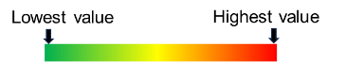

Note: More than one infection and/or organ dysfunction was present per patient. GBD: Global Burden of Disease; ICD-10-AM: International Classification of Disease- 10th Revision- Australian Modification
Explicit: Presence of one of the explicit sepsis ICD-10-AM codes as the primary or secondary diagnosis (Additional File 1; Supplementary Table 1)
- Implicit modified GBD method (N=90)
Sites of infection

Note: More than one isolated pathogen and infection was present per patient. CNS: Central Nervous System; GBD: Global Burden of Disease; IV: Intravenous; ICD-10-AM: International Classification of Disease-10th Revision- Australian Modification
Implicit: Presence of an infection code listed as the primary diagnosis and an “organ dysfunction code” listed as secondary diagnosis from the modified GBD codes (Additional File 1; Supplementary Tables 2 and 3) OR one of the explicit sepsis codes (Additional File 1; Supplementary Table 1)

- Implicit plus modified GBD method (N=70)
Sites of infection

Note: More than one infection and/or organ dysfunction code was present per patient. CNS: Central Nervous System; GBD: Global Burden of Disease; IV: Intravenous; ICD-10-AM: International Classification of Disease- 10th Revision- Australian Modification
Implicit plus: Presence of an infection code and an “organ dysfunction code” from the modified GBD codes (Additional File 1: Supplementary Tables 2 and 3) OR one of the explicit sepsis codes (Additional File 1; Supplementary Table 1)

Characteristics of true and false positive cases
Comparison of infection and organ dysfunction codes
For the implicit modified GBD method, N39 (Urinary tract infection, site not specified) was the most common infection code in both true (20.8%) and false (26.0%) positive cases. I95.9 (Hypotension, unspecified) (40.0%) was the most common organ dysfunction code noted in false positive cases while N17.9 (Acute Kidney Failure, unspecified) (45.6%) was most commonly noted in true positive cases. For the implicit plus method, N39 (Urinary tract infection, site not specified) (28.6%) was the most common infection code in false positive cases whereas N39 (Urinary tract infection, site not specified) and J18.9 (Pneumonia, unspecified) were most commonly noted infection codes (each 19.3%) in the true positive cases. Both I95.9 (Hypotension, unspecified) and N17.9 (Acute Kidney Failure, unspecified) (each 37.7%) were commonly noted organ dysfunction codes in false positive cases while latter was the most common organ dysfunction code noted in 44.8% true positive cases. A higher proportion of viral infections were noted in false positive compared to true positive cases in both implicit and implicit plus methods. Other infection and organ dysfunction codes were similar in true and false positive cases for both implicit and implicit plus methods (Supplementary Figure 4A-4B).

Supplementary Figure 4 Comparison of infection and organ dysfunction codes in true and false positive cases in the two implicit modified GBD methods
- Implicit
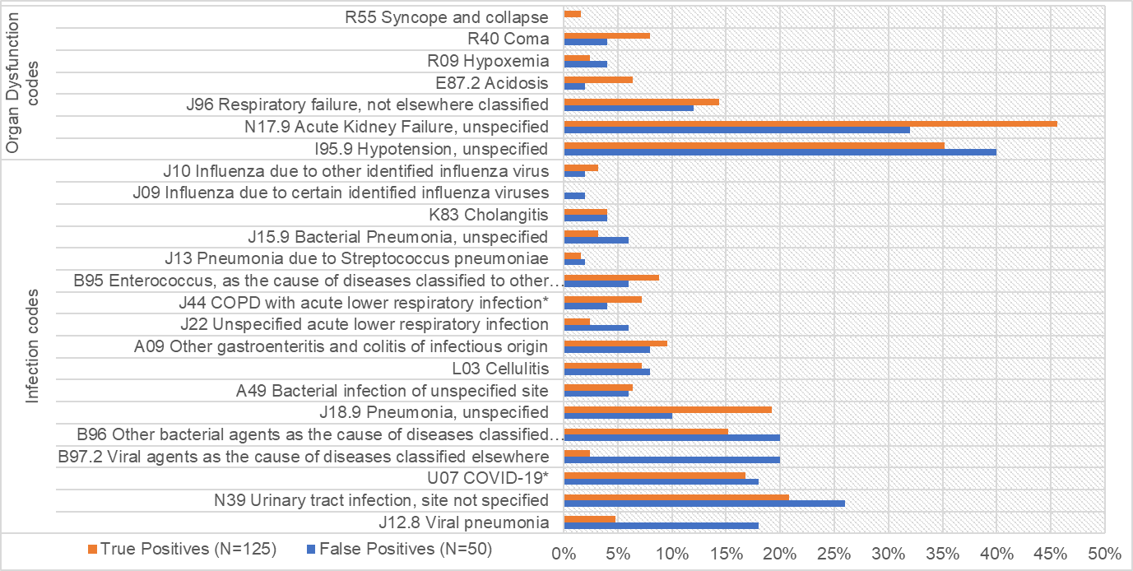
*Not included in the modified GBD code list.
Implicit: Presence of an infection code listed as the primary diagnosis and an “organ dysfunction code” listed as secondary diagnosis from the modified GBD codes (Refer Additional File 1; Supplementary Tables 2 and 3) OR one of the explicit sepsis codes (Refer Additional File 1; Supplementary Table 1)

- Implicit plus
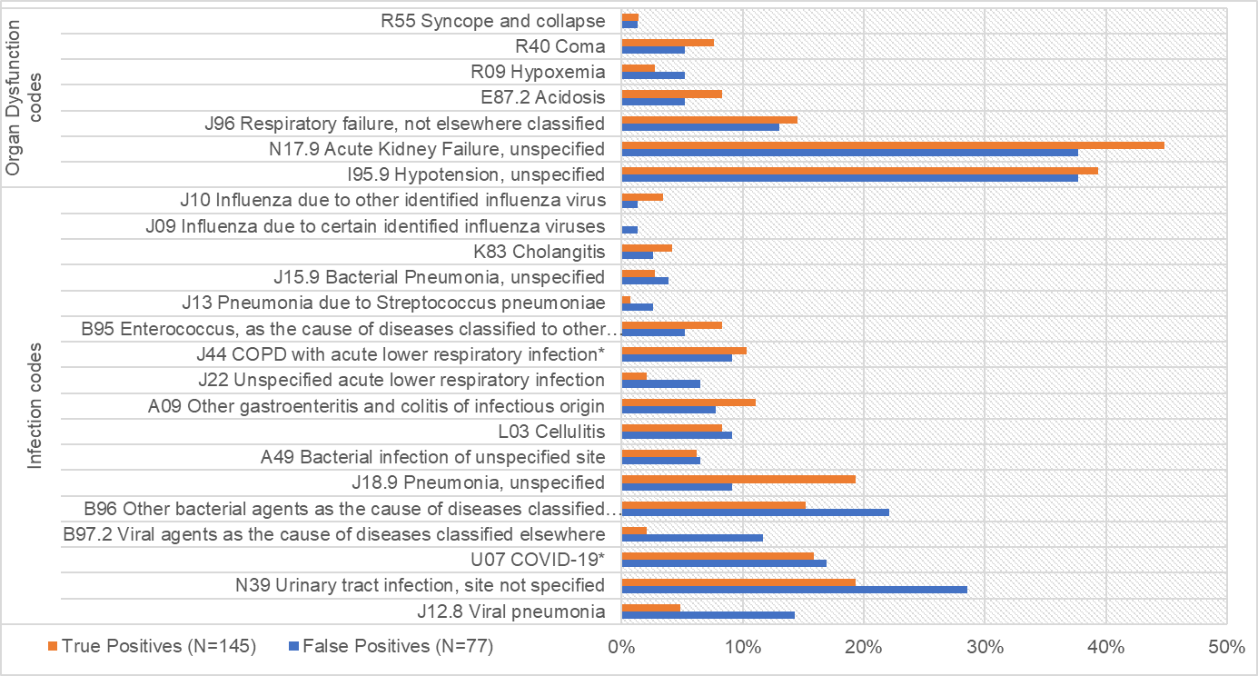
*Not included in the modified GBD code list.
Implicit plus: Presence of an infection code and an “organ dysfunction code” from the modified GBD codes (Refer Additional File 1; Supplementary Tables 2 and 3) OR one of the explicit sepsis codes (Refer Additional File 1; Supplementary Table 1)

Characteristics of true and false positive cases
Comparison of infection and organ dysfunction codes
For the implicit modified GBD method, N39 (Urinary tract infection, site not specified) was the most common infection code in both true (20.8%) and false (26.0%) positive cases. I95.9 (Hypotension, unspecified) (40.0%) was the most common organ dysfunction code noted in false positive cases while N17.9 (Acute Kidney Failure, unspecified) (45.6%) was most commonly noted in true positive cases. For the implicit plus method, N39 (Urinary tract infection, site not specified) (28.6%) was the most common infection code in false positive cases whereas N39 (Urinary tract infection, site not specified) and J18.9 (Pneumonia, unspecified) were most commonly noted infection codes (each 19.3%) in the true positive cases. Both I95.9 (Hypotension, unspecified) and N17.9 (Acute Kidney Failure, unspecified) (each 37.7%) were commonly noted organ dysfunction codes in false positive cases while latter was the most common organ dysfunction code noted in 44.8% true positive cases. A higher proportion of viral infections were noted in false positive compared to true positive cases in both implicit and implicit plus methods. Other infection and organ dysfunction codes were similar in true and false positive cases for both implicit and implicit plus methods (Supplementary Figure 5A-4B).
Supplementary Figure 5 Comparison of infection and organ dysfunction codes in true and false positive cases in the two implicit modified GBD methods
- Implicit
*Not included in the modified GBD code list.
Implicit: Presence of an infection code listed as the primary diagnosis and an “organ dysfunction code” listed as secondary diagnosis from the modified GBD codes (Refer Additional File 1; Supplementary Tables 2 and 3) OR one of the explicit sepsis codes (Refer Additional File 1; Supplementary Table 1)

- Implicit plus
*Not included in the modified GBD code list.
Implicit plus: Presence of an infection code and an “organ dysfunction code” from the modified GBD codes (Refer Additional File 1; Supplementary Tables 2 and 3) OR one of the explicit sepsis codes (Refer Additional File 1; Supplementary Table 1)
Comparison of site of False negatives and true positives
A higher rate of unconfirmed site of infection was noted in false negatives compared to true positives for all three methods: explicit (38.1% versus 23.6%), implicit (50.0% versus 16.8%) and implicit plus (55.6% versus 42.4%, respectively). Although a higher proportion of false negative cases lacked an isolated pathogen compared to true positive cases in implicit (44.3% versus 27.6%) and implicit plus methods (54.3% versus 44.1%), this difference was not noted in explicit method. Moreover, a higher proportion of false negative cases lacked both isolated pathogen and confirmed site of infection compared to true positive cases (31.1% versus 16.8%) in implicit method which was not noted in the explicit and implicit plus methods (Supplementary Figure 6A-6C).

Supplementary Figure 6 Comparison of site of infection and causative pathogen for the true positive and false negative cases
- Explicit
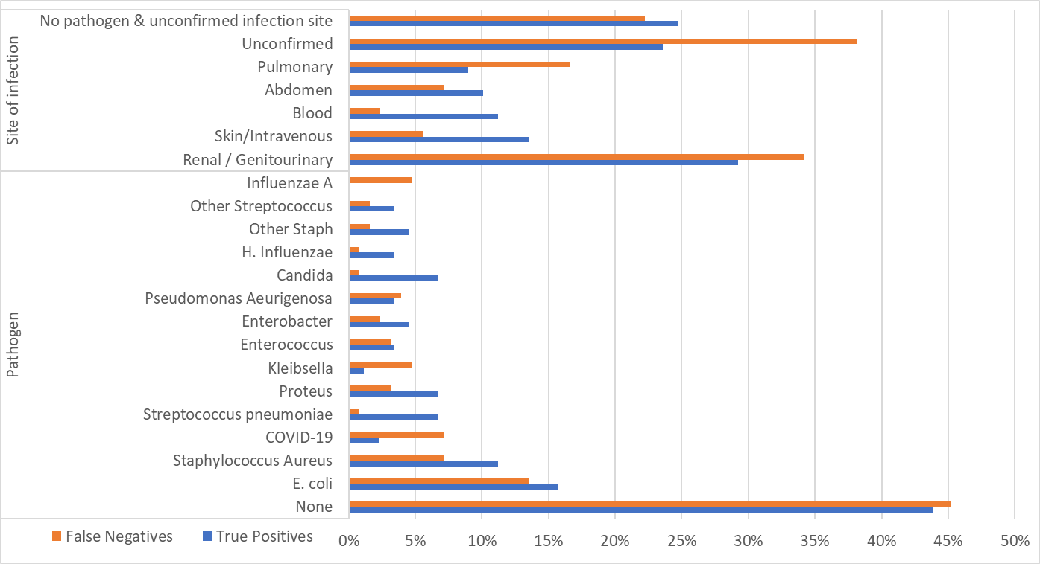
Explicit: Presence of one of the explicit sepsis ICD-10-AM codes as the primary or secondary diagnosis (Refer Additional File 1; Supplementary Table 1)

- Implicit
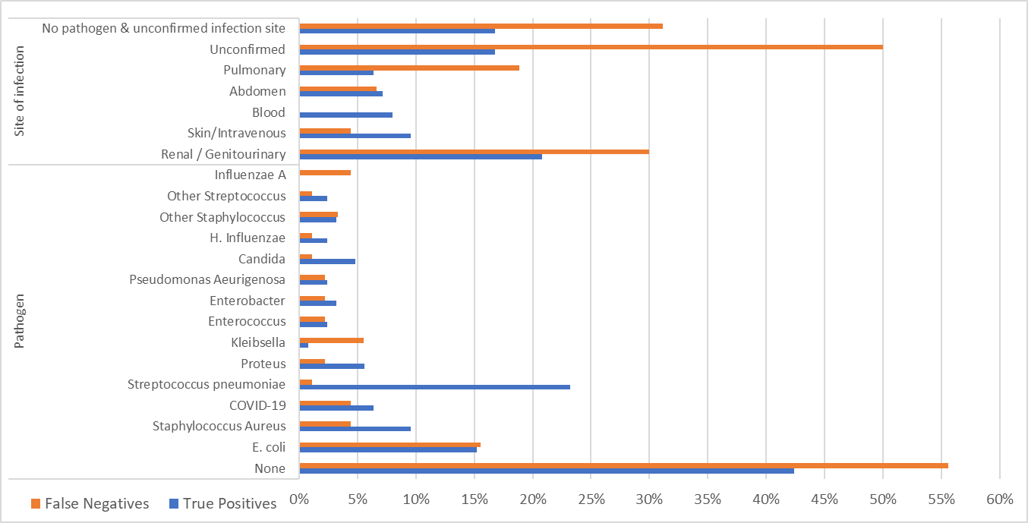
Implicit: Presence of an infection code listed as the primary diagnosis and an “organ dysfunction code” listed as secondary diagnosis from the modified GBD codes (Refer Additional File 1; Supplementary Tables 2 and 3) OR one of the explicit sepsis codes (Refer Additional File 1; Supplementary Table 1)
- Implicit plus
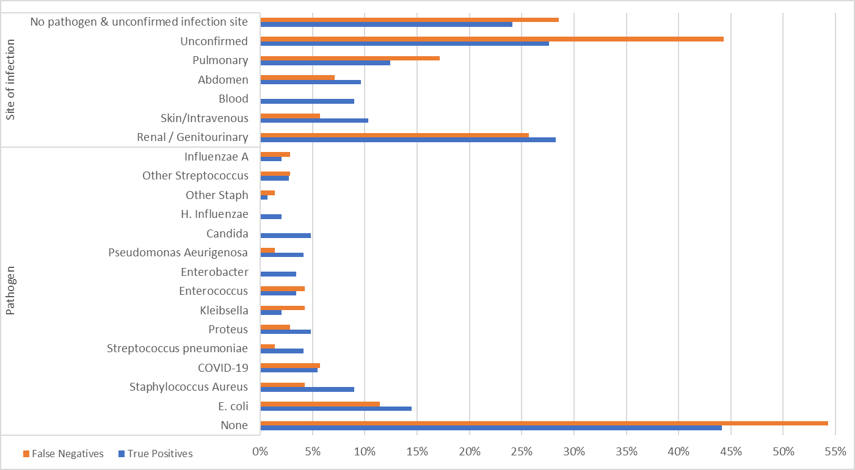
Implicit plus: Presence of an infection code and an “organ dysfunction code” from the modified GBD codes (Refer Additional File 1; Supplementary Tables 2 and 3) OR one of the explicit sepsis codes (Refer Additional File 1; Supplementary Table 1)

