Supplemental Material
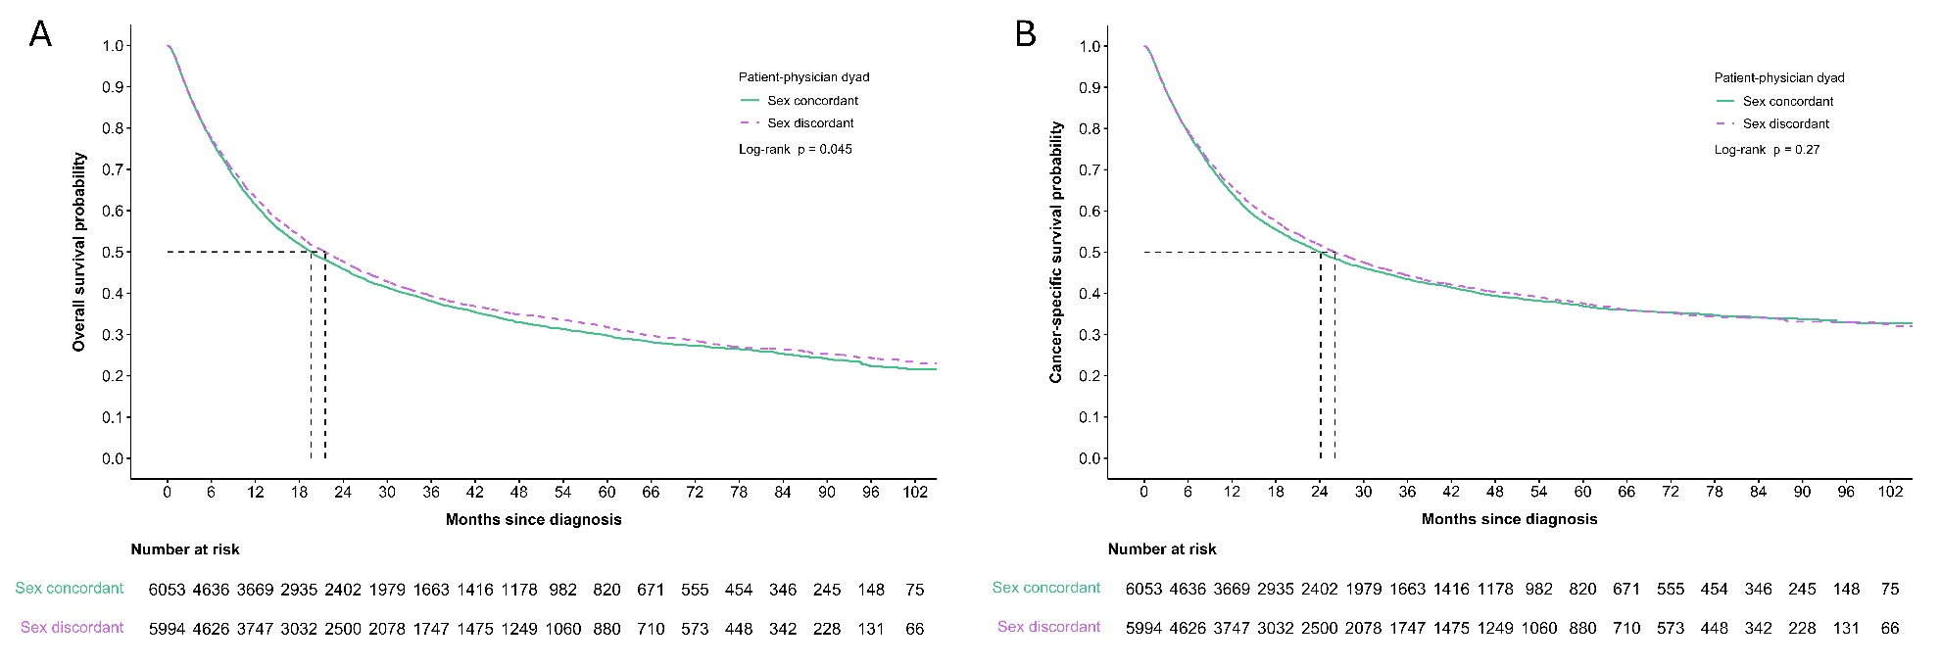
Supplemental Figure 1. (A) Overall survival and (B) Cancer-specific survival in the overall crude cohort, by patient-physician sex concordance

