Supplementary data.
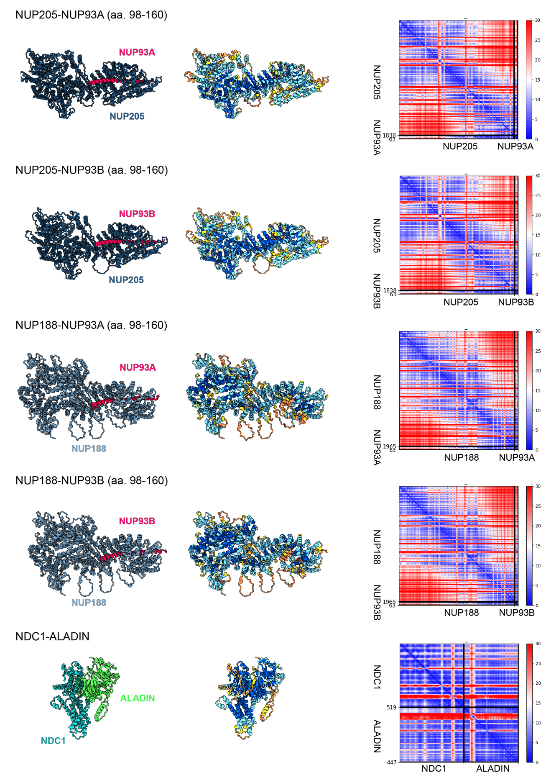
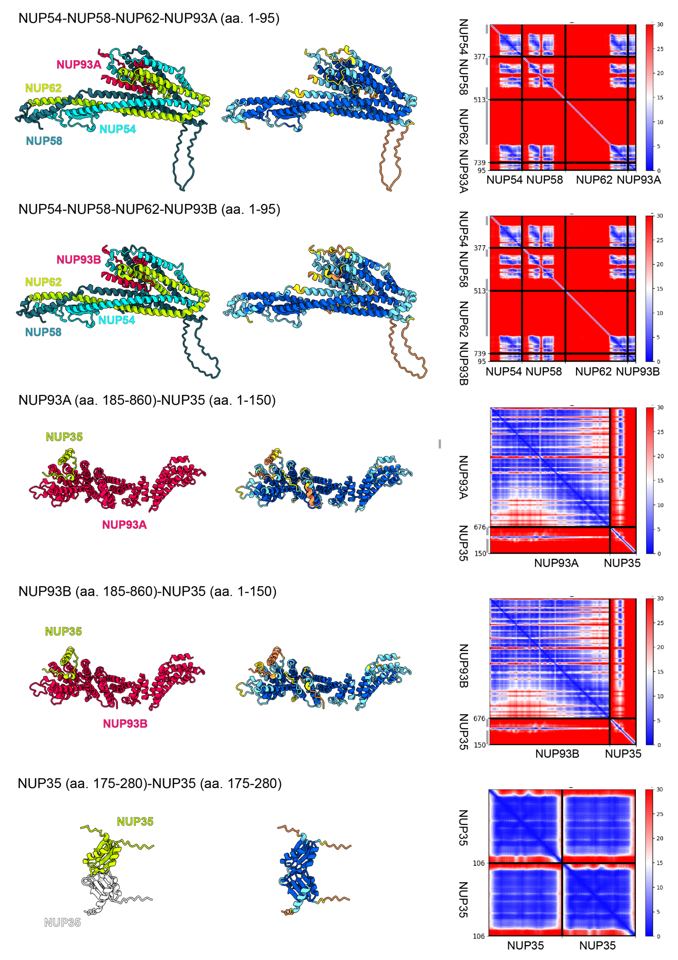
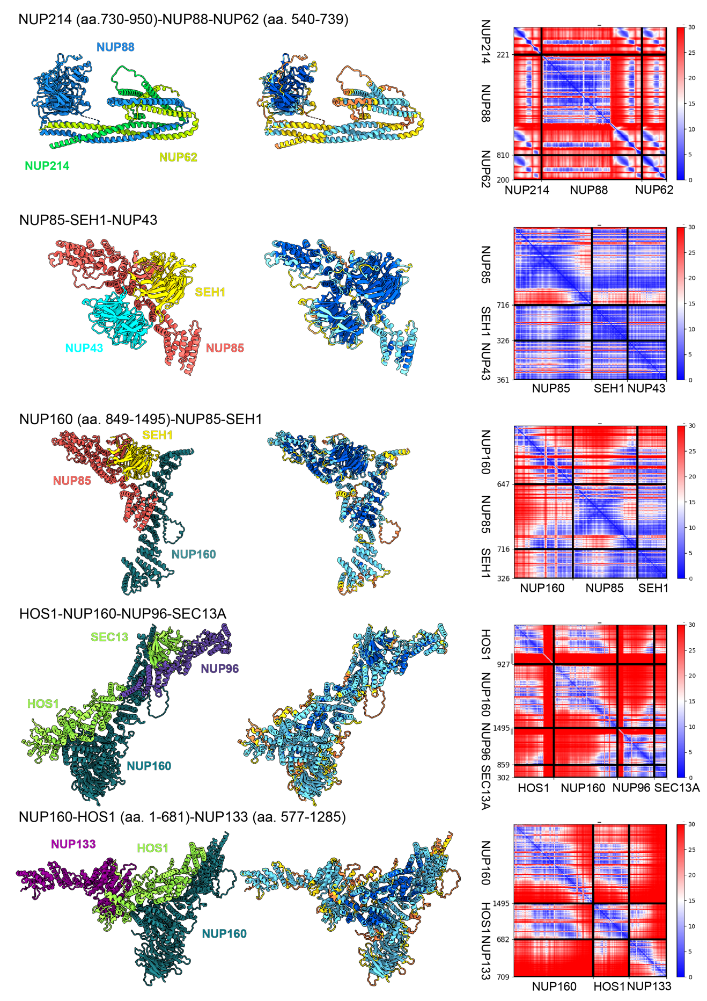
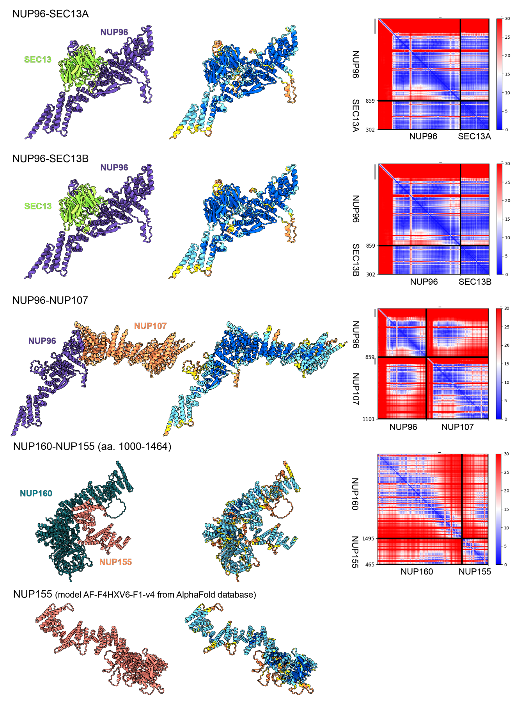
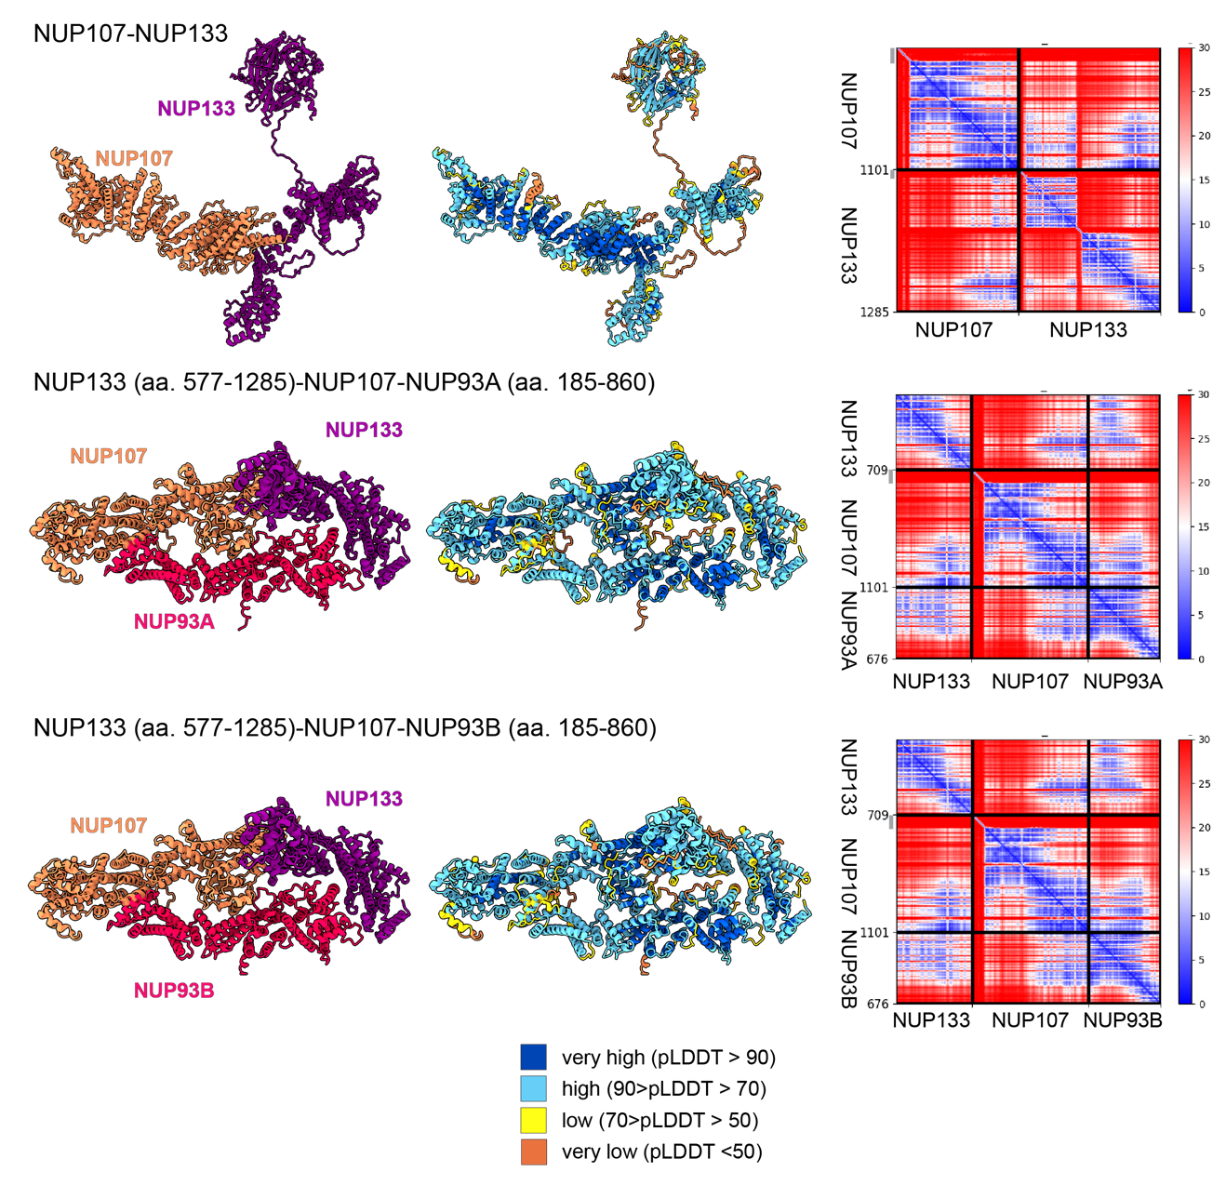
Supplementary Figure 1: Structural models of the A. thaliana NUP subcomplexes modeled using AlphaFold2. Each row shows, from left to right: a model colored by the NUP color code; a model colored by the local confidence estimated with predicted local distance difference test (pLDDT), as returned by AlphaFold. pLDDT > 90 (dark blue) indicates high estimated accuracy of backbone and side chain rotamers, whereas pLDDT > 70 (yellow) indicates confident backbone prediction⁵¹. The confidence of interdomain and inter-chain orientations estimated with the expected distance error between all pairs of residues in the complex, as returned by AlphaPulldown. The color at each (x, y) position of the matrix corresponds to the expected distance error in residue x’s position when the prediction and true (unknown) structure are aligned on residue y. Blue indicates low error. The heat maps show the sequence covered in the initial prediction and indicated in brackets. Long disordered regions, indicated with grey bars next to the matrix are not shown in the figures of model structures. aa. – amino acid residues.

Supplementary figure 2. The unassigned density in the CR of the AtNPC. Unassigned region of density that could correspond to the second Y-ring of the CR in A. thaliana NPC.

