Table S1. Baseline Characteristics of Participants
Characteristic | Study Participants
Characteristic | All (n=1923) | No (n=1562) | Yes (n=361) | P value
Age | 48.18(0.72) | 47.42(0.67) | 51.93(1.48) | 0.002
BMI | 29.56(0.31) | 29.11(0.34) | 31.78(0.39) | < 0.001
HDL | 1.41(0.01) | 1.42(0.01) | 1.41(0.01) | 0.51
HS.CRP | 3.80(0.24) | 3.44(0.23) | 5.57(0.70) | 0.01
Total.Cholesterol | 4.92(0.04) | 4.95(0.04) | 4.78(0.07) | 0.05
Vitamin.D | 79.75(1.56) | 79.68(1.53) | 80.06(2.86) | 0.88
Glucose | 5.95(0.06) | 5.88(0.05) | 6.28(0.11) | 0.001
Lead (umol/L) | 0.04(0.00) | 0.04(0.00) | 0.04(0.00) | 0.2
Cadmium (ug/L) | 3.23(0.15) | 2.98(0.14) | 4.45(0.28) | < 0.0001
Manganese (ug/L) | 171.46(2.60) | 171.99(2.86) | 168.84(2.93) | 0.35
Selenium (umol/L) | 2.31(0.01) | 2.32(0.01) | 2.26(0.02) | 0.01
Mercury (nmol/L) | 6.31(0.56) | 6.65(0.63) | 4.62(0.50) | 0.01
LeadQ |  |  |  | 0.86
Q1 | 641(39.11) | 522(39.10) | 119(39.14)
Q2 | 640(32.60) | 523(32.85) | 117(31.36)
Q3 | 642(28.30) | 517(28.05) | 125(29.50)
CadmiumQ |  |  |  | < 0.0001
Q1 | 638(38.53) | 556(41.04) | 82(26.10)
Q2 | 646(32.30) | 532(32.32) | 114(32.19)
Q3 | 639(29.17) | 474(26.63) | 165(41.72)
ManganeseQ |  |  |  | 0.83
Q1 | 641(33.04) | 522(32.81) | 119(34.15)
Q2 | 638(33.51) | 523(33.59) | 115(33.12)
Q3 | 644(33.45) | 517(33.59) | 127(32.73)
SeleniumQ |  |  |  | 0.01
Q1 | 663(33.57) | 516(32.02) | 147(41.21)
Q2 | 615(33.03) | 507(33.47) | 108(30.85)
Q3 | 645(33.41) | 539(34.51) | 106(27.94)
MercuryQ |  |  |  | 0.001
Q1 | 650(35.72) | 499(33.55) | 151(46.43)
Q2 | 639(32.90) | 524(33.39) | 115(30.43)
Q3 | 634(31.39) | 539(33.05) | 95(23.14)
Sex |  |  |  | 0.01
Male | 858(49.09) | 725(50.76) | 133(40.83)
Female | 1065(50.91) | 837(49.24) | 228(59.17)
Ethnic |  |  |  | 0.72
Non-Hispanic White | 1240(65.65) | 1017(65.74) | 223(65.22)
Non-Hispanic Black | 183 (8.81) | 146(8.72) | 37(9.27)
Mexican American | 129(6.92) | 111(7.16) | 18(5.72)
Other | 371(18.62) | 288(18.38) | 83(19.79)
Marital |  |  |  | < 0.001
Unmarried or other | 810(34.70) | 612(32.35) | 198(46.33)
Married or living with a partner | 1113(65.30) | 950(67.65) | 163(53.67)
Education |  |  |  | < 0.0001
 | 172(6.95) | 104(5.32) | 68(14.97)
≥High school | 1751(93.05) | 1458(94.68) | 293(85.03)
Poverty_ratio |  |  |  | < 0.0001
Below Poverty line (<1.00) | 212(9.05) | 140(7.19) | 72(18.27)
At or above Poverty line (≥1.00) | 1711(90.95) | 1422(92.81) | 289(81.73)
Smoke |  |  |  | < 0.0001
Never | 1201(65.84) | 1027(68.77) | 174(51.35)
Former | 479(21.68) | 377(20.91) | 102(25.46)
Current | 243(12.48) | 158(10.31) | 85(23.20)
Alcohol.use |  |  |  | < 0.0001
No | 188(9.06) | 131(8.12) | 57(13.71)
Yes | 1735(90.94) | 1431(91.88) | 304(86.29)
Hypertension |  |  |  | < 0.0001
No | 1250(70.36) | 1073(73.65) | 177(54.11)
Yes | 673(29.64) | 489(26.35) | 184(45.89)
Asthma |  |  |  | 0.01
No | 1600(83.88) | 1315(84.85) | 285(79.09)
Yes | 323(16.12) | 247(15.15) | 76(20.91)
Arthritis |  |  |  | < 0.0001
No | 1324(75.01) | 1147(79.04) | 177(55.11)
Yes | 599(24.99) | 415(20.96) | 184(44.89)
Congestive.Heart.Failure |  |  |  | < 0.001
No | 1874(98.28) | 1536(98.83) | 338(95.57)
Yes | 49(1.72) | 26(1.17) | 23(4.43)
Coronary.Heart.Disease |  |  |  | 0.03
No | 1834(96.59) | 1499(97.00) | 335(94.59)
Yes | 89(3.41) | 63(3.00) | 26(5.41)
Thyroid.Problem |  |  |  | 0.15
No | 1690(90.12) | 1383(90.73) | 307(87.06)
Yes | 233(9.88) | 179(9.27) | 54(12.94)
COPD |  |  |  | < 0.001
No | 1821(96.16) | 1509(97.43) | 312(89.86)
Yes | 102(3.84) | 53(2.57) | 49(10.14)
liver.Condition |  |  |  | < 0.0001
No | 1832(96.12) | 1508(97.36) | 324(89.94)
Yes | 91(3.88) | 54(2.64) | 37(10.06)
Cancer |  |  |  | 0.04
No | 1635(89.02) | 1341(89.80) | 294(85.18)
Yes | 288(10.98) | 221(10.20) | 67(14.82)
Kidney.Disease |  |  |  | < 0.0001
No | 1874(97.89) | 1542(99.17) | 332(91.56)
Yes | 49(2.11) | 20(0.83) | 29(8.44)
PHQ9 |  |  |  | < 0.0001
No | 1692(88.56) | 1460(93.64) | 232(63.47)
Yes | 231(11.44) | 102(6.36) | 129(36.53)
Age |  |  |  | 0.01
20-29 | 217(17.24) | 184(17.70) | 33(14.96)
30-39 | 290(18.23) | 252(19.53) | 38(11.78)
40-49 | 273(17.16) | 232(17.96) | 41(13.21)
50-59 | 297(18.10) | 229(16.97) | 68(23.68)
60-69 | 482(16.45) | 384(15.95) | 98(18.90)
≥70 | 364(12.82) | 281(11.88) | 83(17.48)
BMI |  |  |  | < 0.0001
18.5-30.0 | 1141(59.25) | 972(61.73) | 169(46.96)
<18.5 | 14(0.70) | 11(0.69) | 3(0.75)
≥30.0 | 768(40.05) | 579(37.58) | 189(52.29)
This table provides weighted estimates of participants' baseline characteristics, representing US population demographics and considering the National Health and Nutrition Examination Survey's complex sampling design. UCR stands for urinary creatinine; BMI stands for body mass index (calculated as weight in kilograms divided by height in meters squared).

Table S2. Discriminative Features of 11 Machine Learning Models in the Testing Set
Characteristics | SVM | NN | MLP | GP | GBM | LR | NB | XGB | C5.0 | KNN | RF
Apparent  prevalence | 0.89 (0.86, 0.92) | 0.91 (0.88, 0.94) | 0.89 (0.85, 0.92) | 0.95 (0.93, 0.97) | 0.92 (0.89, 0.94) | 0.91 (0.88, 0.94) | 0.79 (0.75, 0.83) | 0.92 (0.89, 0.94) | 0.91 (0.87, 0.93) | 0.99 (0.97, 1.00) | 0.96 (0.93, 0.97)
True prevalence | 0.81 (0.77, 0.85) | 0.81 (0.77, 0.85) | 0.81 (0.77, 0.85) | 0.81 (0.77, 0.85) | 0.81 (0.77, 0.85) | 0.81 (0.77, 0.85) | 0.81 (0.77, 0.85) | 0.81 (0.77, 0.85) | 0.81 (0.77, 0.85) | 0.81 (0.77, 0.85) | 0.81 (0.77, 0.85)
Sensitivity | 0.96 (0.93, 0.98) | 0.97 (0.94, 0.98) | 0.96 (0.93, 0.98) | 0.99 (0.98, 1.00) | 0.97 (0.95, 0.99 | 0.97 (0.94, 0.98) | 0.86 (0.82, 0.90) | 0.97 (0.94, 0.98) | 0.96 (0.93, 0.98) | 1.00 (0.98, 1.00 | 0.99 (0.97, 1.00)
Specificity | 0.39 (0.28, 0.51) | 0.32 (0.21, 0.44) | 0.42 (0.30, 0.54) | 0.22 (0.13, 0.34) | 0.31 (0.20, 0.43) | 0.33 (0.23, 0.45) | 0.50 (0.38, 0.62) | 0.29 (0.19, 0.41) | 0.32 (0.21, 0.44) | 0.04 (0.01, 0.12) | 0.19 (0.11, 0.30)
PPV | 0.87 (0.83, 0.91) | 0.86 (0.82, 0.89) | 0.88 (0.84, 0.91) | 0.85 (0.81, 0.88) | 0.86 (0.82, 0.89) | 0.86 (0.82, 0.90) | 0.88 (0.84, 0.92) | 0.86 (0.81, 0.89) | 0.86 (0.82, 0.89) | 0.82 (0.78, 0.86) | 0.84 (0.80, 0.88)
NPV | 0.68 (0.52, 0.82) | 0.70 (0.51, 0.84) | 0.68 (0.52, 0.81) | 0.89 (0.65, 0.99) | 0.71 (0.52, 0.86) | 0.71 (0.53, 0.85) | 0.45 (0.34, 0.57) | 0.68 (0.49, 0.83) | 0.64 (0.46, 0.79) | 0.75 (0.19, 0.99) | 0.82 (0.57, 0.96)
PLR | 1.57 (1.30, 1.89) | 1.42 (1.21, 1.67) | 1.64 (1.34, 1.99) | 1.28 (1.13, 1.45) | 1.40 (1.20, 1.63) | 1.45 (1.23, 1.71) | 1.72 (1.36, 2.17) | 1.37 (1.18, 1.59) | 1.41 (1.20, 1.65) | 1.04 (0.99, 1.09) | 1.23 (1.10, 1.38)
NLR | 0.11 (0.06, 0.20) | 0.10 (0.05, 0.20) | 0.11 (0.06, 0.19) | 0.03 (0.01, 0.12) | 0.09 (0.05, 0.20) | 0.10 (0.05, 0.19) | 0.28 (0.20, 0.40) | 0.11 (0.05, 0.22) | 0.13 (0.07, 0.24) | 0.08 (0.01, 0.73) | 0.05 (0.01, 0.17)
The table below compares the discriminative features of 11 machine learning models without data augmentation. Abbreviations: SVM stands for Support Vector Machine; NN stands for Neural Network; MLP stands for Multi-Layer Perceptron; GP stands for Gaussian Process; GBM stands for Gradient Boosting Machine; LR stands for Logistic Regression; NB stands for Naive Bayes; XGB stands for XGBoost; C5.0 stands for C5.0 Decision Trees; KNN stands for K-Nearest Neighbor; RF stands for Random Forest; PPV stands for Positive Predictive Value; NPV stands for Negative Predictive Value; PLR stands for Positive Likelihood Ratio; NLR stands for Negative Likelihood Ratio.

Table S3. Initial Generalized Linear Regression Model Assessing the Impact of Heavy Metals and Demographic Factors on Disability Outcomes in Stroke Survivors
Response Variable | Model Formula | Coefficient | Lower CI | Upper CI | P-Value
Model 1 | Lead | -0.185 | -0.379 | 0.005 | 0.059
Model 1 | cadmium | 0.56 | 0.404 | 0.718 | <0.001
Model 1 | manganese | -0.13 | -0.486 | 0.225 | 0.474
Model 1 | selenium | -1.129 | -2.053 | -0.236 | 0.015
Model 1 | mercury | -0.187 | -0.293 | -0.082 | 0.001
Model 2 | Lead | -0.323 | -0.549 | -0.102 | 0.005
Model 2 | cadmium | 0.514 | 0.348 | 0.681 | <0.001
Model 2 | manganese | -0.096 | -0.459 | 0.265 | 0.602
Model 2 | selenium | -1.07 | -1.987 | -0.188 | 0.02
Model 2 | mercury | -0.193 | -0.3 | -0.087 | <0.001
Model 3 | Lead | -0.26 | -0.514 | -0.011 | 0.043
Model 3 | cadmium | 0.348 | 0.143 | 0.554 | <0.001
Model 3 | manganese | -0.176 | -0.586 | 0.232 | 0.398
Model 3 | selenium | -0.863 | -1.91 | 0.15 | 0.101
Model 3 | mercury | -0.073 | -0.195 | 0.049 | 0.243
This table presents the results of generalized linear regression models examining the relationship between heavy metals and stroke survivors. Model 1 includes only the five heavy metals as predictors. Model 2 incorporates additional covariates for sex and age. Model 3 expands the analysis further by including a comprehensive set of variables: age, sex, ethnicity, marital status, smoking status, alcohol use, body mass index (BMI), high-density lipoprotein (HDL) levels, and various health conditions, including hypertension, asthma, arthritis, congestive heart failure, coronary heart disease, thyroid problems, chronic obstructive pulmonary disease (COPD), liver conditions, cancer, high-sensitivity C-reactive protein (HS-CRP), total cholesterol, vitamin D levels, glucose, kidney disease, and the Patient Health Questionnaire-9 (PHQ9) score, as well as the poverty ratio.

Table S4 Generalized Linear Regression Analysis of Heavy Metal Concentrations in Stroke Survivors
Response Variable | Concentration Level | Model Formula | Coefficient | Lower CI | Upper CI | P-Value
Model 1 | Q1 | lead | Ref | Ref | Ref | Ref
Model 1 | Q2 | lead | -0.089 | -0.3874 | 0.2089 | 0.5582
Model 1 | Q3 | lead | -0.1612 | -0.4719 | 0.149 | 0.3085
Model 1 | Q1 | cadmium | Ref | Ref | Ref | Ref
Model 1 | Q2 | cadmium | 0.4428 | 0.1265 | 0.7631 | 0.0064
Model 1 | Q3 | cadmium | 0.9334 | 0.6196 | 1.2537 | 8.95E-09
Model 1 | Q1 | manganese | Ref | Ref | Ref | Ref
Model 1 | Q2 | manganese | -0.0407 | -0.3324 | 0.2508 | 0.7843
Model 1 | Q3 | manganese | -0.0369 | -0.3252 | 0.2515 | 0.802
Model 1 | Q1 | selenium | Ref | Ref | Ref | Ref
Model 1 | Q2 | selenium | -0.2837 | -0.5691 | -0.0009 | 0.0502
Model 1 | Q3 | selenium | -0.2628 | -0.5507 | 0.0229 | 0.0724
Model 1 | Q1 | mercury | Ref | Ref | Ref | Ref
Model 1 | Q2 | mercury | -0.3359 | -0.6159 | -0.0582 | 0.0182
Model 1 | Q3 | mercury | -0.5212 | -0.8194 | -0.2268 | 0.0006
 | Q1 | lead | Ref | Ref | Ref | Ref
Model 2 | Q2 | lead | -0.2251 | -0.5442 | 0.0928 | 0.1658
Model 2 | Q3 | lead | -0.3307 | -0.6778 | 0.0155 | 0.0615
Model 2 | Q1 | cadmium | Ref | Ref | Ref | Ref
Model 2 | Q2 | cadmium | 0.2973 | -0.0306 | 0.6286 | 0.0768
Model 2 | Q3 | cadmium | 0.7786 | 0.4495 | 1.1134 | 4.47E-06
Model 2 | Q1 | manganese | Ref | Ref | Ref | Ref
Model 2 | Q2 | manganese | -0.041 | -0.3341 | 0.2518 | 0.7837
Model 2 | Q3 | manganese | -0.0313 | -0.3225 | 0.26 | 0.833
Model 2 | Q1 | selenium | Ref | Ref | Ref | Ref
Model 2 | Q2 | selenium | -0.2468 | -0.5341 | 0.0382 | 0.0909
Model 2 | Q3 | selenium | -0.2236 | -0.5137 | 0.0645 | 0.1294
Model 2 | Q1 | mercury | Ref | Ref | Ref | Ref
Model 2 | Q2 | mercury | -0.3632 | -0.645 | -0.0837 | 0.0112
Model 2 | Q3 | mercury | -0.5218 | -0.8213 | -0.226 | 0.0006
 | Q1 | lead | Ref | Ref | Ref | Ref
Model 3 | Q2 | lead | -0.0833 | -0.4417 | 0.2749 | 0.6482
Model 3 | Q3 | lead | -0.142 | -0.5392 | 0.2553 | 0.4833
Model 3 | Q1 | cadmium | Ref | Ref | Ref | Ref
Model 3 | Q2 | cadmium | 0.3402 | -0.0226 | 0.7064 | 0.0672
Model 3 | Q3 | cadmium | 0.6041 | 0.2232 | 0.9895 | 0.002
Model 3 | Q1 | manganese | Ref | Ref | Ref | Ref
Model 3 | Q2 | manganese | -0.0283 | -0.3569 | 0.2998 | 0.8656
Model 3 | Q3 | manganese | -0.0707 | -0.3982 | 0.2564 | 0.6716
Model 3 | Q1 | selenium | Ref | Ref | Ref | Ref
Model 3 | Q2 | selenium | -0.1872 | -0.511 | 0.1347 | 0.2556
Model 3 | Q3 | selenium | -0.1525 | -0.4826 | 0.1759 | 0.3636
Model 3 | Q1 | mercury | Ref | Ref | Ref | Ref
Model 3 | Q2 | mercury | -0.3177 | -0.6351 | -0.0025 | 0.049
Model 3 | Q3 | mercury | -0.177 | -0.5134 | 0.1576 | 0.3007
This table displays the results of generalized linear regression models investigating the relationship between categorized concentrations of five heavy metals and stroke survivors. The concentrations of each metal are divided into three quartiles (Q1, Q2, and Q3) to assess their impact on outcomes. Model 1 includes only these categorized metal concentrations as predictors. Model 2 adds covariates for sex and age. Model 3 further expands the analysis by incorporating a comprehensive set of variables, including age, sex, ethnicity, marital status, smoking status, alcohol use, body mass index (BMI), high-density lipoprotein (HDL) levels, and various health conditions such as hypertension, asthma, arthritis, congestive heart failure, coronary heart disease, thyroid problems, chronic obstructive pulmonary disease (COPD), liver conditions, cancer, high-sensitivity C-reactive protein (HS-CRP), total cholesterol, vitamin D levels, glucose, kidney disease, and the Patient Health Questionnaire-9 (PHQ9) score, along with the poverty ratio.

Figure S1. Partial Dependence of 5 Heavy Metals (A-E) on Stroke Prediction Probabilities Using LIME
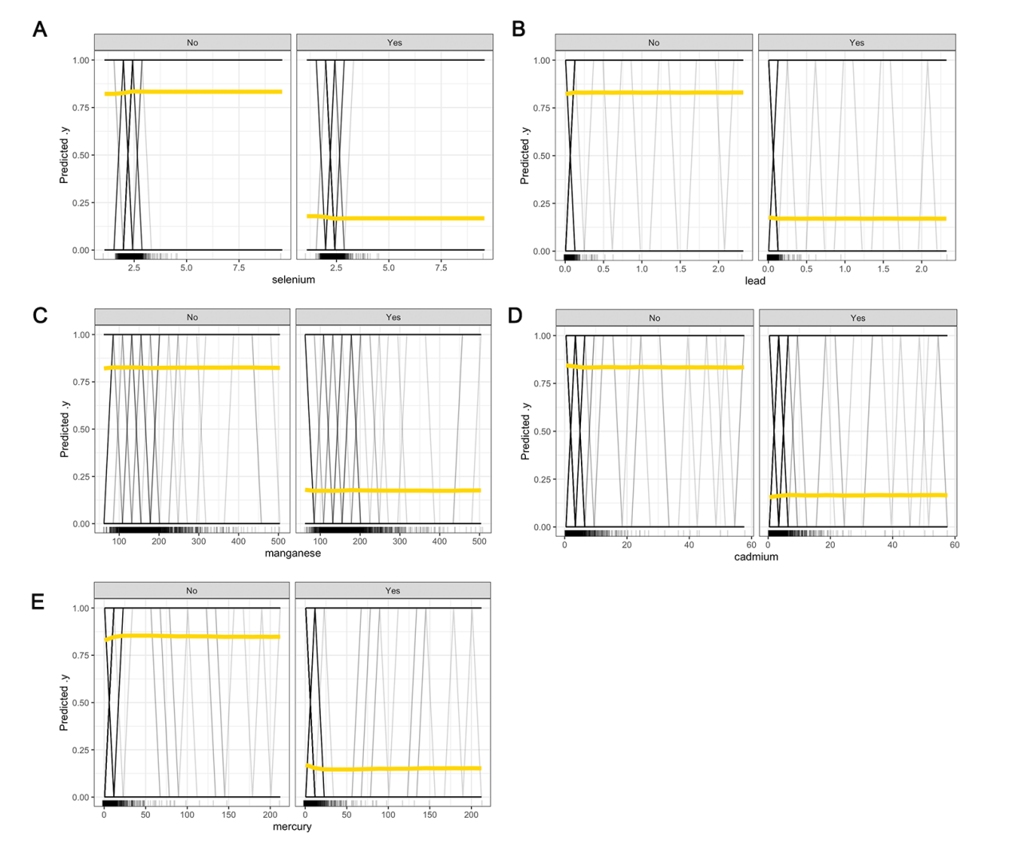

Figure S2. Accumulated Local Effects (ALE) of Heavy Metals and Health Factors on Stroke Survival Prediction
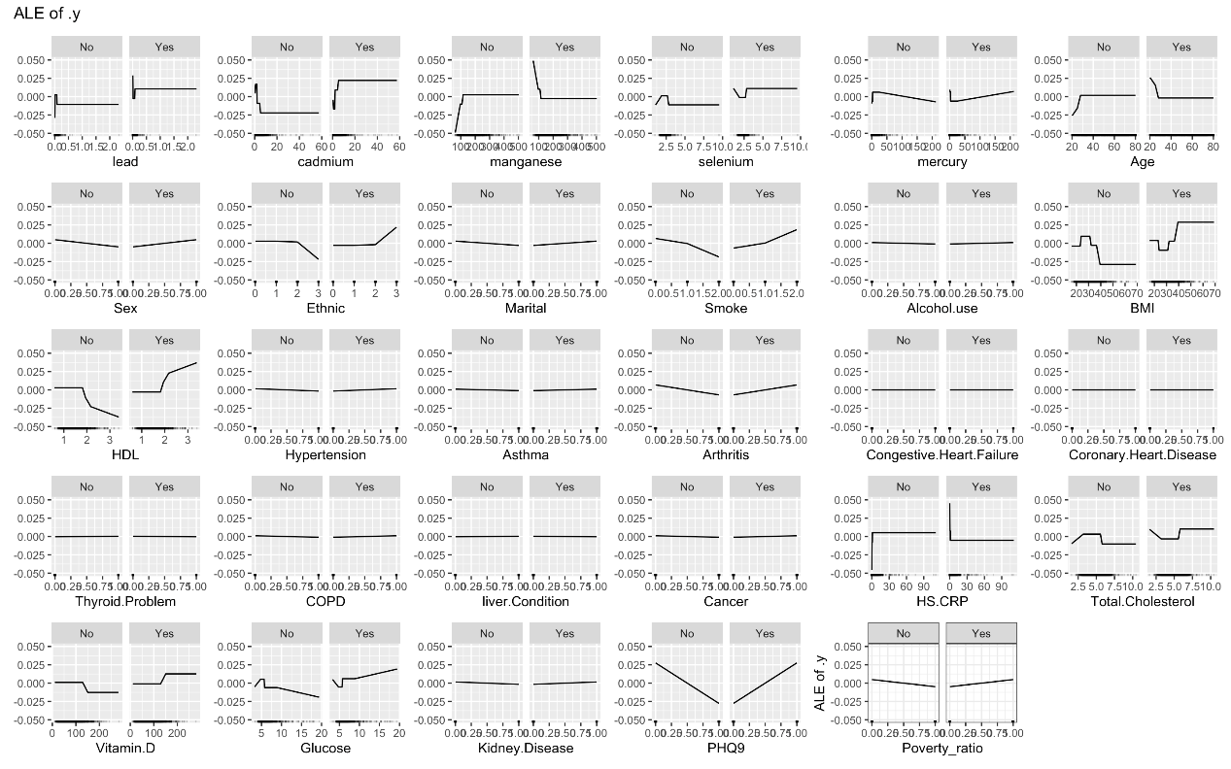

Figure S3. Results of Pearson's correlation analysis among heavy metal factors.
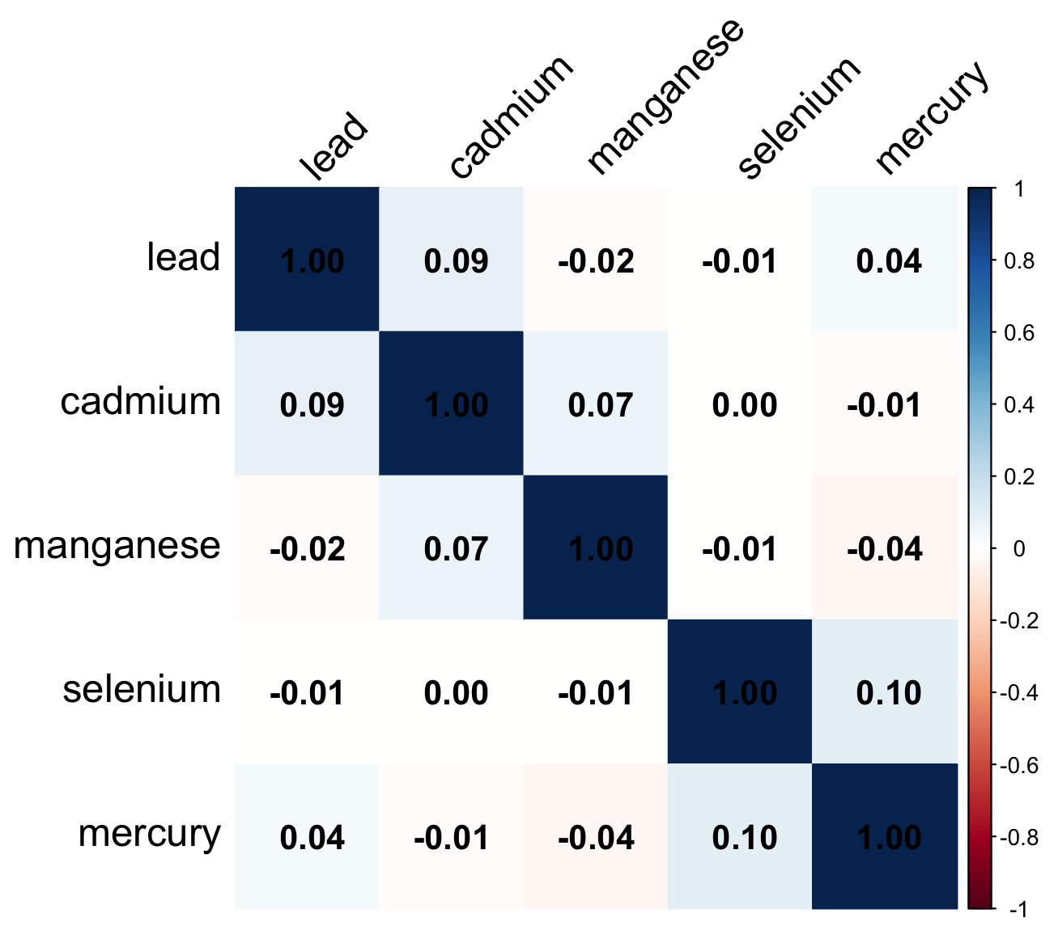

Figure S4. Predictive model contribution of metal factors and baseline variables. (A) A stroke prediction model based on LIME features and weights (B) Based on LIME analysis, the forest map shows the contribution weights and standard deviations of heavy metals and baseline variables.
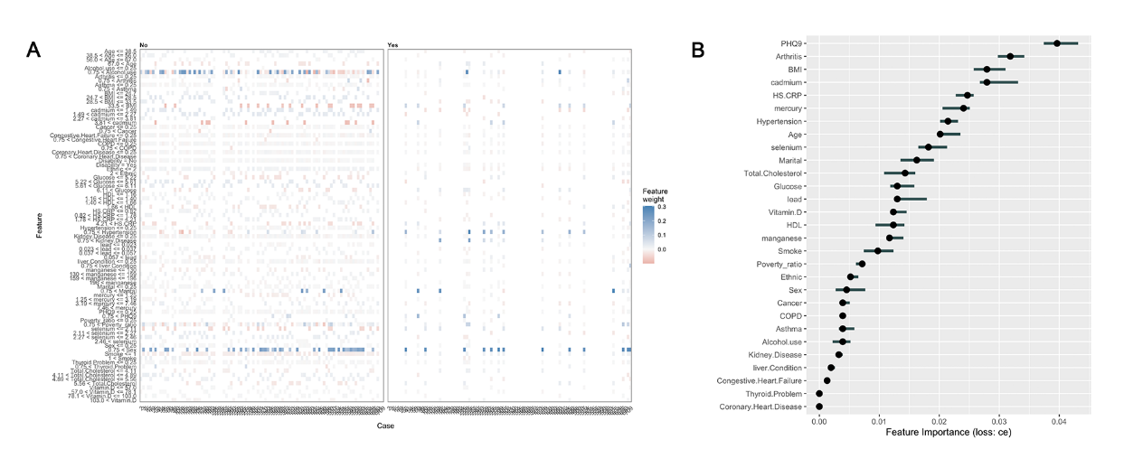

Figure S5 SHAP Dependence Analysis of 5 Heavy Metals (A-E) on Stroke Survivors' Risk Prediction.
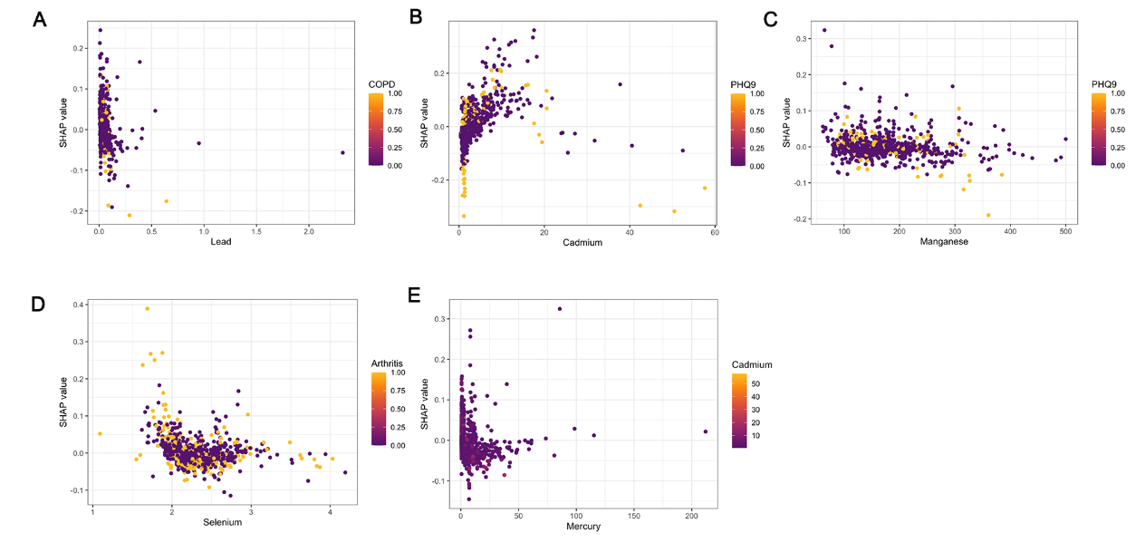

Figure S6. SHAP Waterfall Plots Illustrating the Contribution of Heavy Metal Exposure and Clinical Features to Predicted Risk Scores in Stroke Survivors (1, 10, 100, 1000)
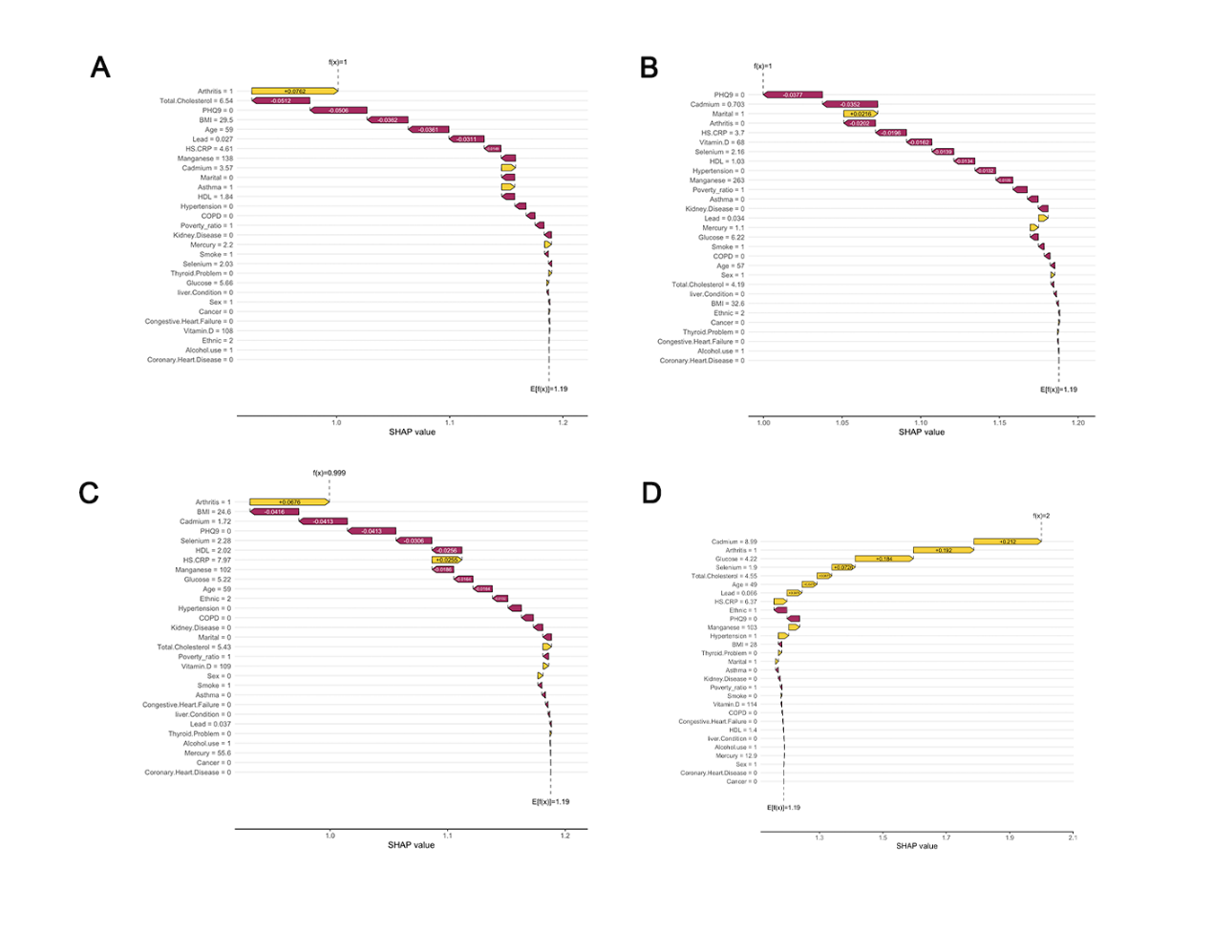

Figure S7. SHAP Summary Plot Showing Feature Contributions to Predicted Risk in Stroke Survivors with and Without Adverse Outcomes 1, 10, 100, 1000

