Supplementary Information

Regular-wrinkling tunable MXene lattice for electromagnetic interference shielding

Shan Zhang, Juntao Wu, Zhi-Ling Hou, Pengfei Hu, Bo Cai, Chenming Liang, Lu Zhou, Wenhao Liang, Yufeng Xue, Martin C. Koo, Teobaldi Gilberto, Pei-Yan Zhao, Li-Min Liu, Mingjie Liu and Guang-Sheng Wang

Corresponding authors: Li-Min Liu, liminliu@buaa.edu.cn; Mingjie Liu, liumj@buaa.edu.cn and Guang-Sheng Wang, wanggsh@buaa.edu.cn.

The PDF file includes:

Materials
Supplementary Text
Figure S1 to S32
Tables S1 to S8
References

Materials
Materials
4,4′-oxydianicurve (ODA; 99%), Pyromellitic dianhydride (PMDA, 99%) was purchased from Shanghai Research Institute of Synthetic Resins and sublimated prior to use. Ti₃AlC₂ powders (99%, 400 mesh) were purchased from Jilin 11 technology Co., Ltd. Lithium fluoride (LiF, 99%). Hydrochloric acid (HCl, 37 wt%), N, N-dimethyl-formamide (DMF, analytically pure, ≥99.5%) were supplied by Beijing Chemical Works. Polyethylene terephthalate (PET) was purchased from Dongguan Jubang plastic material Co., LTD.

Supplementary Figures and Tables
Supplementary Figure 1. Schematic of MXene solution blade-coating process on polymer surface.

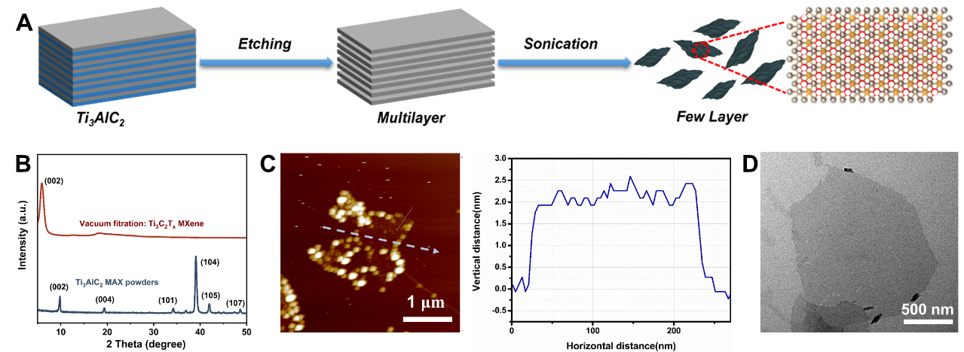
Supplementary Figure 2. The synthesis characterization of Ti₃C₂T_{x} MXene. (A) Schematic representing the fabrication process of few-layer Ti₃C₂T_{x} MXene flakes (B) XRD patterns of Ti₃AlC₂ MAX powders and Ti₃C₂T_{x} MXene film (C) AFM image and height profiles of the Ti₃C₂T_{x} MXene flakes. (D) TEM image of Ti₃C₂T_{x} MXene flakes.

The preparation and characterization of Ti₃C₂T_{x} MXene flakes
The few-layer Ti₃C₂T_{x} MXene flakes were obtained through the selective etching of Al layers from the MAX phase of Ti₃AlC₂ in the HCl/LiF mixture to produce multilayer MXene solution, followed by ultrasonication (Supplementary Fig. 2A)¹. As shown in Supplementary Fig. 2B, the characteristic peak (002) of MXene moves to the left, and the aluminum peak (104) of Ti₃AlC₂ completely disappears, proving that the aluminum layer is completely etched. The atomic force microscope (AFM) and transmission electron microscopy (TEM) characterized the morphology and thickness of single-layer MXene flakes. As shown in Supplementary Fig. 2C and 2D, the size of monolayer MXene is about 1 μm, and the thickness of single-layer flakes ranged from 1~3 nm.

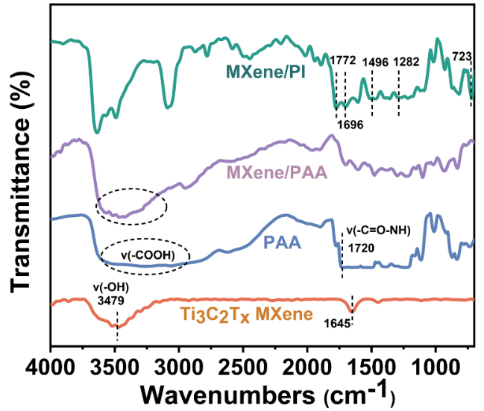
Supplementary Figure 3. FTIR spectra of corresponding composite films.

The peak strength of PAA/MXene at 3500 cm⁻¹ increases and the peak becomes steeper, indicating that the strong force between MXene and PAA is a hydrogen bonding force.

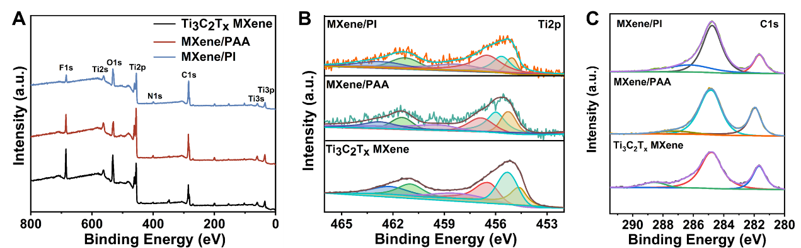
Supplementary Figure 4. XPS curves of Ti₃C₂T_{x} MXene, MXene/PAA and MXene/PI films. (A) XPS broad survey spectra (B) Ti2p XPS spectra (C) C1s XPS spectra of Ti₃C₂T_{x} MXene, MXene/PAA and MXene/PI films.

Supplementary Fig. 4A shows the total spectrum of Ti₃C₂T_{x} MXene, MXene/PAA and MXene/PI films. Supplementary Fig. 4B, C show the fine peak spectra of Ti2p and C1s. The fine peak of Ti2p moves to a higher binding energy (Supplementary Fig. 4B), which proves the formation of hydrogen bond. Hydrogen bonds anchor MXene to the surface of the PAA.

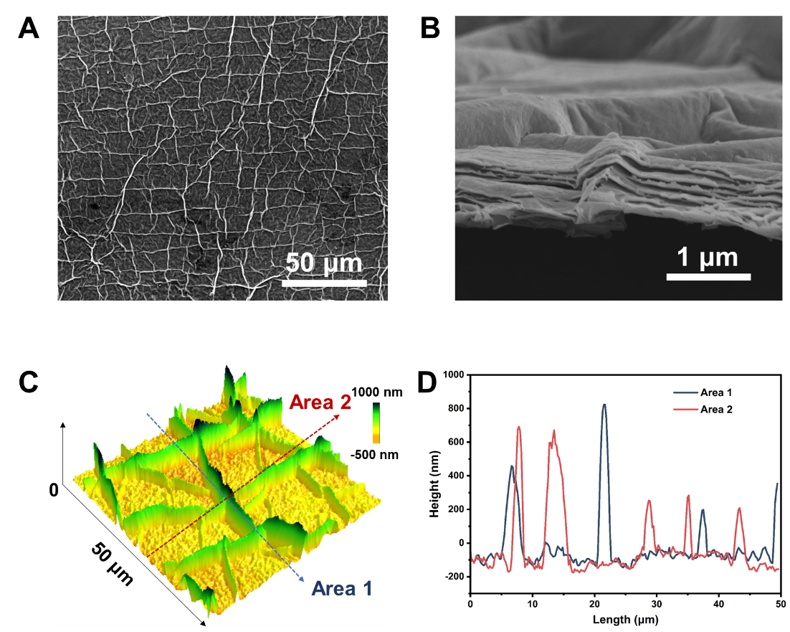
Supplementary Figure 5. The morphology of MXene/PAA film. (A) SEM image of MXene on PAA surface. (B) Cross-sectional SEM images of MXene on PI surface. (C) AFM 3D images with (D) height profiles of the MXene/PAA films with H=100 μm.

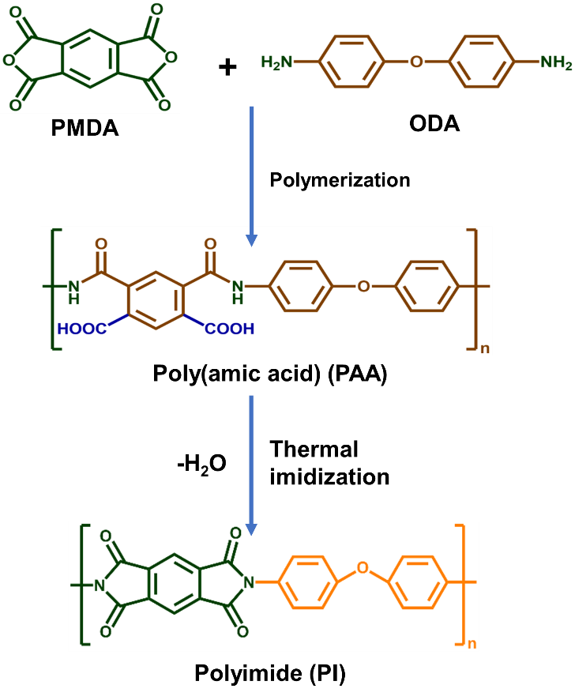
Supplementary Figure 6. The synthesis process of poly(amic acid) precursors (PAA) and polyimide (PI).

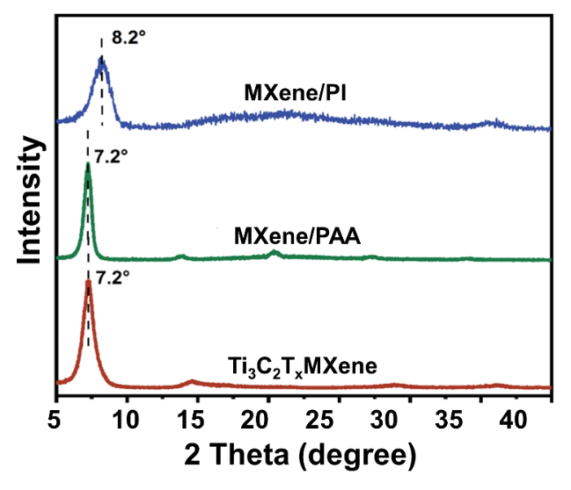
Supplementary Figure 7. The XRD patterns of Ti₃C₂T_{x} MXene, MXene/PAA and MXene/PI films.

In XRD patterns, the (002) peak of MXene shifts from 7.2°to 8.2°, demonstrating that the spacing of the MXene layers decreased with the loss of water during the heat treatment process.

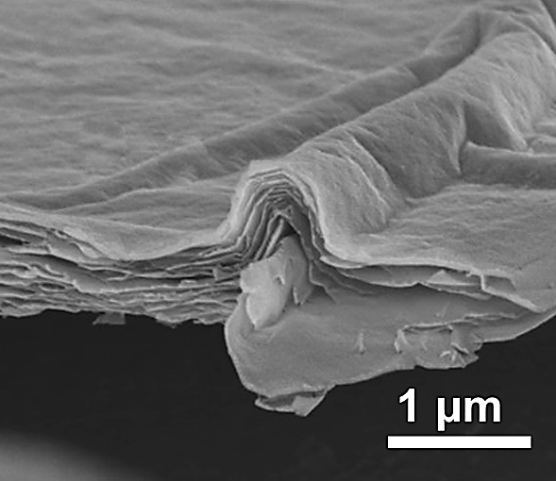
Supplementary Figure 8. SEM images of the cross-section for MXene on PI surface.

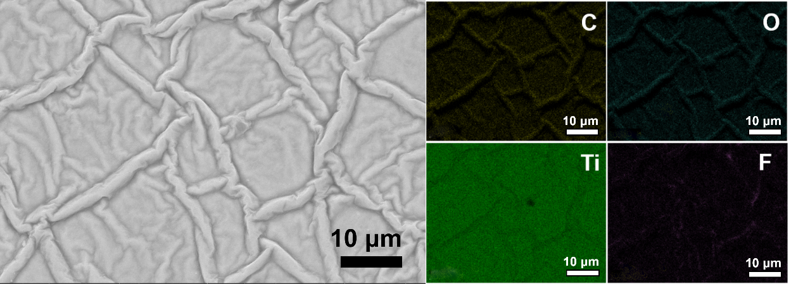
Supplementary Figure 9. SEM and EDS mapping images of MXene on PI surface.

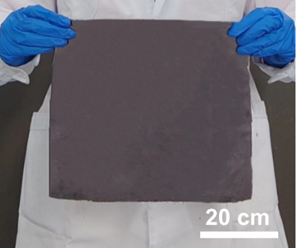
Supplementary Figure 10. An optical photograph of a large size film (45×45 cm).

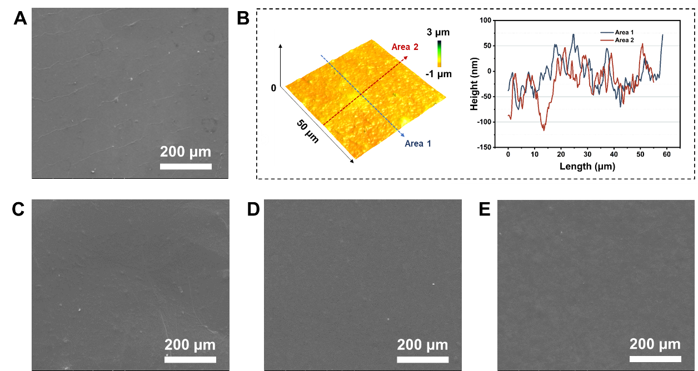
Supplementary Figure 11. Morphology of MXene on other polymer surfaces. (A) SEM of MXene coating on PET. (B) 3D AFM images with height profiles for the microscopic surface morphology of MXene/PET. (C) SEM of MXene coating on PTFE. (D) SEM of MXene coating on PVDF. (E) SEM of MXene coating on glass.

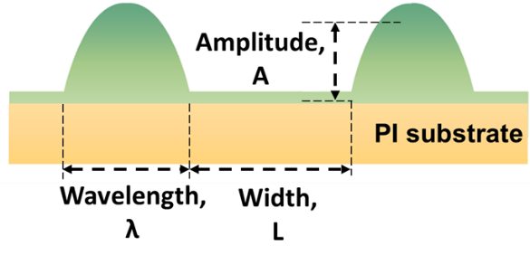
Supplementary Figure 12. Schematic for the definition of amplitude (A), wavelength (λ) and width (L) of the surface wrinkle and PI substrate.

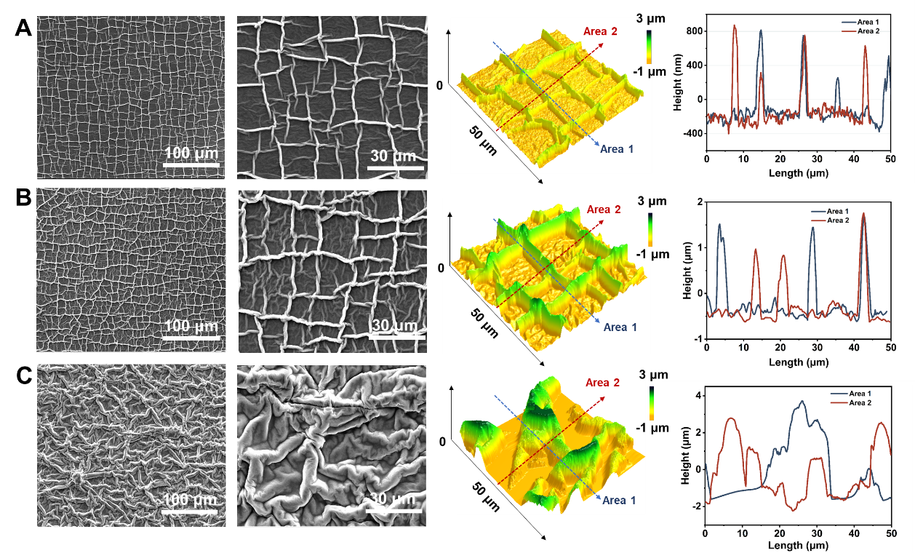
Supplementary Figure 13. Effect of polymer thickness on MXene morphology. SEM images, 3D AFM, height profiles of MXene coating with the same thickness on PI of different thicknesses. (A) Thickness (PI)=1 μm, (B) Thickness (PI)=5 μm. (C) Thickness (PI)=25 μm.

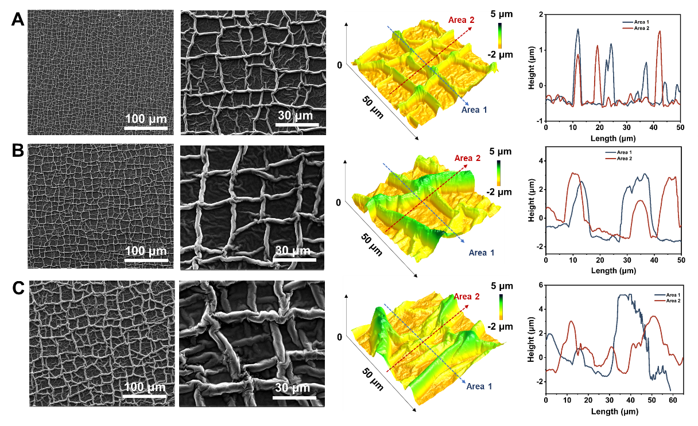
Supplementary Figure 14. Effect of coating times on the morphology of MXene. SEM images, 3D AFM and height profiles of the MXene coating with various blade-coated times on PI (thickness=5 μm). (A) one time. (B) two times. (C) three times.

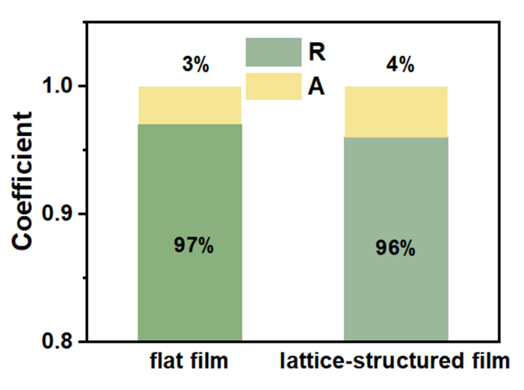
Supplementary Figure 15. Absorption coefficient (A) and reflection coefficient (R) of the flat MXene/PET film and lattice-structured MXene/PI films.

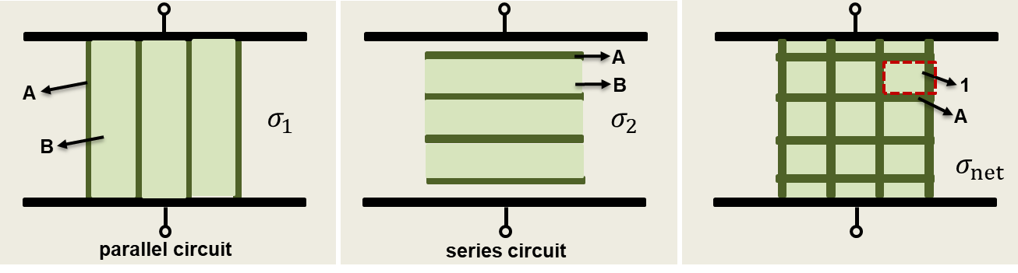
Supplementary Figure 16. The conductivity model of lattice-structured MXene.

Equate the lattice as a horizontal lattice and air in parallel and a vertical lattice and air in series. The conductivity of the horizontal lattice ($σ_{1}$) is expressed as:
$σ_{1}$=$φ_{A}σ_{A}$+$φ_{B}σ_{B}$
The conductivity of the vertical lattice ($σ_{2}$) is expressed as:
$σ_{2}^{-1}$=$φ_{A}σ_{A}^{-1}$+$φ_{B}σ_{B}^{-1}$
$\frac{1}{σ_{2}}$=$\frac{φ_{A}}{σ_{A}}$+$\frac{φ_{B}}{σ_{B}}$
The conductivity of the lattice network ($σ_{net}$) is expressed as:
$σ_{net}^{-1}$=$φ_{A}σ_{A}^{-1}$+$φ_{B}σ_{B}^{-1}$
$σ_{net}^{-1}$=$φ_{A}σ_{A}^{-1}$+$φ_{B}(φ_{A}σ_{A}$+$φ_{A}σ_{B}$)⁻¹
If B is air, and $σ_{B}$= 0. The conductivity of the lattice network ($σ_{net}$) is expressed as:
$σ_{net}$=$\frac{φ_{A}σ_{A}}{φ_{A}^{2}+V_{B}}$
If B is air and flat on the bottom MXene like in parallel, the proportion of flat bottom surface to total thickness is denoted as R, and the proportion of lattice network to total thickness is denoted as R₁
$σ_{B}$=$Rσ_{A}$+R₁$σ_{air}$=$Rσ_{A}$
The conductivity of the lattice-structured MXene (according to the thickness at the flat) is:
$$σ_{lattice}=\frac{(φ_{A}+φ_{B}R)}{R[φ_{A}\left(φ_{A}+φ_{B}R\right)+φ_{B}]}σ_{A}$$
Calculations show that the lattice network increases the conductivity of lattice-structured MXene, adding additional conductive paths to lattice-structured MXene.

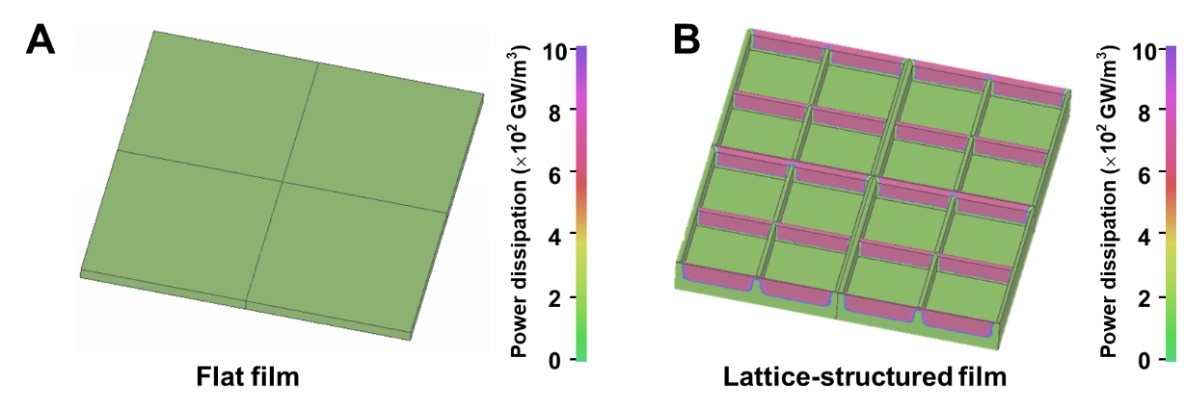
Supplementary Figure 17. (A) Simulated power loss density (PLD) maps of flat film (B) lattice-structured film at 10 GHz via finite element method.

In order to explore more clearly the loss of electromagnetic waves on the lattice surface, power loss density (PLD) distribution of the incident electron beam perpendicular to the flat and lattice-structured films at 10 GHz is simulated by finite element simulations. As can be seen in Fig.S17, the electric field is divided by the lattice into multiple conductive regions, increasing the reflective surface area compared to a flat surface.

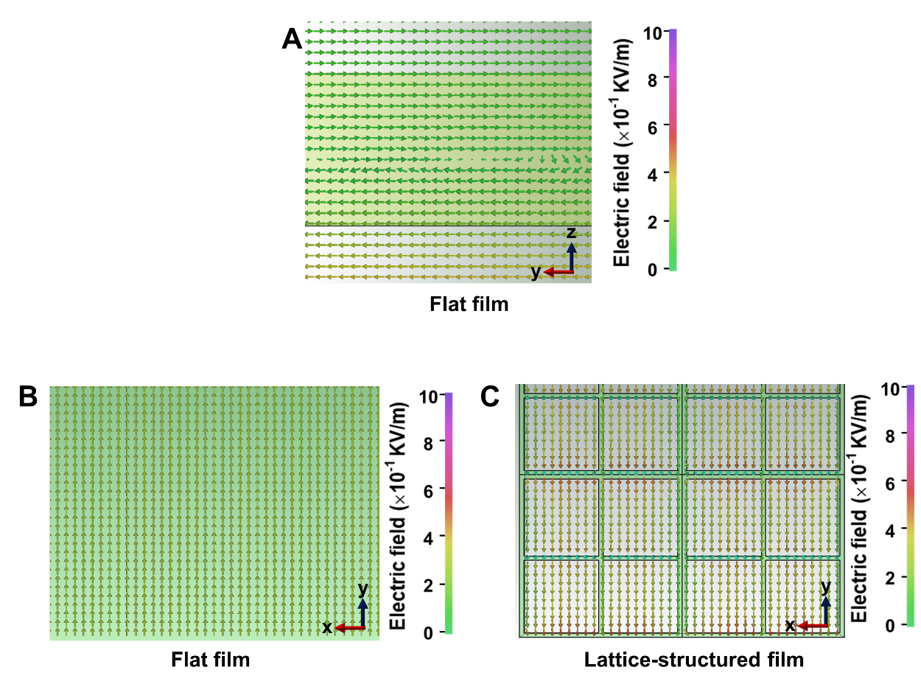
Supplementary Figure 18. Simulated EF direction maps of (A) flat film in y-z plane (B) flat film in x-y plane (C) lattice-structured film in x-y plane at 10 GHz via finite element method.

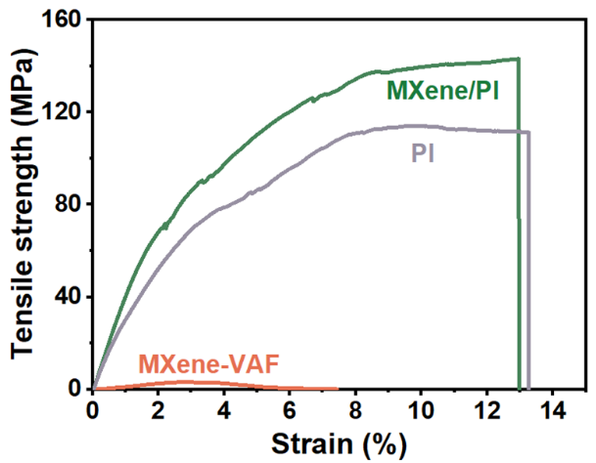
Supplementary Figure 19. Tensile stress-strain curves of the composite and pristine films.

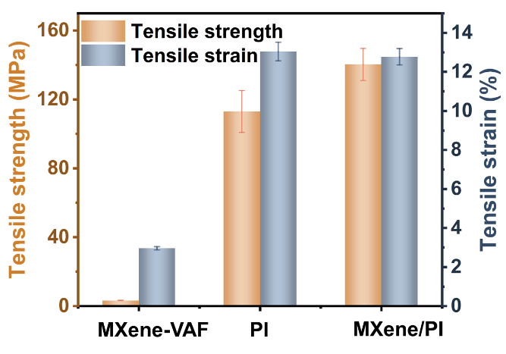
Supplementary Figure 20. Tensile strength and modulus of the composite and pristine films.

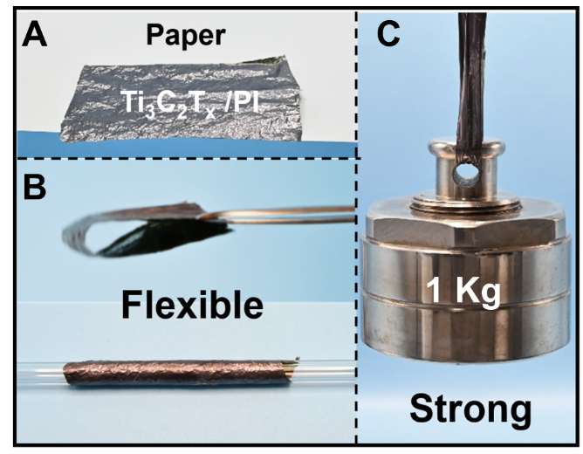
Supplementary Figure 21. Photograph of the strong and flexible performance of MXene/PI film. (A) MXene/PI is placed on white paper (B) MXene/PI can be bent and crimped (C) 0.1g of MXene/PI can lift 1kg of heavy objects.
Fig. S21A shows the macroscopic morphology of MXene/PI film, and its thinner thickness can be seen when compared with A4 paper. Fig. S21B illustrates that the MXene/PI can be bent and crimped, demonstrating the flexibility of the sample. Fig. S21C illustrates that the MXene/PI is capable of withstanding a load of 1 kg, which is nearly 100,000 times of its own weight, revealing strong mechanical properties.

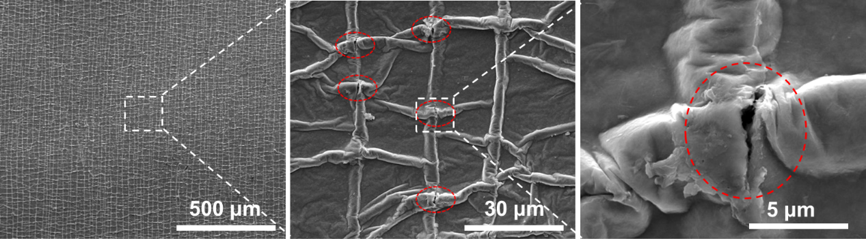
Supplementary Figure 22. SEM images with different magnification after MXene/PI film is stretched by 11%. The cracks are marked in the red circle.

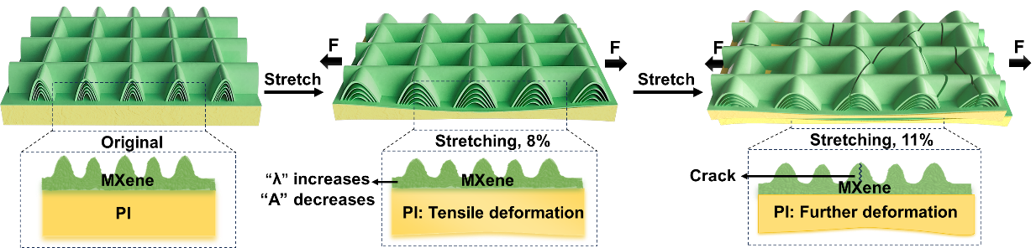
Supplementary Figure 23. Fracture mechanism of the MXene/PI film.

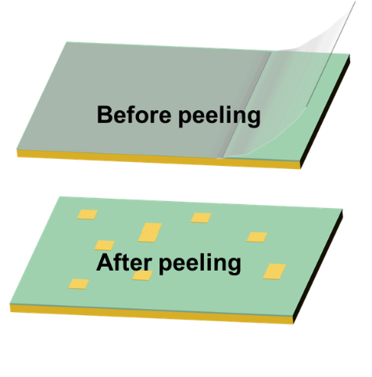
Supplementary Figure 24. Schematic diagram of adhesion characterization grades for coated films according to ASTM D3359.

Schematic diagram of adhesion characterization grades for coated films according to ASTM D3359. The adhesion grades are defined from low to high as 0B, 1B, 2B, 3B, 4B, 5B, respectively. 5B means that the coated film is intact after repeated tearing of the tape. 4B, 3B, 2B, 1B, and 0B represent exfoliated areas <5%, 5-15%, 15-35%, 35-65%, and >65%, respectively.

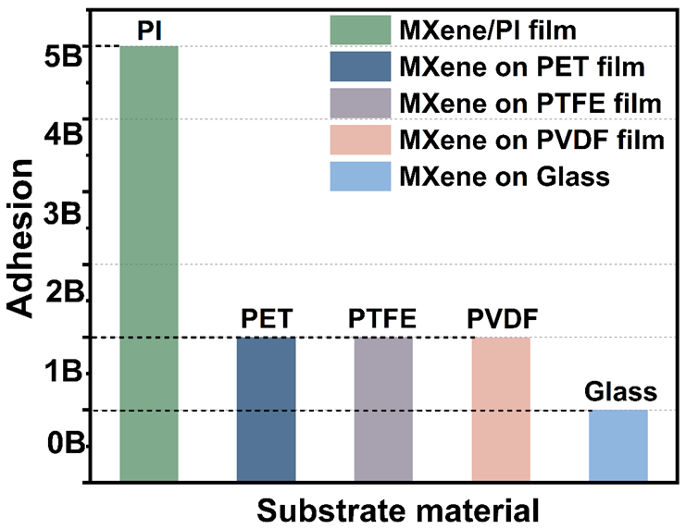
Supplementary Figure 25. Adhesion of MXene on different substrates materials.
Since the adhesion of coated films to the substrate is of significance in practical applications, we further investigated the adhesion strength of the MXene layer on different substrates (PI, PET, PTFE, PVDF and Glass). The MXene on substrates other than PI show quite a weak adhesion. In sharp contrast, the MXene/PI films obtained after heat treatment have a tight bonding with an adhesion class of 5B due to the strong interaction force between MXene and PAA.

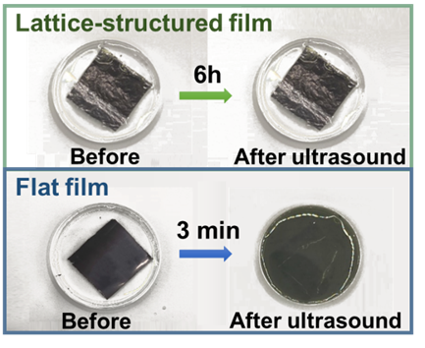
Supplementary Figure 26. Photographs of lattice-structured MXene/PI and flat MXene/PET films after ultrasound in aqueous solution for 6 h and 3 min, respectively.

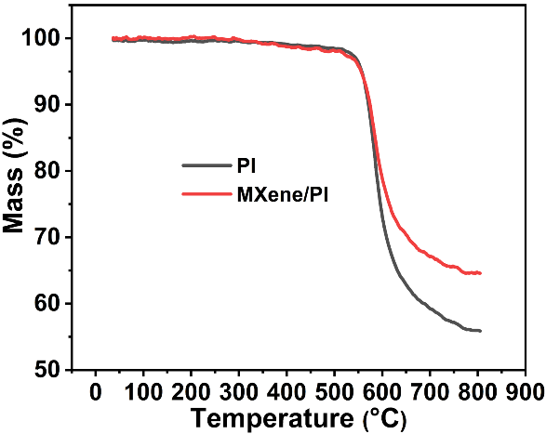
Supplementary Figure 27. TGA curves of PI and MXene/PI films.

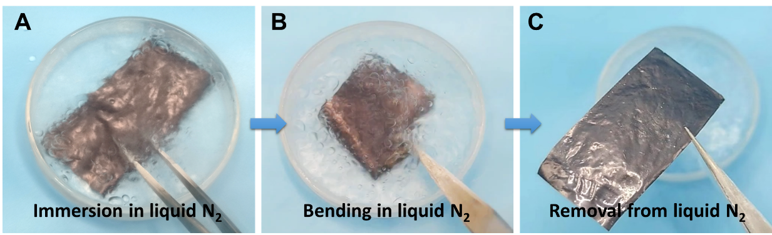
Supplementary Figure 28. Photographs of MXene/PI in liquid nitrogen. (A) MXene/PI films are immersed in liquid nitrogen (B) MXene/PI films bend in liquid nitrogen (C) MXene/PI films are removed from liquid nitrogen.

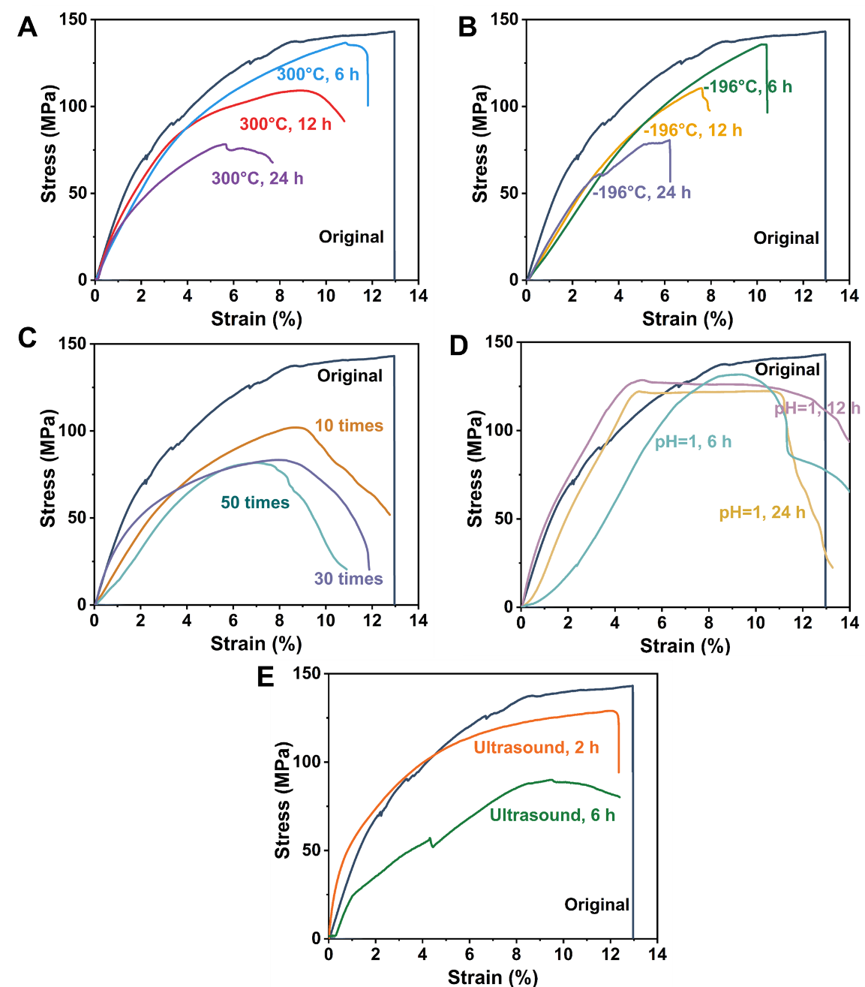
Supplementary Figure 29. Tensile stress-strain curves of MXene/PI film after enduring various harsh testing conditions. (A) treatment at 300°C, (B) immersion in liquid N₂ (-196°C), (C) thermal shock between -196°C and 300°C, (D) immersion in an acidic solution of pH=1, (E) ultrasonic cleaning.

Supplementary Figure 30. The equilibrium temperature curves in terms of the U² for the films and typical commercial metal-based heaters.

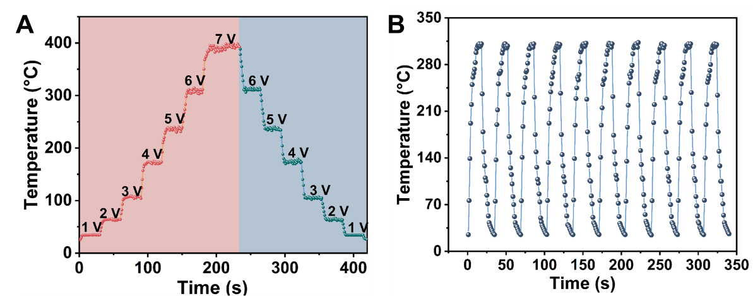
Supplementary Figure 31. Joule thermal properties of MXene/PI films. (A) Saturation temperature change curve during voltage adjustment. (B) Joule heating cycle stability under 6 V.

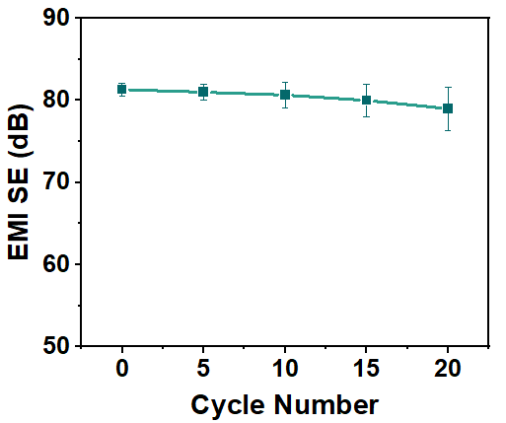
Supplementary Figure 32. The EMI SE of MXene/PI film after several joule deicing cycles.

Supplementary Table1. Comparison of MXene/PI films and other EMI shielding materials reported in literature
Material type | References | Thickness (μm) | EMI SE (dB) | Ref.
Metal-based | EM/LM | 1000 | 72.2 | 2
Metal-based | SBS/MXene/LM | 430 | 47.1 | 3
Metal-based | SEBS/Ag/LM | 200 | 75.3 | 4
Metal-based | PDMS/LM lattice | 3000 | 72.0 | 5
Metal-based | PVA/LM/Ni | 1000 | 65.8 | 6
Metal-based | ANF/LM/CNT | 600 | 53.0 | 7
Metal-based | ANF/MTM/CNF/AgNW | 24 | 44.1 | 8
Metal-based | ANF/AgNW | 55 | 63.3 | 9
Metal-based | PCPES/Cu | 300 | 59.7 | 10
Metal-based | EP/MXene/AgNWs | 2000 | 79.3 | 11
Metal-based | MXene/AgNWs | 100 | 81.0 | 12
Metal-based | EP/LM/GO | 3000 | 48.2 | 13
Metal-based | PDMS/LM | 4000 | 84.0 | 14
MXene-based  MXene-based | ANF/MXene/AgNWs | 91 | 80.0 | 15
MXene-based  MXene-based | PBO/MXene/BN | 13 | 31.8 | 16
MXene-based  MXene-based | MXene-CNF | 35 | 40 | 17
MXene-based  MXene-based | PI/Fe₃O₄/MXene | 85 | 75.0 | 18
MXene-based  MXene-based | MXene-PEDOT | 6.6 | 40.5 | 19
MXene-based  MXene-based | HA/MXene | 13 | 43.0 | 20
MXene-based  MXene-based | MXene/CNF | 7.5 | 55 | 21
MXene-based  MXene-based | MXene-TPU | 10 | 49.4 | 22
MXene-based  MXene-based | ANF/MXene | 16.7 | 25.8 | 23
MXene-based  MXene-based | LBM-1 | 1.1 | 26 | 24
MXene-based  MXene-based | LBM-5 | 15.2 | 58.2 | 24
MXene-based  MXene-based | MXene (HCl treated) | 7 | 54 | 25
MXene-based  MXene-based | MXene-Ag-Ag | 7 | 39.44 | 26
MXene-based  MXene-based | MXene-Ag-Ag | 0.5 | 20.38 | 26
MXene-based  MXene-based | MBLM | 31 | 85.5 | 27
Graphene-based | PTEF/GNS | 1000 | 50.9 | 28
Graphene-based | PI/GN/Carbon fiber | 2000 | 73.0 | 29
Graphene-based | PI/GO/EG/Fe₃O₄ | 85 | 34.0 | 30
Graphene-based | M-o-GWFs | 1850 | 61.0 | 31
Graphene-based | Nylon/GN | 180 | 58.1 | 32
Graphene-based | PDMS/rGO/hBN | 4000 | 43.1 | 33
Graphene-based | PEG/MXene/GN | 2500 | 36 | 34
Graphene-based | MXene-rGO-PVA | 12 | 41.35 | 35
Graphene-based | ANF/rGO | 30 | 33.6 | 36
Graphene-based | PDMS/rGO/GNP | 2000 | 86.0 | 37
Graphene-based | EP/rGO/Fe₃O₄ | 1000 | 13.6 | 38
CNT-based | WPU/MXene/CNTs | 90 | 60.0 | 39
CNT-based | ANF/BF/CNT | 48 | 24.6 | 40
CNT-based | ANF/CNT | 24 | 35.9 | 41
CNT-based | TPU/CNT | 1200 | 42.5 | 42
CNT-based | PAN/MCMB/MWCNTs | 180 | 80.5 | 43
CNT-based | ANF/CNT | 568 | 41.9 | 44
Latticed MXene | 1 | 0.7 | 38.6 | This work
Latticed MXene | 2 | 1.5 | 45.7 | This work
Latticed MXene | 3 | 2.8 | 50.4 | This work
Latticed MXene | 4 | 7.0 | 65.7 | This work
Latticed MXene | 5 | 17.0 | 81.5 | This work

Supplementary Table2. Effect of PAA thickness on lattice size.
The height of between the PAA and the blade edge Scraper (μm) | The thickness of PI (μm) |  | Amplitude, A (μm) | Wavelength, λ (μm) | Width, L (μm)
125 | 1 | 0.8~1.0 |  | 2 | 10~20
500 | 5 | 1.5~2.0 |  | 2 | 10~20
2000 | 25 | 4.0~6.0 |  | 5 | 20~30

Supplementary Table3. Effect of MXene coating times on lattice size.
The height of between the PAA and the blade edge Scraper (μm) | The thickness of PI (μm) |  | The height of between the MXene and PAA (μm) | MXene coating times | The thickness of MXene (μm) | Amplitude, A (μm) | Wavelength, λ (μm) |  | Width, L  (μm)
500 | 5 | 100 |  | 1 | 0.7 | 1.5~2.0 | 2 | 10~20
500 | 5 | 100 |  | 2 | 2.1 | 2.5~3.5 | 3 | 15~25
500 | 5 | 100 |  | 3 | 2.8 | 5.0~6.0 | 5 | 25~35

Supplementary Table4. The average SE_{T}, average SE_{A} and average SE_{R} of MXene/PET and MXene/PI films composites in the X-band.
Sample | The height of between the MXene and PAA (μm) | Blade-coating times | Average SE_{T} (dB) | Average SE_{A} (dB) | Average SE_{R} (dB)
Flat MXene/PET | 100 | 3 | 38.4 | 23.2 | 15.2
lattice-structured MXene/PI | 100 | 3 | 50.4 | 33.5 | 16.9

Supplementary Table5. The average SE_{T} of the MXene/PI films with various thicknesses in the X-band.
Sample | The thickness of MXene  (μm) | The thickness of PI  (μm) | Total sample thickness  (μm) | Average SE_{T}  (dB)
1 | 0.7 | 5.0 | 5.7 | 38.6
2 | 1.5 | 5.0 | 6.5 | 45.7
3 | 2.8 | 5.0 | 7.8 | 50.4
4 | 7.0 | 5.0 | 12.0 | 65.7
5 | 17.0 | 5.0 | 22.0 | 81.5

Supplementary Table6. The mechanical properties of MXene-VAF, PI, MXene/PI film
Sample | tensile strength  (MPa) | tensile strain  (%)
MXene-VAF | 3.0 | 2.8
PI | 114.6 | 13.3
MXene/PI | 141.3 | 13.0

Supplementary Table7. Thickness, EMI SE, SE/t, Stress and Strain of the MXene/PI and previously MXene-based materials
Materials | Thickness(mm) | EMI SE (dB) | SE/t (dB/mm) | Stress（MPa） | Strain（%） | Ref.
MXene/CNF | 0.047 | 24.0 | 510.6 | 44.2 | 3.10 | 45
MXene/ANF | 0.017 | 33.0 | 1941.2 | 80.1 | 2.20 | 46
MXene/PEDOT: PSS | 0.011 | 42.1 | 3827.3 | 13.7 | 0.29 | 47
MXene/PANI | 0.040 | 36.0 | 900.0 | 19.9 | ------ | 48
MXene/PVDF/Ni | 0.100 | 19.3 | 193.0 | 40.2 | 9.00 | 49
MXene/PI | 0.110 | 34.7 | 315.7 | 67.6 | ------ | 50
MXene/cellulose nanocrystals/waterborne polyurethane | 0.035 | 54.2 | 1548.6 | 52.2 | 2.50 | 51
MXene/CNT/CNF | 0.038 | 38.4 | 1010.5 | 97.9 | 4.60 | 52
MXene/CNF/silver | 0.046 | 50.7 | 1102.2 | 32.1 | 1.60 | 53
MXene/PI | 0.022 | 81.5 | 6455.8 | 141.0 | 13.00 | This work

Supplementary Table8. Joule thermal properties comparison of MXene/PI films and other materials reported in literature
Material type | Voltage (V) | Temperature (°C) | Ref.
CoFe₂O₄@MXene-  AgNWs/CNF | 0.5 | 30.6 | 54
CoFe₂O₄@MXene-  AgNWs/CNF | 1 | 34.6 | 54
CoFe₂O₄@MXene-  AgNWs/CNF | 1.5 | 43.6 | 54
CoFe₂O₄@MXene-  AgNWs/CNF | 2 | 60.6 | 54
CoFe₂O₄@MXene-  AgNWs/CNF | 2.5 | 74.2 | 54
CoFe₂O₄@MXene-  AgNWs/CNF | 3 | 93.7 | 54
Ti₃C₂T_{x}/(ANF@FeNi) films | 1 | 39.8 | 26
Ti₃C₂T_{x}/(ANF@FeNi) films | 3 | 111.2 | 26
PA-PEI-rGO | 2 | 32.5 | 55
PA-PEI-rGO | 5 | 75.5 | 55
Ti₃C₂T_{x}/modified sawdust paper | 4 | 100 | 56
Fe₃O₄/PPy | 3 | 104.8 | 57
MXene/rGO/Ag | 1 | 29.2 | 58
MXene/rGO/Ag | 2 | 34.2 | 58
MXene/rGO/Ag | 3 | 41 | 58
MXene/rGO/Ag | 4 | 49.7 | 58
MXene/rGO/Ag | 5 | 65.3 | 58
MXene/rGO/Ag | 6 | 73.7 | 58
Gallium-doped MXene/cellulose | 2.5 | 46.5 | 51
Gallium-doped MXene/cellulose | 3 | 74.3 | 51
Gallium-doped MXene/cellulose | 3.5 | 104 | 51
Gallium-doped MXene/cellulose | 4 | 140 | 51
C-MXene@PI | 4 | 34 | 59
C-MXene@PI | 6 | 53 | 59
C-MXene@PI | 8 | 85 | 59
C-MXene@PI | 10 | 114 | 59
ScPEG-coated A-GFF | 1.6 | 45.4 | 60
ScPEG-coated A-GFF | 1.8 | 53.6 | 60
ScPEG-coated A-GFF | 2 | 70.1 | 60
MXene/HG | 2 | 61.5 | 61
MXene/HG | 3 | 101 | 61
PCC/MXene/PMP | 2 | 51.7 | 62
PCC/MXene/PMP | 2.5 | 84.1 | 62
PCC/MXene/PMP | 3 | 114.9 | 62
SiBCN fiber paper | 6 | 88 | 63
SiBCN fiber paper | 8 | 137 | 63
SiBCN fiber paper | 10 | 226 | 63
SiBCN fiber paper | 12 | 300 | 63
MPP-H Textiles | 5 | 123.8 | 64
MXene/PI | 1 | 34.7 | This work
MXene/PI | 2 | 64.1 | This work
MXene/PI | 3 | 107 | This work
MXene/PI | 4 | 173.6 | This work
MXene/PI | 5 | 235.2 | This work
MXene/PI | 6 | 311 | This work
MXene/PI | 7 | 397 | This work

References
1. Peng, X. et al. Graphitized and flexible porous textile updated from waste cotton for wearable electromagnetic interference shielding. Carbon 207, 144-153 (2023).
2. Xu, Y. et al. Tailorable, lightweight and superelastic liquid metal monoliths for multifunctional electromagnetic interference shielding. Nanomicro Lett. 14, 29 (2021).
3. Yi, P. et al. MXene-reinforced liquid metal/polymer fibers via interface engineering for wearable multifunctional textiles. ACS Nano 16, 14490-14502 (2022).
4. Dong, J. C. et al. Highly permeable and ultrastretchable E-textiles with EGaIn-superlyophilicity for on-skin health monitoring, joule heating, and electromagnetic shielding. Nano Energy 108, 108194 (2023).
5. Wang, Z. Y. et al. Rational assembly of liquid metal/elastomer lattice conductors for high-performance and strain-invariant stretchable electronics. Adv. Funct. Mater. 32, 2108336 (2021).
6. Zhao, B. et al. Self-healing liquid metal magnetic hydrogels for smart feedback sensors and high-performance electromagnetic shielding. Nanomicro Lett. 15, 79 (2023).
7. Zhou, G. et al. Controllable construction of CNT-Interconnected liquid metal networks for thermal management. Compos. Part A Appl. Sci. Manuf. 175, 107743 (2023).
8. Hu F, G. et al. Nacre-inspired strong nanopapers of aramid nanofiber-integrated montmorillonite nanoplates, cellulose nanofibrils, and Ag nanowires for high-performance electrical heaters. J. Mater. Chem. A 11, 14126 (2023).
9. Li, S. et al. Flexible multilayered aramid nanofiber/silver nanowire films with outstanding thermal durability for electromagnetic interference shielding. Compos. Part A Appl. Sci. Manuf. 151, 106643 (2021).
10. Zhao, H. et al. Flexible and lightweight porous polyether sulfone/Cu composite film with bidirectional differential structure for electromagnetic interference shielding and heat conduction. Chem. Eng. J. 440, 135919 (2022).
11. Liu, H. B. et al. Construction of 3D MXene/Silver nanowires aerogels reinforced polymer composites for extraordinary electromagnetic interference shielding and thermal conductivity. Chem. Eng. J. 427, 131540 (2022).
12. Ma, Z. P. et al. An ultralight and thermally conductive Ti₃C₂T_{x} MXene-silver nanowire cellular composite film for high-performance electromagnetic interference shielding. J. Mater. Chem. C 10, 14169 (2022).
13. Li, D. et al. Toughing epoxy nanocomposites with graphene-encapsulated liquid metal framework. Chem. Eng. J. 455, 140887 (2023).
14. Zhu, R. Q. et al. Anisotropic magnetic liquid metal film for wearable wireless electromagnetic sensing and smart electromagnetic interference shielding. Nano Energy 92, 106700 (2022).
15. Ma, Z. et al. Ultraflexible and mechanically strong double-layered aramid nanofiber-Ti₃C₂T_{x} MXene/silver nanowire nanocomposite papers for high-performance electromagnetic interference shielding. ACS Nano 14, (2020).
16. Liu,Y. et al. Mechanically strong and flame‑retardant PBO/BN/MXene nanocomposite paper with low thermal expansion coefficient, for efcient EMI shielding and heat dissipation. Adv. Fiber Mater. 5, 1657-1670 (2023).
17. Ma M. et al. Construction of gradient conductivity cellulose nanofiber/MXene composites with efficient electromagnetic interference shielding and excellent mechanical properties. Compos. Sci. Technol. 226, 109540 (2022).
18. Zhang, Y. L. et al. Controlled distributed Ti₃C₂T_{x} hollow microspheres on thermally conductive polyimide composite films for excellent electromagnetic interference shielding. Adv Mater 35, 2211642 (2023).
19. Wan, Y. J. et al. Lightweight, flexible MXene/polymer film with simultaneously excellent mechanical property and highperformance electromagnetic interference shielding. Compos. Part A Appl. Sci. Manuf. 130, 105764 (2020).
20. Xiong, J. H. et al. High-strength, super-tough, and durable nacre-inspired MXene/heterocyclic aramid nanocomposite films for electromagnetic interference shielding and thermal management. Chem. Eng. J. 474, 145972 (2023).
21. Wu, N. et al. Ultrafine cellulose nanofiber‐assisted physical and chemical cross‐linking of MXene sheets for electromagnetic interference shielding. Small Methods 5, e2100889 (2021).
22. Zong, Z. et al. Synergistic effect of 2D TiC and 1D CNT towards absorption-dominant high-performance electromagnetic interference shielding in 3D macroporous carbon aerogel. Carbon 197, 40-51 (2022).
23. Zhang, Y. L. et al. Flexible Ti₃C₂T_{x}/(aramid nanofiber/PVA) composite films for superior electromagnetic interference shielding. Research 2022, 9780290 (2022).
24. Li, W. et al.. Ultrastrong MXene film induced by sequential bridging with liquid metal. Science 385, 62-68, (2024).
25. Chen, H. et al. Pristine titanium carbide MXene films with environmentally stable conductivity and superior mechanical strength. Adv. Funct. Mater. 30, 1906996 (2020).
26. Niu, Y. et al. Ultrathin MXene/Ag-Ag nanocomposite films for 3D-conformal electromagnetic shielding via aerosol jet printing. Chem. Eng. J. 506, 160122 (2025).
27. Sun, Y. et al. Flexible solid-liquid bi-continuous electrically and thermally conductive nanocomposite for electromagnetic interference shielding and heat dissipation. Nat Commun 15, 7290 (2024).
28. Wei, Q. Y. et al. Scalable fabrication of nacre-structured graphene/polytetrafluoroethylene films for outstanding EMI shielding under extreme environment. Small 19, 2302082 (2023).
29. Li, X. et al. Graphene/carbon fiber network constructed by co-carbonization strategy for functional integrated polyimide composites with enhanced electromagnetic shielding and thermal conductive properties. Chem. Eng. J. 464, 142595 (2023).
30. Guo, Y. Q. et al. Hierarchically multifunctional polyimide composite films with strongly enhanced thermal conductivity. Nanomicro Lett 14, 26 (2021).
31. Tan, X. et al. Enhanced electromagnetic shielding and thermal conductive properties of polyolefin composites with a Ti₃C₂T_{x} MXene/graphene framework connected by a hydrogen-bonded interface. ACS Nano 16, 9254-9266 (2022).
32. Wang, W.-Y. et al. Flexible, multifunctional, and thermally conductivenylon/graphene nanoplatelet composite papers with excellent EMI shielding performance, improved hydrophobicity and flame resistance. J. Mater. Chem. A 9, 5033 (2021).
33. Yang, Y. Q. et al. Oriented rGO framework induced hBN confined network in PDMS for absorption enhanced EMI shielding and through-plane thermal conductivity. Compos. Sci. Technol. 243, 110259 (2023).
34. Jin, L.Y. et al. Isolated solid wall-assisted thermal conductive performance of three-dimensional anisotropic MXene/graphene polymeric composites. ACS Appl Mater Interfaces 14, 1747-1756 (2022).
35. Si, Y. et al. Roll-to-roll processable MXene-rGO-PVA composite films with enhanced mechanical properties and environmental stability for electromagnetic interference shielding. Ceram. Int. 48, 24898–24905 (2022)
36. Xie, C. J. Aramid-based highly conductive composite films by incorporating graphene for electromagnetic interference shielding and Joule heating applications. Compos. Sci. Technol. 236, 109992 (2023).
37. Li, J. C. et al. Bubble-templated rGO-graphene nanoplatelet foams encapsulated in silicon rubber for electromagnetic interference shielding and high thermal conductivity. Chem. Eng. J. 415, 129054 (2021).
38. Liu, Y. C. et al. Anisotropic thermal conductivity and electromagnetic interference shielding of epoxy nanocomposites based on magnetic driving reduced graphene oxide@Fe3O4. Compos. Sci. Technol. 174, 1-10 (2019).
39. Nguyen, V.-T. et al. Ti3C2Tx MXene/carbon nanotubes/waterborne polyurethane based composite ink for electromagnetic interference shielding and sheet heater applications. Chem. Eng. J. 430, 133171 (2022).
40. Song, S. X. et al. Flexible basalt fiber/aramid nanofiber/carbon nanotube electromagnetic shielding paper with outstanding environmental stability and joule heating performance. ACS Appl Mater Interfaces 15, 35495-35506 (2023).
41. Fu, C. et al. Laminated structural engineering strategy toward carbon nanotube-based aerogel films. ACS Nano 16, 9378-9388 (2022).
42. Shin, B. et al. Flexible thermoplastic polyurethane-carbon nanotube composites for electromagnetic interference shielding and thermal management. Chem. Eng. J. 418, 129282 (2021).
43. Chaudhary, A. et al. Scalable development of a multi-phase thermal management system with superior EMI shielding properties. Compos. B. Eng. 158, 206-217 (2019).
44. Hu, P. Y. et al. Multifunctional aramid nanofiber/carbon nanotube hybrid aerogel films. ACS Nano 14, 688-697 (2020).
45. Cao, W. T. et al. Binary strengthening and toughening of MXene/Cellulose nanofiber composite paper with nacre-inspired structure and superior electromagnetic interference shielding properties. ACS Nano 12, 4583-4593 (2018).
46. Xie, F. et al. Ultrathin MXene/aramid nanofiber composite paper with excellent mechanical properties for efficient electromagnetic interference shielding. Nanoscale 11, 23382-23391 (2019).
47. Liu, R. T. et al. Ultrathin biomimetic polymeric Ti₃C₂T_{x} MXene composite films for electromagnetic interference shielding. ACS Appl. Mater. Inter. 10, 44787-44795 (2018).
48. Zhang, Y. L. et al. Fabrication and investigation on the ultra-thin and flexible Ti₃C₂T_{x}/co-doped polyaniline electromagnetic interference shielding composite films. Compos. Sci. Technol. 183,107833 (2019).
49. Wang, S. J. et al. Synergistic effects between MXenes and Ni chains in flexible and ultrathin electromagnetic interference shielding films. Adv. Mater. Interfaces 6, 1900961 (2019).
50. Chu, N. et al. Ti₃C₂T_{x} MXene/polyimide composites film with excellent mechanical properties and electromagnetic interference shielding properties. J. Alloys Compd. 955, 170241 (2023).
51. Zhao, J. R. et al. Flexible bilayer Ti₃C₂T_{x} MXene/cellulose nanocrystals/waterborne polyurethane composite film with excellent mechanical properties for electromagnetic interference shielding. Colloids Surf. 669, 131556 (2023).
52. Cao, W. T. et al. Ultrathin and flexible CNTs/MXene/Cellulose nanofibrils composite paper for electromagnetic interference shielding. Nanomicro Lett 11, 72 (2019).
53. Xin, W. et al. Lightweight and flexible MXene/CNF/silver composite membranes with a brick-like structure and high-performance electromagnetic-interference shielding. RSC Adv. 9, 29636-29644 (2019).
54. Guo, Z. Z. et al. Multifunctional CoFe₂O₄@MXene-AgNWs/cellulose nanofiber composite films with asymmetric layered architecture for high-efficiency electromagnetic interference shielding and remarkable thermal management capability. ACS Appl. Mater. Inter. 14, 41468-41480 (2022).
55. Xie, L. J. et al. Interfacial enhancement enables highly conductive reduced graphene oxide-based yarns for efficient electromagnetic interference shielding and thermal regulation. Carbon 230,119655 (2024).
56. Wang, P. L. et al. Robust and multifunctional Ti₃C₂T_{x}/modified sawdust composite paper for electromagnetic interference shielding and wearable thermal management. Small 20, 2304914 (2024).
57. Liu, J. X. et al. Durable Fe₃O₄/PPy particle flow spun textile for electromagnetic interference shielding and Joule heating. Adv. Fiber Mater. doi:10.1007/s42765-024-00498-2 (2024).
58. Pan, F. et al. Porifera-inspired lightweight, thin, wrinkle-resistance, and multifunctional MXene foam. Adv Mater. 36, 2311135 (2024).
59. Zeng, Z. H. et al. Porous and ultra-flexible crosslinked MXene/polyimide composites for multifunctional electromagnetic interference shielding. Nanomicro Lett 14, 59 (2022).
60. Liang, C. B. et al. Robust solid–solid phase change coating encapsulated glass fiber fabric with electromagnetic interference shielding for thermal management and message encryption. Adv. Funct. Mater. 34, 202409146 (2024).
61. Cai, Z. et al. Multifunctional MXene/holey graphene films for electromagnetic interference shielding, Joule heating, and photothermal conversion. Compos Part B-Eng. 251, 110477 (2023).
62. Li, X. L. et al. Wearable janus‐type film with integrated all‐season active/passive thermal management, thermal camouflage, and ultra‐high electromagnetic shielding efficiency tunable by origami process. Adv. Funct. Mater. 33, 2212776 (2023).
63. Ding, Q. et al. Novel fire-resistant SiBCN fiber paper with efficient electromagnetic interference shielding and Joule-heating performance. Chem. Eng. J. 497, 154485 (2024).
64. Kim, J. et al. Thermo-chemo-mechanically robust, multifunctional MXene/PVA/PAA-Hanji textile with energy harvesting, EMI Shielding, flame-retardant, and Joule heating capabilities. Adv Mater. 36, 2411248 (2024).

