Supplementary Material

- Supplementary Data

List of 301 IRD genes analysed and corresponding transcripts used
ABCA4 (NM_000350.3), ABCC6 (NM_001171.6), ABHD12 (NM_001042472.3), ACBD5 (NM_145698.5), ACO2 (NM_001098.3), ADAM9 (NM_003816.3), ADAMTS18 (NM_199355.4), ADGRV1 (NM_032119.4), AFG3L2 (NM_006796.3), AGBL5 (NM_021831.6), AHI1 (NM_001134831.2), AIPL1 (NM_014336.5), AIRE (NM_000383.4), ALDH3A2 (NM_000382.3), ALMS1 (NM_001378454.1), ALPK1 (NM_025144.4), AMACR (NM_014324.6), ARHGEF18 (NM_001367823.1), ARL13B (NM_001174150.2), ARL2BP (NM_012106.4), ARL3 (NM_004311.4), ARL6 (NM_001278293.3), ARSG (NM_001267727.2), ATF6 (NM_007348.4), ATOH7 (NM_145178.4), BBIP1 (NM_001195305.3), BBS1 (NM_024649.5), BBS10 (NM_024685.4), BBS12 (NM_152618.3), BBS2 (NM_031885.5), BBS4 (NM_033028.5), BBS5 (NM_152384.3), BBS7 (NM_176824.3), BBS9 (NM_198428.3), BCOR (NM_001123385.2), BEST1 (NM_004183.4), C1QTNF5 (NM_001278431.2), C21orf2 (NM_004928.3), C2orf71 (NM_001029883.3), C8orf37 (NM_177965.4), CABP4 (NM_145200.5), CACNA1F (NM_001256789.3), CACNA2D4 (NM_172364.5), CAPN5 (NM_004055.5), CC2D2A (NM_001378615.1), CDH23 (NM_022124.6), CDH3 (NM_001793.6), CDHR1 (NM_033100.4), CEP164 (NM_014956.5), CEP250 (NM_007186.6), CEP290 (NM_025114.4), CEP41 (NM_018718.3), CEP78 (NM_001330691.3), CERKL (NM_201548.5), CFAP20 (NM_013242.3), CFH (NM_000186.4), CHM (NM_000390.4), CIB2 (NM_006383.4), CLCC1 (NM_001377458.1), CLN3 (NM_001042432.2), CLN5 (NM_006493.4), CLN6 (NM_017882.3), CLN8 (NM_018941.4), CLRN1 (NM_174878.3), CNGA1 (NM_001379270.1), CNGA3 (NM_001298.3), CNGB1 (NM_001297.5), CNGB3 (NM_019098.5), CNNM4 (NM_020184.4), COL11A1 (NM_001854.4), COL18A1 (NM_001379500.1), COL2A1 (NM_001844.5), COL4A1 (NM_001845.6), COL9A1 (NM_001851.6), COL9A2 (NM_001852.4), COL9A3 (NM_001853.4), COQ2 (NM_001358921.2), COQ8B (NM_024876.4), CRB1 (NM_201253.3), CRX (NM_000554.6), CSPP1 (NM_001382391.1), CTC1 (NM_025099.6), CTNNA1 (NM_001903.5), CTNNB1 (NM_001904.4), CTNND1 (NM_001085458.2), CTSD (NM_001909.5), CWC27 (NM_005869.4), CYP4V2 (NM_207352.4), DHDDS (NM_205861.3), DHX38 (NM_014003.4), DRAM2 (NM_001349884.2), DYNC2H1 (NM_001377.3, NM_001080463.2), EFEMP1 (NM_001039348.3), ELOVL4 (NM_022726.4), ERCC6 (NM_001277058.2, NM_000124.4), ERCC8 (NM_000082.4), EXOSC2 (NM_014285.7), EYS (NM_001142800.2), FAM161A (NM_001201543.2), FAM57B (NM_031478.6), FBLN5 (NM_006329.4), FLVCR1 (NM_014053.4), FRMD7 (NM_194277.3), FSCN2 (NM_012418.4), FZD4 (NM_012193.4), GDF6 (NM_001001557.4), GNAT1 (NM_144499.3), GNAT2 (NM_001377295.2), GNB3 (NM_002075.4), GNPTG (NM_032520.5), GPR143 (NM_000273.3 ), GPR179 (NM_001004334.4), GRK1 (NM_002929.3), GRM6 (NM_000843.4), GRN (NM_002087.4), GUCA1A (NM_001384910.1), GUCA1B (NM_002098.6), GUCY2D (NM_000180.4), HARS (NM_002109.6), HCCS (NM_005333.5), HGSNAT (NM_152419.3), HK1 (NM_000188.3, NM_001358263.1), HKDC1 (NM_025130.4), HMCN1 (NM_031935.3), HMX1 (NM_018942.3), IDH3A (NM_005530.3), IDH3B (NM_006899.5), IFT140 (NM_014714.4), IFT172 (NM_015662.3), IFT27 (NM_001177701.3), IFT43 (NM_001102564.3), IFT74 (NM_025103.4), IKBKG (NM_001099857.5), IMPDH1 (NM_000883.4), IMPG1 (NM_001563.4), IMPG2 (NM_016247.4 ), INPP5E (NM_019892.6 ), IQCB1 (NM_001023570.4), KCNJ13 (NM_002242.4), KCNV2 (NM_133497.4), KIAA1549 (NM_001164665.2), KIF11 (NM_004523.4), KIF3B (NM_004798.4), KIZ (NM_018474.6), KLHL7 (NM_001031710.3), LAMA1 (NM_005559.4), LAMP2 (NM_002294.3), LCA5 (NM_001122769.3), LRAT (NM_004744.5), LRIT3 (NM_198506.5), LRP2 (NM_004525.3), LRP5 (NM_002335.4), LZTFL1 (NM_020347.4), MAK (NM_001242957.3), MCOLN1 (NM_020533.3), MED12 (NM_005120.3), MERTK (NM_006343.3), MFRP (NM_031433.4), MFSD8 (NM_001371596.2), MKKS (NM_170784.3), MKS1 (NM_017777.4), MMACHC (NM_015506.3), MPDZ (NM_001378778.1), MSTO1 (NM_018116.4), MTTP (NM_001386140.1), MVK (NM_000431.4), MYO7A (NM_000260.4), NBAS (NM_015909.4), NDP (NM_000266.4), NEUROD1 (NM_002500.5), NMNAT1 (NM_022787.4), NPHP1 (NM_001128178.3), NPHP3 (NM_153240.5), NPHP4 (NM_015102.5), NR2E3 (NM_014249.4), NR2F1 (NM_005654.6), NRL (NM_001354768.3), NYX (NM_001378477.1, NM_001378477.3), OAT (NM_000274.4), OFD1 (NM_003611.3), OPA1 (NM_130837.3), OPA3 (NM_025136.4), OPN1LW (NM_020061.6), OPN1MW (NM_000513.2), OTX2 (NM_021728.4), P3H2 (NM_018192.4), PANK2 (NM_001386393.1), PAX2 (NM_000278.5), PCDH15 (NM_001384140.1, NM_033056.4), PCYT1A (NM_001312673.2), PDE6A (NM_000440.3), PDE6B (NM_000283.4), PDE6C (NM_006204.4), PDE6G (NM_002602.4), PDE6H (NM_006205.3), PDSS1 (NM_014317.5), PDZD7 (NM_001195263.2), PEX1 (NM_000466.3), PEX2 (NM_000318.3), PEX6 (NM_000287.4), PEX7 (NM_000288.4), PHYH (NM_006214.4), PITPNM3 (NM_031220.4), PLA2G5 (NM_000929.3), PLK4 (NM_014264.5), PNPLA6 (NM_001166114.2), POC1B (NM_172240.3), POMGNT1 (NM_017739.4), POMGNT2 (NM_032806.6), POMT1 (NM_001077365.2), PPT1 (NM_000310.4), PRCD (NM_001077620.3), PRDM13 (NM_021620.4), PROM1 (NM_006017.3), PRPF3 (NM_004698.4), PRPF31 (NM_015629.4), PRPF4 (NM_001244926.2), PRPF6 (NM_012469.4), PRPF8 (NM_006445.4), PRPH2 (NM_000322.5), PRPS1 (NM_002764.4), PYGM (NM_005609.4), RAB28 (NM_001017979.3, NM_004249.4), RAX2 (NM_001319074.4), RBP3 (NM_002900.3), RBP4 (NM_006744.4), RCBTB1 (NM_018191.4), RD3 (NM_001164688.2), RDH12 (NM_152443.3), RDH5 (NM_002905.5), REEP6 (NM_138393.4, NM_001329556.3), RGR (NM_001012720.2), RGS9 (NM_003835.4), RHO (NM_000539.3), RIMS1 (NM_014989.7), RIMS2 (NM_001348484.3), RLBP1 (NM_000326.5), ROM1 (NM_000327.4), RP1 (NM_006269.2), RP1L1 (NM_178857.6), RP2 (NM_006915.3), RP9 (NM_203288.2), RPE65 (NM_000329.3), RPGR (NM_001034853.2), RPGRIP1 (NM_020366.4), RPGRIP1L (NM_015272.5), RS1 (NM_000330.4), RTN4IP1 (NM_032730.5), SAG (NM_000541.5), SAMD7 (NM_001304366.2), SCAPER (NM_020843.4), SDCCAG8 (NM_006642.5), SEMA4A (NM_022367.4), SGSH (NM_000199.5), SLC24A1 (NM_004727.3), SLC38A8 (NM_001080442.3), SLC6A6 (NM_003043.6), SLC7A14 (NM_020949.3), SNRNP200 (NM_014014.5), SPATA7 (NM_018418.5), SRD5A3 (NM_024592.5), SSBP1 (NM_003143.3), STN1 (NM_024928.5), TEAD1 (NM_021961.6), TIMM8A (NM_004085.4), TIMP3 (NM_000362.5), TINF2 (NM_001099274.3), TMEM216 (NM_001173990.3), TMEM218 (NM_001258244.2), TMEM231 (NM_001077418.3), TMEM237 (NM_001044385.3), TMEM67 (NM_153704.6), TOPORS (NM_005802.5), TPP1 (NM_000391.4), TRAF3IP1 (NM_015650.4), TREX1 (NM_033629.6), TRIM32 (NM_012210.4), TRNT1 (NM_182916.3), TRPM1 (NM_001252024.2), TSPAN12 (NM_012338.4), TTC8 (NM_144596.4), TTLL5 (NM_015072.5), TTPA (NM_000370.3), TUB (NM_177972.3), TUBB4B (NM_006088.6), TUBGCP4 (NM_014444.5), TUBGCP6 (NM_020461.4), TULP1 (NM_003322.6), UNC119 (NM_005148.4), USH1C (NM_153676.4, NM_005709.4), USH1G (NM_173477.5), USH2A (NM_206933.4), USP45 (NM_001346022.3), VCAN (NM_004385.5), VPS13B (NM_152564.5, NM_017890.5), VWA8 (NM_015058.2), WDPCP (NM_015910.7), WDR19 (NM_025132.4), WHRN (NM_015404.4), ZFYVE26 (NM_015346.4), ZNF408 (NM_024741.3), ZNF423 (NM_001379286.1).
Candidate genes analysed and corresponding transcripts used
CCZ1B (NM_198097.5), CROCC (NM_014675.5), FOXI2 (NM_207426.3), FUT5 (NM_002034.2), GARIN4 (NM_153606.4), IRX5 (NM_005853.6), ITIH2 (NM_002216.3), NAALADL1 (NM_005468.3), NUMB (NM_001005743.2), NUMBL (NM_004756.5), OR2M7 (NM_001004691.1), OXR1 (NM_001198533.2), PLD4 (NM_138790.5), PODNL1 (NM_001370095.3), POMZP3 (NM_012230.5), PRDX6 (NM_004905.3), PRTFDC1 (NM_020200.7), SLC37A3 (NM_207113.3), TLCD3B (NM_031478.6), UBAP1L (NM_001163692.2), WASF3 (NM_006646.6).

- Supplementary Methods
ABCA4 midigene-based splice assay
The splicing effect of ABCA4 c.859-442C>T was assessed using an in vitro splice assay, based on a previously established wild-type (WT) midigene (BA7) containing ABCA4 exons 7 to 11 (1). The variant of interest was introduced into the WT construct via site-directed mutagenesis, followed by Gateway Cloning. Both constructs were transfected separately into Human Embryonic Kidney (HEK293T, ATCC# CRL-3216) cells, cultured in Dulbecco’s Modified Eagle Medium (DMEM) supplemented with 10% foetal bovine serum, 1% penicillin-streptomycin and 1% sodium pyruvate at 37°C and 5% CO₂. Cells were seeded in a six-well plate and transfected at 70% confluency with 600 ng of plasmid DNA using FuGENE HD reagent (Promega, Madison, WI, USA), as per the manufacturer’s protocol. Transfection of the mutant construct was performed in duplicate. After 48 hours, total RNA was extracted using the Nucleospin RNA kit (Machery-Nagel, Düren, Germany) and cDNA was synthesised from 1000 ng of RNA using the iScript cDNA Synthesis kit (Bio-Rad, Hercules, CA, USA). Reverse transcription–polymerase chain reaction (RT-PCR) was performed to evaluate splicing. RT-PCR conditions for the ABCA4 RNA were as follows: initial denaturation at 94°C for two minutes, followed by 30 cycles of 30 seconds at 94°C, 30 seconds at 58°C, and five minutes at 72°C, with a final extension step of two minutes at 72°C. ACTB (actin beta) was selected as housekeeping gene control and exon 5 of RHO served as a transfection control. RT-PCR conditions for these controls were: initial denaturation at 94°C for two minutes, followed by 35 cycles of 30 seconds at 94°C, 30 seconds at 58°C, and thirty seconds at 72°C and a final extension step of two minutes at 72°C.
Details on the primers used for mutagenesis, PCR, and Sanger sequencing are provided in Supplementary Table S3. Following PCR amplification, agarose gel analysis and Sanger sequencing were performed to assess the nature of splicing defects. Ratios between different RNA products were assessed by semi-quantification using Fiji software after agarose gel electrophoresis (Supplementary Table S5).

- Supplementary Figures
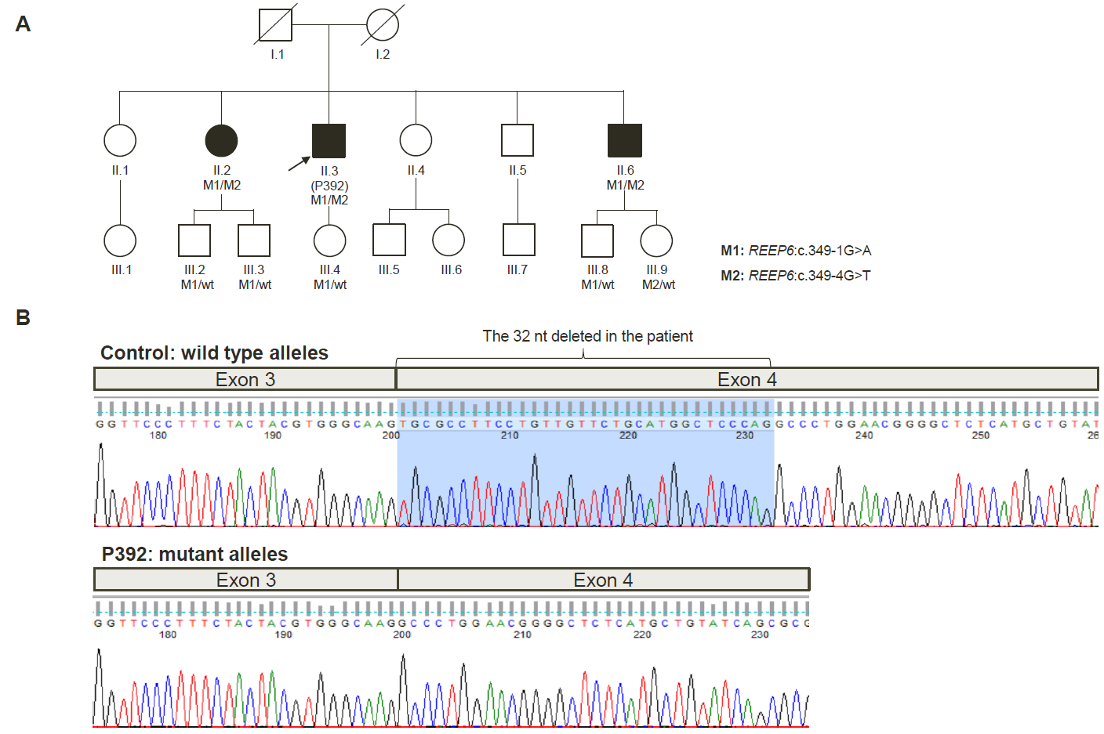
Fig. S1. Effect of splicing variants c.349-1G>A and c.349-4G>T in REEP6. (A) Pedigree of P392 illustrating variant co-segregation within the family. (B) Sanger sequencing electropherograms showing that both splice site variants lead to the deletion of 32 nucleotides from exon 4 of the REEP6 gene.
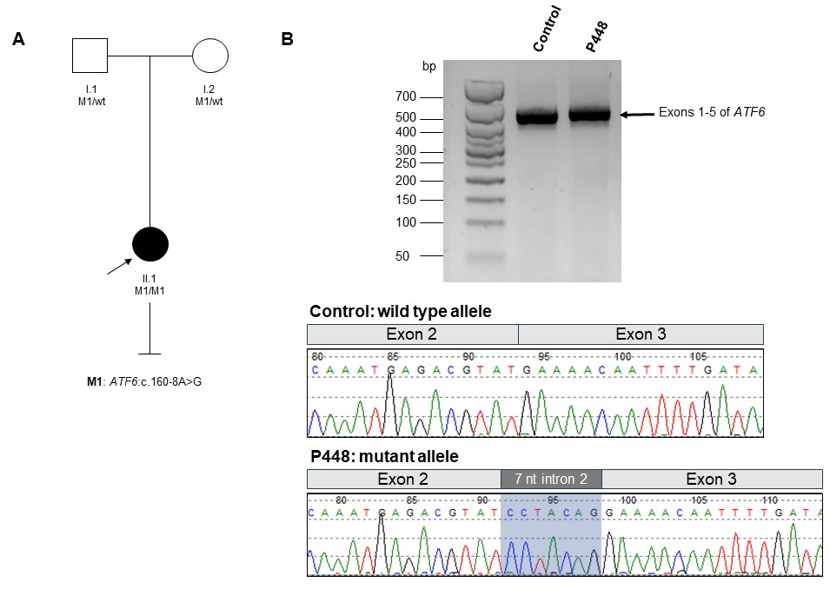
Fig. S2. Splicing analysis of the c.160-8A>G variant in ATF6 gene. (A) Pedigree of P448 demonstrating that both parents are carriers of the c.160-8A>G variant. (B) Agarose gel analysis revealing a subtle increase in the band corresponding to the amplification of exons 1-5 of the ATF6 gene in P448 compared to the control. Bellow, electropherograms illustrate the insertion of seven nucleotides from intron 2 into the coding sequence in P448 relative to the control.

- Supplementary Tables

Table S1. Primers used for mRNA analysis of the variants identified in ATF6 and REEP6.
Gene | Forward Primer (5'-3') | Reverse Primer (5'-3') | Product size (bp)
REEP6 | CACTCTGCTAAGCCTGTATC | CACTTGTCCTTCGGCTGC | 432
ATF6 | CACAGGCTGGATGAAGATTG | AGTCTTGTTCCTAGGACCAG | 424

Table S3. In silico splicing predictions for candidate variants in REEP6, ATF6 and ABCA4.
Gene | Variant | Splice AI score  Acceptor loss  (position) | Splice AI score  Acceptor gain  (position) | Splice AI score  Donor loss (position) | Splice AI score  Donor gain  (position)
REEP6 | c.349-1G>A | 0.99 (1 bp) | 0.17 (33 bp) | - | 0.01 (212 bp)
REEP6 | c.349-4G>T | 0.07 (4 bp) | 0.16 (36 bp) | - | -
ATF6 | c.160-8A>G | 0.11 (8 bp) | 0.99 (1 bp) | - | -
ABCA4 | c.859-442C>T | 0.01 (-304 bp) | 0.28 (243 bp) | - | 0.23 (6 bp)

Table S4. Oligonucleotides used in the splicing assay. (A) Primers for reverse transcription-PCR analysis and Sanger sequencing. (B) Oligonucleotides designed to introduce mutations into wild-type entry clones.
A
BA_ID | Primer sequences (5'-3') | Product size (bp)
BA7_forward | ACACTCCTAGACAGCCGTTC | 780
BA7_reverse | CTCCAGGTATTGATTGACCAG | 780
RHO_exon5_forward | ATCTGCTGCGGCAAGAAC | 140
RHO_exon5_reverse | AGGTGTAGGGGATGGGAGAC | 140
ACTB_mouse_exon3 | ACTGGGACGACATGGAGAAG | 383
ACTB_mouse_exon4 | TCTCAGCTGTGGTGGTGAAG | 383

B
WT fragment | DNA variant_primer orientation | Mutagenesis primer sequences  (5'-3')
BA7 | c.859-442C>T_Fwd | CGATGTCTACTCACTGTAAGTTCTGCCCCCCAGG
BA7 | c.859-442C>T_Rev | CCTGGGGGGCAGAACTTACAGTGAGTAGACATCG

Table S5. Semi-quantification of RT-PCR fragments based on densitometry analysis of the gel electrophoresis results. Semi-quantification was performed on gel electrophoresis images using ImageJ software for two independent transfection experiments (biological replicates) and in technical replicates (1) and (2). PCR fragments are numbered as in Fig. 3. The average values were considered to determine the order of splice defects in the protein notation.
 | Mutant Fragment | Raw intensity  (1) | Raw intensity  (2) | Fragment size (nt) | Size correction factor | Corrected intensity  (1) | Corrected intensity  (2) | Percentage | Average (%)
1st biological replicate | 1 | 765,3 | 795,9 | 1.018 | 1,0 | 765,3 | 795,9 | 36,5% | 79,7% (MUT)
1st biological replicate | 3 | 75,1 | 89,9 | 539 | 0,5 | 141,8 | 169,8 | 7,3% | 79,7% (MUT)
1st biological replicate | 4 | 212,3 | 213,3 | 282 | 0,3 | 766,3 | 769,86 | 35,9% | 79,7% (MUT)
1st biological replicate | 2 | 340,0 | 326,3 | 780 | 0,8 | 443,77 | 425,9 | 20,3% | 20,3%  (WT)
2nd biological replicate | 1 | 2543,9 | 2588,0 | 1.018 | 1,0 | 2543,9 | 2588,0 | 36,9% | 79%  (MUT)
2nd biological replicate | 3 | 273,7 | 280,1 | 282 | 0,3 | 516,9 | 529,1 | 7,5% | 79%  (MUT)
2nd biological replicate | 4 | 669,4 | 663,9 | 539 | 0,5 | 2416,4 | 2396,9 | 34,6% | 79%  (MUT)
2nd biological replicate | 2 | 1106,6 | 1130,9 | 780 | 0,8 | 1444,3 | 1475,9 | 21% | 21% (WT)

References
1. Sangermano R, Khan M, Cornelis SS, Richelle V, Albert S, Garanto A, et al. ABCA4 midigenes reveal the full splice spectrum of all reported noncanonical splice site variants in Stargardt disease. Genome Res. 2018 Jan;28(1):100–10.

