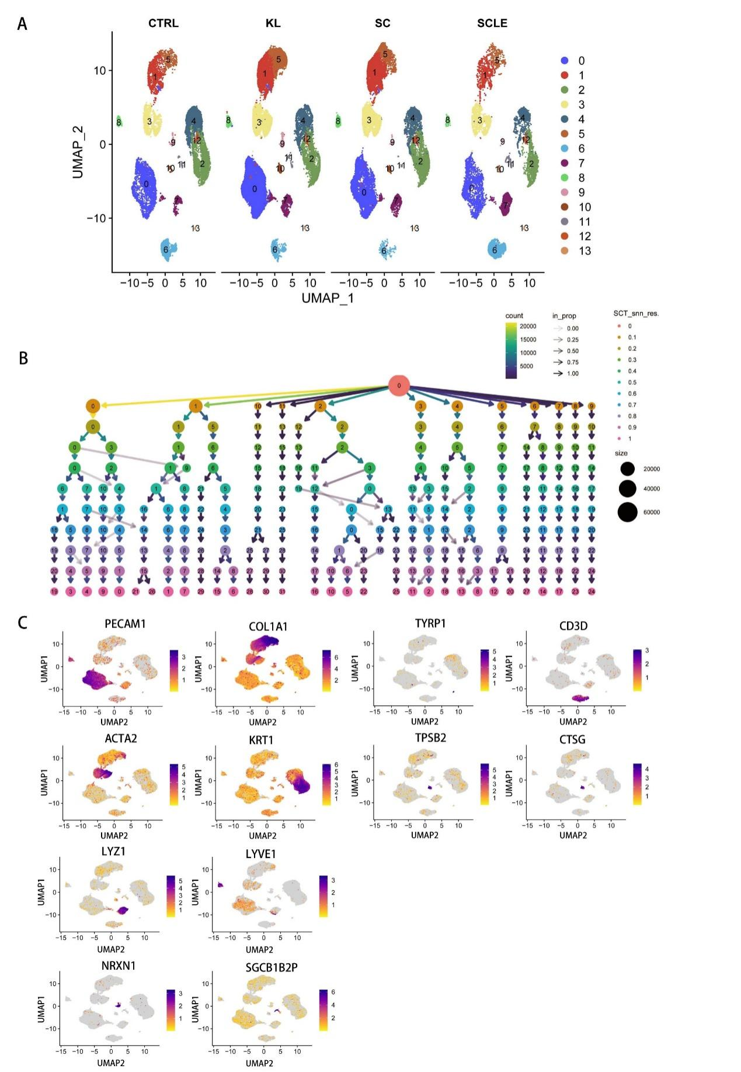
SM.Fig.1 (A) The split UMAP of all cells in 4 different state including CTRL, KL, SC, and SCLE； (B) Clustering tree plot for the whole cells using various resolution parameters (from 0.1 to 1); (C) Feature plots of expression distribution for selected cluster-specific genes. Expression levels for each cell are color-coded and overlaid onto the UMAP plot.

