Supplementary material
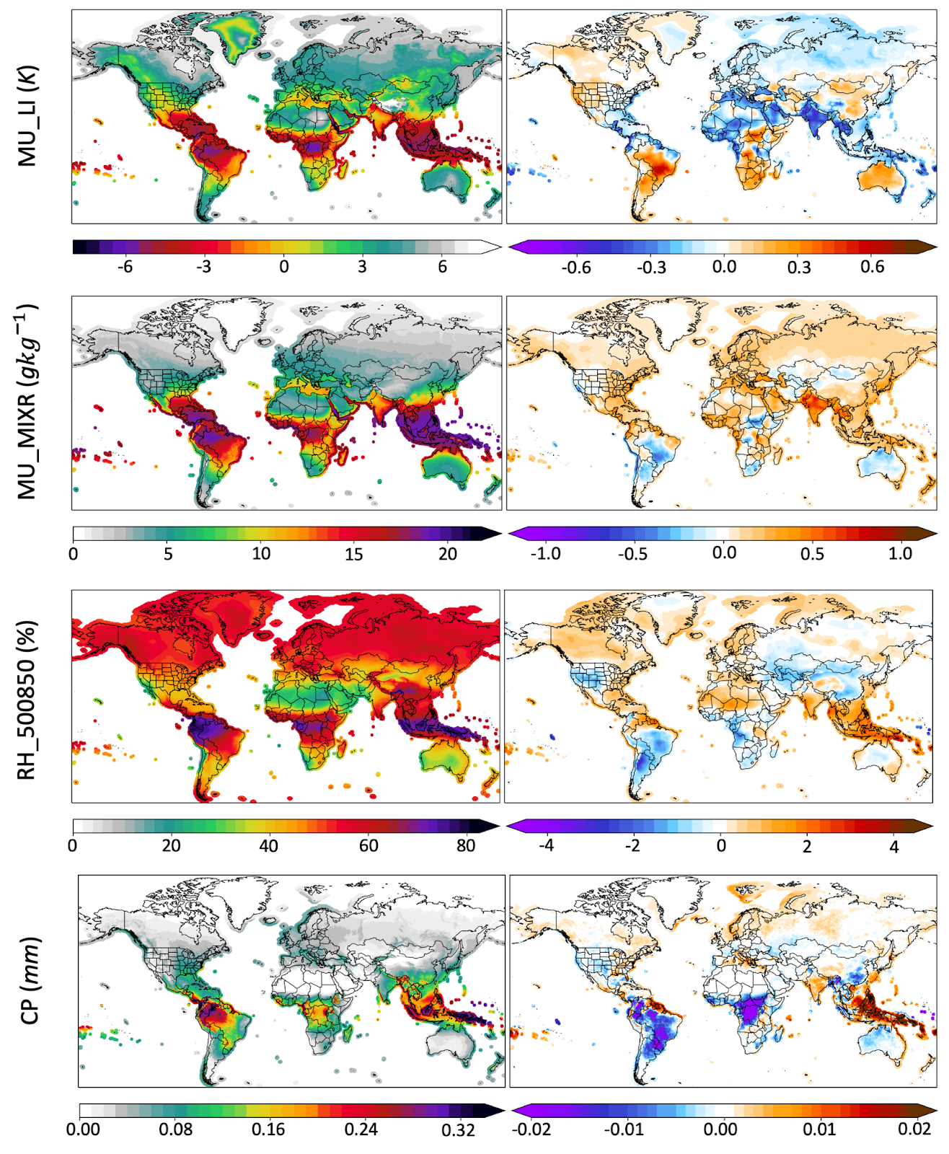
Fig. 1: Mean values and decadal trend in lightning model ($P_{lightning}$) predictors. From top to bottom: Most Unstable Lifted Index (MU_LI), Most Unstable Mixing Ratio (MU_MIXR), Mean Relative Humidity between 500 and 850 hPa (RH_500850hPa), and Convective Precipitation (CP).
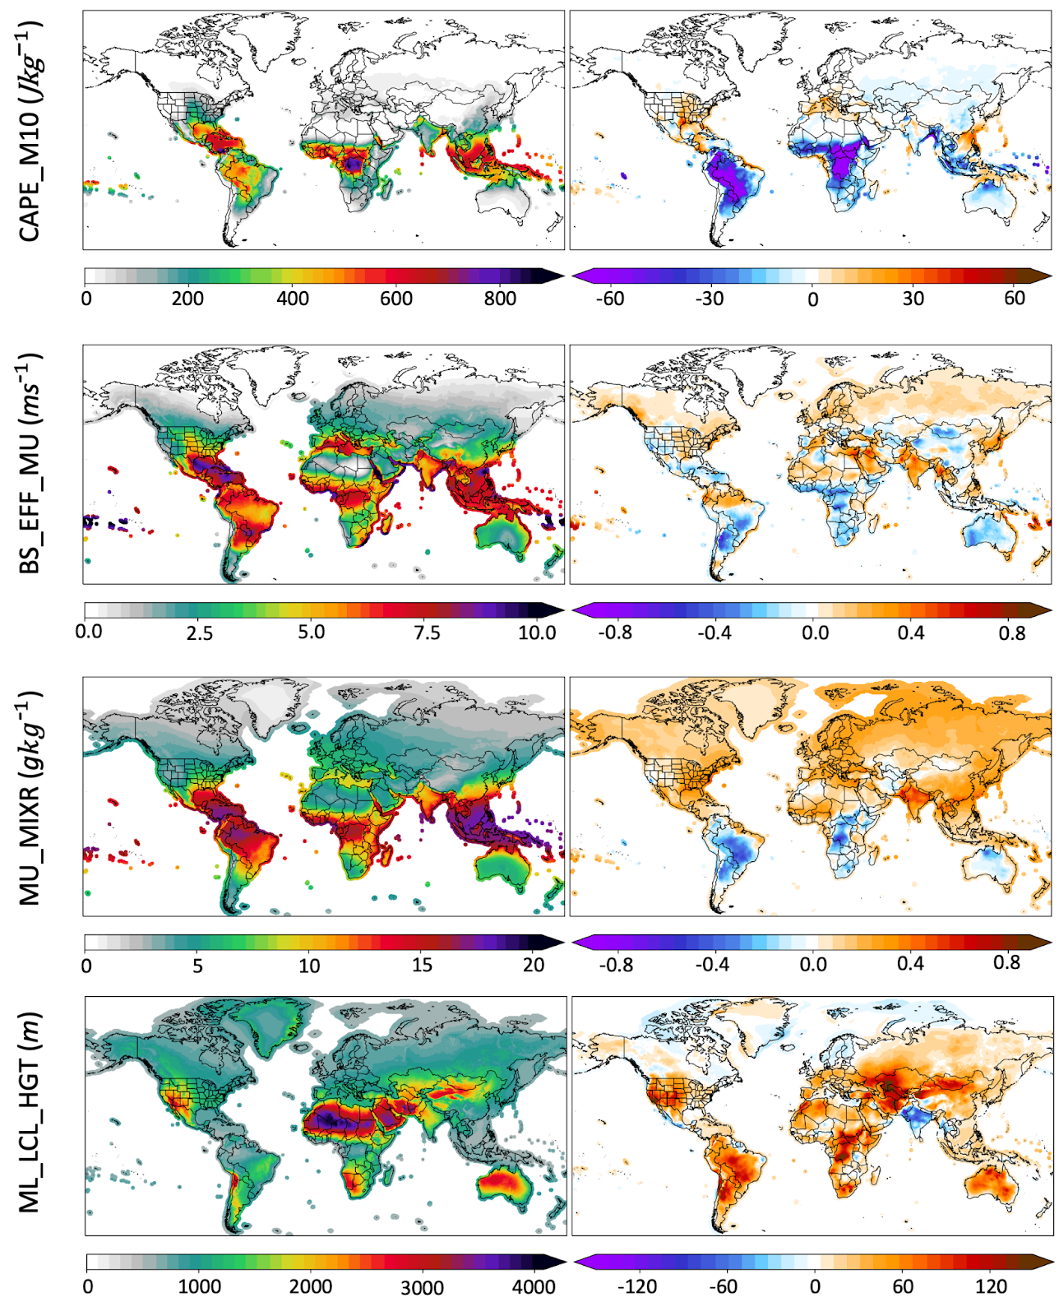
Fig. 2: Mean values and decadal trend in conditional VLH model ($P_{VLH|lightning}$) predictors. From top to bottom: Most Unstable CAPE above the -10°C isotherm (CAPE_M10), Effective Most Unstable Bulk Shear (BS_EFF_MU), Mixed Layer Mixing Ratio (ML_MIXR), and Mixed Layer Lifting Condensation Height (ML_LCL_HGT).

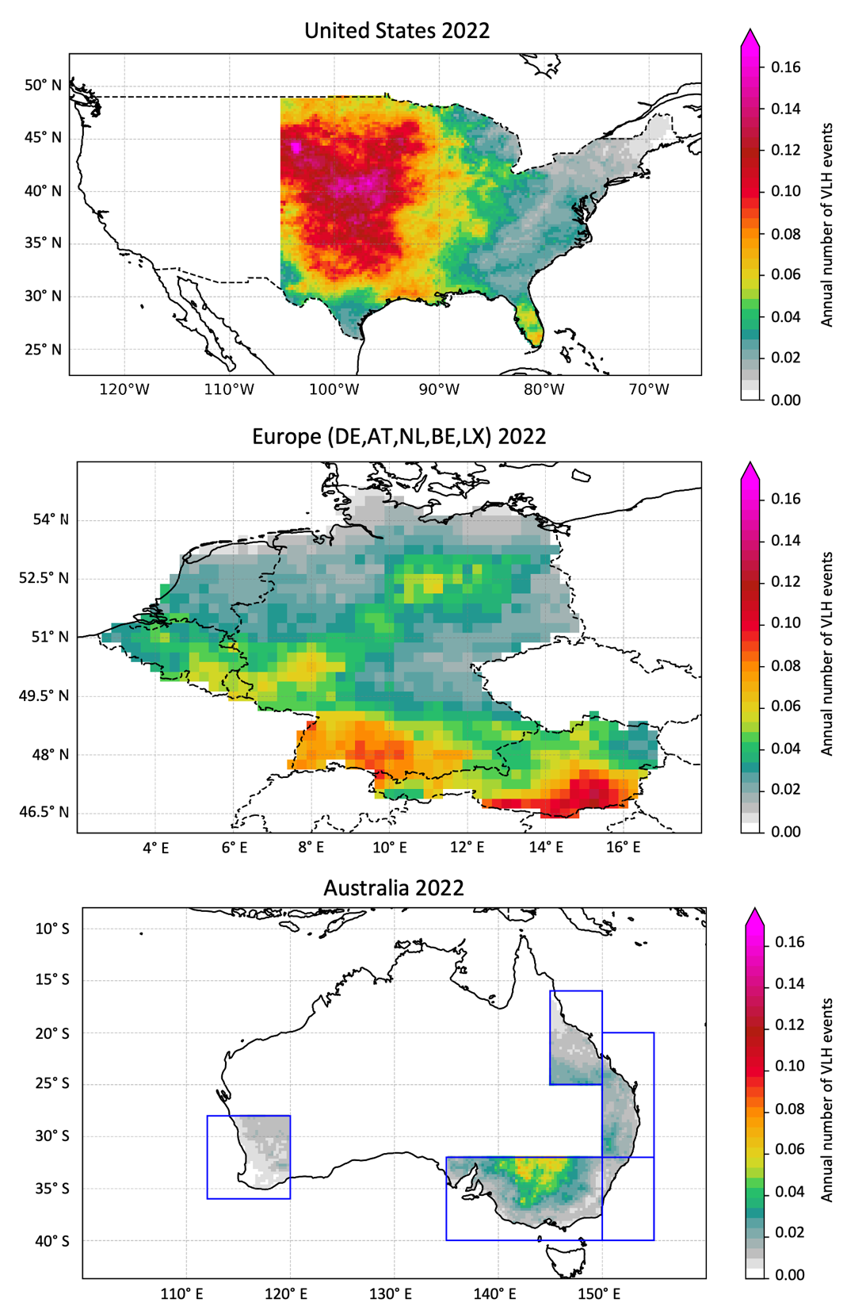

Fig. 3: Areas considered for the comparison of trends in VLH frequency and those in hail loss events. The annual number of VLH events is shown for the areas considered and a specific year (2022) across the three regions.

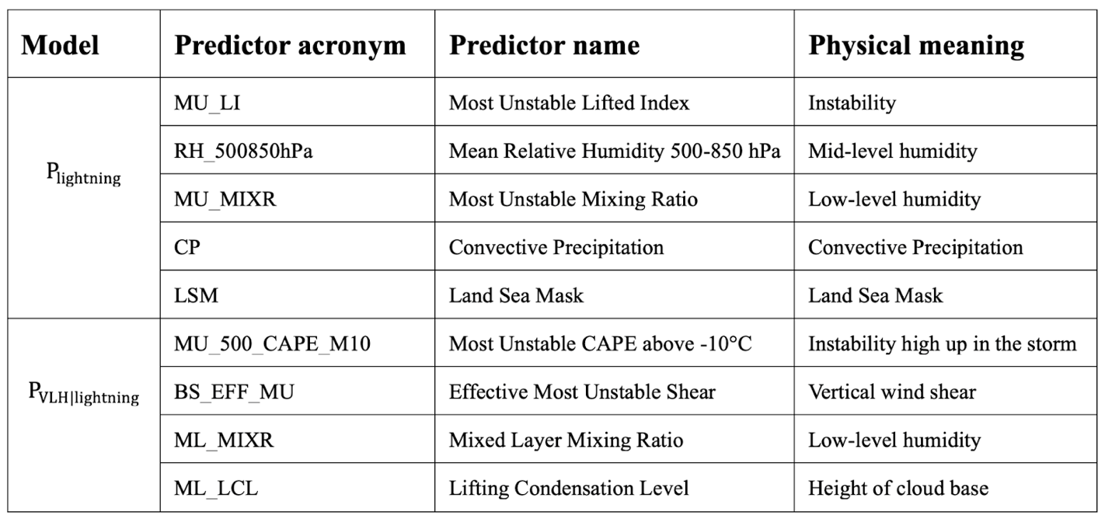Table 1: List of predictors names for the VLH model, their acronym, and the corresponding physical meaning. Parameters are distinguished between the ones used for the lightning model ($P_{lightning}$) and for the conditional VLH model ($P_{VLH|lightning}$).

Quantitative trends attribution
We calculated the relative contribution of each predictor (see Table 2) on the changes in VLH frequency in two regions: one in northern Italy (45.0°–46.0°N, 8.50°W–9.50°E) and the other in northwestern Argentina (32.0°–33.0°S, 68.0°–69.0°W). The procedure to calculate the contribution of each predictor is the following:
- Calculate predictor mean and trends: We calculated the area-averaged mean and trend between 1950 and 2023 of each predictor when the 99th percentile of VLH probability was met. Using the 99th percentile of VLH probability allowed us to focus on the conditions when VLH is most likely to happen.
- Interpolate the values to 1950 and 2023: Using the trend of each predictor, we estimated the value of each predictor at the beginning (1950) and end (2023) of the time series.
- Calculating the relative contributions: For each predictor, we calculated how its trend (from its 1950 value to its 2023 value) affected the likelihood of VLH (or lightning). We did this by comparing the probability of VLH (or lightning) under two conditions:
  - Using the mean values of all predictors (from 1950 to 2023) except one (the one we are testing) for which the 1950 value is used.
  - Using the mean values of all predictors (from 1950 to 2023) except one (the one we are testing) for which the 2023 value is used.
  - We took the ratio of these two probabilities and calculated the percentage change in VLH probability (or lightning) due to the trend in that predictor.
  - We repeated this process for all the other predictors.

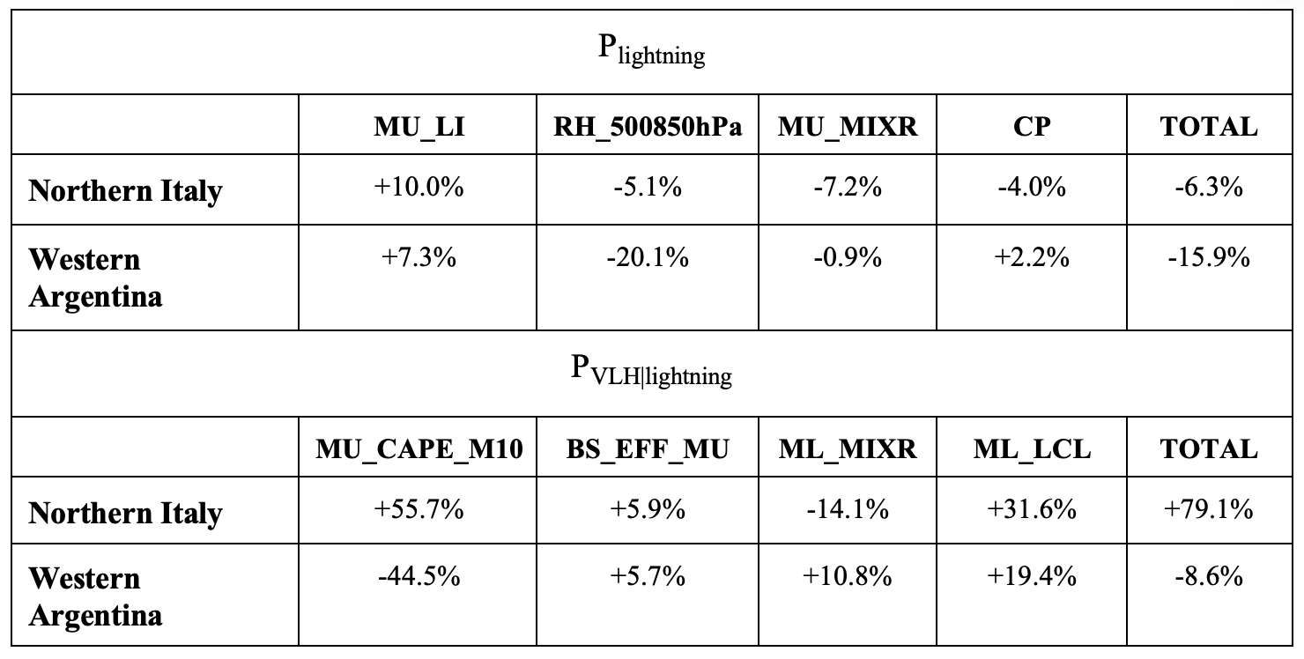
Table 2: List of predictors’ contributions to the lightning model $P_{lightning}$ and the conditional VLH model ($P_{VLH|lightning}$) across northern Italy and western Argentina.

