Supplementary Information

Low-temperature oxidation of hexagonal boron nitride during oxidative dehydrogenation reactions

Mehran Sajad ², Kateřina Knotková ², Roman Bulánek ², Ota Bludský ¹, Miroslav Rubeš ^{1,2*}

¹ Institute of Organic Chemistry and Biochemistry, Academy of Sciences of the Czech Republic, Flemingovo nám. 2, 162 10 Prague, Czech Republic
² Department of Physical Chemistry, Faculty of Chemical Technology, University of Pardubice, Studentská 573, 532 10 Pardubice, Czech Republic

E-mail: miroslav.rubes@uochb.cas.cz

Catalysts
Boron-based materials used in this study were prepared as follows. The h-BN was purchased from Sigma-Aldrich (product no. 255475) and used in the catalytic test as received. For the purpose of testing the influence of the existence of the bulk B₂O₃ phase on the h-BN surface, the original h-BN was impregnated with a methanol solution of boric acid with a boron content corresponding to a final concentration of "extra" boron of 1.5 wt. % (BOx/h-BN (1.5 wt.%). Samples of boron oxide deposited on fumed silica (Sigma-Aldrich, product no. S5505) were prepared by wet impregnation method from an aqueous solution of boric acid of the appropriate concentration (the final boron content in the samples was 2.46 wt.% (BOx/SiO₂ (2.46 wt. %) and 31 wt. % (BOx/SiO₂ (31 wt. %)). Impregnations were carried out by gradual evaporation of the solvent with constant stirring until complete evaporation of the liquid at 55°C; then, the materials were dried in a drying oven at 80°C for 24 h, subsequently ground in a mortar, and calcined at a temperature of 450°C (heating rate 2°C/min, kept target temperature for six h) in the flow of dry air (20 ml/min). Bulk B₂O₃ was prepared by thermal decomposition of boric acid while heating to a final temperature of 490°C.

Catalytic tests
The catalytic behavior of various boron-based catalysts in propane oxidative dehydrogenation was investigated in a plug-flow fixed-bed tubular shape reactor with an inner diameter of 15.5 mm, using 100 mg of catalyst with a grain size of 0.35 to 0.50 mm at 490°C under atmospheric pressure. A reaction mixture consists of C₃H₈/O₂/He = 30/15/55 vol. % and a total flow rate of 20 ml min⁻¹. Before each catalytic test, a pretreatment was performed by He (11 ml min⁻¹) at 490°C for 2 hours. The blank test was carried out in an empty reactor under the same conditions as a test with catalysts. The reaction products were analyzed with an online gas chromatograph (Agilent 7890A) equipped with both a flame ionization detector (FID) and a thermal conductivity detector (TCD). The GS-Carbonplot GC column (50 m long with a diameter of 530 µm) was used for the separation of compounds. The injector and oven temperature were 150 °C, and the detector temperature was 270 °C. Helium was used as carrier gas with a flow of 3 ml/min.
The propane conversion varies in a wide range from 3% to 23%, depending on the nature of the boron-based catalyst. It should be noted that a blank test performed on an empty reactor showed a propane conversion of only 2.5%. The h-BN material as a prototype of an active boron-based catalyst shows the highest propane conversion under the given conditions (23%), followed by a catalyst based on BOx clusters supported on silica in an amount roughly corresponding to the capacity of a BOx monolayer on the silica surface with a conversion of ca. 21%. Both activated h-BN and BOx/SiO₂ (2.46 wt.%) have isolated or only partially agglomerated BOx particles anchored on the surface. The presence of bulk B₂O₃ oxide on the catalyst surface, generated by impregnation of B₂O₃ on h-BN in an amount of 5 wt.% or by creating a multilayer of oxidic B₂O₃ phase on the silica surface (boron content 31 wt.%), leads to a decrease in propane conversion, and therefore in the activity of the catalytic material. The decrease is in the case of h-BN ca. 30 rel. % (a decrease in conversion from 23 to 16%), while in the case of impregnated silica, the conversion drops to a third of the value obtained on a catalyst with a boron content of 2.46 wt.% (a decrease in propane conversion from 21% to 7%). Pure bulk unsupported boron oxide shows negligible activity, as evidenced by the propane conversion, which is 3.2% (it should be noted that the blank experiment without catalyst led to a conversion of 2.5%). These experimental data contradict the hypothesis that the quasi-liquid interface of molten B₂O₃ (melting point 450°C) generates active particles/centers for the ODH reaction and that the existence of this liquid layer on the support is the cause of the observed catalytic activity, which has been proposed in the literature.

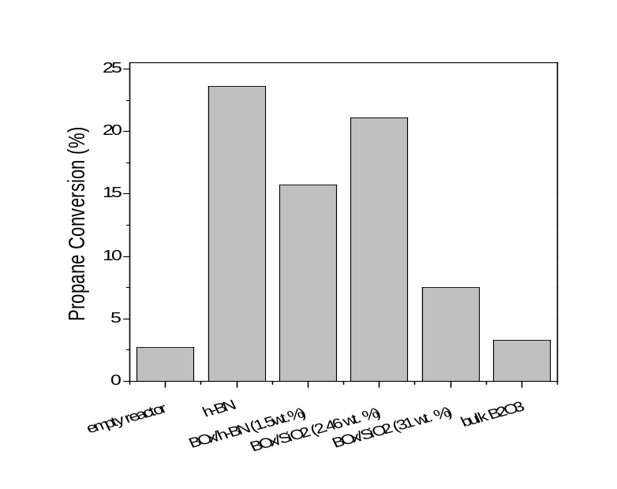
Figure S1 Propane conversion in oxidative dehydrogenation reaction at 490°C in a reaction gas mixture with a flow rate of 20 ml.min⁻¹ and the composition C₃H₈/O₂/He = 30/15/55 vol. % over 100 mg of various boron-based catalysts.

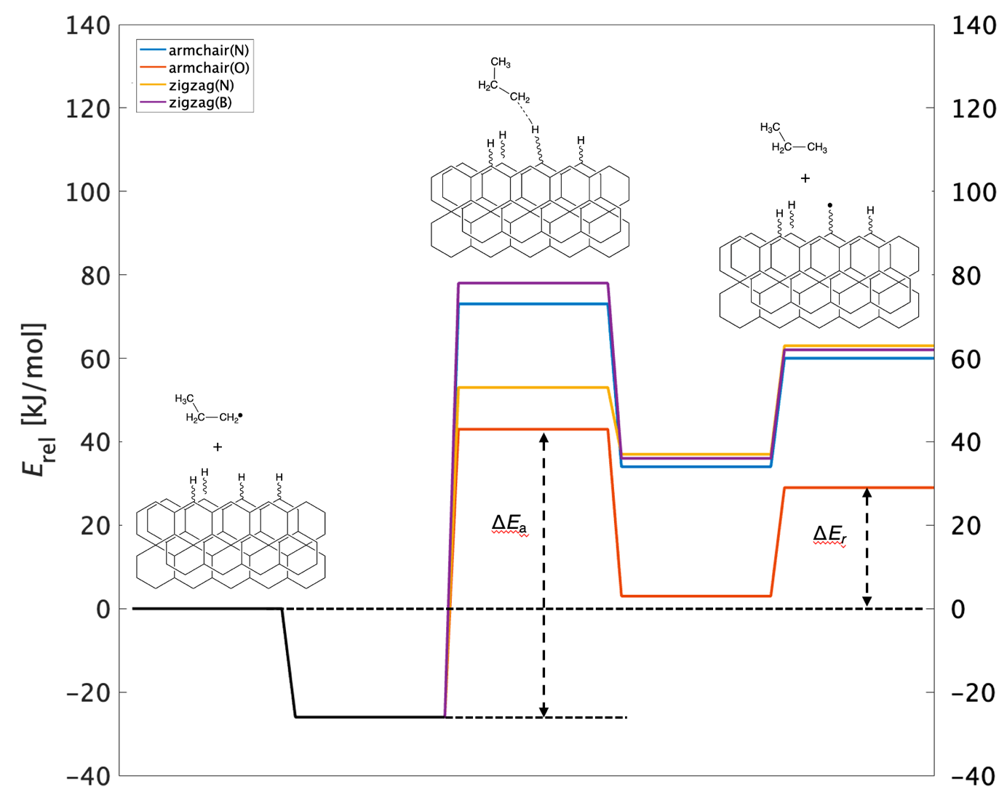
Figure S2 The energetics of h-abstraction via n-propyl radical for different h-BN edges. The definition of activation energy (ΔE_{a}) and reaction energy (ΔE_{r}) are also shown.

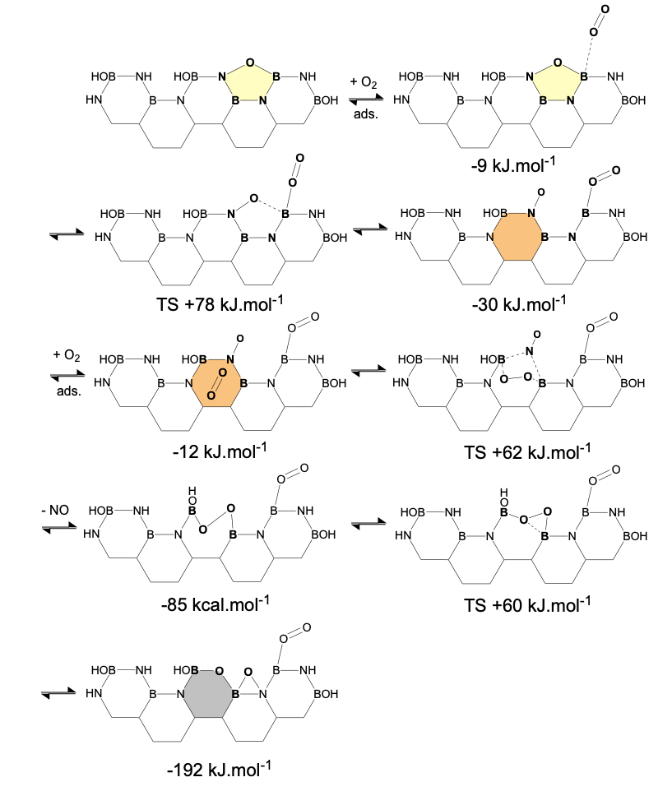
Scheme S1 Mechanism of oxidation of armchair edge including relative energies with zero set to correspond to the stoichiometry of the process (i.e., the total energy of h-BN model including the energy of two oxygen molecules).

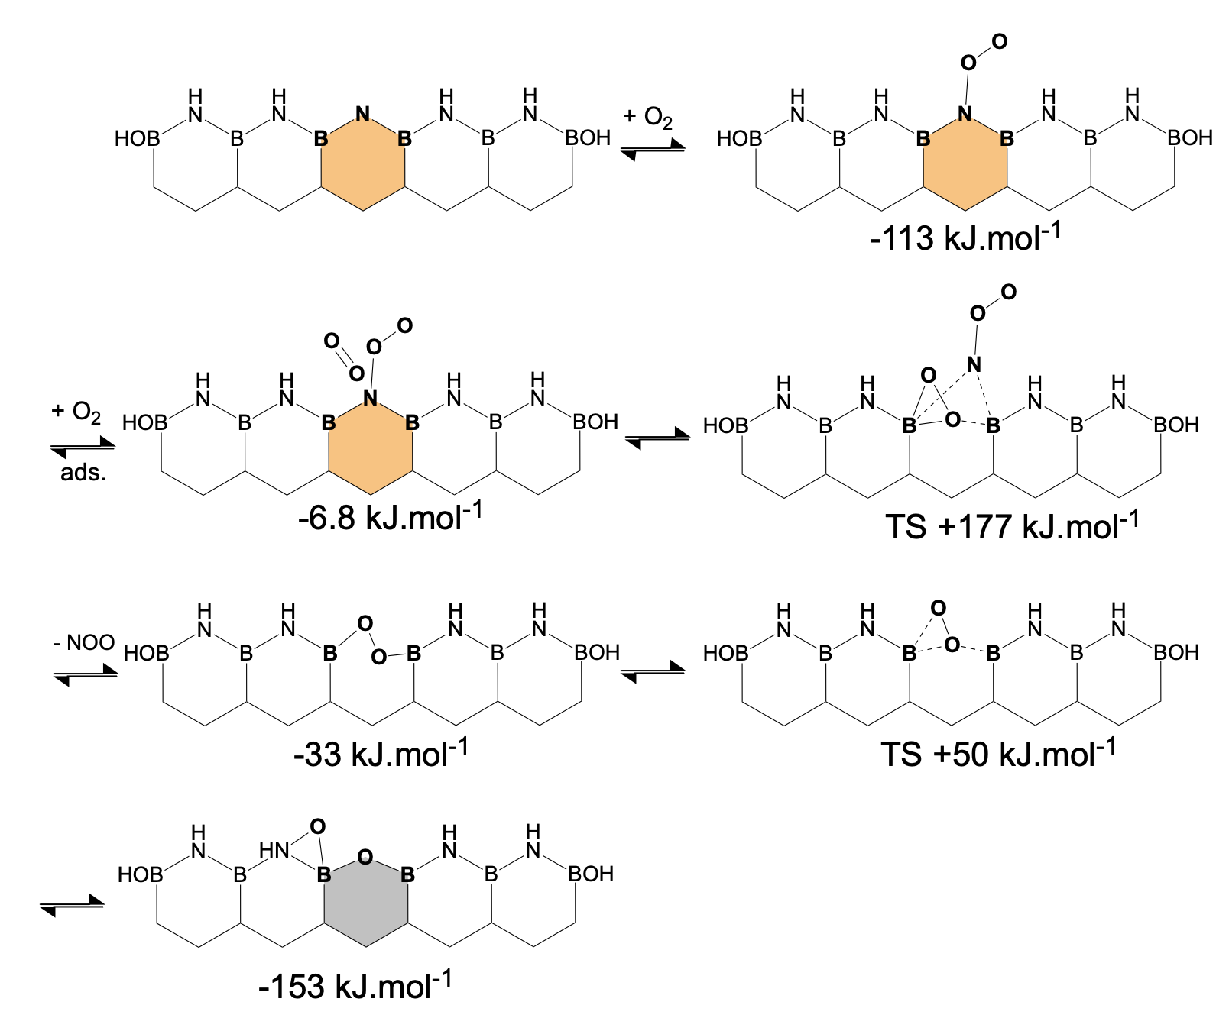
Scheme S2 Mechanism of oxidation of zig-zag(N) edge including relative energies with zero set to correspond to the stoichiometry of the process.

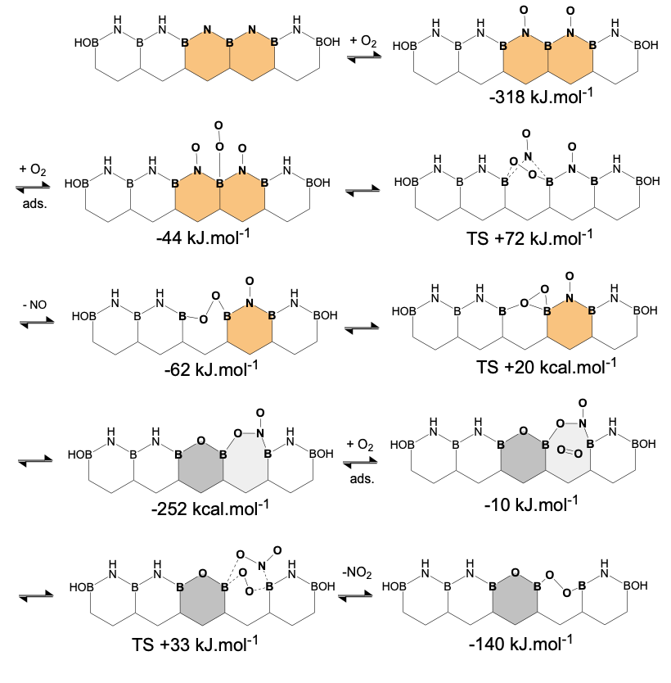
Scheme S3 Mechanism of oxidation of zig-zag(N) edge including relative energies with zero set to correspond to the stoichiometry of the process.

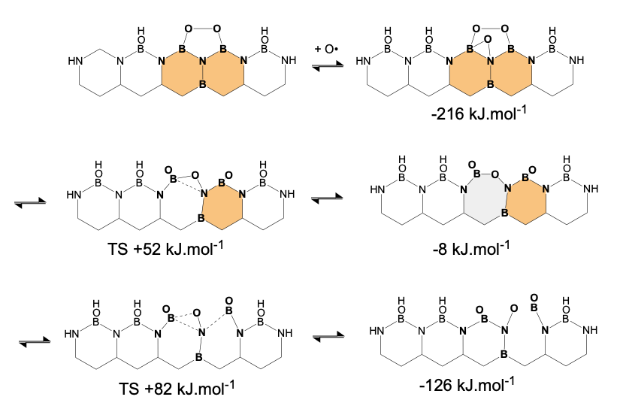
Scheme S4 Mechanism of oxidation of zig-zag(O) edge including relative energies with zero set to correspond to the stoichiometry of the process.

a | b
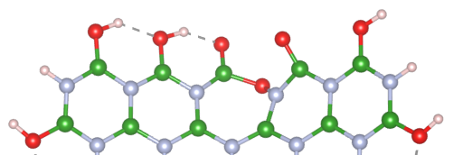 | 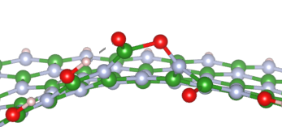

Figure S3 The 7MR ring formed at zig-zag(O) edge; (a) top view and (b) side view.

Figure S4 Snapshots from AIMD (900 °C) showing h-BN edge oxidation (B-green, N-blue, O-red, H-white). Within the first 5 ps, radical oxygen atoms attack B-N bonds at the edge. By 20–25 ps, further oxygen interactions lead to NO desorption (20.5 ps), replacing nitrogen with oxygen. These oxidized sites become more susceptible to additional oxidation. Note that at these elevated temperature the molecular oxygen can dissociate into oxygen radicals.
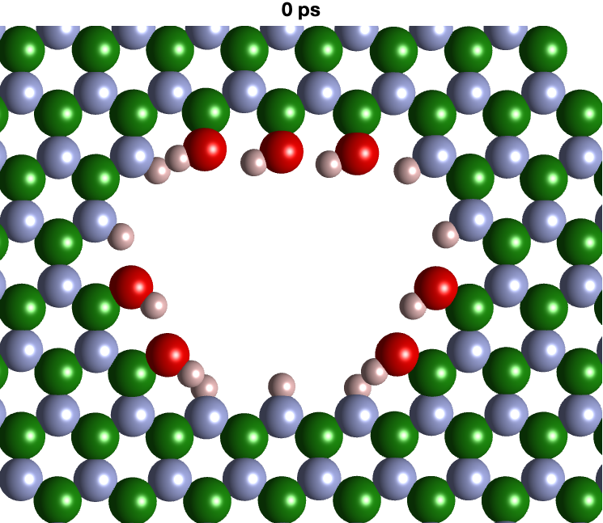 | 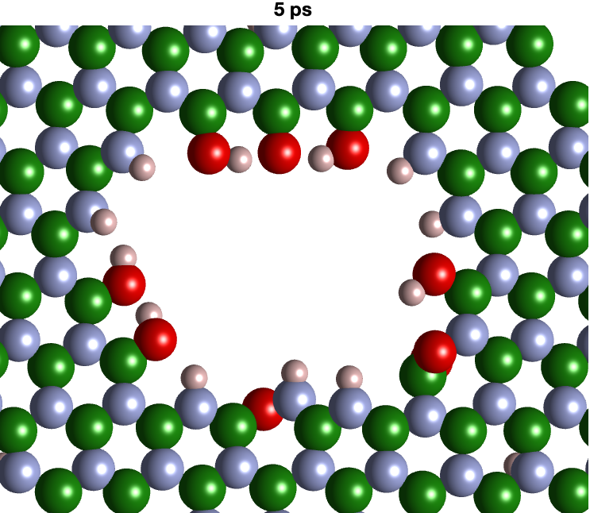 | 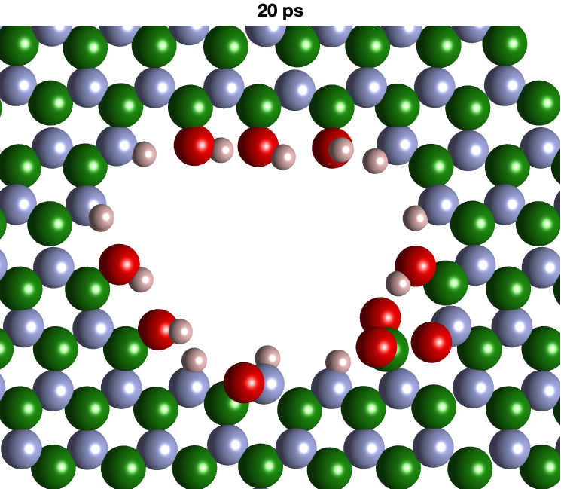
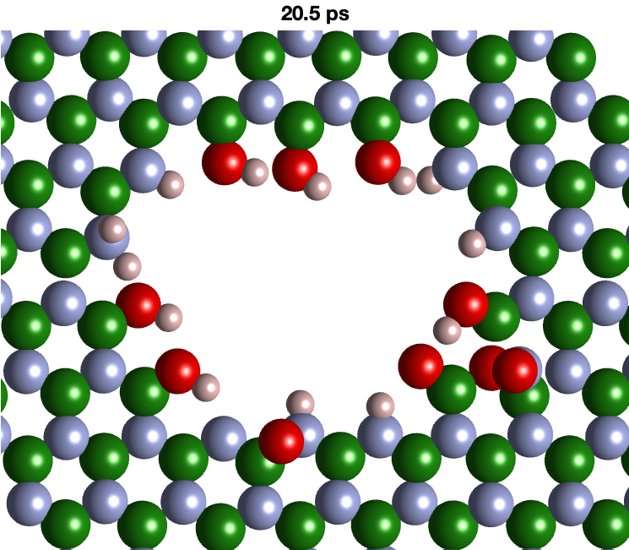 | 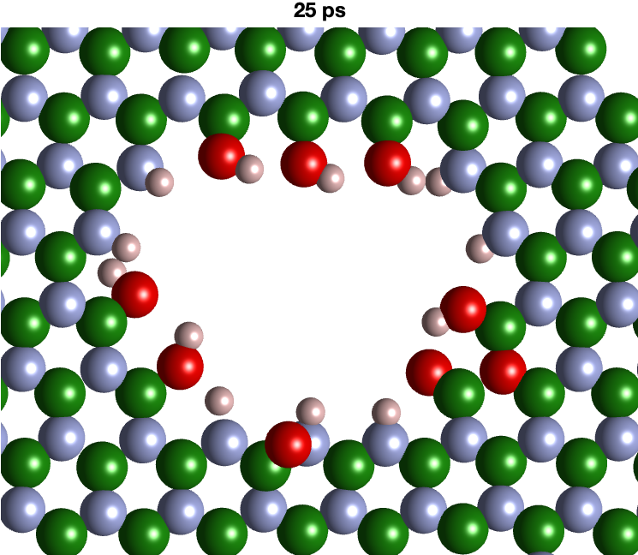 | 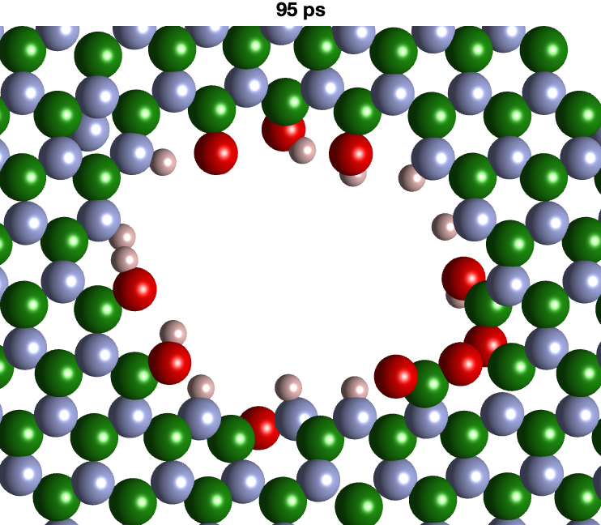
Figure S5 Snapshots from AIMD (900 °C) showing h-BN edge oxidation on activated model (B-green, N-blue, O-red). Within the first 5 ps, the unsaturated N sites are saturated with oxygen forming NO groups. The surface adsorption of O₂ at 8 ps leads to desorption of NO (9 ps) followed by formation of B-O-O-B motif, which further transforms into B-O-B followed by formation of BO₂ group. Additional four simulation were performed yielding a very similar NO desorption mechanism.
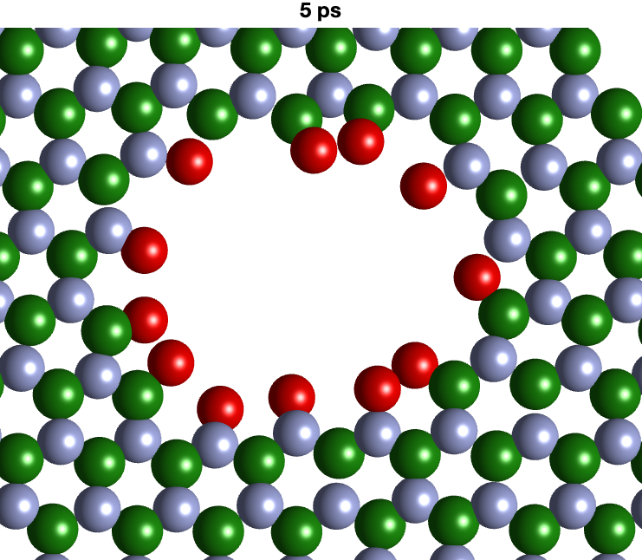 | 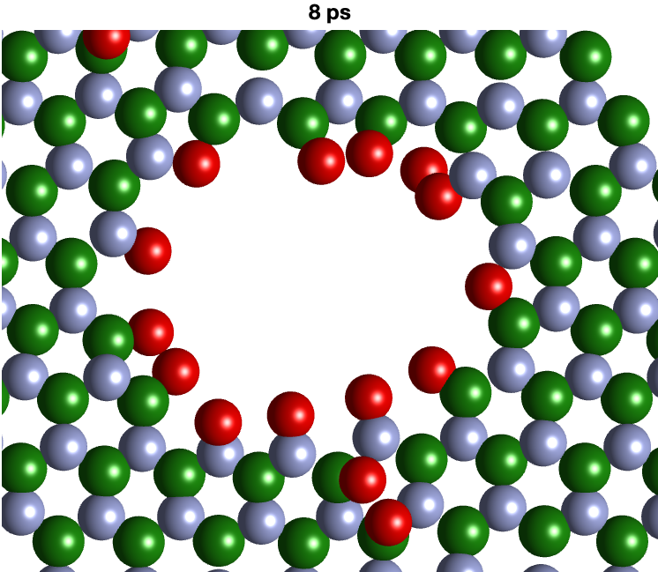 | 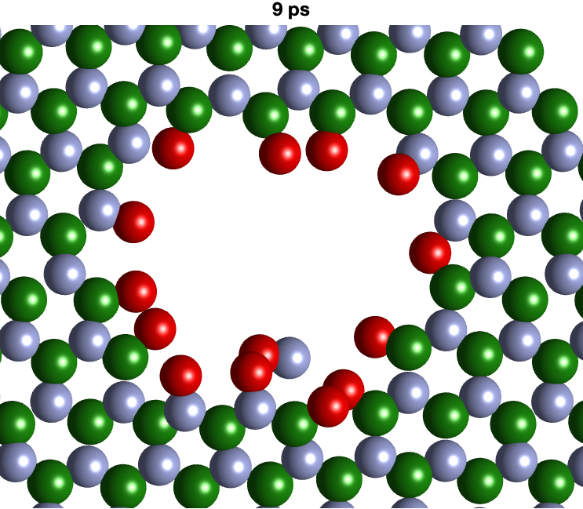
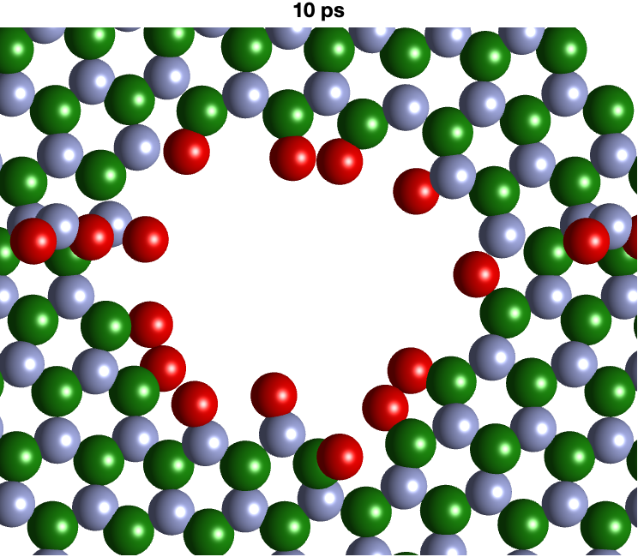 | 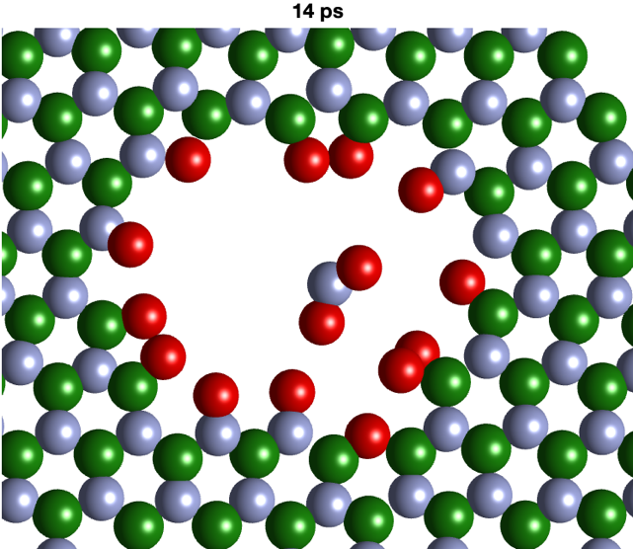 | 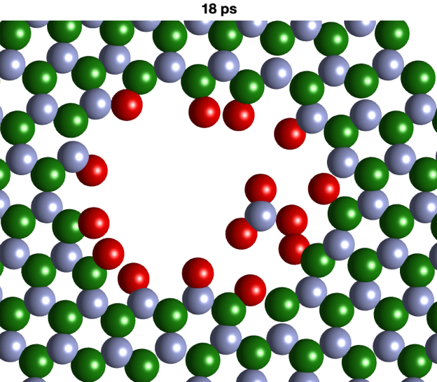

0 ps | 10 ps
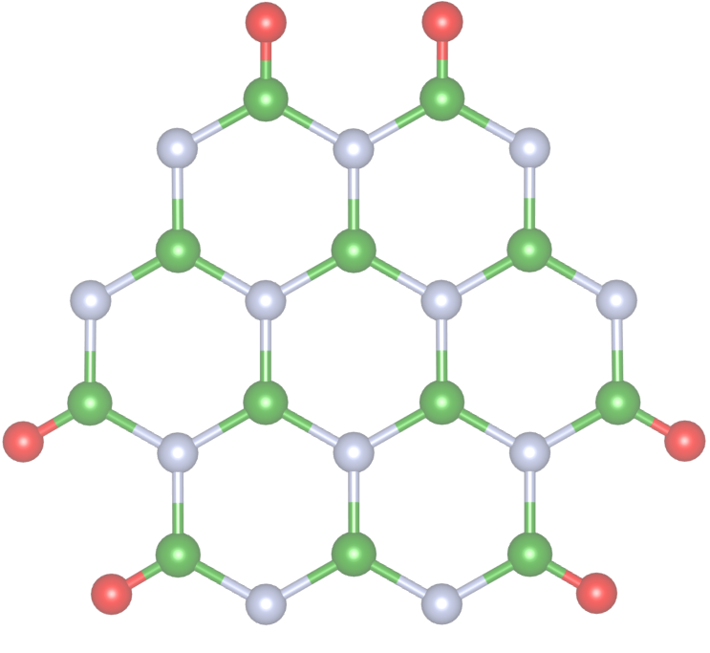 | 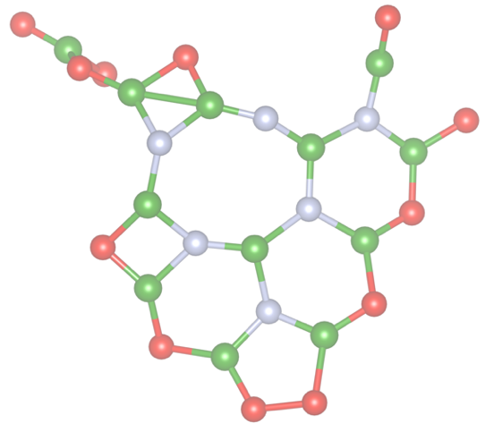
20 ps | 30 ps
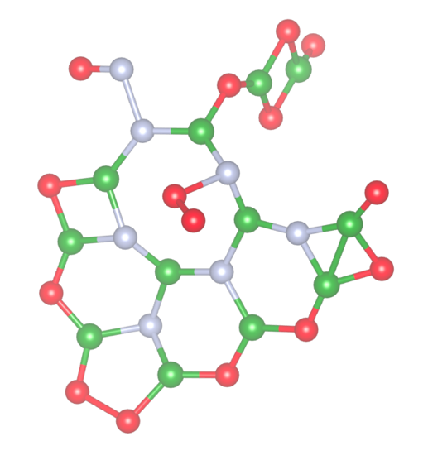 | 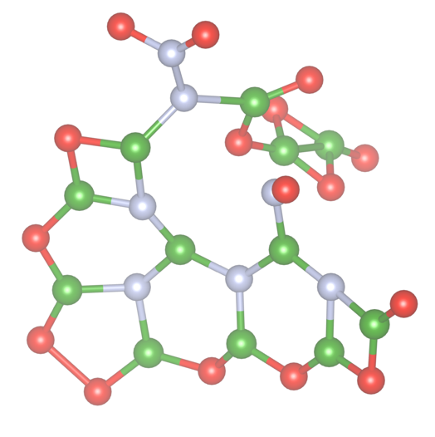

Figure S6 Snapshots from AIMD (1200 °C) showing the oxidation of a coronene-like structure into a BOx phase (B-green, N-blue, O-red).

