Supplementary Table 1 Search terms in articles searches
Search terms in articles searches
terms | (CDKAL1) AND (macrosomia OR “giant infant” OR “large-for-dates infant” OR “giant children” OR “giant neonate” OR “giant infant” OR “great children” OR “huge children” OR “giant infants” OR “large infant” OR “large fetus” OR “giant fetuses” OR “tremendous children” OR “huge child” OR “huge infant” OR “big fetus” OR “bigness fetus” OR “giant child” OR “giant baby” OR “low birth weight” OR “light birth weight” OR “low birth weight infant” OR “low birth weigh” OR “low birth weight infants” OR “lower-birthweight” OR “low birth weight” OR “low birth” OR “large for gestational age” OR “small for gestational age” OR “premature delivery” OR “premature” OR “preterm birth” OR “preterm delivery” OR “prematurity” OR “premature infant” OR “parturition praematurus” OR “precocious birth” OR “premature infants” OR “miscarriage” OR “misbirth” OR “premature labour” OR “neonatal” OR “preterm infants” OR “spontaneous preterm birth” OR “preterm premature” OR “abortion” OR “preterm newborn” OR “premature labor” OR “premature birth” OR “early ripening” OR “premature neonates” OR “preterm pregnancy” OR “premature bieth” OR “preterm gestations” OR “early fruiting” OR “early delivery” OR “pre-birth” OR “preterm neonate” OR “preterm infant” OR “early shooting” OR “term infant” OR “stillborn” OR “stillbirth” OR “drops dead” OR “fetal death” OR “natus mortus” OR “dead birth” OR “intrapartum deaths” OR “Weight-to-length ratio” OR “neonatal hypoglycemia” OR “hypoglycemia of newborn” OR “newborns with hypoglycemia” OR “neonatal hypoglycaemia” OR “fracture in newborn” OR “neonatal fracture” OR “transient respiratory distress of the newborn” OR “newborn infants with respiratory distress” OR “neonatal respiratory distress” OR “Apgar score” OR “NICU” OR “shoulder during childbirth” OR “shoulder dystocia” OR “brachial plexus injury” OR “brachial plexus palsy” OR “brachial plexus injuries” OR “branchial plexus injury” OR “brachia plexus injury” OR “injury of brachial plexus nerve” OR “brachial plexus root injury” OR “spinal trauma” OR “neonatal asphyxia” OR “congenital deformity” OR “congenital abnormalities” OR “congenital malformations” OR “congenital abnormality” OR “congenital anomalies” OR “congenital scoliosis” OR “fetus congenital malformation” OR “malformation” OR “urinary tract congenital malformation” OR “congenital deformities” OR “congenital malformed” OR “congenial malformation” OR “congenital anomaly” OR “congenital thumb aplasia” OR “hereditary malformation” OR “primary anomaly” OR “congenital malformation” OR “congenital abnormality” OR “neonatal fetal acidosis” OR “childhood obesity” OR “children obesity” OR “pediatric obesity” OR “obese children” OR “children simple obesity” OR “child obesity” OR “children adiposis” OR “children adiposity” OR “children simple obese”).
Filters | Publication date to 2024/09/20.
Items | PubMed (18), Web of Science (36), Cochrane Library (0), Embase (25), SpringerLink (21), Wiley Online Library (0), ScienceDirect (21), Medline (18), CNKI (9), Wanfang Med Online (5), Google Scholar (14), The Lancet (0), Nature (0), Science (0), The New England Journal of Medicine (0), and JAMA (1).  Items found: 50 (Non duplicated articles).

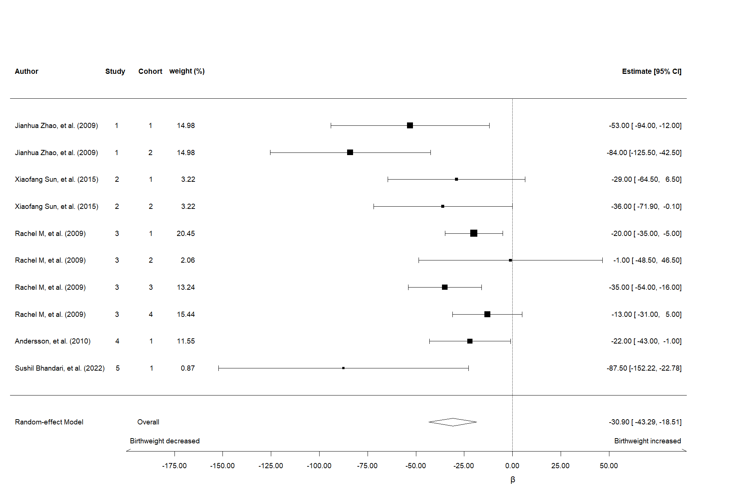
Supplementary Fig 1 Forest plot of meta-analysis of the effect of CDKAL1 gene on birthweight.
The black horizontal lines represent the 95% CI while the squares represent the point estimate, with larger squares indicating greater weight of the study. All analyses are based on the random-effects model.
β: Grams of change in birthweight of newborn due to per additional risk allele of CDKAL1 gene.
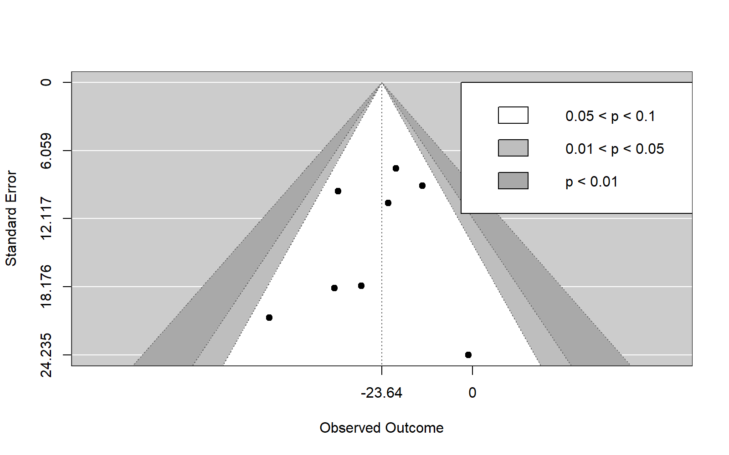
Supplementary Fig 2 Meta-analysis funnel diagram of the effect of CDKAL1 gene on birthweight.
The horizontal line in the funnel plot indicates the summary estimate, while the sloping lines indicate the expected 95% CI for a given standard error, assuming no heterogeneity between studies.
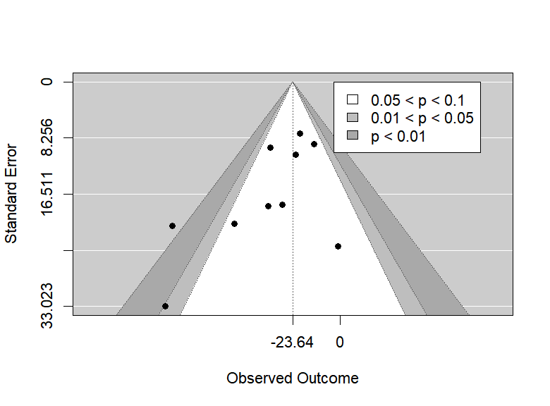
Supplementary Fig 3 Meta-analysis funnel diagram of the effect of CDKAL1 gene on birthweight.
The horizontal line in the funnel plot indicates the summary estimate, while the sloping lines indicate the expected 95% CI for a given standard error, assuming no heterogeneity between studies.
Supplementary Table 2 Detailed information on the articles excluded.
Title | Study | Cohort | Author | Year | Country | Sample | NOS-score | β | LCI | UCI | P
Examination of Type 2 Diabetes Loci Implicates CDKAL1 as a Birth Weight Gene | 1 | 2 | Jianhua Zhao, et al. | 2009 | American | 5465 | 8 | -84.0 | -126.0 | -43.0 | <0.001
Population history and genome wide association studies of birth weight in a native high altitude Ladakhi population | 5 | 1 | Sushil Bhandari, et al. | 2022 | Irish | 316 | 7 | -87.5 | -171.0 | -41.5 | 0.019
NOS, Newcastle-Ottawa Scale; LCI, Lower Confidence Interval; UCI, Upper Confidence Interval.

