Full-length blots/gels Supplementary Figure
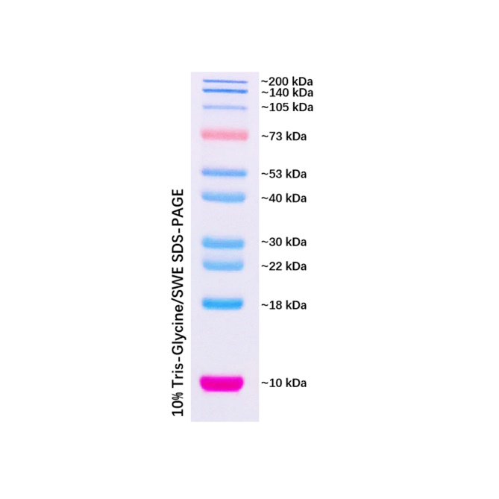
Protein marker and cropped site of Western blots

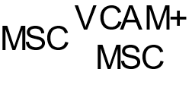
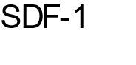
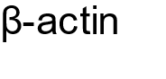
Figure1

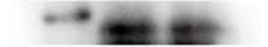
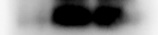
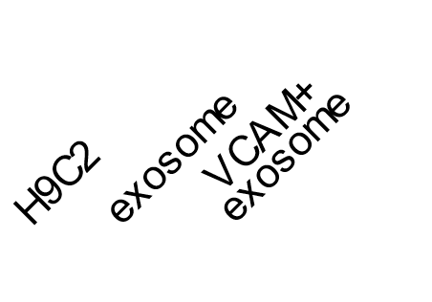


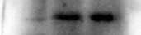
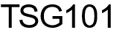
Figure2

Figure3
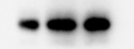
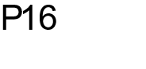
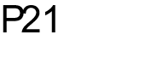
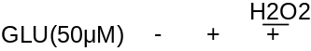
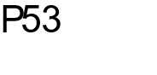
H9c2

Primary
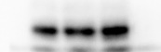
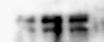

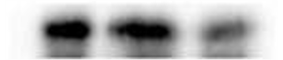

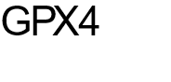
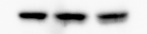
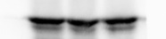
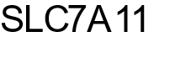
Figure4

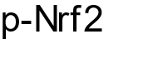
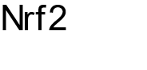
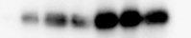
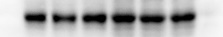
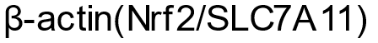
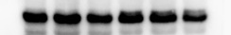

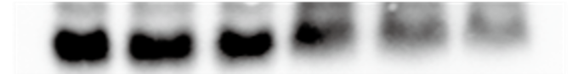
Figure5

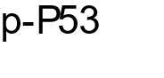
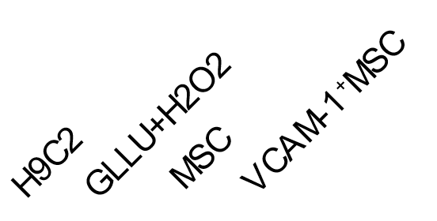
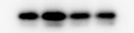
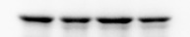
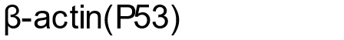
Figgure6

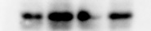
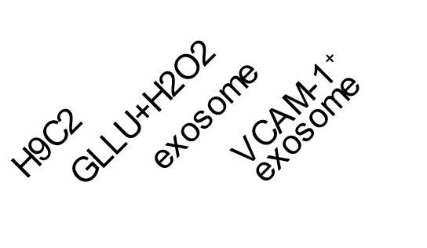
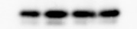
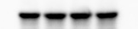
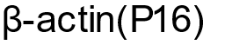
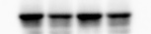
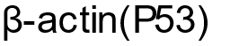
Figure7

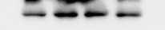
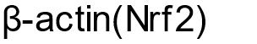
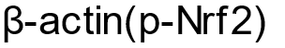
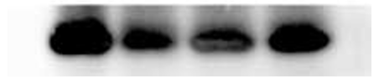
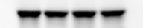
Figure8

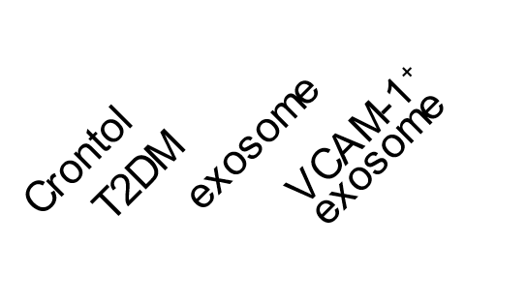
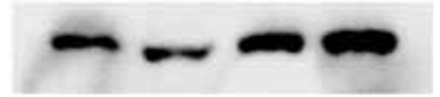
Figure9

Figure10
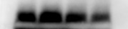

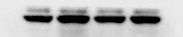


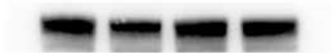
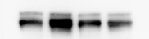

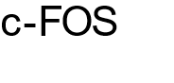
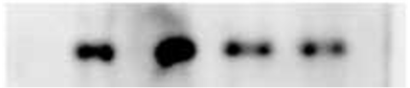
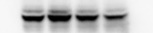


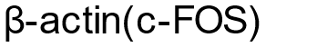
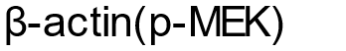
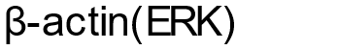
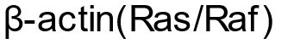
H9c2:

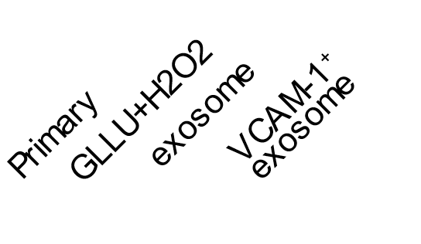
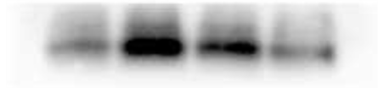
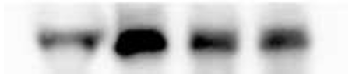
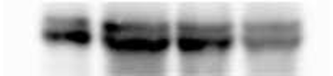
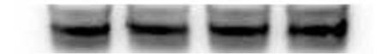
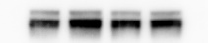
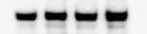
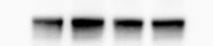
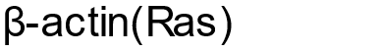
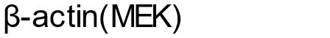
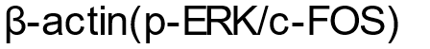
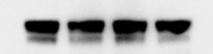
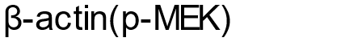
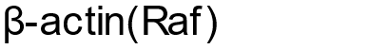
Primary:

